Collaborative Session Title Here

Contents

Executive Summary 3
Problem Statement 4
Session Goals and Objectives 5
Roster of Participants 6
Collaborative Session Participants 7
Ideal Participant Matrix (Optional) 8
Agenda 9
Process Diagram 10
Activity Details 12
Activity #1: ActivityName 12
Activity #2: ActivityName 13
Activity #1: ActivityName 14
Event Budget 15
Implementation Details 16
Conclusion 17
Appendices 18
Appendix 1: Name 18
Appendix 2: Name 19
Appendix 3: Name 20

Executive Summary
This is a ONE-PAGE (maximum) summary of the entire proposed project, summarizing the basics of the collaborative effort and highlighting the benefits of the project to the “client.”

This section should QUICKLY convince the "client" executives to authorize/fund the proposed project.
- WHAT is the problem? (Get straight to the point!)
- WHY should they care/act/help? (Be persuasive!)
- WHAT will happen during the event? (Be BRIEF!)
- HOW MUCH will it cost? (List a TOTAL amount here, provide details in your budget section.)

What RESULT should they expect after this HUGE investment of time and resources?
- What is the “return on investment” for all the resources that will be dedicated to it?
You should summarize the expected results here and provide details in your "conclusion" section!

This is usually written LAST, after all the other components are drafted.

Problem Statement
Refer to the PDF posted to Canvas for specific instructions on how to write a formal problem statement. The ideal length is generally 2-4 paragraphs… no more than 1 page!

You will want to highlight key issues (or CSFs) that shape/influence/affect the problem, such as:
- Critical success factor #1: FactorName – describe it here;
- Critical success factor #2: FactorName – describe it here;
- Critical success factor #3: FactorName – describe it here.

Then, you will want to describe the consequences of inaction/failure to solve the problem.

Finally, you should identify the parties that might be most likely to develop a solution, and what their expected contributions might be.

Session Goals and Objectives
In this section, you will want to provide a set of EXPLICIT goals and objectives that CLEARLY outline the expectations of the participants and guide the group’s work in the collaborative session.

The proposed collaborative project has been developed to achieve the following goals:
- Goal #1: GoalName – Description here;
- Goal #2: GoalName – Description here;
- Goal #3: GoalName – Description here;
- Goal #4: GoalName – Description here;

The goals above should be PRIORITIZED, with the most important/achievable goal listed first.

Write supporting paragraphs to explain WHY these goals were selected and/or HOW they relate to the problem outlined in the previous section.

Roster of Participants
Ideally, this section would serve as a way for all the session participants to contact each other, both DURING the session and IN THE FUTURE. Write a brief introductory paragraph to replace this text, and explain how the group was carefully selected to broaden the perspective of the assembled group… improve the chances of success… or whatever factors are most important to ACTUALLY ACHIEVING the desired outcome of the session (a solution to the problem).

You MAY find it useful to provide a “Participant Matrix,” so that if a desired representative is unavailable, an appropriate replacement may be found. I will leave it up to you to determine whether this is appropriate to be included or not.

Collaborative Session Participants
NAME | ORGANIZATION | TITLE | PHONE | EMAIL ADDRESS

Ideal Participant Matrix (Optional)
 | ENTITY | ENTITY | ENTITY | ENTITY | ENTITY | ENTITY | ENTITY
TITLE/ROLE/SKILL | … | … | … | … | … | … | …
TITLE/ROLE/SKILL | … | … | … | … | … | … | …
TITLE/ROLE/SKILL | … | … | … | … | … | … | …
TITLE/ROLE/SKILL | … | … | … | … | … | … | …
TITLE/ROLE/SKILL | … | … | … | … | … | … | …

Agenda
Every meeting is different… clients are different… the locations are different… select a PROFESSIONAL meeting agenda template/format for your project and insert it here. Or you may create your own.

You might also want to include the formatting for your meeting INVITATION here, as well.

KEEP IN MIND: Your participants WILL judge this meeting based upon the professionalism of your invitation and your agenda! If this project is REALLY important to you, you should take EXTRA EFFORT to make these deliverables look great and contain all the accurate information that is needed.

Remember the concept of “Expectations Theory,” and set the proper expectations for your session. It all begins with well-crafted pieces here in this section!

Process Diagram
You will write an introductory paragraph here that will “set up” your diagram of the process

In this term project, you’re going to be developing the steps of a scientific process that aims to create a “PRODUCT” that will help a “client” solve a complex problem. The process will include many steps that may be confusing to your participants… they may not understand how one step relates to another, especially if the session/process is a long one! To keep the group’s efforts focused, to maintain their enthusiasm, to preserve their motivation, and to ensure that their efforts are effective, a GREAT visualization is required!

Replace the diagram below with a PROFESSIONAL illustration, WordArt diagram, or image that CLEARLY depicts every step of the process… highlights the relationships between the steps (INPUTS/OUTPUTS)… and provides a VISUAL “road map” that helps your participants understand the process you are creating.

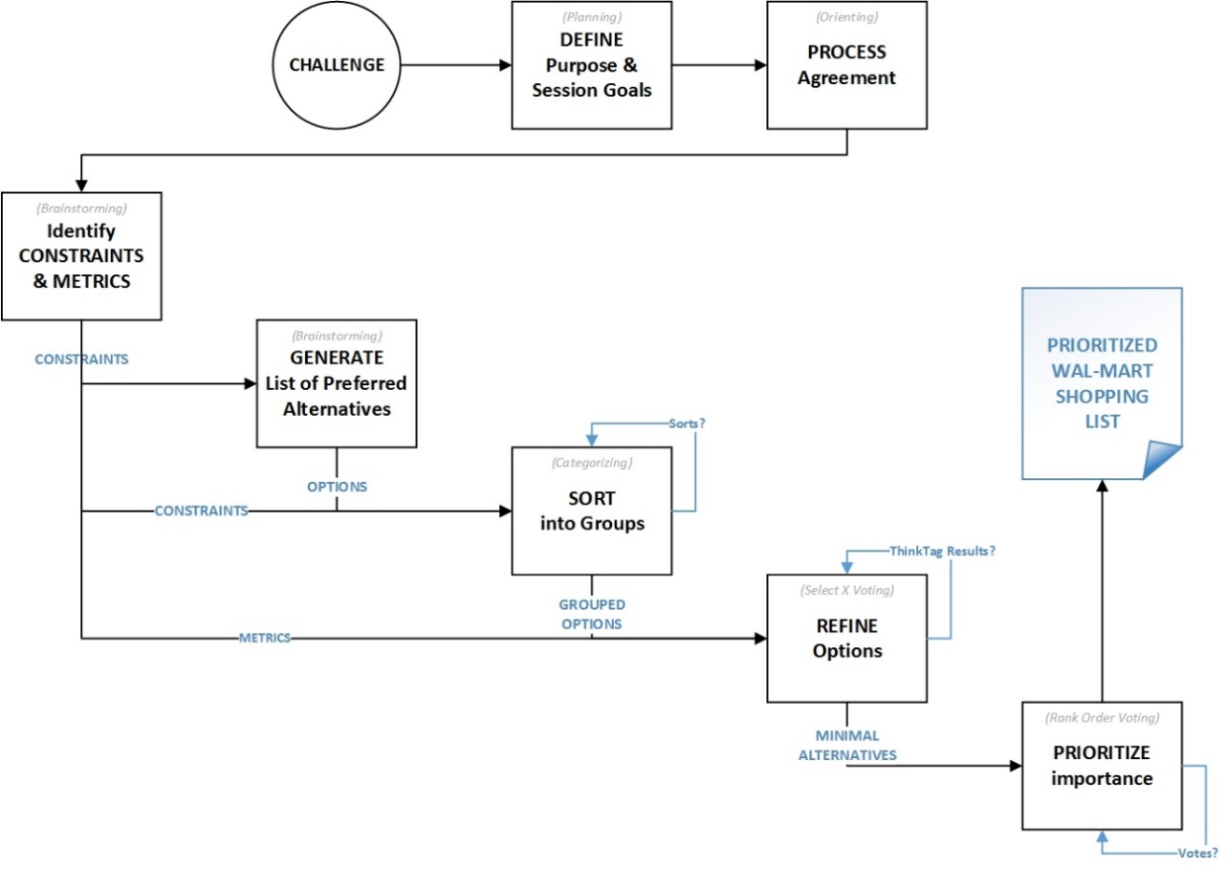
You will also want to write a paragraph for each of the more complicated steps in your process. This will help the “client” understand the reasons why certain activities/steps are included and their value.

Activity Details
Write an introductory paragraph that explains the METHODOLOGY of your process. The reason why this section is important is because it will enable future replication of the process if it is ever needed again.

Document everything as precisely as you possibly can! THIS IS THE MOST IMPORTANT SECTION!!!

Activity #1: ActivityName
TOOL/METHOD: ToolName or ThinkLet or Customized Task Name – (Collaboration Pattern?)
PARTICIPANTS: All (or specify a subset, for “breakout” tasks)
MATERIALS: Background data, info, whatever is needed to complete the task
TIME ALLOTTED: XX minutes (12:00 AM – 12:00 AM CDT)
INSTRUCTIONS: This should be EXPLICIT! Tell the participants EXACTLY what they need to do… how to use the software/tool… how they should contribute… GIVE THEM PRECISE INSTRUCTIONS! Any ambiguity here could TOTALLY undermine the success of the entire session! This is the BIGGEST PART of your grade for this entire project… take this ESPECIALLY seriously! (These instructions could take up several paragraphs, perhaps a page or more!)

Activity #2: ActivityName
TOOL/METHOD: ToolName or ThinkLet or Customized Task Name – (Collaboration Pattern?)
PARTICIPANTS: All (or specify a subset, for “breakout” tasks)
MATERIALS: Background data, info, whatever is needed to complete the task
TIME ALLOTTED: XX minutes (12:00 AM – 12:00 AM CDT)
INSTRUCTIONS: This should be EXPLICIT! Tell the participants EXACTLY what they need to do… how to use the software/tool… how they should contribute… GIVE THEM PRECISE INSTRUCTIONS! Any ambiguity here could TOTALLY undermine the success of the entire session! This is the BIGGEST PART of your grade for this entire project… take this ESPECIALLY seriously! (These instructions could take up several paragraphs, perhaps a page or more!)

Activity #1: ActivityName
TOOL/METHOD: ToolName or ThinkLet or Customized Task Name – (Collaboration Pattern?)
PARTICIPANTS: All (or specify a subset, for “breakout” tasks)
MATERIALS: Background data, info, whatever is needed to complete the task
TIME ALLOTTED: XX minutes (12:00 AM – 12:00 AM CDT)
INSTRUCTIONS: This should be EXPLICIT! Tell the participants EXACTLY what they need to do… how to use the software/tool… how they should contribute… GIVE THEM PRECISE INSTRUCTIONS! Any ambiguity here could TOTALLY undermine the success of the entire session! This is the BIGGEST PART of your grade for this entire project… take this ESPECIALLY seriously! (These instructions could take up several paragraphs, perhaps a page or more!)

Event Budget
Meetings ALWAYS have a cost – it might not always be a financial expense or outlay, but the TIME of every participant is valuable and it adds up quickly! Your “client” will understand this, and you need to demonstrate that you have thought out as many of the cost details as possible for your collaborative session. You will provide details of these costs in this section.

Some of the most popular items in these types of event budgets include:
- Facility Rental – WHERE will the event take place? Is there a rental cost involved?
- Travel Expenses – Will people need to travel to your meeting? Are you reimbursing them for airfare, mileage, and/or hotel accommodations?
- Food/Catering – If you’re having a long meeting, you ARE planning to feed your participants, right?
- Technology Expenses -- Does the facility feature the technological resources you need for your meeting? Display projectors? Projection screens? Laptop computers? WiFi access? Is there a license required for any collaborative software you’re using?
- Facilitation Expenses – Are you going to pay for a professional facilitator?

IMPORTANT: THIS DOES NOT HAVE TO BE PRECISE! Develop a set of REALISTIC expense numbers that will serve as a good ESTIMATE of the meeting’s total cost to the “client” organization. Go online to look at conference room rental rates, airfare, hotel & catering costs, etc. and round them appropriately.

The LAST thing a client wants to see is an event cost that EXCEEDS the budgeted/authorized amount. Think of as many things that might contribute to the cost of the event and include them in a PROFESSIONAL, itemized budget. (Insert a table, Excel worksheet, or go find an event planning budget template here in this section.

You will probably write a summary paragraph (and possibly supporting paragraphs) to explain any significant expenses that will be incurred.

Implementation Details
Obviously, this event is important to YOU… if you were put in charge of it, you would want it to be an unqualified success!

What “extra stuff” will you need to pull this off? What “things” do you need to do to actually make the event go smoothly?

In this section, you’ll create a bulleted list of the items that YOU (the event planner) will need to remember to do the day of the event’s opening. The details here will prove that you have actually given the event serious thought… and not just completed this as an academic exercise.

You’ll begin this section with an introductory paragraph explaining that the following list is a set of things that you must remember to do before the meeting begins. (THIS IS DELIBERATELY INCOMPLETE!)
- Acquire/distribute the power strips for the participants’ laptops;
- Name tags for participants;
- Printers available in the conference room? Do we have extra paper/toner on hand?
- Additional WiFi access points?
- Post-It Notes, pens, markers
- Copies of needed background materials?

This section will CLEARLY show which students have made an EXTRA EFFORT, and which students simply want to achieve a minimum level of acceptability.

Conclusion
This section serves as your LAST CHANCE to convince the "client" executives to authorize/fund the proposed project.
- WHAT is the problem? (Summarize its importance!)
- WHY should they care/act/help? (Be persuasive!)
- WHAT will happen during the event? (Just describe the biggest highlight of your design!)
- HOW MUCH will it cost? (Indicate any areas that might be negotiable/flexible.)

What RESULT should they expect after this HUGE investment of time and resources?
- What is the “return on investment” for all the resources that will be dedicated to it?

Your executive summary “touched” on all these points… but here is the place where you should FULLY explain the EXPECTED RESULTS of your session. In other words, when it is all over, what will the “client” have in their possession? What is the PRODUCT of the session? What will it contain?

Wrap it up with a POSITIVE close that “asks for the sale”… something like:
“We can solve this problem… let us know when you are ready for us to begin.”

Appendices
Use this section to include material that will be germane to the event/discussion/process. This could include background material, items that encourage debate/consideration, etc.

Copy-and-paste the heading below to create as many appendix pages as you need.

Appendix 1: Name
Something brilliant here

Appendix 2: Name
Something brilliant here

Appendix 3: Name
Something brilliant here

