Head to our virtual lab

https://phet.colorado.edu/sims/html/circuit-construction-kit-dc-virtual-lab/latest/circuit-construction-kit-dc-virtual-lab_en.html

What are properties of series circuits concerning:
- Voltage used for the element(s)?
Voltage: The supply voltage in a series circuit is equal to the sum of the individual voltage-using devices.

- Current through each element?
Current: The amount of current is the same through any component in a series circuit.

Series Circuit
Lab:
1
A
B
C
2
- Create a series circuit shown to the right.

- Measure the following:

battery voltage _______

voltage light 1 _______ voltage light 2 _______

Question:
- How does this show the series property for voltage usage?

- Measure the following:

Current at point A ______ Current at point B _______ Current at point C _______

Question:
- How does this show the series property for currents? (Refer to the answers in red above)

Parallel Circuit
Question:
What are the properties of a parallel circuit concerning?
a. Voltage usage for each parallel branch?
A Parallel circuit has certain characteristics and basic rules: Voltage is the same across each component of the parallel circuit.

b. Current through each branch?
A parallel circuit has two or more paths for current to flow through. The sum of the currents through each path is equal to the total current that flows from the source.

A
B
C
1
2
Lab:
Create the parallel circuit to the right.
- Measure the following:

battery voltage _______

voltage light 1 _______ voltage light 2 _______

Question:
How does this show the parallel property for the voltage in parallel branches?

Lab:
- Measure the following:

Current at point A ______ Current at point B _______Current at point C _______

Question:
- How does this show the parallel property for current in parallel branches?
(Refer to the answers in red above)

Place each of the items listed into a circuit and list whether the item is a conductor or an insulator:

Item | Conductor/Insulator
fuse
dollar bill
paper clip
coin
eraser
hand
dog
pencil
Battery | Voltage (V)
1
2
3
1+2
1+2+3

Drag three batteries onto the circuit field. Measure the voltage of each using the voltmeter and record. Measure each battery as a single battery and then measure two inked together and finally all three linked together.

Describe the relationship between the number of the batteries and the voltage.

Use the scissors to disconnect one of the batteries and then flip the polarity of the disconnected battery. Reconnect and use the voltmeter to measure the total voltage of the three batteries again. What is the voltage reading now? Why do you think this has changed?

Build the circuits with a battery of 12 V and light bulbs. Using the voltmeter and the ammeter, measure the voltage and the current and complete the table:
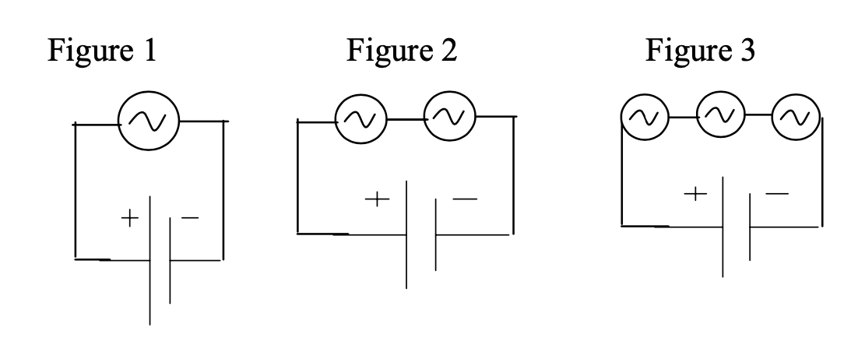
# of bulbs | Battery (V) | Current into battery (A) | Brightness of bulbs

Summarize the relationships you observed and explain why you think this is happening. Change the battery voltage (double or triple the voltage). Does the relationship you cited above still hold?

