PROPOSAL
  - APEX INFORMATICS
  - 2019

Table of contents

Executive summary …………………………………………………..……….………………… 3
Introduction ……………………………………………………………………….…………….. 3
Scope of consulting ………………..…………………………………………………………… 5
Solution to your questions ………………………………………………..……………..……… 6
- Outline the steps you will take in developing an automation plan for our firm, including a budget, setting a time frame for implementation and training. We are especially interested in being able to show how our investment in technology means time saved and that this investment will have an impact to our firm’s productivity….

- Present a billing practice solution – they would like to consider a new role model for charging clients, rather than just by billable hours. We would also like to be able to capture- and cover the true costs of all our efforts. What do you recommend?

- Litigation will be the lifeblood of our firm. As such…
- They are interested in your recommendations for implementing a litigation support system.
- The partners and staff have worked in firms that were primarily paper-based operations and we would like our practice to be as “paperless” as possible.
- Because litigation also involves research, please advise us on the alternatives for legal and factual research and the advantages and disadvantages of each approach..

- Recommend case management and docket control software including a conflicts database. Please describe the advantages, features and functionality of this types of software.

- Recommend court room preparation and presentation software. present the issue they need to be aware of using this kind of software and technology.

- Discuss issues regarding electronic discovery. Identify which Federal Rules apply to ED and what firm policies or training they should implement to steer clear of violations.

- Finally, present some of the ethical issues that using technology in the practice of law may involve. Select one type of law firm technology covered during the semester and discuss it from the perspective of the Rules of Professional Conduct as well as any rules related to evidence or civil or criminal procedure.
Budget Quotation ………………………………………………………..………………….….. 8

- Executive summary
Apex Informatics is a Tech automation organization with an aim at developing and maintaining any social grade law suits and firms. The firm offers best sling shots for both baby-step companies and big companies too. Our tremor goes deep into the solution finding for constraints that require economical break through.
1.1 Introduction
- Outline the steps you will take in developing an automation plan for our firm, including a budget, setting a time frame for implementation and training. We are especially interested in being able to show how our investment in technology means time saved and that this investment will have an impact to our firm’s productivity
Apex informatics has front room services as well as backroom services. In the front room, we provide the client with fully function software and relevant alternative decisions. This will include installation of soft wares and provide manuals to their use and application. In the back room services, we have a set of experts who operate parallel software. They monitor how you organization is using the software and keep track of its data and storage. We also offer experts to work with you in your offices and alternatively train your staff on how to work with our tech. The total synchronization of data allows a paperless environment in storage and use of data in a safe way. This is also a feature that allows for search an information from a load of data in a very short period, say a few seconds to go over up to 5TB of data.
Steps in billing automation plan for the law firm. Apex informatics runs in the thread mill of technology. With any new developments of any kind of piece of technology, we are at the fore front in having the piece and manipulating it to suit our client’s needs. This means that we keep our clients at par with trending technology hence we can proudly say we keep you up to date.
Due to constraints of time, full group training may inconvenience your firm. To tackle this, we offer part time classes for your staff who are already working with you. Evening, night and weekend training sessions are offered by our professional tutors. In cases where your firm may require all your staff to be trained all at once, we offer substitute staff from our company. Our qualified time steps in for your time.
The substitution may be partial such that both teams work together in your firm of complete substitution where our time stands in the gap. After training, your firm reinstates your staff back to their duties. I recommend a partial substation.

- Present a billing practice solution – they would like to consider a new role model for charging clients, rather than just by billable hours. We would also like to be able to capture- and cover the true costs of all our efforts. What do you recommend?
For your customer satisfaction and your firm’s convenience, I recommend to you the Star Track Software. This is programmable software that can be manipulated to allow administration-software-client interchange. Its ability to connect to the internet allows all data to be synchronized at every passing second. It also allows real time communication between its users. The software can be connected to up to three bank servers that will enable it to allow clients to be billed directly from their accounts rather than having to relay large sums of money in their hands. After the service, the customer only needs to authorize transaction by confirming two password verification steps. First, a password on the login handles for the client to access their dashboard and the second, a password to allow bank transactions.
We consider this a 360 degree security that will keep of siphon users who snoop on online transaction.

- Litigation will be the lifeblood of our firm. As such …

- They are interested in your recommendations for implementing a litigation support system.
- The partners and staff have worked in firms that were primarily paper-based operations and we would like our practice to be as “paperless” as possible.
- Because litigation also involves research, please advise us on the alternatives for legal and factual research and the advantages and disadvantages of each approach.
The Star Track Software from Apex Informatics has an expandable administrative platform that allows merging of tasks. The Litigation Support Software will be installed by Apex Informatics. The Star Track Software was launched in 2017. The soft wares interface allows for access of cloud based file from all devices with legal orientation. It has bug fixes with features like date booking, task management, data storage and synchronization and automatic billing. The Star Track Software can assist your firm in achieving your goals while stile staying in your mission to of admirable legal services. It offers database for organizing, searching and editing of legal information. Its technological advancement to use cloud storage has allowed it give clean works far from use of papers. . The total synchronization of data allows a paperless environment in storage and use of data in a safe way. This is also a feature that allows for search an information from a load of data in a very short period, say a few seconds to go over up to 5TB of data.

- Recommend case management and docket control software including a conflicts database. Please describe the advantages, features and functionality of these types of software.
To come up with a successful Ral Law Firm plan, making decisions guided by the economical balloon that fits within the firm’s constraints should be the key element.
The backroom feature of Apex Informatics has incomparable amounts of data synchronized with other firms. This is only possible from the liability that the firm accepts terms and conditions of use of the Star Track Software. The research data saved for the purpose of recovery from disaster attack like virus intrusion into the system, spy and siphon users and software breakdown is safe stored. Its advantage is that it offers quick data restoration no matter what kind of data disaster the client firm must have suffered. However, the terms and conditions of services request that firms that pool the data here can also access it in their quest for research purposes in taking litigation measures. It is also in the feature that multiple search result may bring up confidential client data. Though it is only the administrators who can access this information, in case of malicious intentions, it may be leaked leading to violation of consumer privacy.

For hardware, I would recommend HP Laptop with the following specification. The price of the given below specifications is $ 1400 per laptop.
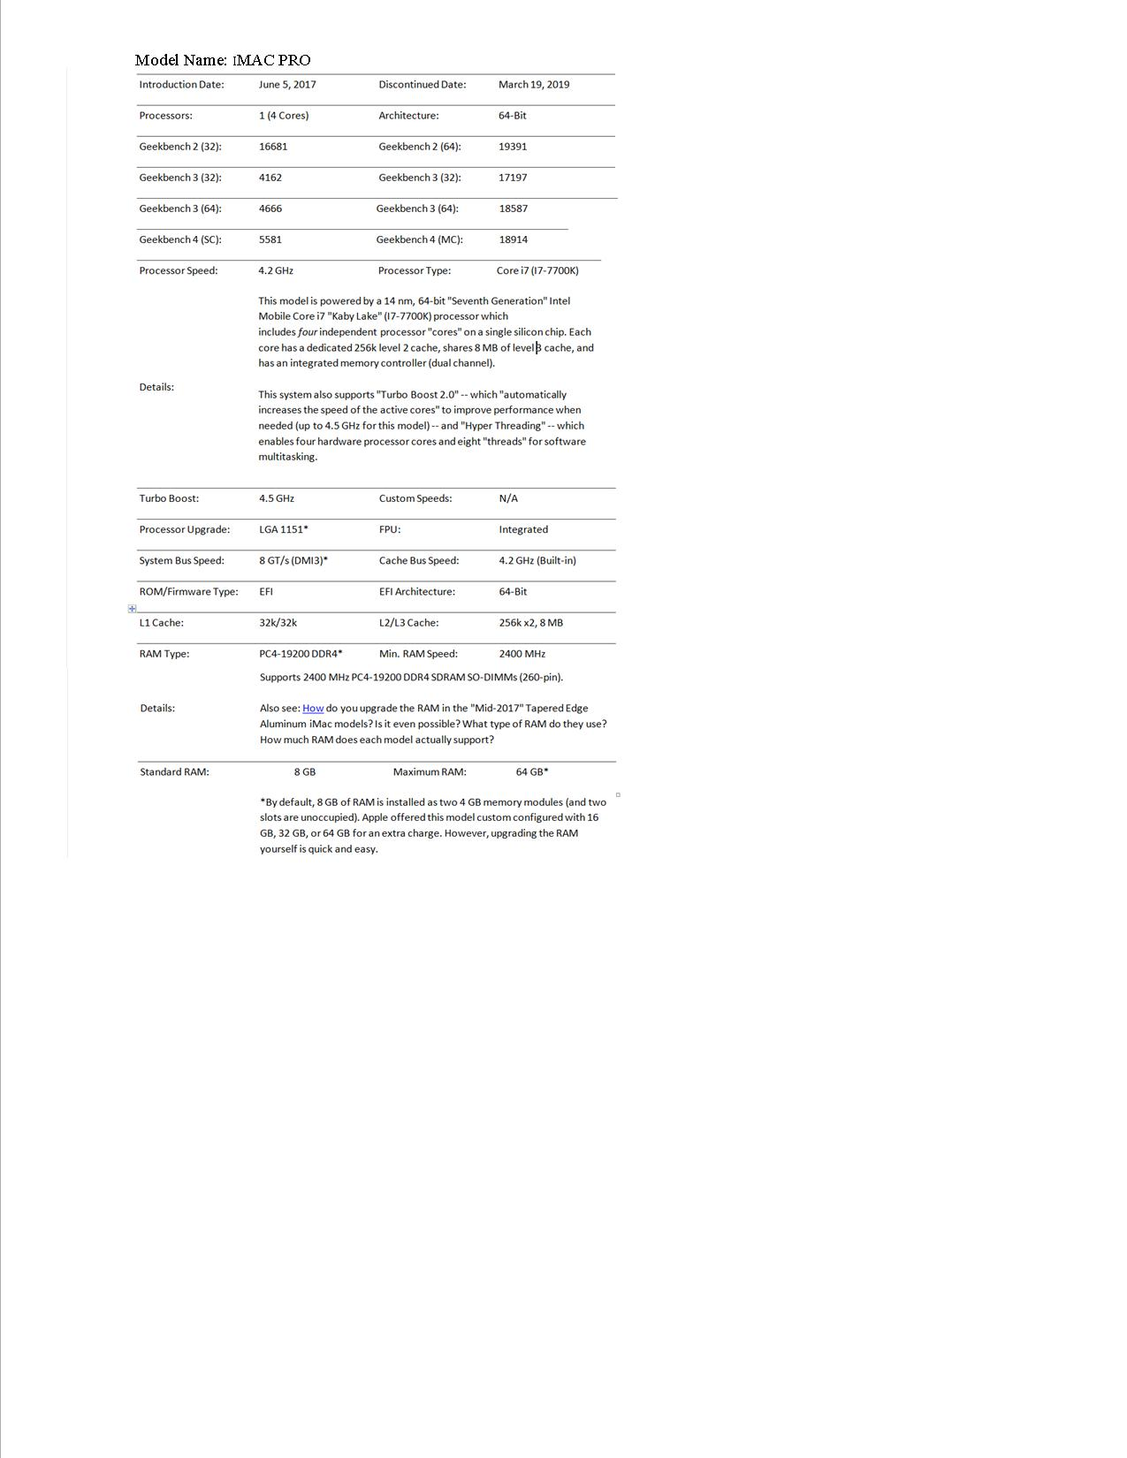

- Recommend court room preparation and presentation software. present the issue they need to be aware of using this kind of software and technology.

Away from the front of the computer screen, on the ground, the court room assimilation is also taken care of. The jury, the complaint and the defendant will be provided with Apex Tablets that are synchronized with controlled data from the main server. The data depends on the case before the court. During a court hearing, for instance, the full details of the proceedings are captured. New data is also recordable in the case of additional evidence of witnesses. However, all the information being displayed may lead to intrusion of the inner self. For example, if the is a court hearing about a manslaughter or defilement, some details will be in the consumption by the public.
We also need Android tablets with reliable internet connectivity from CYBER HOUSE INV., a super-fast internet connection with a rating of 100 Mbps. For protection of data and software from virus, malware and spyware intrusion, we will need a premium subscription of ESET NOD86 SECURITY. A premium subscription of $ 20 in trio-months will be needed.

- Discuss issues regarding electronic discovery. Identify which Federal Rules apply to ED and what firm policies or training they should implement to steer clear of violations.

Since the court environment expects clear and utmost truth and pledge of faith, every detail is put to light and test. This is in conjunction with the court ledger, but also a violation of the Federal Rules for every human right that everyone has a right to privacy and protection of their information. Therefore, the firm policies should include taking of oath for all parties that access Apex Informatics data to ensure protection of all people’s information under the common seal and protection of the Federation.

- Finally, present some of the ethical issues that using technology in the practice of law may involve. Select one type of law firm technology covered during the semester and discuss it from the perspective of the Rules of Professional Conduct as well as any rules related to evidence or civil or criminal procedure.

- Scope of consulting assignment
Apex Informatics provides consultancy services to legal firms. It is a reviewed organization that will be recommended by 8 out of 10 persons who have worked with us. In our mission to be the acme of providence to legal services, we have integrated technological advancement for the idea of stepping a foot forward to compete globally. Our services are of cutting edge quality with manageable cost. We also offer cut off prices during peak seasons.
Apex Informatics has a total of 2 attorneys and 2 paralegal professional with one office in Indianapolis with a combination of desktop PCs, laptops, tablets, mobile phones, desktop printers/scanners, network infrastructure, support/service subscriptions, file server- cloud based file storage, backup disaster recovery, internet service, software and executable programs.
The scope of the consulting assignment is as follows:
- Ral Law Firm wants to do Tech Integration of its law offices by utilizing technology as an ‘equalizer’ that will enable them to compete with large law firms in Indianapolis
- The client’s (Ral Law Firm) practice concentration on litigation, but they anticipate serving the business community with general types of legal matters
- Consultation will provide them with a breakdown of budget cost in a pasted spreadsheet within this proposal
- Consultation has also answered 7 questions in the solution which will help clarify our solution on various parameters.
- Budget Quotation
