Title: History of mental health treatment
Name:
Course name:
Course code:
Professor:
Date:

History of mental illness and treatment
In the past, the mentally sick were dealt with inadequately. It was trusted that psychological instability was satanic, a form of witchcraft, or an irate god establishment. For instance, irregular controlled by the evil spirits/mentally ill, there were a few types of treatment to discharge spirits from the person. The most widely recognized treatment was expulsion. This was directed by the clerics or different religious figures. Incantations and supplications were administered on the mentally ill’s body as well as therapeutic beverages. Trephining would also be administered. A little opening was made in the burdened person's skull to discharge spirits from the body. Many people treated in this way died. Other practices included execution or detainment of individuals with mental clutters. Other mentally ill were left to be destitute poor people. The common hypothesis of mental illness was the devilish ownership by either a malevolent soul or a shrewd god. The mentally sick individuals were slaughtered in the wake of being blamed for being witches or affected by witchcraft (Bijl, Ravelli, & Van Zessen, 1998).
By the eighteenth century, individuals who were viewed as odd and strange were set in havens. Havens were the principal organizations made for the particular motivation behind lodging individuals with mental clutters, yet the concentration was shunning them from society as opposed to treating their scatters. Regularly these individuals were kept in austere cells, beaten, tied to their beds, and had practically zero contact with parental figures. In the late 1700s, a French doctor, Philippe Pinel, contended for more empathetic treatment of the rationally sick. He proposed that they be unchained and conversed with, and that is exactly what he improved the situation patients at La Salpêtrière in Paris in 1795. Patients profited from this more empathetic treatment, and numerous could leave the doctor's facility. Endeavors for psychological well-being care in the United States started. This led to the production of the primary mental refuges in the United States (Bijl, Ravelli, & Van Zessen, 1998).
In spite of many reformers' endeavors, in any case, a normal refuge was grimy, offered next to no treatment, and regularly kept individuals for quite a long time. At Willard Psychiatric Center in upstate New York, for instance, one treatment was to submerge patients in chilly showers for drawn out stretches of time. Electroshock treatment was likewise utilized, and the way the treatment was regulated frequently crushed patients' spirits. The use of electroconvulsive treatment, began the journey of technological advancement in the approach of mental illness and treatment. A short utilization of electric boost is utilized to create a summed up seizure. Many of the wards and rooms were cold to the point that a glass of water would be solidified by morning. Willard's entryways were not shut until 1995. Conditions like these stayed typical until the twentieth century (Bijl, Ravelli, & Van Zessen, 1998).
Beginning in 1954 and picking up fame in the 1960s, antipsychotic meds were presented. These demonstrated an enormous help in controlling the side effects of certain mental issue, for example, psychosis. Psychosis was a typical determination of people in mental healing facilities, and it was frequently prove by side effects like pipedreams and dreams, demonstrating lost contact with reality. In 1963, Congress passed and John F. Kennedy marked the Mental Retardation Facilities and Community Mental Health Centers Construction Act, which gave government support and subsidizing to group psychological wellness focuses. This enactment changed how psychological wellness administrations were conveyed in the United States. It began the procedure of deinstitutionalization, the end of vast havens, by accommodating individuals to remain in their groups and be dealt with locally. In 1955, there were 558,239 extremely mentally sick patients systematized at open healing facilities (Bijl, Ravelli, & Van Zessen, 1998).
Modern treatment/approach of mental illness
Today, there are group psychological well-being focuses the country over. They are situated in neighborhoods close to the homes of customers, and they furnish huge quantities of individuals with emotional wellness administrations of different sorts and for some sorts of issues. Focuses were underfunded, staff was not prepared to deal with extreme diseases, for example, schizophrenia, there was high staff burnout, and no arrangement was made for alternate administrations individuals required, for example, lodging, nourishment, and employment preparing. Another group of the rationally sick populace is engaged with the amendments framework. As indicated by a 2006 uncommon report by the Bureau of Justice Statistics (BJS), roughly, 705,600 mentally sick grown-ups were detained in the state jail framework, and another 78,800 were imprisoned in the government jail framework (Kessler, et. al., 1994).
Today, rather than refuges, there are mental healing centers keep running by state governments and neighborhood group doctor's facilities. In a wide range of doctor's facilities, the accentuation now stays, with the normal length of stay being under two weeks and regularly just a few days. This is incompletely because of the high cost of mental hospitalization, which can be about $800 to $1000 every night. Consequently, protection scope regularly constrains the time allotment a man can be hospitalized for treatment. Typically, people are hospitalized just on the off chance that they are a fast approaching risk to themselves or others. The vast majority experiencing psychological maladjustments are not hospitalized (Kessler, et. al., 1994).
A few people look for treatment since they are included with the state's kid defensive administrations that is, their kids have been expelled from their care because of mishandle or disregard. The guardians may be alluded to mental or substance manhandle offices and the youngsters would likely get treatment for injury. A few people look for treatment in light of the fact that the criminal equity framework alluded them or expected them to go. For a few people, for instance, going to week after week guiding sessions may be a state of parole. In the event that an individual is commanded to go to treatment, she is looking for administrations automatically. Automatic treatment alludes to treatment that isn't the person's decision. Different people may deliberately look for treatment. Intentional treatment implies the individual goes to treatment to acquire help from manifestations. Mental treatment can happen in an assortment of spots. A mentally ill patient currently is able to see a school advisor, school therapist, or school social laborer. An imprisoned individual may get aggregate treatment in jail. There are a wide range of kinds of treatment suppliers, and permitting necessities change from state to state. Other than analysts and specialists, there are clinical social laborers, marriage and family advisors, and prepared religious work force who additionally perform guiding and treatment (Satcher, 2010).
A scope of financing sources pay for psychological wellness treatment, medical coverage, government, and private pay. Before, notwithstanding when individuals had medical coverage, the scope would not generally pay for emotional wellness administrations. This changed with the Mental Health Parity and Addiction Equity Act of 2008, which requires gather wellbeing designs and safety net providers to ensure there, is equality of psychological well-being administrations. This implies co-pays, add up to number of visits, and deductibles for emotional wellness and substance manhandle treatment should be equivalent to and can't be more prohibitive or harsher than those for physical diseases and medicinal/surgical issues (Luxton, et al., 2011).
Discovering treatment sources is likewise not generally simple. There might be restricted alternatives, particularly in provincial regions and low-wage urban zones; holding up records; low quality of tend to poverty stricken patients; and monetary impediments, for example, co-pays, deductibles, and time off from work. More than 85% of the l,669 governmentally assigned emotional wellness proficient lack zones are country, frequently essential care doctors and law authorization are the primary line psychological well-being suppliers, in spite of the fact that they don't have the specific preparing of an emotional well-being proficient, who regularly would be better prepared. Accessibility, availability, and worthiness are for the most part issues in rustic zones (Kessler, et. al., 1994).
Considering everything, it was once trusted that individuals with mental scatters, or those displaying peculiar conduct, were controlled by evil presences. These individuals were compelled to participate in expulsions, were detained, or executed. Afterward, shelters were worked to house the rationally sick, however the patients got next to zero treatment, and huge numbers of the techniques utilized were pitiless. Philippe Pinel and Dorothea Dix contended for more others conscious treatment of individuals with mental clutters. In the mid-1960s, the deinstitutionalization development picked up help and havens were shut, empowering individuals with dysfunctional behavior to return home and get treatment in their own particular groups. Some went to their family homes, however numerous ended up destitute because of an absence of assets and bolster instruments.
Today, rather than shelters, there are mental healing centers keep running by state governments and nearby group doctor's facilities, with the accentuation on here and now remains. In any case, the vast majority experiencing psychological maladjustment are not hospitalized. A man enduring indications could talk with an essential care doctor, who in all likelihood would allude him to somebody who works in treatment. The individual can get outpatient psychological wellness administrations from an assortment of sources, including clinicians, specialists, marriage and family advisors, school instructors, clinical social laborers, and religious faculty. These treatment sessions would be secured through protection, government assets, or private (self) pay.
Looking at technology today and its use in mental health, inventive research and designing groups are consolidating their abilities to address an extensive variety of psychological well-being concerns. For example, the introduction of self-Management Apps. For instance, the client may set up medication updates, or utilize the application to create instruments for overseeing pressure, tension, or rest issues. Some product can utilize extra gear to track heart rate, breathing examples, circulatory strain, and so on and may enable the client to track advance and get input. Applications that assistance the client with intellectual remediation (enhanced reasoning aptitudes) are promising. These applications are regularly focused toward individuals with genuine psychological sicknesses. Disease management applications on the other hand enable the client to associate with peer bolster or may send data to a prepared medicinal services supplier who can offer direction and treatment alternatives. (Satcher, 2010).
Other trends in the utilization of technology in mental health include the gathering of information using sensors incorporated with cell phones. These sensors can record development designs, social cooperation, conduct at various circumstances of the day, vocal tone and speed, and the sky is the limit from there. Later on, applications might have the capacity to examine these information to decide the client's continuous mental health. Such applications might have the capacity to perceive changes in conduct designs that flag a temperament scene, for example, craziness, melancholy, or psychosis before it happens.
References
Bijl, R. V., Ravelli, A., & Van Zessen, G. (1998). Prevalence of psychiatric disorder in the general population: results of The Netherlands Mental Health Survey and Incidence Study (NEMESIS). Social psychiatry and psychiatric epidemiology, 33(12), 587-595.
Kessler, R. C., McGonagle, K. A., Zhao, S., Nelson, C. B., Hughes, M., Eshleman, S., ... & Kendler, K. S. (1994). Lifetime and 12-month prevalence of DSM-III-R psychiatric disorders in the United States: results from the National Comorbidity Survey. Archives of general psychiatry, 51(1), 8-19.
Luxton, D. D., McCann, R. A., Bush, N. E., Mishkind, M. C., & Reger, G. M. (2011). mHealth for mental health: Integrating smartphone technology in behavioral healthcare. Professional Psychology: Research and Practice, 42(6), 505.
Satcher, D. (2010). Mental health: A report of the Surgeon General--Executive summary. Professional Psychology: Research and Practice, 31(1), 5.

Appendix
Bijl, R. V., Ravelli, A., & Van Zessen, G. (1998). Prevalence of psychiatric disorder in the general population: results of The Netherlands Mental Health Survey and Incidence Study (NEMESIS). Social psychiatry and psychiatric epidemiology, 33(12), 587-595.
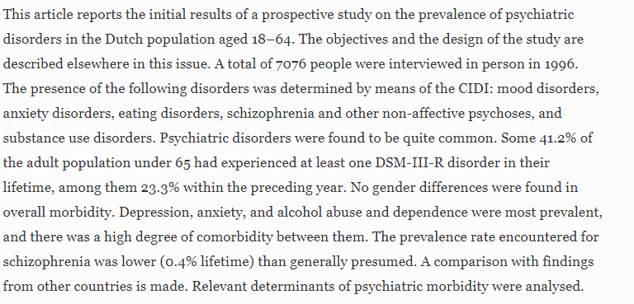
Kessler, R. C., McGonagle, K. A., Zhao, S., Nelson, C. B., Hughes, M., Eshleman, S., ... & Kendler, K. S. (1994). Lifetime and 12-month prevalence of DSM-III-R psychiatric disorders in the United States: results from the National Comorbidity Survey. Archives of general psychiatry, 51(1), 8-19.
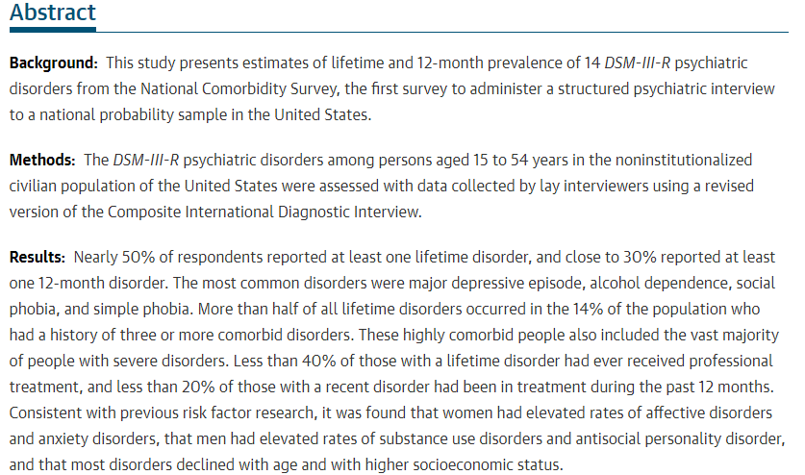
Luxton, D. D., McCann, R. A., Bush, N. E., Mishkind, M. C., & Reger, G. M. (2011). mHealth for mental health: Integrating smartphone technology in behavioral healthcare. Professional Psychology: Research and Practice, 42(6), 505.
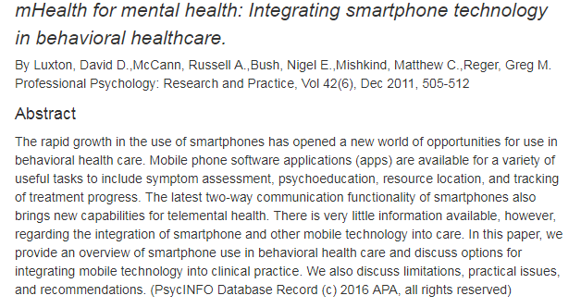
Satcher, D. (2010). Mental health: A report of the Surgeon General--Executive summary. Professional Psychology: Research and Practice, 31(1), 5.
