Public Relations
As technology creates business opportunities to open up products and services to the world, organizations have to consider how to develop relationships with their publics beyond their home country. This node explores the concept of international public relations and how companies can use the discipline to supplement advertising campaigns to inform and persuade global customers to buy their products.
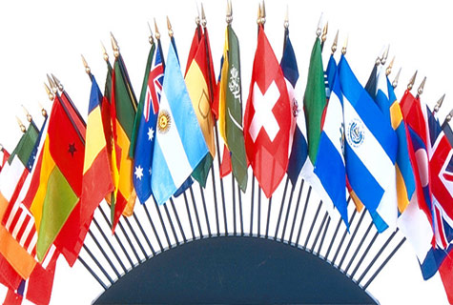

Learning Materials
Possane, Inc. is a perfume distributor that makes a variety of name-brand perfume and thousands of different fragrances. Recently, it decided to offer consumers its perfume varieties at a discount rate as well as widen its distribution channels not only in its home country of Canada and its European distribution, but also into South America. It has created an innovative social and traditional media campaign to reach its diverse audience in the age range of 18 to 80. The typical customer segment is well-educated, makes at least $80,000 per year in a professional career, and is interested in high-end fashion, accessories, and perfumes.
Marie, the social media specialist for Possane, Inc., has created an international public relations campaign to create awareness about the company as it moves its discount distribution virtual warehouses online only. The new Web distribution store is name Luxperdisc.com. Marie is aware of the challenges ahead of her team to design a campaign that educates potential customers worldwide about the discounter. A few activities she has planned include the following:
- A press conference with the international trade press and media
- Multilingual press releases about the launch released to major international media outlets
- A demonstration of the Web site with multilingual applications in a video press release
- Various articles sent to the international media for publication
- Interviews with Possane’s executives for international reporters
International public relations is about working with and developing relationships with constituencies worldwide, not only in the organization’s home country, but also in its stakeholders’ or publics’ countries. The discipline of international public relations is defined as the planned and organized effort of a company to establish mutually beneficial relationships with publics of other nations (IPRSA, 2016). Transnational environments, global media, and international non-governmental organizations (INGOs) are some of the global stakeholders in the international public relations arena.
As technology creates more business opportunities for global expansion, working with international stakeholders is important. This requires knowledge and understanding of cultures, global issues, ethics, and cross-cultural communication.
Find out more about international public relations at the following link: https://prssa.prsa.org/
Find out more about international/global public relations with these virtual flashcards: https://quizlet.com/11471171/flashcards
Challenges of International Public Relations

Communication and culture are two of the most powerful influencers of building international relationships. A message that works in one country may not work in another. This is due to perceptions of an organization’s cultural issues, language, and external environmental differences, such as the economy, politics, and legal and religious differences. When working with diverse countries and cultures, international public relations includes the challenges of language, laws, and culture.

Communication Differences

Communication in international public relations is impacted by high and low-context cultures in all countries. The key to building successful international relationships with global publics involves understanding this context. Communication context is about how countries and cultures convey meaning in messages.
Click here to explore the high/low cultural contexts of several countries: http://3.bp.blogspot.com/-yr8m4zWd9T4/UTPPRlwM2QI/AAAAAAAABes/3ai_f2k1gWY/s400/High+and+Low+Context.png
Edward Hall introduced the concepts of high and low context when identifying cultural differences among countries and societies. In high-context cultures, information is relayed in physical context or initialized by a person. Relationships are dependent on trust and take some time to develop. Getting things done depends on these relationships and the group process. This includes situational and relational knowledge. Other indicators in high context communication include the following:

High use of nonverbal language, such as body language, voice tone, facial expressions, and gestures
The verbal message is indirect or not getting directly to the point.
More internalized understanding of the message, such as insider information or jokes
Used in long term, well-established relationships
Decisions are based on personal, face-to-face communication around an authoritative figure.
There is a strong awareness of who belongs to the group versus outside members.
Low-context communication is more rule-oriented where knowledge is public and accessible. The following are a few characteristics of low-context communication (ToughNickel, 2016):

Knowledge is transferred.
The message is more word-oriented than nonverbal.
The verbal message is direct.
Communication is based on exchanging information, ideas, and opinions.
Find out more about high and low-context communication at the following link: https://toughnickel.com/business/High-Context-vs-Low-Context-Communication
Cultural Differences
Understanding country cultural differences is important in international public relations, too. Geert Hofstede introduced the following five cultural constructs, known as dimensions of power (itim International, n.d.):
- Power distance index (PDI): How power is distributed in society
- Individualism: This relates to how members of a culture define themselves either as individuals or group members. More individualistic societies, such as the United States, tend to emphasize individual goals and accomplishments. A more collectivist society is more group-oriented, where goals are defined by the group.
- Masculinity: This concept refers to gender roles in a culture. More masculine cultures value competition, assertiveness, and wealth. More feminine cultures value relationships and quality of life.
- Uncertainty avoidance index (UAI): Refers to the tolerance for uncertainty and ambiguity in a society.
- Long-term orientation (LTO): This concept measures the importance a society attaches to the future instead of the past and present. For example, future rewards might be emphasized versus an orientation related to the past and present, including social obligations traditions and immediate stability.

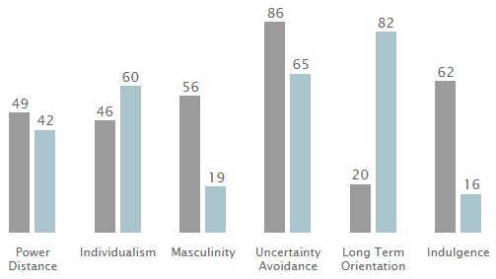
(itim International, n.d.)
Learn more about Hofstede’s ideas and the application of his five cultural dimensions at the following link: https://geerthofstede.com/landing-page/national-culture.html
These cultural differences and dimensions are important in building relationships with international stakeholders. Find out more about these cultural dimensions and international public relations at the following link: https://sarahaasullivan.wordpress.com/2011/01/30/hofstedes-cultural-constructs-and-pr/
In addition, there are a variety of variables to consider in international public relations, especially related to cultural competence, or knowing and understanding the issues that face a global society relative to internal and external environments impacting current and potential customers in those countries. Some of these variables include the following:
- Public opinion and pluralistic views
- Political ideologies in government and political systems
- Cultural ideals
- Censorship issues in other countries
- Technological development
- Economic freedom and decision making by consumers
- Perceptions of transnational organizations by customers
- Global media organizations
- Understanding journalistic values and customer media consumption
These differences in how messages are communicated through international public relations are important in developing strong, trusting relationships with a company’s global publics.

Key Terms
High-context communication | Hofstede’s dimensions of power
International public relations (or global public relations) | Low-context communication

A fictional situation that I have witnessed in a television program

This is a fictional situation that I have witnessed in a television program, the group was focused around women who are having or had problems within their family, like abusing boyfriend or husband. It was focused to help women, to make them empowered and take control of their own life. The group consists of 9 women, each of them having their own problems but here we will focus on just three women Lilly, Rosa and Martha. Martha is Lilly mother, Martha is a widow and her husband used to abuse her, it was a classic domestic abuse case in which husband beats his wife. Martha shares that she didn’t do anything at that time because she was worried for her child as she didn’t know what she will do if he left her. On the other hand her daughter who is now eighteen have different opinion about her mother situation according to her point of view, she should have left him. If someone hurts you, you leave that’s her ideology.

Summary

International public relations are about building relationships with the publics from various nations while being cognizant of a variety of cultural and environmental differences. These differences include understanding the external environment, such as politics, legal issues, and culture. Communication and culture are two major influencers on how customers and other stakeholders perceive an organization and its products. Different cultures also communicate in different ways with high and low-context communication.

Reference

Itim International. (n.d.). 2019 Geert Hofstede: National culture. Retrieved from https://geert-hofstede.com/national-culture.html

Tehran. (2016). International Dept [Image]. Retrieved from http://en.tehran.ir/Portals/0/Image/1387/BasePic/InternationalDept-01.jpg

ToughNickel. (2016, April 21). High-context vs. low-context communication. Retrieved from https://toughnickel.com/business/High-Context-vs-Low-Context-Communication

