Block and Tackle System

Student’s Name
Institutional Affiliation
Course
Professor’s Name
Date

Block and Tackle System
Introduction
Block and tackle system is a machine which comprises of rope and pulleys that allows the operator to tread force for distance. The system is a 4-1 mechanical advantage using the force moving pulley and a multi-purpose device with internal ratchet to arrest back fall of its rope (Saito, et.al, 2017). After pulling, the mechanical advantage decreases amount of force (F) necessary to translate the block along the concrete floor. It is designed as a steel base and stands for stability.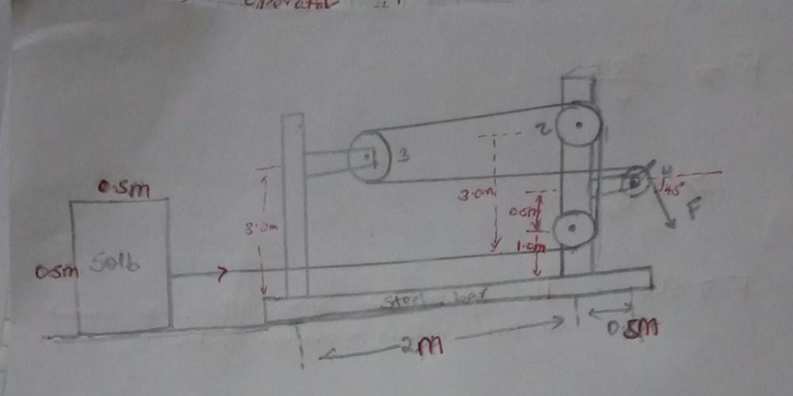
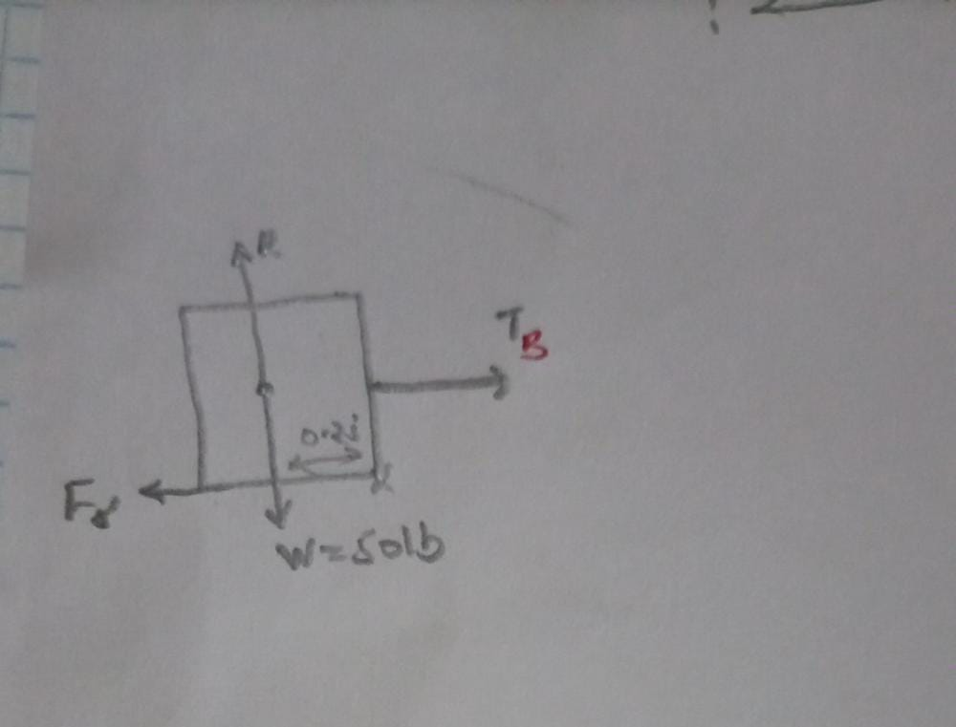
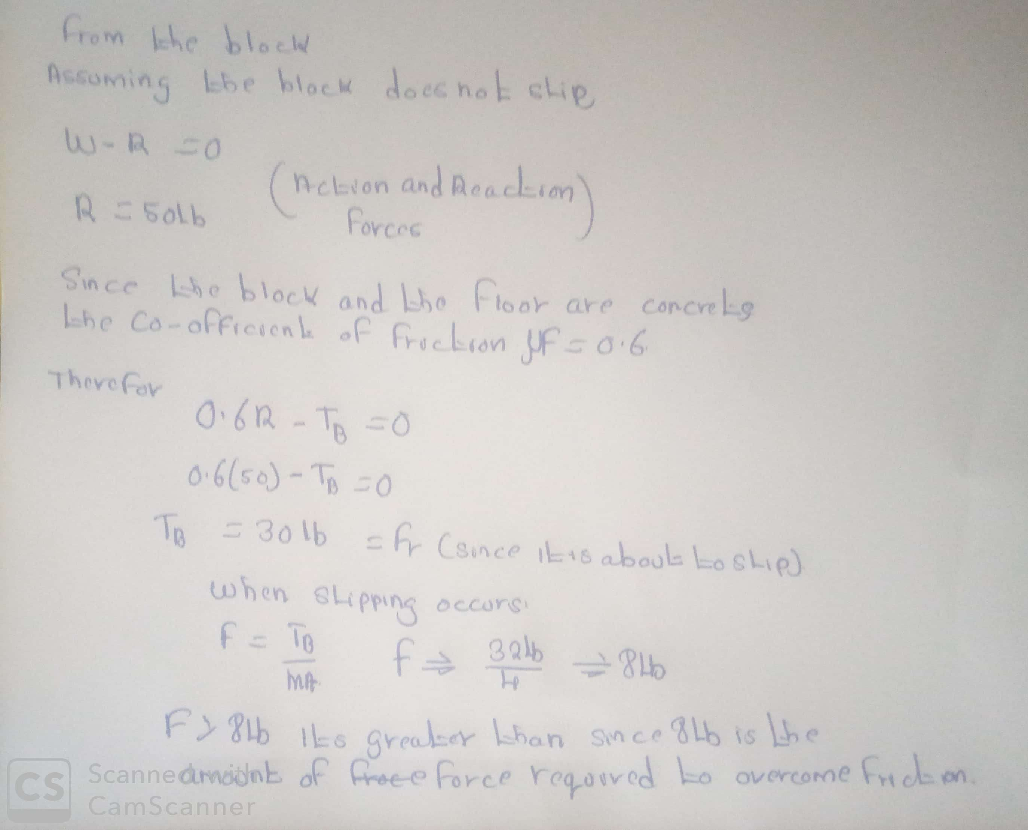
Recommendation
The system can contain as many pulleys as possible although at some point of friction in pulley shifts begins to become a significant source of resistance. According to Fairchild, the system can be improved by:
- Use of automobile transmission in place of pulleys.
- The steel have to be fixed with rolling wheels to increase its mobility.
- Instead of using the hand to pull the resultant force (F), a motor can be fitted to pull its rope.

References
Fairchild, G. B., & Goldberg, R. (ND). Shanti Block and Tackle.
Saito, T., Maegawa, T., Denno, S., Sakai, S., Uchikawa, M., Kanagawa, M., & Ryujin, H. (2017, January). New Seismic Response Control System using Block and Tackle. In 16th World Conference on Earthquake Engineering, Santiago Chile.

