Q1. Consider the population of adult female residents in Melbourne. (Given the implausibility of the numbers provided below – maybe you would prefer to think of the population as that of planet Jupiter rather than Melbourne). Our focus is on the population mean height. Let height be called X. Assume we know 𝜎 (population standard deviation) is 25, but we do not know the population mean, µ. We take a sample of adult female residents in Melbourne (n=100) and calculate the sample mean height as 70 cm.
i) Using the above information draw a clearly labelled diagram illustrating the distribution of X ̅. Mark the two points that contain exactly 95% of the distribution of X ̅. Can you show the position of X ̅= 70? Explain. (2 marks)
ii) Redraw the above diagram now assuming that µ=120. Mark the two points that contain exactly 95% of the distribution of X ̅. Can you now show the position of X ̅= 70? Explain. (2 marks)
iii) Is 70 a long way away from 120? Explain clearly and precisely with reference to your diagram. (3 marks)
Iv) Now test the null hypothesis that µ=120, against the alternative that µ≠120. Use a 5% level of significance.(3 marks)
Solution:
i) Detailed diagram is given below. We can construct a normal distribution with mean 70 and a standard deviation 2.5= (25/√100), using central limit theorem.
In the below graph central part is sample mean 70 and (65.1, 74.9) Interval contains 95% distribution.
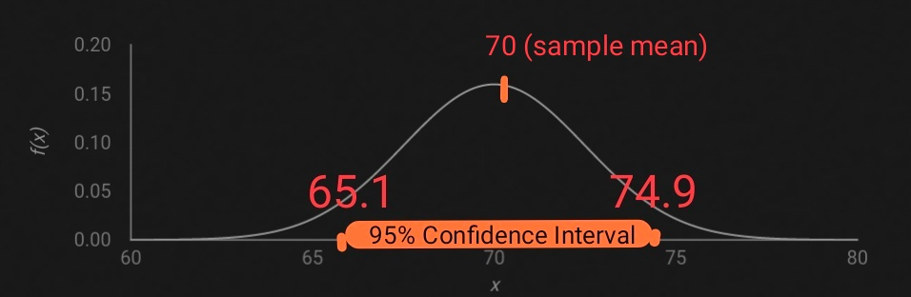
ii)
If we draw the sampling distribution of x bar with population mean mu = 120, then you should find Z score. Z score = (70 - 120)/2.5 = -20 which is not possible to indicate in a Z curve.
I also provide the population curve (below) where you can indicate the sample mean 70
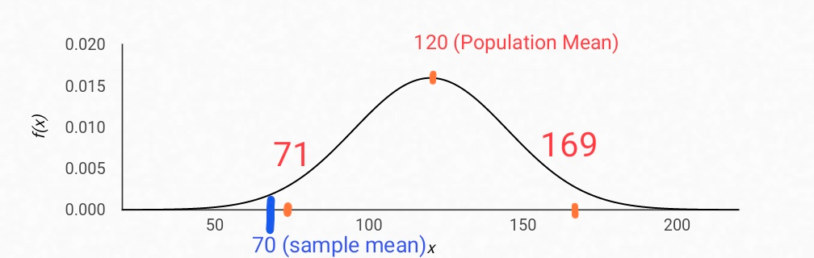
iii)
Yes, it is far away from 120. Since Z score is -20 also you can find from the Population Curve above, 70 falls below 71 where (71,169) together constitutes 95% of the distribution.
iv)
H_{o}: µ=120
H_{a}: µ≠120
α=0.05
This is two-tailed X-test
Z = (Sample mean - Population mean)/Standard error
Z = (70 - 120)/2.5 = -20
Z critical value= 1.96 (obtained from normal table)
Decision: Since |Z| > Z critical, Test is significant. We reject Ho
Conclusion: At 95% confidence level we conclude that population mean is different from 120.

