Type answers below image 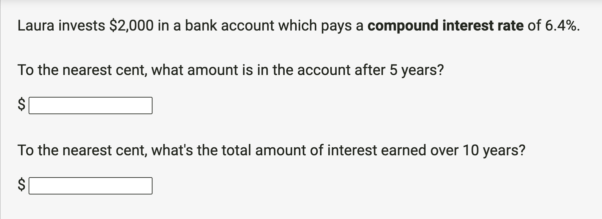

- $2,727.30
- $1,719.20

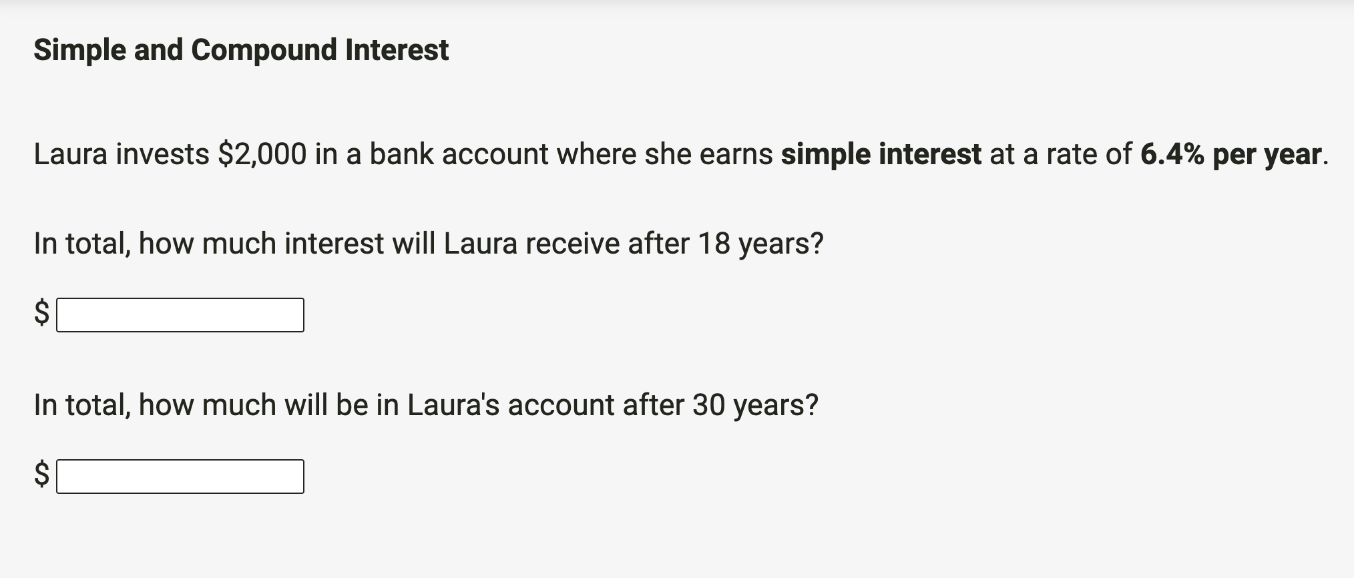

- $ 2304
- $ 5840

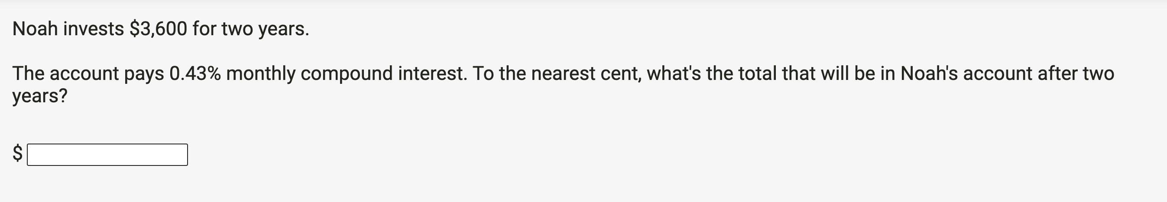

$3631.10
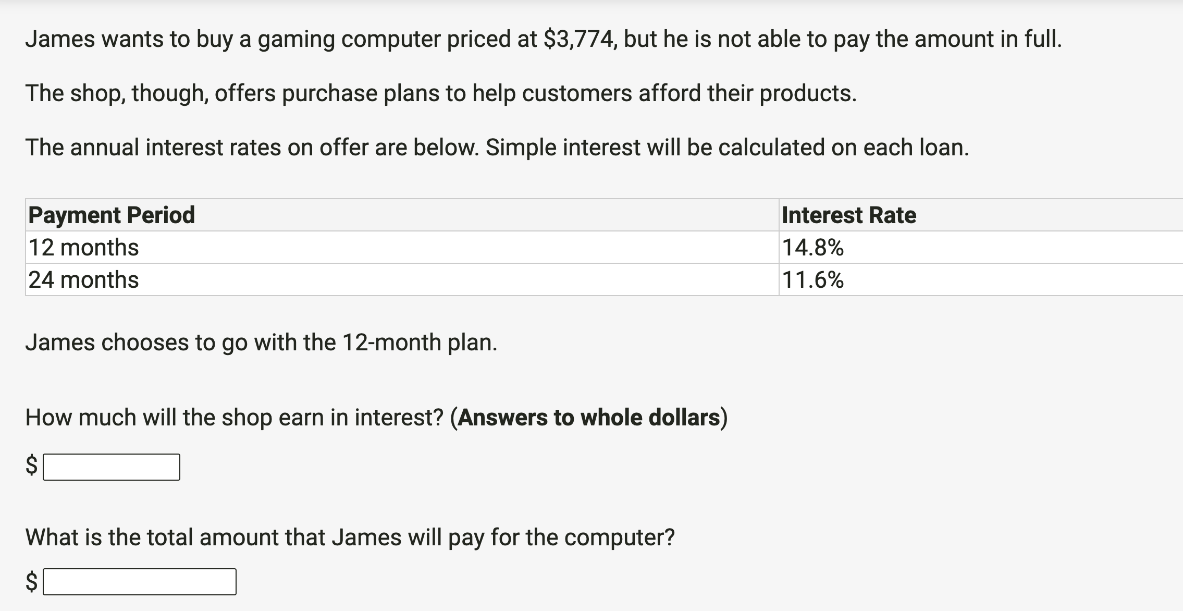

- Interest = $559
- Total amount = $4,333

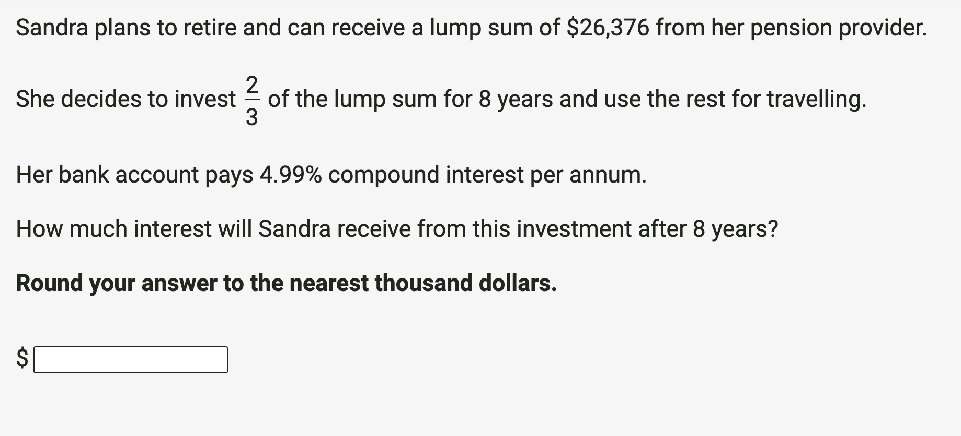

$8,000

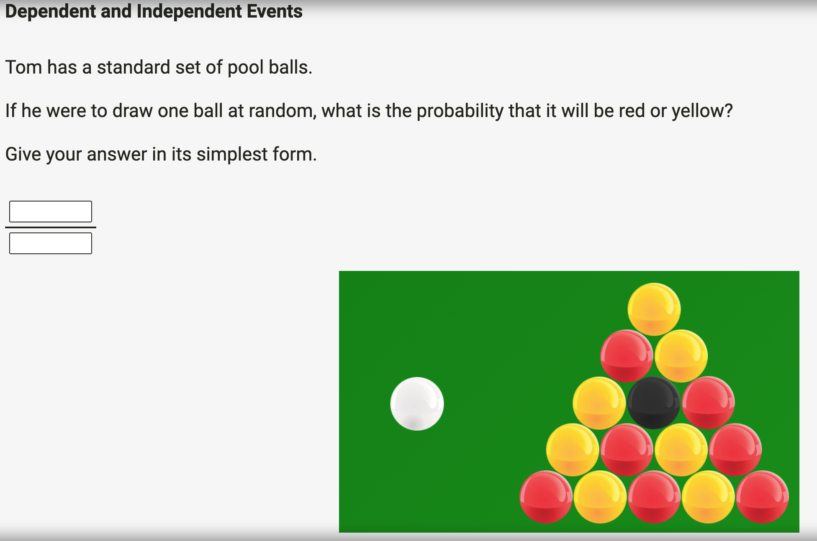
14/15

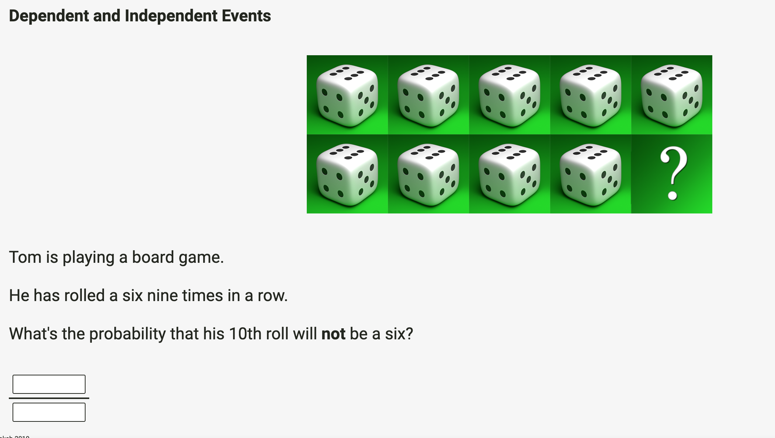

5/60466176

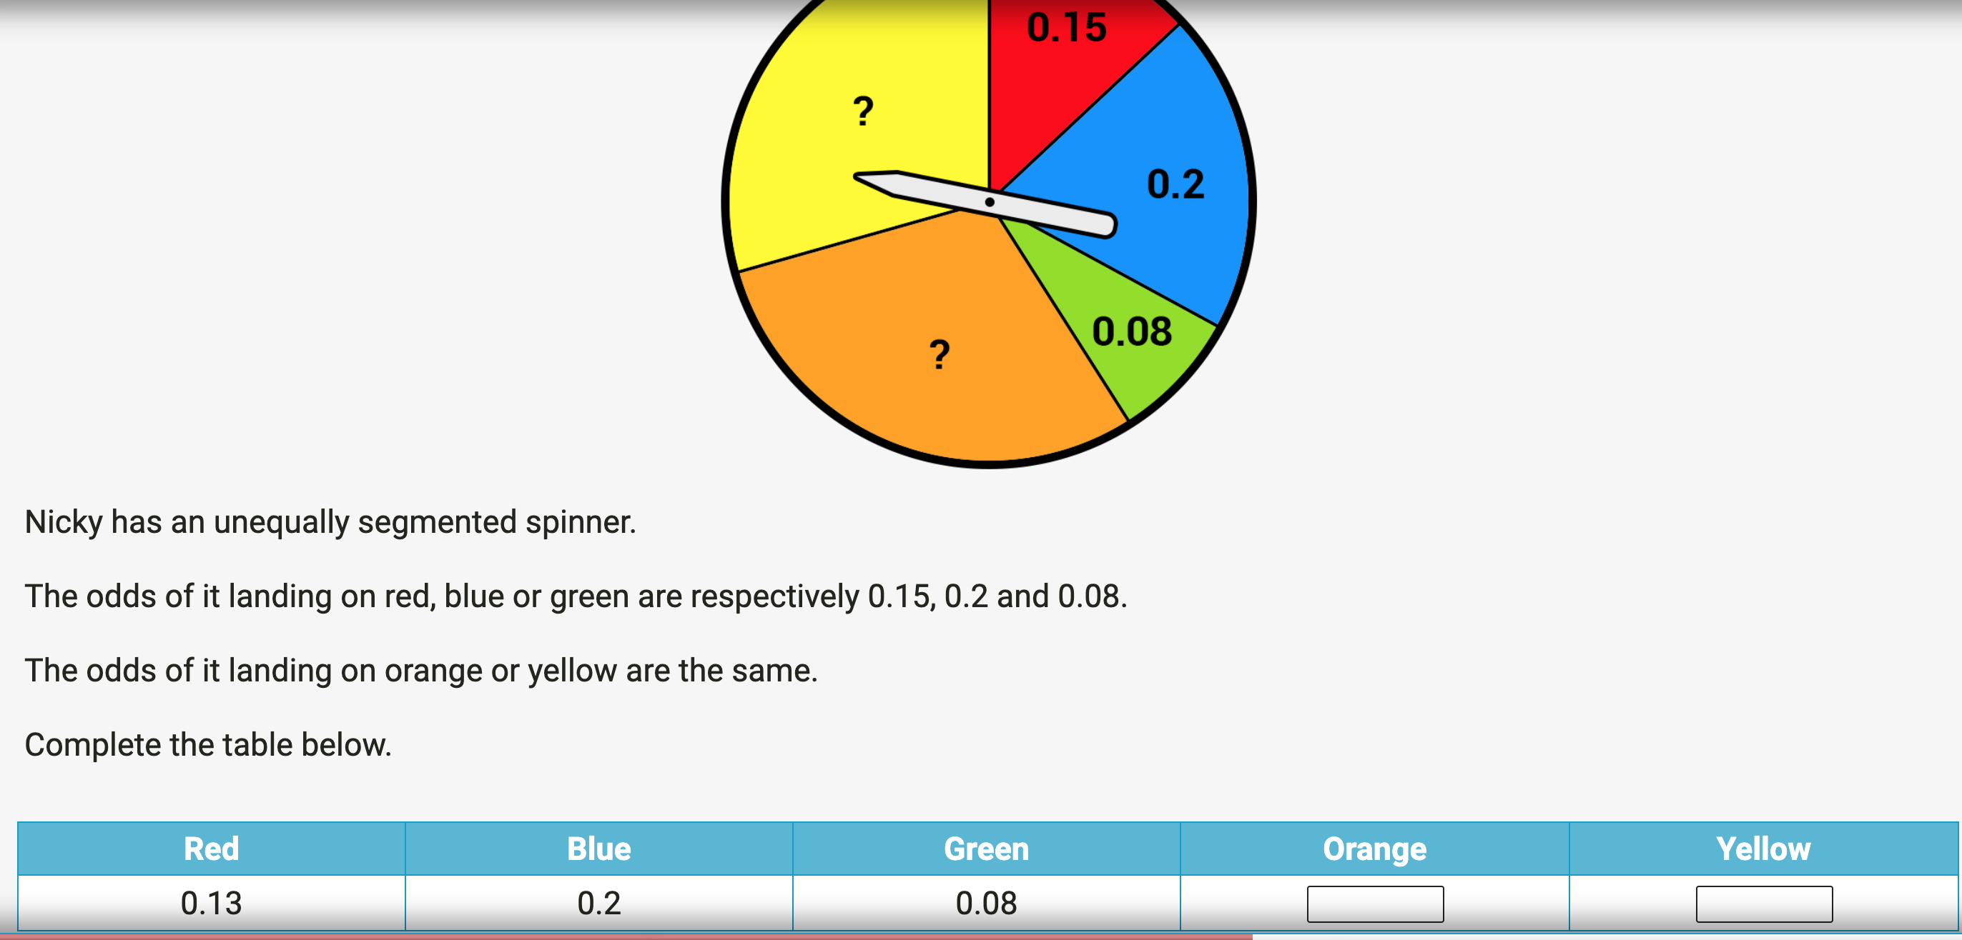

Orange = 0.285
Yellow = 0.285

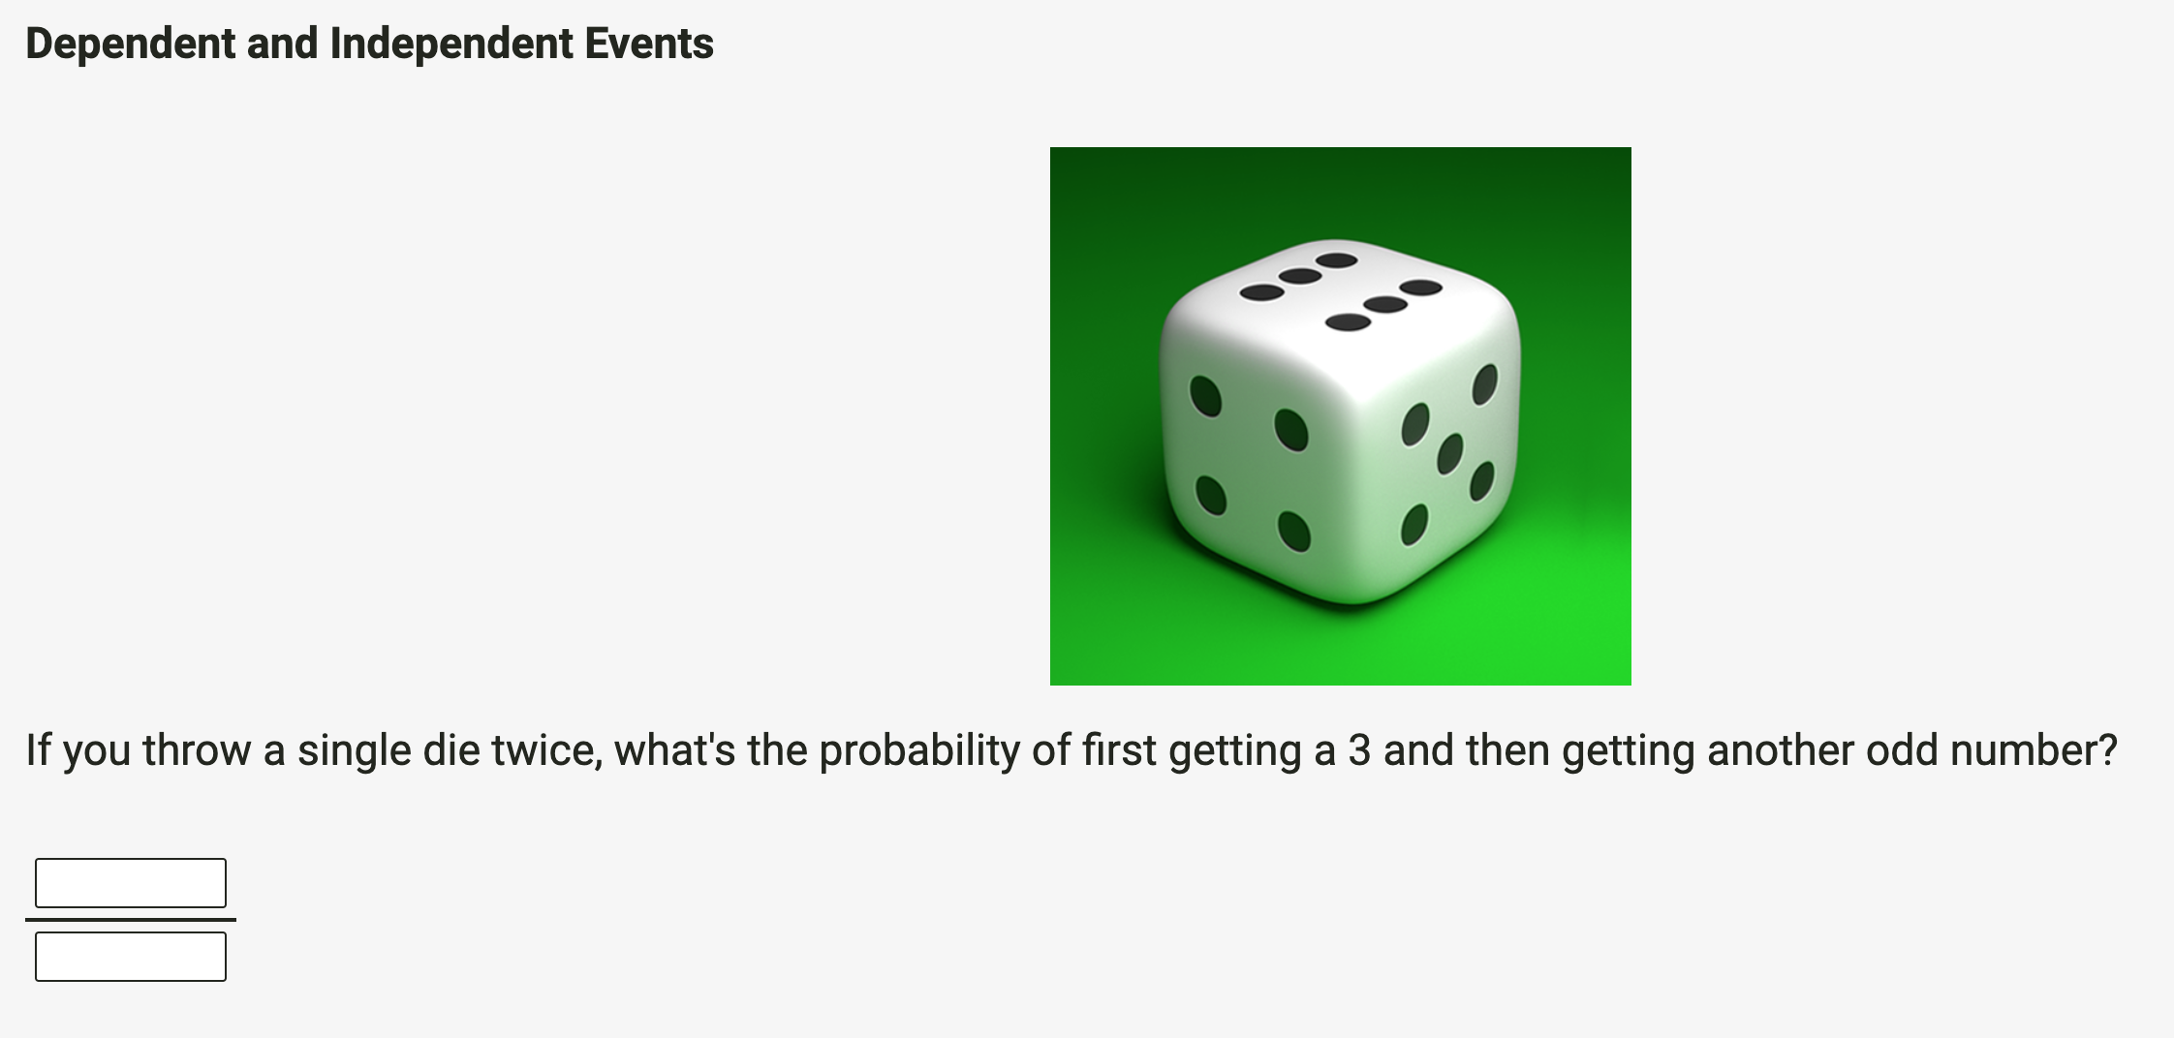
1/2
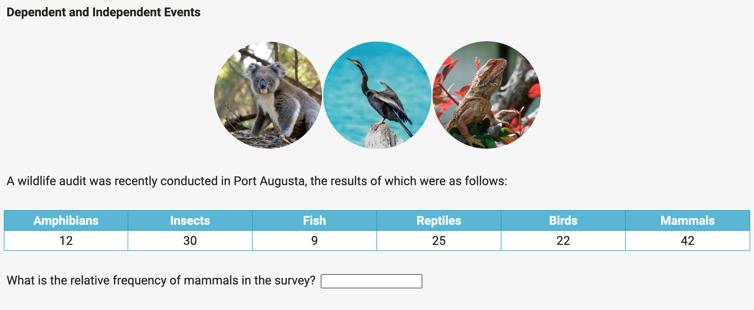

0.3

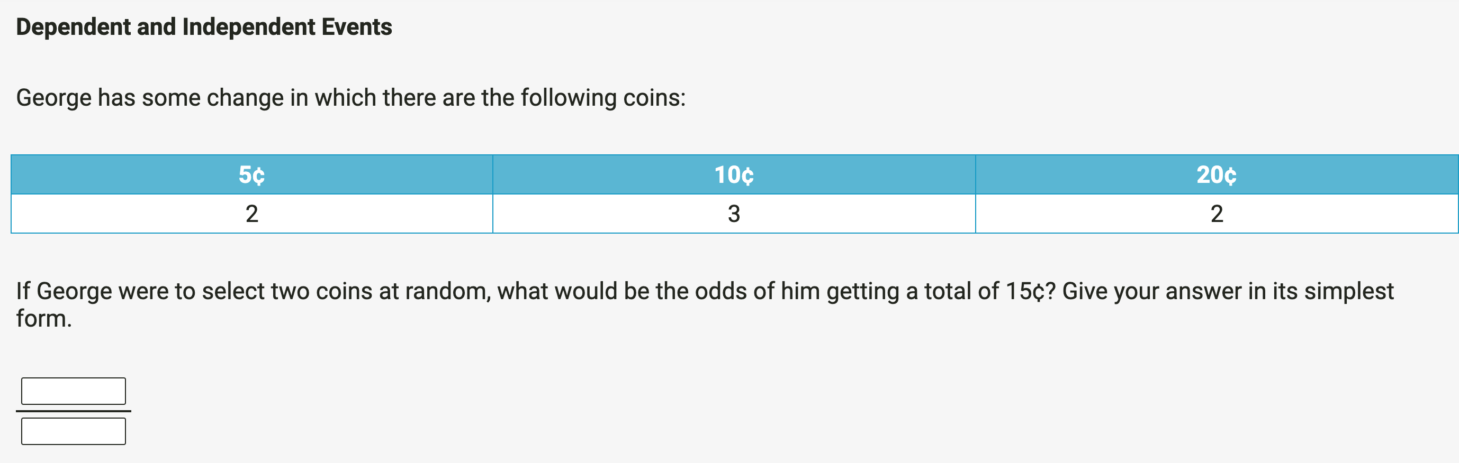

5/7

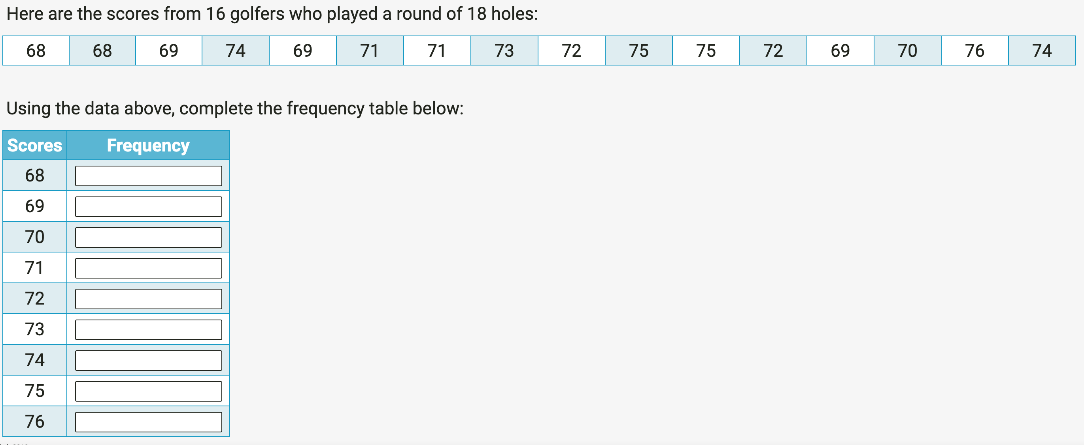

68 – 2
69 - 3
70 – 1
71 - 2
72 - 2
73 - 1
74 - 2
75 - 2
76 - 1
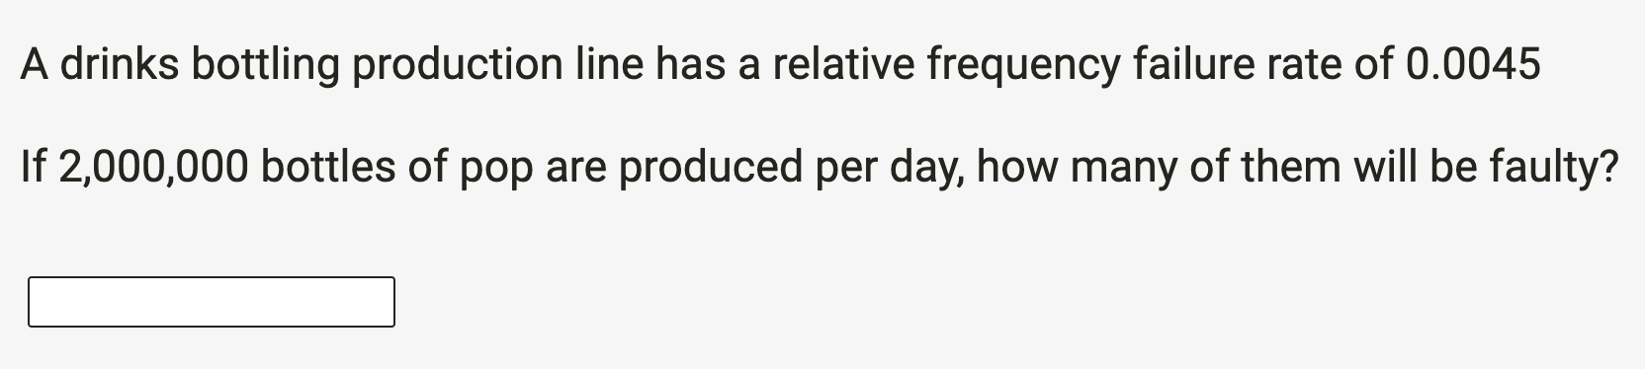

9000

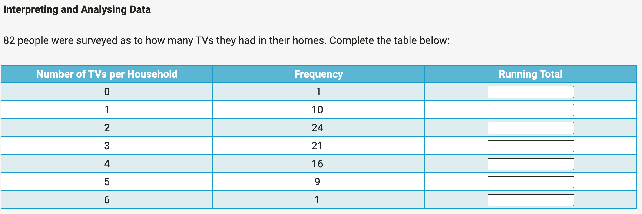

No. of TVs | Frequency | Running Total
0 | 1 | 0
1 | 10 | 10
2 | 24 | 48
3 | 21 | 63
4 | 16 | 64
5 | 9 | 45
6 | 1 | 6

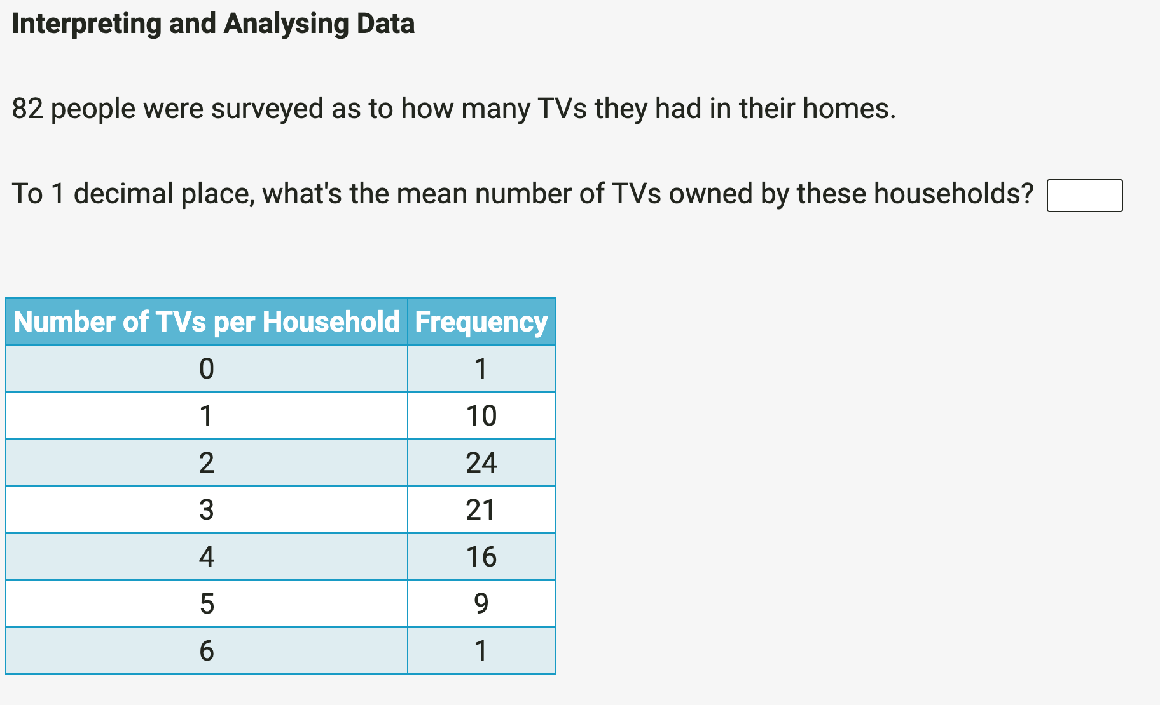
2.9

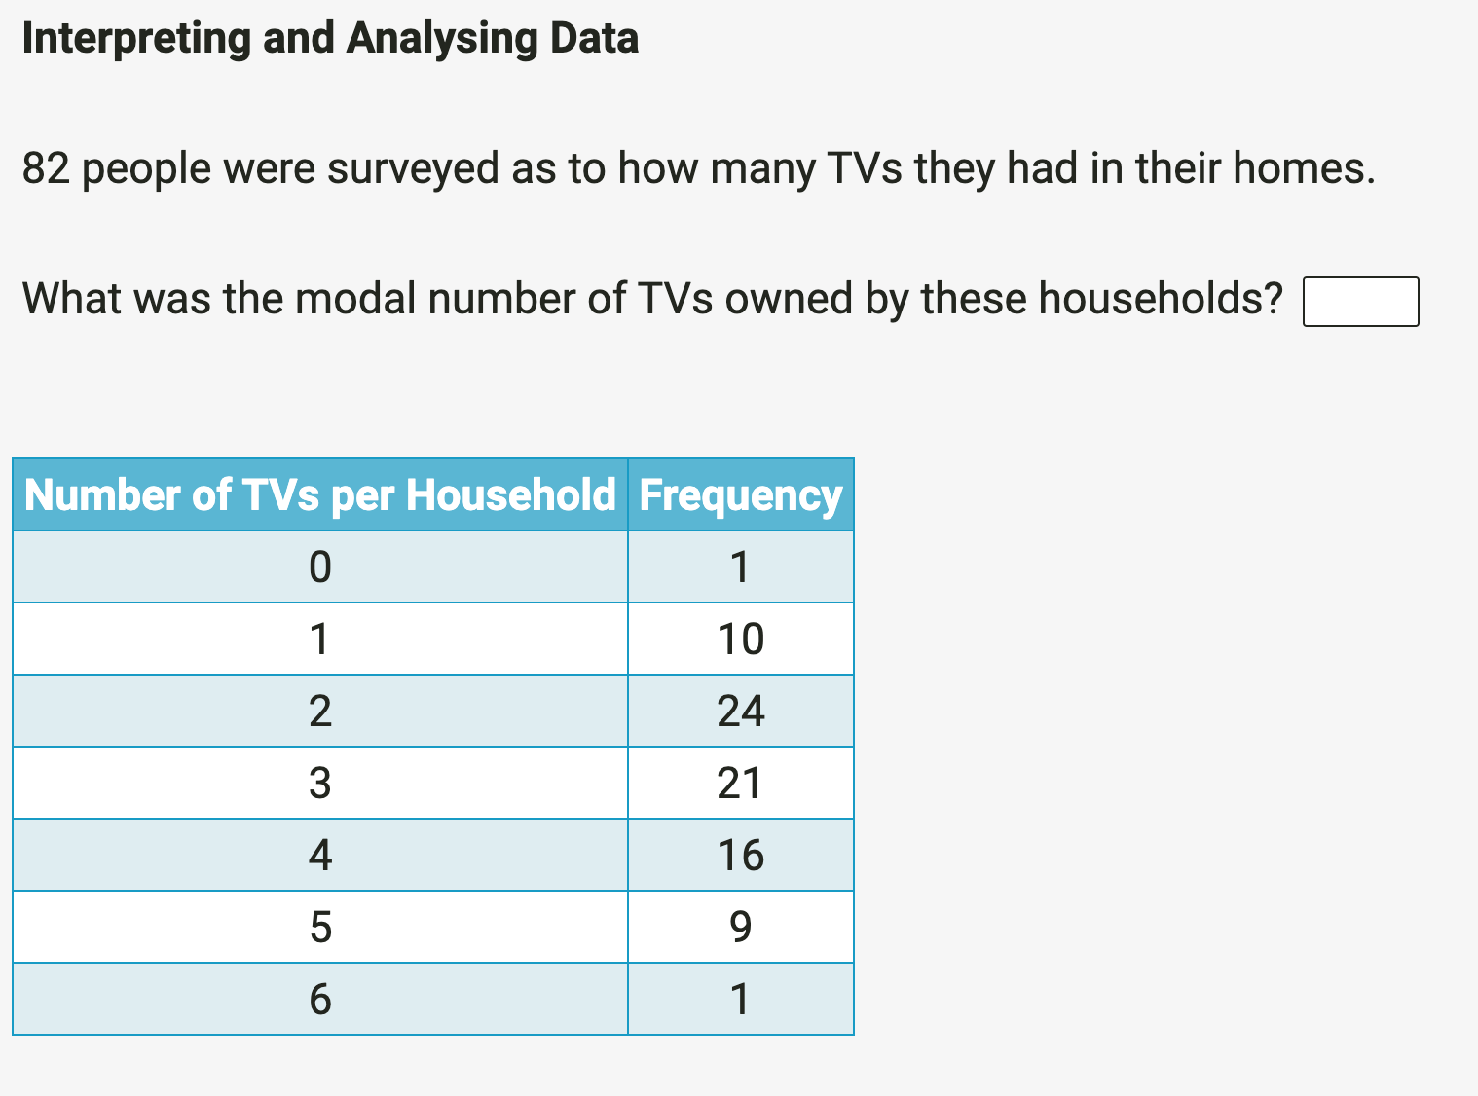

Modal number of TVs is 2

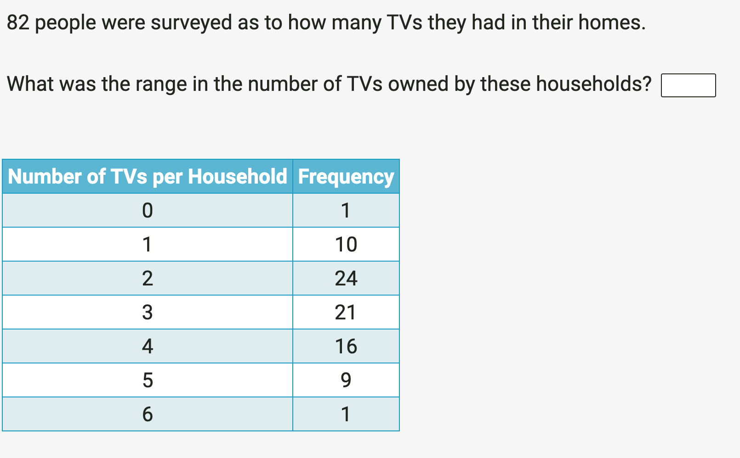

Range = 6

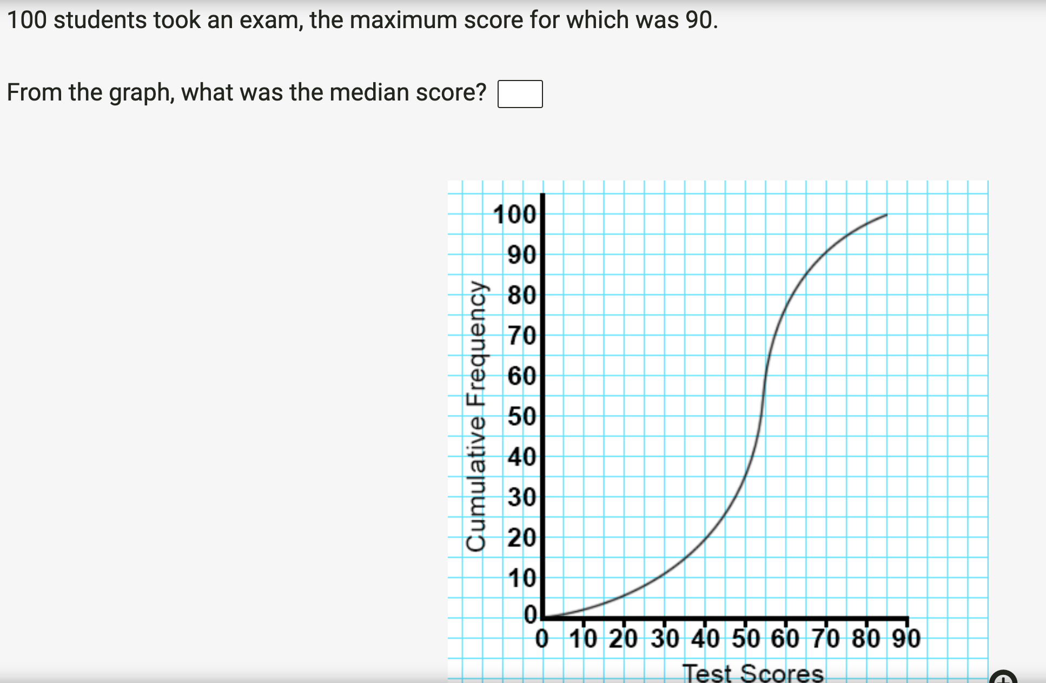

Median score = 55

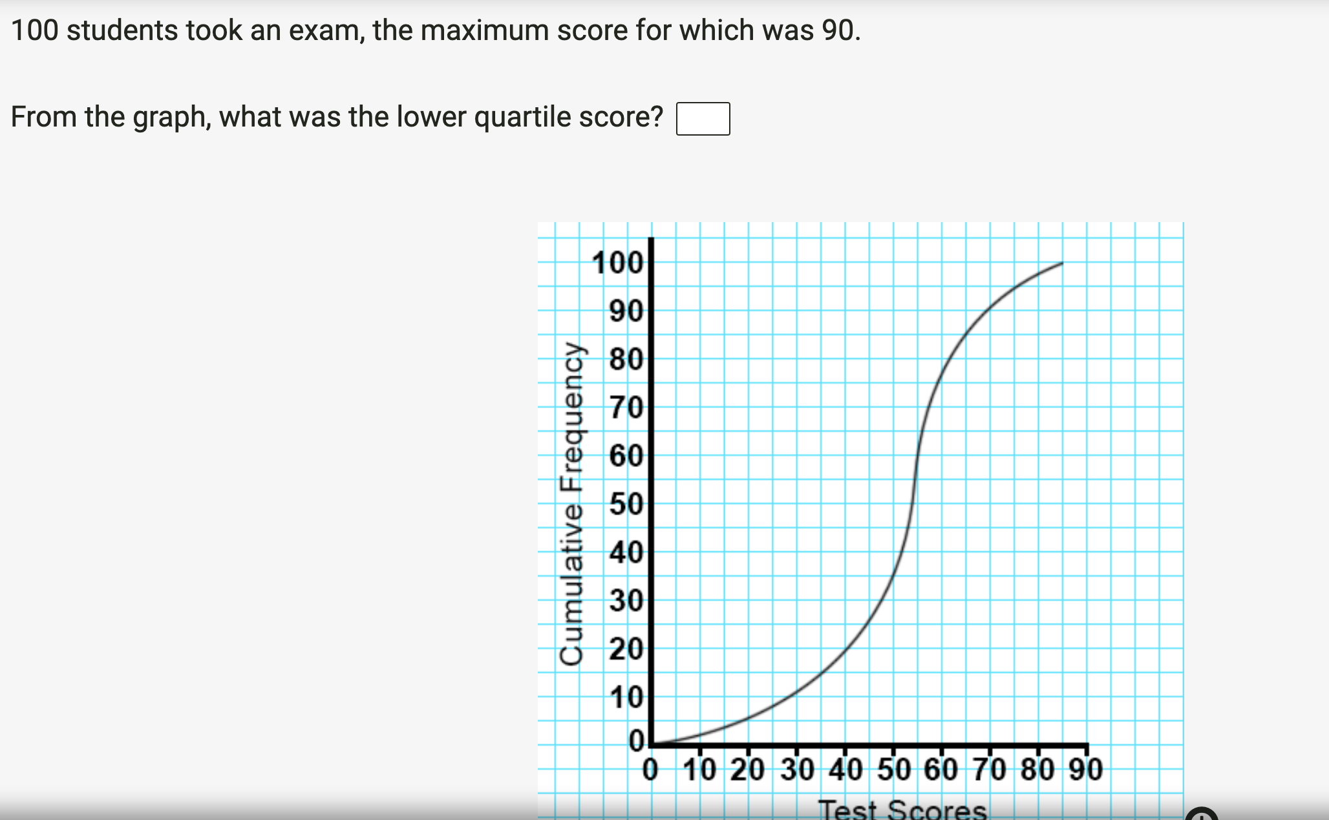

Q1 = 45
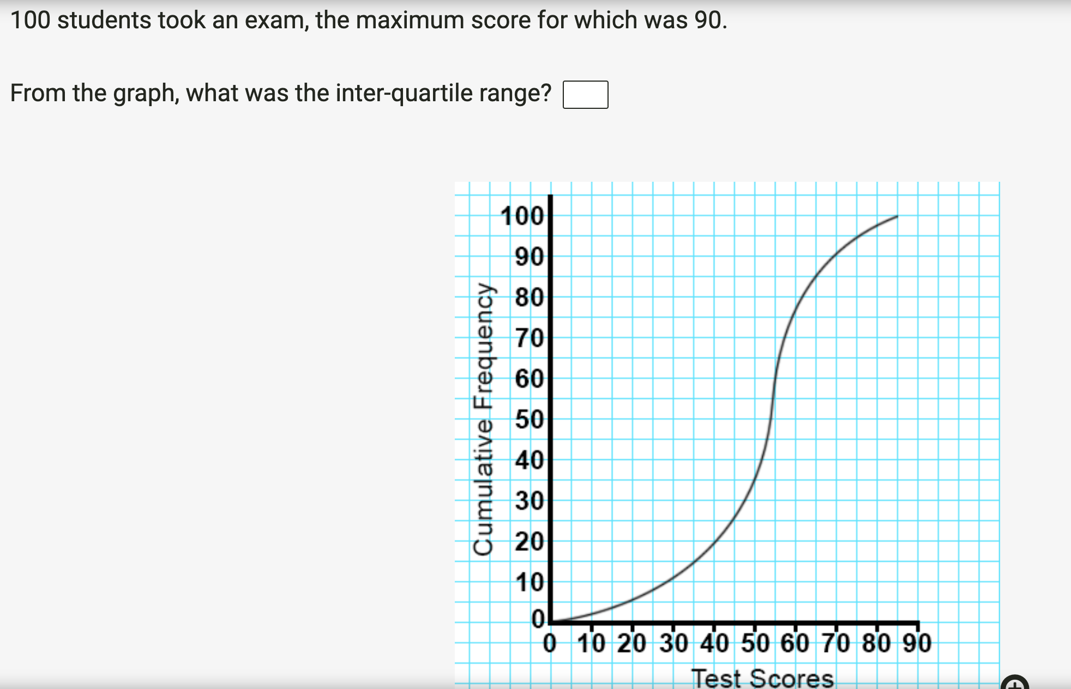

Interquartile range = 15

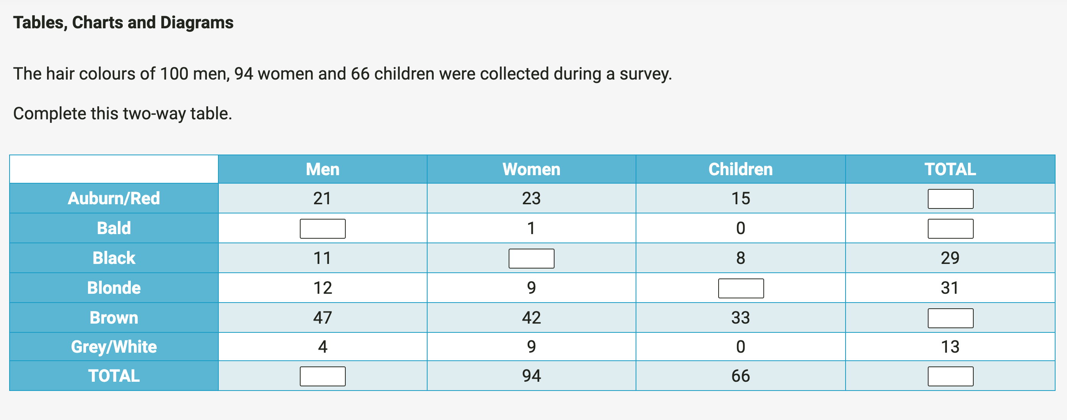

 | Men | Women | Children | Total
Auburn/Red | 21 | 23 | 15 | 59
Bald | 5 | 1 | 0 | 6
Black | 11 | 10 | 8 | 29
Blonde | 12 | 9 | 10 | 31
Brown | 47 | 42 | 33 | 122
Grey/White | 4 | 9 | 0 | 13
TOTAL | 100 | 94 | 66 | 260

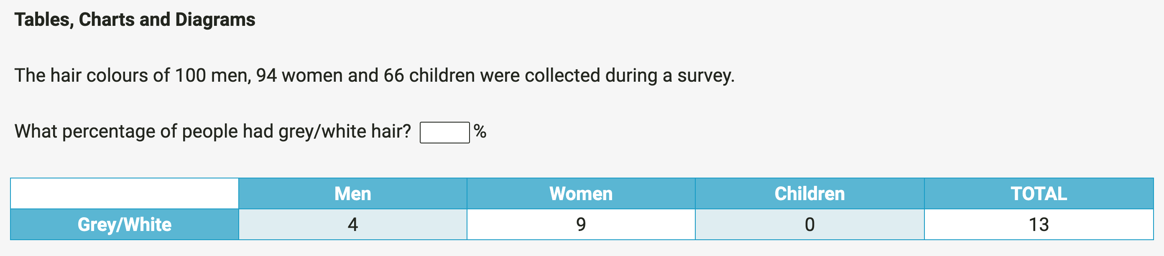

5%

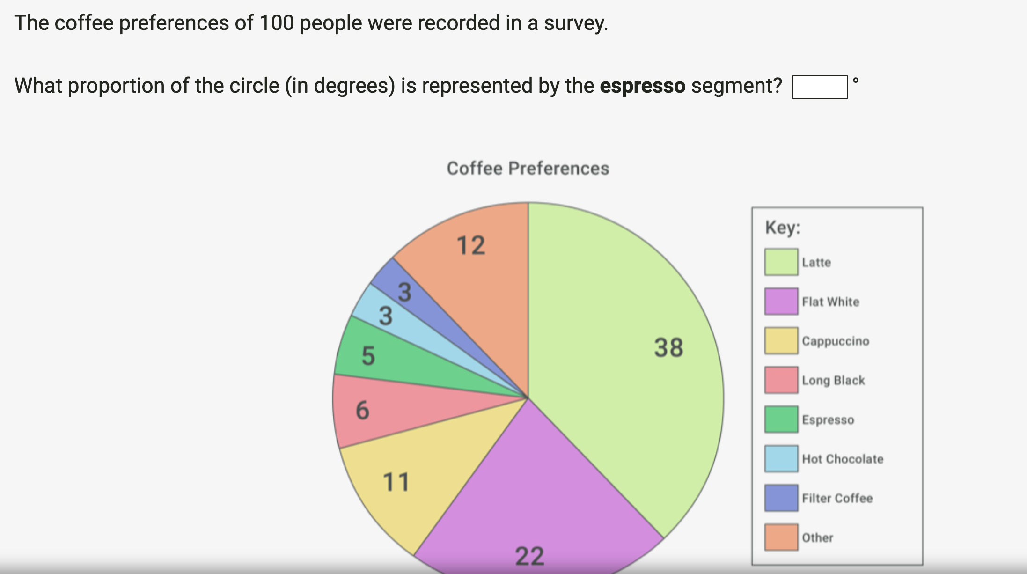

Expresso segment = 18º

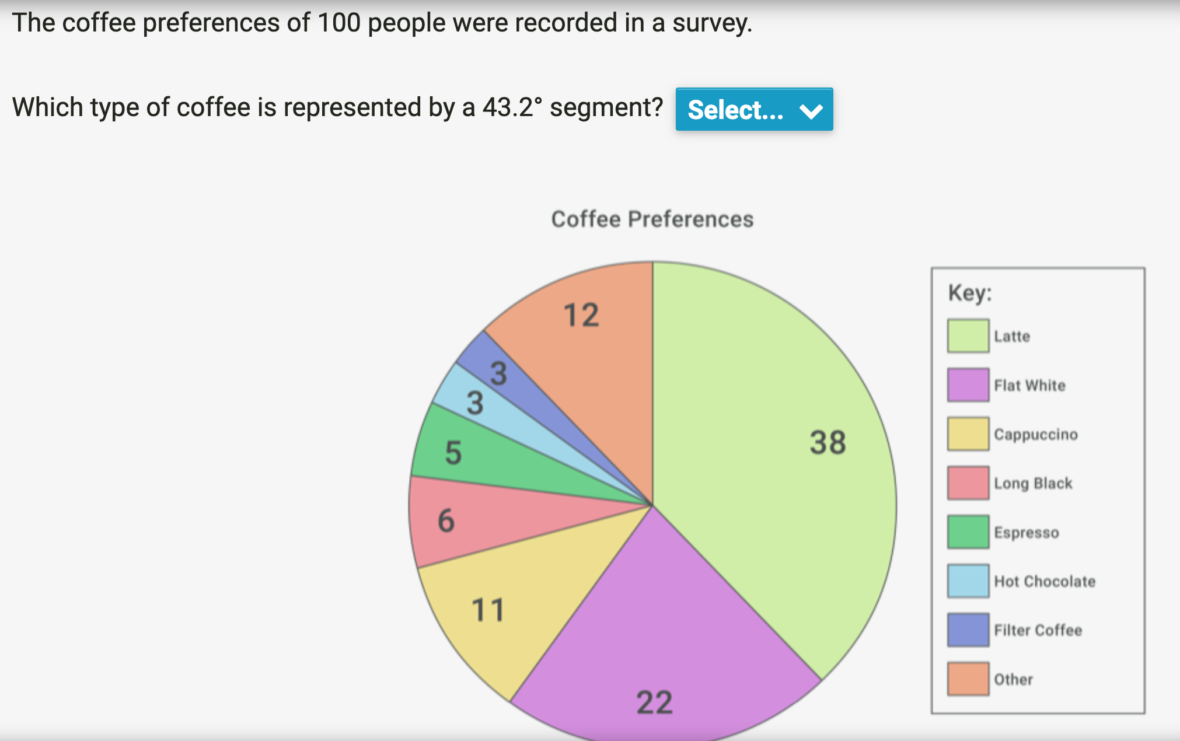

Long Black

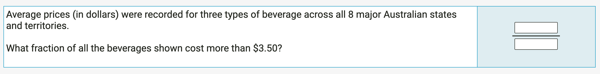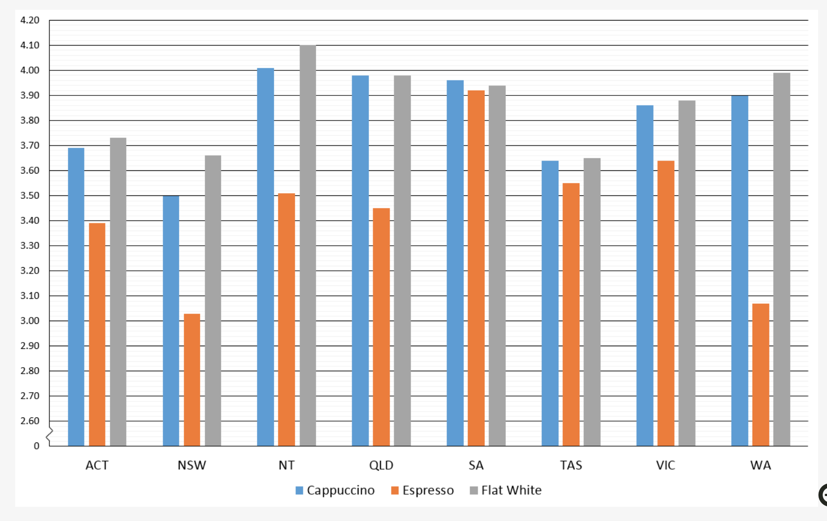

16/243

