Question #2
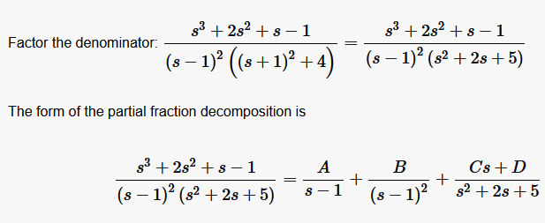
Option is D

Question #5
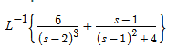
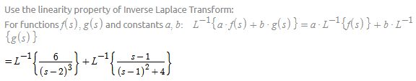
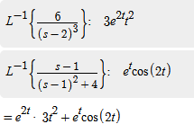

Option is A
Question #9
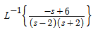

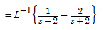
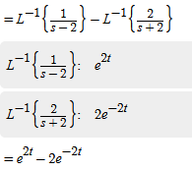
Option is B
Question #12
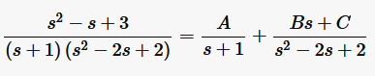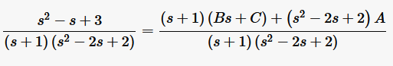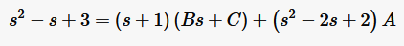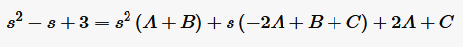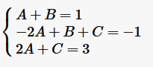
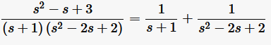
Option is B
Question #11
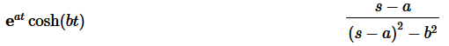
Given a=2 and b =4
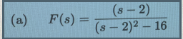
Option is A
Question #6
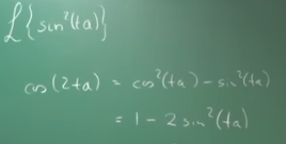
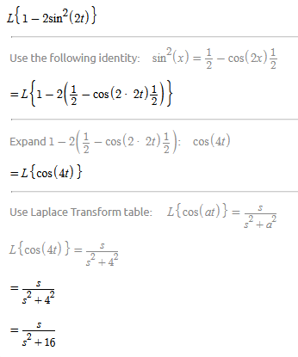
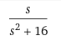
Option is B

Question #7
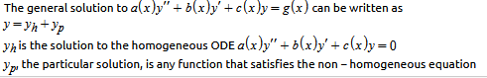
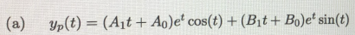
Option is A

