Questions.
Student Name.
Institution Affiliation.
Date.

Questions.
- What makes the moon bright in the sky?
As we have learned, the moon does not emit any form of energy; instead it gets light from the sun; the moon reflects the light from the sun making it bright in the sky
- Why does the sky look different in different seasons?
When we look at the sky at night in different seasons; it looks different; these changes are due to earths motions in its orbit as it rotates around the sun
- How might the knowledge of the constellation’s locations in the sky help someone who is lost?
Constellation is very important; it helps people recognize stars in the sky by just noting the patterns. When people are lost; this knowledge is instrumental in finding directions. When a lost person finds the Ursa Minor; they can easily spot the North star and using the height of this northern star; people could find their latitudes hence helping them find their travelling directions.
Continuation Science.
Question 7
D. When cooled, water turns to ice
Question 8.
C. Lowering the temperature of the water.
Question 9.
A. The mass of the candle remains the same
Question with images.
This is during winter.
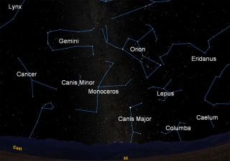
This is for Summer
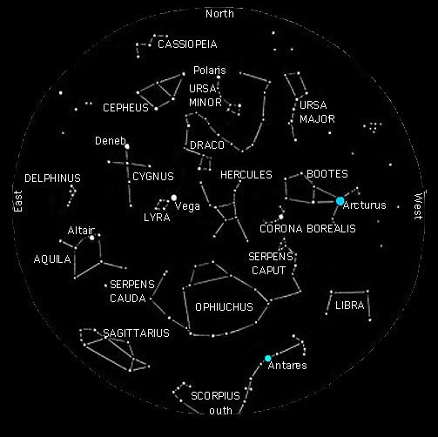

Math Questions.
Question 1.
D. 72 Cubic Meters.
Question 2.
B. (6*16*6)+(14*16*7)
E. (6*16*13)+(8*16*7)
Question 3.
Length A = (8-3)ft = 5ft.
Width B = (9-7)ft = 2 ft.
Volume of the Trough.
V = (l*w*h)+(l*w*h) = (3*2*9)+(5*2*2)
= 54+20
= 74ft^3
Question 4.
The question states that the rectangular prism are identical; the measurement of each of these prisms are the same Austin calculated the volume of one prism only.
The correct volume for this is
Volume = (l*w*h)*2 = (15*5*3)*2
= 255*2
= 450 m^3

Question 8
B. 6.042
Question 9
B. 49.7
Question 10.
D. 208,920

References.
Fang, Z. (2018). The Review of Maths Meets Myths: Quantitative Approaches to Ancient Narratives.
Pepper, G., & Nettle, D. (2017). The behavioural constellation of deprivation: Causes and consequences. Behavioral and Brain Sciences, 40, e314.
Qu, Z., Zhang, G., Cao, H., & Xie, J. (2017). LEO satellite constellation for Internet of Things. IEEE Access, 5, 18391-18401.

