Question 1
Descriptive statistics cannot reveal _______.
 | variability among the data points in a sample
 | central tendency of a frequency distribution

 | hypothesis testing result
 | the shape of a frequency distribution
Question 2s
Parametric statistical tests can be performed on a dependent variable like ____.
ethnicity
type of college degree earned

employment status (full time, part time, unemployment)
age (in years)

Flag this Question
Question 3
How is the standard deviation for descriptive statistics different from the standard deviation for inferential statistics?
The descriptive version is calculated from the sample while the inferential version is calculated from the population.
With the same variable, the descriptive version of standard deviation is slightly smaller than the inferential version.

The descriptive version is calculated with the function of STDEV.s in Excel while the inferential version is calculated with the function of STDEV.p in Excel.
The descriptive version is calculated automatically by SPSS while the inferential version requires an additional step after the SPSS analysis.

Question 41 pts
Histogram is different from a bar graph in that _____.
The bars in a histogram always represent frequencies while the bars in a bar graph can represent other statistics.
The bar graph is primarily for displaying a continuous variable while the histogram is primarily for a discrete variable.

The bars in a bar graph always represent frequencies while the bars in a histogram can represent other statistics.
The normal curve is required in a histogram but not in a bar graph.

Flag this Question
Question 51 pts
Which of the following dependent variable would suggest the use of a non-parametric test like the Mann-Whitney U test?
Number of customers served daily through the customer service call center
Quarterly profit (in dollar amount) of a company

Customer satisfaction score on a rating scale from 1 to 5
Monthly sales volume of a product

Flag this Question
Question 61 pts
I am planning to implement a new tool for collaborative learning in this course for the next semester. To examine the potential effect of this new tool on learning, I can analyze the class performance in this section and the class performance in the next semester with _____.
Z test
paired-samples t test

independent-samples t test
one-sample t test

Flag this Question
Question 71 pts
What can be concluded from the Levene's test result in the following SPSS output?
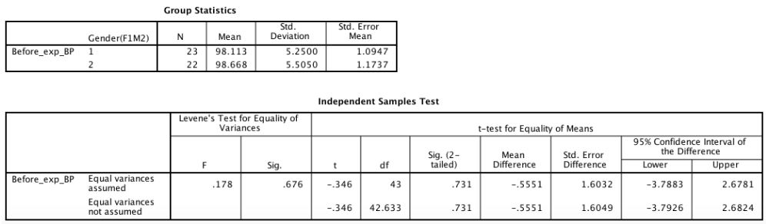
Females and males do not differ significantly in the Before-experiment BP.
Females and males differ significantly in the Before-experiment BP.

The two populations have unequal variances.
The two populations have equal variances.
Question 81 pts
A researcher reported the result from an independent-samples t test as follows. The data were collected from how many subjects?
t(43) = 3.56, p = .04
42
44

45
43

Flag this Question
Question 91 pts
Setting a higher α level increases the probability of _____.
committing the type I error
confirming the alternative hypothesis

confirming the null hypothesis
committing the type II error

Flag this Question
Question 101 pts
The p value from a hypothesis test refers to the probability of _____.
the alternative hypothesis can be rejected based on the given sample
the null hypothesis can be rejected based on the given sample

the alternative hypothesis being true based on the given sample
the null hypothesis being true based on the given sample

Flag this Question
Question 111 pts
A researcher conducted a study to examine whether brain training can prevent cognitive decline in individuals with early-stage Alzheimer's disease. She recruited 100 individuals meeting the disease criteria and assign each into either the experimental group or control group. For 6 months, the experimental group of subjects were engaged in an hour-long brain training session on an ipad everyday while the control group of subjects also came to the lab for an hour-long session but were told to simply do whatever they liked on an ipad. Demographic information was recorded for each subject and cognitive functions were assessed at the beginning of the study and again after the 6-month period. Which of the following questions is answered with inferential statistics?
Were there more females than males in the participants of this study?
Does the brain training program on ipad affect cognitive function?

What is the average age of this sample of early-stage Alzheimer's patients?
What were the subjects' reactions toward using ipad every day in the lab?

Flag this Question
Question 121 pts
Hypothesis testing is a process to _____.
directly compare the probabilities of two different hypotheses
directly examine the target population in terms of the research hypothesis

calculate the probability of the null hypothesis being true
find out if the researcher hypothesis is actually true or not

Question 131 pts
Of all the online courses offered through the New College of interdisciplinary arts and sciences, the average rating on the instructor's presence in the classroom is .8 (4 on a scale of 5). I have had various ratings from the dozen courses I have taught. The ____ can be used to statistically compare my own sample of ratings to the college average of .8 and see if I deviate from the college average.
z test
one-sample t test

paired-samples t test
independent-samples t test

Flag this Question
Question 141 pts
A one-sample t test in SPSS produces the following output. What is the effect size?
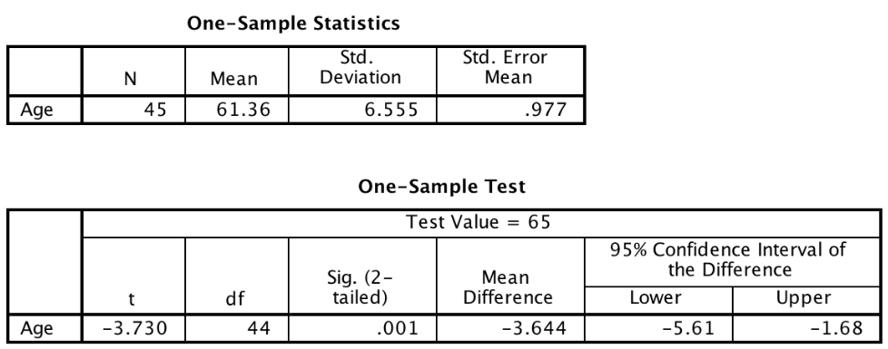
-3.64
-.56

.001
-3.73

Flag this Question
Question 151 pts
A one-sample t test was conducted to see if the blood pressure from a particular sample was significantly different from 90. What can be concluded from the SPSS output below?
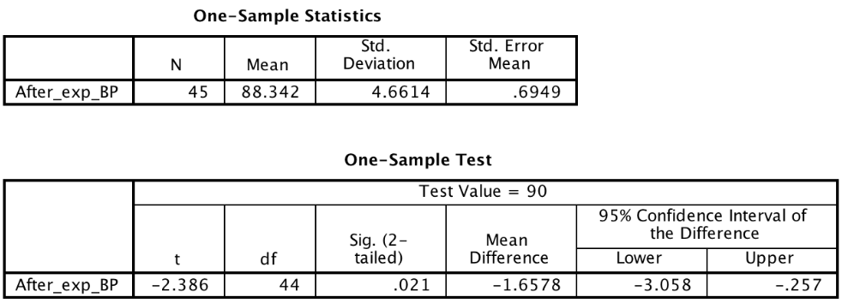
No conclusion can be drawn from the test result.
The sample blood pressure was significantly lower than 90.

The sample blood pressure was not significantly different from 90.
The sample blood pressure was significantly higher than 90.

Flag this Question
Question 161 pts
In order to run a one-sample t test on a variable, it must be coded as as _____ variable in SPSS.
discrete
scale

nominal
ordinal

Flag this Question
Question 171 pts
According to the SPSS output below, how many subjects were in the study?
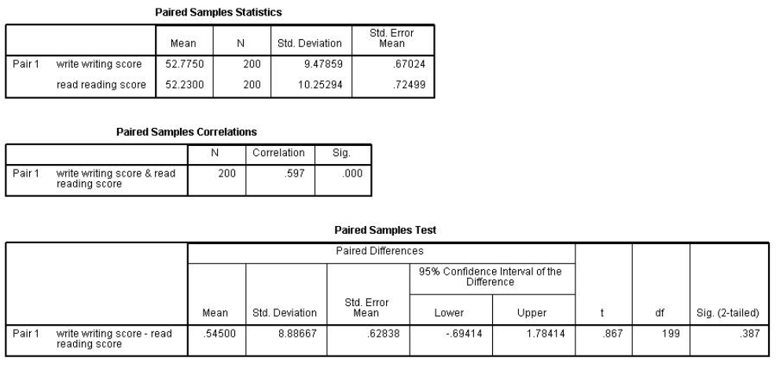
200
398

199
400

Flag this Question
Question 181 pts
A researcher would like to find out whether, in general, taking the GRE a second time produces a significantly higher score compared to the first time. This question can be answered by performing ____.
paired-samples t test
one-samples t test

independent-samples t test
descriptive statistics

Flag this Question
Question 191 pts
What is an adequate conclusion from the SPSS output below?
Writing score and reading score of the same test taker are not significantly different.
A sample of writing scores are not significantly different from a separate sample of reading scores.

A sample of writing scores are significantly different from a separate sample of reading scores.
Writing score and reading score of the same test taker are significantly different.

Flag this Question
Question 201 pts
The following SPSS output indicates that a(n) _____ was performed.
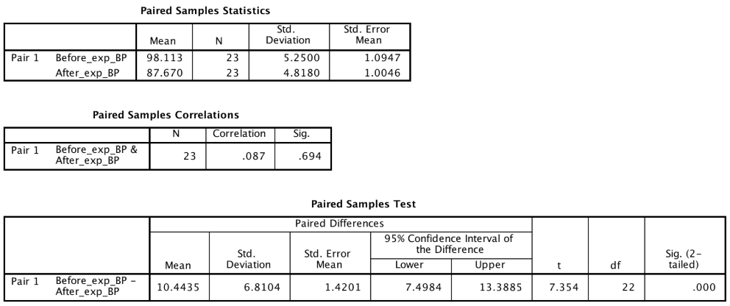
paired-samples t test
one-sample t test

independent-samples t test
Z test

