- a) i)The float value cannot be expressed in binary scientific notation because the numeric value of the mantissa is too small to be stored in the available space
The problem is referred to as underflow
ii) 3.1 * 10⁻⁹
0.0*10⁻⁷ is stored
iii)
0000 | 0001 | 0010 | 0011 | 0100 | 0101 | 0110 | 0111
0 | 1 | 2 | 3 | 4 | 5 | 6 | 7
1111 | 1110 | 1101 | 1100 | 1011 | 1010 | 1001 | 1000
-1 | -2 | -3 | -4 | -5 | -6 | -7 | -8

Ans: -5
b) i) 0.01101₂
fraction | 1/2¹ | 1/2² | 1/2³ | 1/2⁴ | 1/2⁵
binary | 0 | 1 | 1 | 0 | 1
decimal | 0 | 0.25 | 0.125 | 0 | 0.03125

0+0.25+0.125+0.03125=0.40625₁₀

ii) 0.0110₂ and 0.0111₂
iii) Minimum= 0.0110₂+0.0110₂=0.1100₂
Maximum=0.0111₂+0.0111₂=0.1110₂
iv) Minimum:- 0.1100₂=0+1/2+1/4=0.75₁₀
Maximum:- 0.1110₂=0+1/2+1/4+1/8=0.875₁₀
v) 0.40625₁₀ + 0.40635₁₀=0.8126
$$\frac{0.875-0.8126}{0.8126}X100\%$$
=8%

c) i)
(A OR B) AND NOT C | A AND (B OR C)
1 | 0
1 | 1
0 | 0
1 | 1
0 | 0
0 | 0

ii) Output = X AND NOT Y AND NOT Z

2.a)
>Draw four equilateral triangles
>>draw the first triangle
For sides from 1 to 3
Draw a line of length 20 units
Turn left 120 degrees
>>move pen to the start of the second triangle
Take pen off the paper
Turn left 60 degrees
Move pen up diagonally 30 units
Turn right 60 degrees
Put pen on paper
For sides from 1 to 3
Draw a line of length 40 units
Turn left 120 degrees
>>move pen to the start of the third triangle
Take pen off the paper
Turn left 60 degrees
Move pen up diagonally 50 units
Turn right 60 degrees
Put pen on paper
For sides from 1 to 3
Draw a line of length 60 units
Turn left 120 degrees
>>move pen to the start of the fourth triangle
Take pen off the paper
Turn left 60 degrees
Move pen up diagonally 70 units
Turn right 60 degrees
Put pen on paper
For sides from 1 to 3
Draw a line of length 80 units
Turn left 120 degrees

b) > Draw triangles along a diagonal of increasing size
Set number_of_triangles to 4
For triangles from 1 to number_of_triangles
>> Draw a triangle
For sides from 1 to 3
Draw a line of length 10 + (triangles * 10)
Turn left by 60 degrees
Take the pen off the paper
Turn left 60 degrees
move forward 20+ (triangles*10) units to start position of next triangle
Turn right 60 degrees
Put the pen on the paper
c)

# Draw triangles along a diagonal of increasing size
from turtle import *
number_of_triangles = 4
for triangles in range(1, number_of_triangles + 1):
# Draw a triangle
for sides in range(1, 4):
forward(10 + triangles * 10)
left(120)
# Move forward to start position of next square
penup()
left(60)
forward(20 + triangles * 10)
right(60)
pendown()

It is successive in producing required output.

3 a)
An operating system is a software whose main role is to provide an interaction between a computer user, computer software and computer hardware.
Functions
Provides a user interface which enables communication between the user and the computer through provision of data input and output facilities.
Multi-tasking. The operating system offers the processors the ability to switch between different executing programs hence managing multiple programs..
Memory Management. The operating system allocate appropriately sized areas of memory to each executing program, and ensures that program instructions and data do not interfere with each other or with data and instructions of other programs.
Peripheral devices coordination and control. The operating system ensures proper control of input and output devices and ensures that they do not interrupt proper functioning of the computer.
b) i) 2bits
ii) 45*10³*2=9.00*10⁴ bits per second
iii) 45*10³*2*{(3*60)+10}=17,100,000‬bits=1.71*10⁷bits
iv) 40*10³*2*{(3*60)+10}=15,200,000‬bits=1.52*10⁷bits
v) % decrease =$\frac{\left(1.71-1.52\right)*{10}^{7}}{1.71*{10}^{7}}X100\%=11.1\%$
c) Kotlin is designed to interoperate fully with Java, and the JVM version of its standard library depends on the Java Class Library, but type inference allows its syntax to be more concise. [Wikipedia, 22 April 2020, Kotlin), programming languages, https://en.wikipedia.org/wiki/Kotlin_(programming_language)]

4 a) i) Inputs are a, b and c they are all of the type integer
The outputs are the sums of b and c, a and c, a and b which are integers and answer which is a string
ii) Admissible input values are whole numbers
b) i) missing colons at the end of the second and third test syntax.
ii) Test 3. Because the syntax is checking whether the sum of a and b is greater than c instead of whether it is equal to c as required by the test. Meaning it will return the wrong answer due to the wrong test.
iii) The input values of the first three sets are chosen that the sum of two adjacent inputs is equal to the preceding value and that the value of the one equated to the sum of the other two is the next integer in the order. The inputs for test 4 is in that none of the values is a sum of any two.
c) Pattern 4.4 ensures that no case is forgotten.
Algorithm
- Initialize a, b and c
- If a+b<c and b+c<a and c+a<b
2a) Set answer to no number is sum of others
- If a +b equals to c
Set answer to c= a+b
- If b+c is equal to a
4a) Set answer to a=b+c
- If c+a equals to b
5a) Set answer to b=c+a
- If a + b>c and b+c>a and c+a>b
6a) Set answer to no number is sum of others
- Print the answer

d)
#input: a as an integer between 0 and 100
a = input("enter the value of a between 0 and 100:")
# Input: b as an integer between 0 and 100
b = input("enter the value of b between 0 and 100:")
# Input: c as an integer between 0 and 100
c = input("enter the value of c between 0 and 100:")
#compute and check the output
if (a < b + c) and (b < a + c) and (c < a + b):
answer= 'No number is sum of others'
if c == a + b :
answer = 'c = a + c'
if a == b + c :
answer= 'a = b + c'
if b == a + c:
answer= 'b = a + c'
if (a > b + c) and (b > a + c) and (c > a + b):
answer = 'No number is sum of others'
#print the output from the test as a string
print(answer)

5 a)
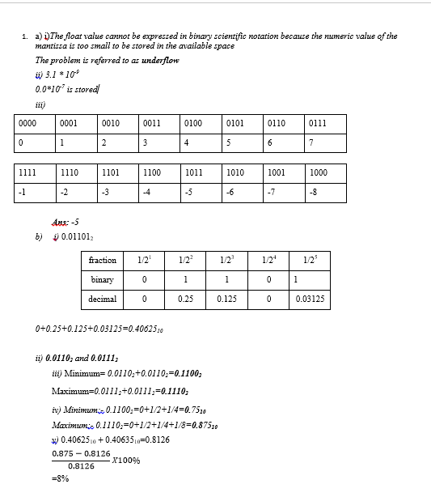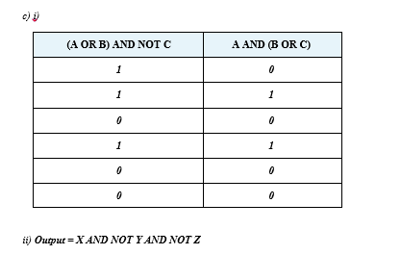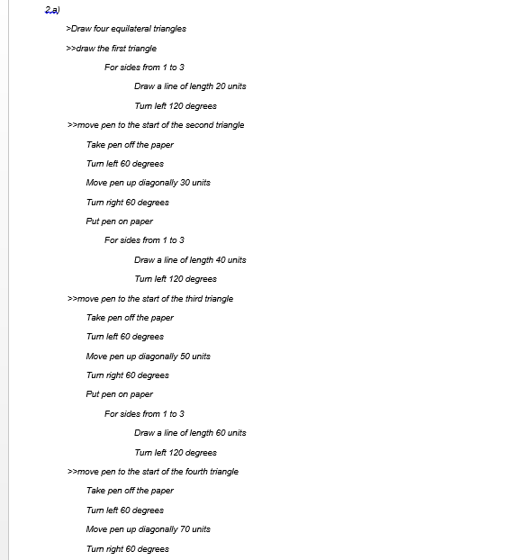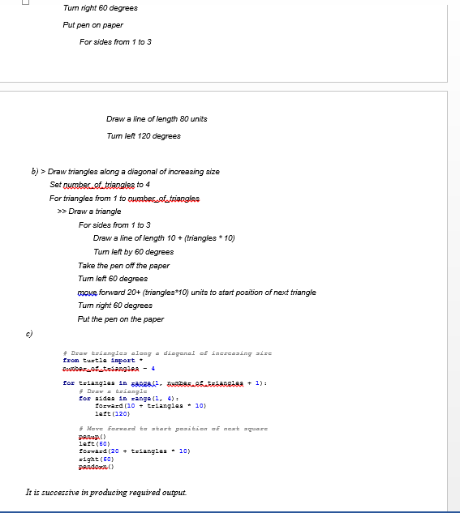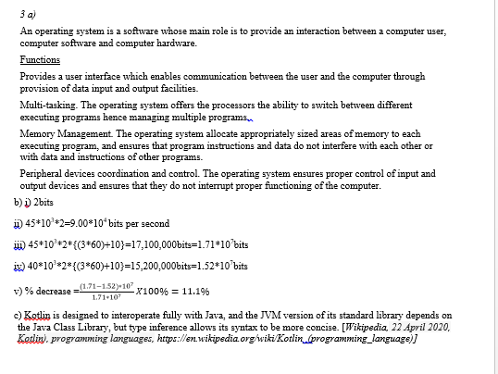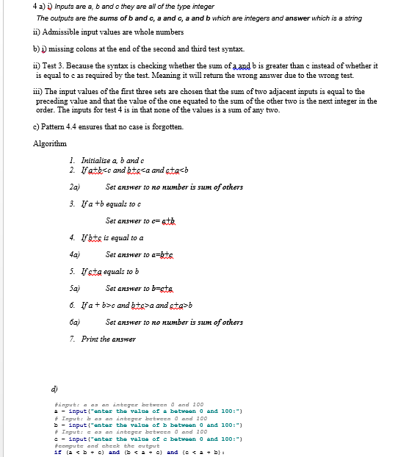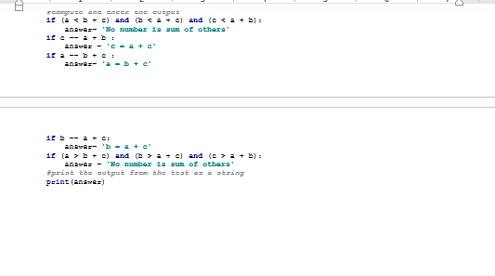
b) The test was worth and it was a link up of atleast the major techniques learnt in the module. It was a better way of not only accessing understanding but also ensuring proper understanding and practical application. Questions regarding programming were the most interesting and those involving digital logic too were sweet. However, question 2 was breath taking.

