Questions
Name of Student
Institutional Affiliation

PART 1
- (d) Medical care
- (b) Common property resources
- (b) nonrivalry and nonexclusion in consumption.
- (b) negative externalities.
- (b) is zero.
- (c) tax revenue from pollution charges is maximized.
- (b) real national output grows by the value of the control equipment.
- (b) pollution until the external effects were negligible
- (b) help a person or institution to choose a project with the highest benefits and lowest costs.
- (b) Probability caught * MC of compliance + penalty for cheating.
- (c) Members tend to cheat on their agreements
- (a) the external cost of air pollution will increase

Part 2: Short answer
- FALSE; this is because an externality refers to benefits or costs that occur to third parties who are not involved directly in the production or consumption of goods. From the above definition of an externality, trade between two parties cannot be an externality.
- FALSE: taxes and subsidies can only reduce negative externalities such as increasing fuel cost to minimize fuel usage and thus abate the pollution caused by petroleum products. Taxes and subsidies cannot, however, reduce the positive externalities.
- TRUE; if the neighbor can feel the negativity of the loud music and he or she is far away, this means that you yourself would be many consumers of the loud sound of the music.
- FALSE; this is because the private sector does not provide any goods to the public rather, private goods are consumed by individuals who own it. A road, for example, I a public good because it can be used by many people without affecting it. On the other hand, a private car can only be used by the owner himself and not anybody else.
Part 3: Long answer
- (a) If both brewer and paint maker were parts of the same firm, the only option is to close the paint making firm; this is because the cost-benefit analysis of the paint maker is much higher than that of the brewery. Closing the paint firm at $90 000 would be cheaper than all the other alternatives which would cost $140 000. It would not be a socially efficient outcome because the marginal social benefit (MSB) does not equal the marginal social cost (MSC). Social efficiency is only achieved when MSB is equal to MSC.
(b)If the law favored the brewer, and the paint maker’s lawyer would only charge $50 to work out a deal, the only thing that should be done is the paint maker compensating the brewer for the cost. This is socially efficient because the MSB would be equal to the MSC.
(c) If the law favored the paint maker, and the brewer’s lawyer would only charge $50 to work out a deal, the only thing that should be done is by is to close the breweries, this is because the marginal social cost of the breweries would be much higher. This is not a socially efficient outcome because the MSB is not equal to the MSC.
(d) The brewer should close the firm because he would incur an extra cost of $25 000. This is not a socially efficient outcome because there is a discrepancy between the marginal social benefit and the marginal social cost.
(e) If the law favored the paint maker, and the brewer’s lawyer would only charge $25,000, to work out a deal, the only option is to close brewery, this is because the breweries would be working under losses. However, this is not socially efficient outcomes because MSB would not be equal to MSC.
- (a)

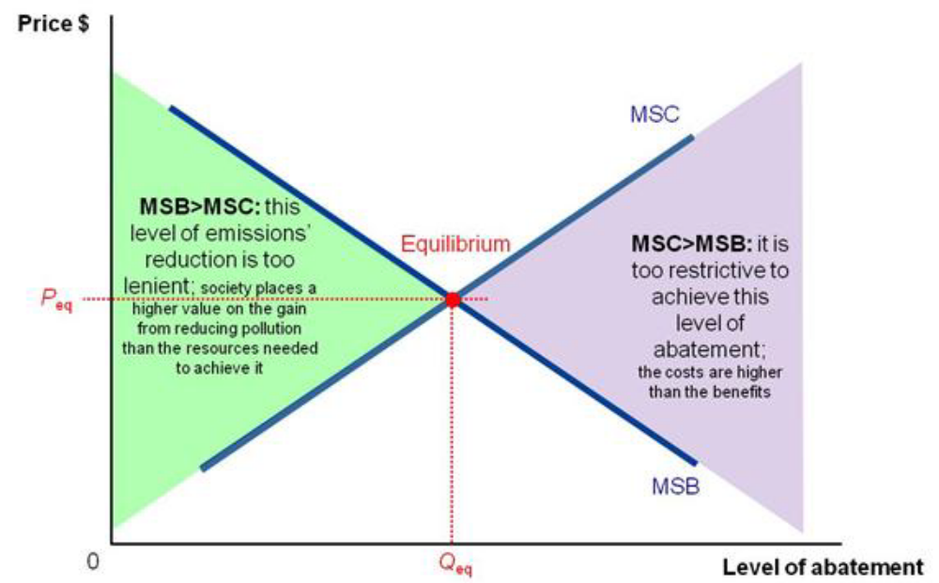

(b) 50*15=$750; this is because the penalty is given by damage multiplied by the number of units of pollution
(c) Pollution by the three firms; 50*3= 150
Revenue collected; Volvo=5+0.2A=50
Therefore A=225
Ford=5+0.25A=50
Therefore A=180
Toyota= A-5=50
Therefore A=55
Total Revenue =225+180+55= $460
This is because the revenue collected by the government is the sum of A of both firms.
(d) The optimal number of pollution permits would be; 750-460=290
This is because the optimal number of pollution is the favorable price of pollution which should be less than the penalty posed by the government.
(e) Price of the permit would be; 750/50=15
Permits for each firm; 15/3=5
This is because to find the permit we take the penalty taken divide it by the number of units of pollution by each firm.Therefore, we divide the permits by the total number of the firm to get the number of units for each firm.
(f) Revenue collected= (5*225) + (5*180)+ (5*55)=$2300
The reason is that revenue is given by the number of permits obtained by each firm time the tax levied on the respective firm.
(g) The government would prefer to tax the firms rather than setting cap and trade system. This is because the tax has more income compared to the caps.

