RIGHT CARE, RIGHT NOW

CONTENT
- Chain of Infection
- Standard Precautions
- Hand Hygiene
- Cleaning and Disinfection
- Waste Segregation
- Transmission-Based Precautions/Expanded Precautions
- Acute respiratory infection and case definitions
- Accountability

THE CHAIN OF INFECTION

Susceptible Host
Cancer patients Elderly, Burns patients Surgical patients
D.M patients
Infectious Agent
Bacteria, Virus Fungi, Protozoa Parasite

Reservoir
People Equipment Water

Portal of Entry
Respiratory Gastrointestinal Genitourinary Mucous Membrane

Modes of Transmission
CONTACT DROPLET AIRBORNE

Portal of Exit
Excretion Secretions Droplets

STANDARD PRECAUTIONS
- A group of infection prevention practices that apply to all patients, regardless of infection status, in any setting where healthcare is delivered.

- Based on the principle that all blood, body fluids, secretions, excretions except sweat, non-intact skin, and mucous membranes may contain transmissible infectious agents.

STANDARD PRECAUTIONS

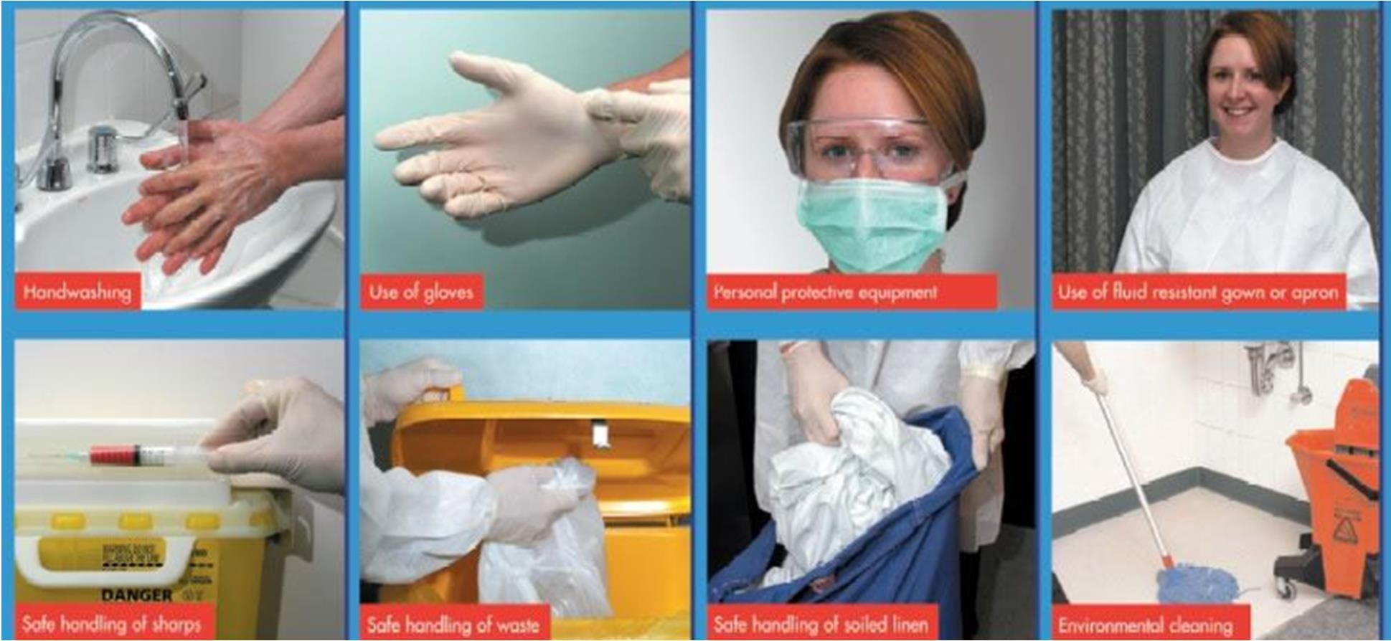

HAND HYGIENE
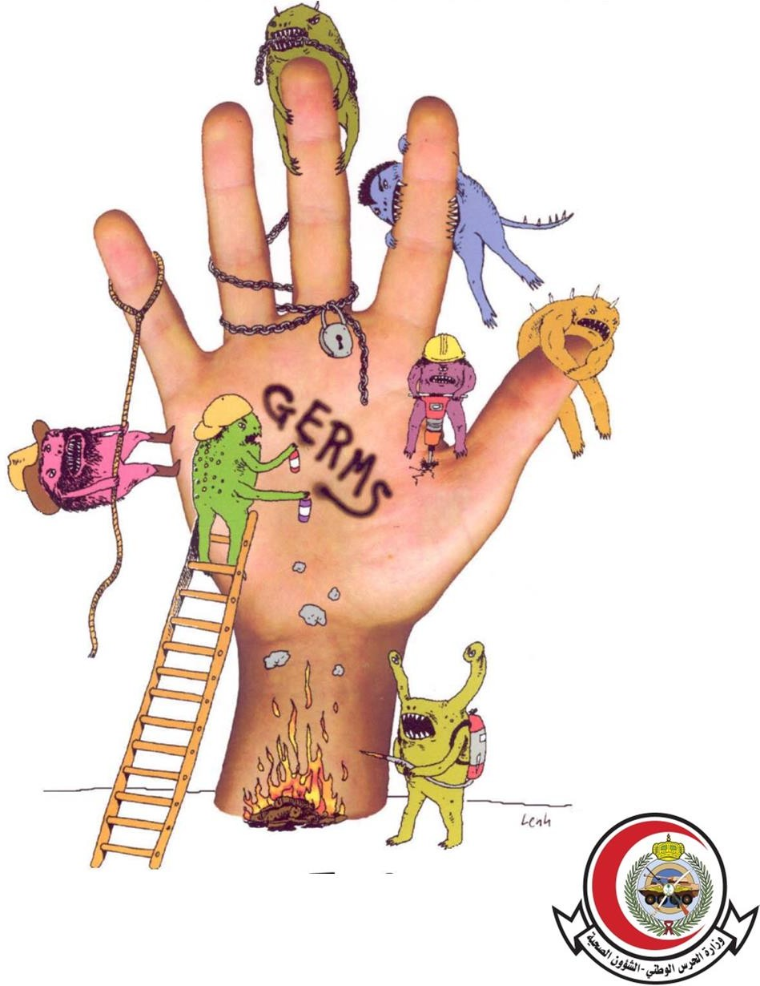
- Hand hygiene is the single most effective measure to reduce infections, including HAIs, respiratory and MDROs.






ŃOU ents


nd iiene


World Health Organization

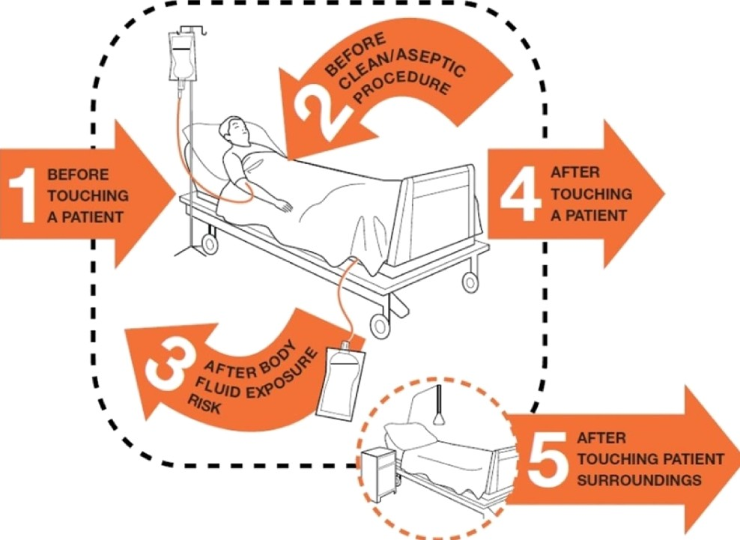

  - 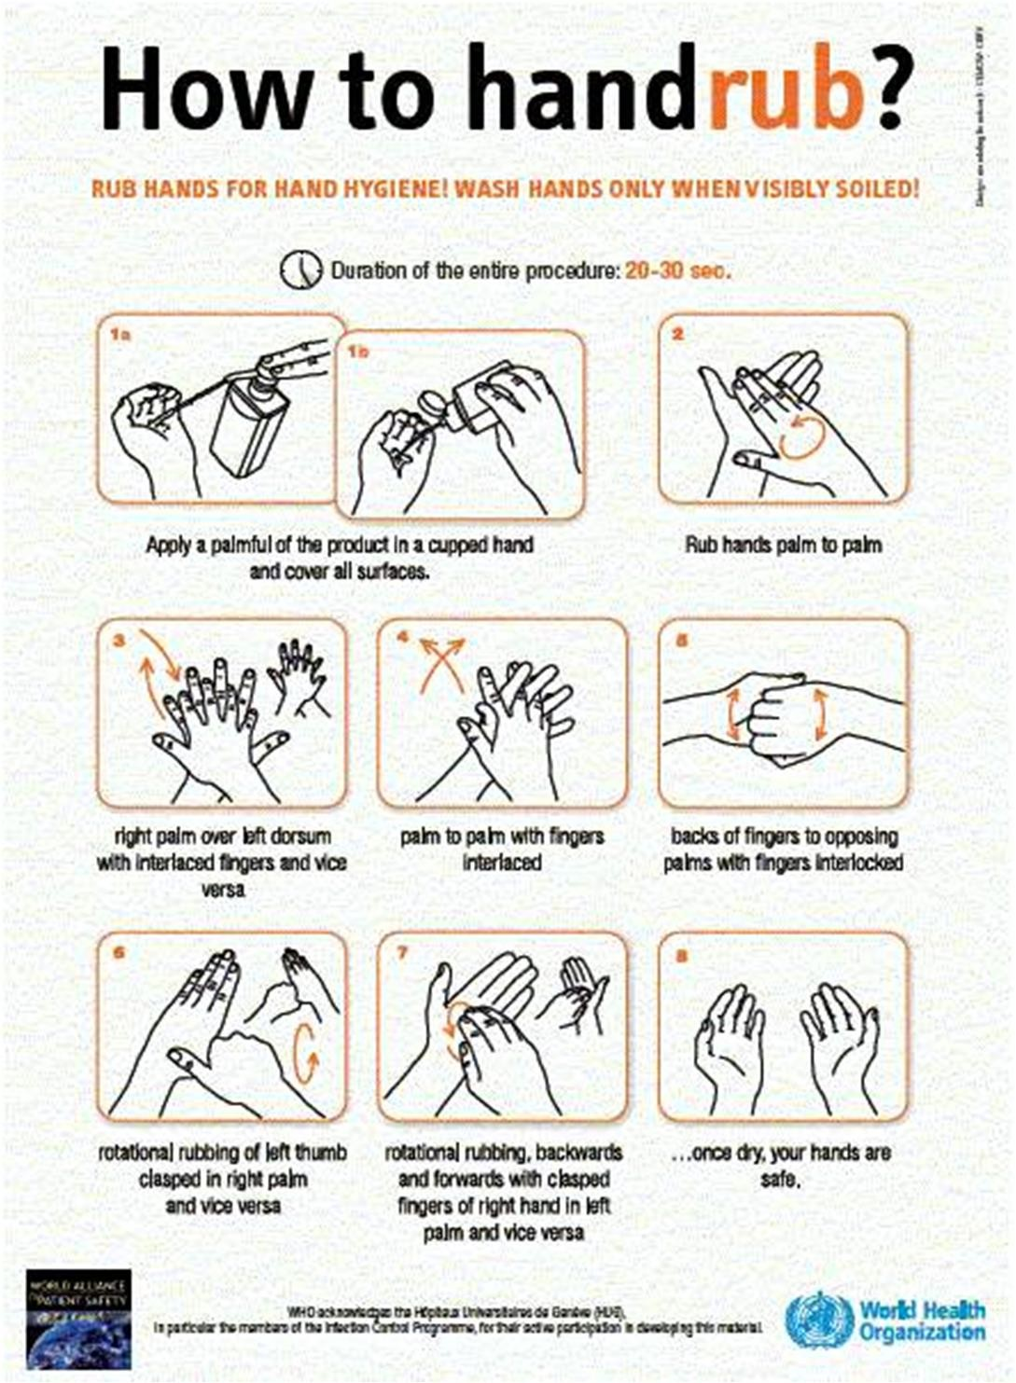Alcohol gel
  - 20-30 seconds

  - 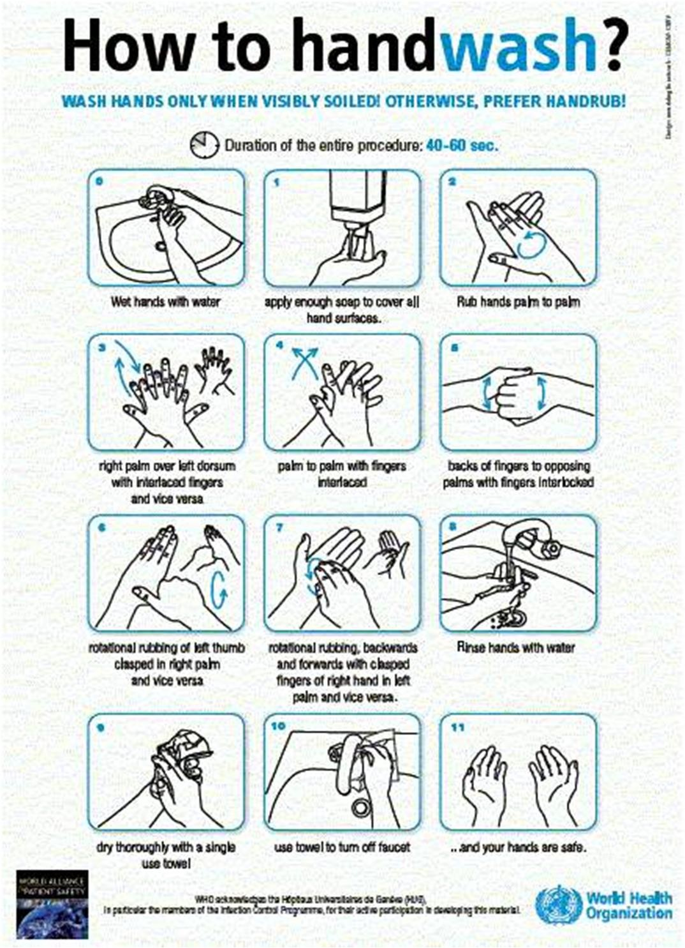Soap and water
  - 40-60 seconds

Handwash when?
  - C. difficile
  - Visible soilage on hands
  - Before eating
  - After using the restroom
  - Buildup of residue on
  - hands

PERSONAL PROTECTIVE EQUIPMENT (PPEs)
- Specialized clothing or equipment worn by an employee for protection against infectious materials

DONNING PPE

Perform hand hygiene
Gown
Surgical mask or N95 respirator
Goggles or face shield
Gloves

HOW TO DON A GOWN
- 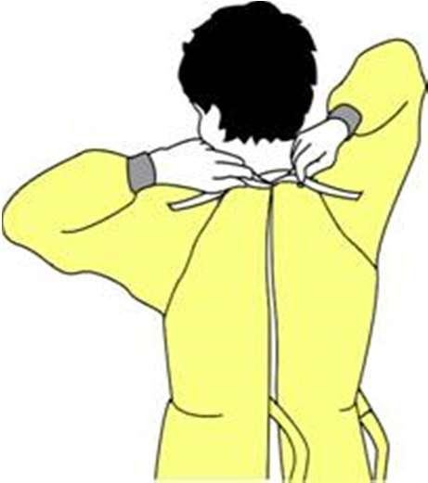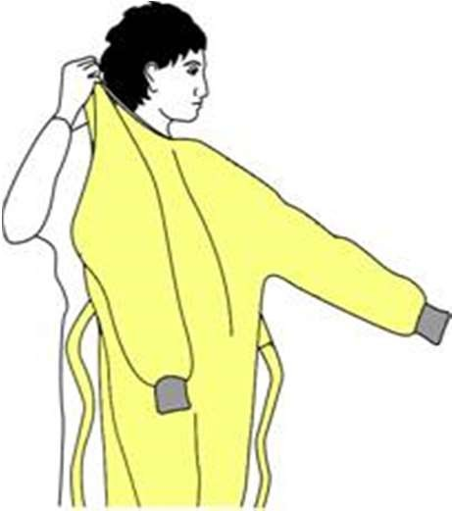Select appropriate type and size
- Opening is in the back
- Secure at neck and waist
- If gown is too small, use 2 gowns:
- Gown #1 ties in front
- Gown #2 ties in back

HOW TO DON A SURGICAL MASK
- 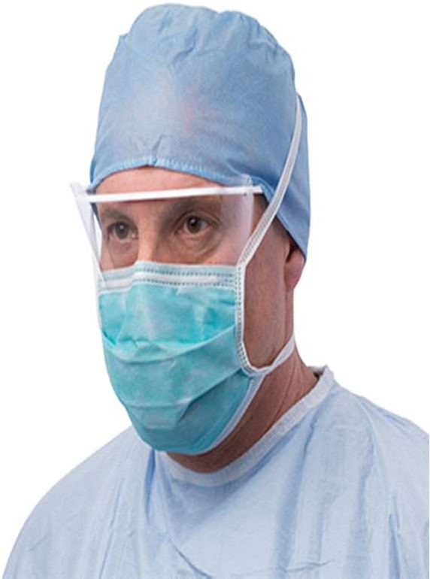Place over nose, mouth and chin
- Fit flexible nose piece over nose bridge
- Secure on head and neck with ties
- Adjust to fit

HOW TO DON EYE AND FACE PROTECTION
- 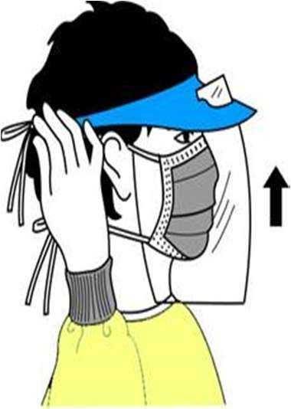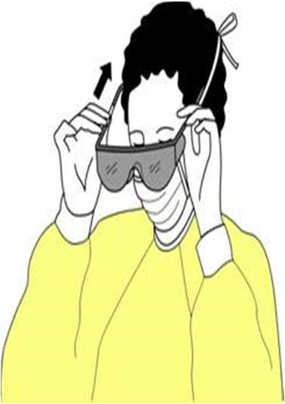Position goggles over eyes and secure to the head using the ear pieces or headband
- Position face shield over face and secure on brow with headband
- Adjust to fit comfortably

HOW TO DON GLOVES
- Don gloves last
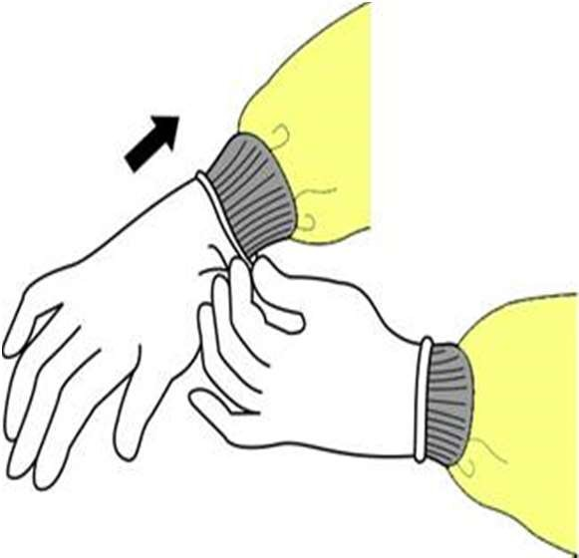
- Select correct type and size
- Insert hands into gloves
- Extend gloves over isolation gown cuffs

DOFFING PPE

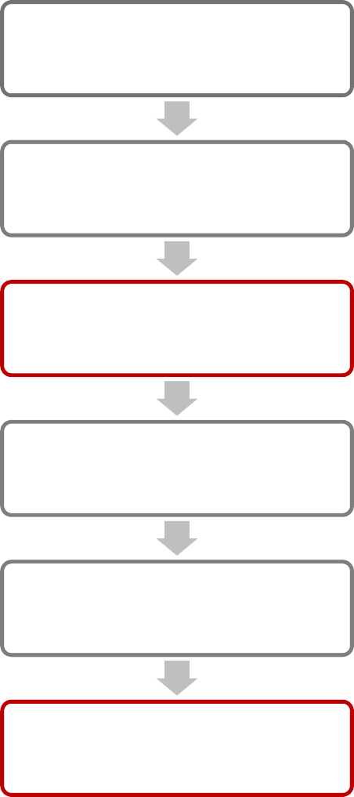
Gloves
Gown
Perform hand hygiene
Face shield or goggles
Mask
Perform hand hygiene

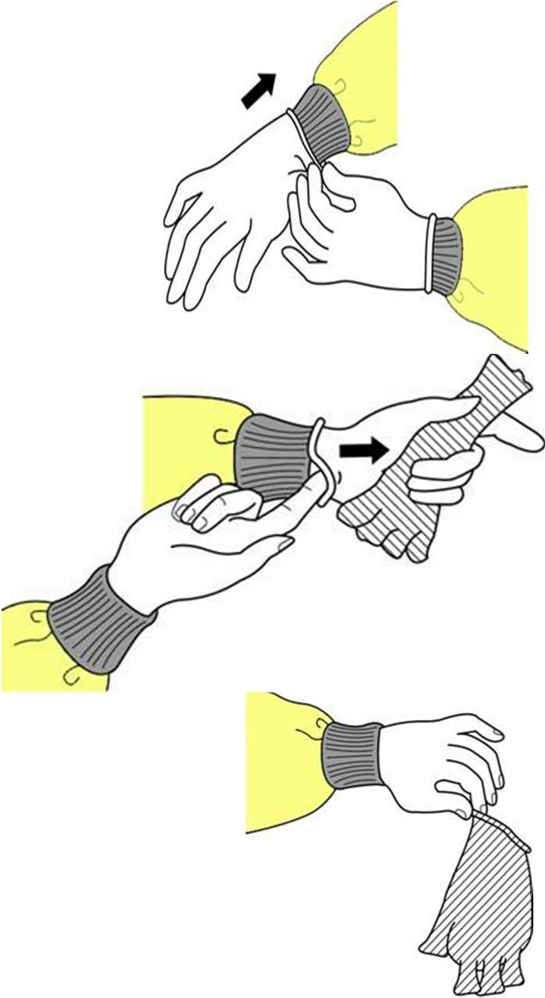HOW TO DOFF GLOVES
  - Grasp outside edge near wrist
  - Peel away from hand, turning glove inside-out
  - Hold in opposite gloved hand
  - Slide ungloved finger under the wrist of the remaining glove
  - Peel off from inside, creating a bag for both gloves
  - Discard

HOW TO DOFF A GOWN
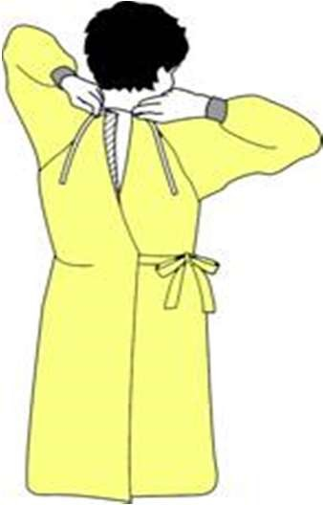
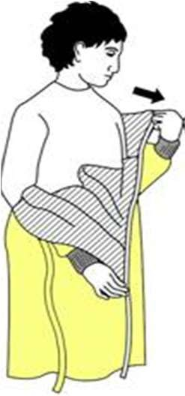
  - Unfasten ties
  - Peel gown away from neck and shoulder
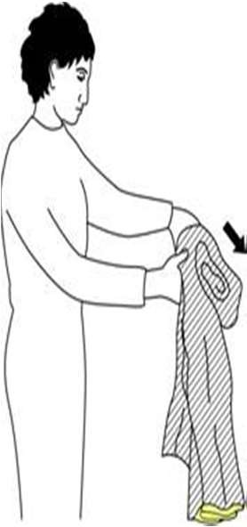
  - Turn contaminated outside toward the inside
  - Fold or roll into a bundle
  - Discard

HOW TO DOFF GOGGLES OR FACE PROTECTION
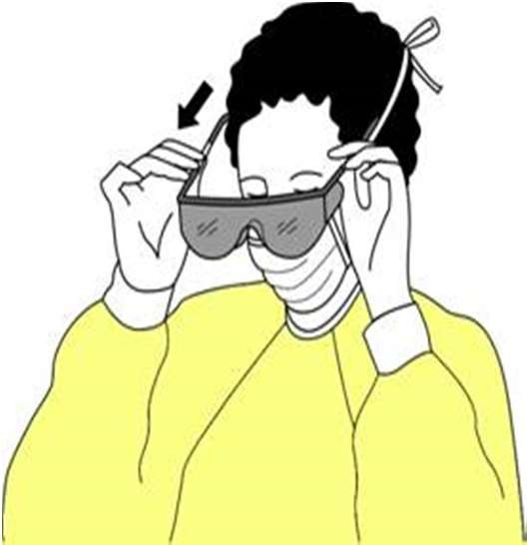
  - Grasp ear or head pieces with ungloved hands
  - Lift away from face
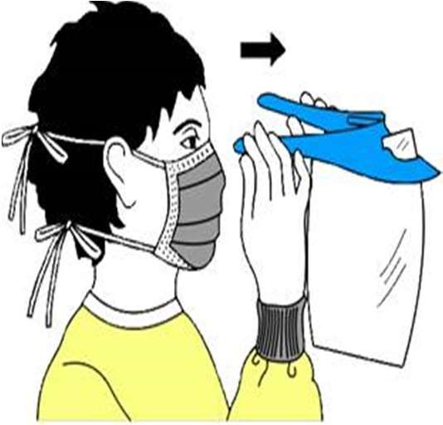
  - Place in designated receptacle for reprocessing or disposal

HOW TO DOFF A SURGICAL MASK

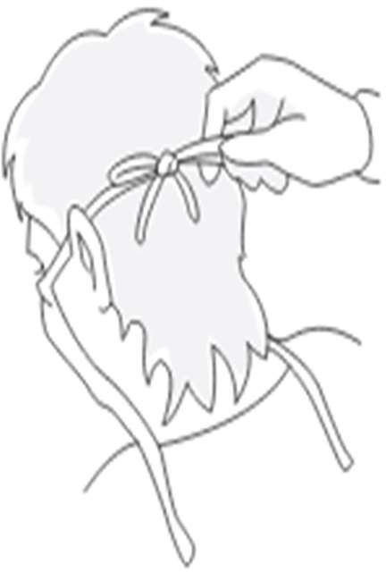
  - Grasp the bottom ties or elastics of the mask, then the ones at the top.
  - Discard, taking care not to touch the front part.
  - Perform hand hygiene

WHERE TO REMOVE PPEs
- At doorway, before leaving patient room or in anteroom.
- If wearing N95 respirator, remove outside room, after door has been closed.

CLEANING AND DISINFECTION

EQUIPMENT WHO? HOW OFTEN?
WITH WHAT?

Stethoscope, cell phones
Physician Nurse
After each use Alcohol wipes

Pumps: IV, PCA, feeding

Nurse After each use *Approved disinfectant

Monitors, wires, cables, sensors
Nurse, PCT or Respiratory therapist
After each use *Approved disinfectant

Ventilator Respiratory therapist/technician
After each use *Approved disinfectant

Bed, bedrails, tables Housekeeping Daily and as
needed

*Approved disinfectant

Toilets, Sinks, Flooring
Housekeeping Daily and as needed
Approved disinfectant

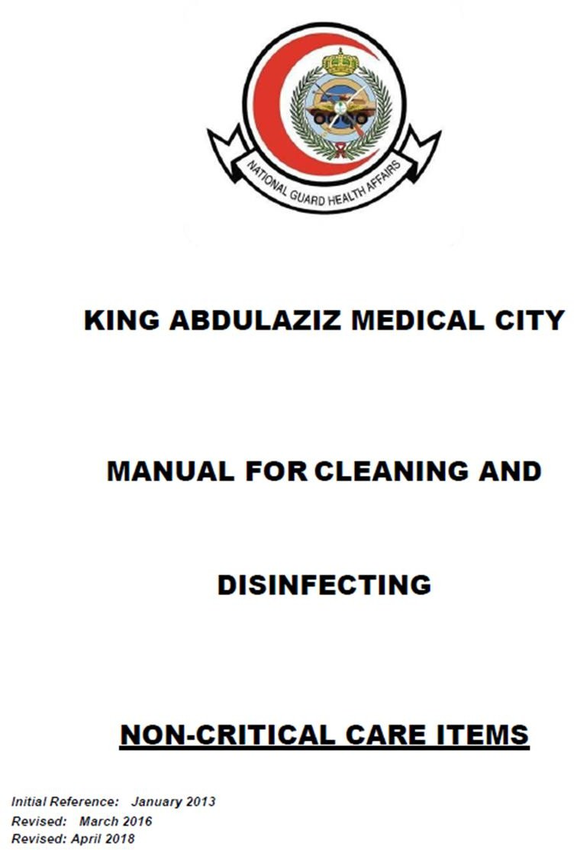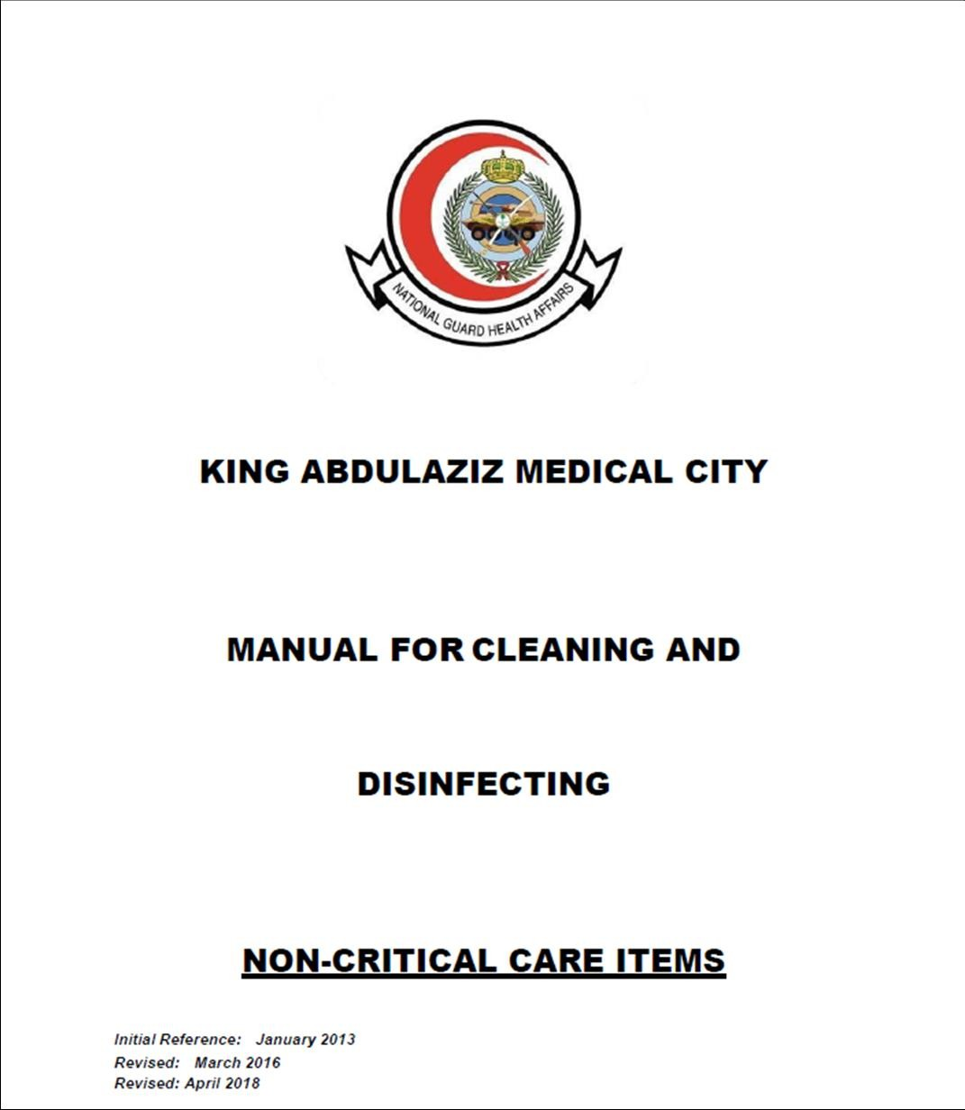To access:
Intranet Home > Regulations > Manuals

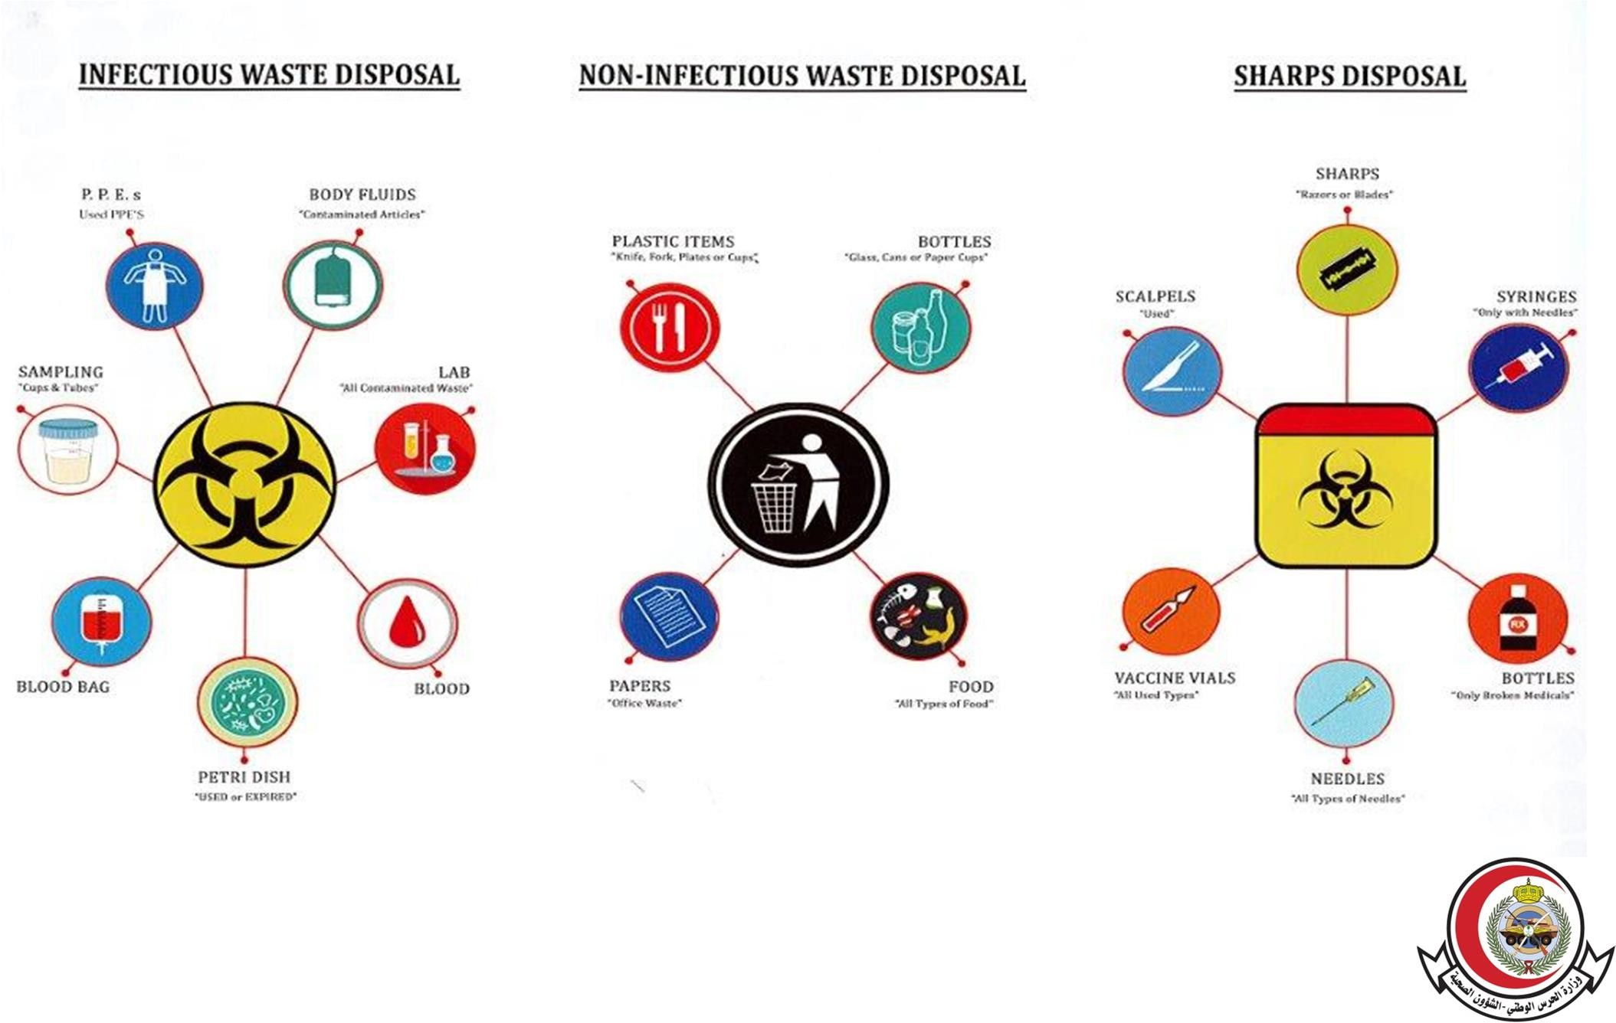
WASTE SEGREGATION

YELLOW BAG
BLACK BAG
YELLOW SHARP BOX

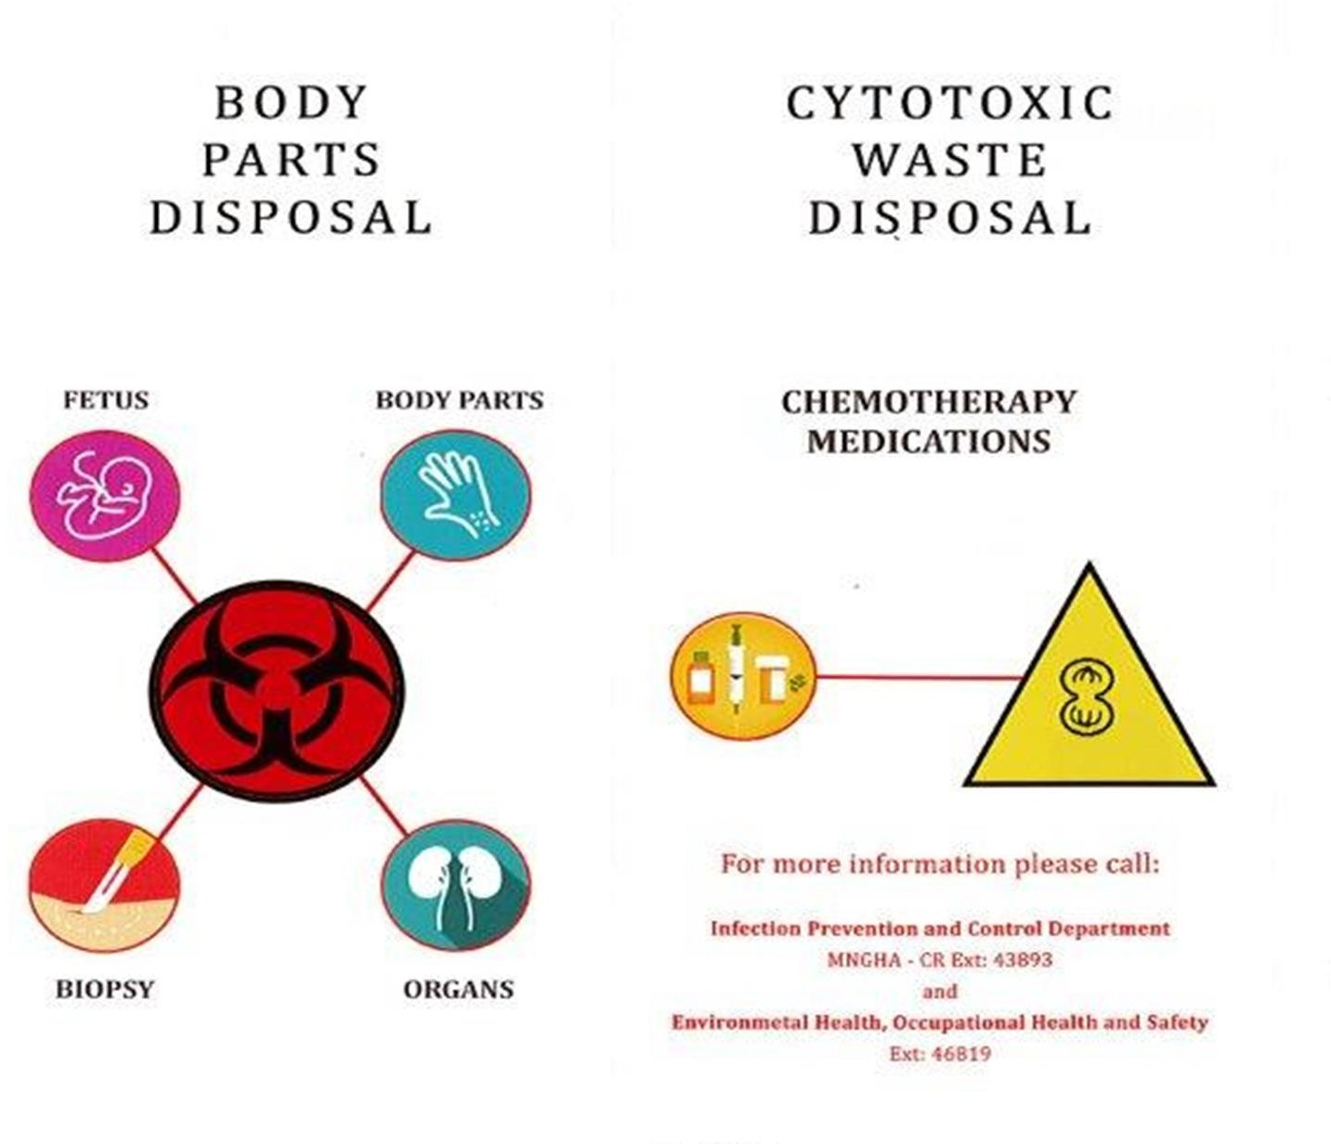WASTE SEGREGATION

RED BAG
YELLOW SHARP BOX (BULK) YELLOW BAG (TRACE)

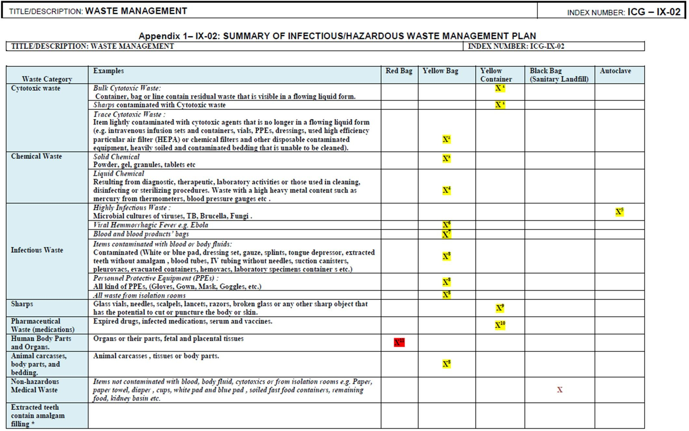

RESPIRATORY HYGIENE/ COUGH ETIQUETTE

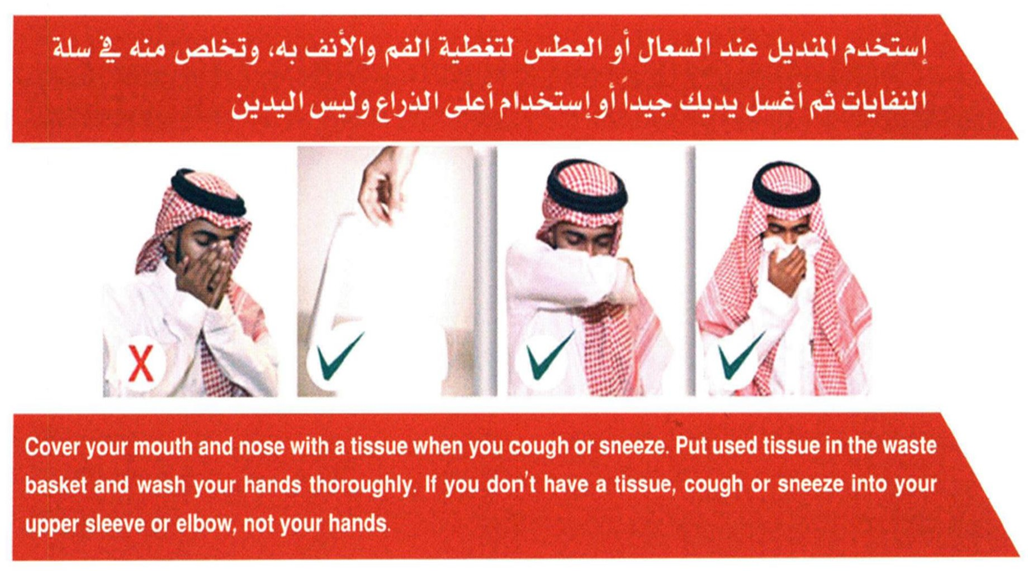

Modes of Transmission
Mechanism for the transfer of an infectious agent from a reservoir to a susceptible host:

- Contact Transmission
- Droplet Transmission
- Airborne Transmission

DIFFERENCE BETWEEN DROPLET AND AIRBORNE MODE OF TRANSMISSION

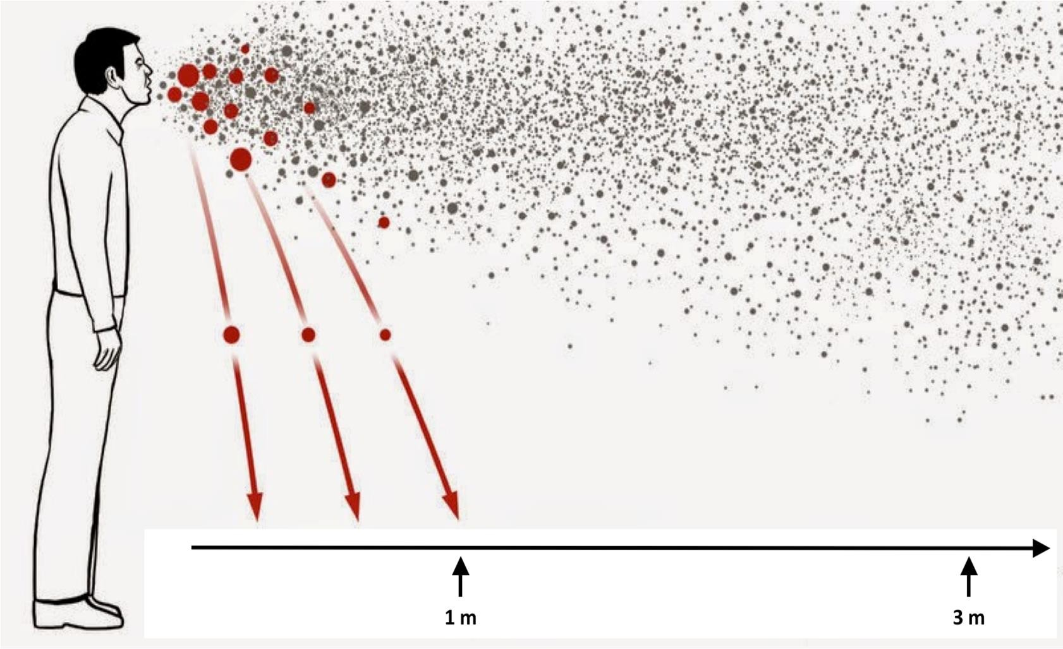Droplets
>5um
Airborne
<5um

1.5

TRANSMISSION-BASED PRECAUTIONS EXPANDED PRECAUTIONS

Contact Precaution
  - Droplet Precaution
  - Airborne Precaution

CONTACT PRECAUTIONS
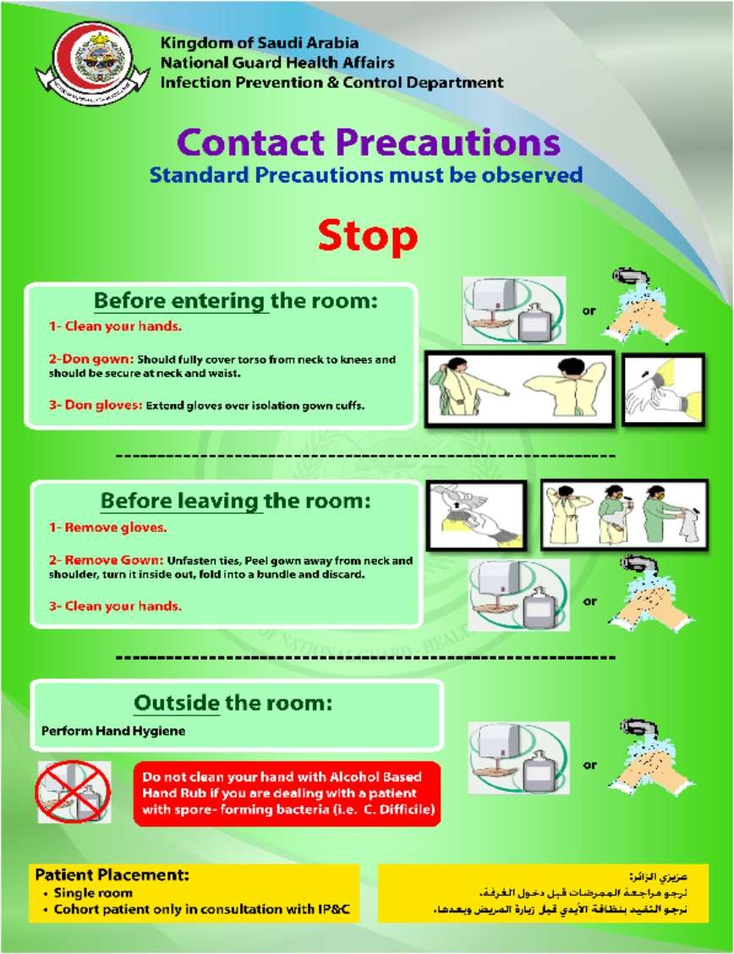Components:
    - Hand hygiene
    - Gown
    - Gloves
Examples:
    - MRSA, VRE, MDRO etc.
    - RSV
    - C. difficile, norovirus
(hand washing)

DROPLET PRECAUTIONS
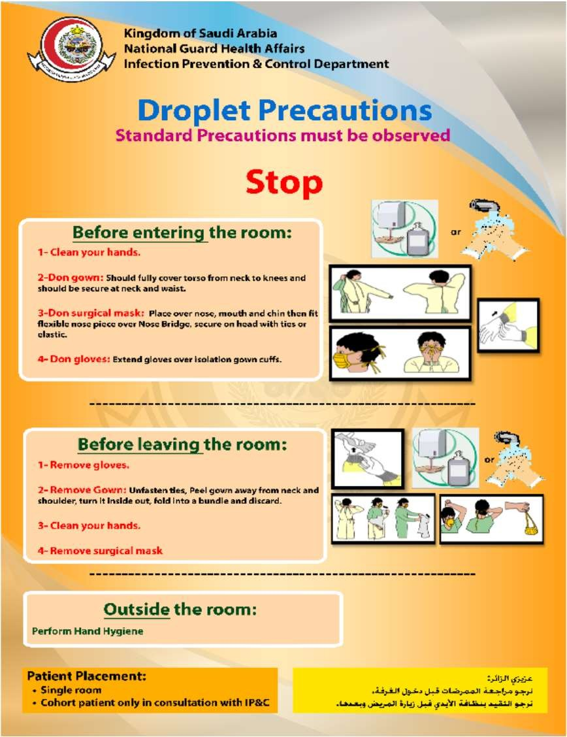Components:
    - Hand hygiene
    - Gown
    - Mask (remove in room)
    - Gloves
Examples:
    - N. meningitidis
    - Influenza and other respiratory viruses

AIRBORNE PRECAUTIONS
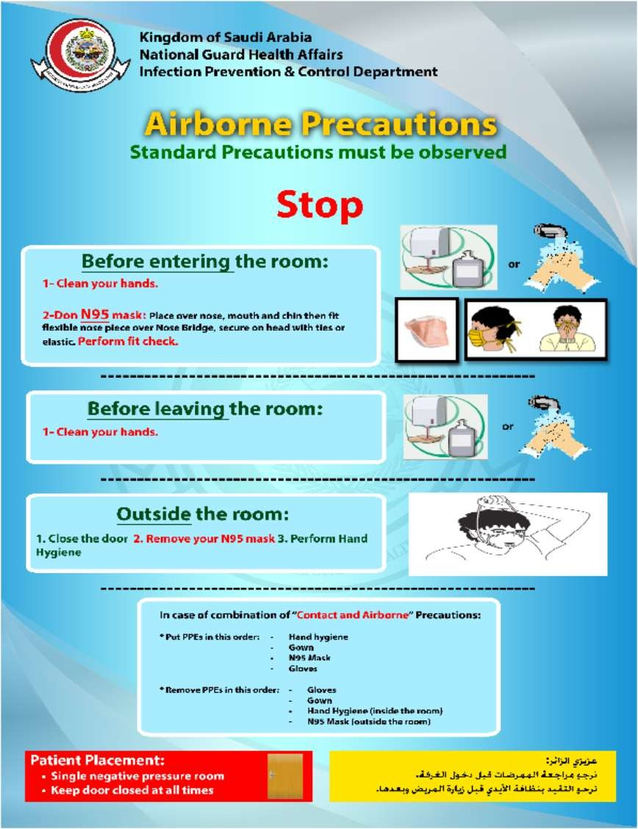Components:
    - Hand hygiene
    - Respirator / N95 mask
(Remove outside the room)
    - Keep door closed (to maintain negative pressure)
Examples:
    - M. tuberculosis
    - Measles
    - Varicella + contact

RESPIRATORY PROTECTION

Medical/Surgical Masks
- Indicated for prevention of Droplet Transmission
N95 Respirators or PAPRs
- Indicated for prevention of Airborne Transmission
- Used for all aerosol generating procedures

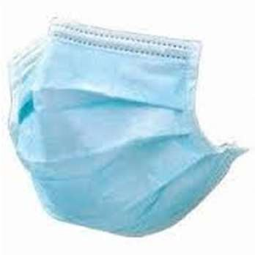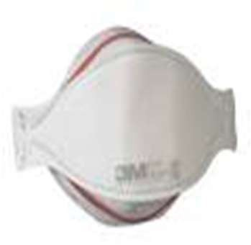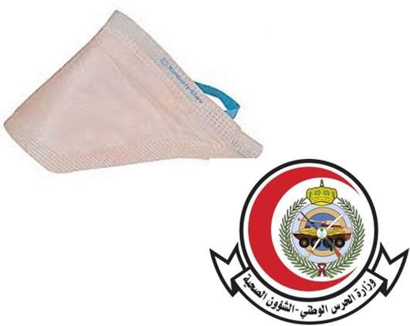

CLINICAL MANIFESTATIONS OF ACUTE RESPIRATORY INFECTION (ARI)
- Fever ≥38ºc
- Cough
- Sore throat
- Runny or stuffy nose
- Muscle or body aches
- Headaches
- Fatigue (tiredness)
- Vomiting and diarrhea

WHEN TO THINK ABOUT MERS-CoV
- Acute respiratory infection symptoms
– fever, cough, sore throat, shortness of breath
- Exposure within 14 days
– contact with camels, contact with infected patient
- Diarrhea with fever with leukopenia and thrombocytopenia

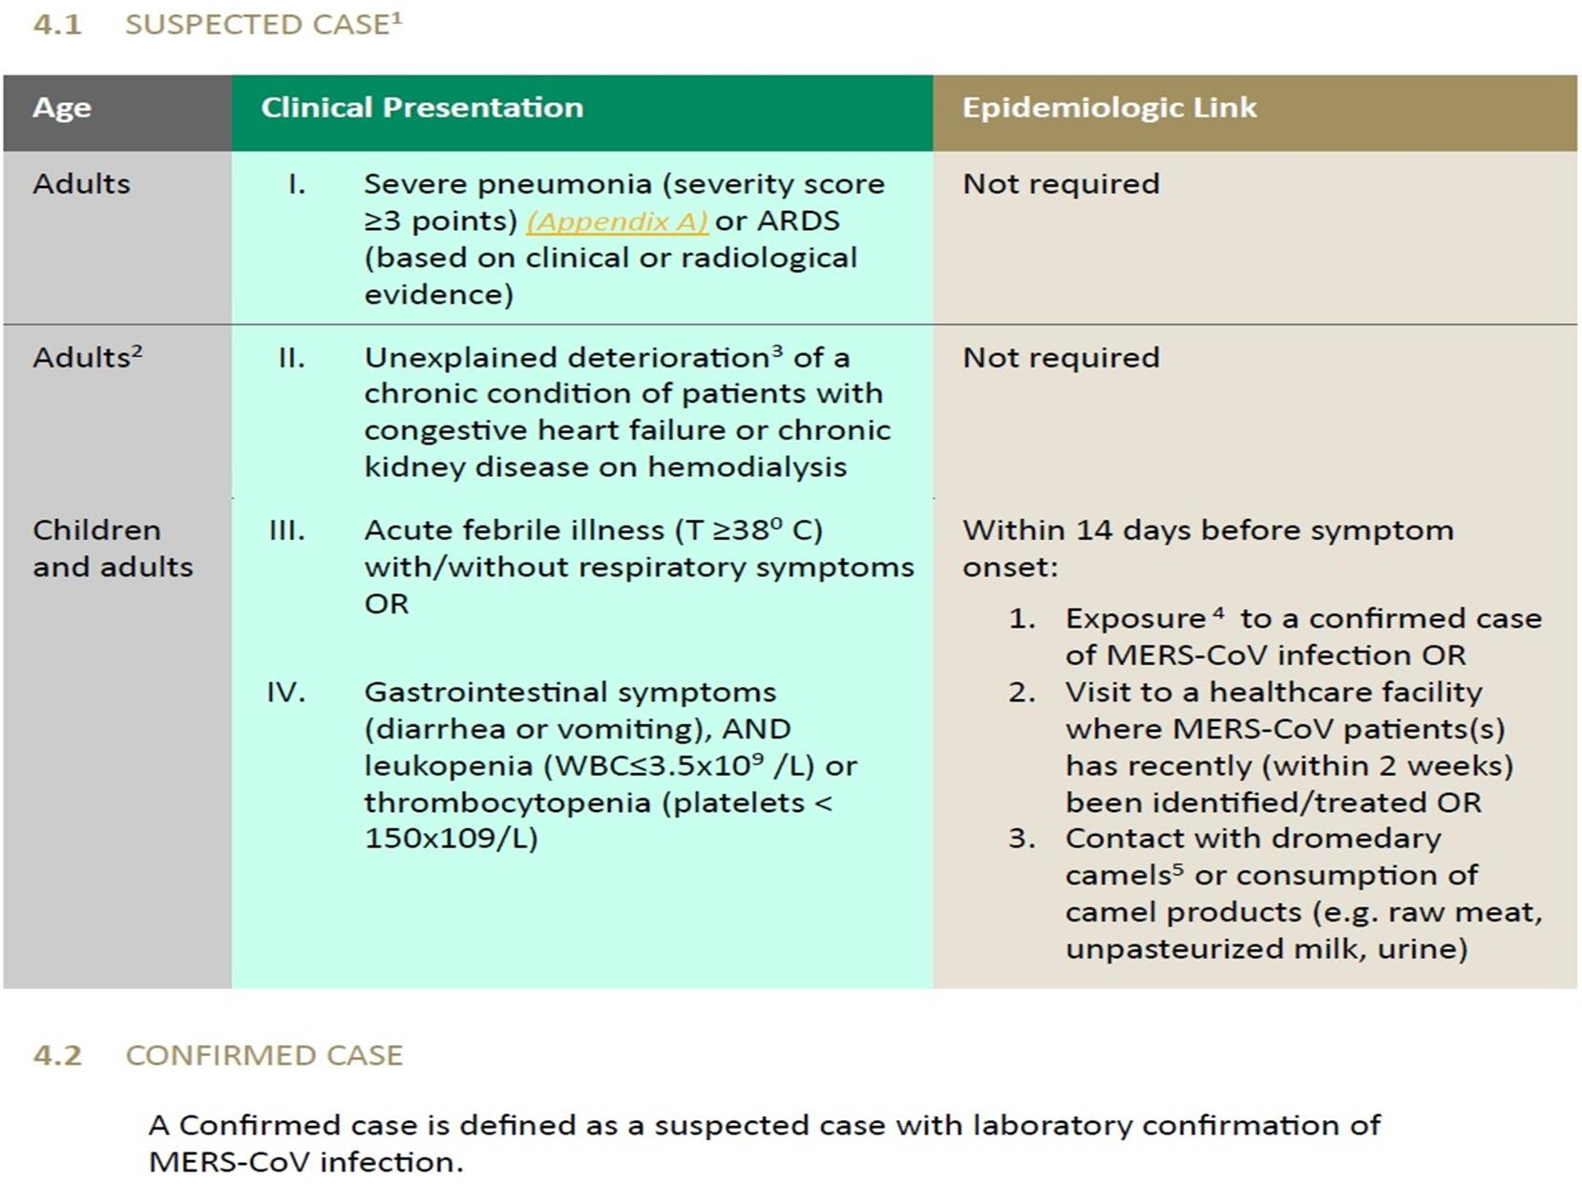MERS-CoV CASE DEFINITION (KSA-MOH, May 2018)

WHEN TO THINK ABOUT CoVID-19
- Acute respiratory infection symptoms
– fever, cough, sore throat, shortness of breath
- Travel history abroad within 14 days
- Exposure to a confirmed COVID-19 case

COVID-19 CASE DEFINITION (NGHA-IPG)
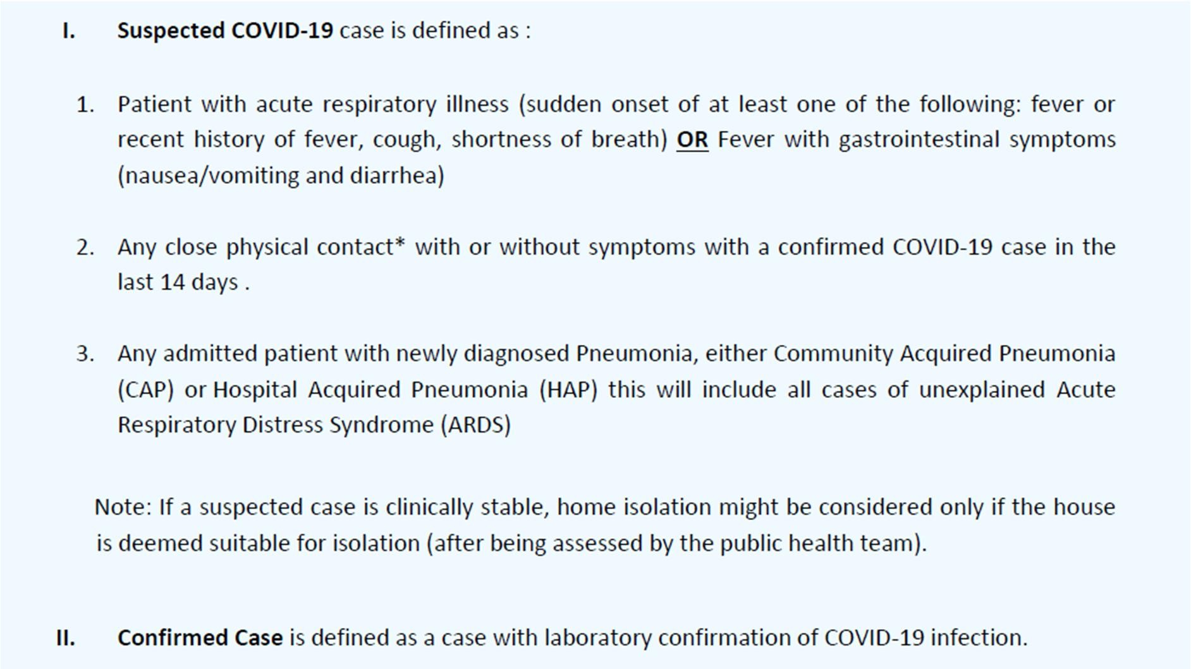


AR! Screening Form (Adult and Pediatric J

Health Caze Facility Name:

/L Clinical sympt‹xri/sip |  | Points | score
1. | Fever(>38•C ) histoY offer for last5 days | 4
2. | Cough (New or worsening) | 4 | a
3. | Shorlriess of breah (New or worsening) | 2 | a
* | Sore throat an‹t/‹xrunny nose | @ | 0
1 | Nausea/votitirg AND diaohea
B. Ri | sksexlzmzeto HEIR/¢D¥tD-19
*' | Re‹endy Diagnmwl as acorfimwIC0VI0-19 and NERS cases within Iast30 dgs | 4
7. | Unpn›tectwIExpos›reto aconfirmedNERScasein IaRtwoweeI‹s | 4 | CI
8. | UnpzotectwlEzposireto aconfirrredCOVfD-19 casein IasttwoweeI‹s | 4 | ^
9. | Exposuretocatelorcarriel prod as(directorindre‹t) inthelasttwo wed‹s | 2 | >
ID. | uy Health carefacilties stdfeitheheab› caewoterorsuwatingse‹vices | 2 | >
Total Sazze

sA cot Place patient in an isolation room and informMD for assessment

LABORATORY DIAGNOSIS
Molecular tests are used to diagnose presence of MERS-CoV and COVID-19.
Real-time reverse-transcription polymerase chain reaction (rRT-PCR) assays are molecular tests that can be used to detect viral RNA in clinical samples.
Specimen:
- Sputum
- Tracheal aspirates
- Bronchoalveolar lavage (BAL)
- Nasopharyngeal swab

COVID-19 INTERIM PRACTICE GUIDANCE:
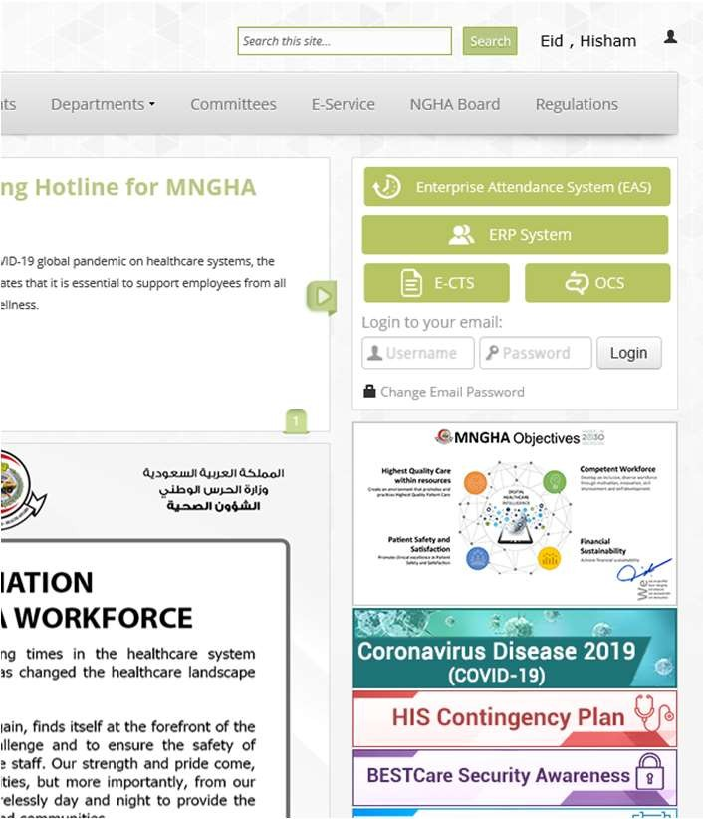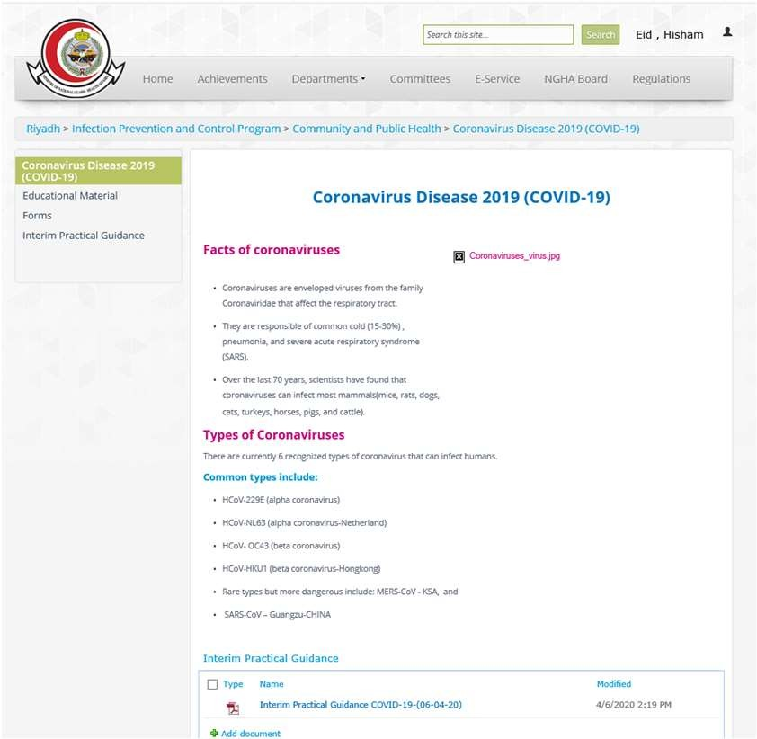
1
2

Note: Check uploaded guidance frequently for updates.

SUMMARY
- Acute respiratory infection can have many causes
- Seasonality does not exclude influenza or coronavirus disease
- Have a low threshold when suspecting MERS- CoV or COVID-19
- Respiratory symptoms
- Epidemiologic links
- Gastrointestinal symptoms with fever , leukopenia and thrombocytopenia (for MERS- CoV)

RIGHT CARE, RIGHT NOW
ACCOUNTABILITY

ACCOUNTABILITY

- Taking responsibility for your actions
- Always ensuring you are competent to do the activity you’ve been asked to perform
- Always putting patients’ interests first

IN PRACTICE
Whatever you do in your work:
- You can justify it as a sensible course of action:
- Know why you’re doing it
- Know you have been properly trained and assessed as being competent to do it
- Know you are doing it part of an agreed plan of care for the patient.

- Even if your supervisor is accountable for the overall care given by the team, YOU are still accountable for what you do as part of the team.



THANK YOU

QUESTIONS?

