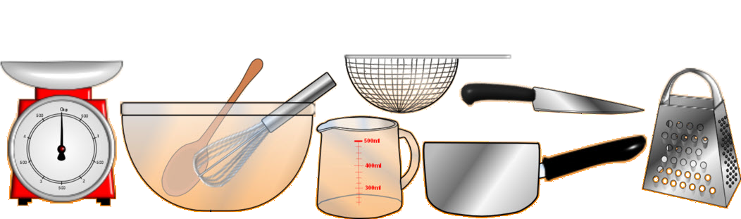A recipe for Crispy Fish Fillets

Wet fried Fish Recipe
Ingredients
- Deep fried Tilapia fish
- 1 tomato(cubed)
- 1 onion
- Cooking oil (1table spoon)
- 2 cloves garlic(crashed)
- Dhania
- Water (1/2 cup)

Procedure
  - Put cooking oil in a pre-heated cooking pan.
  - Add the onions cook for a minute (until light brown)
  - Add the garlic and cook for half a minute
  - Add the tomatoes and cook till a paste is formed (about 2 minutes)
  - Add the water and bring the mixture to boil (or use pre-boiled water).
  - Dip the fish and cover to cook for about 5 minutes (under low heat)
  - Sprinkle the dhania on top and set aside.
  - Serve with Ugali

MENU (OFFER) 50$
- Fish,
- Jerky,
- Fajitas,
- Cioppino
- Banana Split,
- Baked Beans
- Steak,
- Pasta & Vegetarian Dishes

YOU ARE WELCOME

