Instructions:
Step 1. Choose enabling documentation to analyze. Examples:
- David McMurrey’s open-education chapter on technical instructions, guides, etc.:
  - -McMurrey: Instructions
  - -McMurrey: User guides
  - -McMurrey: Standard Operating Policies and Procedures
  - -McMurrey: Handbooks
  - Examples:
    - Formidable Forms with WordPress: User Guide
    - LView Pro: User Guide
    - iBooks: User Guide
    - Video Edit Master: User Guide
    - GIMP User Guide
    - Parallels User Guide
- Other resources for tips and tricks on how to write instructional documentation:
  - https://writingcommons.org/article/instructions-a-process-reports/
  - https://pressbooks.bccampus.ca/technicalwriting/chapter/writinginstructions/
Step 2. Fill in a documentation profile table (see also “Template” section below):

Genre | In this title cell, provide the formal name followed by the genre/type of document.
Example | Manuals, guides, and how tos: You can also use instructions and directions. If the documentation is a hardcopy, take a picture of pertinent pages and upload to the documentation archive. You can use whatever you’re most comfortable with and not necessarily from the examples above.
What | Subject/topic: Describe the main subject/topic of the enabling documentation. Does the documentation enable readers exploring a conceptual subject, using a physical product, completing a process, following a procedure, training, or other?
Why | Rationale: Provide the rationale/purpose/intent/aim/exigency/need/urge/demand of the enabling documentation. Use some or all of the following questions from the textbook to help you write your response:  - What main goal/s or task/s is this enabling documentation helping users accomplish? What is the purpose for writing this documentation?  - What pressures and exigencies (needs, urges, demands) motivated the writers to create the document?  - What needs to be done and how does this document help to get that done?  - What would/does the achievement/output of the purpose look like?
Who by/from | Writer/s and publisher:  - Authors: What are the professional identity/ies of the author/s? Provide the title of role/responsibility/identity (ethos) of the writers who composed this technical documentation. (FYI: This can include co-writers/co-authors and/or other collaborators, including: project managers, editors, peer-reviewers, proofreaders, or others in the editorial process, see also the “ego-centric” model, figure 1.2).  - Publisher: Provide the name of the publisher of this documentation.
Who for/to | User profiles/personas: In many ways, enabling documentation is all about its readers, also commonly known as the documentation’s users. In this analysis, provide a short profile of users: the different levels and types of intended users (and, potentially, the documentation’s other gateway and regulatory readers). Use some or all of the questions and reference material below to help you develop a user profile:  - Who is the primary user audience of this documentation? The people who use the product or service may be mass market consumers, private clients, or members of the organization. They may have technical knowledge of the product they are using or may have no understanding of how it works.  - Readers who have no familiarity with the process or product may be likely to misread or misunderstand instructions.  - Readers with some understanding of the principles that underlie instructions may use them partially.  - What do members of the audience know or believe, and what are their goals, interests, preferences, needs, and motivations?  - Who are members/groups/roles of the gateway audience for this documentation? Who are the members/groups/roles of the regulatory audience for this documentation? As always, see Mathes and Stevenson’s “egocentric approach” for an example of the gateway, target, and regulatory audiences (below and on page 25 of the IEEE Guide).  Figure 1.2: Mathes and Stevenson’s Egocentric Approach  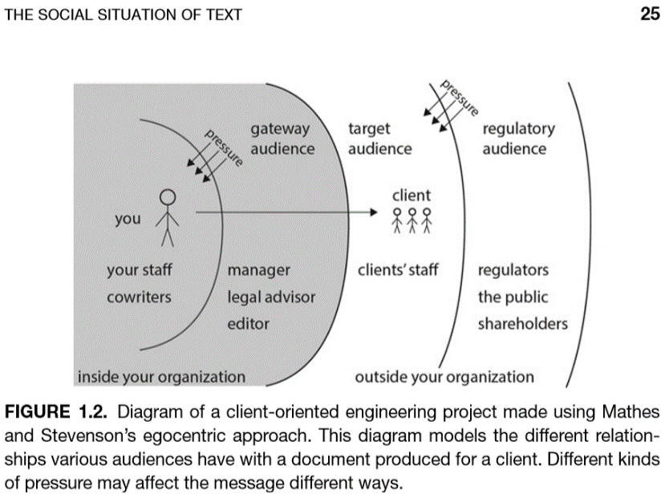
Where | User context: The IEEE Guide discusses the “use context” that contributes significantly to how users access an enabling text, which it defines as “the set of environmental and social factors that motivates the user to pick up your document and use it at the moment they do.” Describe the use context of your example enabling document. Use the following questions from the textbook to help you describe the use context:  - In what environment would someone ideally perform the operation the writers are describing? What variations in this environment affect the ability of a user to perform the operation? How is this variation mitigated by (i) informational text in the text, (ii) operational steps in the text, (iii) and/or publication medium and format of text on the page/screen?  - Does the product or process pose any risks or dangers to people or property that environmental adjustment can mitigate? Are any components flammable, noxious, or carcinogenic? Are components sharp, hot, bright, loud, or particularly heavy? Is electricity involved? Are supplementary materials required to perform the operation hazardous (like lubricating grease applied to bearings or acetone used to prepare a surface)? Under what circumstances might minor risks become more serious? How might the environment be arranged to mitigate accidents (e.g.,working in a dry or well-ventilated area, wearing protective garments, ensuring others are present during the operation)?  - What factors of the environment might damage the product or disrupt the process? Does the user need to take steps to avoid exposing the product to heat, light, moisture, or static electricity? Should the user close applications that may conflict with a software operation before beginning the procedure? Should a user only perform the operation with his or her device plugged in or unplugged?  - Should the product or process only be used in certain circumstances?  - Keep also in mind that the context can also include where the writing and publishing are occurring, as well as the conceptual field of discipline and/or industry/ies. Are you able to provide a full view of all contexts?
When | Timing: Describe the timeline of the technical writing, including a high-level understanding of any important milestones and durations in the documentation pre-publication and post-publication schedule. When was the documentation published? Are you able to provide a full view of the timing?
How | Process: Describe any processes and tools that the writing takes to complete, including different versioning standards, genre conventions, style guides, editors, reviewers, or other people involved. Include any known resources, and references. See also the 5-steps to creating documentation. Use the following questions from the textbook to help you write:  - Given this community, what generic practices exist that are used?  - What pre-existing documents match the purpose, audience, and identity?  - How are documents constructed and what form do they take?  - What authoritative resources, like style guides and templates, are available?
Rhetoric | Rhetorical analysis: Analyze the ways in which the social situation and elements above affect the text and images of the documentation. Are certain terms used to speak to the readership? Is the document content structured in a way that is specific to the readership? The IEEE states, “Enabling documents also represent the relationship that you want to establish and maintain with your audience.” How are writers establishing and maintaining a relationship with their users via this enabling documentation also represent the relationship? This section does not have to be comprehensive, but it should point to the rhetorical/social aspects of the document as applicable.
Exposure | Experience and interest: Describe your own exposure to, experience with, and/or interest in the documentation. The first-person singular is fine to use for this section.

Grading Rubric:
Whatever words and syntax you use and however you generally put together your thoughts, your reading reflection should include text divided by and devoted to the following required elements:
Requirements | Yes | No
Is the heading pattern and style followed? | 1 | -
Is “genre” covered? | 1 | -
Is an example archive link provided? | 1 | -
Is “who by/from” covered? | 1 | -
Is “who for/to” covered? | 1 | -
Is “what” covered? | 1 | -
Is “when” covered? | 1 | -
Is “where” covered? | 1 | -
Is “how” covered? | 1 | -
Is “why” covered? | 1 | -
Is “social/rhetoric” covered? | 1 | -
Is “exposure” covered? | 1 | -
Is text in the third-person perspective/point of view? | 1 | -
Formatted correctly (third-person, style, font, layout)? | 1 | -
Minimum word count (600 words)? | 1 | -
Total out of 15 | +15 | 0

** USE THE TEMPLATE IN STEP 2, PLEASE! **

