- The fundamental law of radioactive decay is dependent on the fact that the decay is a purely statistical process. The disintegration probability is a fundamental property of an atomic nucleus and remains equal in time.
Mathematical expression of this law:
Letting the original number of particles be N,
dN= $c$.dt ---(i)and $λ=\frac{(-\frac{dN}{dt})}{N}$ ----(ii) where $-\frac{dN}{dt}$ denotes the negative change of N per unit of time and $λ$ is the decay per nucleus per unit of time and is constant for every mode of each particular nuclide. Radioactivity or decay rate is thus defined as the count of disintegrations per unit of time:
mathematical expression of radioactivity:
A=-$\frac{-dN}{dt}$ =$λN$ as shown in the graph below the number of nuclides drop by half after a period of time known as half life and the decay is exponential as displayed.
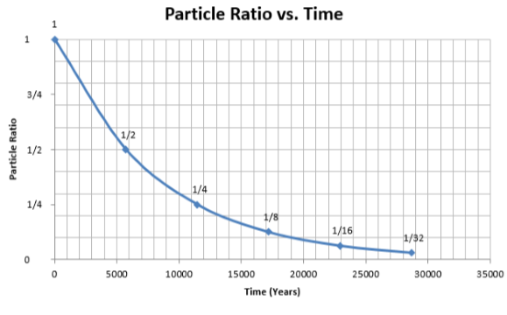
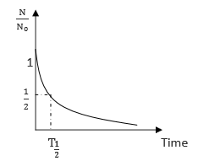
Applying boundary conditions that at in the start t = 0 and N = N_{o}
Then ln(N/N_{o}) = -$λt$ ---ii
Thus the equation of exponential decay:
N = N_{o}$e^{-λt}$ or A=A₀$e^{-λt}$ ₋₋₋₋(iv)
Time taken by A_{O} to reduce to A is T = (1/$λ$)ln(A/A_{o})---(v)
Half life formula
To get half life the ratio A/A_{O}= ½ because the particles decrease to half.
Thus half life T_{1/2}= (-1/$λ)\ln\left(\frac{1}{2}\right)=\frac{\ln\left(2\right)}{λ}=0.693/λ$ ---(vi)
- Successive radioactive transformation occurs where a nuclide is situated far away from the stability line such that the new nuclide after the first radioactive decay is still radioactive and undergoes another radioactive disintegration several times until a stable end product is formed. successive transformations be considered from 1→2→3with decay constants λ1, λ2.
Letting N_{o} be the initial number of radioactive substances available. Before the first decay there is no single atom of the second element and is created after the start of disintegration.
$\frac{dN1}{dt}=-λ1N1$----(I)
When N₂ is produced at a rate of $λ1N1$ it decays at the rate $λ2N2$
Therefore ,
$\frac{dN2}{dt}$= $λ1N1-λ2N2$----(ii)
From eqn I N₁ =N_{O}$e^{-λt}$, inserting this expression for N1 into eqn 2 we get:
$\frac{dN2}{dt}$= $λ1NOe^{-λt}-λ2N2$ or N_{O}$e^{-λt}λ1=\frac{dN2}{dt}$+$λ2N2$
Multiply all through by $e^{λ2t}$,
$\frac{dN2e^{λ2t}}{dt}$ +$λ2N2e^{λ2t}$= ($N_{0}ⅇ\left(λ_{2}-λ_{1}\right)t)λ1$
or$\frac{ⅆ\left(N_{2}ⅇλ_{2t}\right)}{ⅆt}=λ_{1}N_{0}ⅇ\left(λ_{2}-λ_{1}\right)t or ⅆ\left(N_{2}ⅇλ_{2t}\right)=λ_{1}N_{0}ⅇ\left(λ_{2}-λ_{1}\right)t dt$

integrating, $\left(N_{2}ⅇλ_{2t}\right)=$ $\frac{λ_{1}N_{0}ⅇ\left(λ_{2}-λ_{1}\right)t}{λ_{2-λ_{1}}}$ +C where C is a constant of integration
at t=0, N2=0 , $∵$ C=$\frac{λ_{1}N_{0}}{λ_{2}-λ_{1}}$
N₂ =$\frac{λ_{1}N_{0}}{λ_{2}-λ_{1}}\left(ⅇ^{-λ_{1}t_{-e}-λ_{2}t}\right)$ and this equation gives the number of atoms of 2 present after time t after the start of disintegration

