Radiologic Technology on the Knee Injury.
Name
Instructor
Course
Date

Radiological Technology on the Knee Injury
Many patients suffer from knee trauma that needs the application of radiologic technology. In my course of work, I have encountered several patients with injuries that required radiologic technology for diagnosis and prognosis. However, the trauma may not only be as a result of an accident but also an infection in the body. Therefore, to identify the bacteria or virus that might have caused the disease, it is necessary for a radiographer to be involved and carry out the technological diagnosis. Also, the technology is required is essential after the determination to carry out appropriate care for the patient. The knee forms the largest parts of the joints in the human body, and it is regarded as more delicate than other joints. It is easily injured, and the injury in most cases requires the radiographer to determine the cause. There are several injuries associated with the knees leading to severe pains on the patient. In this paper, I will discuss the radiologic technology process that I carried out on a patient that had a knee trauma.
I work at Lincoln Medical Hospital where we handle patients of different kinds. However, in my department, I am a radiologist dealing the imaging process for the patient and provide therapy that could heal the joint that is injured. In my course of work, I received a patient from DX College since he was a student in that institution. He was brought as an emergency case that needed special attention since he was in great pain. After consulting with the person who brought him, we were told that he was playing football, where he was hit and fell down. He could not stand straight, and because of the pain, he was unable to walk. I also asked about his past condition about the knee or the hip, and I was told that he has never complained of any pain in his body parts. Therefore, I had to start the care by giving him painkillers and start the process of radiography. The patient was admitted to the hospital to ensure that the process of imaging was done within the hospital premise. The therapy that could see his recovery was to be done out of the hospital. Therefore, the patient was more of an outpatient.
The patient, after having the painkillers complained of the knee injury that he developed after the game. It is evident that whenever there is a football game was played near the hospital, many patients came to the hospital with injuries that could lead them to a radiographer. At the hospital, these patients are generally grouped as outpatient and inpatients. This patient that I received had severe pain where the X-ray technology was needed to determine the primary cause. I used a high kVp and low mAs dose by radiologic technology to diagnose the patient so that I could identify if it was a fracture or a dislocation of the joint. The radiographic machine was set at 75kVp and 6mAs since it would help to get the clear image of the knee injury. After the diagnosis, I realized that the patient had a dislocation on the joint that could even lead to damage on the kneecap or risk him of arthritis thus, the patient needed more attention to restoring it back. This led the patient to be subjected to weekly therapy, and he had to go through another X-ray process after three months. The patient was in great pain that made it difficult to position him for the imaging.
The image below shows the kind of knee dislocation that the patient suffered. Extracted from: http://www.svuhradiology.ie/case-study/knee-dislocation/
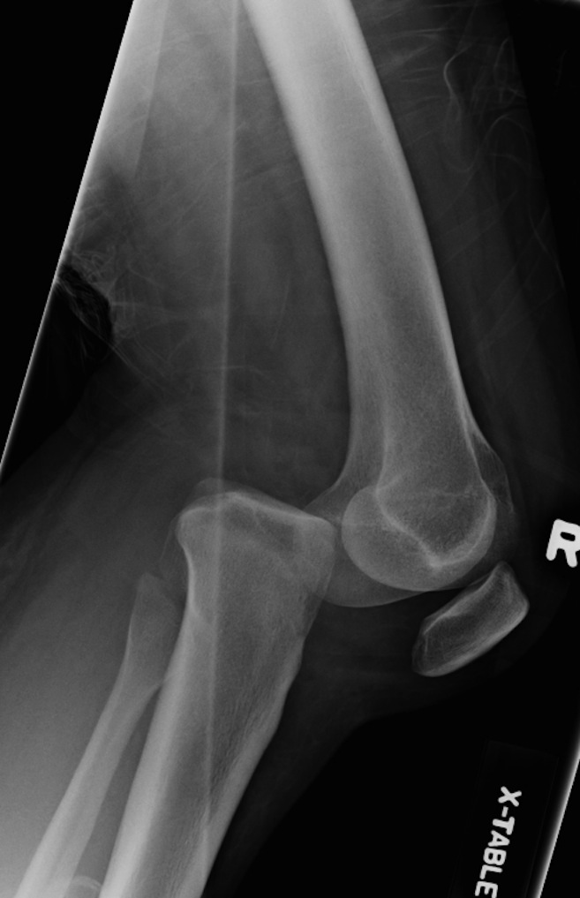
Since the patient could not settle well for the imaging, he was injected with a drug to cool him down. Although the injection could not affect the imaging process, thus I had a clear result. The patient was required to position his leg such that the pelvis was not rotated during imaging. Therefore, the joint had to be slightly flexed so that the apex of the patella could be easily located. This implies that he slept on the radiographic table with his knees facing upward so that the slight flex could be achieved on the joint. Therefore, I adjusted his leg by placing the femoral epicondyles parallel with IR. I directed the central ray to the point of 1.3cm inferior to the patella apex. However, the central ray also had to parallel with the tibia plateau since the fibula and tibia are a little bit inclined. This was achieved through a CR of 1.3cm. The same process was repeated when the patient’s knee faced downward such that the toes rested on the radiographic table. Although the image got out of the X-ray was the same for both the positioning. This positioning was necessary to get a clear image of the open joint and soft tissues around the knee joint. Also, it was essential to get the details of the patella. Before administering the patient with the medicine that made him go numb, the positioning was impossible, and I could not get a clear image.
From the results, I was able to understand that the patient fell in the field during the game causing his kneecap to slide off from the groove hence, leading to complete dislocation. The patient could not walk nor stand straight since the knee could not support his weight anymore by the time he got into the hospital. Therefore, after the diagnosis, I had prescribed the therapy until he heals. The first action to apply treatment was to take the kneecap back to its usual point (groove). This process is referred to as reduction, and during this process, I was forced to apply some gentle force on the kneecap to push it back to the groove. Since the patient had been injected with a drug that cooled him, it was easy to carry out the reduction process as he could not feel the pain.
The patient had no damages on the underside of the kneecap thus I could not recommend surgery. Besides surgery could only be recommended if he stood a chance of being infected by arthritis. However, I recommended him with other activities that could fasten the healing process and strengthen the joint. The first activity was exercise and braces. The practice was necessary for him since it could enhance the muscles on the thighs. The strong muscles on the thigh cause the alignment of the kneecap. The braces also were to make sure that the kneecap stayed aligned in the groove and prevented any further dislocation during exercise. This implied that the braces could not affect the exercising process of the patient. However, I suggested that the patient would not involve himself in a thorough exercise that would have increased the pain instead of fastening the healing. Thus the exercise had to be done gently and with the braces around the injured knee.
I also recommended cycling as part of the physical therapy that could see him go back to his normal life. Cycling enables the muscles to contract and relax. Therefore, it would help the patient, especially on his thigh muscle to contract and relax and also to function better than he could just be seated. Alongside that, I suggested that the patient could be going for a walk, but he had to put on the braces that ensure that the kneecap stayed aligned to the position despite the activities. However, such activities could be commenced when the patient felt little pain and experienced not any swelling since these could prolong the healing process. Hips strengthening activities was also recommended. The weak hips play a significant role in the dislocation of the knee, and thus, the activities meant to strengthen the hip bone could help the patient heal faster and prevent further dislocation. However, such activities could be started two weeks after the diagnosis and reduction.
Lastly, I advised the taping technology on the knee. The tape helps control and keep the kneecap into the position as the knee comes back to its normal functioning. In addition to all the physical therapy, the patient was advised to come back for the last imaging after three months. This was meant to determine if the knee was fully recovered and if the patient could go back to his normal activities without the risk of further injury. However, the patient was administered with drugs to kill the pain and prevent swelling of the knee. This was found necessary so that he could go on with the other activities during his therapy.

References

CE4RT, 2016. Radiographic positioning of the leg and the knee. Retrieved from: https://ce4rt.com/positioning/radiographic-positioning-of-the-leg-and-knee

St. Vincent’s university hospital, 2018. Radiology. Posterior knee dislocation. Retrieved from: http://www.svuhradiology.ie/case-study/knee-dislocation/

