Problem Set #2
(Due: Wednesday 6/13/18 at the start of class)
Directions: Answer all of the following questions showing all of your work
APR, EAR and Continuously Compounded Interest Rates
- Here is the five-year stock chart for Amazon (AMZN).
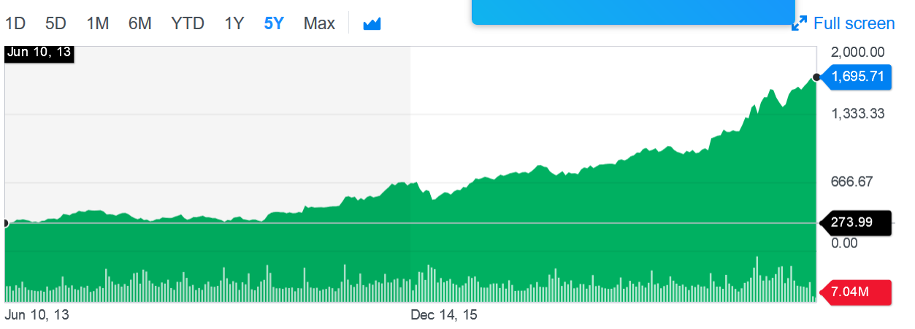
  - What is the five-year holding period return for Amazon?
The holding period return is the total return received from holding a portfolio of assets. The five year holding period return for Amazon is:
Total return = (1695.71 – 273.99) / 273.99
= 5.188 or 518%
Since we are considering 5 years we will use 0.2 as the rate
Annualized return = (1+5.18)^{0.2} – 1
= 0.439

  - What is the compound annual growth rate for Amazon over the last five years?
= (1695.71 / 273.99)^{1/5}
Compound Annual growth rate =4.27
- Suppose a credit card charges an annual percentage rate (APR) equal to 15.24% per year.
  - What is the periodic monthly rate charged?
The annual percentage rate = 15.24%
Periodic monthly rate = 15.24% / 12
=1.27%
  - What is the corresponding effective annual rate (EAR)?
= (1+1/n) ^{n} – 1
= (1 + 15.24% / 12)^{15.24%} - 1
=0.00193
=19.2%
  - What is the continuously compounded interest corresponding to the EAR calculated in part b?
19.2%/12
1.6%
Fisher Equation
- If inflation is expected to be 2.5% and a lender demands a real return of 6%, what (minimum) nominal interest rate would she charge?
Real interest rate = nominal interest rate – inflation rate
Nominal interest rate = 2.5% + 6%
= 8.5%
- If the interest rate is 4%, what is the value of a company that will earn profits in each of the next four years given by the following Excel table?
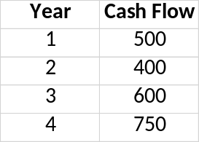
Year | Cash Flow | Cumulative Cash Flow | Profit
1 | 500 | 500 | 20
2 | 400 | 900 | 36
3 | 600 | 1500 | 60
4 | 750 | 2250 | 90

