Prion Disease: Death By Misfolding
Consider the following case:
“When university president, George Caspase, hung up the phone, he had a very worried look on his face. Another alumnus had passed away. It was the second time that the Centers for Disease Control and Prevention (CDC) had called in the past week. Henry Proton, age 26, Emily Reticulum, age 25, and Frank Spongiform, age 26, had all died in the past year. The loss of these young people was tragic enough, but it was the way they died that had the President’s mind reeling and the CDC concerned. Henry was a sportscaster, husband, and father of an infant son. He was outgoing, smart, and seemed to have a bright future. That spring he began to feel depressed. His wife talked him into seeing a psychologist. He was put on an antidepressant and, for a while, it seemed to help. However, in a couple of weeks the depression was back and he began hallucinating. Later that fall, Henry’s movements became more rigid, and it became clear that the problem was more than psychological and that they had better see a neurologist. After months of testing and progressive deterioration of his physical movements, his doctors still did not have a diagnosis. Henry passed away one week before his son’s first birthday. An autopsy was ordered; it was discovered that Henry’s brain was filled with holes and a call was made to the CDC. The stories were similar for Emily and Frank, and it did not take long for Dr. Annie Isomerase, an infectious disease specialist at the CDC, to determine that these cases were due to a transmissible prion disease. It also did not take long to determine that these cases had another connection: All of the affected individuals attended the same university at the same time.Upon further investigation, the CDC determined that the graduates were likely afflicted with variant Creutzfeldt-Jacob disease (vCJD). While in college together, all three former students had studied abroad in Scotland, along with 30 other students and two professors. From personal accounts, the students had a wild time studying glaciation patterns during the day and drinking scotch ale and eating haggis and brawn, meat from a calf's head that is cooked and pressed in a pot, each night. During that same year, Scotland had an outbreak of mad cow disease. Thousands of cows and 49 human deaths were recorded.”

What is going on here? How are vCJD and mad cow disease related?

A misfolded brain protein seems to be the causative agent of these rare degenerative brain diseases in mammals. Perhaps the best known of these is bovine spongiform encephalopathy (BSE; also known as mad cow disease). Related diseases include kuru and Creutzfeldt-Jakob disease in humans, scrapie in sheep, and chronic wasting disease in deer and elk.These diseases are also referred to as spongiform encephalopathies, because the diseased brain frequently becomes riddled with holes (Fig. 1). Progressive deterioration of the brain leads to a spectrum of neurological symptoms, including weight loss, erratic behavior, problems with posture, balance, and coordination, and loss of cognitive function. The diseases are fatal.
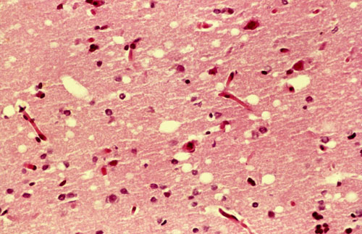
FIGURE 1: Stained section of cerebral cortex from autopsy of a patient with Creutzfeldt-Jakob disease shows spongiform degeneration, the most characteristic neurohistological feature. The yellowish vacuoles are intracellular and occur mostly in pre-and postsynaptic processes of neurons. The vacuoles in this section vary in diameter from 20 to 100 μm.
In the 1960s, investigators found that preparations of the disease-causing agents seemed to lack nucleic acids. At this time, Tikvah Alper suggested that the agent was a protein. Initially, the idea seemed heretical. All disease-causing agents known up to that time—viruses, bacteria, fungi, and so on—contained nucleic acids, and their virulence was related to genetic reproduction and propagation. However, four decades of investigations, pursued most notably by Stanley Prusiner, have provided evidence that spongiform encephalopathies are different.
The infectious agent has been traced to a single protein,which Prusiner dubbed prion protein (PrP). The name was derived from proteinaceous infectious, but Prusiner thought that “prion” sounded better than “proin.” Prion protein is a normal constituent of brain tissue in all mammals. Its role is not known in detail, but it may have a signaling function. Strains of mice lacking the gene for PrP (and thus the protein itself) suffer no obvious ill effects. Illness occurs only when the normal cellular PrP, or PrP^{C}, occurs in an altered conformation called PrP^{Sc} (Sc denotes scrapie). The structure of PrP^{C} features two α helices. The structure of PrP^{Sc} is very different, with much of the structure converted to amyloid-like β sheets (Fig. 2). The interaction of PrP^{Sc} with PrP^{C} converts the latter to PrP^{Sc}, initiating a domino effect in which more and more of the brain protein converts to the disease-causing form. The mechanism by which the presence of PrP^{Sc} leads to spongiform encephalopathy is not understood. A complete understanding of prion diseases awaits new information on how prion protein affects brain function. Structural information about PrP is beginning to provide insights into the molecular process that allows the prion proteins to interact so as to alter their conformation.
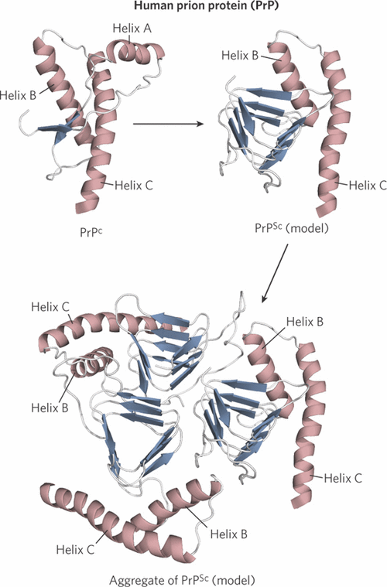
FIGURE 2: Structure of the globular domain of human PrP and models of the misfolded, disease-causing conformation PrP^{Sc}, and an aggregate of PrP^{Sc}. Theα helices are labeled to help illustrate the conformation change. Helix A is incorporated into the β-sheet structure of the misfolded conformation.

Answer the following questions in the space provided. DO NOT EXCEED SPACE LIMITATIONS.
1. Concerning the case study: do you think one person got Creutzfeldt-Jakob disease and then passed it to the other people? Or do you think they each contracted the disease separately? Explain your choice.

_____________________________________________________________________________________

_____________________________________________________________________________________

_____________________________________________________________________________________

_____________________________________________________________________________________

_____________________________________________________________________________________
2. How are Mad Cow Disease and Creutzfeldt-Jakob disease related?

_____________________________________________________________________________________

_____________________________________________________________________________________

_____________________________________________________________________________________

_____________________________________________________________________________________
3. What is an amyloid-like b sheet? How does this cause tissue damage in the brain?

_____________________________________________________________________________________

_____________________________________________________________________________________

_____________________________________________________________________________________

_____________________________________________________________________________________
4. Describe the structural difference between PrPsc and PrPc.

_____________________________________________________________________________________

_____________________________________________________________________________________

_____________________________________________________________________________________

