

Table of Contents
Introduction……………………………………………………………………………….……….
Current Vision Statement………………………………………………………………….………
Proposed Vision Statement………………………………………………………………….…….
Current Mission Statement………………………………………………………………………..
Proposed Mission Statement………………………………………………………………………
Competitive Profile Matrix (CPM)…………………………………………………………….….
Financial Statements…………………………………………………………………..…………..
Ratio Analysis…………………………………………………………………………….……….
Internal Factor Evaluation (IFE) Matrix…………………………………………………….…….
External Factor Evaluation (EFE) Matrix………………………………………………….…….
Proposed Strategies Developed from SWOT Matrix………………………………………….…
Strategic Position and Action Evaluation (SPACE) Matrix……………………………………..
Boston Consulting Group (BCG) Matrix………………………...………………………………
Internal-External (IE) Matrix…………………………………………………………...………..
Quantitative Strategic Planning Matrix (QSPM)…………………………………………...…,,,,
Recommendations………………………………………………………………………………..
Explanation for Recommendations………………………………………………………..……..
Organizational Chart……………………………………………………………………..………
Perceptual Map…………………………………………………………………………………..
Firm Valuation…………………………………………………………………………………..
EPS-EBIT Analysis……………………………………………………………………………..
Projected Financial Statements…………………………………………………………………
Projected Financial Ratios………………………………………………………………………
Retained Earnings Table………………………………………………………………………..
Executive Summary……………………………………………………………………………….
Introduction
Johnson & Johnson (J&J) is a healthcare company that manufactures and distributes consumer health products, medical devices, and pharmaceutical products. The overall focus of the company is to keep people healthy at every age and stage of life while being accessible and affordable for all communities within reach (Johnson & Johnson, n.d.). Some well-known business products include Band-Aid, Tylenol, Johnson’s Baby line, Acuvue contact lenses, and their Covid-19 vaccine and more.

Current Vision Statement

“for every person to use their unique experiences and backgrounds, together --- to spark solutions that create a better, healthier world”
Source: Johnson & Johnson. (n.d.) About Johnson & Johnson. https://www.jnj.com/about-jnj

Proposed Vision Statement

To ensure healthy living for all people through the provision of high-quality and affordable health and pharmaceutical products.

Current Mission Statement

We believe our first responsibility is to the patients, doctors and nurses, to mothers and fathers and all others who use our products and services. In meeting their needs everything we do must be of high quality. We must constantly strive to provide value, reduce our costs and maintain reasonable prices. Customers' orders must be serviced promptly and accurately. Our business partners must have an opportunity to make a fair profit.
We are responsible to our employees who work with us throughout the world. We must provide an inclusive work environment where each person must be considered as an individual. We must respect their diversity and dignity and recognize their merit. They must have a sense of security, fulfillment and purpose in their jobs. Compensation must be fair and adequate and working conditions clean, orderly and safe. We must support the health and well-being of our employees and help them fulfill their family and other personal responsibilities. Employees must feel free to make suggestions and complaints. There must be equal opportunity for employment, development and advancement for those qualified. We must provide highly capable leaders and their actions must be just and ethical.
We are responsible to the communities in which we live and work and to the world community as well. We must help people be healthier by supporting better access and care in more places around the world. We must be good citizens — support good works and charities, better health and education, and bear our fair share of taxes. We must maintain in good order the property we are privileged to use, protecting the environment and natural resources.
Our final responsibility is to our stockholders. Business must make a sound profit. We must experiment with new ideas. Research must be carried on, innovative programs developed, investments made for the future and mistakes paid for. New equipment must be purchased, new facilities provided and new products launched. Reserves must be created to provide for adverse times. When we operate according to these principles, the stockholders should realize a fair return.
Source: Johnson & Johnson. (2021). Our credo. https://www.jnj.com/credo/

Proposed Mission Statement
Our mission is to provide doctors and nurses the equipment and products necessary in order to serve the community and improve their health. Provide high-quality and affordable pharmaceutical products and improve the health of our members and the communities we serve. We use new equipment; modern technology, and customers trust our products. We care for our employees and other stakeholders, and we are committed to ensuring the satisfaction of our clients.

Competitive Profile Matrix (CPM)

The matrix below compares Johnson & Johnson with two major competitors – Pfizer and Merck.

 |  | Johnson & Johnson |  | Pfizer |  | Merck
Critical Success Factors | Weight | Rating | Score | Rating | Score | Rating | Score
Product Variety | 0.12 | 4 | 0.48 | 1 | 0.12 | 3 | 0.36
Global Expansion | 0.11 | 2 | 0.22 | 4 | 0.44 | 3 | 0.33
Domestic Market Penetration | 0.07 | 1 | 0.07 | 4 | 0.15 | 3 | 0.21
Customer Service | 0.05 | 1 | 0.05 | 4 | 0.15 | 3 | 0.15
Brand | 0.09 | 4 | 0.36 | 3 | 0.27 | 3 | 0.27
Research and development | 0.11 | 3 | 0.33 | 2 | 0.22 | 4 | 0.44
Business Ethics | 0.07 | 2 | 0.14 | 3 | 0.21 | 4 | 0.28
Financial Profit | 0.09 | 2 | 0.18 | 4 | 0.36 | 3 | 0.27
Social Responsibility | 0.09 | 4 | 0.36 | 2 | 0.18 | 3 | 0.27
Market Share | 0.08 | 4 | 0.33 | 2 | 0.17 | 3 | 0.25
Product Quality | 0.08 | 3 | 0.25 | 3 | 0.25 | 3 | 0.25
Management | 0.08 | 4 | 0.33 | 3 | 0.25 | 2 | 0.17
Price Competitiveness | 0.07 | 2 | 0.21 | 3 | 0.21 | 4 | 0.28
Totals | 1.00 |  | 2.84 |  | 2.86 |  | 3.17

Johnson & Johnson’s weighted score is 2.84 revealing it is the weakest competitor. Pfizer’s weighted score of 2.86 shows it is marginally a stronger competitor than Johnson & Johnson. Merck has a weighted score of 3.17 demonstrating it is the strongest of the three competitors.

Financial Statements

Below are the Income Statement and Balance Sheet for Johnson and Johnson fiscal years 2019 and 2020.
Income Statement |  | 12/31/2019 | 12/31/2020 |  | Percent Change
Revenues |  | $15,119,000 | $14,714,000 | -1 | -3%
Cost of Goods Sold |  | 27,556,000 | 28,427,000 | 1 | 3%
Gross Profit |  | (12,437,000) | (13,713,000) | 1 | 10%
Operating Expenses |  | 22,178,000 | 22,084,000 | -1 | 0%
EBIT |  | (34,615,000) | (35,797,000) | 1 | 3%
Interest Expense |  | 2,525,000 | 2,899,000 | 1 | 15%
EBT |  | (37,140,000) | (38,696,000) | 1 | 4%
Tax |  | 18,163,000 | 17,442,000 | -1 | -4%
Non-Recurring Events |  | 0 | 0 | NA | NA
Net Income |  | (55,303,000) | (56,138,000) | 1 | 2%

Balance Sheet | 12/31/2019 | 12/31/2020 |  | Percent Change
Assets
Cash and Short Term Investments | $17,305,000 | $13,985,000 | -1 | -19%
Accounts Receivable | 14,481,000 | 13,576,000 | -1 | -6%
Inventory | 9,020,000 | 9,344,000 | 1 | 4%
Other Current Assets | 4,468,000 | 14,332,000 | 1 | 221%
Total Current Assets | 45,274,000 | 51,237,000 | 1 | 13%
Property Plant & Equipment | 17,658,000 | 18,766,000 | 1 | 6%
Goodwill | 33,639,000 | 36,393,000 | 1 | 8%
Intangibles | 47,643,000 | 53,402,000 | 1 | 12%
Other Long-Term Assets | 58,788,000 | 66,333,000 | 1 | 13%
Total Assets | 203,002,000 | 226,131,000 | 1 | 11%
Liabilities
Accounts Payable | 8,544,000 | 9,505,000 | 1 | 11%
Other Current Liabilities | 27,420,000 | 32,988,000 | 1 | 20%
Total Current Liabilities | 35,964,000 | 42,493,000 | 1 | 18%
Long-Term Debt | 26,494,000 | 32,635,000 | 1 | 23%
Other Long-Term Liabilities | 71,763,000 | 78,981,000 | 1 | 10%
Total Liabilities | 134,221,000 | 154,109,000 | 1 | 15%
Equity
Common Stock | 3,120,000 | 3,120,000 | 0 | 0%
Retained Earnings | 97,888,000 | 101,768,000 | 1 | 4%
Treasury Stock | 38,417,000 | 38,490,000 | 1 | 0%
Paid in Capital & Other | 0 | 0 | NA | NA
Total Equity | 139,425,000 | 143,378,000 | 1 | 3%
Total Liabilities and Equity | 273,646,000 | 297,487,000 | 1 | 9%

Ratio Analysis

 | Historical Ratios
 | 12/31/2019 |  | 12/31/2020
Current Ratio | 1.26 |  | 1.21
Quick Ratio | 1.01 |  | 0.99
Total Debt-to-Total-Assets Ratio | 0.66 |  | 0.68
Total Debt-to-Equity Ratio | 0.96 |  | 1.07
Times-Interest-Earned Ratio | -14 |  | -12
Inventory Turnover | 3.05 |  | 3.04
Fixed Assets Turnover | 0.86 |  | 0.78
Total Assets Turnover | 0.07 |  | 0.07
Accounts Receivable Turnover | 1 |  | 1
Average Collection Period | 349.60 |  | 336.77
Gross Profit Margin % | -82% |  | -93%
Operating Profit Margin % | -229% |  | -243%
ROA % | -27% |  | -25%
ROE % | -40% |  | -39%
Below are the financial ratios for Johnson & Johnson for 2019 and 2020.

The healthcare, consumer goods, and medical device industries are influenced by a variety of factors including state of the economy, natural disasters, or pandemics. Generally, these industries have consistent demand. Johnson & Johnson’s average collection period of close to a year is significant. With a long average collection period, Johnson & Johnson will need to increase debt to continue producing products while awaiting payment from customers.

Internal Factor Evaluation Matrix (IFE)
The Internal Factor Evaluation Matrix for Johnson & Johnson is below and details the organization’s greatest strengths and weaknesses.
 | Strengths | Weight | Rating | Weighted Score
1 | J&J revenue increase from 82.06 million in 2019 to 82.58 million in 2020. | 0.14 | 3 | 0.42
2 | Employee morale is exceptional. | 0.10 | 3 | 0.30
3 | During the first 9 months of 2020, J&J pharma outfit generated $33.3 billion in global sales, a 5.2% increase from the same period last year. | 0.07 | 4 | 0.28
4 | J&J beat the market on pharma growth in the 3rd quarter of 2020, seven branded pharmaceuticals brought in $3.8 billion in sales. | 0.07 | 3 | 0.21
5 | J&J over-the-counter drugs are expected to perform well as consumers look to self-manage conditions like fever and pain. | 0.06 | 4 | 0.24
6 | Leadership position in diverse healthcare segments owning more than 250 companies in over 60 countries | 0.05 | 3 | 0.15
7 | J&J is the largest and most broadly based healthcare company in the world. | 0.03 | 3 | 0.09
8 | Focus on R&D allowing innovative product launches | 0.03 | 2 | 0.06
9 | During 2020 more the 50% of J&J employees located in China are back to work | 0.02 | 3 | 0.06
10 | Out of the top 15 highest-paid biopharma CEO, J&J CEO Alex Gorsky was ranked 3rd in place. | 0.02 | 2 | 0.04

 | Weaknesses | Weight | Rating | Weighted Score
1 | Total expenses increased 828K within the past twelve months | 0.10 | 4 | 0.40
2 | Rivals in the market effects revenue and production | 0.08 | 3 | 0.24
3 | Paused distribution of COVID 19 vaccine due to rare/severe symptons reported | 0.07 | 4 | 0.28
4 | Due to COVID-19 there was reduction in doctor’s visit, which meant fewer diagnoses and new patient starts on medicines. | 0.03 | 3 | 0.09
5 | Six branded meds posted sales declines due to generic and biosimilar competition. | 0.03 | 4 | 0.12
6 | Product recall and lawsuits could affect the company's brand image | 0.03 | 3 | 0.09
7 | The Supreme Court has rejected J&J's appeal of a $2.11B Missouri verdict that found the company's talc-based products caused ovarian cancer. | 0.02 | 2 | 0.04
8 | Debt-to-total asset ratio increased from 0.66 in 2019 to 0.68 in 2020. | 0.02 | 1 | 0.02
9 | Inventory turnover decrease from 3.05 in 2019 to 3.04 in 2020. | 0.02 | 1 | 0.02
10 | Pricing pressure factor-If unemployment remain high, fewer patients will be on commercial insurance which pays a higher price for drugs. However, J&J pharma growth is all based on volume, not price. | 0.01 | 4 | 0.04
 | Total IFE Score | 1.00 |  | 3.19

External Factor Evaluation Matrix (EFE)
Below is the EFE Matrix for Johnson & Johnson and the pharmaceutical, medical device, and consumer goods industries. The matrix reveals major opportunities followed by threats.
 | Opportunities | Weight | Rating | Weighted Score
1 | Pharmaceutical companies invested nearly $7 trillion in research and development in new medications and vaccines for new and better treatments and cures. | 0.12 | 4 | 0.48
2 | It is anticipated that growth in the Internet of Medical Things (IoMT) market will continue by 30.8% annually, reaching $159.1 billion by 2022. | 0.08 | 4 | 0.32
3 | Revenue for Supply and Manufacturing forecasted to rise to $97.2 billion over the next five years | 0.06 | 3 | 0.18
4 | By 2025, the use of extended reality devices is expected to reach $51 billion. | 0.06 | 3 | 0.18
5 | The use of artificial intelligence and machine learning will increase in 2021 and is expected to become an $8 billion industry in 2022. | 0.04 | 3 | 0.12
6 | Until 2024, it's anticipated that growth in the medical device industry will average 5.6 percent. | 0.04 | 3 | 0.12
7 | Gain back trust when it comes to the government, social media, safety and people everday live. The pharma industry plans to be more informative, transparent and more personalized. | 0.03 | 4 | 0.12
8 | 56.9 million Americans will be of age 65 and required more healthcare thus increasing demand | 0.01 | 3 | 0.03
9 | Skin care market set to recover from pandemic in 2021 growing at 7.4% | 0.01 | 2 | 0.02
10 | Overall sunscreen manufacturing expected to grow 2.7% until 2026 | 0.01 | 1 | 0.01
 | Threats | Weight | Rating | Weighted Score
1 | Increased access to health insurance allows government, employers, and health plans to save trillions by using generics. | 0.08 | 4 | 0.32
2 | In 2022, the pharmaceutical industry is expected to have almost $50 billion in prescription drug sales worldwide at risk due to patent expiration. | 0.07 | 4 | 0.28
3 | Opioid manufacturers are under fire for feeding the epidemic sweeping the nation. Hundreds of lawsuits filed, accuse drug makers of misleading the public about the addictive properties of opioid painkillers. | 0.07 | 4 | 0.28
4 | Multinational pharma companies must ensure they meet U.S. quality standards while adhering to all local regulations abroad, and responsible for blocking for illegal trafficking of counterfeit medications | 0.06 | 3 | 0.18
5 | Cyber security concerns. Potential security breach can be leeway for hackers to access medical devices and tamper with them, which can negatively affect product quality and recall rates. | 0.06 | 3 | 0.18
6 | Medical devices must undergo pre and post market test before receiving authorization and certifications. Due to the pandemic the healthcare industry was overwhelmed, this making the effective delivery of medical services to patients a challenge. | 0.06 | 2 | 0.12
7 | High cost to develop a medical device from a just an idea to a realization. | 0.05 | 2 | 0.10
8 | Consumer confidence index change from -27.2% to 15.2 about business profiles | 0.04 | 1 | 0.04
9 | Instrument and Supply manufacturing forecasted to decline 1% yearly. | 0.03 | 2 | 0.06
10 | Consumer beauty industry fell 4.5% in 2020 as an adverse effect from the pandemic | 0.02 | 2 | 0.04
 | Total EFE Score | 1.00 |  | 3.18

Proposed Strategies Developed from SWOT Matrix
The following strategies can be implemented by Johnson & Johnson to growth the company and remain a strong competitor.
Strength-Opportunity (SO) Strategies
SO Strategies
1 | Focusing R&D with AI and machine learning will aide in innovative product launches as industry is forecasted to grow to $8 Billion in 2022 (S8, O5)
2 | As IoMT climbs, J & J can use its leadership position to further expand current companies (S7, O6)
3 | More transparency from government, Internet, and organization consumer will look to self-diagnose with OTC drugs and products (S5, O7)
4 | Almost 60 million Americans relies on healthcare and increases demand increasing revenues to $82.58 million in 2020 (S1, O8)

Strength-Threat (ST) Strategies
ST Strategies
1 | Supply manufacturing forecasted to decline 1% yearly with J & J manufacturing plants in China producing products at 50% employee rate (S9, T9)
2 | As largest an international healthcare company, U.S standards must be met while adhering to local regulations and blockage of counterfeit medications (S7, T4)
3 | J & J pharma profited $3.8 billion in Q3 of 2020 and the overall industry is expected to have $50 billion worth of prescription drug patents expiring (S4, T2)
4 | Consumer confidence index increased as business profiles are becoming more transparent through employee morale (S2, T10)

Weakness-Opportunity (WO) Strategies
WO Strategies
1 | Lowering the Debt ratio by increasing production of the supply and manufacturing department as the forecasted revenue is to rise to $97.2 billion over the next five years (W8, O3)
2 | increase inventory turnover by researching product development to grow the skin care line of products as the industry is growing by 7.4% in 2021. (W9, O9)
3 | Create job opportunities with benefits to employees to by building a department to market sunscreens as the industry is expected to advance by 2.7% by 2026. (W10, O10)
4 | Increase online presence in the Telehealth industry as the virtual doctor visits have increased. By sponsoring telehealth companies, doctors will be more inclined to recommend J&J products (W4, O6)

Weakness-Threat (WT) Strategies
WT Strategies
1 | Invest in R&D to increase the growth in equipment and assets to generate more revenue with competitor’s in the market place (W6, T6)
2 | Develop more vaccine research and improvement to gain the trust of the community and to resume distribution of the new and trusted brands of vaccines (W3, T7)
3 | Develop a competitive edge in medical products and sales as the industry is growing by 5.6% in the upcoming years. This will eliminate competition in the market (W2, T7)
4 | Create a new product in that does not require strict government regulations to generate generic products. This will help the organization regain consumer confidence back (W9, T10)

Strategic Position and Action Evaluation (SPACE) Matrix
Below is the Strategic Position and Action (SPACE) Matrix for Johnson & Johnson and its two closest competitors.
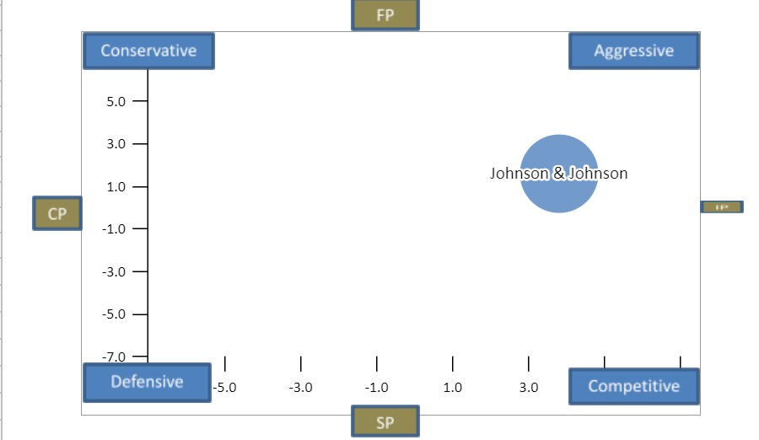
 | Johnson & Johnson | Pfizer | Procter & Gamble
X Axis | 3.8 | 4.0 | 1.0
Y Axis | 1.6 | 6.0 | 4.0

Internal Analysis: |  |  |  |  | External Analysis:
Financial Position (FP) |  |  |  |  | Stability Position (SP)
Current Ratio |  |  |  | 7 | Rate of Inflation |  |  |  | -3
Debt to Equity |  |  |  | 3 | Technological Changes |  |  |  | -1
Net Income |  |  |  | 5 | Price Elasticity of Demand |  |  |  | -3
Revenue |  |  |  | 7 | Competitive Pressure |  |  |  | -4
Inventory Turnover |  |  |  | 4 | Barriers to Entry into Market |  |  |  | -7
Financial Position (FP) Average |  |  |  | 5.2 | Stability Position (SP) Average |  |  |  | -3.6

Internal Analysis: |  |  |  |  | External Analysis:
Competitive Position (CP) |  |  |  |  | Industry Position (IP)
Market Share |  |  |  | -1 | Growth Potential |  |  |  | 7
Product Quality |  |  |  | -1 | Financial Stability |  |  |  | 6
Customer Loyalty |  |  |  | -2 | Ease of Entry into Market |  |  |  | 4
Variety of Products Offered |  |  |  | -1 | Resource Utilization |  |  |  | 5
Control over Suppliers and Distributors |  |  |  | -3 | Profit Potential |  |  |  | 5
Competitive Position (CP) Average |  |  |  | -1.6 | Industry Position (IP) Average |  |  |  | 5.4

The analysis identifies market penetration and research as the key problems facing the company. About the market penetration issue, the company should dig deeper into the markets dynamics and relevant factors that contribute to the company's product attaining a good competitive advantage in the market. This can be achieved through seeking cheap resources of similar quality with the current resources to sustain the cost of production and enable revision of market prices.
The research and development need to advance to ensure the sustainability of the company and at the same time ensure customer satisfaction. This will require research into other means of production that will be needless to provide quality pharmaceutical products. Here the company will be able to retain its customers and at the same time compete healthily with its competitors such as Pfizer and Merck.

Boston Consulting Group (BCG) Matrix
The following is the Boston Consulting Group (BCG) Matrix for Johnson & Johnson by division.
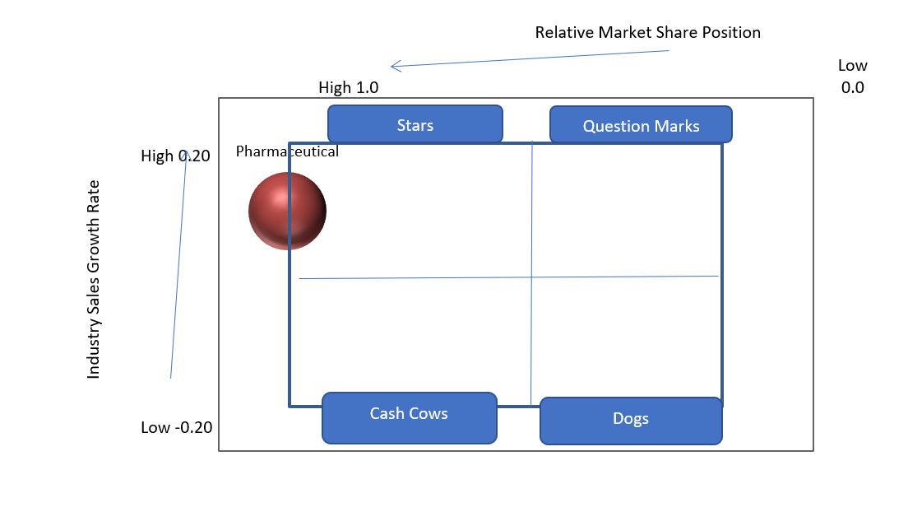
Division | Your Firm's Division Revenues | Top Firm in Industry Division Revenues | Industry Sales Growth Rate | Relative Market Share Position
Consurmer | $3,543 | $467 | 0.09 | 7.59
Pharmaceutical | $12,199 | $11,367 | 0.14 | 1.07
Medical Devices | $6,579 | $680 | 0.15 | 9.68

Johnson and Johnson’s (J & J) BCG matrix reveal that all divisions perform similarly and are stars (David & David, et al., 2020). J & J should use this information to develop strategies to maintain all divisions star performance. Resources will be allocated to optimize performance of all three divisions of consumer products, pharmaceuticals, and medical devices. Even though, the three divisions perform equivocally does not mean that resources will be allocating evenly.

Internal-External (IE) Matrix
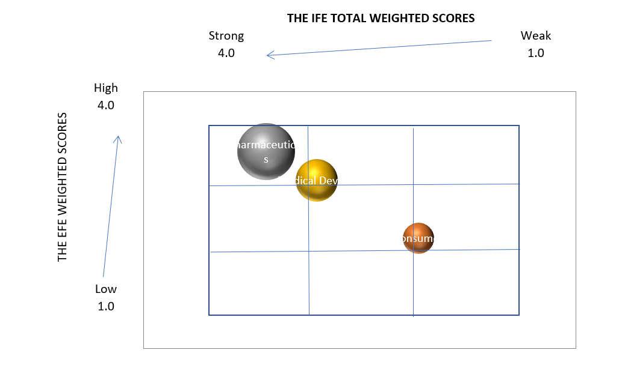
Per the Internal-External (IE) Matrix above, Johnson & Johnson’s strongest division is pharmaceuticals. Pharmaceuticals has strong internal and external positioning while producing the most revenue as noted by the IFE and EFE score of 3.5. Consumer goods and medical devices are weaker divisions producing less revenue. Both consumer products and medical device industries are highly competitive requiring competitive pricing which lessens revenue.

Quantitative Strategic Planning Matrix (QSPM)
The SWOT matrix constructed for Johnson & Johnson (J & J) provides 16 possible strategies that might be pursued. The two recommended strategies are:
Invest in R&D to increase the growth in equipment and assets that are currently in place to generate more revenue
- Invest in R & D to increase the growth in equipment and assets that are currently in place to generate more revenue with competitors in the marketplace.
- Create new products that do not require strict government regulations to generate generic products.
Johnson & Johnson (J & J) holds a strong competitive position in the marketplace. Investing in research and development to improve equipment and assets leads to more efficient and larger volume production. Producing more quality products increases J & J’s revenue while increasing competitive position against current competitors.
Generic products are popular with consumers due to the lower price. Johnson & Johnson (J & J) should start producing and selling new generic products. Consumer’s value saving money on quality products and J & J is associated with high quality. Selling generic products will enhance revenue while converting competitor’s consumers to J & J. The larger consumer base and higher revenues will increase J & J’s already strong position in the marketplace.

The QSPM Matric below evaluates both strategies.

 |  |  | Invest in R&D to increase the growth in equipment and assets that are currently in place to generate more revenue with competitors in the market place. |  | Create new products that do not require strict government regulations to generate generic products. This will help the organization regain consumer confidence back
 | Strengths | Weight | AS | TAS | AS | TAS
1 | J&J revenue increase from 82.06 million in 2019 to 82.58 million in 2020. | 0.14 | 4 | 0.56 | 4 | 0.56
2 | Employee morale is exceptional. | 0.10 | 0 | 0.00 | 0 | 0.00
3 | During the first 9 months of 2020, J&J pharma outfit generated $33.3 billion in global sales, a 5.2% increase from the same period last year. | 0.07 | 4 | 0.28 | 1 | 0.07
4 | J&J beat the market on pharma growth in the 3rd quarter of 2020, seven branded pharmaceuticals brought in $3.8 billion in sales. | 0.07 | 2 | 0.14 | 4 | 0.28
5 | J&J over-the-counter drugs are expected to perform well as consumers look to self-manage conditions like fever and pain. | 0.06 | 0 | 0.00 | 2 | 0.12
6 | Leadership position in diverse healthcare segments owning more than 250 companies in over 60 countries | 0.05 | 0 | 0.00 | 0 | 0.00
7 | J&J is the largest and most broadly based healthcare company in the world. | 0.03 | 0 | 0.00 | 0 | 0.00
8 | Focus on R&D allowing innovative product launches | 0.03 | 4 | 0.12 | 4 | 0.12
9 | During 2020 more the 50% of J&J employees located in China are back to work | 0.02 | 0 | 0.00 | 0 | 0.00
10 | Out of the top 15 highest-paid biopharma CEO, J&J CEO Alex Gorsky was ranked 3rd in place. | 0.02 | 0 | 0.00 | 0 | 0.00
 |  |  | Invest in R&D to increase the growth in equipment and assets that are currently in place to generate more revenue with competitors in the market place. |  | Create new products that do not require strict government regulations to generate generic products. This will help the organization regain consumer confidence back
 | Weaknesses | Weight | AS | TAS | AS | TAS
1 | Total expenses increased 828K within the past twelve months | 0.10 | 4 | 0.40 | 1 | 0.10
2 | Rivals in the market effects revenue and production | 0.08 | 4 | 0.32 | 0 | 0.00
3 | Paused distribution of COVID 19 vaccine due to rare/severe symptons reported | 0.07 | 2 | 0.14 | 4 | 0.28
4 | Due to COVID-19 there was reduction in doctor’s visit, which meant fewer diagnoses and new patient starts on medicines. | 0.03 | 0 | 0.00 | 0 | 0.00
5 | Six branded meds posted sales declines due to generic and biosimilar competition. | 0.03 | 2 | 0.06 | 4 | 0.12
6 | Product recall and lawsuits could affect the company's brand image | 0.03 | 0 | 0.00 | 4 | 0.12
7 | The Supreme Court has rejected J&J's appeal of a $2.11B Missouri verdict that found the company's talc-based products caused ovarian cancer. | 0.02 | 1 | 0.02 | 4 | 0.08
8 | Debt-to-total asset ratio increased from 0.66 in 2019 to 0.68 in 2020. | 0.02 | 4 | 0.08 | 2 | 0.04
9 | Total expenses increased 828K within the past twelve months | 0.02 | 4 | 0.08 | 2 | 0.04
10 | Pricing pressure factor-If unemployment remain high, fewer patients will be on commercial insurance which pays a higher price for drugs. However, J&J pharma growth is all based on volume, not price. | 0.01 | 2 | 0.02 | 1 | 0.01

 |  |  | Invest in R&D to increase the growth in equipment and assets that are currently in place to generate more revenue with competitors in the market place. |  | Create new products that do not require strict government regulations to generate generic products. This will help the organization regain consumer confidence back
 | Opportunities | Weight | AS | TAS | AS | TAS
1 | Pharmaceutical companies invested nearly $7 trillion in research and development in new medications and vaccines for new and better treatments and cures. | 0.12 | 4 | 0.48 | 1 | 0.12
2 | It is anticipated that growth in the Internet of Medical Things (IoMT) market will continue by 30.8% annually, reaching $159.1 billion by 2022. | 0.08 | 4 | 0.32 | 1 | 0.08
3 | Revenue for Supply and Manufacturing forecasted to rise to $97.2 billion over the next five years | 0.06 | 3 | 0.18 | 4 | 0.24
4 | By 2025, the use of extended reality devices is expected to reach $51 billion. | 0.06 | 1 | 0.06 | 4 | 0.24
5 | The use of artificial intelligence and machine learning will increase in 2021 and is expected to become an $8 billion industry in 2022. | 0.04 | 4 | 0.16 | 1 | 0.04
6 | Until 2024, it's anticipated that growth in the medical device industry will average 5.6 percent. | 0.04 | 4 | 0.16 | 1 | 0.04
7 | Gain back trust when it comes to the governament, social media, safety and people everday live. The pharma industry plans to be more informative, transparent and more personalized. | 0.03 | 2 | 0.06 | 4 | 0.12
8 | 56.9 million Americans will be of age 65 and required more healthcare thus increasing demand | 0.01 | 4 | 0.04 | 3 | 0.03
9 | Skin care market set to recover from pandemic in 2021 growing at 7.4% | 0.01 | 2 | 0.02 | 4 | 0.04
10 | Overall sunscreen manufacturing expected to grow 2.7% until 2026 | 0.01 | 1 | 0.01 | 4 | 0.04

 |  |  | Invest in R&D to increase the growth in equipment and assets that are currently in place to generate more revenue with competitors in the market place. |  | Create new products that do not require strict government regulations to generate generic products. This will help the organization regain consumer confidence back
 | Threats | Weight | AS | TAS | AS | TAS
1 | Increased access to health insurance allows government, employers, and health plans to save trillions by using generics. | 0.08 | 2 | 0.16 | 4 | 0.32
2 | In 2022, the pharmaceutical industry is expected to have almost $50 billion in prescription drug sales worldwide at risk due to patent expiration. | 0.07 | 2 | 0.14 | 4 | 0.28
3 | Opioid manufacturers are under fire for feeding the epidemic sweeping the nation. Hundreds of lawsuits filed, accuse drug makers of misleading the public about the addictive properties of opioid painkillers. | 0.07 | 2 | 0.14 | 4 | 0.28
4 | Multinational pharma companies must ensure they meet U.S. quality standards while adhering to all local regulations abroad, and responsible for blocking for illegal trafficking of counterfeit medications | 0.06 | 2 | 0.12 | 4 | 0.24
5 | Cyber security concerns. Potential security breach can be leeway for hackers to access medical devices and tamper with them, which can negatively affect product quality and recall rates. | 0.06 | 0 | 0.00 | 0 | 0.00
6 | Medical devices must undergo pre and post market test before receiving authorization and certifications. Due to the pandemic the healthcare industry was overwhelmed, this making the effective delivery of medical services to patients a challenge. | 0.06 | 4 | 0.24 | 1 | 0.06
7 | High cost to develop a medical device from a just an idea to a realization. | 0.05 | 3 | 0.15 | 1 | 0.05
8 | Consumer beauty industry fell 4.5% in 2020 as an adverse effect from the pandemic | 0.04 | 3 | 0.12 | 4 | 0.16
9 | Instrument and Supply manufacturing forecasted to decline 1% yearly. | 0.03 | 3 | 0.09 | 4 | 0.12
10 | Consumer confidence index change from -27.2% to 15.2 about business profiles | 0.02 | 2 | 0.04 | 3 | 0.06
 | TOTALS |  |  | 4.91 |  | 4.50

The QSPM analysis reveals the more attractive strategy is to invest in R & D to increase the growth in equipment and assets that are currently in place to generate more revenue with competitors in the marketplace with a rating of 4.91 over 4.50 to create new products that do not require strict government regulations to generate generic products. Enhancing current equipment and assets to boost production will require fewer financial resources then developing brand new products and can be implemented sooner.
Recommendations

Explanations for Recommendations

Organizational Chart
Current Organizational Chart
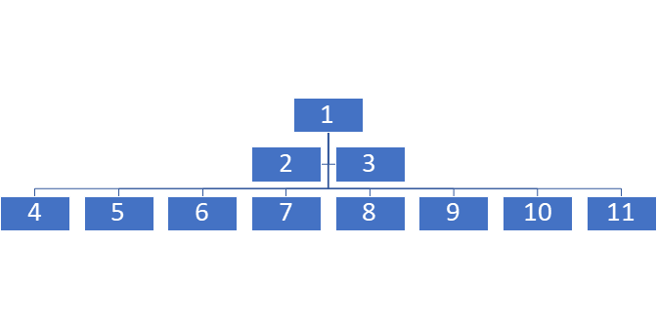
1 -- Chairman of the Board/CEO
2 -- Vice Chairman of Executive Committee
3 -- Vice Chairman of Executive Committee and Chief Scientific Officer
4 -- Executive Vice President, Chief Human Resources Officer
5-- Executive Vice President, Worldwide Chairman, Medical Devices
6 -- Executive Vice President, Worldwide Chairman, Consumer Health
7 -- Executive Vice President, Global Corporate Affairs Officer & Chief Communications Officer
8 -- Executive Vice President, Worldwide Chairman, Pharmaceuticals
9 -- Executive Vice President, General Counsel
10 -- Executive Vice President & Chief Global Supply Chain Officer
11 -- Executive Vice President & Chief Financial Officer

Proposed Organizational Chart
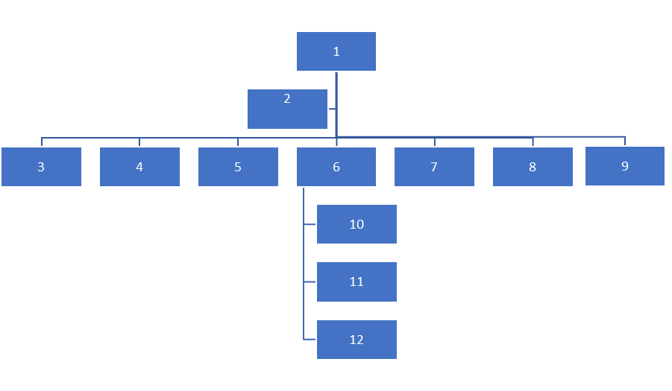
1 -- Chairperson of the Board
2 -- CEO
3 -- Chief Scientific Officer
4 -- Chief Human Resources Officer
5 -- Chief Global Corporate Affairs Officer
6 -- Chief Financial Officer
7 -- Chief Communications Officer
8 -- Chief General Counsel
9 -- Chief Global Supply Chain Officer
10 -- President of Worldwide Pharmaceuticals
11 -- President of Worldwide Medical Devices
12 -- President of Worldwide Consumer Health

The CEO and Chairperson of the Board position was separated into two distinct positions. Since there are three major divisions, each division President should report to the CFO. Formerly, each division Vice-President reported to the Vice-President of the Executive Committee along with numerous other executives. Each division functions as its own entity and needs a President to oversee operations. All three Presidents should have a dedicated person to report to and the CFO is the logical choice as each division’s financial position significantly impacts the company, as a whole. Changes to the organizational chart will better represent the functionality of the three major J & J divisions within the organization.

Perceptual Map
This is a Perceptual Map of Johnson & Johnson’s skin care products and six competitors. Since Johnson & Johnson produces several skin care products four factors are used in the Perceptual Map. The four factors are low price, high price, low quality, and high quality.
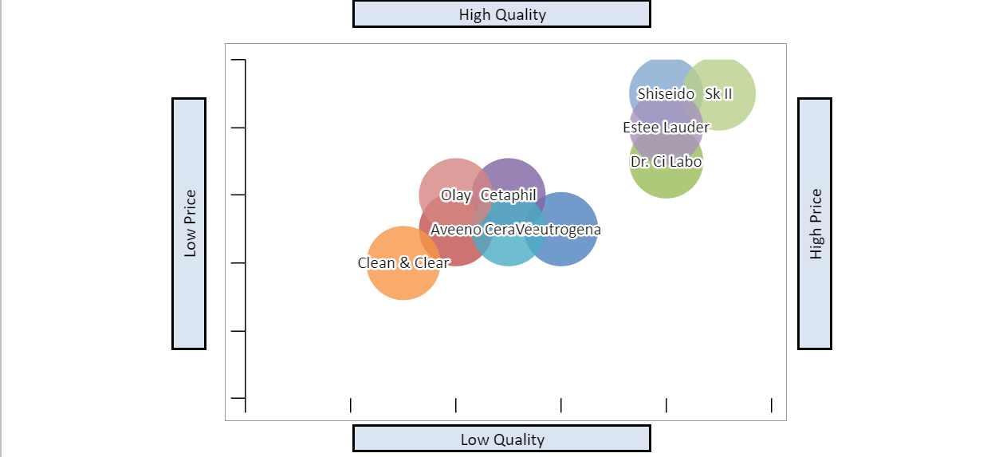
All four Johnson & Johnson (J & J) brands span multiple price points and cater to multiple audiences. The organization does well for having all products dermatologists recommended. In the US, J & J products have the highest market share for skin health products with 52%. It is not recommended diversifying the brands, but to have Clean & Clear’s marketing team focus on spotlighting that its products do not contain fragrance or dyes and does not leave residue after rinsing. The same recommendation would be suggested for Dr. CiLabo’s and focus that this brand is the number one doctor recommended products. With focus on Clean & Clean
and Dr. CiLabo, this will boost awareness of the both brands.

Firm Valuation
Johnson & Johnson
Stockholders' Equity - (Goodwill + Intangibles) | $65,705,000
Net Income x 5 | $73,570,000
(Share Price/EPS) x Net Income | $443,252,450,000
Number of Shares Outstanding x Share Price | $443,252,450,000
Method Average | $221,661,043,750

Calculating Johnson & Johnson’s (J & J) financial worth based on the four methods, it was determined that the net worth method figures for J&J were positive: $65,705,00. This indicates that a company's market value is in good standing, the market value is used to determine the true worth of the company. The net income method of $73,570,000 proves that J&J is in good standing if it were looking to acquire a business. The price-earnings ratio method and the outstanding shares method calculated result were the same at $443,252,450 which indicated that J&J financial worth is in very good standing. The average of the four methods was $221,661,043,750 and the dollar value of J&J is $409,124,000,000, which proves that the company’s receivables are more than its payables, it can be easy to assume that the company is making a profit and it is in good financial health.

EBS-EBIT Analysis
 | Common Stock Financing |  |  |  |  |  |  | Debt Financing
 | Pessimistic |  | Realistic |  | Optimistic |  |  | Pessimistic |  | Realistic |  | Optimistic
EBIT | $13,000,000,000 |  | $14,500,000,000 |  | $18,000,000,000 |  |  | $13,000,000,000 |  | $14,500,000,000 |  | $18,000,000,000
Interest | 0 |  | 0 |  | 0 |  |  | 13,294,166,895 |  | 13,294,166,895 |  | 13,294,166,895
EBT | 13,000,000,000 |  | 14,500,000,000 |  | 18,000,000,000 |  |  | 294,166,895 |  | 1,205,833,105 |  | 4,705,833,105
Taxes | 1,300,000,000 |  | 1,450,000,000 |  | 1,800,000,000 |  |  | 29,416,690 |  | 120,583,311 |  | 470,583,311
EAT | 11,700,000,000 |  | 13,050,000,000 |  | 16,200,000,000 |  |  | 264,750,206 |  | 1,085,249,795 |  | 4,235,249,795
# Shares | 4,006,157,868 |  | 4,006,157,868 |  | 4,006,157,868 |  |  | 2,671,000,000 |  | 2,671,000,000 |  | 2,671,000,000
EPS | $2.92 |  | $3.26 |  | $4.04 |  |  | ($0.10) |  | $0.41 |  | $1.59
 |  | Stock |  | 34% |  | Debt |  |  | 66%
 |  |  |  | Pessimistic |  | Realistic |  |  | Optimistic
 |  | EBIT |  | $13,000,000,000 |  | $14,500,000,000 |  |  | $18,000,000,000
 |  | Interest |  | 8,774,150,151 |  | 8,774,150,151 |  |  | 8,774,150,151
 |  | EBT |  | 4,225,849,849 |  | 5,725,849,849 |  |  | 9,225,849,849
 |  | Taxes |  | 422,584,985 |  | 572,584,985 |  |  | 922,584,985
 |  | EAT |  | 3,803,264,864 |  | 5,153,264,864 |  |  | 8,303,264,864
 |  | # Shares |  | 3,124,953,675 |  | 3,124,953,675 |  |  | 3,124,953,675
 |  | EPS |  | $1.22 |  | $1.65 |  |  | $2.66

Amount Needed | $221,569,448,250
Interest Rate | 6%
Tax Rate | 10%
# Shares Outstanding | 2671000000.0
Additional Shares Outstanding Needed | 1335157868.33
Stock Price | $165.95

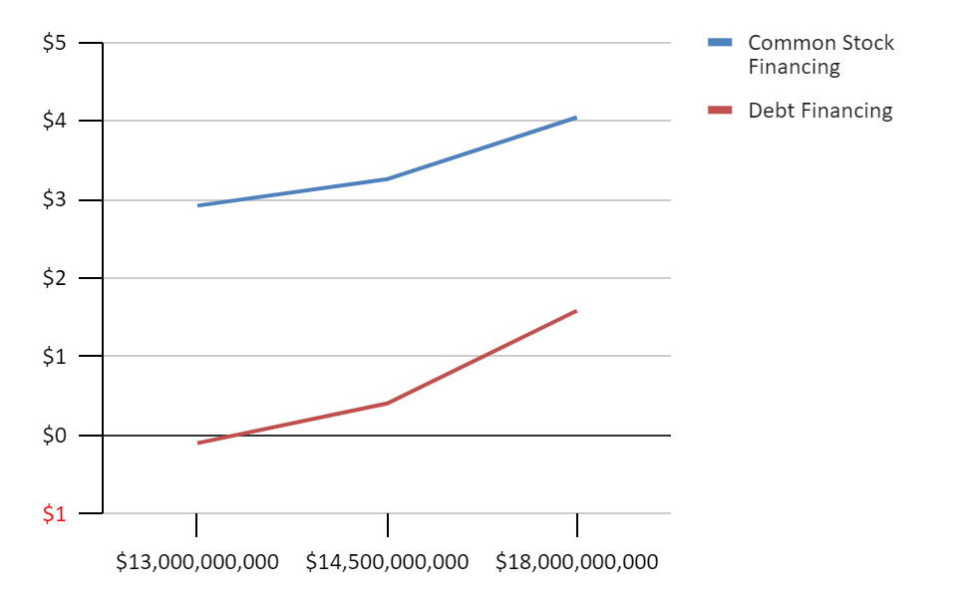

The EPS/ EBIT analysis is a tool that will shed more light on whether the company should depend on borrowing debt or raising capital through stocks (David et al., 2020). Johnson & Johnson has always depended on debt to fund most of its assets. With the pandemic and the restrictions on selling products in the markets, J & J started to spend less money on assets. The above charts show Common stocks financing, and stocks will assist J & J raise capital for its operations and reaching milestones faster from recovery.

Projected Financial Statements
Given the above recommendations, projected financial statements for the next three years are below. The financial statements consist of the income statement and balance sheet.
Projected Income Statement |  | 12/31/2022 | 12/31/2023 | 12/31/2024
Revenues |  | $84,235,680 | $86,341,572 | $88,068,403
Cost of Goods Sold |  | 1,684,714 | 3,453,663 | 2,642,052
Gross Profit |  | 82,550,966 | 82,887,909 | 85,426,351
Operating Expenses |  | 2,527,070 | 2,590,247 | 3,522,736
EBIT |  | 80,023,896 | 80,297,662 | 81,903,615
Interest Expense |  | 5,559,000 | 10,559,000 | 15,559,000
EBT |  | 74,464,896 | 69,738,662 | 66,344,615
Tax |  | 15,637,628 | 14,645,119 | 13,932,369
Non-Recurring Events |  | 0 | 0
Net Income |  | 58,827,268 | 55,093,543 | 52,412,246

Projected Balance Sheet | 12/31/2022 | 12/31/2023 | 12/31/2024
Assets
Cash and Equivalents | $154,372,610 | $184,508,271 | $203,295,102
Accounts Receivable | 58,964,976 | 69,073,258 | 79,261,563
Inventory | 842,357 | 1,726,831 | 2,642,052
Other Current Assets | 842,357 | 1,726,831 | 2,642,052
Total Current Assets | 215,022,300 | 257,035,192 | 287,840,770
Property Plant & Equipment | 18,566,000 | 18,366,000 | 18,166,000
Goodwill | 36,393,000 | 36,393,000 | 39,393,000
Intangibles | 58,402,000 | 63,402,000 | 68,402,000
Other Long-Term Assets | 0 | 0 | 0
Total Assets | 328,383,300 | 375,196,192 | 413,801,770
Liabilities
Accounts Payable | 80,023,896 | 82,887,909 | 85,426,351
Other Current Liabilities | 16,847,136 | 25,902,472 | 35,227,361
Total Current Liabilities | 96,871,032 | 108,790,381 | 120,653,713
Long-Term Debt | 32,635,000 | 32,635,000 | 32,635,000
Other Long-Term Liabilities | 0 | 0 | 0
Total Liabilities | 129,506,032 | 141,425,381 | 153,288,713
Equity
Common Stock | 3,120,000 | 3,120,000 | 3,120,000
Retained Earnings | 157,267,268 | 192,160,811 | 218,903,057
Treasury Stock | 38,490,000 | 38,490,000 | 38,490,000
Paid in Capital & Other | 0 | 0 | 0
Total Equity | 198,877,268 | 233,770,811 | 260,513,057
Total Liabilities and Equity | 328,383,300 | 375,196,192 | 413,801,770

Projected Financial Ratios
Below, are financial rations projected for the next three years based on our recommendations.
 |  |  |  |  | Projected Ratios
 | 12/31/2022 |  | 12/31/2023 |  | 12/31/2024
Current Ratio | 2.28 |  | 2.52 |  | 2.69
Quick Ratio | 2.27 |  | 2.51 |  | 2.67
Debt-to-Total-Assets Ratio | 0.39 |  | 0.36 |  | 0.34
Debt-to-Equity Ratio | 0.63 |  | 0.56 |  | 0.51
Times-Interest-Earned Ratio | 14 |  | 8 |  | 5
Inventory Turnover | 2.00 |  | 2.00 |  | 1.00
Fixed Assets Turnover | 4.54 |  | 4.70 |  | 4.85
Total Assets Turnover | 0.25 |  | 0.22 |  | 0.20
Accounts Receivable Turnover | 1 |  | 1 |  | 1
Average Collection Period | 255.50 |  | 292.00 |  | 328.50
Gross Profit Margin % | 98% |  | 96% |  | 97%
Operating Profit Margin % | 95% |  | 93% |  | 93%
ROA % | 18% |  | 14% |  | 12%
ROE % | 29% |  | 22% |  | 18%

Projected ratios will help Johnson & Johnson verify that these recommendations are benefitting the business and determine the worth of the company. Since organization is three different segments, the business may feel it’s best to prepare individual projected statements. The organization may also choose to have projected monthly statements to help ensure the company is meeting its financial goals. Adjustments can be made as needed to the projected statements to ensure results and other projected statements are realistic (David et. al., 2020). If any external or internal threats and opportunities were to arise, the business can be will able to assess, troubleshoot, and provide feedback.

Retained Earnings Table
Below is a retained earnings table projected for the next three years based on our recommendations.
 | Dividend Information |  |  | Balance Sheet Information
Steps | 1 | 2 | 3 | 4 | 5
Year | Current Year's Net Income | Less Current Year's Dividends Paid | New RE | Plus Prior Year's RE | Current Year's Balance Sheet RE
12/31/2022 | $58,827,268 | $15,450,000 | $43,377,268 | $113,890,000 | $157,267,268
12/31/2023 | $55,093,543 | $20,200,000 | $34,893,543 | $157,267,268 | $192,160,811
12/31/2024 | $52,412,246 | $25,670,000 | $26,742,246 | $192,160,811 | $218,903,057

The retained earnings table represents projections for 2022, 2023, and 2024. Information was obtained from Johnson & Johnson’s (J & J) 2020 Annual Report (Johnson & Johnson, 2020). Historically, J & J has increased their retained earnings balance each year as well as their dividend payout. We recommended that J & J invest in AI and machine learning to enhance their consumer products. This investment requires J & J to obtain additional funds through debt and will increase their interest expense. Therefore, annual net income over the next several years is anticipated to decrease slightly. However, J & J has ample income to increase both their dividend payout and retained earnings over the next several years.

Executive Summary

References
David, F. R., David, F. R., & David, M. E. (2020). Strategic management concepts and cases: A competitive advantage approach (17th ed.). New York, NY: Pearson Education.
Johnson & Johnson. (2021). 2020 annual report. https://www.investor.jnj.com/annual-meeting-materials/2020-annual-report
Johnson & Johnson. (n.d.) About Johnson & Johnson. https://www.jnj.com/about-jnj
Johnson & Johnson. (2021). Our credo. https://www.jnj.com/credo/
Pharma. (2021). Advocacy research & development. https://www.phrma.org/en/Advocacy/Research-Development
United States Securities and Exchange Commission. (2018). Form 10-5 Johnson & Johnson. https://www.sec.gov/Archives/edgar/data/200406/000020040619000009/form10-k20181230.htm#s3932AEEE4910D3D34ECFD571E91CC898

