Reflection and Refraction

Name: _____________________

Objectives
- Describe what happens to light when it shines on a medium.
- Explain light direction changes at the interface between two media and what determines the angle.
- Describe the effect of varying wavelength on the angle of refraction.
- Explain why a prism creates a rainbow.
- Apply Snell’s law to a laser beam incident on the interface between media.
- Open https://phet.colorado.edu/en/simulation/bending-light . Choose “more tools”.
- Material in the top half should be air and bottom material should be glass.
- Move the laser so that it points vertically down. Enter your data in the table below.
Table-1:
Incident Angle  (degrees) | Reflected Angle (degrees) | Refracted angle (degrees) | % Intensity of reflected ray | % Intensity of refracted ray
0 | 0 | 0 | 0 | 0
10 | 10 | 6.6 | 100 | 66
20 | 20 | 13.2 | 100 | 66
30 | 30 | 19.5 | 100 | 65
40 | 40 | 25.4 | 100 | 63.5
50 | 50 | 30.7 | 100 | 61.4
60 | 60 | 35.3 | 100 | 58.33
70 | 70 | 38.8 | 100 | 55.43
80 | 80 | 41 | 100 | 51.25
90 | - | - | - | -

- Is there a relation between reflected angle and incident angle? Explain it in few sentences.

Yes. The law of reflection states that the angle of reflection is equal to the angle of incidence.

- What do you observe with regards to intensity of the reflected ray? Do you observe a pattern with regards to change in intensity of reflected ray?
The intensity of the reflected ray is constant at 100%.
There is no pattern because the intensity remains the same through out.

- Set the incident angle to 45°. Click and drag the “Speed” meter from the Toolbox, placing its point on the incident ray.
What is the speed of the incident ray? ____1.00 c___________
What is the speed of the reflected ray? _____1.00 c__________

- Place the “speed” meter on the refracted ray. Note down the speeds for the following material in table 2:

Table-2
Medium | Speed (m/s) | n
Air | 186282.40 | 1.00
Water | 139711.80 | 1.33
Glass | 124809.21 | 1.50
Mystery A | 76375.78 | 2.44
Mystery B | 132260.50 | 1.41

Index of Refraction n of a given medium is defined as the ratio of speed of light in vacuum, c to the speed of light in a medium, v. $n=\frac{c}{v}$
- Calculate the index of refraction of materials, mystery A and mystery B. Enter the calculated values in table 2 above.

- If a student proposed the general rule, “The speed of light is a constant in all materials, regardless of n,” would you agree or disagree? Explain your answer.
I would disagree. Because different materials have materials have different refraction indexes therefore speed of light will vary from one material to another.
- Calculate sin θ₁ and sin θ₂ for each trial. Record the results in Table 3.
Calculate n₂ for each trial.

Table 3
Trial | n_{glass} | θ₁ (degrees) | θ₂ (degrees) | Sin θ₁ | Sin θ₂ | n₂ = Sin θ₁ / Sin θ₂
1 | 1.5 | 30 | 19.5 | 0.5 | 0.3338 | 1.479
2 | 1.5 | 45 | 28.1 | 0.7071 | 0.4710 | 1.501
3 | 1.5 | 60 | 35.3 | 0.8667 | 0.5779 | 1.4997

The relationship between the indices of refraction and the angles of incident and refraction is called Snell's law: $n_{1}\sin{θ_{1}}= n_{2}\sin{θ_{2}}$
- Compare your calculated n₂ with the given index of refraction, n_{glass}. Do they agree? Explain why it does or doesn’t.
They do not agree.
The glass used is not entirely pure and may contain some impurities thus the variation from the theoretical value.

- When light passes into a medium where it slows down, does it bend toward the normal or away from the normal?
It bends towards the normal.

- Material in the top half should be glass and bottom material should be water.
- Move the laser so that it points vertically down. Enter your data in the table 4 below.

Table-4:
Incident Angle  (degrees) | Reflected Angle (degrees) | Refracted angle (degrees) | % Intensity of reflected ray | % Intensity of refracted ray
0 | 0 | 0 | 0 | 0
10 | 0 | 11.3 | 0 | 113
20 | 0 | 22.6 | 0 | 113
30 | 30 | 34.2 | 100 | 114
40 | 40 | 46.3 | 100 | 115.8
50 | 50 | 59.5 | 100 | 119

When rays travel from a denser medium to a less dense medium, we can define a critical angle of incidence θ_{c} such that refracted angle θ₂ = 90°. Applying Snell’s law:
Critical angle $θ_{c}=\sin^{-1}\left(\frac{n_{2}}{n_{1}}\right)$
When the angle of incidence is greater than the critical angle, 100% of the light intensity is reflected. This is called total internal reflection because all the light is reflected.

- Calculate the critical angle of glass and water combination. Show your calculation.
Critical angle $θ_{c}=\sin^{-1}\left(\frac{n_{2}}{n_{1}}\right)$
Critical angle $θ_{c}=\sin^{-1}{1.33/1.5}$
Critical angle $θ_{c}$ = 62.46 degrees

- What is the critical angle for the interface between Mystery A and glass? To be internally reflected, the light must start in which material? Show your calculation.
Critical angle $θ_{c}=\sin^{-1}\left(\frac{n_{2}}{n_{1}}\right)$

Critical angle $θ_{c}=\sin^{-1}{1.33/2.44}$

Critical angle $θ_{c}$ = 33.03 degrees

To be internally reflected, the light must start from water.
- What is the critical angle for the interface between Mystery B and glass? To be internally reflected, the light must start in which material? Show your calculation.
Critical angle $θ_{c}=\sin^{-1}\left(\frac{n_{2}}{n_{1}}\right)$

Critical angle $θ_{c}=\sin^{-1}{1.41/1.5}$

Critical angle $θ_{c}$ = 70.05 degrees

To be internally reflected, the light must start from Mystery B.

- Click on the “Prisms” tab. Set up the experiment as shown in the figure below. Measure the angle of incidence (θ₁) and the angle of refraction (θ₂). Calculate the index of refraction.
Simulation tip: Remember that the Normal dashed line and protractor will help take measurements.

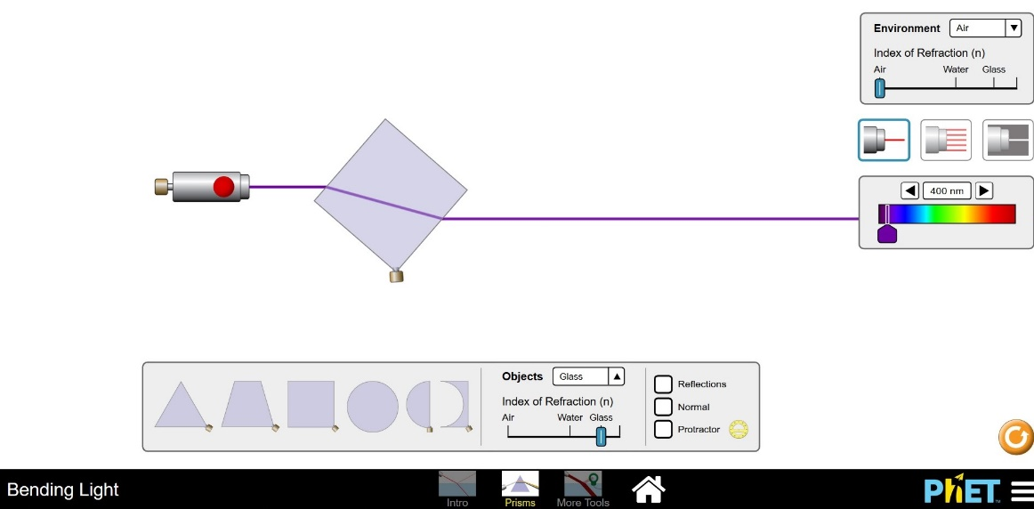

- Does the index of refraction vary as you change the wavelength of light.
Yes
- What is the angle of the ray that leaves the glass square (emergent ray) relative to the ray that enters it?
45 degrees
- What can you say about the path of emergent ray relative to that of the incident ray?
The path of emergent ray is similar to that of the incident ray in that they both have the same angle.

19. Experiment to find ways to make rainbows.
- Insert at least one setup where light passing through a prism gives a rainbow and describe why a rainbow is formed.

Light is made up of different colors. These colors have different refractive indexes. When light moves through the two faces of the prism, the different colors bend differently and in doing so spread out into a rainbow.

- Explain why only some types of light will yield rainbows.
Rainbows form as a result of varying refractive indexes in the colors in white light. Different forms of light have different wavelengths and wavelength affects the refractive index of objects. Therefore, only the lights with similar wavelength as white light can form rainbows.

