The famous iris dataset (the first sheet of the spreadsheet linked above) was first published in 1936 by Ronald Fisher. The dataset contains 50 samples from 3 iris species: setosa, virginia, and versicolor. Four features are measured, all in cm: sepal length, sepal width, petal length, and petal width.What is the equation for the least square regression line where the independent or predictor variable is sepal length and the dependent or response variable is sepal width for iris setosa? What is the predicted sepal width for iris setosa for a flower with a sepal length of 7.48?
Using Excel, we get
Data-Datanalysis:
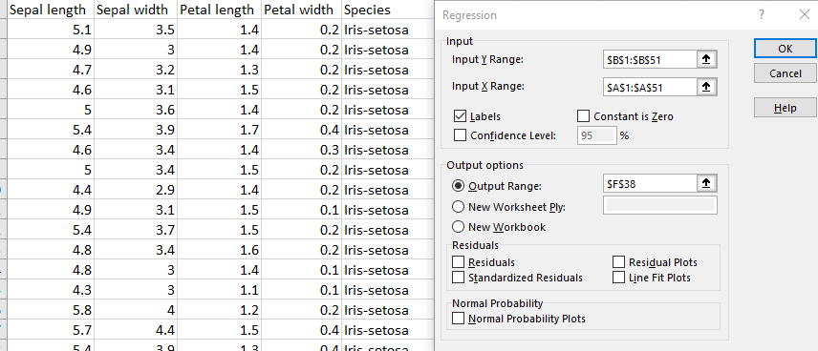

SUMMARY OUTPUT
Regression Statistics
Multiple R | 0.7468
R Square | 0.5577
Adjusted R Square | 0.5485
Standard Error | 0.2560
Observations | 50
ANOVA
 | df | SS | MS | F | Significance F
Regression | 1 | 3.96723057 | 3.96723057 | 60.5189466 | 4.752E-10
Residual | 48 | 3.14656943 | 0.06555353
Total | 49 | 7.1138
 | Coefficients | Standard Error | t Stat | P-value | Lower 95% | Upper 95%
Intercept | -0.6230 | 0.5207 | -1.1965 | 0.2374 | -1.6700 | 0.4239
Sepal length | 0.8072 | 0.1038 | 7.7794 | 0.0000 | 0.5986 | 1.0159

The equation for the least square regression line is
Sepal width = 0.8072 * Sepal length – 0.6230
Or
Y =0.8072 * X – 0.6230
Given , X=7.48
Y =0.8072 * 7.48 – 0.6230 =5.4151
Therefore, is the predicted sepal width for iris setosa for a flower with a sepal length of 7.48 is 5.4151

