Prompt 1
Student’s Name
Course Id
Date of Submission
Prompt 1
The period between the 14th and 17th century is regarded as the period when the culture, art, politics, and economy was undergoing a rebirth. During this period, many classical philosophers, thinkers, literature, artist, and even scientists emerged thus helping to bridge the middle age period and the modern-day civilization era. During this period, a lot of changes and advancements were greatly experienced. The renaissance period got its roots in Florence Italy a place that was characterized by historic culture and budding artists. The changes thereafter spread quickly to other European countries. The renaissance period records some of the most intellectual artists and scientists such as Leonardo da Vinci who painted the Monalisa and the famous last supper painting, Rene Descartes, Galileo, Giant, and others (Merriman, pg. 55).
As such, the period marked as of the important period in the history of man. However, in the late 16th century, most artists rebelled against the classical standards that were there during the period of the renaissance. This was influenced by their ideological differences in the standards. Fillip villain for instance made celebration to his native city Florence which he regarded as the climax of civilization. According to Brucker (pg. 123), though his writing, the villain discusses the lives of the famous men who included the artists. This writing was an important example to show that painting was among the liberal arts and not applied art. Villain also helped to raise the status of the painters over other practitioners of the liberal arts, thus setting the stage for a deeper consideration of the art.
Also, Lorenzo Ghiberti gives a discussion of the lives of the artists. As an artist also, he was able to analyze the life and the progress of his fellow artists during the period of renaissance .in addition, Albrecht Durer, helped to recognize that renaissance of art happened and took place in Florence and he was also the one who was able to state the humanistic principle and the artistic idea that motivated it. By this means of writing and articulations, the artists were successfully able to rebel against the classical standards of the renaissance.
Before the renaissance occurred in Italy and other European countries, there were very many factors that influenced the changes that were experienced and recorded during this period. In Italy, where then changes began, several socio-economic, political, and religious factors highly boosted the occurrence of this historic period of the renaissance (Burckhardt, pg. 122). The people of Italy went through a huge transformation for them to adopt the changes that were awaiting them. Some of the social factors that led to the Italians people being able to welcome the renaissance include social mobility, new rulers, trade, and detachment from backward traditional customs and values.
However, the great workability of the renaissance was just characterized by huge imitation of what could be termed as the lost ancient Greece and Rome. The ancient social works was a great reference to the philosophers, thinkers, and the artist who participated in the period of renaissance (Panofsky, pg. 26). These philosophers, artists, and thinkers created their works and made them equal to those ancient works in Italy. The renaissance was seen to put much stress and emphasis on the individual, beauty, and secular values that were similar to the ancient times. Some of the ancient works include ancient Greek literature and structures.
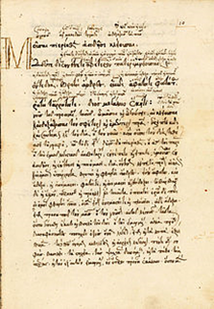
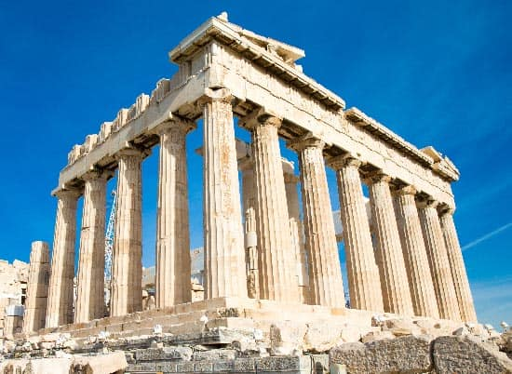
Therefore, it is clear that social works and life were very influential when it came to the changes experienced during the renaissance.
Consequently, the economy of Italy was also another significant factor that facilitated the changes in the period of renaissance. Due to the trading activities in Italy and specifically in Florence, the economy of the country found itself at a high pic causing quick industrialization. According to Panofsky (pg. 55), as a result of industrialization, there emerged a class of weavers who wove cloths and other ligaments for domestic use and also export to other countries. The trading activities and the industrialization Italy highly promoted the rise of wealthy people who later started to have a wider view of the world thus logically approaching the world. Many people converged in the towns and cities and as they interacted, they shared ideas and also exchanges different manuscripts with substantial information and ideologies. This provided a suitable platform for creative and intellectual endeavors.
Also, the changes occurred following the collapse of the feudal economic system that gave considered the landed elite only by giving them political and military power and made other people submit and obey them. This political system also ensures that the people were submissive and obedient to the authority and that they accepted their positions in the society without raising questions. According to Ferguson (pg. 67), after the collapse of this system of governance in Italy, people felt freer and they were ready to exploit their idea and views without fear or intimidation of any kind. In such an environment, people were very optimistic to start ways of expressing their ideas and views through art and writings. The collapse of the feudal system of governance thus created an avenue to the art of the renaissance period.
However, the thinkers and the artists of the renaissance acquired the patronage of rulers. In Italy, unlike other European countries, the new rulers who acquired power during the time of renaissance played a crucial role in making the renaissance develop. They lavishly patronaged the artists and the composers and this motivated the artists and the writers to work constantly. This was the only way he Italians rulers who by default had acquired power through wars could sustain and guarantee their governance. They understood that, despite the composers and the artists having natural talents and gifts, rarely could they have exploited it without adequate funds and resources (Panofsky, pg. 130). Amongst the artists who benefited from such political leaders include Donatello. Similarly, as the leaders and rulers assumed power, they employed humanists to help them in their leadership operations. As such, the humanists obtained a platform to accelerate changes in the country thus influencing more and more changes.
Conclusion
In conclusion, the renaissance not only marked a historic change in Italy alone but also to the whole un inverse. The developments and the changes experienced in the new world is as a result of the renaissance. However, the period also encouraged more and more innovation in different fields and subjects. Through this kind of dynamism, man has been able to solve different mysteries and challenges. The social, economic, and political factors in Italy formed the basis of the renaissance period. In as much as they were not highly appreciated, but the fact remains that they were crucial and very important when it comes to the start and the growth of the renaissance period.

References
Brucker, Gene. Renaissance Florence. Univ of California Press, 1983.
Burckhardt, Jacob. The civilization of the Renaissance in Italy. BoD–Books on Demand, 2019.
Ferguson, Wallace Klippert. The Renaissance in historical thought. Toronto: AMS Press, 1948.
Merriman, John. A history of modern Europe: from the Renaissance to the present. Vol. 1. WW Norton & Company, 2009.
Panofsky, Erwin. Renaissance and renascences in western art. Routledge, 2018.

