Note: There are some selected screenshots on the these two pages to compare your results. This does not include all of the worksheets, but several that might help you. Some of the items are not included because they would give away the answer. See notes.

RentalData Worksheet:

(Note: This does not include the field headings and criteria in cells A1:L3 because I want you to do that on your own and showing this would provide the answer.)

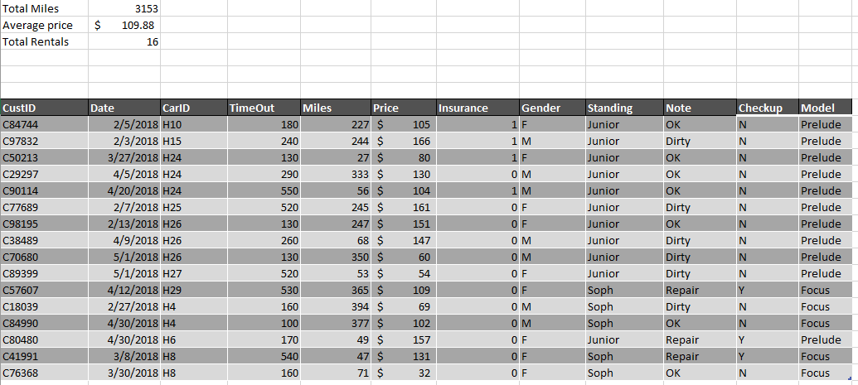

PivotTable Worksheet:

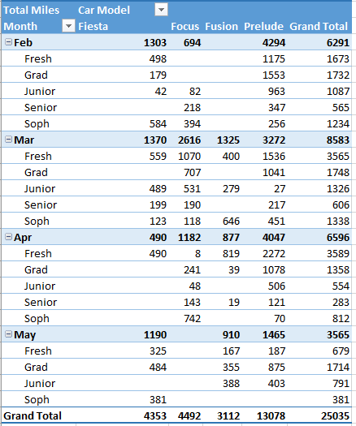

PivotChart Worksheet:

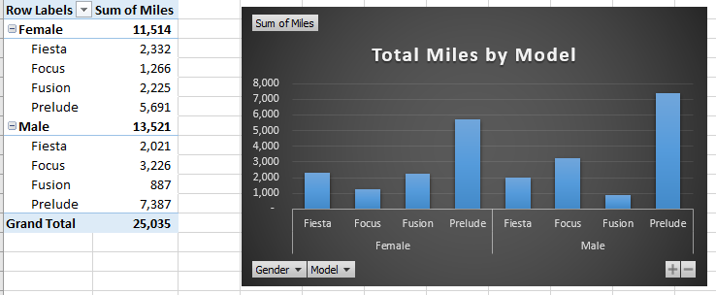

Report Worksheet:

