Amazon Company Analysis
Name
Institution

Introduction.
Amazon is an American company that specializes in e-commerce and cloud-computing services. Founded in 1994 by Jeff Bezos, the Seattle based company is currently the world’s largest e-tailer by market cap and Revenue. The tremendous company growth from a simple online bookstore to a worldwide leader in commerce has seen the company widely lauded for its management and strategic models. This report aims at reviewing and evaluating detailed information and data sources with the aim of identifying and analyzing the company’s strategic management practices.
Background Information.
Bezos founded Amazon as part of the do.com bubble, and he aimed to capitalize on the projected monthly growth rate for the internet and the world wide web which was at the time in the regions of 2300%. After considering selling various items, Bezos decided on selling books given their high demand, availability and their low prices. The company officially began its services in July of 1995. Within the first two months, the company had already expanded in over 50 states in over 45 countries their weekly sales were in the regions of $20,000. Fast forward to May 1997 and the company was released to the public for its first IPO.
According to the company’s financial reports its vision is to be the most customer-centric organization on earth. The company outlines four major guidelines for its operation and captivities: focus on customer obsession rather than competitors, commitment excellence, continuous innovation and long-term strategies since its inception that company has continued to experience massive growths in revenues, users, and loyalty.
Over time the company has continued to expand and grow its products and services. Today there over 12 million unique products sold on Amazon ranging from traditional products such as books and media to newer products such as groceries and electronics. Besides acting as an e-tailer Amazon manufacture and sells devices such as kindle e-readers, Fire-tablets, and Echo devices. Most recently the company has moved into the development and production of media content. The Amazon Web Service franchise is also a growing part of the company that specializes in delivering on-demand cloud computing services to individuals and businesses. Today AWS boasts of customers of over 1 million customers with reputable companies such as Adobe, Airbnb, Alcatel, BMW among them.
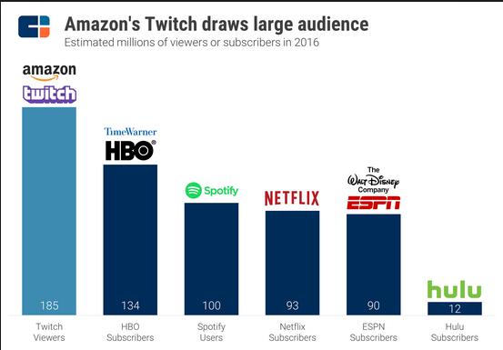
A 2017 survey indicated that Amazon dominated the world of e-commerce with a revenue of over $177 billion representing over 14.8% of the global market share. In the US alone the company’s net income was to the tune of $54.3 billion representing over 34% of the total market share. From a customer base of around 1 million users, the company now records of extraordinary support of over 182 million users.
Some of the initial drivers for companies massive success were its extensive promotional relationship with companies like Yahoo, Excite, American Online among others. To date, 90% of Amazon marketing budget goes to Search Engine Optimization (SEO) and Paper Per Click (PPC). Critical to Amazon continued dominance as also been its commitment to innovation and diversification. Despite the bouncing of the dot.com bubble the company retained was able to sustain its tempo. The company continues to bolster its product portfolio with new developments and acquisition. Today the company has over 40 subsidiaries among them are Amazon Robotics, IMDb, Zappos, ComiXology, and Goodreads.
Despite its impressive growth in revenue, customer base, and product portfolio Amazon has continuously struggled in consistently delivering positive profit margins. Amazon insistence on keeping price lows and investing in speedier deliveries as meaning that its primary retail business has been recording small profits margins for the more significant parts of its existence. Bezos had always maintained that the customer would continue to focus on their strategies on selection, low prices, and fast delivery, despite massive criticism. However, in 2018 the company was able to hit the $2.5 billion mark in profits courtesy of growth in its cloud computing services and advertisement business.
Business Model and Strategies.
One of the most common and renown models for Amazon is the back-of-the-napkin diagram. The story goes that Bezos, Himself drew this diagram on the back of a napkin to demonstrate to another executive how the company operated. The virtuous cycle argues that lower prices will eventually lead to a higher number of customer visits. With more customers, there would be an increased volume of sales that will attract commission paying sellers. This model would be then amenable the company to generate more profits from fixed costs such as fulfillment and the servers running the website. Feeding a part of the flywheel would eventually accelerate the loop.
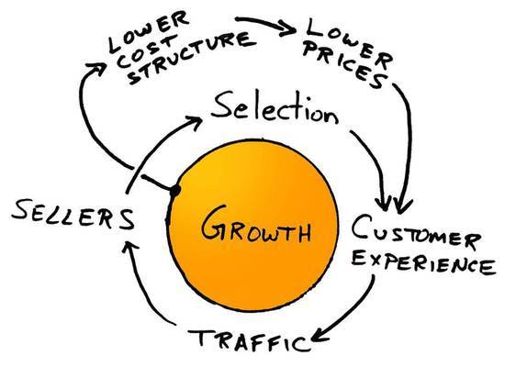
Figure 1. A diagram of the back-of-the-napkin model by Jeff Bezos explaining Amazon’s business model.
Amazon adopts a peculiar business model whereby the retailers tend to make more substantial profit standing when the average profit margin per product is lower. With reduced profits margin on products the sales of the company increase, conversely, an increase in products margin profits results in lowers sales and thus lower net profits. ( Figure 2 helps in demonstrating this relationship). GlobalData (2013) argues that these are the features of a resilient and robust business model. This model is further facilitated by the disintermediation that Amazon plays between consumers and retailers. Overall, low pricing is integral in Amazon’s strategic positioning.
To further boost its customer base the company is pursuing an aggressive diversification of products. According to Ansoff Strategy Matrix (as Cited in Richardson and Evans, 2007 ) while diversification a positive move there needs to be an increased customer targeting and profiling. Amazon in a bid to retain its mantra of being the most customer-centric company in the world has continued to provide exclusive and non-differentiated services to her consumers. Evidence-based research has demonstrated that different customers have different levels of profitability. As shown in the case of Sprint Nextel in 2007 even loyal customers can sometimes be unprofitable, (Kumar et al., 2009).
Business Level Strategy.
Business level Strategies can be primarily described as a set of integrated and coordinated commitments that are used to provide an organization with a competitive edge. Business level strategies usually involve the exploitation of core competencies. Amazon utilizes two of the three competitive edge strategies of cost leadership, differentiation and focuses advocated by Porter,(204).
Popular belief has always been that it is virtually impossible to combine the three strategies since differential is costly and cost leadership most often foregoes some aspects of differentiation through standardization. Amazon has, however, been able to strike a balance between these two systems. For instance, Amazon introduced a niche product in Kindle but managed control its price through lean production and advertisement on its existing customer base.
Situational Analysis
Amazon strength includes having a strong brand image, which is considered as a significant internal strategic factor that helps Amazon to compete favorably in the field of e-commerce. The company also benefits from high economies of scale by providing efficient services to target customers. Amazon weaknesses include low diversification and the high cost of infrastructure. Low diversification as a weakness tends to increase the company's exposure to market-based risks since it represents one of the most significant revenue streams with the United State. On the other hand, a high cost of infrastructure acts as the company's weakness because the company often finds it challenging to compete based on the set prices. However, Amazon is presented with some opportunities which includes expansion and global growth, stronger network externalities and diversification of business opportunities (El Emary et al., 2011).
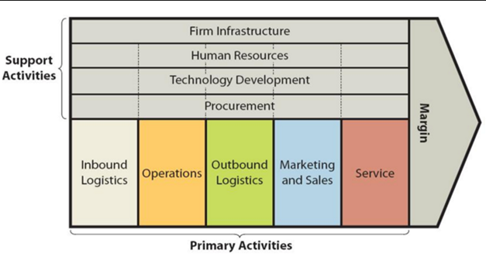 a
Amazon Value Chain Analysis
The first opportunity is the expansion and global growth, which is primarily based on the widespread and development of e-commerce across the world, which enables it to capitalize on technological trends. Diversification of business as an opportunity involves developing new business as a way of spreading risks through the operations of the company's services to the customers beyond USA. The third opportunity consists in strengthening network externalities based on the positive effect of a broader customer base, which boosts the importance of its services by increasing the market share and customer base (El Emary et al., 2011). Amazon Company is also faced with some threats which includes competition, security threat, and natural disasters.
Competition often threatens the company through their aggressiveness and strategies where advancement in technologies among other companies threatens Amazon marketing strategies. Security threats such as breaching against the online transactions that the company heavily relies on can quickly force the customers to stop or reduce the usage of the firm's services. Lastly, occurrences of natural disasters such as floods and earthquakes destroy the firm’s infrastructure, especially technological assets thus reducing the overall company’s performance.
Assumptions and Missing Information
It is assumed that the company's sustained investment in technology by transforming their company businesses into online did not affected the management structure and the operations. There is no clear information about the deal of value for all the shareholders from the market leaders with great momentum. On the other hand, it is assumed that Amazon offers will provide customers with an opportunity to realize the value of setting an attractive price. The marketing strategy will position other competing companies to actively pursue the company's marketing strategy in mobile and unified e-commerce and physical services to the customers. It also covers on the enterprise both development on markets and across other emerging market businesses (Baker, 2014).
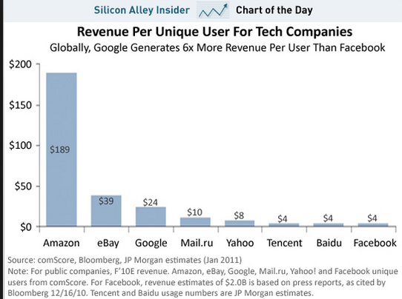
As a result, it is assumed that this will enable the firm to provide substantial returns to the customers and individual shareholders. However, what is missing about the company is how the new marketing strategies will be implemented, especially with the day-to-day advancement in technology and the business dynamics. Across the world, advancement in technology has often resulted in changes in marketing strategies. Therefore, the company has failed to outline what steps it will take to ensure that its mission is achieved and customers remain satisfied with their services.
Statement of Problems
Among several retails and sales companies, Amazon business plays a significant role in connecting people and the world. The company uses technological powers to connect, which enables companies and customers to do amazing and groundbreaking activities. Across the world, millions of Amazon customers primarily rely on the company’s services while counting on the company to deliver for them the digital world of tomorrow through their competitive services provision as well as excellent products sales. To achieve this, the company's marketing strategy needs to focus on offering solutions that are geared to help the customer's needs. “The company needs to focus on promoting their brand, leverage on their extensive distribution network, and jointly market their products and services to large government and business customers with the sales and retail companies” (Varadarajan, 2010). This is achievable when using company's business units that encompass all of Amazon solutions for large, medium businesses and global customers.
The following are the problems that the Amazon company faces:
• The United State's wireless market is mostly saturated, which makes most of the major carriers to remain tied down to the battles for market share. As a result, customers have been wrested away from this form of competition for the company to spur growth and further ensure that the market struggle has ushered in a vicious price war. This compelled the company to focus on two marketing initiatives which include sponsorship and marketing to diverse markets as the best marketing strategies that will spearhead the growth and expansion of the company (Grishunin & Suloeva, 2015).
• Amazon activities which include the purchase of the stores and retail shops in the country is not paying the profits expected in that they are spending more on things that may take a lot of time to realize the profits. The company specializes in wireless business, but the decision by the management to diversify their business scope led them into adding other internet businesses. These activities are making the company spent a lot with the returns not matching the expenditure. These initiatives mean that the company is trying to embrace diversification and growth, but they registered a fall by roughly 4% in sales.
• They are facing fierce competition from other emergent companies such as Alibaba.com. This means that the company has to reduce their services costs to remain competitive. By so doing, they will likely to encounter losses, and it does not mean that they will win the customers back — the ever-increasing debt Load as well as earning capacity. The company registered a debt of $108 billion and a $105 billion net debt load. The employees’ salary and the company management funds keep increasing due to the activities taking place in the company. This means that the company spends almost more than they are earning and in no time, their budget will burst.
Development of Alternatives
Although the company is already doing a phenomenal job with their marketing strategies, there is a need to think on how to develop alternatives to enhance their plan. As a sales and retailers company, they need to establish a seamless operational channel which will consistently provide high quality and reliable service through marketing is considered as the best alternative to the marketing strategies already in use (Mohr, Sengupta & Slater, 2010).
• The company needs to work on policy that will reduce their wage bill and narrow down on their debts. The increasing deficits means that the company has to increase their annual earnings and returns and as such, they have to address the cost of their services as well as trimming the employees pay. The company needs to shape their business structure and management to reduce the employees’ redundancy which is costing them the huge payload.
• Marketing the company's products and services by lowering their prices enables the company to keep pace with the network capacity needs and further offer highly reliable national coverage for their customers globally. The company concentrates mostly on advertising their online shopping services through television advertisements but is essential for them to develop new alternatives by focusing on advertising more of their other products and services via television advertisements. This aspect is common in and seen in most of their competitors who have successfully advertised their products through television stations — most of the competitive companies embarked on advertising their products and services via television to reach out to a broader customer base.
Most customers own TVs at home; therefore, if the company decides to market their new products and services via television advertisements, most customers will be interested in doing business with the company (Baker, 2014). Using different methods of advertising the company’s products and services will be lucrative regarding increasing sales and reaching out to the extended customer base. Using this, they will make their customers aware of their other services and products they have diversified because many of their customers are still unaware of that.
Evaluation of Alternatives and Recommendations
After the development of the alternatives, it is essential to carry out an evaluation of the selected options and further give recommendations. As a marketing strategy, the best alternative will be to advocate for a television advertisement to reaches many customers worldwide. Being an online company, reaching out to customers through advertisements is essential. Given that the company has an establishment as a basesetter in the broadcasting access industry, it is necessary to recognize that the company is not trying to seek the use of cost-strategy but instead attempts to use advertisement through television to reach out to more customers across the world (Baker, 2014). It is essential that Amazon aims to continue to develop this marketing strategy to boost their overall sales thus increase revenue.
The company needs to diversify its business by acquiring more firms that relate to the industry. This is achievable if the company will employ the best marketing strategies so that interested parties may come on board. The primary purpose of doing this is to spread risk and further reduce dependence on information and communications technology. On the other hand, Amazon needs to expand globally by offering new wireless services to the new markets after capitalizing on advertising through television. As a result, this will increase the use of wireless telecommunications services across the world. Lastly, the company needs to strengthen the competitive advantage by maximizing on the quality of services offered to highlight high quality when it comes to marketing strategies (Varadarajan, 2010). When the above-mentioned recommendations are taken into consideration by the management of the company, then it will encourage growth and expansion to other countries in the world.
Implementation
Implementation of the marketing strategies to be used by Amazon may be cumbersome, especially with the day-to-day advancement in technology. The company’s mission is to expand globally by enhancing customer satisfaction. However, the implementation of the proposed strategies may be a challenge because of the number of resources needed. For instance, since the company introduced new products and services into the market, there was a need for informing the consumers what was new in the market. Therefore, there was a need for advertising the products to reach out to the broad customer base. The proposed strategy involves advertising the new products and services through the television, which might cost the company a considerable sum of money. The implementation process may take longer, but in the end, it is going to be a success because the company is competing with others in the same industry. The implementation process will be a success because the company has an added competitive advantage over other companies especially when it comes to providing 4G internet success (Varadarajan, 2010). With the successful implementation of the proposed marketing strategies, the company will flourish regarding increasing the number of customers and expanding to other countries across the world, which in turn will generate more revenue for the company.
Evaluation and Control
The implementation of the proposed marketing strategy needs to be evaluated and controlled. Assessment of the marketing strategy is essential, especially when it comes at determining whether the company has benefited after the implementation. For instance, it is expected that the company will attract more customers after advertising their products and services through the use of television advertisement (Moreno, Lozano & Gutiérrez, 2013). Also, the company needs to expand and grow globally to remain competitive. However, the marketing strategies need to be controlled to ensure it meets all the required standards. On the other hand, the management of the company needs to ensure that the implemented strategies are commanded not to interfere with the day-to-day activities of the customers and the employees. Evaluation should be carried out after a short duration to ensure all mechanisms are in place. Recently, the company has been experiencing growth and development as a result of introducing new strategic marketing techniques. Being a global company, the management should introduce control mechanisms that will ensure the selected marketing strategies remain functional to both the company and the customers.
Company and brand management
There is no exact definition of a brand as the terms have undergone evolution and drastic changes over the years due to its ever-changing dimension. It is a collection of corporate expectations, stories, memories, and their underlying relationships who combination encompasses consumer's decision into the choice of the product and services of their preferred company. The company logo, it is packaging, the typography, as well as representative and personality are all the representation of a brand. It extends to customer services, product prices, corporate responsibility, and product quality (Kim, 2017). The brand is more intangible, emotional, human, visual, and historical.
Brand management is a marketing concept that involves the analysis, designing and planning on the means under which the brand perception will fair in the market. It is essential that the company strives to develop a brand that will attain a good relationship between the company and the target market (Hegner, Beldad & Kamphuis op Heghuis, 2014). The tangible elements in Time Inc. under the umbrella of brand management are the company products, the products look, their price of goods and services, and the packaging mechanisms. The corporation also has the intangible elements which are the customers’ experience with the brand as well as their relationship and association with the brand. Time Inc. has a president who oversees all these components with the aim of improving and perfecting the brand as a way of scoring highly in the market (Donoghue, 2017).
The publication media houses dropped drastically with the emergence of the internet. This is because digital media became the primary source of news and information to the consumers. Amazon was not spared, and it led to its decline after enjoying years of dominance due to the sales of publications (Kim, 2017). When Amazon decided to compete in a digital publication with other services providers, the company started picking and its business resume normalcy. The company has been in operation in the past years and with an established brand, it became more comfortable for them to convince companies and consumers into consuming their products (Pappu & Stowe, 2018).
Amazon is one of the most famous publishers of journals and magazine. In 1923, the company created the first newsweekly, and since then it has progressively risen into being defined by the most iconic brands such as People, Entertainment Weekly, Sports Illustrated, Fortune, Life, Money, and Time itself (Pappu & Stowe, 2018). Since the company was dominant and pacesetter in the significant part of the twentieth century in the magazine, newspapers and TV journalism across the globe, the company established its brand.
Brand identity
Brand identity encompasses the face of any given brand. It includes the colors, logos, packaging, typography, and messaging, and it works to complement the reputation that exists in a brand. Brand identity functions by attracting new customers into the company while ensuring that the existing customers have the right feeling factor of being at home. Since the brand's identity represents and reinforces the emotions and feel-factors of that particular brand, the message which the brand identity portrays has to be clear, precise and uniformly displayed (Hegner, Beldad & Kamphuis op Heghuis, 2014).
Amazon has a good mastery in the discipline of brand identity as their logo, the publications, and their online displays are so “Times-style.” They stand out uniquely hence making their brand to be rated even higher. The company has invested a lot in brand management as they have a president who oversees all the activities about the brand. The company has an established system in place for a style guide, brand management software, employees training, and market analytics which are aimed at making the brand that fits the current taste of the customers. The design of their brand is outstanding as they apply the brand identity techniques. It is their exceptional performance in the field of brand management that has helped them in moving other companies into being their brand ambassadors (Pappu & Stowe, 2018).

Their brand identity as in the figure above has a purpose and excellent positioning making their designs more lively and purpose-oriented. Given that the company has a brand purpose, it is clear to determine their identity and the related product making them a better option amongst their competitors. The choice of their logo creation strategy, that of color palette and the strategic positioning of the logo make an ideal for bringing out logo personality (Hegner, Beldad & Kamphuis op Heghuis, 2014).
Positioning & Differential Values
Since the Amazon is identically differentiated, it can attract customers while retaining the existing one. It is in this capability that the company has even drawn other companies into their business despite having experienced a deep slip in their operation due to the emergence of digital media. The company has great pride due to their high score in performance index, its outstanding employees and the products and services that the team is offering to the customers (Chapleo & Clark, 2016). Amazon understands that there is a need for differentiation and brand positioning as they are part of marketing strategy. In business, it is merger and business alliances that strike the deals which ensure that the company survives and as such, the Amazon has an outstanding brand that has helped them over the years to re-emergence.
Basing on the company’s progress and strategic activities, it is the positioning that categorizes the company while the differentiation separates it from the rest of the crowd. After the fall in the magazine publishing industry, the Amazon decided to change their business dimension rather than die with the sector (Hegner, Beldad & Kamphuis op Heghuis, 2014). This has yielded fruits as the company is in a position to attract business partners and mergers which has been their survival means up to date.
Strategy & Implementation
The president of Amazon who is responsible for brand management understands that there is a need for attracting the customers through the brands. This means that the marketers will find it easy to win customers and that ideology starts by first understanding the customers’ current brand and the latest desires. By viewing the brand from the consumers’ perspective is the ultimate strategy that the companies should always apply for the success of the company brand. The president of Amazon should understand the fixed brandings of any given project as a way of identifying and allocating appropriately the branding strategies where it best fits (Chapleo & Clark, 2016). There are also those brands and brand strategies that are variable, and as such, the project managers and brand managers of the company must understand their funding protocols.
There is a need to have operational excellence of the brand and the Amazon understands how they need to do their strategies and implementations. Amazon has a comment section in all their website where the website visitors leave their comments. As part of the web design team and the company strategy on brand management, this section has been accredited for the continuous improvement of the company brand design and operations. All these elements are oriented towards customers’ suggestions as the improvements made on the brands aligns to the “taste” of the viewers (Chapleo & Clark, 2016). The implementation strategies align with the demands of the consumers and the dictates of the company standards and goals. The Amazon designers and managers get motivated to improve the operation, the design and the attractiveness of the company brand.
Brand Equity & Valuation
In brand equity, the measure of its valuation is a result of multiple steps. Given that the perception brought by the product depends on the service and product performance in the market, the company should manage their product to a level that it scores highly in the market. Amazon established their brand during their monopolistic years in publication, and at the moment, they have a brand trust which has garnered greater loyalty amongst their customers and stakeholders. This is the reason behind the continued existence of Amazon in the face of media despite the competitiveness in the market space. The company enjoys greater trade cooperation amongst the investors and unwavering support from the business world and the consumers due to their brand management (Chapleo & Clark, 2016).
Shifting and expanding their business beyond the publication of magazines has not affected the company operates in the market space. Their increased marketing communication regarding efficiency and effectiveness means that they are in a better position to serve more customers and attend to the dictates of their clients, business partners, and their sponsors. It is the brand equity and valuation of the Amazon that attracts more customers into marketing their products through this company. They always have a room for brand licensing and extension and being a trusted media corporation, and the company is in a better position to attract more business partners. The company’s brand value relies on its brand knowledge dimensions as well as its sources for brand equity with the aspects being measurable (Ward & Perrier, 2012).
Different firms vary regarding their products, business model and company size. Taking the company to an international scale will ensure that there is a larger customer base among other benefits. It also means that the door to new challenges is opened. How the firm will adapt and perform well in international level will depend mainly on the Porter’s Diamond Model the company will have adopted. Basing on this model, the factors such as Related and Supporting Industries, Firm Structure, Strategy, and Rivalry, Demand Conditions, and Factor Conditions will play a vital role in the success of the company.
For the case where an international firm has ventured its businesses to a given nation and finds another domestic firm in that nation, the global firm will face some significant challenges. They will have to move in and adapt strategies such as products innovation, new customers and customer relations, lower costs of its products, and diversify their products and markets (Lehrich, Paredes & Ravikumar, 2009). How they treat the locals of the host nations will affect their customer attractions which will translate to the success of the company. The main risks that the international companies frequently face is the political, cultural and economic status of the host nation. These conditions have to be favorable for the company to succeed and if these conditions persist, they have to embrace continuous upgrades and innovations for them to remain relevant in the market.
Risks and rewards may not be different for the two firms for the situations where politic tensions of the host nation are high, and the business operations are high. This factor will, however, become different for the two companies when the same political class imposes higher taxation rates for the foreign companies. There are times where the quota system will be implemented, and the local companies will be given higher priorities in their region of supplying their products (Henderson & Reavis, 2009). The native companies will also be better than the foreign companies regarding cultures as they will be well conversant as compared to their international counterparts.

References
Baker, M. J. (2014). Marketing strategy and management. Macmillan International Higher Education.
El Emary, I. M., Shalhoub, M. H., Shalhoub, L. A. B., Ali, M. M. S., & Al Aqeel, K. S. (2011). Practical Reality of SWOT in Telecommunications Companies Worldwide Domain. Paper Title Page No., 3(1), 2.
Grishunin, S., & Suloeva, S. (2015, August). Project controlling in telecommunication industry. In Conference on Smart Spaces (pp. 573-584). Springer, Cham.
Henderson, R. & Reavis, C. (2009). Corning Incorporated: The Growth and Strategy Council. MIT Sloan School of Management. Retrieved from: https://mitsloan.mit.edu/LearningEdge/strategy/CorningIncorporated/Pages/default.aspx
Lehrich, J., Paredes, P. & Ravikumar, R. (2009). Compsis at a Crossroads. MIT Sloan School of Management. Retrieved from:
https://mitsloan.mit.edu/LearningEdge/strategy/compsis/Pages/default.aspx
Mohr, J. J., Sengupta, S., & Slater, S. F. (2010). Marketing of high-technology products and innovations. Pearson Prentice Hall.
Moreno, P., Lozano, S., & Gutiérrez, E. (2013). Dynamic performance analysis of US wireline telecommunication companies. Telecommunications Policy, 37(6-7), 469-482.
Nickell, D., Bettina Cornwell, T., & Johnston, W. J. (2011). Sponsorship-linked marketing: a set of research propositions. Journal of Business & Industrial Marketing, 26(8), 577-589.
Varadarajan, R. (2010). Strategic marketing and marketing strategy: domain, definition, fundamental issues, and foundational premises. Journal of the Academy of Marketing Science, 38(2), 119-140.

