Weekly Activity 6:
Resonators

There are several different types of resonators we have discusses: mechanical and acoustic (Helmholtz and tube resonators are both acoustic resonators). Each has similarities and differences to the others. We will look at each below. Type your answers below each question, save to your computer and upload into Blackboard as appropriate.

Mechanical and Helmholtz

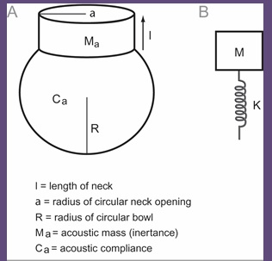

In the image above, you see a Helmholtz resonator (A) and a mechanical resonator (mass-spring model, B). Which parts of the mechanical resonator are similar to which parts of the Helmholtz resonator and why?
The neck of the Helmholtz resonator corresponds to the mass of the mechanical resonator and the cavity of the Helmholtz resonator corresponds to the spring of the mechanical resonator. The reason behind this is that the volume of the Helmholtz resonator acts a spring whose spring constant can be calculated. The fluid on the neck has a total effective mass which corresponds to the mass of the mechanical resonator.

The following two formulas are used to find the resonance frequencies of mechanical and Helmholtz resonators. Which formula belongs to which resonator and what do the variables mean?

Formula 1: $Fr=\frac{1}{2π }*\sqrt{K}/M$
This formula belongs to the mechanical resonator.
K- Spring Constant
M - Mass

Formula 2: $Fr=\frac{c}{2π}*\sqrt{S}/Vl$
This formula belongs to the Helmholtz resonator
c - Sound velocity in the fluid
S - Projection area of the neck
V- Volume of the cavity
l- Effective length of the neck

Tube Resonators
Compute the first three resonant frequencies for tubes open at both ends and having lengths of: (a) 10 cm, (b) 14 cm, and (c) 18 cm. Use your computer values for the three tube lengths to plot them on the frequency-by-tube-length chart shown below (copy and paste the image below to your computer, print it and complete it. Then, take a picture of the completed image and paste it below). At each tube length, use unfilled circles for the lowest resonance (R1), unfilled squares for the second resonance (R2), and unfilled triangles for the third resonance (R3)- see the right side of the graph. Please write out the actual values for each resonance next to the symbol (round to the nearest whole number). Be sure to label both the x- and y-axes. Also indicate which formula you used to complete the calculations.

f = (c x n)/2L; where c = speed of light, n = number of resonance, l = length of tube in cm
Assuming that the speed of sound is 34000 cm/s:

(a) 10cm

f (R1) = (34000 x 1)/20 = 1700 Hz
f (R2) = (34000 x 2)/20 = 3400 Hz
f (R3) = (34000 x 3)/20 = 6400 Hz

(b) 14 cm

f (R1) = (34000 x 1)/28 = 1214 Hz
f (R2) = (34000 x 2)/28 = 2429 Hz
f (R3) = (34000 x 3)/28 = 3643 Hz

(c)18cm

f (R1) = (34000 x 1)/36 = 944 Hz
f (R2) = (34000 x 2)/36 = 1889 Hz
f (R3) = (34000 x 3)/36 = 2833 Hz

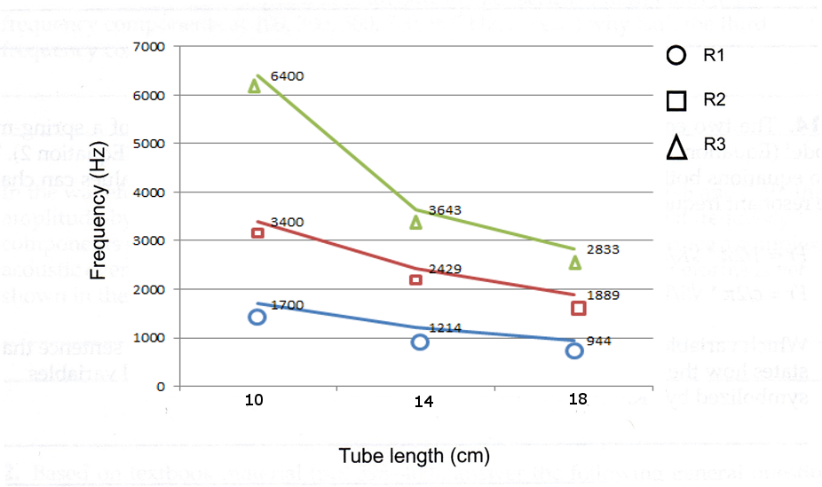

Compute the first three resonant frequencies for tubes open at one end and closed at the other and having lengths of: (a) 10 cm, (b) 14 cm, and (c) 18 cm. Use your computer values for the three tube lengths to plot them on the frequency-by-tube-length chart shown below (copy and paste the image below to your computer, print it and complete it. Then, take a picture of the completed image and paste it below). At each tube length, use unfilled circles for the lowest resonance (R1), unfilled squares for the second resonance (R2), and unfilled triangles for the third resonance (R3)- see the right side of the graph. Please write out the actual values for each resonance next to the symbol (round to the nearest whole number). Be sure to label both the x- and y-axes. Also indicate which formula you used to complete the calculations.

f = (c x (2n – 1))/4L; where c = speed of light, n = number of resonance, l = length of tube in cm
Assuming that the speed of sound is 34000 cm/s

(a) 10 cm
f (R1) = (34000 x (2*1 – 1))/40 = 850 Hz
f (R2) = (34000 x (2*2-1))/40 = 2550 Hz
f (R3) = (34000 x (2*3-1))/40 = 4250 Hz

(b) 14 cm

f (R1) = (34000 x (2*1 – 1))/ 56= 607 Hz
f (R2) = (34000 x (2*2-1))/56 = 1821 Hz
f (R3) = (34000 x (2*3-1))/56 = 3036 Hz

(C) 18 cm

f (R1) = (34000 x (2*1 – 1))/72 = 472 Hz
f (R2) = (34000 x (2*2-1))/72 = 1417 Hz
f (R3) = (34000 x (2*3-1))/72 = 2361 Hz

