Food And Beverage Business Report Of Restaurant Hubert
Name
Institution
Professor
Date

Food and Beverage Business Report of Restaurant Hubert
A restaurant should serve different purposes as the user’s desire. Some people seek to relax and have fun, others seek to meditate, and others also want to have meet-ups with friends and colleagues while other people would just want to eat from a restaurant. An ideal restaurant is one that serves all these needs comprehensively without fail. Several factors, therefore, contribute to the perfect status of a restaurant, including the location, the ambiance, the service, and product delivery. Restaurant Hubert is one typical restaurant, as illustrated below.
Site Presentation
On Location Restaurant Hubert is strategically located in a highly populated downtown area of Sydney and therefore has a strong customer base. However, the restaurant is quite hidden and hard to get to and ideal for people who want a serene environment (www.restauranthubert.com). It is away from the noises in the city and is a quiet place offering an ideal environment for fun and meditation. The front location of the restaurant Hubert is highly visible. The restaurant is large enough to accommodate all the facilities like freezers, a kitchen. The sitting area is also spacious; the bar and lounge are also wide enough to hold a significant number of people at a go. The restaurant has a big parking area that can accommodate several cars of customers. 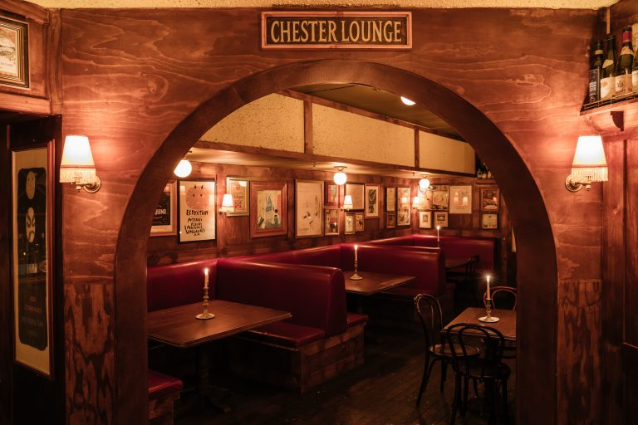The lounge area
As one approaches the restaurant, there is road signage with the name of Restaurant Hubert. The sign shows with arrows the direction of the restaurant and gives an approximation in kilometers of how far the restaurant is. These road signs are three in intervals of one and a half kilometers each. There is also an arrow indicating the entrance of the restaurant and a massive poster of the restaurant at the gate, showing the structural design of the restaurant.
Restaurant Hubert has a well-done Décor with excellent interior design for an ideal restaurant. The layout of the restaurant is also appealing, with good furnishing both within and around the restaurant. The toilets are strategically located within the restaurant. They are clean and well located, such that the smell from the toilet does not interfere with the comfort of the clients in the dining area and at the bar. The restaurant also has high-class furniture with beautiful dining tables and ideal dining seats (www.restauranthubert.com). The bar also has some very comfortable leather seats. (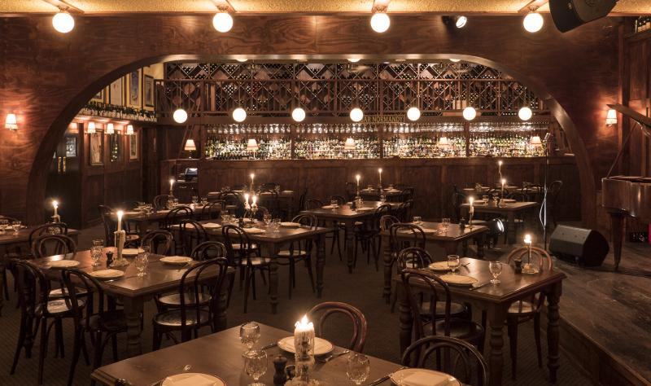The dining area
Ambiance
Restaurant Hubert has unique experiential touchpoints. It has a dark, moody, and welcoming atmosphere. It has a cute booth that gives the customers a feeling of relaxation. The restaurant has such a good vibe that adds to its comfort factors. The Smells and Aromas of the food are just excellent. The music levels at Restaurant Hubert are irresistible. There is live music well regulated to suit the different events happening at the restaurant. 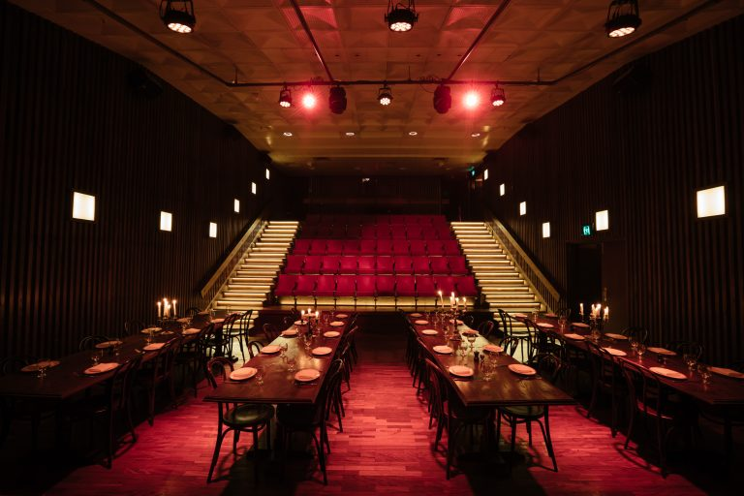 The beautiful furniture of the restaurant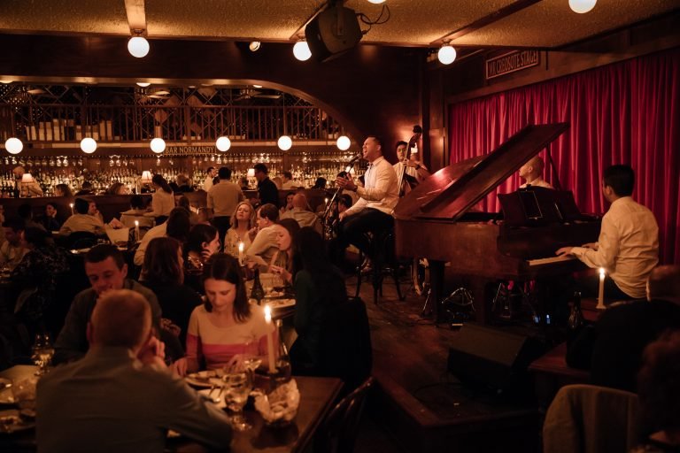Live music is happening as customers enjoy the food.
Service
Staff friendliness levels are fantastic. The staff always put on smiles on their faces and are very courteous as well as welcoming to all the people. The staff talks to people in a friendly and respectful manner that one would always want to go back. The Staff knowledge of menu items is also intriguing. They are well aware of the foods available each day, including the cost of the food and how the foods are served (www.restauranthubert.com). They know the accompaniments of all the main dishes.
Staff also have high efficiency and deliver food on time. The staff also provide the ordered food without confusing the different orders of clients. The Staff presentation is admirable, with the staff having branded outfits. The staff also cover their heads, put on gloves and aprons while serving the clients. The staff are very decent and appear presentable.
Product Delivery
The Menu style is impressive, with the name of the restaurant on top of the menu and different types of glasses with different images surrounding the menu on both the right and the left margins (www.restauranthubert.com). The images on the glasses are talking images expressing romance, happiness, and somber moods. The main dishes are also bolded with their accompaniments written along with them in an unbolded font. The menu has a variety of French dishes that are both vegetarian-friendly and gluten-free. There are also different types of meat, including snails, and pommes Anna. There are also snacks like a burger and non-alcoholic beverages besides the alcoholic drinks of different flavors.
The food presentation is welcoming, with unique cutlery used to serve the food. There are buffets and single-meals as preferred by the customers. The food is also fresh and tastes incredible. The Price of the food is high but resonates with the value and quality of the food and the general service offered at the restaurant (www.restauranthubert.com).
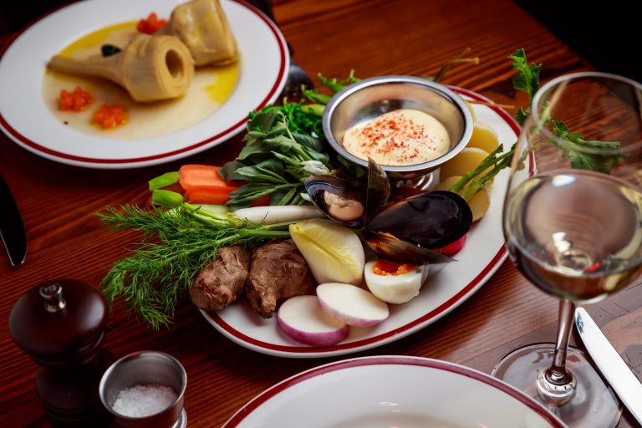 The variety of foods at the restaurant
Recommendations For Improvement
To make the site of the restaurant easily accessible, restaurant Hubert should put several posters on the streets of Sydney for people to know where the restaurant is located. This would give people knowledge of the existence of the restaurant even at its hidden state. The ambiance of the restaurant should be improved by having some background music playing at all times and making it possible for customers to request specific songs as they drink and have them performed. The service should also be diversified so that it meets not only the customer preferences of the French people but also the preferences of other customers who might not like French foods and services. On product delivery, the menu presentation should be revised so that it includes images of the different foods and drinks available at the restaurant as opposed to pictures of people.
Conclusion
Restaurant Hubert is an ideal restaurant for events, single dishes, and meetups, as well as for fun. The location is serene, while the services are standard with good food and a pleasant atmosphere. However, some improvement is needed so that the restaurant serves diverse groups of people. The menu should also be attractive with images of foods and their prices indicated on it.

References
www.restauranthubert.com

