

Restaurant management; Technical Report
Name
Institution Affiliation
Date

Project Overview
The restaurant has so far shown very good progress. The management was able to tackle previous challenges as documented including employee’s performance, creating a good working environment, capital requirements, and point of sale management. The management is now only concerned with the prospects of the company that has been able to successfully build from its initial point to a running restaurant that is fast gaining loyal customers and frequent walk-ins that are converted into repeat purchases and loyalty into the restaurant. It has shown effective human resource amazement as the staff express satisfaction working in the restaurant despite heavy tasks and a busy and demanding work environment.
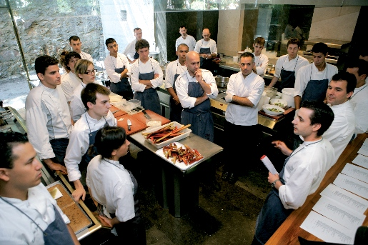

Project Goals
The management is now the placing emphasis on the business continuity of the restaurant to ensure stabilized growth and future profitability and adaptability of the restaurant to changing market trends.
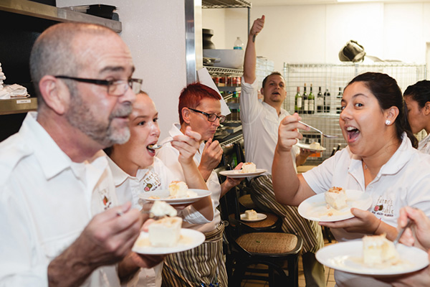
Project Approach
The management looks to form stable and long-term partnerships with business distribution channels, suppliers and corporate consumers to established business operations. It also is looking to source more investors into the restaurant growth as its strategies to expand the restaurant and open outlets and branches in other states and countries. Later on, the management objects to make international market entry. The management is also diversifying its services including catering services, lodging services, and a tour company sources to increase its income streams.
Expected results
As a result of the strategic partnerships, the resultant sales are expected to increase and stabilize. The restaurant is also expected to have opened 20 outlets and branches within five years of operation. The management also expects to enter the international market after seven years of the operation of the restaurant.
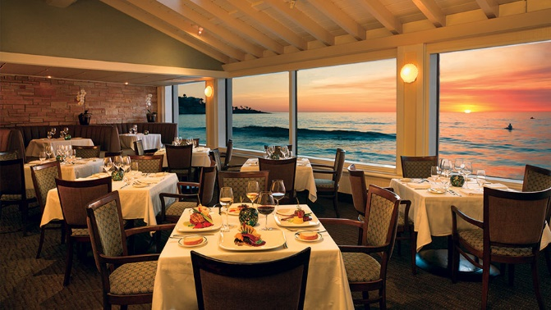
Resources
The expansion and strategic partnership formation are capital intensive. The management will, therefore, look to raise not less than $1,000,000 from the inventors it will source to find this strategic move. Capital generated from sales will also be used to fund this business strategy.
Assumptions
The management assumes that there will be no catastrophic event in the future that may lead to the closure of the restaurant including hostile weather events or economic downturns. It also assumes there will be positive response from investors anchoring on the performance it has had so far.
Milestones

The milestones as mentioned are to open twenty braches of the restaurant in five years’ time and to enter the international market after seven years of operation.

Limitations
The restaurant is new and will, therefore, expect tough competition in the restaurant market. Insufficient capital to expand its operations will also see that the expansion is delayed until the iminium capital requirement is attained.

