Result
Name
University
Date

Method Section
Participants
They were 15 participants who participated in this study. 60% were females, 13% male while the rest were either non binary or did not want to indicate their sexes. The average ages of the participants was 20 years with the youngest being 19, while the oldest being 22 years. Although the study aimed at random requirement, the study selectively required participants’ to fit the study aim.
Design
A quasi experimental study design was used with the study participants subjected to before and after scenarios. The judgment percentage likelihood of the participants was measured for the first time and premeasured in the after scenarios. The feedback was recorded as “Abstract Large”, “Abstract small”, “Concrete large”, and “Concrete small”.
Procedure
After randomly recruitment, the participants were subjected to a series of questions with their feedback recorded as either abstract or concrete. The abstract large was recorded as either large or small while judgment size comparison was either large or small. All the feedbacks were recorded in a clean excel sheets.
Results Section

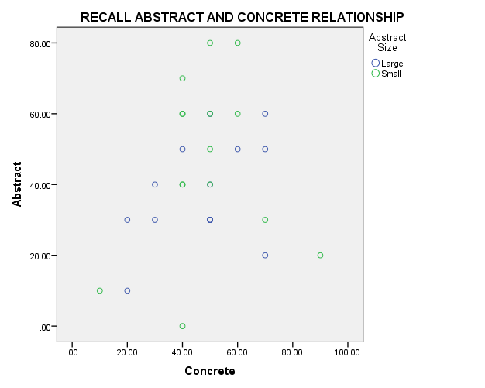
Figure 1: Response difference
Figure 1: Showing the differences in concrete Abstract responses in questions answered by the participants.
The analysis of Variance (ANOVA) showed that there were no significance differences in judgment within and between the two groups ((F (2, 29) = 1.659, p = . . 208)") and ((F(2,29) = .045, p = . .833)"). The means distribution is well shown in the figure 1.0 above. The T test also showed no significance differences between the difference measures of judgments (F, 15= 3.932, p=0.057). The resulting graphs are shown in figures 2 and figure 3 below.

Figure 2: T mean differences in responses between concert and Abstract Responses

Figure 3: Judgment Comparison.

