- (24%) We use a processor with CPIs for the following classes of instructions to execute the given C-code. For array B[N], 40% of its elements are NOT zeros. For the IF-ELSE statement, assuming 2 branch instructions are executed if the branch condition is true (the Then path), and 1 branch instruction is execution if the branch condition is false (the Else path). Every array reference needs a load or store instruction. Answer in the table 1) the number of instructions to be executed for each of the classes, 2) the total number of cycles used for executing each class’s instructions, 3) the percentage of total cycles by each class with respect to the overall total cycles. Also answer after the table 4) the overall total number of instructions of all classes that are executed, 5) the overall total cycles spent for all classes, and 6) average CPI (cycles per instruction in average). Addition used for calculating memory effective address for load and store instructions should NOT be considered. But loop count increment is considered as addition.

Instruction class | CPI
add | 2
load/store | 12
branch | 3

int N = 1000;
int A[N], B[N], C[N]
int i;
for (i=0; i < N; i++) {
if (B[i] != 0) A[i] += 3.14 + B[i] + C[i]; //Then
else A[i] += 3.14 + C[i]; //Else
}

Instruction class | CPI | # instructions x10³ | # Cycles x10³ | Cycles Percentage
add | 2
load/store | 12
branch | 3
Correct answer to each cell makes 1 point.

4) Overall Total instructions (1%) =
5) Overall Total cycles (1%) =
6) Average CPI (1%) =

Solution:
For each iteration, one add instruction for i++, three add instructions for the Then path of the loop body which has 40% chances, and two add instructions for the else path, which has 60% chances. Thus total add instructions = 1 + 3 * 0.4 + 2 * 0.6 = 3.4 * 10³

For load, the if (B[i] !=0) has one load, The Then path has 3 loads, 1 store, thus total 4 * 0.4, Else path has 2 loads and 1 store, thus total 3 * 0.6. Thus total load/store = 1 + 4 * 0.4 + 3 * 0.6 = 4.4 * 10^3

For branch instruction, the for loop has 2 branch per iteration, 2 branch instructions of the THEN path (0.4) and 1 branch instruction for the ELSE path (0.6), thus total 2 + 2*0.4 + 1 * 0.6 = 3.4 * 10^3

Instruction class | CPI | # instructions * 10³ | Total Cycles x10³ | Cycles Percentage
add | 2 | 3.4 | 6.8 | 9.7%(6.8/69.8)
load/store | 12 | 4.4 | 52.8 | 75.6%(52.8/69.8)
branch | 3 | 3.4 | 10.2 | 14.6%(10.2/69.8)

Correct answer to each cell makes 1 point, thus total 9 points.

4) Overall Total instructions = 3.4 + 4.4 + 3.4 = 11.2 * 10^3 (1 point)
5) Overall Total cycles = 6.8 + 52.8 + 10.2 = 69.8 * 10³ (1 point)
6) Average CPI = Total Cycles / Total Instructions = 69.8/11.2 = 6.2 (1 point)

If answers to the first column of the table are incorrect, but other answers that are based on those answers in the first column are calculated in the correct way and steps are shown correctly, 75% partial points should be given.

- (10%) The following diagram shows the data path and control signals of a standard 5-stage CPU design for load, store, and arithmetic/logic instructions. We will introduce a li instruction, which is in the format of “li Rd, #imm”. The instruction performs loading an immediate number (#imm) to register Rd, i.e. Reg[Rd] = #imm. If you implement the instruction using the provided CPU in the diagram, highlight the data path used for the li instruction. To draw from MS Word, using the draw feature of the Word application, see below screen shot of the menu: 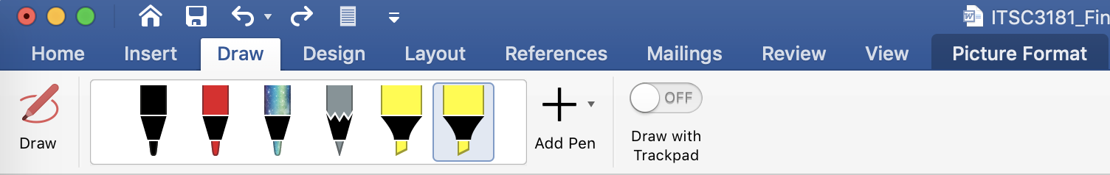

Solution: The implementation is the same as “addi Rd, x0, #imm”, thus the diagram as follows:
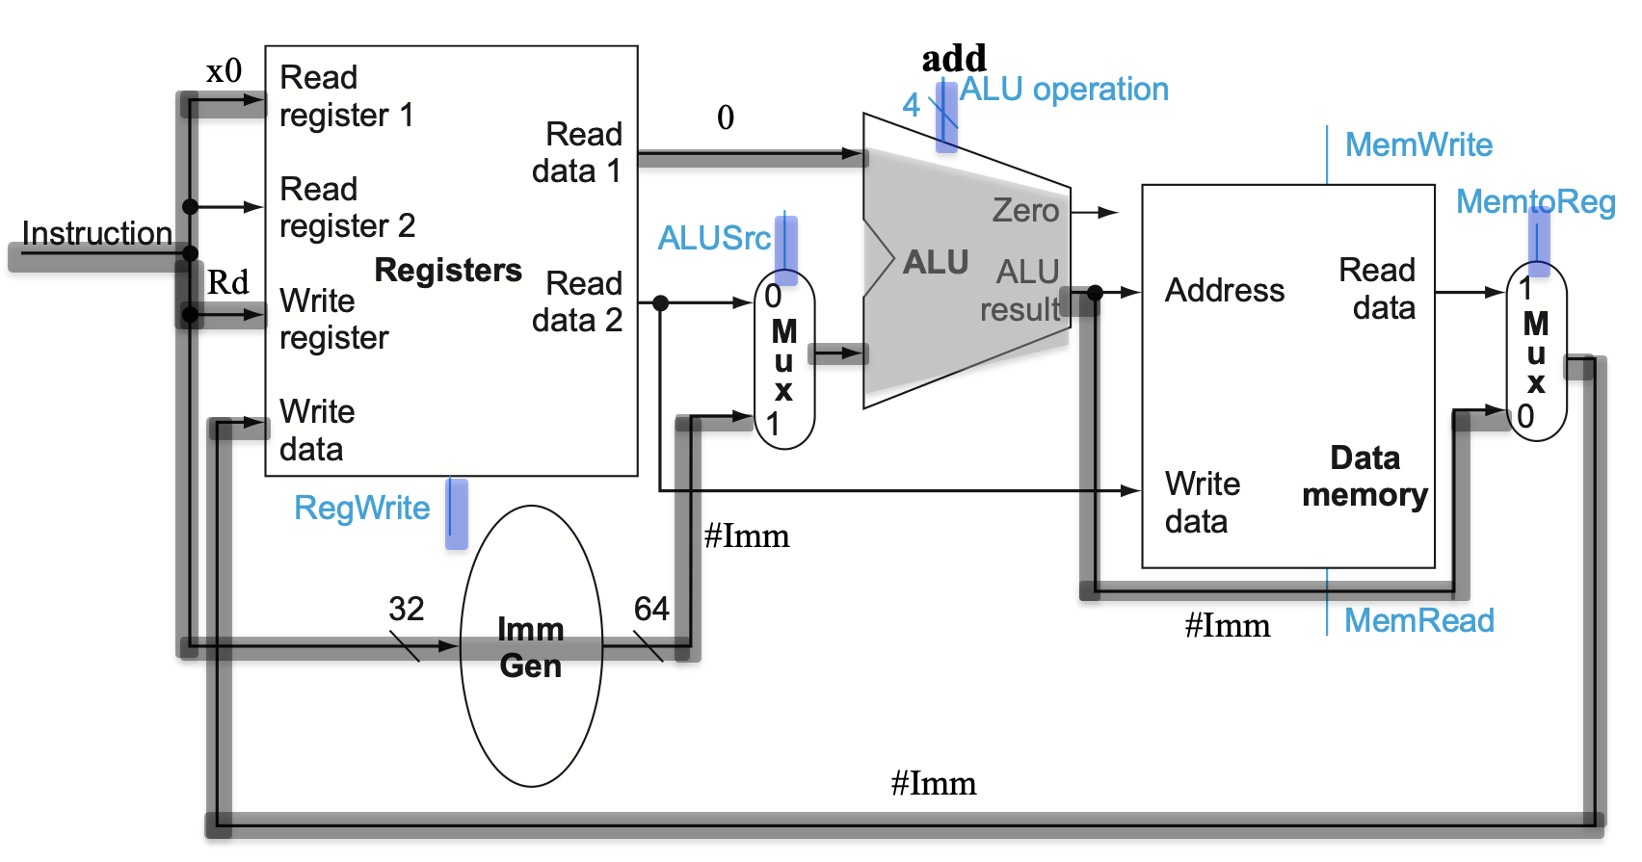

Grading: 2 point for each color-highlighted (green, red and yellow) datapath and circled path.

- (36%) Given the following CPU diagram that you use for your Homework 4, you will be asked in the same way as the question 2 of HW4. Given instructions to be executed on the CPU, fill in a table with values for selected datapath for each instruction when being executed on CPU.

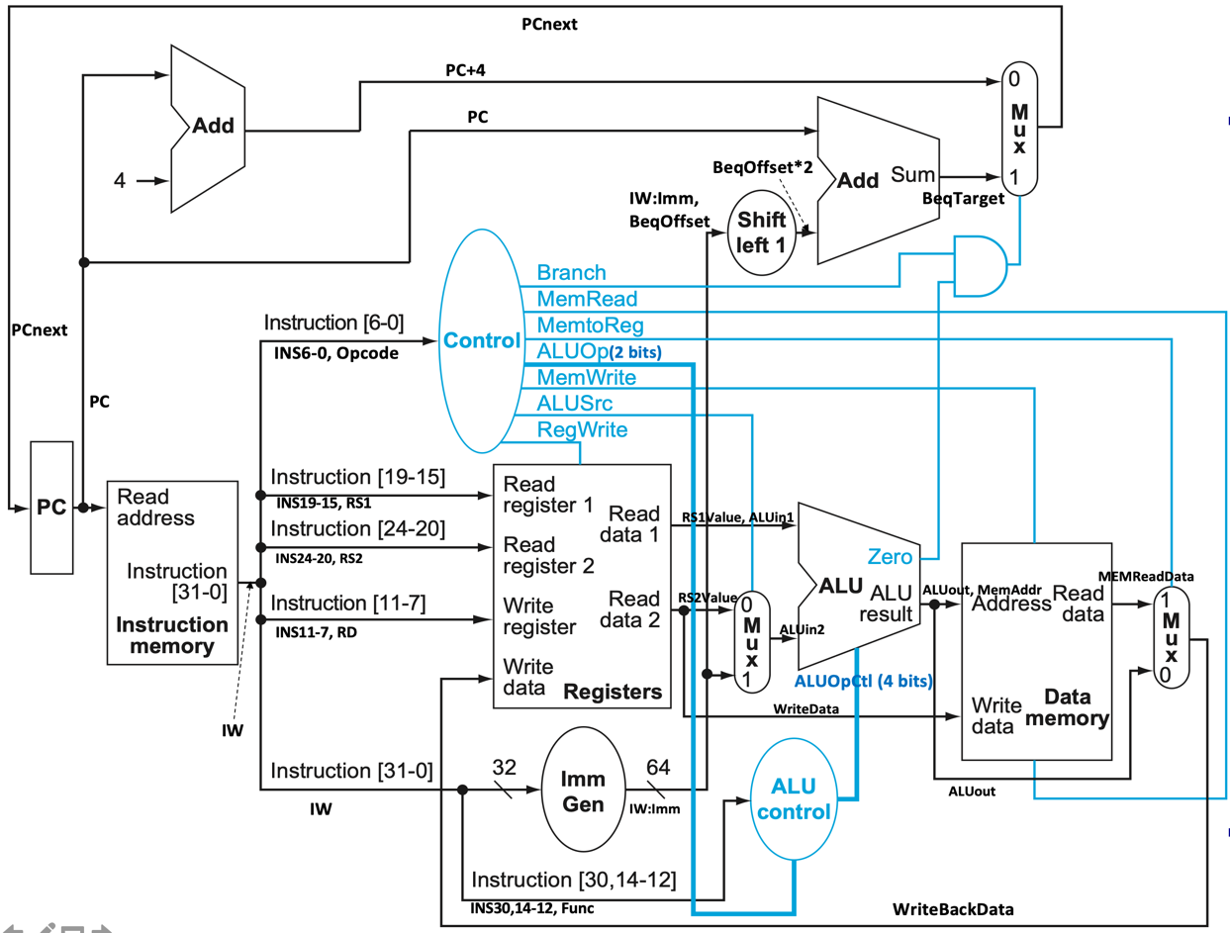
Register # | value
0 | 0
1 | 8
2 | 12
3 | 24
4 | 26
5 | 10
6 | 6

Memory Address | value
16 | 20
20 | 24
24 | 26
30 | 32
34 | 48
38 | 72

Instr Address |  | INS19-15, RS1 | INS24-20, RS2 | INS11-7, RD | RS1Value, ALUin1 | RS2Value | ALUin2 | ALUout | MEMReadData | WriteBackData | PCnext
2 | add x3, x2, x1 | 2 | 1 | 3 | 12 | 8 | 8 | 20 | X | 20 | 6
8 | sub x6, x4, x2 | 4 | 2 | 6 | 26 | 12 | 12 | 14 | X | 14 | 12
12 | Or x3, x2, x0 | 2 | 0 | 3 | 12 | 0 | 0 | 12 | X | 12 | 16
24 | addi x2, x4, 54 | 4 | X | 2 | 26 | X | 54 | 80 | X | 80 | 28
32 | lw x5, 18(x2) | 2 | X | 5 | 12 | X | 18 | 30 | 32 | 32 | 36
36 | sw x6, 12(x4) | 4 | 6 | X | 26 | 6 | 12 | 38 | X | X | 40
40 | bne x2, x4, 24 | 2 | 4 | X | 12 | 26 | 26 | -14 | X | X | 88
60 | beq x5, x6, 4 | 5 | 6 | X | 10 | 6 | 6 | 4(not zero) | X | X | 64

Your answer should be in the following table. Instructions are independently executed, i.e. instruction will not change register or memory after being executed. Datapath whose values are not used for the instruction can be marked X, even if they may have valid values. Branch target address is calculated by PC + #label * 2
Grading: 3 points for each instruction. For each instruction (see the color highlight in the table)
- Correct RS1, RS2, RS1Value and RS2 value 2 point
- Correct Rd, ALUin2, and ALUout 2 point
- Correct MEMout, WriteBackData and PCnext 2 point

- (10%) Based on the same diagram as Question 4, the following table shows the values of each control signals. For the ALU operation, English word for the operation, e.g. add, sub, etc are used instead of the actual bit code.

 | RegWrite | ALUSrc | ALU Operation | MemRead | MemWrite | MemtoReg
Add | 1 | 0 | Add | 0 | 0 | 0
Addi | 1 | 1 | Add | 0 | 0 | 0
Or | 1 | 0 | Or | 0 | 0 | 0
Load | 1 | 1 | Add | 1 | 0 | 1
Store | 0 | 1 | Add | 0 | 1 | 0
beq | 0 | 0 | Sub | 0 | 0 | x

Explain: a) why the ALU operation for load/store instructions is add operation? (2 points)
Because load/store instructions need ALU to perform add operation to calculate the effective address which is [rs1] + #Imm
b) why the ALU operation for beq instruction is sub operation? (2 points)
Because beq needs ALU to perform sub for the two source operands of beq to see whether the results is 0 or not. If the result is 0, the two source operands equal, which is used for the beq condition.
c) Why the ALUSrc control for add is 0 and for Addi/load/store is 1? (2 points)
ALUSrc is used to select which one from [RS2] or #Imm to use for the ALU Input 2, 0 is for selecting [RS2] and 1 is for selecting #imm. For add, the second operand is [RS2], thus ALUSrc is 0; and for addi/load/store, the second operand is #imm, thus ALUSrc is 1.
d) Why the MemRead is 1 for load, but 0 for store? (2 points)
MemRead is the control to indicate memory read operation, which is what load instruction performs. Store instruction perform memory write operation, and should not set MemRead control.
e) Why the RegWrite control is 1 for Add/Addi/Or/Load and 0 for Store/beq? (2 points)
RegWrite is the control to indicate that register write should be performed for the instruction, add/addi/or/load all need to write their results to register, thus they need to set RegWrite control. But for store/beq, no register write is needed, thus they should reset RegWrite as 0.

- (20%) Pipeline execution and RAW (Read-After-Write) data hazard. For the following RISC-V style instruction sequence,

addi x1, x0, 4
lw x2, 0(x1)
lw x3, 4(x1)
lw x4, -4(x1)
add x5, x4, x10
add x6, x3, x5
add x7, x2, x6
sw x7, 0(x1)

- Fill in the following table about RAW dependency between two consecutive instructions and also mark those RAW dependencies that are load-use.
Instruction that writes the register | Instruction that reads the register | The register | Grading:
addi x1, x0, 4 | lw x2, 0(x1) | X1
lw x4, -4(x1) | add x5, x4, x10 | X4 (load-use) | 2 points
add x5, x4, x10 | add x6, x3, x5 | X5 | 2 points
add x6, x3, x5 | add x7, x2, x6 | X6 | 2 points
add x7, x2, x6 | sw x7, 0(x1) | X7 | 2 points

Grading: 6 points in total for any three correct rows
- Draw the 5-stage pipeline execution using stage labels (IF, ID, EX, ME, and WB). CPU has no any forwarding, register files can be read/written in the same cycle, and instruction memory and data memory are separated. Use X to indicate a stalled cycle. (6 points) Grading: There are five RAW hazards and two delays for each. For each RAW/stall cycles correctly answered, one point. For the rest of the instruction pipeline, 1 point
- Draw the 5-stage pipeline execution using stage labels on the same CPU but with fully forwarding. (4 points) Grading: only Load-use hazard causes one cycle delay (2 points), and all others should have no delay (2 points).
- For the CPU with fully data forwarding, rearrange instructions to eliminate the stall(s) from load-use hazard and then draw the 5-stage pipeline execution of the rearranged instruction sequence. (4 points) Grading: see the re-ordering of the instruction in the answer. There are other solutions, but as long as load-use has one instruction in between, it is correct.

 | Cycles
b) No Forwarding | 1 | 2 | 3 | 4 | 5 | 6 | 7 | 8 | 9 | 10 | 11 | 12 | 13 | 14 | 15 | 16 | 17 | 18 | 19 | 20 | 21 | 22
addi x1, x0, 4 | IF | ID | EX | ME | WB
lw x2, 0(x1) |  | X | X | IF | ID | EX | ME | WB
lw x3, 4(x1) |  |  |  |  | IF | ID | EX | ME | WB
lw x4, -4(x1) |  |  |  |  |  | IF | ID | EX | ME | WB
add x5, x4, x10 |  |  |  |  |  |  | X | X | IF | ID | EX | ME | WB
add x6, x3, x5 |  |  |  |  |  |  |  |  |  | X | X | IF | ID | EX | ME | WB
add x7, x2, x6 |  |  |  |  |  |  |  |  |  |  |  |  | X | X | IF | ID | EX | ME | WB
sw x7, 0(x1) |  |  |  |  |  |  |  |  |  |  |  |  |  |  |  | X | X | IF | ID | EX | ME | WB
c) Full Forwarding
addi x1, x0, 4 | IF | ID | EX | ME | WB
lw x2, 0(x1) |  | IF | ID | EX | ME | WB
lw x3, 4(x1) |  |  | IF | ID | EX | ME | WB
lw x4, -4(x1) |  |  |  | IF | ID | EX | ME | WB
add x5, x4, x10 |  |  |  |  | X | IF | ID | EX | ME | WB
add x6, x3, x5 |  |  |  |  |  |  | IF | ID | EX | ME | WB
add x7, x2, x6 |  |  |  |  |  |  |  | IF | ID | EX | ME | WB
sw x7, 0(x1) |  |  |  |  |  |  |  |  | IF | ID | EX | ME | WB
d) Rescheduling
addi x1, x0, 4 | IF | ID | EX | ME | WB
lw x2, 0(x1) |  | IF | ID | EX | ME | WB
lw x4, -4(x1) |  |  | IF | ID | EX | ME | WB
lw x3, 4(x1) |  |  |  | IF | ID | EX | ME | WB
add x5, x4, x10 |  |  |  |  | IF | ID | EX | ME | WB
add x6, x3, x5 |  |  |  |  |  | IF | ID | EX | ME | WB
add x7, x2, x6 |  |  |  |  |  |  | IF | ID | EX | ME | WB
sw x7, 0(x1) |  |  |  |  |  |  |  | IF | ID | EX | ME | WB

