Part Two
- Shale or mudstone
Closeup photo
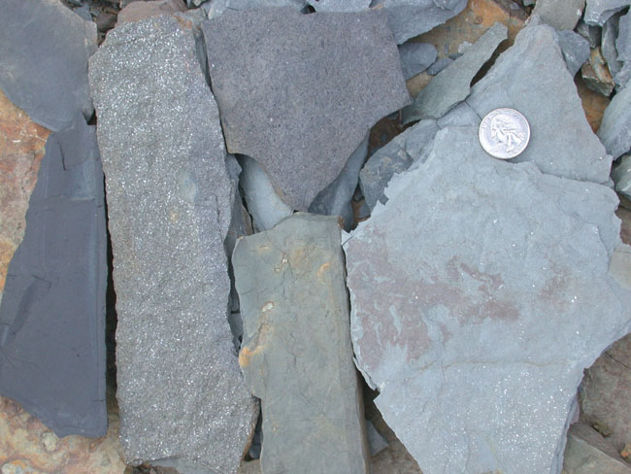
Photo of rock in nature
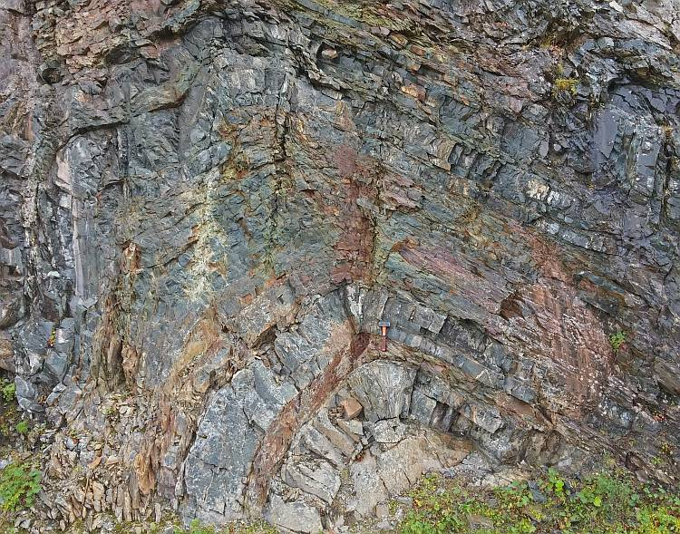
Depositional environment
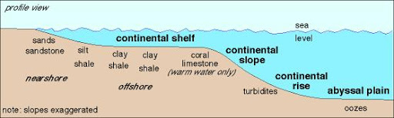
- Quartz arenite sandstone
Closeup Photo
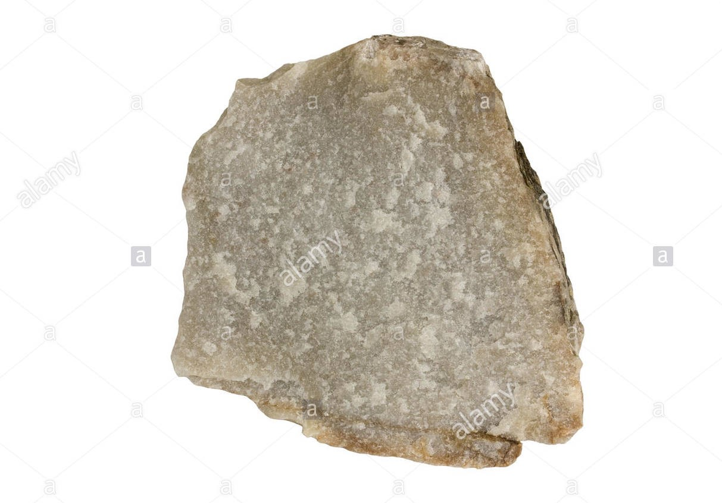

Photo in Nature
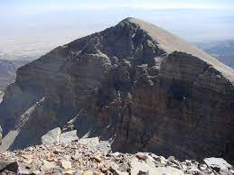
Depositional environment
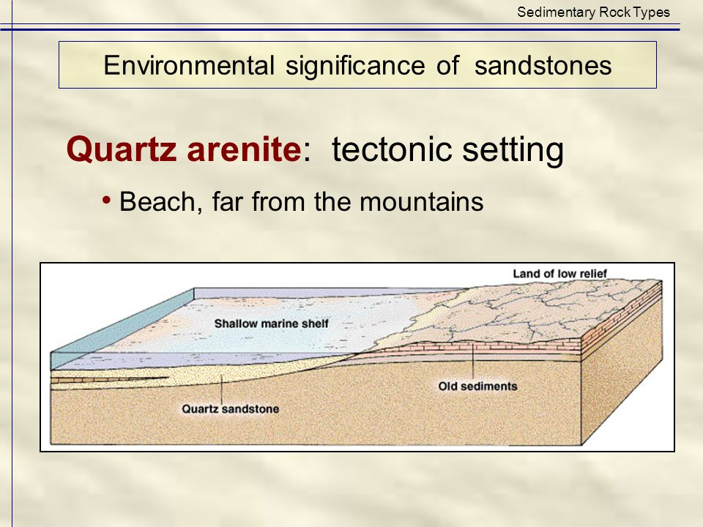
- Greywacke sandstone
Closeup photo
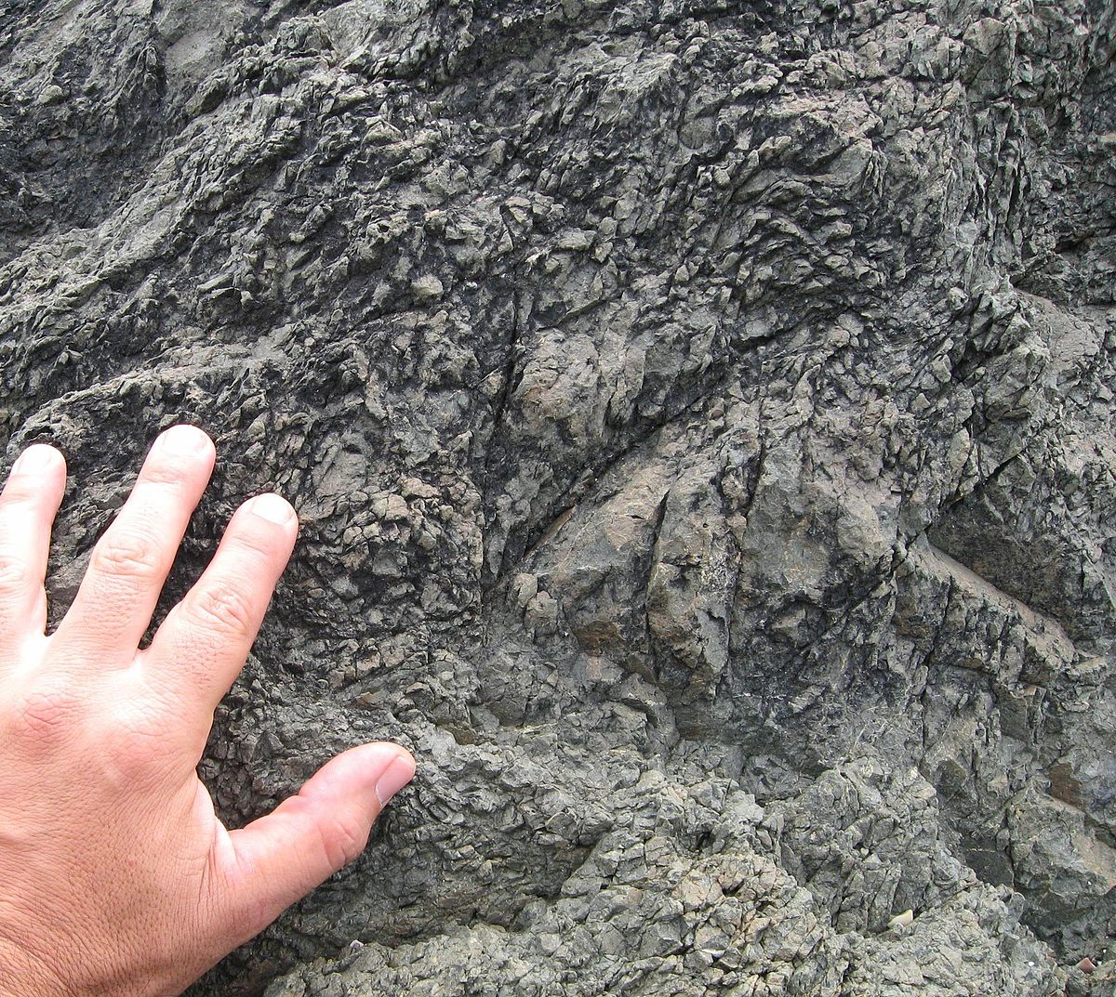
Photo in nature
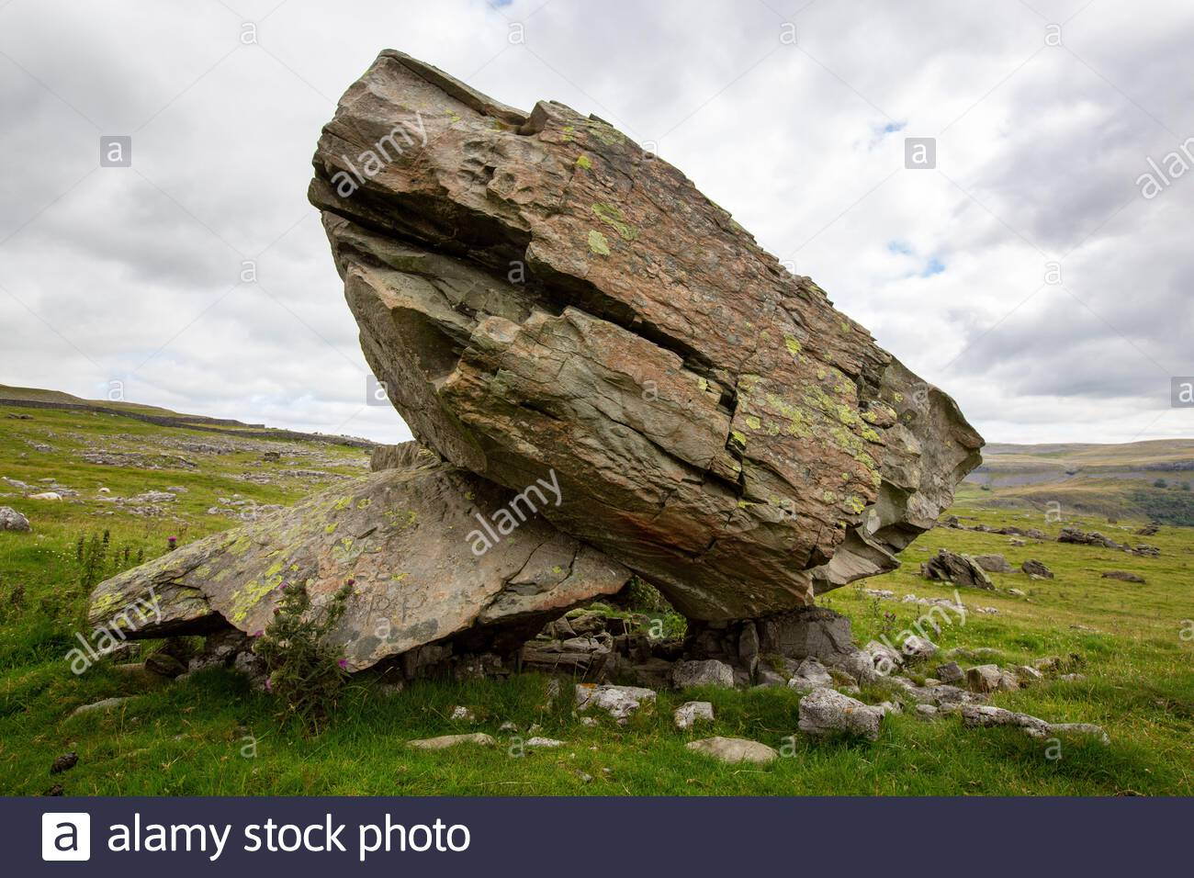
Depositional environment
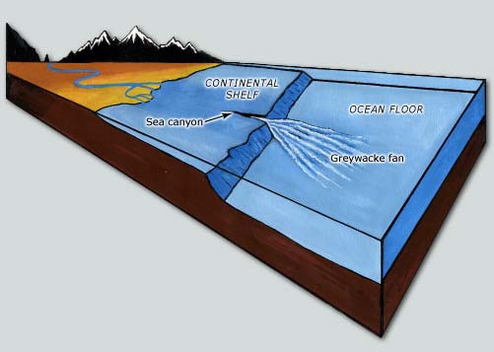
- Conglomerate
Closeup photo
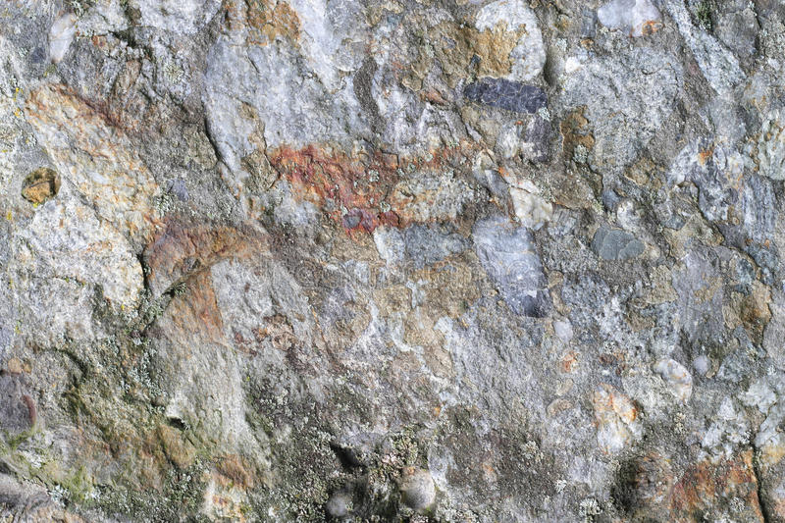
Photo in nature
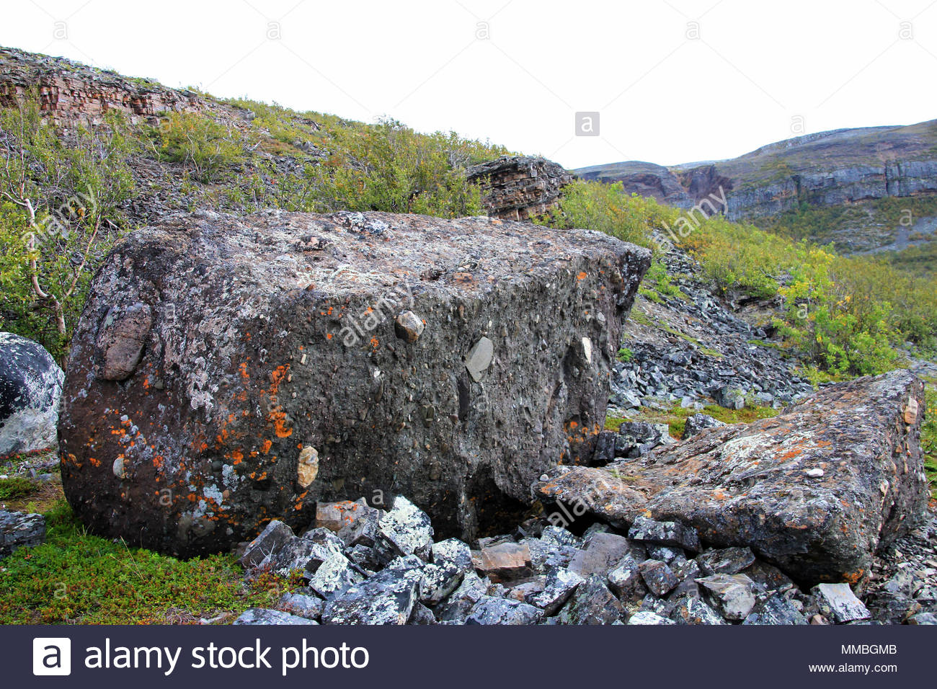
Depositional environment
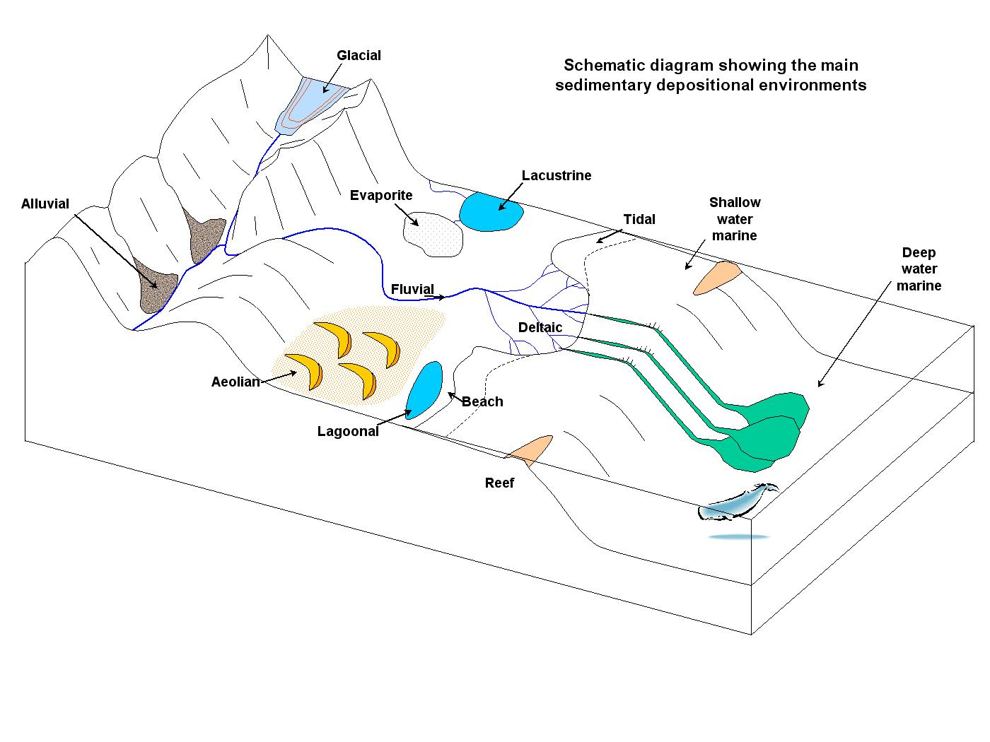
- Breccia
Closeup photo
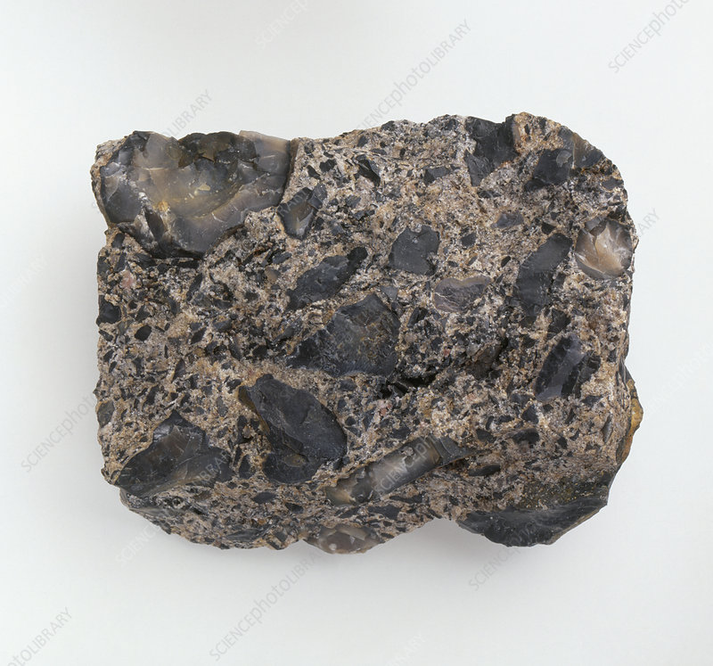
Photo in environment
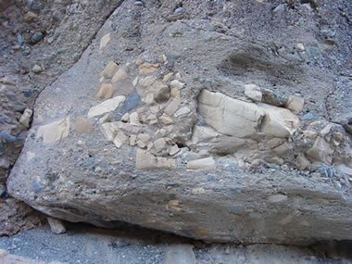
Depositional environment
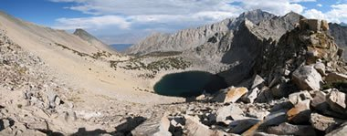
- Evaporite salt
Closeup photo
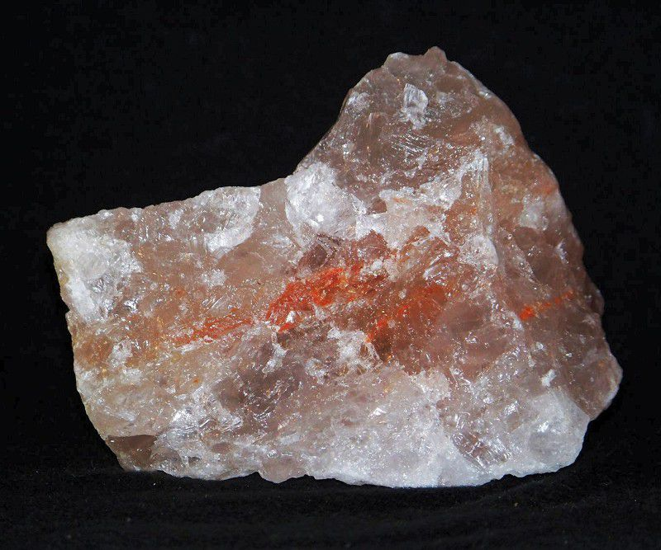
Photo in nature
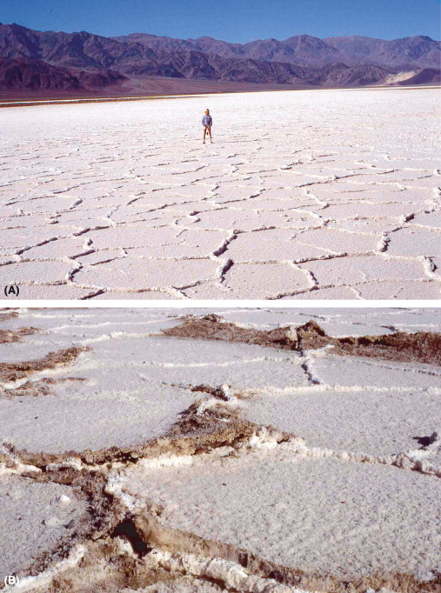
Depositional environment
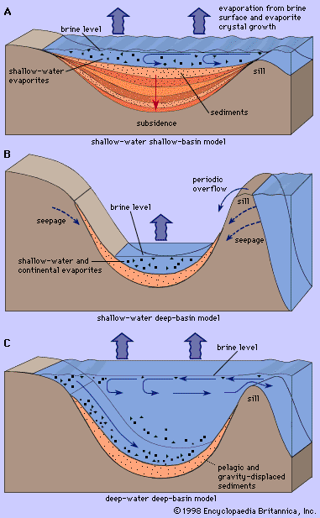
- Coal
Closeup photo
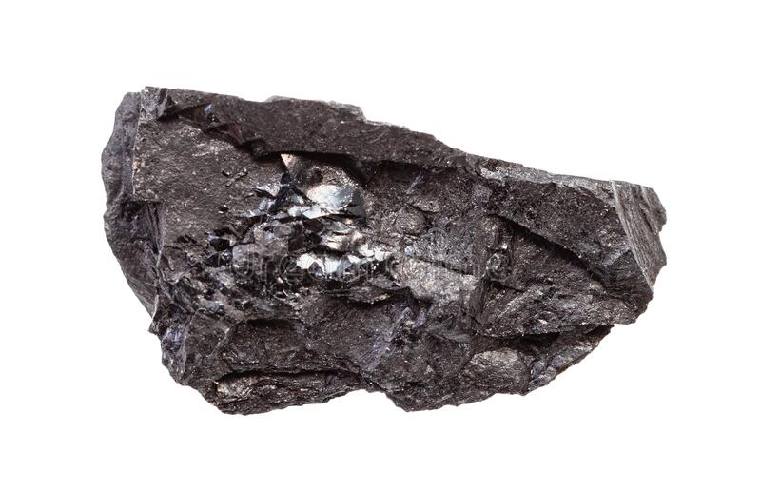
Photo in nature
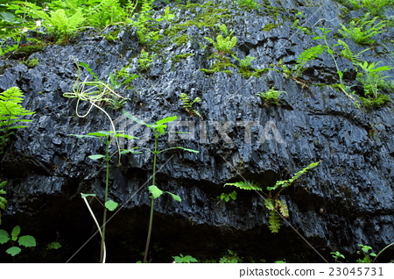
Depositional environment
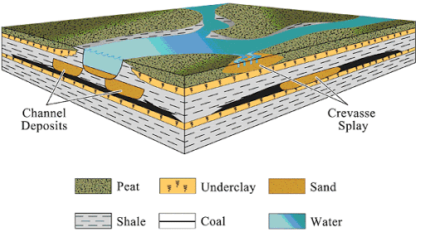
- Travertine limestone
Closeup photo
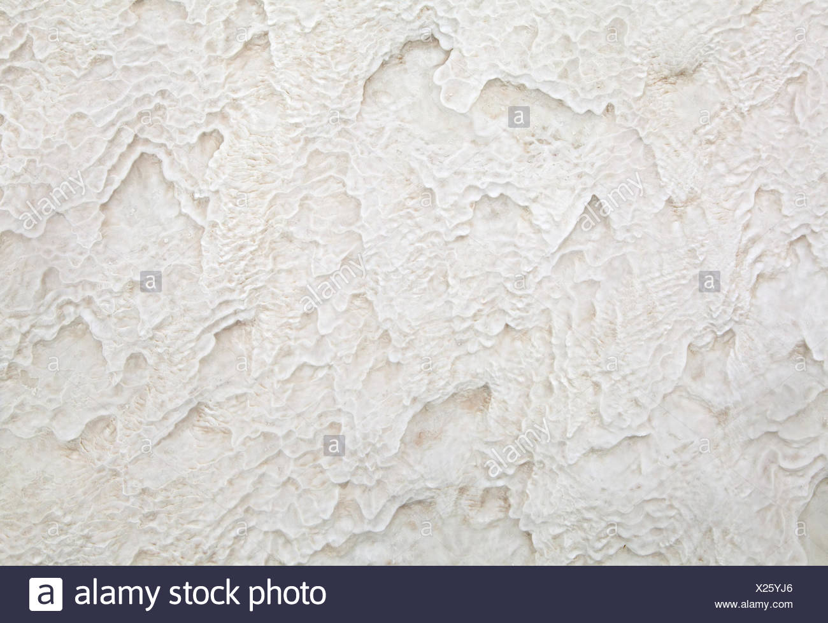
Photo in environment
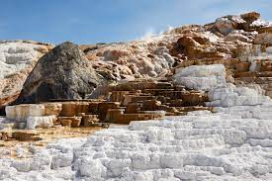
Depositional environment
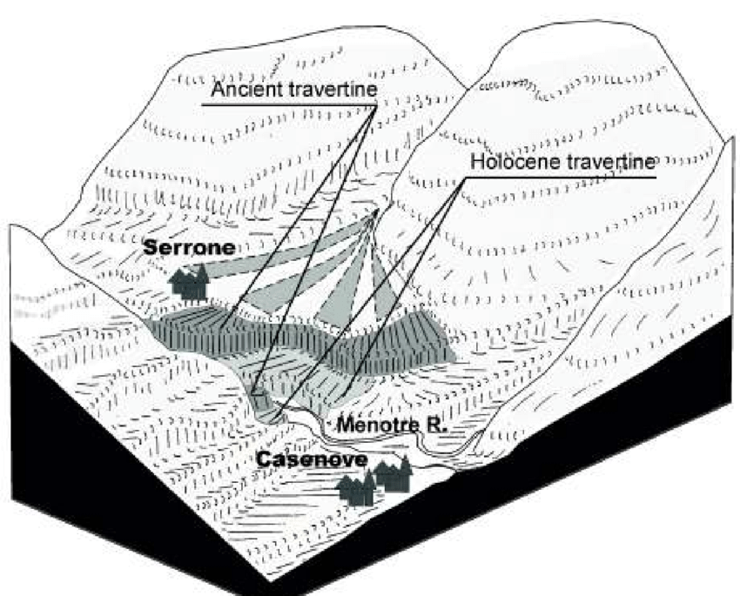
- Oolitic limestone
Closeup photo
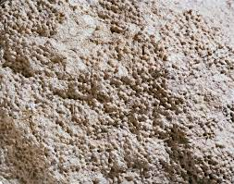
Photo in nature
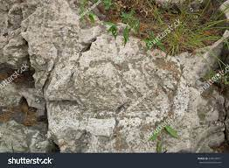
Depositional environment
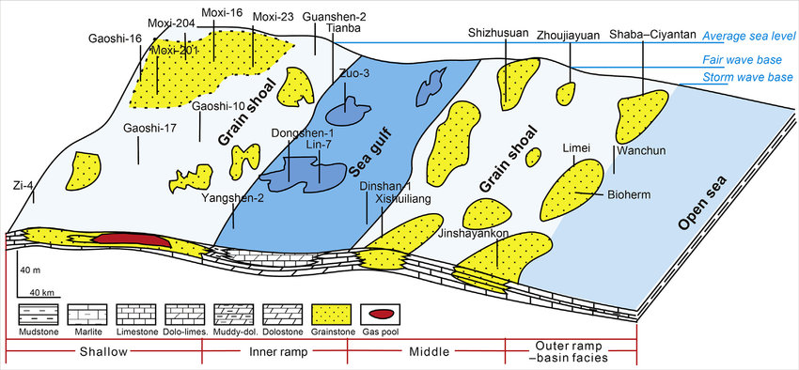
- Fossiliferous limestone
Closeup photo
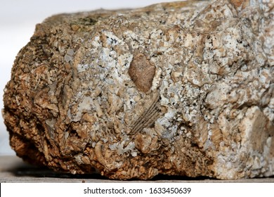
Photo in nature
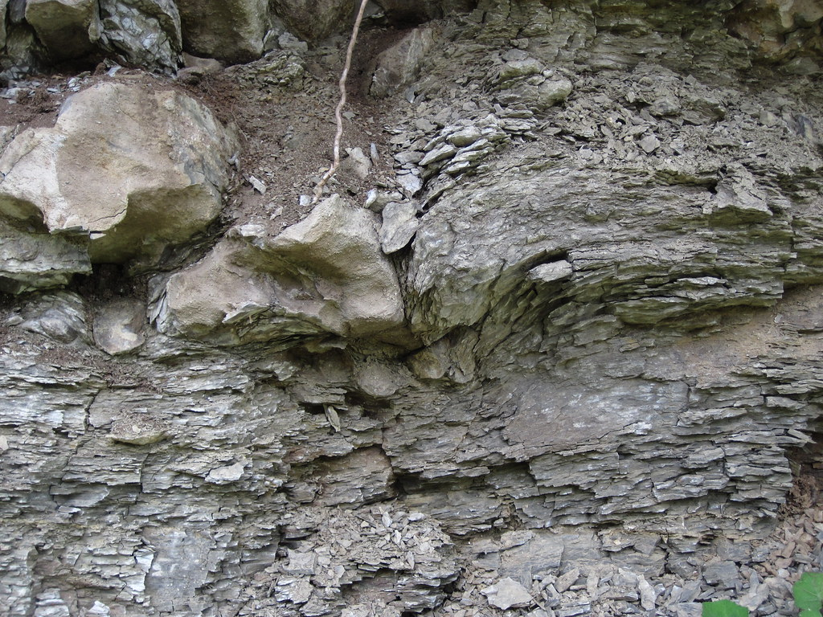
Depositional environment
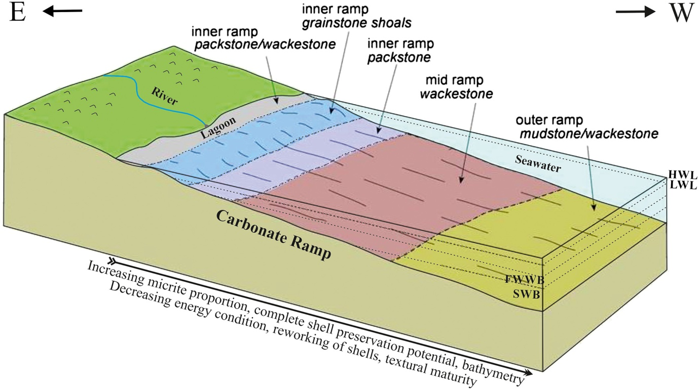
- Chert
Closeup photo
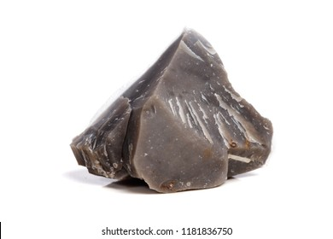
Photo in nature
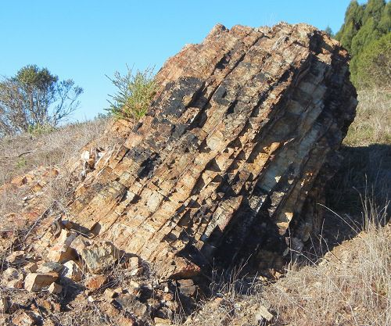
Depositional environment
- Branded iron formation
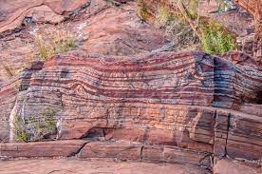

Part 3
How strata forms
Strata forms during sediment deposition.
How laminae forms
They form from cyclic changes in the supply of sediments.
How crossbedding occurs
It is formed by the downstream migration of bedforms such as ripples or dunes in a flowing fluid.
How mudcracks form
They form in very fine clay material that has dried out. As the moisture is removed, the surface will split into cracks that extend a short way down into the mud. The cracks form polygons on the surface of the mud.
Raindrop impressions
They form in mud during a shower.
Graded bedding
They form when a steep pile of sediment on the sea floor suddenly slumps into canyon or off a steep edge.
Ripple marks formation
They are formed by water flowing over loose sediment which creates bed forms by moving sediment with the flow.
Bioturbation (burrows)
Form from mixing of plant and animal materials in rocks.

