Exercise 8: Sedimentary Rocks and Their Depositional Environments
Geology Lab 111 Names_____________________________________________
This exercise has 3 parts.
Part 1. Identify all 8 of the sedimentary rocks in the bag labelled “Sedimentary.” Use this website, http://www.minsocam.org/msa/collectors_corner/id/rock_key.htm#Key, and its key to identify your rocks. Use this table (or something similar) to record your answers (24 pts):

Photo of rock  (1 pt each) | Name (2 pts each)
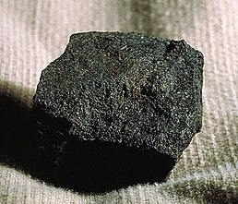 | Coal
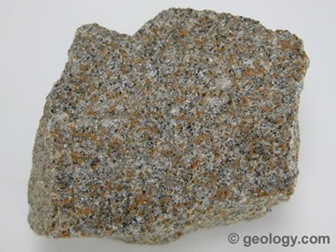 | Sandstone
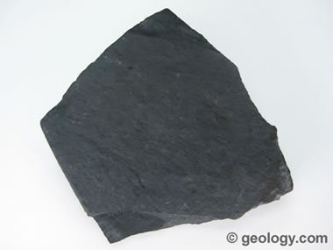 | Shale
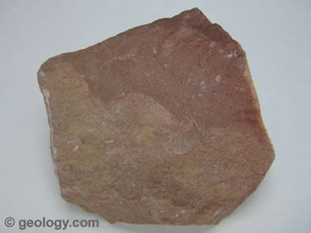 | Siltstone
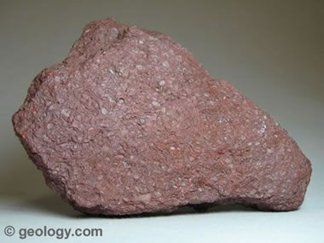 | Iron Core
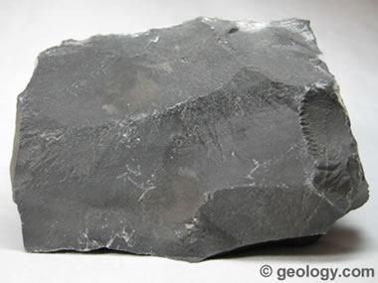 | Limestone
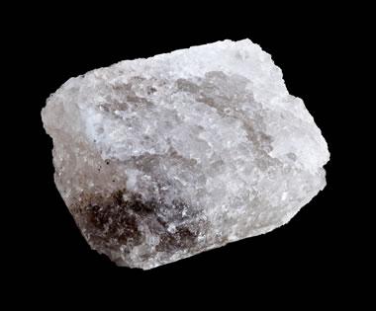 | Rock salt
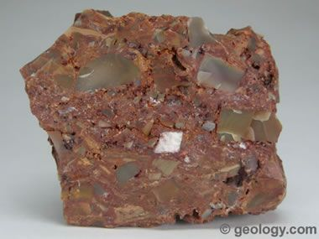 | Breccia

Use Google Slides, Google docs, Powerpoint, or Word to create Parts 2 and 3.

Part2. Show three images for the 12 sedimentary rock types below. (36 pts)
- Shale or mudstone
- Quartz arenite sandstone
- Greywacke sandstone
- Conglomerate
- Breccia
- Evaporite Salt
- Coal
- Travertine limestone
- Oolitic limestone
- Fossiliferous limestone
- Chert
- Banded iron formation
For each of the 12 you need: 1) a closeup photo of that rock (use your own photos for 8 of the 12 rocks); 2) a photo that shows that rock type in nature as part of an outcropping of rock; 3) a picture or diagram that illustrates the depositional environment in which that rock formed

Read more about depositional environments of sedimentary rocks here https://en.wikipedia.org/wiki/Depositional_environment

Part 3.Find photos of the following sedimentary structures and briefly explain how each of them form. (16 pts)
- Strata
- Laminae
- Crossbedding
- Mudcracks
- Raindrop impressions
- Graded bedding
- Ripple marks
- Bioturbation (burrows)

Websites that might be helpful:
https://en.wikipedia.org/wiki/Sedimentary_rock
https://geology.com/rocks/sedimentary-rocks.shtml

For every photo used in your atlas, give a copy of the url from which you took the photo.

