4’-hydroxychalcone, a possible novel nicotinic receptor modifier

Introduction:

Structure based drug design (SBDD) is a promising modern method for drug development. SBDD utilises the information from high-resolution 3D protein structures to predict structure-activity relationships. Further, it is also used for the identification and selection of therapeutically relevant targets and proteins. Other functions of SBDD include characterization of binding pockets, development of target specific compound libraries and optimization of lead compounds. SBDD is one of the most powerful emerging tools because of the high speed and low cost during drug design and development processes ^{[1]}. Furthermore, SBDD can also utilize data from Protein Data Bank (PDB) which is an online library containing the information of more than 130000 biological structures including 3D structures. This library was used as a database for this experiment with both imported template protein and the library for compound scanning coming from PDB ^{[2]}. This series of experiments were conducted with the aim to develop a receptor that contained (α4)₃(β2)₂ stoichiometry from the imported α₄β₂ nAChR structure. The receptor was then docked with a ligand library tested at the α₄α₄ interface of an α₄β₂ nAChR model, then a hit compound would be chosen for further optimization and evaluated as a potential drug molecule.

Methods:
To mimic the process of designing a novel drug based on our understanding of a biological target, the software Maestro was utilized.
Target Identification and ligand preparation workflow
Three reference compounds were constructed; NS9283, (S)-nicotine, and (-) -(1R, 2R, 4S) –epibatedine (shown in figure 1) and docked at the previously constructed allosteric site consisting of an α₄α₄ interface.

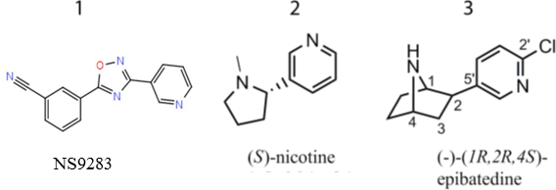

Figure 1. Chemical structure of NS9283, (S)-nicotine, and (-) -(1R, 2R, 4S) – epibatidine as neutral species.

These structures were then prepared using LigPrep (Maestro) to transform them into the form they would appear at physiological pH.
Grid Generation and Ligand Docking

A grid was then generated around the allosteric binding site in order to insert the ligands from the docking library.

Database screening
The lead compound with the highest docking score was selected by screening prepared structures imported from library 5 and docked as described above.
A lead compound was selected based on the highest docking score, molecular weight, Lipinski’s rule of five and noncovalent interactions.
Optimisation of lead compound
Receptor binding site characterization and identification of hydrogen bond acceptor/donor as well as hydrophobic region was performer using Sitemap tools (Maestro).
Addition of new relevant functional groups were made and the lead compound was selected based on the greatest improvement of docking score as well as conforming to Lipinski’s rule of five.
Results
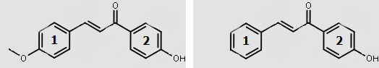
Figure 1: A comparative view of the 2 dimensional structures of the hit compound (Left) and lead compound (Right) as generated by students with rings labelled 1 and 2.

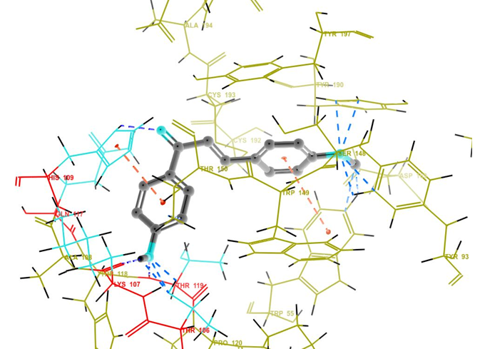
Figure 2: A theoretical docking pose of the hit compound in the allosteric site of α₄β₂ nicotinic receptor. The ligand-receptor complex contains several intermolecular interactions; hydrogen bonds (blue) between phenol hydroxide and Primary amines (Lysine 107, Threonine 119, 106), carboxyl lone pairs and heterocyclic imidazole (Histidine 109) and ester lone pair to hydroxide (Serine 148, Tyrosine 190) and pi-pi stacking (orange) between ring 1 to heterocyclic indole (Tryptophan 149) and ring 2 to heterocyclic indole (Tryptophan 118).
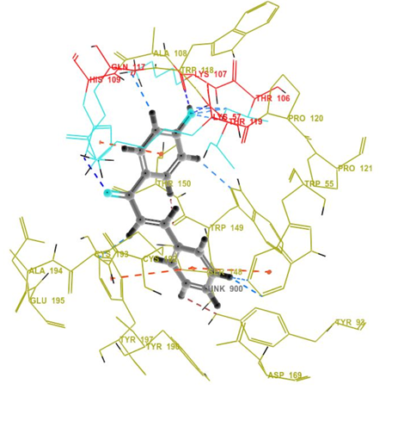
Figure 3: A theoretical docking pose of the lead compound in the allosteric site of α₄β₂ nicotinic receptor. The ligand-receptor complex contains several intermolecular interactions; hydrogen bonds (blue) between phenol hydroxide and Primary amines (Lysine 107, 57 and Threonine 119, 106), carboxyl lone pairs and heterocyclic imidazole (Histidine 109) and pi-pi stacking (orange) between ring 1 to heterocyclic indole (Tryptophan 55) and Phenol (Tyrosine 197) and ring 2 to heterocyclic indole (Tryptophan 118).
Table 1: A report of the docking scores generated by Prime software. Scores of natural and existing therapeutic ligands as well as research and student tested ligands with the Allosteric binding site of α₄β₂ Nicotinic receptor.
Ligand | Docking Score
Epibatedine | -7.588
Nicotine | -5.924
NS9283 | -5.798
Hit Compound | -9.618
Lead compound | -10.193

Discussion
Drug discovery has significantly advanced with the use of two techniques; computational screening and structure-based virtual screening. Rapid identification of quality lead compounds has significantly eased the discovery of potential therapeutic targets ^{[3]}. To effectively optimize the lead compound, it was modified randomly and tested following each modification. Pharmacophore mapping was used to differentiate generalized molecular features from anticipated biological activities ^{[4]}. The final lead compound was 4’-hydroxychalcone.

Docking interactions:
The optimized compound was created according to pharmacophore mapping, where favorable regions were potential sites for change. 4’-hydroxychalcone was created after removing the ether group from the hit (Figure 1). This resulted in an improved docking score of -10.193 and was due to hydrophilic and hydrophobic bonds positioned in more favorable positions. The removal of the Ether also strengthened the pi interactions for ring 1 (Figure 2), as electron withdrawing groups have been shown to weaken pi interactions ^{[5],} ^{[6]}. More pi-pi interactions were also observed between ring 1 and α₄β₂. These additional pi-pi stacks also increased the binding affinity of the drug through its enhanced stability ^{[7]}.

Docking:
The strength of the binding affinity of the ligand in the receptor site increased from -9.618 (hit compound) to -10.193 (lead compound). The lead compound also had a better docking score than all three references. The change of ring 1 from anisole to benzyl improved the docking score as more pi-stacks formed and existing ones were strengthened. This modification from the lead compound allowed a promising change in Gibbs binding free energy, as noncovalent bonds improved between the ligand and receptor ^{[8]}.

Molecular flaws:
The unsaturated Carbonyl, which is β to the electron withdrawing ketone group can act as a Michael acceptor. The Michael acceptor can be attacked by base for nucleophilic addition. This reactive center may make this compound unsuitable as a drug. Furthermore, chalcones have been known to react with DNA and be extremely allergenic, so off-site effects are likely to be many ^{[9], [10]}.

Lipinski’s rule of five:
Another simple judge of suitability for lead compounds is Lipinski’s Rule of Five. The optimized compound had a molecular weight of 224g/mol, 1 hydrogen bond donor, 1 hydrogen bond acceptor and a log P value of 3.59. Each of these passes Lipinski’s rule of five. However, the target is within the brain, so a higher LogP (5-7) would be desirable. In conclusion, the lead may be a candidate for future assessment.

References.
- Cavasotto, CN, & Phatak, SS 2009, Homology modeling in drug discovery: current trends and applications. Drug Discovery Today, 14, 676-83.
- Bank R. RCSB Protein Data Bank - RCSB PDB [Internet]. Rcsb.org. 2017 [cited 3 June 2017]. Available from: http://www.rcsb.org/pdb/home/home.do].
- Lyne PD. Structure-based virtual screening: an overview. Drug discovery today. 2002 Oct 15;7(20):1047-55.
- Yang SY. Pharmacophore modeling and applications in drug discovery: challenges and recent advances. Drug discovery today. 2010 Jun 30;15(11):444-50.
- Roberts JD, Caserio MC. Basic principles of organic chemistry. WA Benjamin, 1977 May 15.
- Bissantz C, Kuhn B, Stahl M. A medicinal chemist’s guide to molecular interactions. Journal of medicinal chemistry. 2010 Mar 26;53(14):5061-84.
- Boehr DD, Farley AR, Wright GD, Cox JR. Analysis of the π-π stacking interactions between the aminoglycoside antibiotic kinase APH (3′)-IIIa and its nucleotide ligands. Chemistry & biology. 2002 Nov 30;9(11):1209-17.
- Zavodszky MI, Kuhn LA. Side‐chain flexibility in protein–ligand binding: The minimal rotation hypothesis. Protein Science. 2005 Apr 1;14(4):1104-14.
- Michael A. Ueber die Addition von Natriumacetessig‐und Natriummalonsäureäthern zu den Aethern ungesättigter Säuren. Advanced Synthesis & Catalysis. 1887 Mar 21;35(1):349-56.
- Brunk D. Benzophenones named 2014 Contact Allergen of the Year. Dermatology News Digital Network (March 14, 2014), www. skinandallergynews. com/single-view/benzophenones-named-2014-contact. 2014.

