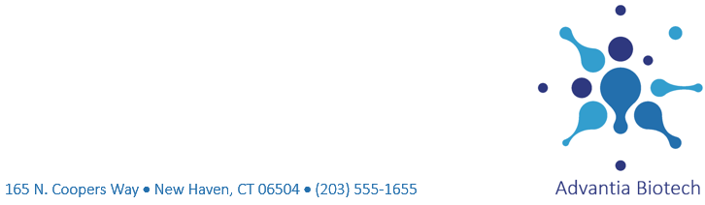
May 5, 2021

Dr. Tracy Lamont
Jefferson Healthcare
1245 Prince Street
Philadelphia, PA 10190
Dear Dr.Lamont:
Thank you for your interest in the upcoming Innovations in Biotechnology Conference running from May 10 to May 12 this year in Dallas, Texas. I have enclosed an information sheet that provides details about the conference and the program topics.
As you may know, the Innovations in Biotechnology Conferenceis the largest gathering of biotechnology experts from around the world. Some of this year’s featured topics include the following:
- Nano biotechnology
- Biosensors and biomarkers
- Analytics and diagnostics
- Regenerative medicine
I hope that one or more of those topics interests you and your colleagues. I look forward to meeting you if you attend the conference.
Sincerely,
Keisha Ballantyne
Director of Special Events
enc.

Seventh Annual Conference on

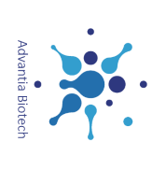
Innovations in Biotechnology
Hosted by Advantia Biotech
May 10-12, 2021 • Dallas, TX

Conference Highlights
The Innovations in Biotechnology Conference brings together hundreds of experts and leaders from biotechnology, pharmaceutics, and academia to share and discuss recent advances in biotechnology research and application.
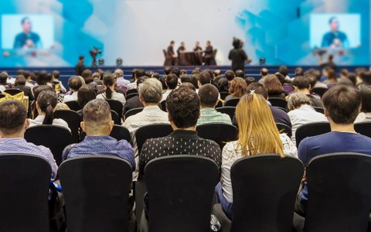

Why Attend?
Biotechnology depends on interdisciplinary interactions to spur research and applications in human, animal, and agricultural health and sustainability. The conference is designed to present a comprehensive, cogent snapshot of the field today, highlighting advances in research and practices that can be applied to future biotechnological challenges.
At the conference, you can meet and mingle with other professionals and academics committed to learning about biotechnology and contributing to advancements in the field. The annual Innovations in Biotechnology Conference is the largest gathering of biotechnology experts from around the world.

Who Attends?
- Leaders in biotechnology and pharmaceutical companies
- Experts in healthcare
- Scientists and technologists
- Researchers at academic, government, and financial institutions
- Members of the scientific press

Conference Programs
The conference programs are organized into four tracks.

Days 1 and 2 May 10 & 11
Topic | Track
Plant and agricultural biotechnology | 1
Food and nutritional biotechnology | 2
Nano biotechnology | 3
Environmental biotechnology | 4
Medical biotechnology | 3
Cell biology and immunology | 2
Biosensors and biomarkers | 1
Energy Research | 4

Day 3 May 12
Topic | Track
Marine biotechnology | 1
Industrial and microbial biotechnology | 2
Analytics and diagnostics | 3
Agricultural biotechnology | 1
Mechanics of biotechnology | 2
Regenerative medicine | 4
Applied biotechnology | 2

Dallas City Attractions

In the evenings, take advantage of performances, restaurants, and activities available in the city. Dallas has a free trolley that takes you from the Downtown neighborhood to Uptown and the Dallas Arts District. Dallas has 15 districts with dining, shopping, and nightlife in each one. The following table lists a few suggestions. See www.advantia.cengage.com for more.
District | To Do
Downtown | History museum
Uptown | BBQ restaurant
Arts | Theater

For More Information
Visit our website at www.advantia.cengage.com.
Brochure
Submit Abstracts
Registration

