F-Troo

SFTY 330 – Aircraft Accident Investigation

Scenario: “Zonk Air Accident”

Accident Case Number ERAU-330RL

This accident is fictional, but based on many true events. The characters and company are fictional.

Accident Scenario
Investigators:
Jake Dillion - NTSB
Party to Investigation:
Sharon Bair - Engine Representative
Dawn Smith- Airframe Representative

Nov 7, 2018
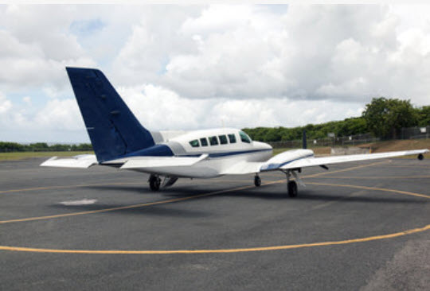
The charter pilot and four passengers boarded a light twin and departed Tahoe Airport (KTVL) at dusk, with the weather reported as two miles in lowering clouds and 900 feet overcast and deteriorating. The aircraft departed on Runway 18. The aircraft had arrived a day before from Burbank, CA and was returning to KBUR after a brief photo flight around the local area.
After takeoff, the aircraft rotated, entered the lowering mist. Approximately 5 miles past the departure end of the Runway 18, the airplane was seen exiting the clouds in a steep left “rolling like” bank, trailing smoke. It first impacted the top of a 100-foot communication tower. The next impact point, a ground impact scar with a red tip light was discovered 400 feet from the base of the tower. An additional ground scar with a green tip light was located 100 feet from the first ground scar. The aircraft came to rest 50 feet from that point. The aircraft burned. This was a fatal accident. There was no flight plan or radio contact with the aircraft after departure.
On-scene management tasks: It was determined that specific investigative organization and procedures were completed.
On-scene observations: It was determined the aircraft traveled at a specific angle and distance from the top of the a 100 foot communication tower, thence airborne-downward to the first ground impact 400 feet from the base of the tower. It was determined which wing impacted the ground first. All wreckage was twisted, partially burned, and crushed into a consolidated area.
The crushed portions of fuselage and wing roots had vertical soot marks. There were slipstream soot marks running along the side of the right engine nacelle, aft towards the remains of the right horizontal stabilizer, which had tiny emery light droplets of metal and soot. There was no such detail noted on the remains of the left horizontal stabilizer.
The engines were mangled. The right prop, however, showed span and chord wise striations with numerous classic "S" compressions on the trailing edges, as well as, the blade tips jagged, broken and pieces missing. Fire and impact made inspection of other components nearly impossible. NOTE: Follow-up lab tear downs were made difficult by the burn and impact damage. However, the expert inspections revealed the right engine was developing some power at time of impact, however, the left engine showed no evidence of significant power via signatures from gear, cooled metal exhaust ducting, and analysis to the props. It was noted on the left engine that the fuel line support bracket appeared to have some propagation cracks along the boltholes that connected to the firewall, but it had not separated from the firewall bracket and the fuel line showed no cracks or breech of integrity.
The left engine nacelle showed evidence of some vertical dark residue marks or soot trails. The engine was severely damaged by impact and burned. The left prop was intact; the tips were bent aft, and the blades showed little sign of trailing edge compression. The left propeller remained attached to the left engine and investigators noted that the blades were secure in their grips, and the blade angles corresponded to a feathered position relative to normal direction of flight.
The cockpit and passenger areas were crushed and destroyed, mostly beyond recognition. The seats were broken and twisted. Evidence showed this was a non-survivable accident. Rescue crews had removed the bodies, cutting the restraint systems. The county coroner retained control of the bodies and had indicated massive blunt trauma as the cause of death for all occupants. Toxicology reports on the pilot were negative.
All instruments were destroyed. The throttle quadrant was damaged, but did show all levers, props, throttle, mixture and feathering levers to be pushed forward-into the cockpit panel. Rescue personnel at the scene were unsure if they had disturbed any devices, controls or levers. Initial cable tracing showed integrity, but due to burning and impact damage, actuator positions were inclusive.
The large cargo trunks had burned, but some remnants were distributed in the aft cabin, but larger parts of the trunks and contents were also noted scattered in the cockpit area and outside, forward of the crash site. No tie down straps or other restraint cables were noted in the wreckage.
It was determined the 1980 PA-31-310 had a max gross weight of 6500 pounds. The mishap aircraft had an empty weight of 3900 pounds. It was determined the aircraft was carrying 1000 pounds of fuel. It was determined the four passengers had a combined weight of 800 pounds, the pilot weighed 180 pounds and the 4 cargo trunks weighed approx. 900 pounds. It was determined the center of gravity of the aircraft was aft and outside the normal envelope datum based on time the aircraft was loaded with the cargo.

Follow-up Observations:
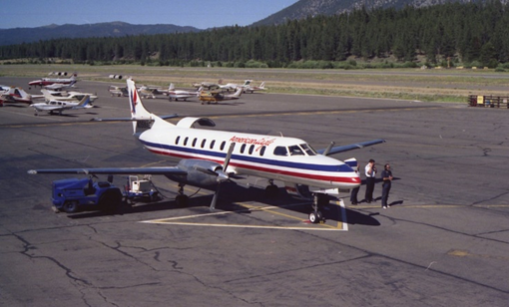

It was determined that Lake Tahoe Airport (KTVL) is an FAA certified airport. The mishap aircraft departed on Runway 18.
It was determined that at the time of the mishap the airport density altitude was within operating limits of a properly operating PA-31.
It was determined that this was a sunset photo flight within 20 miles of the airport with a return to the same airport or with an option to continue to Burbank, CA. The flight departed under visual flight rules (VFR) and visual meteorological conditions (VMC). There were 4 passengers, one pilot and 4 trunks of camera and photo equipment.”

It was determined the newly hired (one year) pilot possessed a commercial multi-engine instrument rating. The pilot had a total of 300 hours, 50 hours in twins with 15 hours in make and model of the mishap aircraft. The pilot had 5 hours of actual instrument meteorological condition (IMC) flight time. He had completed three flights with the principle company, Zonk Air, all day light, VFR sightseeing tours. Prior to working at Zonk Air, the pilot was employed in Arizona, flying a light twin, Part 91, for a solar panel company. Prior to that, the pilot received multi-engine flight training from a FBO, called “Super Pilot” based in Arizona, but it is no longer in business.
Prior to the mishap, the pilot had not flown for Zonk Air in over ten days. In addition, the pilot, on return from the mishap flight would be two days over his “grace” period for a Part 135-check ride. However, due to a lack of pilots, and urgency of the flight, management told the pilot to take the flight.
It was determined that the aircraft, N517RL (fictional) was a 1980 PA-31-310 twin engine, turbo-charged “Navajo” with Lycoming IO-540 reciprocating engines. The aircraft has a max gross weight of 6500 pounds. It was determined this aircraft had an empty weight of 3900 pounds. Total time on the airframe was 15,000 hours+ the engines had been rebuilt, however, now, both were within 10 hours of Time Before Overhaul (TBO). The aircraft was within 2 hours of its next 100-hour inspection. The aircraft was considered “airworthy” by the company and possessed an FAA registration, airworthy certificate and Form 337. Ten years prior, the mishap aircraft was seized by the DEA from a drug smuggler. Most of the aircraft’s original paperwork and records were lost during a shoot-out and subsequent fire at the smuggler’s hanger.
After sitting in government storage for two years, the aircraft was auctioned off to a civil operator. The aircraft was sold several times over and operated from the Arctic and Florida in various cargo and charter operations.
It was determined there was an Air Worthiness Directive (AD) issued three days prior to the mishap for a cracking of fuel line support brackets. The AD stated to inspect and or remove/replace. There was no indication of AD compliance though the aircraft was to receive a100-hour inspection on the conclusion of the flight.
It was determined the operator of this aircraft was “Zonk Air Charters” based in Oxnard, CA. Zonk Air operates three aircraft, a PA-31 (mishap aircraft) and two 1979 Cessna 310s. Most of the charter business is related to scenic flights, etc. The company is certified for Part 135 and Part 91 operations. There are six part-time pilots, the owner, and secretarial staff. Maintenance is contracted out to another operation on the field. Zonk Air has had no accidents in the past, but has been cited by the FAA for “failure to maintain proper records in accordance CFR 135 operations.”

Training and flight proficiency were accomplished by the owner/operator who is a designated Part 135 check airman. Pilots are called in to fly; they do the pre-flight, file a flight plan, obtain weather, load the passengers, and execute the mission. Maintenance of the aircraft is contracted out to various vendors.

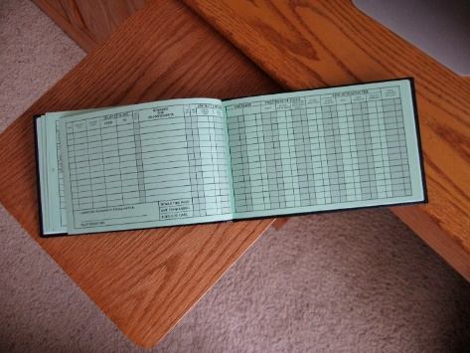

A review of maintenance records indicated some aircraft logs are incomplete and lacking some sign-offs. Pilot records were noted to be incomplete and often showed no dates of the 135 check rides or line checks though personal logbooks of some pilots did reflect such information. There were no records to indicate that the pilot had attended any formal flight training from a recognized and certified flight safety training company.

It was determined that Zonk Air had been up for sale for two years and was delinquent in paying fuel bills and maintenance inspections. The company was in the process of filing for Chapter 11, bankruptcy protection.

Zonk Air had no formal dispatching or flight monitoring system, but does have an operations manual stating the need for such requirements. There was no documentation to show pilots received any human factors training or a company manual or procedures for an SMS program. Currently, there is some FAA ambiguity on what constitutes an SMS program for small operations. Though SMS is highly recommended, specific mandated procedures have not been totally adopted and placed into rules. The general theme repeated by the pilots as told to them by the owner is, “never be unsafe, but try and be creative before aborting a flight.”


Interviews with the maintenance personnel said that about ten days prior to the mishap, the accident pilot "thought" there was a possible power loss and noted a few minor fuel droplets below the right engine on a preflight, but ground tests conducted by another line pilot could not duplicate the problem. The owner stated he was aware of the rough running engine and a few drops of fuel, but it was "just the nature of this aircraft.” There was one maintenance entry approximately 15 hours before the mishap that indicated work was done on the right engine to correct a small “seep” of the fuel line gasket and readjust the turbo waste gates. On the morning of the mishap, the pilot called Zonk Air stating there were, again, small fuel drips coming from the right engine. The manager/owner stated it was probably an old vent/fuel cap leaking a bit, which was normal for this old aircraft after top-off. Note, the vent/fuel cap was burned at the crash site and pre-accident quality was not determined.
The mechanic that usually serviced the company aircraft was no longer employed and had moved. However, his A&P was valid. The maintenance company, “Wrench and Fix” that serviced the PA-31 did not have experience working on PA-31 aircraft, but did service a few light twins that came to Oxnard, CA. The maintenance operation had no major FAA violations, except for some minor “record management issues.” The company indicated they worked on the mishap aircraft but noted no squawks listed from the company. However, it was not unusual for Zonk Air to request that a mechanic come over and take a “quick gander” at something before they wrote up the squawks as was the case with the leaky fuel drops on the right engine.
It was determined there were a list of deferred maintenance items on the aircraft that included; repair loose cooling baffling on the right engine, tightening friction controls on the cockpit power quadrant adding cargo nets and straps to the aircraft flight kit, as well as inspecting and replacing first aid kits, adjusting the pilot’s seat springs and locking the travel adjustment slide on the pilot’s seat.
It was determined that no VFR or IFR flight plan was filed nor a weather report provided to the mishap aircraft.

Witness Interviews:
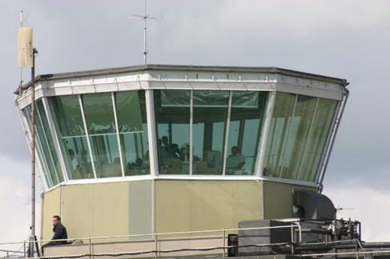

WIT-1: Air Traffic Controller at TVL tower confirmed ATIS information to the mishap aircraft and provided taxi and take-off instructions. The ATC personnel advised the pilot that it was marginal VFR and asked if he was requesting an IFR clearance? Pilot stated no, he would pick up an IFR clearance enroute, if needed. The tower operator again commented the weather seemed to be really going down to the south and the mountain peaks were beginning to get obscured. “The pilot, replied, that he had better “scoot it on out of here.” The airport went officially IFR a short time after the mishap. The controller gave taxi clearance, watched the plane taxi directly to the hold short line, then request take-off. He did not observe any run-up prior to take-off. After take-off, he observed the plane use about ¾ length of the runway, rotate, then suddenly, to what he perceived, continue and enter an abrupt and very high angle of pitch. The controller then lost sight of the aircraft as it disappeared in the mist past the end of the runway. The controller advised the pilot to report clear, but never received a reply. About 10-15 minutes later the controller was advised by local law enforcement of a possible aircraft down south of the airport.
WIT-2: The “Tahoe FBO Service” fuel attendant/line tech had, one hour prior to the departure, “topped off the tanks” and asked the pilot where he was going. The pilot stated it was a local flight of about 45 minutes, but wanted “extra gas” in case the clients wanted to go home to Burbank. The pilot seemed “rushed” and was getting “anxious” about the fast changing weather. The fuel truck driver also helped the pilot load four or five large, “like metal sea trunks marked photo gear” into the back passenger compartment of the plane. The fuel attendant asked where the tie down straps or netting was and the pilot stated he would secure the stuff later. The fuel attendant estimated the trunks had to be near 100 pounds each and were stacked on top of one another.



WIT-3: A secretary for the Tahoe FBO Service said she greeted the passengers of the mishap flight and directed them to the ramp. She heard one the passengers jokingly tell the pilot to hurry-up or they would leave without him. The pilot approached the counter and paid the fuel bill with a company credit card.
WIT-4: A geologist standing at the departure end of the runway looked up as the plane crossed over and noted, “lots of yellow sparks or flame coming from the right engine, then the plane disappeared into the mist.” He thought he heard a “boom” a short time later but couldn’t be sure.



WIT-5: A retired LAPD police helicopter pilot working as a bartender at the airport café saw the plane depart and wondered if the “guy was going IFR” as the weather was quickly going down at the airport. He said he saw some smoke coming off the right engine and though he didn’t actually see it, “knew the right engine had flames.” The WIT was sitting on the east side of the field with a view perspective of only the left side of the aircraft as it rolled by.


WIT-6: A vacationing ERAU professor was standing in the parking lot mid-field and commented to her husband “about how fast the weather was changing and then noted the mishap aircraft rotating off the runway with a smoking right engine. She thought she saw some flames coming from the right engine, but, “it went by pretty quick” so she couldn’t be sure. She was standing on the south side/west of the field and could see the right side of the aircraft.

WIT-7: A forest ranger was on the roadway, about 5 miles from the airport when he saw an airplane “just come out of the mist,” strike the tip of the tower and crash. He immediately called 911 and attempted to reach the crash site, but was blocked by rough terrain and mud.

Company Interviews:



WIT-8: A Zonk Air staff member, the part-time bookkeeper, indicated the owner told the pilot several times that this (mishap flight) was a last minute, urgent “hot flight with good money making potential so do it up right and give them a good show.”

WIT-9: Another company pilot stated he had called in sick and so the “new guy” was to take the flight. He said, the “new guy” was a good kid, but seemed tired all the time. He said this was a last minute deal and didn’t leave the “new guy” with much time to get to the airport and take the flight.



WIT-10-12: Numerous employees for the company said the new pilot was seen many times sleeping in the crew lounge before flights. He was, they said, going through a break-up with a girlfriend and didn’t want to go “home.”

WIT-13: The owner/operator said he knew the pilot was a “bit tired,” but wanted to work. He thought the pilot had passed a 135-check ride, but couldn’t find the records or recall giving him a flight test. The owner told the pilot, “This was a pretty straightforward” gig however, “Don’t take any chances.” The owner also stated the new pilot, to his knowledge, had never flown to Lake Tahoe before, but did think the pilot had some mountain experience from previous jobs. There were no records to indicate that the pilot had any mountain flying experience, as the pilot logbook was never located.
End of Information Briefing

