Name
Grade | /50
- When you select SAVE AS, please add your name to the file title.
- Please submit the completed study guide on or before midnight Sunday.
- This study guide contains only selected portions of each chapter.
- The page numbers refer to the eREADING BOOK and its (pdf numbering)
- Write in the answers rather than copy and paste to learn the spelling
- Some answers may be used not at all or more than once in each section.
If screen size of the online book under eResources is too small, or if the page numbers are not visible, activate the adobe tool bar or click on the right hand scroll button. If that does not help, DOWNLOAD the file for each chapter and open it on your computer (instead of online) using ADOBE or ACROBAT, the pages may be easier to see and scrolling will be much more user friendly.
CHAPTER 18: CARDIOVASCULAR SYSTEM: BLOOD, P. 737 -776 (2-40)
18.1 FUNCTIONS OF BLOOD: plasma , platelets, WBCs, RBCs, buffers 738-739(2-3)
 | 1 | Erythrocytes (erythro = red) cells that carry gases
 | 2 | Leukocytes ( leuko = white) defend us from disease bacteria
 | 3 | Pale straw colored fluid which is mostly water
 | 4 | Clotting factors that block ruptured vessels to prevent blood loss
 | 5 | Proteins that regulate blood pH to keep it close to 7.4
Hematocrit: If you take a sample of blood and centrifuge it in a tube, the plasma will separate from the red blood cells and both can be measured. The suffix "emia" means "a serious condition of the blood . The prefix "an" means "lack of" and the prefix "poly" means "many".
FIGURE 18.2 COMPOSITION: normal, anemia, polycythemia (some terms used twice) 739(3)
 | 1 | About 45% of blood is RBCs, about 55% is plasma components
 | 2 | Less than 10% of blood is RBCs, about 90% is plasma
 | 3 | More than 65% of blood is RBCs, about 35% is plasma
 | 4 | Serious condition of a lack of RBCs (depressed hematocrit)
 | 5 | Serious condition of too many RBCs (elevated hematocrit)
18.1 CHARACTERISTICS OF BLOOD: Please give the units for all numerical answers! 739(3)
 | 1 | What is the normal average temperature of blood.
 | 2 | What is the range of blood pH in a healthy person?
 | 3 | What is the normal temperature of blood in °C?
 | 4 | What percentage of a normal adult weight is composed of blood?
 | 5 | How many liters of blood are in an average adult male?
 | 6 | How many liters of blood are in an average adult female?
18.1 BLOOD PLASMA: 92%, 8% 739 (3)
 | 1 | What % of blood is composed of water?
 | 2 | What % of blood is composed of proteins, electrolytes & gases ?
We can tell that a chemical is a protein because it ends in the suffix "in" or "en". If that protein is an enzyme it will end in the suffix "ase". By contrast, carbohydrates often end in the suffix "ose" and lipids often end in the suffix "oid" or "one".
18.1 BLOOD PROTEINS: albumin, globulin, fibrinogen, antibodies (immunoglobulins) 740(4)
 | 1 | Specialized proteins produced by WBCs to destroy bacteria
 | 2 | Essential blood clotting protein, produced by liver
 | 3 | Alpha, beta, gamma forms transport vitamins, provide immunity
 | 4 | Most abundant protein that provides osmotic pressure (viscosity)
HEMATOPOIESIS: "Poiesis" is the "the process of creating", and "hemato" is "blood". In adults, RBCs are produced at a rate of about 2 million per second...and destroyed by the liver at a rate of 2 million per second...so ultimately the number remains stable. Immature "blasts" or "baby" stem cells have a nucleus, but mature Red (erythro) cells (cytes) lack a nucleus so they cannot divide and must constantly be replenished from the hematopoietic tissues in the bone marrow. On the average a RBC lives for about 120 days. Because there is no nucleus, the flat round RBC is biconcave (like a life-saver) and can roll easily. The absence of a nucleus and other organelles means the erythrocyte has more space for the transport of oxygen and carbon dioxide which are carried on the 300,000,000 hemoglobin molecules inside each cell.
18.2 SITES OF HEMPOIESIS before birth, after birth 742 (6)
 | 1 | Yolk, liver, spleen, red bone marrow, lymph nodes
 | 2 | Red bone marrow of major bones, liver, spleen
FIGURE 18.4 HEMATOPOIETIC SYSTEM hemocytoblasts, myeloid stem cell, lymphoid stem cell 743(7)
 | 1 | Multipotent hematopoietic stem cell
 | 2 | Platelets, erythrocytes, basophils, neutrophils, eosinophils, monocytes
 | 3 | NK, T and B lymphatic cells are derived from this stem cell.
18.2 GROWTH FACTORS erythropoietin, thrombopoietin 743 -744 (7-8)
 | 1 | Hormone that stimulates formation of erythrocytes (RBCs)
 | 2 | Hormone that stimulates formation of thrombocytes (platelets)
18.3 ERYTHROCYTES TRUE OR FALSE? 747 (11)
 | 1 | A mature RBC is a biconcave disc.
 | 2 | A mature RBC lacks a nucleus
18.3 HEMOGLOBIN Find the numbers (see the paragraph below the image) 748(12)
 | 1 | How many oxygen molecules can each hemoglobin carry?
 | 2 | How many hemoglobins in total are in one red blood cell?
 | 3 | How many oxygens in total can one red blood cell carry?
18.3 HEMOGLOBIN TRUE OR FALSE? 748 (12) (Look at Figure 18.7 as well)
 | 1 | In polycythemia, the blood becomes too viscous (thick).
 | 2 | Hypoxemia is low blood oxygen
 | 3 | Hemoglobin has an iron (Fe) center
 | 4 | Hemoglobin contains 2 alpha and 2 beta protein chains
 | 5 | Bright red blood contains oxygen so is called oxyhemoglobin
 | 6 | Dark red blood has lost oxygen so is called deoxyhemoglobin
18.3 LIFE CYCLE heme, globin, ferritin, hemosiderin, biliverdin, bilirubin, urobilin 749(13)
 | 1 | Iron found inside a hemoglobin molecule
 | 2 | Protein portion of hemoglobin
 | 3 | Storage forms of iron, found in the liver or spleen (2 answers)
 | 4 | Yellow-green protein waste (verdi = green.)
 | 5 | Yellow-red protein waste (rubin = red ...aka "ruby")
 | 6 | Yellow protein waste found in urine (uro = yellow)
Error in book p. 751: Sickle cell is far more common in North African, Mediterranean and Middle Eastern populations than it is in people of general African descent. Individuals with sickle cells are less likely to develop malaria since the Plasmodium falciform needs normal round RBCs in order to reproduce. As a result sickle cell anemia provides some protection from fatal malaria. People can survive to have children, who inherit their sickle cell traits. Malaria is the most common fatal disease in the world, followed closely by tuberculosis.

18.3 DISORDERS OF THE RED BLOOD CELLS
sickle cell anemia, polycythemia, thalassemia, aplastic anemia, pernicious anemia 751-752(15-16)
 | 1 | High altitude adaptation process of forming many RBCs
 | 2 | Poor absorption of vitamin B12
 | 3 | Mediterranean form, inherited hemoglobin malformation, ironically this form protects against malaria.
 | 4 | Radiation, medications, chemotherapy destroy RBC shape
 | 5 | North African form, inherited malformation of alpha and/or beta proteins in hemoglobin, also provides malaria protection.
LEUKOCYTES: WHITE BLOOD CELLS
Some useful prefix meanings: baso = basic, cyto = cell, dia = through, eosino = acidic, leuko = white, lympho = lymph, macro = large, mono = one or alone, neutro = neutral, ped = foot
Some useful suffix meanings: em = blood , ia = serious condition , in = protein, gen = to create, lysis = breakdown, oma = mass, osis = condition, phil = to love, pen = lack,
CHARACTERISTICS OF LEUKOCYTES & FIGURE 18.10 EMIGRATION
diapedesis, chemotaxis, macrophage, cytotoxic chemicals 752-753(16-17)
 | 1 | Wounded cells release prostaglandins act as "chemical taxis" to transport immunoglobullins and WBCs to injured tissues.
 | 2 | WBCs squeeze through capillary pores to infection site, like a food (ped) though (dia) a door....
 | 3 | Neutrophils "eat" (phage or engulf) pathogens
 | 4 | Chemical toxins from eosinophils destroy pathogens
18.4 CLASSIFICATION OF GRANULAR LEUKOCYTES neutrophil, eosinophil, basophil 754(18)
 | 1 | Tiny neutral grains, "ambulance" - rapid responders to infection
 | 2 | Large pink (eosin) grains - abundant only if you have worms
 | 3 | Large blue (basic) grains - produce histamines that cause swelling
18.4 AGRANULAR LEUKOYCTES NK, B cells, T cells, monocytes 754-755 (18-19)
 | 1 | Large "janitors" clean up debris and worn out cells
 | 2 | Natural killer kill unusual "non-self" cells - cancer, pathogens...
 | 3 | Bone marrow cells that produce antiBodies (Immunoglobulins).
 | 4 | Thymus cells released on demand as aggressive killers! (Terrible mercenary cells)
18.4 LEUKOCYTE DISORDERS leukopenia, leukocytosis, leukemia, lymphoma 755(19)
 | 1 | Excessive WBC production
 | 2 | Inadequate WBC production
 | 3 | Many immature, non-functional WBCs
 | 4 | Masses of non-functional T or B cells in lymph nodes
CLOTTING FACTORS 760 (24):
We will only cover two factors of the 13 platelet factors: FIBRINOGEN AND PROTHROMBIN. For prothrombin enzyme to cause thrombin formation, calcium from damaged cells and oxygen from the air (in an open wound) must be present. The thrombin enzyme will then cause the fibrinogen in the blood to form fibrin (sticky fibers) that will seal the wound so the red blood cells and platelets can no longer escape, plasma may still seep out until the fibers harden to form a scab. Please note that if any of the 13 factors are missing, then a wound will not clot! So the process is far more complex than indicated, but the two factors selected give you an idea of how it works.
18.4 PLATELETS Thrombocytes, thrombocyctosis, thrombocytopenia 755-756(19-20)
 | 1 | Insufficient platelets, blood does not clot properly
 | 2 | Platelets
 | 3 | Too many platelets, blood clots form easily (thrombosis)
18.5 HEMOSTASIS: hemorrhage, vascular spasm, plug, coagulation 757-758(21-22)
 | 1 | Uncontrolled bleeding lasting longer than 3 minutes
 | 2 | Constriction of a damaged blood vessel to slow bleediing.
 | 3 | Platelets clump together to weakly stem fluid leakage
 | 4 | Process of forming a fine sticky fibrin mesh between RBCs
18.5 CLOTTING FACTORS: fibrinogen, fibrins, prothrombin, thrombin (see the note above)
 | 1 | Precursor to thrombin
 | 2 | Enzyme that causes fibrinogen to be activated
 | 3 | Enzyme that causes fibrin to be generated
 | 4 | Sticky fibers that seal an open wound
18.5 FIBRINOLYSIS/PLASMA ANTICOAGULANTS
Plasmin, anticoagulant, antithrombin, heparin 761(25)
 | 1 | Any substance that prevents coagulation (ie aspirin)
 | 2 | Substance that prevents prothrombin from forming thrombin.
 | 3 | Insects bite and introduce this specific protein into the wound to prevent clotting while they drink your blood.
 | 4 | Plasma protein dissolves scab connections so it falls off
18.5 DISORDERS OF CLOTTING Hemophilia, thrombus, embolus 761-762(25-26)
 | 1 | Non-moving clot that "throbs" with pain
 | 2 | Clot (bolus) that moves in the blood (em)
 | 3 | Serious condition of excessive bleeding

FIGURE 1: BLOOD TYPING & FIGURE 2: AGGLUTINATION (See the diagrams at the end of this file) In the discussions this week you will look at your own particular blood type to determine what blood types you can donate to and from whom you can safely receive blood.
18.6 BLOOD TYPING Antibodies, antigens, agglutination, hemolysis 762-763(26-27)
 | 1 | Plasma proteins produced by B cells that attack foreign bodies
 | 2 | Proteins forming a recognizable pattern on the surface of RBCs.
 | 3 | Process of plasma antibodies attaching to surface antigens to cause sticky clumps that are "glued" together.
 | 4 | Process of lysis (breakdown) of blood
There are actually about 495 proteins that can be found on blood! But A, B, AB, O and Rh (D) are the most common..... so those are the only ones we will discuss.
18.6 ABO BLOOD GROUP A, B, O, AB 763(27)
 | 1 | A antigens on RBC surface, B antibodies in plasma
 | 2 | B antigens on RBC surface, A antibodies in plasma
 | 3 | NO antigens on RBC surface, A and B antibodies in plasma
 | 4 | A and B antigens on RBC surface, NO antibodies in plasma
18.6 Rh BLOOD GROUPS Rh +, Rh -, hemolytic disease of the newborn, RhoGAM 763-765(27-29)
 | 1 | These people will never produce Rh antibodies in their plasma
 | 2 | These people produce Rh antibodies, after exposure to the antigen
 | 3 | Mom is Rh- but baby is Rh+. The baby may be at risk if Rh antibodies form in mom's blood and cross the placenta!
 | 4 | Substance that ties up Rh plasma antibodies in an Rh- mom's blood so they cannot cross the placenta to the RH+ baby.
In preparing blood for a transfusion, the blood is centrifuged so that the RBCs and plasma can be separated. The plasma is discarded since it can contain many nasty antibodies and it is replaced with physiological saline solution which has no antibodies. Even so, every blood sample must be tested for every transfusion since the recipient may synthesize antibodies to the foreign blood.
18.6 ABO TRANSFUSION PROTOCOLS universal donor, universal recipient 765(29)
 | 1 | Type AB can receive A, B, AB or O type blood
 | 2 | Type O can donate to anyone, but receive only from O types.

CHAPTER 19: CARDIOVASCULAR SYSTEM: HEART, P. 777 - 825 (1-60)
The heart circulates DEOXYGENATED blood through the lungs first to pick up oxygen and disposed of carbon dioxide. The OYXGENATED blood then is pumped through the entire body to replenish cells.
19.1 LOCATION OF HEART True or False? 778-779 (2-3)
 | 1 | The heart is located in the abdominal cavity.
 | 2 | The heart is located in the thoracic cavity
 | 3 | The pericardial sac surrounds the heart
 | 4 | The Thymus gland is above the heart
 | 5 | The heart is between the right and left lungs
19.1 CIRCULATION THROUGH HEART & FIGURE 19.4 p.782 (6)
FIGURE 3 : HEART CIRCULATION (See the end of this file). Trace the flow of blood through the heart. NOTE: All vessels that come from the hear t are arteries, all vessels carrying blood to the heart are veins. The statements below are in order of normal directional flow for easy study purposes. Multiple Choice: Choose the correct terms from the ones in parentheses.
 | 1 | Blood from the head travels down into the right atrium (RA) through the (superior vena cava (SVC), inferior vena cava (IVC))
 | 2 | Blood travels from the lower body into the right atrium through the (superior vena cava, inferior vena cava)
 | 3 | Blood from the superior vena cava (SVC) & inferior vena cava (IVC) travels to the (right atrium (RA), right ventricle (RV), left atrium (LA), left ventricle (LV))
 | 4 | From the RA blood must pass through the  (mitral valve, pulmonary semi-lunar valve, tricuspid valve)
 | 5 | After passing through the valve (TV) from the RA, blood goes to the (left atrium, left ventricle, right ventricle, pulmonary trunk)
 | 6 | From the right ventricle (RV), blood flows past what valve?  (mitral valve, pulmonary semi-lunar valve, tricuspid valve)
 | 7 | After entering the pulmonary trunk (PT), deoxygenated blood enters the right & left lungs via the pulmonary (arteries, veins)
While in the lungs, the blood discharges the CO2 and picks up O2 and returns to the heart
 | 9 | After leaving the lungs, the oxygenated blood returns to the heart via the (pulmonary arteries (PA), pulmonary veins (PV))
 | 10 | The first heart chamber that blood enters after leaving the lungs is the (right atrium, left atrium, right ventricle, left ventricle)
 | 11 | From there the blood must pass through which valve ?  (Tricuspid (TV), Pulmonary semi-lunar (PSL), mitral valve (MV))
 | 12 | After passing through the bicuspid (or mitral) valve, what chamber will the blood enter? (right ventricle (RV), left ventricle (LV))
 | 13 | From this strong muscled chamber the blood will pass into the aorta through the (aortic semi-lunar valve (ASL), mitral valve (MV))
 | 14 | After passing through the semi-lunar valve the blood can go to all areas of the body via the (superior vena cava SVC), aorta (A))

To check your work, here are the directional acronyms:
SVC→IVC→RA→TV→RV→PSLV→PT→PA→LUNGS→PV→LA→MV(BV)→RV→ASLV→A
Please learn this directional flow by heart so the heart structures are more readily remembered.

19.1 SURFACE FEATURES right coronary, left coronary, great cardiac, circumflex artery 783-4(7-8)
Figure 19.15 arteries and veins. 796 (10)
 | 1 | Arteries and veins that service the cardiac muscles on right side
 | 2 | Arteries and veins that service the cardiac muscles on left side
 | 3 | Major (large) vessel to both ventricles
 | 4 | Artery that circles to the back of the heart
Figure 19.9 Shows the internal structures of the heart.
19.1 LAYERS myocardium, epicardium, endocardium 784-785(7-8)
 | 1 | Outside of heart
 | 2 | Inside of heart
 | 3 | Muscles of heart
FIGURE 3: CONDUCTION SYSTEM: The SA node acts as a "pacemaker" to control how fast the heart beats. The signal is sent quickly across both atria to make them contract together, forcing the blood into the corresponding ventricles. The closing of the TV and MV make a LUBB sound. The two ventricles then receive an electrical signal via the bundle of HIS and the signal quickly passes to the right and left branches and to the tiny nerve fibers to cause both ventricles to contract simultaneously. The closing of the ASLV and PSLV make a DUBB sound.
Figure 3: Look at the conduction system at the end of this file.
19.2 CONDUCTION: SA nodes, AV node, Bundle of HIS, bundle branches, purkinjes 801-803(25-27)
 | 1 | Pacemaker sends signal to nodes in the atrial sacs of the heart
 | 2 | Signal from SA node goes to node between the ventricles
 | 3 | AV node signal goes via this nerve bundle to a point between the ventricles. (The bundle is labeled in Fig. 19.18 in your book.)
 | 4 | Signal goes to right and left ventricles via these branches.
 | 5 | Signal goes to all the tiny nerve cells in the ventricles
Figure 4: Look at the EKG diagram at the end of this file.
19.2 ELECTROCARDIOGRAM & Figure 19.23: P wave, QRS complex, T wave 805-807 (29-31)
 | 1 | Both atria depolarize (contract)
 | 2 | Both atria relax and both ventricles contract
 | 3 | Both ventricles relax
Your heart beats an average of 72 to 75 beats per minute (BPM). That is a little less than 1 second per beat. This is called EUCARDIA (eu = true) Any rate over 90 BPM is called TACHYCARDIA. Any rate less than 60 BPM is called BRADYCARDIA.
19.2 HEART BLOCK: First degree, Second degree, Third degree, bradycardia 810-811 (34-35)
 | 1 | Signal from SA to AV node is delayed occasionally.
 | 2 | Signal from SA sometimes does not reach the AV node
 | 3 | Signal from SA never reaches the AV node
 | 4 | AV node assumes pacemaker role, but it is very slow
19.3 CARDIAC CYCLE P. Systole, diastole 812(36)
 | 1 | Contraction
 | 2 | Relaxation
FIGURE 19.28: P wave, QRS complex, T wave 814(38)
 | 1 | Both atria depolarize (contract)
 | 2 | Both atria relax and both ventricles contract
 | 3 | Both ventricles relax
FIGURE 19.28 P wave, QRS complex, T wave (using medical terms) 814(38)
 | 1 | Atrial systole
 | 2 | Atrial diastole and ventricular systole
 | 3 | Ventricular diastole
Lubb dubb...lubb dubb...lubb dubb...lubb dubb...lubb dubb....lubb dubb...lubb dubb...lubb dubb....
19.3 HEART SOUNDS Lubb, dubb, murmur, AV defect, SL defect 814-815(38-39)
 | 1 | AV valves (tricuspid & mitral) snap closed
 | 2 | SL valves (pulmonary & aortic) snap closed
 | 3 | Swishing sound heard if the valves do not close properly
 | 4 | Lubb swish dubb (Opps! The mitral valve is leaky!)
 | 5 | Lubb dubb swish (Opps!The arotic valve is leaky!)
19.4 CARDIAC PHYSIOLOGY CO, SV, HR 816(40)
 | 1 | Average resting stroke volume is 70 ml (milliliters) per beat
 | 2 | Average resting heart rate is 72 to 75 BPM
 | 3 | Cardiac output = SV x HR = 70 ml x 75 BPM = 5250 ml/min
CONTROL OF HEART RATE: The cardiovascular centers of the brain control the stimulation of the pacemaker of the heart. If you have "sympathy" for someone, you will usually "help" them, so a sympathetic nerve action, usually "increases" a response. Conversely a parasympathetic signal, will slow a response. While we cannot stop or start the cardiac, or vagus nerve, impulses to our heart, we can speed them up or slow them down, by thoughts or actions. For example, you can speed up your heart by aggressive, angry thoughts and slow it down by deliberately mellowing out. You can speed up your heart by exercise or slow it down by sleeping!
19.4 CARDIOVASCULAR CENTERS Parasympathetic, sympathetic 818(42)
 | 1 | Medulla oblongata signal decreases heart rate
 | 2 | Medulla oblongata signal increases heart rate
19.4 CARDIOVASCULAR CENTERS vagus nerve, cardiac nerve 818(42)
 | 1 | Medulla oblongata signal decreases heart rate via this nerve
 | 2 | Medulla oblongata signal increases heart rate via this nerve
19.4 FACTORS INFLUENCING HEART RATE & TABLE 19.1: 821-822 (45-46)
Which actions Increase sympathetic heart rate and which factors decrease heart rate?
 | 1 | Elevated K+, Na+, O₂, sleep, decreased thryoid hormones
 | 2 | Nicotine, caffeine, decreased K+, Na+, O₂, exercise, increased T₃

CHAPTER 20: CARDIOVASCULAR SYSTEM: BLOOD VESSELS P. 837-902 (0-82)
FIGURE 20.3 STRUCTURE OF BLOOD VESSELS: Artery, vein (terms used twice) 840(4)
 | 1 | Thick wall in strong round vessel able to withstand pressure
 | 2 | Thinner flexible walls, not able to withstand strong pressure
 | 3 | Carries high pressure blood from the heart to the body cells
 | 4 | Carries low pressure blood to the heart from the body cells
20.1 ARTERIES True or false 842 (6)
 | 1 | Major arteries have thick muscular walls
 | 2 | Arteries carry oxygenated blood from the heart to the body cells
20.1 ARTERIOLES True or false 843(7)
 | 1 | Walls of arterioles are thinner than major arteries.
 | 2 | Vasoconstriction is a narrowing of the lumen of an arteriole
 | 3 | Vasodilation allows more blood flow through the arteriole
FIGURE 1: CAPILLARY BED. See the image at the end of this report. Large arteries and small arterioles carry high pressure oxygenated blood to tissues, but actual gas exchange only occurs in capillary beds. Venules and large veins carry deoxygenated, low pressure blood back to the heart.
20.1 CAPILLARIES & FIGURE 20.6: capillary, metarteriole, precapillary sphincter 843-844(7-8)
 | 1 | A transition vessel where an arteriole meets a capillary
 | 2 | A vessel with 1 layer of endothelium where gas exchange occurs.
 | 3 | A circular muscle that pinches to regulate flow into capillary bed
20.1 VENULES, VEINS veins, venules 845-846(10-11)
 | 1 | Tiny vessels that receive deoxygenated blood from capillary bed
 | 2 | Larger vessels with valves to prevent back flow.
20.2 BLOOD PRESSURES systole, diastole 849-850(13-14)
 | 1 | Pressure of contraction of the heart
 | 2 | Pressure of relaxation of the heart
 | 3 | What is normal blood pressure (systole/diastole)?

NORMAL BLOOD PRESSURES: 160→120→80→30→15→2→0→15→160
When blood first enters the aorta, the pressure can reach 160 torr, but by the time it reaches your upper arm, pressure has dropped to 120 torr. In the arm the pressure continually drops as it passes into smaller vessels such as the arterioles (80 torr) and capillaries (30 torr). Once the blood leaves the capillary bed where gas and water exchange occurs, the venules (15 torr) and larger veins (2 torr) take the used blood back to the heart. The veins need valves to prevent back flow since the driving pressure is so low.

By the time the blood flows through the veins and reaches the right atrium of the heart, the pressure is 0 torr. The right ventricle forces blood into the lungs at about 15 torr and then after the blood reaches the left ventricle, the strong ventricular contractions cause the blood to shoot out into the aorta at 160 torr once again.

HIGH BLOOD PRESSURE: Alarm signals (Headaches) are felt if our blood brachial (arm) blood pressure approaches 190 torr. This means that the pressure in the aorta is over 250 torr and the pressure of blood to the brain is most likely over 200 torr, which can lead to a stroke. A stroke occurs when the tiny aneurysms and vessels in the brain burst. The blood accumulating in the brain in those areas cannot leave easily so brain cells will start to die. If the dying areas are in the right side of the brain, the left side of the body will fail to function properly. Conversely, if the damage is on the left side of the brain, the right side of the body may fail to function properly.

Fig. 20.11 PULSE SITES: Use Fig. 20.11 to find the medical names for the pulse points. 852(16)
 | 1 | Wrist (on the same side as the thumb)
 | 2 | Neck (This is the strongest pulse)
 | 3 | Temple (This is what you rub when you have a headache)
 | 4 | Arm (This is taken at the inner side of the elbow)
20.2 VENOUS SYSTEM Figure 20.15 True or False? 858 (22)
 | 1 | Skeletal muscle contractions help move blood during exercise
 | 2 | Valves in veins help prevent back flow
 | 3 | If the valves are damaged, you might develop varicose veins
HYDROSTATIC PRESSURE: Hydrostatic pressure is the pressure of water against a membrane or within a tube such as a blood vessel. This is the pressure that forces blood through the vessels to all the capillaries and to the tissues. If the blood hydrostatic pressure is too high, water may be forced into the tissues causing edema. If the hydrostatic pressure is too low, capillaries may collapse. This water pressure can "push" water, salts and nutrients across a blood vessel membrane to areas of lower pressure in the interstitial space around the cells .
OSMOTIC PRESSURE: Osmotic pressure is the movement of water only due to a water concentration gradient across a cell membrane... regardless of how strong the blood hydrostatic flow may be, this metabolic water can still move into and out of the cells. . In osmotic pressure water is "attracted" to regions of higher salt or colloidal (solute) concentration until equilibrium occurs inside and outside of a cell. Osmosis occurs best when the hydrostatic pressure is the same on both sides of a membrane!

20.3 CAPILLARY EXCHANGE Hydrostatic pressure, osmotic pressure (one term used twice) 859(23)
 | 1 | High water pressure (35 mmHg) in the arteriole end of the capillaries forces nutrients and water out to the cells
 | 2 | Lower water pressure (18 mmHg) at the venous end of the capillaries draws some fluids and salts back into the blood vessels
 | 3 | Water moves from a region of higher water concentration ( lower salt concentration) to a region of lower water concentration (higher salt concentration) until equilibrium occurs
20.4 NEURAL REGULATION baroreceptors, cardiovascular center, chemoreceptors 863-865(28-29)
 | 1 | Medulla oblongata region controls blood pressure and heart rate.
 | 2 | Pressure sensitive spots in aorta and carotid send signals to brain
 | 3 | CO₂ and H+ sensitive spots respond to blood chemistry changes
20.4 ENDOCRINE REGULATON rennin, angiotensin, ADH, epinephrine or adrenalin 865-866(29-30)
 | 1 | If BP drops, because of bleeding, the kidneys produce this substance to help us retain fluids.
 | 2 | Liver produces this vasoconstrictor hormone which eventually acts on the kidneys to increase fluid retention and BP tension.
 | 3 | Sudden blood loss triggers this anti-diuretic hormone to be released from the brain which causes the kidneys to retain water.
 | 4 | Fright or flight hormones trigger vasodilation in muscle blood vessels so we can run.

LOW BLOOD PRESSURE: If the blood pressure in your upper arm drops below 120 torr to around 90 torr, that means that the pressure to the brain has dropped and you will begin to feel dizzy. If the blood pressure to the brain drops below 90 torr due to blood loss, you will start to go into hypovolemic shock. If the pressure drops below 60 torr, the shock is often irreversible.

20.4 CIRCULATORY SHOCK: hypovolemic shock, cardiogenic shock, septic shock, anaphylactic shock, neurogenic shock 870(34)
 | 1 | Myocardial infarction (death of heart cells) can lead to failure of the cardiac organ to pump blood or a heart attack.
 | 2 | Low blood volume due to bleeding or massive fluid loss due to vomiting or diarrhea.
 | 3 | Bacterial or viral infections can slowly lead to sudden onset of shock due to release of septic toxins to the blood stream.
 | 4 | Medulla oblongata damage can lead to loss of hear t regulation and erratic changes in blood pressure.
 | 5 | Severe allergic reaction to toxins in foods, water or inhaled air can result in excessive histamine release and sudden shock.
FIGURE 7: CIRCULATORY PATH WAYS: (in this file) We will learn only the major vessels. Look at the diagrams on page 875 and 890 of your online book for more blood vessels. Remember that most blood vessels are named after the bones they are near or the organs they serve.
Fig. 20.24 ARTERIES: aorta, ulnar, radial, carotid, femoral, brachial, renal 875(39)
 | 1 | Name the major artery in the upper arm
 | 2 | Name the major artery in the upper leg
 | 3 | Name the common arteries going up into the head
 | 4 | Name the artery in the lower arm going towards the thumb
 | 5 | Name the artery in the lower arm going towards the baby finger
 | 6 | Name the artery ascending directly from the heart
 | 7 | Name the artery servicing the kidney (renal) organ
Fig. 20.35 VEINS: great saphenous, palmar, digital, jugulars, inferior vena cava 890(54)
 | 1 | Name the veins carrying blood down from the head
 | 2 | Name the veins servicing the fingers
 | 3 | Name the veins servicing the palm of the hand
 | 4 | Name the large vein bringing blood from the abdomen up
 | 5 | Name the vein running the entire length of the leg
YOUR BLOOD VESSELS: Look at your inner wrist. The blue lines you see are the veins which are just under the skin. If you cut one of these by accident the blood will flow gently out since they are low pressure vessels. Very deep in your wrist are the high pressure arteries which will rhythmically pump blood out in spurts, if cut. In the same pathways as the arteries and veins, you have nerves and lymph vessels. All four (veins, arteries, lymph, nerves) travel together to serve your cells in a coordinated way.

CHAPTER 21: LYMPHATICS & IMMUNE SYSTEM, P. 919-972 (1-54)
FIGURE 21.1: As you are looking at the AIDS map, can you figure out where the disease probably originated? Look for the most intense number of cases. The pink WBC in the diagram has long membrane extensions which are trying to capture the tiny green AIDS viruses on a cell surface. Please note that most SEM images are colored to make identification of the parts easier! 919 (1)
21.1 LYMPHATIC SYSTEM lymph, lymph node, lymph vessels, lymphatic duct, adenoids, thymus 920(2-3)
 | 1 | Tubes carry excess fluids from tissues to blood to reduce swelling
 | 2 | Fluid found inside a lymph vessel travels one way only
 | 3 | Opening where lymph fluid enters or leaves a node
 | 4 | Small bean-like structure where macrophages digest bacteria
 | 5 | Tonsils at the back of your throat (often removed )
 | 6 | Gland above the heart where the T-cells are stored
21.2 LYMPH CAPILLARIES Interstitial fluid, lymph fluid, lacteals, chyle, hydrostatic pressure 922(4)
 | 1 | Digested lipid enter the lymph as tiny fatty acids and triglycerides
 | 2 | Lymph tubes in microvilli of the ileum where lipids are absorbed
 | 3 | Fluid in the space between cells in tissues
 | 4 | Fluid that moves into the lymph vessels to reduce tissue swelling
 | 5 | Water pressure forces the movement of molecules
21.1 LYMPH VESSELS & Figure 21.3: Yes or No (logic exercise) 922(4)
 | 1 | Is the flow in the lymph two directional?
 | 2 | Do valves exist in the lymph to prevent backflow?
 | 3 | Do skeletal muscle contractions promote lymph flow?
 | 4 | Will elevation of your swollen feet promote lymph flow?
 | 5 | Will gentle massage promote lymph flow?
21.1 IMMUNE FUNCTION skin, mucus, bone marrow, lymphocytes, pathogens 923(5)
 | 1 | Bacteria - digested by granular phagocytic neutrophils
 | 2 | B cells - produce antibodies to help control immune responses.
 | 3 | Primary site of WBC and RBC production in adults
 | 4 | Sticky substance that traps bacteria & protects tissues from acids
 | 5 | Exterior epithelial barrier to bacterial or parasite invasion.
21.1 LYMPHOCYTE TYPES B cells, T cells, Plasma cells, NK cells 923()
 | 1 | Natural killers that attack and destroy any unusual cell
 | 2 | Aggressive WBC that secrets nasty germ warfare chemicals
 | 3 | Activated WBC that produces 300,000 antibodies per second
 | 4 | Inactive WBC can be stimulated to produce memory antibodies
We produce CANCER cells all of our lives. Neutrophils, which are the most abundant of the white blood cells, remove most foreign bodies but the NK (natural killer) cells are best suited to remove cancer cells. They are often helped by the aggressive T cells when the cancer starts to go out of control. As we age, if these cells fail to recognize and destroy cancer cells, that is when we suffer.
STAGE 1: Cancer cells are trapped in a benign mass.
STAGE 2: Cancer cells escape the mass and become malignant
STAGE 3: White blood cells engulf the escaped cancer cells and digest them in lymph nodes.
STAGE 4: Cancer cells escape from lymph nodes and can establish new cancer loci.
21.1 DEVELOPMENT bone marrow, thymus, thymocyte, lymph nodes, naive lymphocyte 924(6)
 | 1 | Primary site of WBC and RBC production
 | 2 | Name for inactive WBCs
 | 3 | Locations where WBCs digest pathogens.
 | 4 | T cell
 | 5 | Location where the inactive nasty T cells are stored. 24 hours after being triggered, T cells leave as an army for serious fights!
21.1 LYMPH NODES Afferent vessels, capsule, cortex & germinal center, efferent vessel, medulla 928(10)
 | 1 | Many lymph vessels that enter lymph node
 | 2 | Tough connective tissue covering, or cap, over a node
 | 3 | Inner "rooms" where WBCs gather to digest pathogens & die
 | 4 | Middle region where cleansed lymph collects
 | 5 | Single large exit tube from a lymph node
21.1 SPLEEN & TONSILS spleen, palatine tonsil, lingual tonsil, pharyngeal tonsil 929-930(11-12)
 | 1 | Located on either side of upper mouth palate, near the uvula
 | 2 | Located in the posterior wall of pharynx or throat
 | 3 | Located below the tongue or lingua (language organ)
 | 4 | Organ located inferior to the stomach
Figure 21.10: Tonsil location. Look at this section carefully to find the pharyngeal (back of the throat), the palatine (top back of the mouth) and the lingual (below the tongue) tonsils.930 (12)
Table 21.2 BARRIER DEFENSES: sweat, oil, lysozymes, mucus, acids 933(15)
 | 1 | Sticky substance that traps bacteria and debris in mouth
 | 2 | Digestive enzymes found in saliva
 | 3 | Low pH substance in stomach that kills bacteria
 | 4 | Sebacious gland - bacteriocidal secretion that coats hair strands.
 | 5 | Sudoriferous gland - secretion full of salts
NORMAL FLORA: A large variety of bacteria such as Streptococcus, Staphylococcus, Neisseria, Pneumococcus and E.coli are found inside and on our body. They generally do not do us any harm (unless we become ill)and their presence prevents other (nastier) bacteria from moving in.
21.2 PHAGOCYTIC CELLS Neutrophil, monocyte 933(15)
 | 1 | Most abundant WBC, a granulocyte macrophage with neutral grains, first to the site of an injury...the "ambulance"
 | 2 | Agranular WBC that appears towards the end of an infection to clean up the mess...the lonely "janitor"
21.2 PATHOGEN RECOGNITION True or False? 934(16)
 | 1 | All cells have surface antigen patterns that allow self-recognition.
 | 2 | NK cells recognize patterns that are different from normal.
 | 3 | Macrophages "eat" pathogens based on their protein patterns
 | 4 | NK Macrophages will engulf the offending invaders
If you try to answer some of these matching questions, without reading the book...you will discover that many errors will be made. Many of the following terms are not intuitive.
21.2 MEDIATORS Cytokines, interferons, opsonization, complements 934-935(16-17)
 | 1 | Process of placing identification tags on pathogens
 | 2 | Cells interfere with pathogen attack
 | 3 | Chemical communicators released by damaged cells
 | 4 | Proteins that bind in a complementary way & damage pathogens
21.2 INFLAMMATION chronic, acute, mast cells, histamines, vasodilation, edema 936(18)
 | 1 | Sudden short term medical problem - shock
 | 2 | Long term medical problem - arthritis, cellulitis
 | 3 | Basophil cells trapped in tissues that release histamines
 | 4 | Chemical that increases capillary permeability so tissues swell
 | 5 | Capillaries increase diameter so more blood reaches injury
 | 6 | Medical term for excess fluid in tissues
The following is a logic exercise. Vasodilation occurs when more blood flows into a vessel, expanding it and opening up tiny pores along the walls to allow better lymph action.
21.2 INFLAMMATION True or False? 937(19)
 | 1 | Fluid entry into wounds allows "washing away" of pathogens
 | 2 | Vasodilation allows easier transit of WBCs into wound
 | 3 | Blood heat in a wound increases metabolic rates for faster action
 | 4 | Blood delivers O₂ & glucose to WBCs so they have ATP energy
 | 5 | Vasodilation allows more clotting factors to wound site
MECHANISMS OF T-CELL MEDIATED IMMUNE RESPONSES
Fig. 21.19, P. 944 (26) & Fig. 21.20, p. 945 (27) & Table 21.5, p. 946(28)
Naive Tc, Activated Tc, antigen presenting cells (APC), Clones, Memory Tc,
 | 1 | Cells present pathogens to T cells in the thymus
 | 2 | T cell recognizes antigens on the bacterium and army is activated
 | 3 | T cells inside thymus prior to APC visit that are not active
 | 4 | T cells replicate in thymus producing identical T cells.
 | 5 | T cells remember & stay behind in preparation for future attacks
21.3 T CELLS Helper Th1 & Th2, Suppressor Treg, Cytotoxic Tc 945-946(27-28)
 | 1 | Specialized T cells (assassins) that destroy out of control T cells
 | 2 | Cells that stimulate or support Tc action (Rear eschalon)
 | 3 | Killer cells that release toxic chemicals to perforate & destroy
21.4 B LYMPHOCYTE ANTIBODY STRUCTURE: heavy chain, light chain 947(29)
 | 1 | Constant region that strongly maintains structural integrity
 | 2 | Variable region that attaches to specific pathogen antigens
21.4 FIVE CLASSES OF ANTIBODIES Ig M, Ig G, Ig A, Ig E, Ig D 948(30)
 | 1 | The "Director" that tells the B cells when to start working.
 | 2 | The "Exaggerator" from mast cells causes with severe allergies
 | 3 | Always Active exocrine antibody in mucus, tears, saliva and milk
 | 4 | "General" Y shaped antibody in blood to neutralize toxins
 | 5 | "Massive" round immunoglobulin with 10 effective binding sites
21.4 RESPONSES: clones, plasma cells, memory cells, primary response, secondary response949(31)
 | 1 | When triggered, a B cell stops being "naive" and is activated to divide to produce many identical B cells.
 | 2 | Certain B cells "remember" the foreign pathogen that triggered cloning and remain inactive until needed in a future infection.
 | 3 | Certain B cells immediately produce specific antibodies for a strong response to invading pathogens in the blood plasma.
 | 4 | The first time you have a particular illness, it may take sevearl days for the antibodies to destroy a new pathogen.
 | 5 | If the same pathogen attacks again, a quicker , stronger memory cell response occurs and the illness time is much shorter.

ACTIVE IMMUNITY: With each subsequent exposure, the memory B-cells accumulate and the illness time becomes shorter and shorter since the B and T cells activate more quickly each time. This is ACTIVE LIFE-LONG immunity.

PASSIVE IMMUNITY: If you take synthetic antibiotics, the immunity is PASSIVE and short lived. You will NOT store any memory cells and may become dependent on antibiotics! For that reason is it important to not run to the Doctor right away unless you are extremely ill or have a terribly high fever. Instead, wait for a few days, resting, to see if a spontaneous natural recovery can occur. Over use of synthetic antibiotics can lead to bacterial resistance and strains that cannot be treated!

21.4 IMMUNITY passive, active 950(32)
 | 1 | Potential life-long protection with illness, vaccines and boosters
 | 2 | Short term protection only since no memory cells are formed

AIDS (Auto Immune Deficiency Syndrome) is now know to be a very long term HIV (Human Immuno Virus) infection. It begins with 1-2 years of mild flu-like symptoms. The virus then goes into hiding, or remission, inside the T and/or B cells and the cold-like symptoms disappear for up to 10 years. If the latent (waiting) viruses are triggered by illness, or stressors, they can then become lytic (active) and come out of hiding. The virus bursts out of the T or B cells, destroying them. Usually, by this time, the virus has mutated and may not be recognized by the remaining immune system cells. This generally then leads to death within the next 1 to 5 years.

21.6 IMMUNODEFICIENCIES AIDS, HIV, Infection, Remission, Full blown AIDS 954-955(36-37)
 | 1 | Human immuno-virus that invades T cells and B cells.
 | 2 | Auto-immune deficiency syndrome.
 | 3 | Flu-like symptoms occur after initial blood-to-blood infection
 | 4 | Virus hides in T cells for several years, no symptoms present
 | 5 | Stress or illness triggers hidden virus to become fatally active
Usually, when disease types are numbered, they are listed from mild to severe.
21.6 HYPERSENSITIVITIES Type 1, Type II, Type III, Type IV 956-957(38-39)
 | 1 | Response is delayed 24 hours. AggressiveT cells are activated
 | 2 | Long term irritations of the kidneys, joints, blood vessels
 | 3 | Rare blood transfusion mismatches cause agglutination.
 | 4 | Rapid mild allergies to: food, gases, toxins, skin irritants
21.6 AUTOIMMUNE RESPONSE Rheumatoid arthritis, lupus erythematosus, Diabetes mellitus 957(39)
 | 1 | WBCs destroy the insulin producing beta cells in pancreas
 | 2 | WBCs irritate the joint capsule causing inflammation
 | 3 | WBCs damage tissues causing bumpy(mat) red (eryth) skin

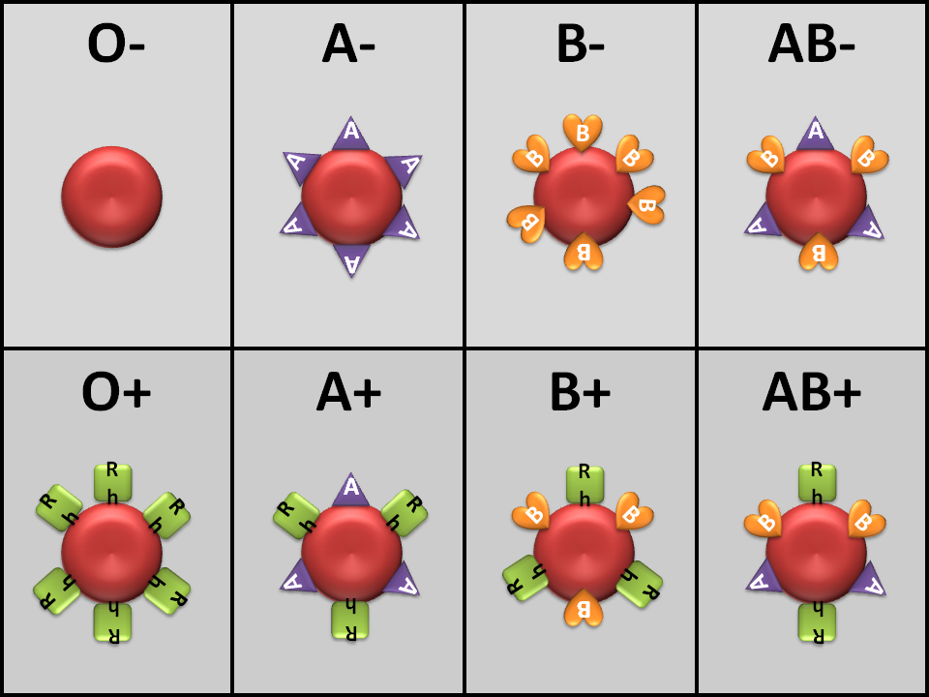
FIGURE 1: BLOOD TYPES

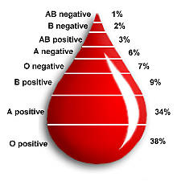

FIGURE 2: AGGLUTINATION
Plasma antibody A will bind with Antigen A on the surface of a red blood cell making it sticky.
Plasma antibody B will bind with Antigen B
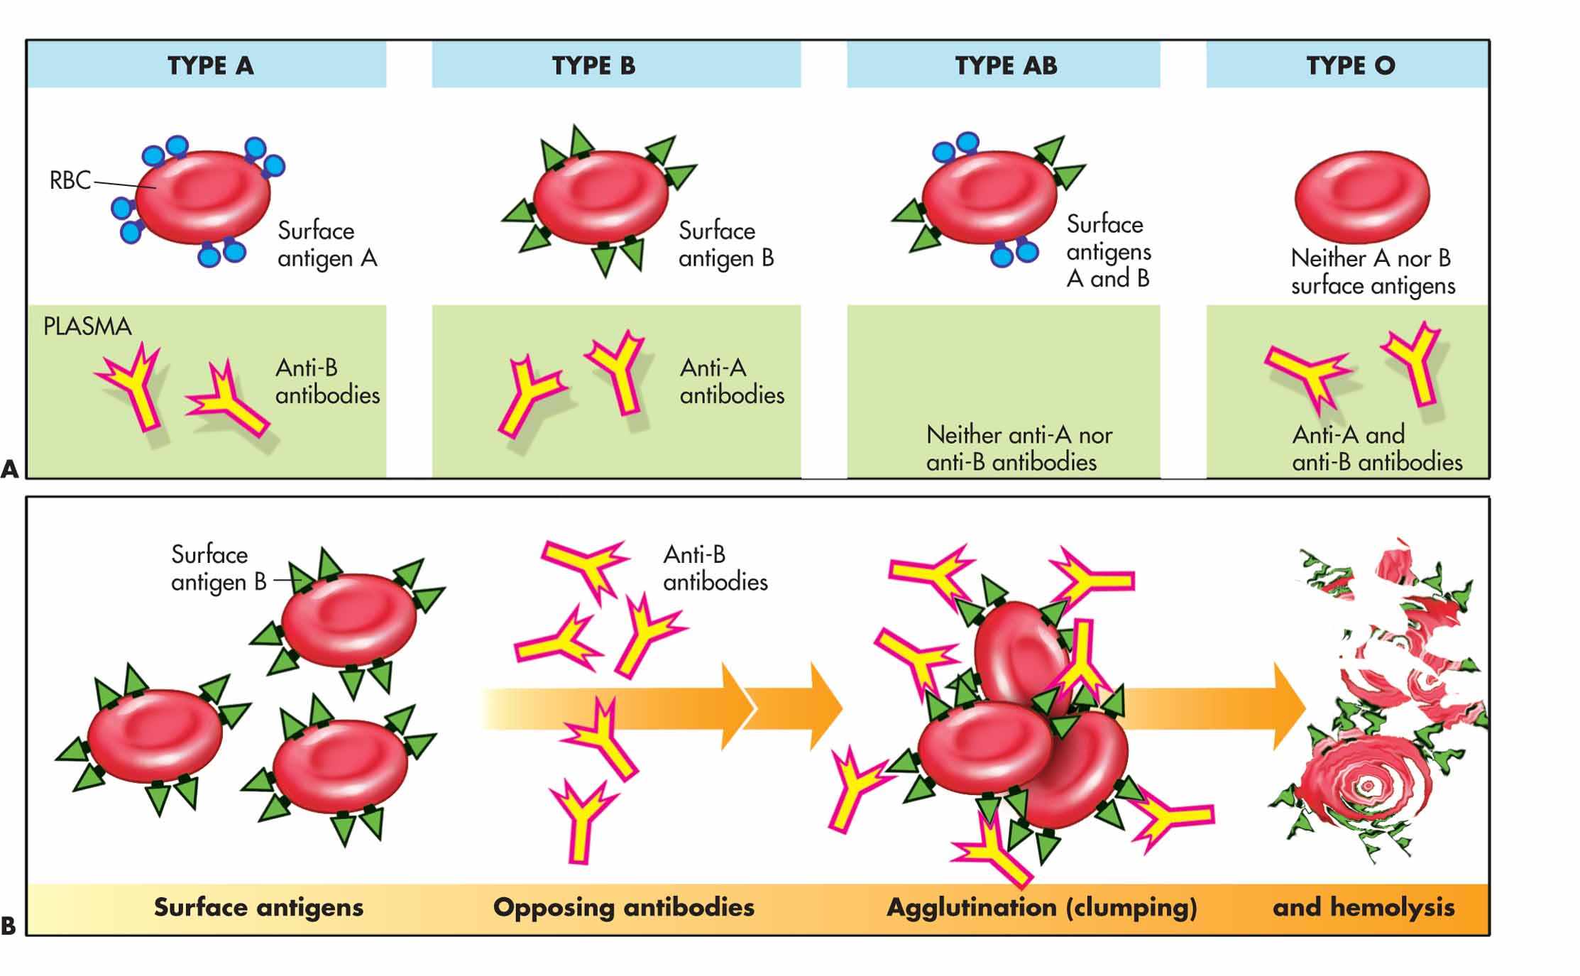
Plasma antibody RH (or D) will bind with Antigen RH (or D)

FIGURE 3: BASIC HEART ANATOMY & CIRCULATION
SVC→IVC→RA→TV→RV→PSLV→PT→PA→LUNGS→PV→LA→MV(BV)→LV→ASLV→A
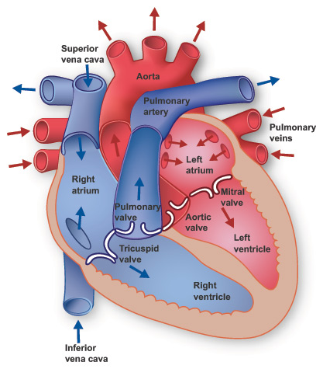

FIGURE 4: ELECTRICAL CONDUCTION
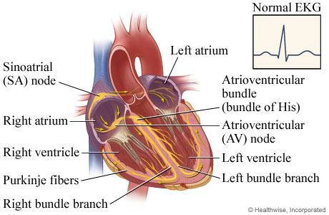
FIGURE 5: ELECTROCARDIOGRAM (ECG)

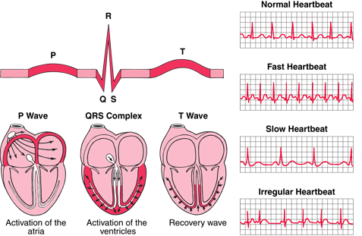

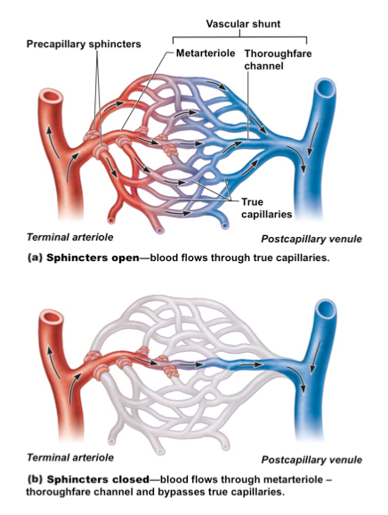
FIGURE 6: CAPILLARY BED

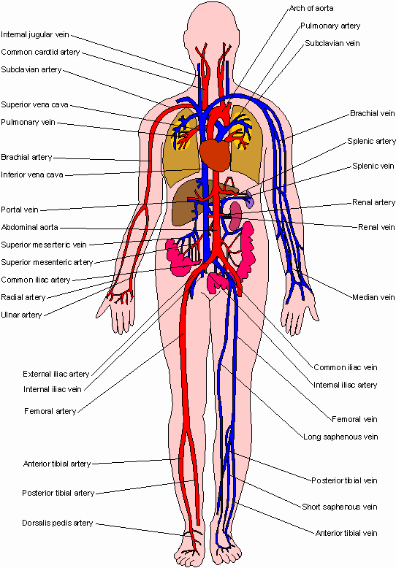
FIGURE 7: ARTERIAL (RED) & VENOUS (BLUE) CIRCULATION

Print the diagrams out for easy reference when you do your homework.

