The description can be drawn from the lectures, readings, videos, books, journals, or websites. It should be about 50-70 words in sentence form for each archeological site
Description
provide information on these four criteria
•The country and nearest city of location.
•Principal components of local physiography (e.g.,
desert, forest, grasslands, tropics, near this ocean, onthis river, in these mountains or valley).
•Dates or period name when the site was at its
height (not when it was discovered by an archaeologist).
•Affiliated archaeological culture group or significance.
Below each description add in thesource(s)of informationfor those facts and the image,
naming the title of the article, author, and year published. In the “Link” box below the description panel, copy and paste the article URL(s) to hyperlink the site title to the article.
•Be careful not to simply cut-and-paste information from other sources—that is plagiarism and is a breach of the Student
Conduct Code. You must summarize information from sources in your own words.

Albert Park tunnels – World War II civilian air raid shelters sealed in 1946
Te Wairoa – "The Buried Village", a Maori village buried by volcanic eruption in 1886
Wairau Bar – rivermouth site of pre-European Maori settlement
Borg in Lofoten, Viking Age longhouse site
Borre mound cemetery, cemetery from the Merovingian period to the Viking Age
Gokstad ship burial
Oseberg ship burial
Tune ship burial
Biskupin Iron Age
Giecz Middle Ages
Krzemionki Opatowskie Neolith
Odry Iron Age
Ostrów Lednicki Middle Ages
Otalążka near Grójec, possibly cult-related
Augusta Raurica
Aventicum (Avenches)
La Tène, Iron Age
Vindonissa (Windisch)
Sacred Ridge
Serpent Mound
Snaketown
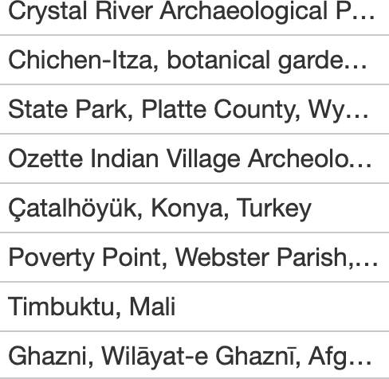
St. Mary's City, Maryland
