Slab
Institution
Name
Date

Moisture is the leading cause of plate foundation confusion. Heavy rains and plumbing problems caused by water leak of the underground pipeline may cause a lot of moisture to be trapped in the floor. You may lose 10 to 50 gallons of water a day, and perhaps more. If you are suspicious of what might happen, please check the water fee. It becomes hard when the soil is moist. The weight of the earth may be large enough to push you up. When this happens, the owner of the house usually notices that there is a lock on the door and increases fire column and steel pillar.
Slab grade bases are usually carefully placed on 2 to 3 inches of the washed gravel or sand and 6 million miles a year. Â 0.006 inch â polyethylene stream obstruction. The suggested methods prevent humidity in the soil from flowing through the plate. The layers of sand or gravel act mainly the same as capillaries to transport moisture in the ground through the ground. If the underlying drainage system is depleted, gravel layers will help to drain. The grade of the plate above 10 feet in any size may be cracked by pressure and shrinkage, which can cause internal tension in concrete. To prevent cracking, the designer frequently specifies several enhancements such as welded wire fabrics, WWF. The location of the crack can be managed by placing a joint in a fixed position at an angle or strategically placed on the concrete floor.

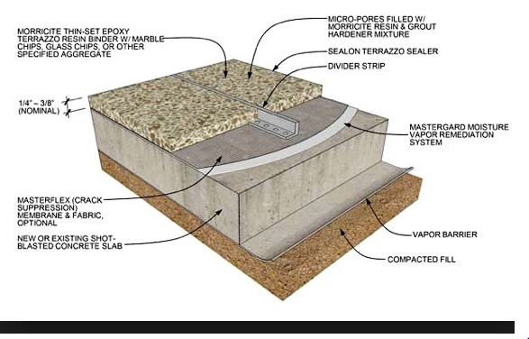

Constructability description
Constructability is the ideal utilization of development learning and involvement in arranging, structure, acquirement, furthermore, field tasks to accomplish generally speaking undertaking objective. In the description of constructability is a venture the board strategy to audit development forms from beginning to end amid the preconstruction stage. It is to recognize impediments before an experiment is worked to lessen or avert blunder, postponements and cost overwhelm Constructability is the main administration idea that is being planned and created for as far back as 30 years by the development industry for the development ventures. From its initiation in the mid-1980s constructability has moved from its unique thin concentration to consolidate Decision Support Hypothesis and Decision Support Systems

