Take a look at the diagrams below. Please describe what is happening at each point (1-6) in the process. What is the label or name for the phase and what is going on at that point in the action potential. The phase begins at resting potential and the numbers correspond to the different parts of the action potential.
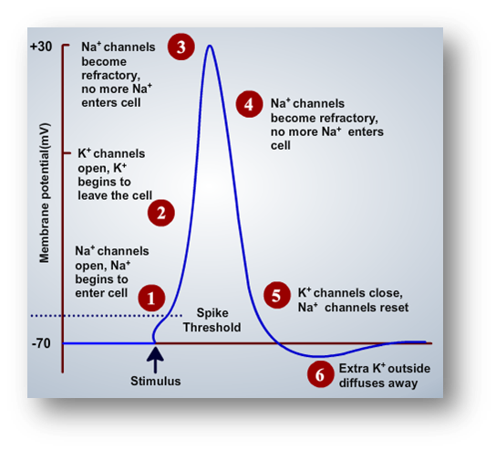
1)
2)

3)

4)

5)

6)
Next, when the action potential makes its way down to the synaptic terminal,
please point out the processes that cause the neurotransmitter to be released (what steps take place
once the action potential reaches its destination). There are 3 parts: what sets the process in motion, how is it released and what happens after release (1-3)?
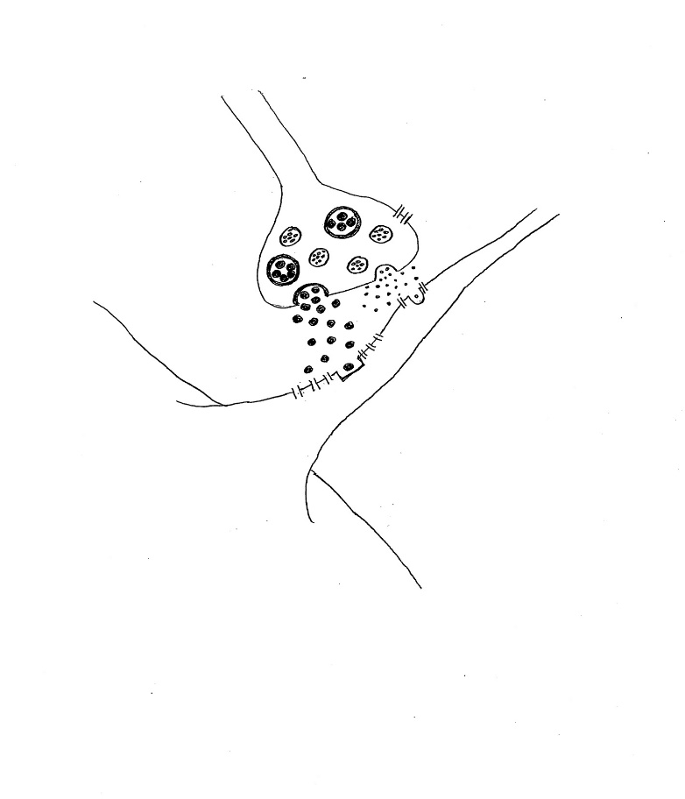
3
1..
2
1)

2)

3)

