Phases of membrane potential
Name
Institution
Course

Take a look at the diagrams below. Please describe what is happening at each point (1-6) in the process. What is the label or name for the phase, and what is going on at that point in the action potential? The phase begins at resting potential, and the numbers correspond to the different parts of the action potential.
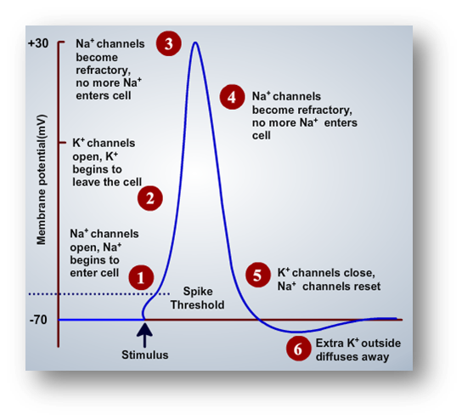
Repolarization
Hyperpolarization
Reset Resting potential
Threshold potential
Depolarization
Peak action potential
1). This is a threshold potential where depolarization of membrane potential occurs, initiating the action potential with rapid rise and fall of particular cell location (Kerr, 2018).
2). This is depolarization where there is a quick opening of channels of voltage-gated sodium once depolarization occurs. The sodium finds its way to the axon and relatively gets electrically positive contrary to initial resting potential (Kerr, 2018).
3). Peak action potential- There is an opening of potassium ions channels where these ions start leaving the cell while channels for sodium ions close (Kerr,2018).
4). Depolarization – the voltage-gated channels of sodium closes shortly once initial depolarization occurs. The channels of voltage-gated Potassium opens, which allows Potassium to efflux axon. This depolarizes the membrane making it more negative (Kerr, 2018).
5). Hyperpolarization- Here, Potassium is still getting out of the axon. The membrane tends to dip below normal resting potential. The channels for sodium now return to the resting state and opens again, provided that membrane potential has exceeded the threshold potential(Kerr,2018).
6). Reset resting potential- Here, the pump for sodium-potassium and the leak channels for Potassium resets ions of both Potassium and sodium. This then re-establishes the membrane potential allowing for next action potential (Kerr, 2018).
Next, when the action potential makes its way down to the synaptic terminal, Please point out the processes that cause the neurotransmitter to be released (what steps take place.
Once the action potential reaches its destination), there are three parts: what sets the process in motion, how it is released, and what happens after release (1-3)?
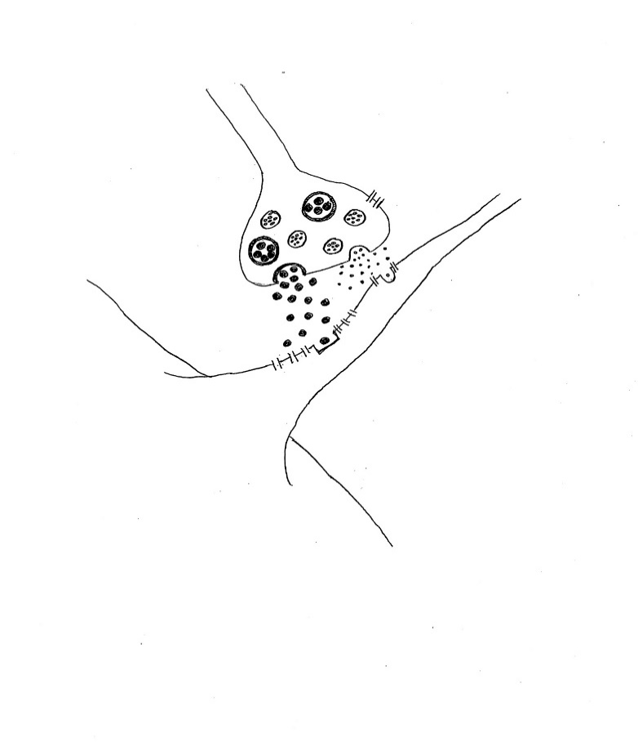
3
1...
2
1). Here the axon terminal is reached by action potential hence depolarizing the membrane. The sodium ions channels, which are voltage-gated, open to enter cells, further depolarizing the presynaptic membrane (Kerr, 2018).
2). The calcium ion channels that are voltage-gated open in presynaptic neurons to allow calcium ions into presynaptic neurons with the synapse.
3). The calcium ions that enter the presynaptic neuron cell. The influx of these ions triggers synaptic vesicle, which then releases neurotransmitters (Kerr, 2018).

Reference
Kerr. S. (2018). Neurons and Glial Cells. Georg Teach Biological Sciences.

