Solutions Manual

About “Instructor Answers”
These files contain answers to the questions in the workbook Exercising Essential Statistics. The questions and answers are from the sections Critical Thinking (Chapters 1–17), Application Exercises (Chapters 1–5), and Data-Based Exercises (Chapters 6–18). When specific page numbers are given, they refer to the text, Essential Statistics for Public Managers and Policy Analysts, 4th edition.
In some cases, questions allow for multiple answers, such as those that require students to apply the material to their area of interest. Some data-based exercises ask students to provide a write-up. Instructors will agree that this is an essential skill, yet each professor is apt to have his or her preferred format or style that is required of students. Hence, the answers given here focus on quantitative results. Also included are additional thoughts about the questions and how they can be used to reinforce the teaching material.
The Instructors’ website also contains PowerPoint Lecture Slides, Sample Syllabi, Test Questions, and Homework Assignments that will assist you in teaching this course. At this point, our text is widely adopted and you can find sample syllabi online, too.
Screen shots reprinted with permission of the Microsoft Corporation and SPSS, inc.

Chapter 1: Why Statistics for Public Managers and Policy Analysts?

Critical Thinking
Note to students: These questions further understanding of selected, key points made in the textbook. Questions in the next section, “Application Exercises,” are designed to encourage application in practice.
1. What is the difference between describing the extent of a social problem and describing the factors that give rise to it? Give an example. How can the latter be useful for developing programs and policies?
Ans: See p. 5, line 10: “By describing the extent of these problems and their underlying causes accurately, managers are able to better formulate effective strategies for dealing with them.” Describing the extent of a problem provides targets for improvement. Describing factors that give rise to it provides possible targets for intervention. For example, if a key factor causing damage to the environment is automobile exhaust, then automobile exhaust becomes a target for possible policy interventions; for example, we might seek to reduce emissions or even the use of cars.
2. What is the role of statistics in connection with the six competencies mentioned in the text? What else might be needed to attain these competencies?
Ans: The six competencies are listed on pp. 7–8. This edition ties quantitative skills to Network of Schools of Public Policy, Affairs, and Administration ; International Commission on Accreditation of Public Administration Education and Training Programs; and European Association for Public Administration Accreditation (p. 7). The role of statistics relates mostly to the third competency, data analysis, and somewhat to the fourth, communication of results. It is clear from the listing of other competencies that more skills are necessary for sound analysis than just those dealing with statistics.
3. Many programs produce routine, administrative data that are used to monitor progress and prevent fraud. How useful are such data for the five common uses of analysis and data mentioned in the text? What other data might be needed, such as might be obtained from citizen or client surveys?
Ans: The five common uses of analysis and data are mentioned on pp. 5–6. Administrative data are useful for uses 2, 3, 4, and to some extent, 5. Survey data are typically necessary for uses 1 and 5.
4. Identify a person or situation associated with each of the four stages of proficiency in quantitative analysis.
Ans: The four stages of proficiency in quantitative analysis are mentioned on pp. 9–10. By asking students to identify a person or situation, students can move from the realm of abstract comprehension and ideas, to a concrete understanding that brings these distinctions to life in greater color and complexity. For example, how well do these persons deal with data and analysis? What can they do well and what not? Students can be asked for specific examples in class.

5. Explain how the following concerns of ethics can affect research and its utilization: (1) dual purposes, (2) full disclosure, (3) truthfulness, (4) alternative explanations, (5) communication, and (6) well-being of human subjects. Give examples of each.
Ans: See pp. 10–13. Again, this question forces application. For example, dual purposes in government policy shops force choices among in research topics. Truthfulness may cause research in, or funded by, government policy shops, not to ask certain questions to avoid having to deal with uncomfortable information later. Some of these items might be discussed in class. Note to instructors: you may wish to emphasize scientific misconduct on p. 11 and 13. You may or may want to elaborate on that with recent examples, and so on.

Application Exercises
Ans: Note to students: Starting in Chapter 6 this section is called “Data-Based Exercises,” which provide hands-on exercises for students that involve real data sets.
1. Identify five problems or challenges in your area of interest that would benefit from analysis or research.
Ans: Note to instructors: This is a great question to help students see the potential benefit of this class for them. As an aside, I use the following online assignment in my first week of class:
Please post a statement about your (i) career interests, (ii) recent or past positions relating to your career (if any), (iii) the next job you would like to have (based on your qualifications and master of public administration degree), and (iv) possible future jobs thereafter in your career. Then, identify (v) how data/quantitative methods played a part in your current or past job, (vi) how data could have played a larger part if you had had more quantitative skills, and (vii) how data/quantitative methods are relevant to your next job, including how having such skills can aid you in getting that job (e.g., assist in job interview).
The posting should be substantive and show significant, relevant elaboration. Grading is curved. Post in the discussion board (under “communication”), called “Week 3: My Career & Quantitative Data.”
2. Identify at least two examples, in your area of interest, of each of the five common uses of analysis and data.
Ans: Answers vary, but you could be sure that they include applications of policy analysis, program evaluation, client/citizen feedback, or surveys. While the evaluation of program outcomes is obvious, you may prompt to think about using data for monitoring fraud, using client/citizen feedback or surveys to identify program needs, and using program data to track improvements in program operations.
3. What data exist in your area of interest? Are there any data sets with which managers and analysts are expected to be familiar?
Ans: See p. 7: “Managers and analysts will have to be familiar with data sources in their lines of business.” I think it is a relevant course assignment for students to become familiar with the secondary data in their area of interest, but it may be a matter of priority in light of other assignments whether you ask them to. I give them such an assignment to identify and describe useful sources of data in their field; other instructors build on this to later ask them to analyze such data, too as part of a final course essay or such.

4. At what stage of proficiency do you see yourself? What is necessary to get beyond this stage? Develop some learning objectives for yourself.
Ans: Answers vary. Many students are at the “know nothing” or “journeyman” stages. At both of these stages, they need more foundation in statistical analysis. Students could read Chapter 2 which highlights matters of program evaluation in more detail and which may force some reflection on what skills are needed. You can ask the class as whole, too, what leaning outcomes they would like to see.
5. Explain how a customer or citizen survey might be useful in your area of interest. What topics might such a survey address? What challenges do you foresee?
Ans: This question will help students see value in doing citizen and client surveys. Many students know that such surveys are valuable, but they fear that the science may be a bit much. Indeed, many workplaces still need people who can run a decent survey and program evaluation! Surveys are discussed in Chapter 5, you could also point to some examples on the data CD. The surveys are described in Chapter 20 of the workbook; you can find many examples of surveys online.
6. Consider the following proposition: “Almost every department needs people with analytical skills.” Verify this proposition by interviewing managers in your area of interest. Also, research salaries at the U.S. Bureau of Labor Statistics, www.bls.gov/oes/current/oessrci.htm, and compare wages for occupations that vary in analytical content, for example, management positions in budgeting, information technology, human resource management, and parks and recreation.
Ans: Students will recognize the truth of this proposition, and you can help them with specific examples. By the way, salary data show that people in technical and analytical positions receive somewhat higher pay than those who are not.
Figure: Mean salaries of selected occupations in government (2013). Source: http://www.bls.gov

I also provide them with the following information:
To learn more about salaries in public administration, I suggest you visit http://www.naspaa.org/students/careers/salary.asp You can also take a more thorough look at salaries in public and nonprofit organizations at http://www.bls.gov/oes/current/oessrci.htm (for government, scroll down and select sector 92; for nonprofits, select NAICS 712100, museums, or NAICS 813300 and then the subgroup “community and social services”). For an interesting look at careers, visit http://www.naspaa.org/students/careers/careers.asp and especially the profiles of alumni. There is also a link to job resources.
7. Identify and consider some ethical situations that would challenge the integrity of your analysis and research, such as being asked to withhold relevant information. How might you deal with such situations?
Ans: This is an excellent question, such as about “speaking truth to power” and being asked by superiors to not provide certain information, even when the public interest is at stake. A starting point for dealing with this specific situation is that research and analysis is about providing information and letting others be responsible for deciding what to do with it. Of course the imagination can wander to very uncomfortable situations, and we need to tell students how to deal with those circumstances.
8. Research the policies and practices that pertain to ethics in research in your agency or in an agency in your area of interest. If there are none, suggest two or three that would serve as a foundation for a more extensive set of policies.
Ans: Student can Google “research ethics” and any agencies or fields they like. Here is an example:
http://www.apa.org/ethics/index.aspx
https://www.nasa.gov/offices/ogc/general_law/ethics_resources_page.html

As a practical matter, instructors will need to decide how much time to spend on research ethics at this early point in their course. I like to raise the topic here and bring it up in different ways throughout the semester. I think that doing so provides students with valuable reinforcement and further clarification.

Chapter 2: Research Design
Note: SI refers to the section introduction on pp. 17–20.
Note: This lecture invites professors to also bring their own program or policy evaluation examples, which additional graphs such as:

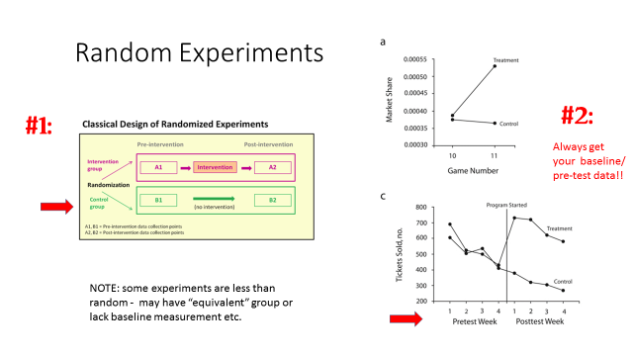

Critical Thinking
SI = section introduction
1. Give examples of basic and applied research questions that might be raised in the context of (1) a program to reduce adult illiteracy and (2) a program that fights international terrorism. (SI)
Ans: Adult literacy
Basic research questions: What is the nature of adult literacy in a specific population? How many people are illiterate? What skills do they have to learn how to read? What barriers to reading exist for them?
Applied research questions: How effective is a specific adult literacy program? Which approaches are more effective? What conditions influence the effectiveness of these approaches?
International terrorism
Basic research questions: What is the nature of international terrorism? How does it differ across countries of origin? Are different countries affected differently? What type of terrorism methods are used?
Applied research questions: How effective is an antiterrorism program? Which approaches are more effective? What conditions influence the effectiveness of these approaches?
2. Why are both quantitative and qualitative methods indispensable in addressing questions of basic and applied research? (SI)
Ans: See p. 19: “Both quantitative and qualitative methods are indispensable in addressing questions of basic and applied research. Quantitative research requires solid knowledge of existing phenomena and how they are related to each other. Simply, before we measure something, we need to be certain that we know what we are measuring and that we are measuring the right thing. However, qualitative research does not provide much specific information about the magnitude of problems and phenomena nor can it offer conclusive, statistical proof about the impacts of programs and policies. Hence, research in public management and analysis typically uses both quantitative and qualitative research methods.”

3. Give some examples of variables. Why are variables key to research?
Ans: Examples of variables include gender, environmental quality, and robberies. Variables are key to research because they are the targets of program and policies (e.g., environmental quality), which themselves are also variables.

4. A program aims to reduce adult illiteracy by providing reading sessions during evening hours. Identify the dependent and independent variables.
Ans: Dependence variable: adult illiteracy Independent variable: reading sessions
5. A study examines the impact of gender and drug use on school performance and political orientations. Identify the dependent and independent variables.
Ans: Dependence variable: school performance and political orientations. Dependence variable: gender and drug use.
6. It is said that in Sweden an empirical association exists between the presence of storks and the incidence of new babies. Explain what is necessary to establish a claim of causation. Do storks really bring babies?
Ans: See p. 25: “Causation requires both (1) empirical (i.e., statistical) correlation and (2) a plausible cause-and-effect argument.”
Storks do not bring babies because, well, they don’t. However, in the context of this question, it is more appropriate to say that no plausible (logical) cause-and-effect argument exists between the presence of storks and the presence of babies.
7. A study examines the relationship between race and crime. Is this a causal relationship or an association? Explain.
Ans: Usually such a relationship is said to be an association, because no plausible cause-and-effect argument exists between race (as in ethnic origin or skin color) and crime. Certain other, socioeconomic, community, or individual conditions associated with crime may or may not be strongly present in certain ethnic groups (as is sometimes argued), but this is not measured adequately by the variable “race.”
8. Apply the following statement to program evaluation: “Research begins with asking questions.” Think about a program that you know about as a basis for answering this question.
Ans: This question helps students to note the importance of asking the right (research) question, before implementing analytical activities such as program evaluation.
9. The developers of the adult literacy program mentioned in question 4 claim that the program is effective. By what measures might this effectiveness be demonstrated?
Ans: This question forces students to think about measurement, discussed in more detail in Chapter 3. The initial answer is obvious—increase literacy skills—but probing a bit further may lead to some questions insight about the amount of learning (hours of literacy training), the method of learning (and support from family members), starting levels, the equivalency of control groups, and more.
10. What might be some rival hypotheses regarding the effectiveness of this adult literacy program?

Ans: Some students are apt to want to answer this question off the cuff rather than focusing on the threats to internal and external validity discussed on pp. 36–37. A rival hypothesis might be that program participants learn simultaneously from other sources, too, not necessarily just the adult literacy program.
11. Discuss an experimental research design for testing the effectiveness of an anger management program. Then apply the three quasi-experimental designs mentioned in Box 2.1 in the text. Diagram the designs as shown in this box.

Ans: This is a detailed question that follows the text discussion on pp. 30–35.

Application Exercises
SI = section introduction
Note: I imagine instructors will choose 3–4 of the following, adapt to their own areas of interest/knowledge, and discuss as part of the class lecture. It might help to point out to students the workbook questions you are raising/modifying.
1. Give examples of basic and applied research questions in your area of interest. (SI)
Ans: Answers vary. (see critical thinking #1, above)
2. Give examples of quantitative and qualitative research methods in your area of interest. (SI)
Ans: Answers vary, but should include—in depth interviews and focus groups as examples of qualitative research, and surveys and experimental designs as examples of quantitative methods, too.
3. Consider the following variables: the number of immigrants, attitudes toward abortion, and environmental pollution. What might be some attributes for each of the variables?
Ans: Answers vary, for example, the number of immigrants: numbers attitudes toward abortion: interview response scale (e.g., Likert-type scale) environmental pollution: measurement scale of pollutants
4. You have been asked to develop a neighborhood crime control program. Thinking ahead, you develop a strategy for evaluating the program in subsequent months and years. Define the program and identify dependent and independent variables that can be used to evaluate it.

Ans: This question makes the larger point that thinking about evaluation is a driver of program design. This problem also helps students to think about programs and policies as independent variables causing dependent variables (here, neighborhood crime). It may also help focus on equivalent groups/neighborhoods for purposes of comparison.

5. Identify a problem in your area of interest. Identify the dependent and one or more independent variables affecting this problem.
Ans: Answers vary.
6. Consider a program or policy in your area of interest. How do the specific issues raised in the text regarding program evaluation apply to your program or policy? For instance, give some examples of how difficult it can be to document program outcomes.
Ans: Answers vary, but they should touch on matters of measurement and disentangling program impacts from other impacts.
7. Discuss how you can apply the six steps of program evaluation to a specific program in your area of interest.
Ans: Answers vary.
8. Find an article that discusses a specific program evaluation and identify in it each of the six steps of program evaluation.
Ans: Answers vary. This question may be a bit difficult to answer, given that articles seldom clearly identify each of these steps in their writing. This is the lesson that needs to be communicated, as well.
9. Identify some rival hypotheses (control variables) that might affect conclusions about the effectiveness of an adult literacy program. Then, discuss how an experimental research design and several quasi-experimental designs might be helpful for determining the effectiveness of the program.
Ans: Answers vary, but all will point toward the need for statistics as a method of controlling for these other factors. See p. 31: “. . . .we can no longer rely on the research design itself to rule out the presence of rival hypotheses; rather, we must use the strategy of statistical control to account for rival hypotheses.”
The point about control variables is also reinforced on p. 38: “The point of this lengthy list is to draw attention to concerns that analysts may want to consider in their research and evaluation. Most researchers consider at least a few or the most important rival hypotheses and threats to validity . . . .”
10. Define the objectives of a job-training program and then identify some rival hypotheses regarding possible outcomes. Explain how baselines and comparison groups might be used.
Ans: Answers vary.

Chapter 3: Conceptualization and Measurement

Critical Thinking
1. Explain the following statement: “Scales should encompass all of the possible values that a variable can assume.”
Ans: Scales must be able to measure all of a variable’s attributes. Also, see p. 46: “We must avoid scales that are incomplete, ambiguous, or overlapping.”
2. Explain the following statement. “Continuous-level scales are preferred over ordinal-level scales, which, in turn, are preferred over nominal-level scales.”
Ans: We prefer scales that provide more, rather than less, information about variables. Continuous scales provide more information than ordinal scales, which provide more information than nominal scales.
3. Explain how measurement scales (e.g., Likert-type scales) can affect the phrasing of survey questions.
Ans: Answers to survey questions must conform to the scales used for measuring them. A typical survey introduction is, for example, “I am going to read you a series of statements. Please tell me after each whether you Strongly Agree, Agree, Don’t Know or Can’t Say, Disagree, or Strongly Disagree.” See Chapter 20 of the workbook for descriptions of survey instruments.
4. The text states that “no correct number of dimensions or variables exist, only bad or lacking ones.” Explain this statement.
Ans: OOPS!! Sorry, this statement is now omitted from the 4e. In the 4th edition, pp. 48–49, make the point that the number of dimensions should be determined the context of the study (“An imprecise guiding principle is that analysts should be comprehensive and true to their study concepts”) and that “Conceptualization should not omit important dimensions.” Sometimes students want to be told what to do rather than exercise their judgment, but this wish cannot always be fulfilled; judgment is required. This is one reason why looking at what past studies have done is important, too.
5. The text distinguishes three approaches to operationalization. When should the most rigorous approach be used? When should the least rigorous approach be used?
Ans: See p. 48: “Complex concepts that are the central focus of one’s research are usually conceptualized with greater rigor than those that are simple or less key to the program or evaluation.” The same is true for selecting the operationalization approach.
6. A study wishes to measure “citizen trust in government” through the number of lawsuits filed against the federal government. Evaluate the measurement validity of this approach.

Ans: This approach certainly lacks content validity, that is, not encompassing a broad range of aspects (see p. 54–55).

7. Explain the theorem of the interchangeability of indicators.

Ans: See p. 52: “The theorem of the interchangeability of indicators states that if several measures are equally valid indicators of a concept, then any subset of these measures will be valid as well. In other words, there are many valid ways to measure a given concept. The analyst’s task is to choose one approach and then justify that that approach is valid.”

8. Explain the following statement: “When one or more of the measurement variables are missing from an observation, the value of the index variables for that observation is missing, too.” Also, what are the pros and cons of guessing the values of missing observations? Why should this not be done?
Ans: See p. 54 (Table 3.2). Although estimating missing values increases the number of observations of an index variable (pro), we do not like to guess the values of missing observations, because doing so is always speculative in some way (con). Note: SPSS now provides missing values analysis, so some students may ask about this.
9. Explain the following concepts, and give an example of each: (1) face validity, (2) construct validity, (3) criterion validity, and (4) content validity.
Ans: See p. 55.
10. Explain the following statement: “Analysts usually collect a few more variables than are minimally needed because they cannot know, prior to reliability analysis, which variable mix will have a sufficiently high α score to lend empirical support for the index measure.”
Ans: This is as stated in the question. You might note that if analysts desire to construct an index measure with five or six variables, they might need to collect information on seven, eight, or nine variables.

Application Exercises
1. Examine the citizen survey in the documentation for the Public Perceptions data set, in Chapter 21 of this workbook. What level of measurement scale is used for the different items?
Ans: Most items are ordinal level (Likert-type scales).
2. Give some examples of nominal-, ordinal-, interval-, and ratio-level variables in your area of interest.
Ans: Answers vary.
3. An analyst wishes to measure public support for a new welfare program. (1) Develop some suitable measures using Likert-type items on a survey. (2) Show how incomplete, ambiguous, and overlapping scales create problems of measurement validity.
Ans: Answers vary. For example, “I am going to read you a series of statements. Please tell me after each whether you Strongly Agree, Agree, Don’t Know or Can’t Say, Disagree, or Strongly Disagree... Workers who actively seek jobs should be able to get a 3 month extension of their welfare benefits.”
4. A survey of citizens assesses the extent to which they perceive the federal government works democratically. A second study measures the extent to which the governments of different countries are democratic. Conceptualize democracy in each of these two study contexts.
Ans: This is a useful exercise, the lesson of which is that context matters. The first study context usually focuses on operational processes and arrangements (e.g., congressional oversight, public input processes), whereas the second one often focuses on institutional characteristics (e.g., holding elections).
5. Develop an index variable to measure “fear of statistics” among students in public and nonprofit management. Then develop an index variable to measure a concept in your area of interest.
Ans: Answers vary.
6. Select a sample of six Government Accountability Office reports (see Box 2.1) or scholarly articles that use empirical data. Examine how these reports or articles address the matter of measurement validity.
Ans: Answers vary. This is a useful exercise for instructors who wish to increase student skills in writing. You might have your own favorite report that carefully addresses measurement (e.g., homelessness, inflation, well-being, etc.)
7. Develop some measures that might be used in a study that assesses a neighborhood crime control program. Discuss some challenges of measurement validity as well as strategies for dealing with these challenges.
Ans: This is a useful classroom exercise.

Chapter 4: Measuring and Managing Performance: Present and Future

Critical Thinking
1. How is a system of key indicators such as performance measurement different from a system of comprehensive measurement?
Ans: See p. 62: “Performance measurement provides a system of key indicators of program activities and performance.” Hence, they are indicative, rather than trying to measure a phenomenon in an exhaustive way. Key indicators may lack content validity (Chapter 3), for example, and are usually supplemented by other, sometimes impressionistic sources of management knowledge.
2. Explain how performance measurement provides useful information about programs and policies, even if it is not free from measurement errors.
Ans: Performance measurement provides systematic information, from program data, community indicators, and systematic client/citizen information, feedback, that, however imperfect, may be more valid and reliable than impressionistic observations and anecdotal feedback.
3. Is the number of arrests by police officers an activity, an output, or an outcome? Explain your answer.
Ans: This question is not as easy it seems. Arrests are a measure reported in uniform crime statistics. Making arrests is an activity, though making correct arrests can be viewed as an output. It is unlikely to be an outcome, however, for example, as a measure of public safety.
4. Give an example of the distinction between efficiency and workload ratios not mentioned in the text.
Ans: Answers vary. The number of students taught per class is a workload; lessons learned per hour studied is an efficiency measure.
5. Examine the measures in Table 4.1 in the textbook. Can you improve on these? Can you identify other measures? In what way might inaccurate or incomplete data affect these measures?
Ans: Answers vary. For example, specific program activities might be measured as well, such as recognizing anger or confronting anger.
6. What practical problems can you foresee in using external benchmarks? Can these problems be overcome? If so, how?
Ans: This is the classic problem of different jurisdictions and organizations having different circumstances and not always identical activities. For example, mowing grass in Florida and Arizona are very different things. Also, external benchmarks (data) are simply not always available.
7. Explain how equity measures are important, especially in the context of public management.
Ans: Equity is always a factor in public management, and many analyses examine that.
8. Discuss some challenges to using performance measurement and how you might address them.
Ans: Many challenges are practical in nature, such as collecting information. Information technology can help. Note that performance measurement also requires analysis, which is a role that graduates can fulfill.
9. Explain the following statement: “Experts can help identify future events that trend forecasting may overlook.” Give an example.
Ans: See p. 73: “The problem of forecasting is, of course, that the future is somewhat unpredictable. Events are likely to happen that are beyond our scope or current vision.” Using experts can help reduce, though not fully eliminate, the problem of trend forecasting. Experts cannot predict the future with certainty either.
10. Discuss the following statement: “The accuracy of forecasts should be determined, such as by comparing predictions about the present against the observed reality of the present.”
Ans: This important opportunity for validation often is overlooked by students. We can use the observations up to t − 1 to forecast known events at T = t.

Application Exercises
1. Identify outputs and outcomes of a program to increase high school student graduation rates through homework assistance for at-risk students. Identify some efficiency and effectiveness measures for this program.
Ans: The program is homework assistance for at-risk students. An effectiveness measure is whether these students learn what is intended. Another effectiveness measure is their graduation rate (though that measure is confounded with other factors, too, of course). Efficiency measures might be these outcomes divided by staff time spent on this program.
2. Identify outputs and outcomes of a program to reduce traffic congestion by adding dedicated bus lanes (lanes that only buses can use). Identify some efficiency and effectiveness measures for this program.
Ans: Output measures reflect the consequences of program activities, such as the number of miles of dedicated bus lanes, information provided to residents about the dedicated lanes and travel times, and other activities such as the availability of parking garages near the dedicated bus lanes.
Outcome measures reflect goals such as bus usage rates, travel time savings among car drivers, and the presence of congestion.
3. Develop a complete performance measurement system for a program or policy in your area of interest. Identify inputs, activities, outputs, outcomes, and goals, as well as measures of effectiveness, efficiency, and equity. See Table 4.1 in the textbook to get you started. You will want to add efficiency, effectiveness, and equity.
Ans: Answers vary.
4. Research and compare examples of performance measurement in agencies in your area of interest. How similar are their measures? Can you explain the differences?
Ans: It is sometimes hard to get detailed performance measurement reports. Here is an example:
http://www.djj.state.fl.us/research/reports/research-reports/car
Of course, many federal agencies also have detailed reports.
5. Look for examples of performance measurement and balanced scorecards on the Internet.
Ans: http://balancedscorecard.org/Resources/Examples-Success-Stories
https://www.fs.fed.us/climatechange/advisor/scorecard/scorecard-guidance-08-2011.pdf
6. Identify some statistical forecasts in your area of interest. What assumptions do they make? How might they be improved?
Ans: Some well-known forecasts are done by the Congressional Budget Office:
http://www.cbo.gov/

7. Develop some scenario-based forecasts in your area of interest.
Ans: Answers vary. The purpose is to get students to think about how they might go about doing this.

Chapter 5: Data Collection

Critical Thinking
1. Identify some examples of the use of administrative data.
Ans: Answers vary. Page 80 states: “Traditionally, administrative data have three purposes: (1) to ensure that resources are not misused, (2) to determine the status of the organization’s activities, and (3) to provide a record of what has been completed and accomplished.” And “Today’s performance and efficiency environment means that data are also used for (4) performance management, benchmarking, and continuous improvement, too. Although administrative data often are not collected with these purposes in mind, these data often cover many input and activity measures but lack data for many important output and outcome measures. For example, administrative data from road repairs are likely to include information about the amount of funding for repairs (input), the number of repairs undertaken in any reporting period (activity), and the number and miles of completed repairs (output). But data might be missing about the timeliness of key repairs and certainly about the condition of the roadways (outcome).”
2. Discuss the problems in the quality of administrative data. How important are these problems and to what extent can they be overcome?
Ans: p. 81: “Administrative data may also suffer from some quality challenges that must be acknowledged or overcome. Data are sometimes (1) missing or incomplete, (2) inaccurately reported, (3) subject to definitions that have changed over time and therefore cannot be compared, (4) not linked to particular events or clients, or cannot be disaggregated in necessary ways, (5) confidential and unavailable for analysis, or (6) insufficiently available in electronic format.”
The importance of these problems varies in practice. Although it may be impossible to fully overcome these problems, the information obtained from administrative data often are quite valuable. These quality problems need to be acknowledged, of course.
3. Identify some examples of the use of secondary data.
Ans: Answers vary. See p. 82: “Secondary data are often used to describe communities in statistical terms,” and “secondary data are also used in scholarly studies.”
4. Discuss the problems in the quality of secondary data. How important are these problems, and to what extent can they be overcome?
Ans: See p. 83: “First, biases may be found in secondary data as a result of uneven sampling . . . . Second, data definitions may be unclear, unstable, or not suited for the study or management purpose.”
5. Contrast the use of systematic surveys and focus groups. For which purposes is each best suited? Give some examples.

Ans: See p. 88: “ . . . focus groups are used to generate insights into the reasoning, priorities, and experiences of participants.” The results are not generalizable.
See p. 83: “The argument for using surveys is that they provide systematic and objective information about stakeholder preferences and conditions . . . Surveys provide the necessary antidote of objectivity and comprehensiveness.”
6. Consider the following statement: “Our city is larger than the city next door, so we need a larger sample size for doing our citizen survey.” Is this statement valid? Why, or why not?
Ans: No, it is typically not valid. See p. 91: “For populations greater than 20,000, sampling errors are independent of population size. The same sampling error applies for a survey of a medium-sized jurisdiction of 40,000 as for the entire United States or the world!”
7. Explain the following statement: “Over 50 items can be asked when questions (in phone surveys) are easy and asked in a similar format.” Find an example on the CD that accompanies the text.
Ans: The employee and citizen surveys on the accompanying student resources demonstrate this principle.
8. Explain the concept of sampling error and why it matters.
Ans: See p. 91: “The term sampling error is defined as discrepancies (errors) that occur because random sampling procedures may cause sample statistics to differ from (unknown) population statistics.” The sampling error is a guesstimate of the error. Specifically, “the sampling error can be calculated for random samples as the range within which one can be 95% certain that the population estimate falls.”
9. What practical problems do you see with drawing a random sample of all Americans as opposed to a random sample of those that live in your city?
Ans: It is much harder and impractical to obtain such a sampling frame of “all Americans.”
10. Discuss why customer comment cards do not constitute a generalizable customer satisfaction survey.
Ans: See p. 90: “Two examples of unrepresentative samples are those based on customer comment cards and responses to enclosures in mass mailings such as utility bills. Although these efforts provide important information, they cannot be relied on for generalization. Those who complete customer comment cards are usually heavily skewed toward clients with gripes, though they typically include a few clients who offer praise. We cannot assume that their opinions reflect all clients.”
11. Identify threats to validity arising from biased questions and sampling in surveys. How can you obtain a representative sample?

Ans: Biased questions result in findings that do not represent the opinions of interviewees. Biased sampling results in a study population that does not reflect the opinions of the population. See p. 88: “Random sampling is the most accurate way to obtain a representative sample.”

12. Explain the following statement: “It is common practice to assume that unexamined data usually contain various errors.” Give some examples.

Ans: p. 96: “Errors include mistyped values, errors that arise in the process of uploading, and other implausible values that have been recorded.”

13. Identify four specific ways in which data that have not been thoroughly cleaned may be problematic.

Ans: Data that have been thoroughly clean may contain erroneous data, missing or duplicate records, values that are assigned to wrong variables, values that have not yet been defined or improperly defined as “missing,” the presence of outliers, values labels that are wrong, variables that are missing.

Application Exercises
1. Identify administrative data in your field of interest. How can such data be used for managing programs?
Ans: Answers vary, but they should point to the purposes mentioned on pp. 80.
2. Critique the validity of administrative data in your field of interest. How might the quality of administrative data be improved?
Ans: Answers vary, but they should include greater consistency over time and use of information technology (see pp. 80–81).
3. Identify secondary data in your field of interest. For what purposes might these be used?
Ans: Answers vary, but they should include some purposes such as those mentioned on pp. 82–83.
4. Discuss how trained observers, actors, experts, and focus groups might be used in your field of interest.
Ans: Answers vary. See pp. 87.
5. Identify how client and citizen surveys might be used in your field of interest.
Ans: Answers vary, but they should include purposes of describing problems and service populations as well as outcome evaluation.
6. Use the Internet to find examples of client and citizen surveys in your field of interest. Then evaluate the (1) validity and (2) usefulness of these surveys.
Ans: Answers vary. Students often can find an example on the Internet. However, they should be told that many more exist that are not posted on the Internet. They should evaluate the usefulness of the examples they find against the uses stated on p. 5 in Chapter 1.
7. Evaluate and improve the following survey question: “Please tell me whether you like living at your present location or would consider moving to another city.”
This statement should be asked as two separate questions:
- “Please tell me whether you like living at your present location.”
- “Please tell me whether you would consider moving to another city.”

8. Develop some other poor survey questions and then improve them. Use a Likert-type scale (see Chapter 3).

Ans: Answers vary.

9. Develop a survey of clients, citizens, or employees in your field of interest.

Ans: Answers vary. This is a major assignment, of course, that is relevant for classes in which instructors wish to emphasize this aspect.

10. Examine the methods section in the survey report on the CD that accompanies the book. Examine carefully how concerns about representative samples are dealt with.

Ans: Answers vary. The concerns deal with minimizing sampling bias.

Chapter 6: Central Tendency

Critical Thinking
SI = section introduction
1. Give some examples of univariate and bivariate analyses. (SI)
Ans: Answers vary, but here are some examples mentioned in the book:
Example of univariate analysis, p. 103: “Descriptive statistics are used widely in public and nonprofit management and analysis. For example, knowing how much pollution is occurring, the percentage of citizens favoring improved parks, or the average rate of absenteeism.”
Example of bivariate analysis, p. 104: “We might want to compare the average crime rate among two or more high schools, or want to know whether violence varies by gender or age.”
2. Why is the mean frequently used?
Ans: We often want to know the mean, or how it changes over time or differs between two groups, before we move on to other questions. The mean is a useful summary measure.
3. Consider the following statement: “Calculating the mean is straightforward, but managers and analysts may encounter some practical issues that, for the most part, concern the data rather than the formula itself.” Give examples of these practical issues.
Ans: See pp. 107–108.
4. Why are observations with missing values typically removed when calculating specific statistics?
Ans: See p. 107: “We do not like to guess the values of these missing data because it is difficult to credibly justify such guesses.”
5. Discuss the challenge of using the mean for calculating the central tendency of an ordinal-level variable (for example, a survey question that uses a Likert-type scale; see Box 3.1 in the text).
Ans: See p. 108, second point: “Calculations of means usually result in fractions (but) fractions are not defined for ordinal scales.”
6. Explain the following statement: “The median should always be used when a few very large or very small values affect estimates of the mean.” Give some examples of variables for which the median is typically used.
Ans: See the example on p. 110–111: “A limitation of the mean is that its usefulness is greatly affected when the data include a few very large or very small values, relative to other values. In the earlier example, if x8 (the eighth observation in the above sequence, which is 225) had been 950, then the mean for the array would be 171—more than double its initial value!”
A typical example of a variable for which the median is used is household income.
7. Explain the following statement: “An advantage of the mode is that it can be used with nominal-level data, which is not possible for calculating the mean or median.”
Ans: For example, we could use the mode as a measure of central tendency when the variable is region.
Data-based Exercises
1. Although computer software is used to calculate statistics, some students find that hand calculation furthers their conceptual understanding. Consider the following values: 4, 5, 7, 9, 11, 13, 13, 16, and 18. Calculate the mean, median, and mode. After completing the exercise below, you might return to your results and verify them using the computer. (To practice, you can make up your own data, too.)
Ans: Mean: Σxi/n = 96/9 = 10.67; median: 11 (value at location [9 + 1]/2 = 5); mode: 13
2. This is an exercise in data input. Data input is a skill that is specific to the software package you are using. Chapter 20 provides data input examples for SPSS. Input the data shown in the workbook Screen W19.4 and use SPSS to calculate the mean, median, and mode. Verify your results with those shown in Screen W19.8.
Ans: See screen W19.4 of the workbook. The data are 20, 20, 67, 70, 71, 80, 90, and 225. Then, input these data. The mean, median, and mode are shown on screen W19.8. Mean = 80.375, median = 70.5, mode = 20.0.

3. This is an exercise in data coding and input. Input the data from Table W6.1 into your statistical software program. For simplicity, the table shows only three respondent records of the three survey items. Note that respondent number 3 did not answer the first question. This needs to be coded as missing. Code this value as a “9” and instruct your statistical software to treat this value as missing. Also, create variable and value labels.
Ans: This is a skill-building exercise using the software of your choice.
4. Read about the Community Indicators data set in Chapter 20 of the workbook. Then open this data set using your statistical software package (e.g., SPSS). Compare the mean and median values of the number of murders (“murder”) in these different cities. Are they close or dissimilar? Calculate the mean and median of other variables of your choice, too. In Chapter 7, we will take this analysis further by making frequency distributions.
Ans: Murder and nonnegligent manslaughter:
Mean: 72.38
Median: 29.5
These numbers are dissimilar, hence, giving a good example of why both are used. A histogram of this variable clearly shows that a few cities have a relatively large number of murders.
5. A local government operates a small park near to its city hall. The department uses the attendance to measure its workload in determining the budget for the park. The city manager has long believed that the park has too few visitors and that the department should reach out to more customers or its budget will need to be reduced. You are an analyst for the city. The city manager has asked you to prepare an analysis for the park to determine whether the budget request for the park is justified in the city’s budget proposal. You randomly selected 25 days in the past year and calculated the park attendance data: 5, 3, 10, 1, 2, 3, 4, 3, 5, 100, 4, 3, 2, 4, 25, 150, 3, 3, 5, 4, 8, 7, 10, 15, and 30.
a. Use computer software (SPSS or Excel) to calculate the mean, the median, and the mode for the data. Write a paragraph to explain the meaning of these statistics. Do you recommend the use of the mean in your presentation? Why or why not? Do you recommend the use of the median or the mode? Why or why not?
b. (optional) Prepare a report to discuss recommendations to the city manager.

Ans: a. The park had an average of about 17 visitors daily. Nonetheless, the average is largely skewed by two extreme values, 100 and 150. The park might hold two special events in these two days that attract many visitors. In half of the days, the park had 4 or fewer visitors (the median = 4). In a typical day, there are three visitors in the park. Clearly, the use of average is biased to represent the performance of the park. The median and mode are better measures in this case.

b. These results support the city manager’s suspension about the low attendance rate of the park, so the budgetary reduction may be considered whether the current park budget request exceeds its service need. Nonetheless, because there are days when there are a large number of visitors for special events, the city may want to consider hiring temporary workers in these days. Also, if the park’s budget is reduced, the city needs to show willingness to allocate supplemental fund in the case of the special events in the park that will attract more visitors.

6. Using the Data_FL_County data set, what is the mean and median of conservation spending in 2008? Why is the mean so much greater than the mode? (In the data set, the variable name is Cons08 and the variable label is 2008 Conservation Spending.)

Ans: The SPSS output is:
Statistics
2008 Conservation Spending
N | Valid | 64
N | Missing | 2
Mean |  | 8052890.91
Median |  | 604401.50
Mode |  | 0ª
ªMultiple modes exist. The smallest value is shown.
Oops! The above question should be: “Why is the mean so much greater than the median”? The answer is because a few counties have very large expenditures of course. Note: as regarding the mode, this variable has no mode as all values occur just once. That is what the SPSS output note is alluding to: “Multiple modes exist. The smallest value is shown.” The smallest value is zero, indeed.

7. Using the Community Indicators data set, calculate the mean burglary rate per capita. To do this, you first need to create a new variable, which is the burglary rate per capita for each city in the data set. Let’s call this variable “burglaryrate” and define it as burglary/pop, whereby “burglary” and “pop” correspond to the variable names on the Community Indicators data set. Use your statistical software program to calculate the mean and median burglary rate per capita. Which three cities have the highest burglary rates per capita? Are these the same cities as those with the largest number of burglaries?
Ans: Creating the variable “burglaryrate” is a good exercise in data transformation for students just starting out using statistical software.
Burglaries per capita:
Mean: .0120 (1.2%)
Median: .0116 (1.2%)
To find the cities with the largest rates, simply sort the data. (In SPSS, Data → Sort Cases → Sort by: burglary rate.) The three cities with the largest rates are Columbus, OH, 3.02%; Las Vegas, NV, 2.97%, and Louisville, KY, 2.68%. You might note that although New York has one of the largest numbers of burglaries, it has one the lowest per capita burglary rates. Whether this is a reporting artifact or something else is an interesting question, but this finding does make the point about looking at data from different viewpoints.
7. Open the Watershed data set and read the description of this survey in workbook Chapter 18. Calculate the mean and median of the number of samples that exceed pollution standards (Conpolut) and fish and wildlife advisories (Advisory).
Ans: Conpolut:
Mean: 19.00
Median: 17.55
Advisory:
Mean: 4.63
Median 3.00
8. Optional (see appendix to Chapter 6 in the text): Consider the table of grouped data (Table W6.2). Calculate the grouped mean and grouped median.
Ans: Following the procedure described in the textbook, pp. 108–109:
a. The grouped mean is calculated as follows: Step 1: The weighted mean (of the categories) is: (33 × 1 + 47 × 2 + 64 × 3 + 32 × 4 + 14 × 5)/190 = 517/190 = 2.721.
Step 2: The estimated mean of the variable is the value of the Category 2, which is its mean, or (5 + 8)/2 = 6.5, plus .721 of the difference between the value of the category two and the value of the category three, which is [(8 + 11)/2=] 9.5, or 6.5 + .721 × (9.5–6.5=)3.0 = 8.67 (with rounding).
b. The grouped median is calculated as follow:
Step 1: The location of the median is (n + 1)/2, or the 95.5th observation. This falls between the second and third categories.
Step 2: The estimated value of the observation at this location is (i) the value of category two, which is its mean, or (5 + 8)/2 = 6.5, plus (ii) (95.5–80)/(144–80) = .242 of the difference between the value of the category two (which is 6.5) and the value of the category three (which is 9.5). Thus, the estimated grouped median is 6.5 + 0.242 × (9.5–6.5=)3.0 = 7.23 (with rounding).

Chapter 7: Measures of Dispersion

Critical Thinking
1. Explain how frequency distributions assist with data cleaning.
Ans: They can help identify implausible values (e.g., those yet to be coded as missing) and values that might be outliers.
2. When variables are continuous, analysts will have to transform their variables, grouping values into categories, before making a frequency distribution. Explain and give an example.
Ans: A frequency distribution is used for nominal- and ordinal-level variables. Obviously, we don’t like to transform continuous variables into such scales, but a frequency distribution can be useful when making bar charts (e.g., as used in presentations).
3. Explain the following statement: “When recoding variables or creating histograms, a practical question is how wide each category should be. To avoid perceptions of lying with statistics, a rule of thumb is that categories should be based on category ranges of equal length.”

Ans: Analysts must prevent the appearance of lying with statistics, regardless of whether it is intended.
4. Describe the difference between a histogram and a bar chart.
Ans: See p. 119: “As a convention, bar charts are used with categorical variables, and the bars in such charts should not touch each other. Histograms are used with interval- and ratio-level variables, and their bars should touch each other, suggesting that these data are continuous.”
5. Research some innovative ways of using graphs to get your points across.

Ans: Students should spend some time on the Internet to find examples in their area of interest that demonstrate how graphical tools are used.

6. What percentage of observations has a higher z-score value than 0.86? What percentage of observations has a lower z-score value than −1.15? What useful questions can a z-score statistic help answer? Hint: In the normal distribution table (see Appendix A in the textbook), look up values of the absolute difference between the above z-score values and 0.50 (|0.5 – z-score|).

Ans: Approximately (from normal distribution table; .50–.3021=) 19.5% of observations have a higher z-score than 0.86. Approximately (from normal distribution table; .50 – .3749) 12.5% of observations have a lower z-score value than −1.15. The data in the table of “normal curve areas” show the area under the normal curve, from z = 0 (midpoint) to the z-score value. z-Score statistics answer questions about the percentage of populations that are above or below certain values, and they can be used to make comparisons across populations.

7. (optional) What is the purpose of boxplots? Is a boxplot fence an actual observation or a calculated number? And what about a whisker?
Ans: See pp. 127–128: “The boxplot is a useful tool for data cleaning and is used in this chapter to discuss outliers.”
Ans: see p. 128: The inner and outer fences are imaginary values that are calculated in order to determine outliers. Whiskers are “the lowest and highest values of the variables that are not outliers.”
8. (optional) Using Figure W7.1, draw a boxplot of a variable with these values: 4, 5, 7, 9, 11, 13, 13, 16, 18, and 24. Are there any outliers? Why, or why not?
Ans: Why do this exercise by hand? Ask which students used a computer, thus saving themselves a lot of time! But if you think it useful, these are the results:
Median = 12.0; mean = 12.0; first quartile = 6.5; third quartile = 16.5; IQR = 10.0.
The boxplot shows no outliers, and this observation is readily confirmed. The inner fence is
6.5 – 1.5 × IQR = −8.5; the upper fence is 16.5 + 1.5 × IQR = 31.5 All of the observations lie between these values.
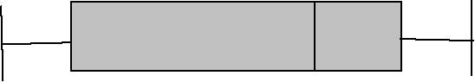
−6.5 6.5 12.0 16.5 31.5
Data-Based Exercises
1. Although the computer calculates statistics, some students find that hand calculation furthers their conceptual understanding. Consider the following values: 4, 5, 7, 9, 11, 13, 13, 16, and 18. (These were also used in workbook Chapter 6, Data-Based Exercise 1.) Now, calculate the interquartile range, inner fence, outer fence, and standard deviation. You can use the computer to verify your results.
Ans: The following results are obtained and can be verified by computer: mean = 96/9 = 10.67; median = 11; mode = 13; first quartile = (5 + 7)/2 = 6; third quartile = (13 + 16)/2 =14.5; IQR = 14.5 – 6 = 8.5; inner fence = 6 – (1.5 × 8.5) = –6.75; outer fence = 14.5 + 1.5 × 8.5 = 26.75; standard deviation is 4.82 (see below).
x : | 10.67
xx− 1 : | 6.67 | (xx )− 1 2 : | 44.49
xx− 2 : | 5.67 | (xx )− 2 2 : | 32.15
xx− 3 : | 3.67 | (xx )− 3 2 : | 13.47
xx− 4 : | 1.67 | (xx )− 4 2 : | 2.79
xx− 5 : | –0.33 | (xx )− 5 2 : | 0.11
xx− 6 : | –2.33 | (xx )− 6 2 : | 5.43
xx− 7 : | –2.53 | (xx )− 7 2 : | 5.43
xx− 8 : | –5.33 | (xx )− 8 2 : | 28.41
xx− 9 : | –7.73 | (xx )− 9 2 : | 53.73
Σ(x_{i} – 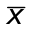)² : | 186.01

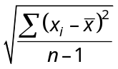 = SQRT [186.01/(9 − 1)] = 4.82

2. Standard deviation is a useful concept in performance management. It can be useful in performance comparison, performance monitoring, and performance evaluation. Let us say that a director in a local fire department wants to know any variation between the performance of this year and that of the last year. He draws a sample of 10 response times of this year (in minutes): 3.0, 12.0, 7.0, 4.0, 4.0, 6.0, 3.0, 9.0, 11.0, and 15.0, comparing them with a sample of 10 response times from last year (in minutes): 8.0, 7.0, 8.0, 6.0, 6.0, 9.0, 7.0, 9.0, 8.0, and 6.0.
a. Does he see a performance variation by the mean?

No. The means are 7.4 min in both years.

b. Does he see a performance variation by the standard deviation? If he does, is it a performance improvement or a performance deterioration from the last year? Why?

Yes. The standard deviation of response times this year is larger, indicating a performance deterioration from the last year. This means that response times have become unstable, unpredictable, and unreliable. There are three long responses this year.

c. Now, imagine that you are a citizen receiving fire protection services from this local fire department. How do you evaluate the response times of this fire department, by the mean, by the standard deviation, or by both?

Ans: Citizens should be concerned because they could be potentially affected by longer responses. Management should use both the mean and the standard deviation in evaluation.

d. If the average response time improves (shortens) but the standard deviation of the response times deteriorates (increases), what is your conclusion of the performance as a service recipient? In other words, do you want a quicker average response at the expense of a more unpredictable response? What is your recommendation to the director on which statistical measures he should use and how he should use them?

Ans: Realize that measures of central tendency and measures of dispersion concern different aspects of performance. Performance managers should use both types of measures to give a complete picture of the performance.

3. This is an exercise in data cleaning. Prior to performing any type of data evaluation, you must first become familiar with the data set and the nature of the variables you wish to evaluate. The first data set is from a citizen survey performed in Orange County, Florida. Open the Public Perceptions data set.
a. Open the data file.
b. There are 1,034 cases.
c. There are 83 variables on the survey instrument. The data set also contains the index variable “satisfac.”
d. The measurement level of gender is nominal, the measurement level of age is ordinal, and the measurement level of “yearsorc” (years living in Orange County) is metric.
e. The variable “yearsorc” includes a value of 301. This is not plausible.
f. The value “301” is an outlier.
g. After removing this value, other values appear as outliers. However, these values are quite plausible, and so they should be left in. This exercise shows the importance of using judgment!

4. According to the Public Perceptions survey, do residents feel that the county has done a good job of balancing growth with environmental concerns? Make a frequency distribution. The variable is named Balance. Also, construct two bar charts: one that includes all three categories, and one that omits the category “don’t know.”
Ans: Respondents are divided: 43.2% say “yes,” 44.5% say “no,” and the remainder “don’t know.”
The matter of making a bar chart without the “don’t know” category is a software matter that can be tricky for students. For some instructors, this might be an opportune time to show students how to recode variables, too (i.e., recode the value “3” as missing.)

5. According to the Public Perceptions survey, how do residents feel about their service experience? Specifically, what percentage of respondents agree or strongly agree that employees were helpful? What percentage of respondents agree or strongly agree that service was provided in a timely manner?
Ans: Note: Analyze data for only those respondents who stated that they have had contact with county employees during the last 12 months.
The “trick” is to first select those respondents who had contact with the county during the last 12 months (i.e., when contact = 1). Then, we look at the frequency distributions of the variables “helpful” and “timely.” Among respondents who have had contact with the county during the last 12 months, 87.2% agree or strongly agree that employees were helpful and 75.2% agree or strongly agree that service was provided in a timely manner.
Optional: For some, professors, the variables in this item provide an opportunity for showing students how to make index variables. The Cronbach’s α measure of internal reliability of the following five variables is .86: “respect,” “friendly,” “nomistak,” timely,” and “exceed.” Cronbach’s α is first mentioned in Chapter 3.
6. Among the items listed in Section I of the Public Perceptions survey, which 5 items are the most important? Which items are the least important for residents? Based on what statistic do you decide this? What type of graph might you use to present your findings?
Ans: Before doing this exercise, don’t forget to deselect the filter used in the previous question: all cases must be included here. The question concerns the 27 variables in Section 1, starting with the variable “control” and ending with “wages” on the spreadsheet.
Instructors will need to decide how they define the most important and the least important. Simplistically, we could look at ranking items based on the percentage of respondents who strongly agree with any item, although a better measure is the percentage of those who strongly agree and agree with an item. Others might calculate the mean response of each item, even though this is an ordinal scale. You decide. A bar chart might be used to show the five most important items. The following results are obtained:
How important are the following issues for you? Please state whether you consider each issue very important, important, somewhat important, or unimportant:
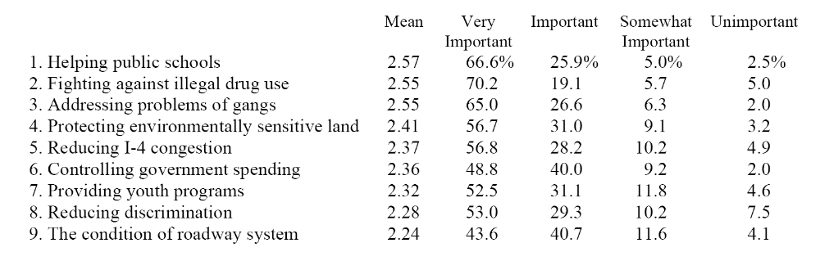

 | Mean | Very important | Important | Somewhat important | Unimportant
10. Improving the water quality of lakes | 2.20 | 42.6 | 39.0 | 14.4 | 4.0
11. Needs of senior citizens | 2.20 | 43.3 | 38.3 | 13.9 | 4.6
12. Increasing public safety | 2.19 | 45.7 | 34.2 | 13.8 | 6.3
13. Increasing the level of wages | 2.17 | 45.4 | 34.7 | 11.2 | 8.6
14. Controlling development and growth | 2.11 | 39.9 | 37.8 | 15.9 | 6.3
15. Providing better job training | 2.08 | 39.3 | 36.6 | 17.0 | 7.0
16. Promoting welfare to work programs | 2.05 | 38.2 | 36.3 | 17.6 | 7.9
17. Cutting property taxes | 1.99 | 35.7 | 36.3 | 19.7 | 8.3
18. Promoting high tech jobs | 1.99 | 32.3 | 42.3 | 17.0 | 8.3
19. Increasing code enforcement | 1.98 | 33.9 | 37.7 | 21.4 | 7.1
20. Helping neighborhoods | 1.96 | 30.4 | 43.0 | 19.2 | 7.4
21. Providing better storm water drainage | 1.86 | 27.2 | 40.8 | 23.2 | 8.8
22. Improving the parks | 1.84 | 22.4 | 45.6 | 26.1 | 5.9
23. Improving mass transit | 1.80 | 30.7 | 32.6 | 22.5 | 14.2
24. Promoting the arts | 1.70 | 23.4 | 36.7 | 26.0 | 13.9
25. Addressing business needs | 1.64 | 16.7 | 42.8 | 28.0 | 12.4
26. Improving appearance of roadways | 1.48 | 20.8 | 26.4 | 32.8 | 20.1
27. Building light rail | 1.22 | 15.4 | 24.2 | 27.1 | 33.2

7. Open the Community Indicators data set. Examine the frequency distributions of the variables murder and nonnegligent manslaughter (called “murder” on the data set), burglary (called “burglary”), and forcible rape (called “rape”). Then use boxplots to determine whether any cities might be considered outliers among these measures. Based on your findings, should you include or exclude these cities from any further analysis? If you include them, should you note and study the impact that these cities have on your results?
Ans: The frequency distributions are a bit unwieldy for making decisions about outliers, which is one of the points of this exercise. Indeed, you might want to make histograms, too.
These are the boxplots. You can increase the size of these charts by double clicking on them and dragging the corners. This approach identifies observations that are outliers. Following the decision rule in the book, if these observations are not believed to be in error, they should be retained (p. 119). However, analysts should note the effects of these observations in their findings, conducting analysis with and without observations found to be outliers. This also shows the usefulness of doing such analysis on a per capita basis, where there are far fewer outliers.

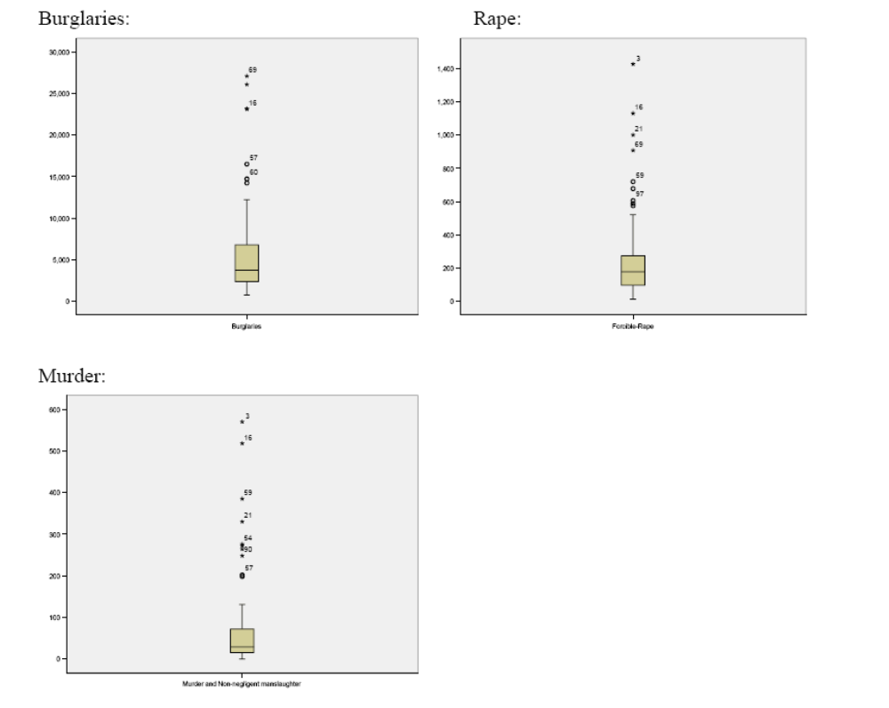
8. The Employee Attitudes survey contains several items that reasonably might affect workplace performance. Read the description of this survey. How do employees feel about the following items: the morale among county employees, the extent that their organization welcomes change, receiving timely feedback about one’s performance, and cooperation among departments? The variables are, respectively, Himorale, Welchang, Feedback, and Coopdept.
Ans: Few employees (24.6%) strongly agree or agree that employee morale is high, 52.5% strongly agree or agree that their organization welcomes change, 58.6% strongly agree or agree that feedback is timely, and 59.6% strongly agree or agree that there is cooperation to get the job done.

9. Open the Watershed data set and read the description of the survey. Calculate the mean and median of the number of samples that exceed pollution standards (Conpolut) and fish and wildlife advisories (Advisory). Make a bar chart of the quality of watersheds (Wshedch).
Ans: The mean and median of the variable “conpolut” are, respectively, 18.99 and 17.55. The mean and median of the variable “advisory” are, respectively, 4.63 and 3.00.
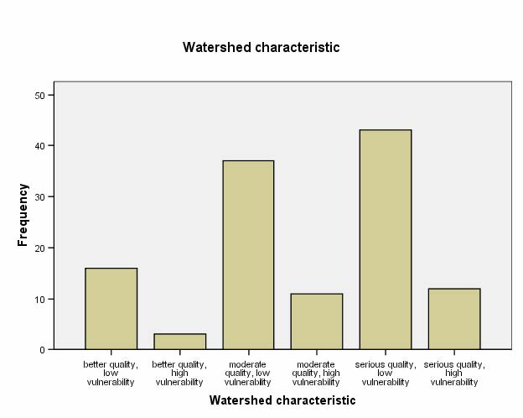

Chapter 8: Contingency Tables

Critical Thinking
1. Identify all of the features that are part of contingency tables: title, clear column and row headings, data cell frequencies, column percentages, marginal totals, and grand total.
Ans: Students could either use a table in the text or be asked to find one outside the book. None of the contingency tables in Chapter 8 show both data cell frequencies and percentages, but in Chapter 10, Table 10.1 does. The concepts “marginal totals” and “grand total” are discussed on p. 133.
2. Explain the following statement: “Examining relationships in contingency tables is usually based on comparing column percentages or groups of rows.” Give an example.
Ans: The example is discussed on p. 134: “The absolute frequency counts in Table 8.1 do not tell us much . . . . Rather, we need to compare the percentages of men and women promoted in each year.” And “The examination of relationships in contingency tables is usually based on comparisons of column percentages or groups of rows. From Table 8.2, we see that men were indeed promoted at a faster rate than women. About 69.8% [32.6% + 37.2%] of men were promoted in the first 2 years, compared with only 42.3% [15.4% + 26.9%] of women.” The latter shows “comparing groups of rows.”
3. Calculate column percentages for Table W8.1:
Ans: Column percentages are shown in parentheses:
Observed frequencies:
Welfare |  | Education
Outcome | No H.S. degree | H.S. degree | Some college | Total
Low | 60 (50.0%) | 55 (39.3%) | 10 (22.2%) | 125 (41.0%)
Medium | 35 (29.2%) | 55 (39.3%) | 15 (33.3%) | 105 (34.4%)
High | 25 (20.8%) | 30 (21.4%) | 20 (44.4%) | 75 (24.6%)
Total | 120 (100.0%) | 140 (100.0%) | 45 (100.0%) | 305 (100%)

4. Practice writing up the results for the preceding question. Identify the number of recipients, and how they differ by education and welfare outcome. Then discuss the relationships between these two variables. Use statements in the form of “Whereas xx percent of recipients with no high school degree have high welfare outcomes, xx percent of recipients with some college have high welfare outcomes,” and so on.
Ans: Answers vary. Regardless of how the table is analyzed, it shows that increases in education are associated with increased welfare outcomes. For example, 44.4% of recipients with some college report high welfare outcomes, compared to only 21.4% of those with a high school degree and 20.8% of those with no high school degree.

5. Explain how pivot tables and contingency tables are relevant to analysis of problems in your area of interest. Provide some examples.
Ans: Answers vary. The textbook shows an example on pp. 141–144.
6. Study the latest issues of research journals or professional reports in your field of interest; examine the use of tables and how the reports are written up.
Ans: Answers vary. You might want to have a few examples on hand and point out elements that you find important. Increasingly, write-ups highlight significant findings only. You might also point out the discussion of research methods.
Data-Based Exercises
Ans: Note: The following exercises ask students to provide a write-up. Although writing up results is an essential skill, each instructor is apt to have his or her preferred format or style. So, I will let you develop your own requirement and formats. Here, I focus on the quantitative results. Elsewhere on the instructor’s website, I provide sample homework assignments, including a complete write-up sample (see Homework Assignment #2).
1. Use the Employee Attitudes data set. Examine the relationship between gender and the morale of county employees (Himorale). Then consider the relationship between gender and stress (Stressed). Use column percentages and write up the result.
Ans: Students need to think about which variable should be in the column. In the first part of this question, gender goes in the column, producing the following result:
The Morale of Seminole County Government Employees is High × Gender
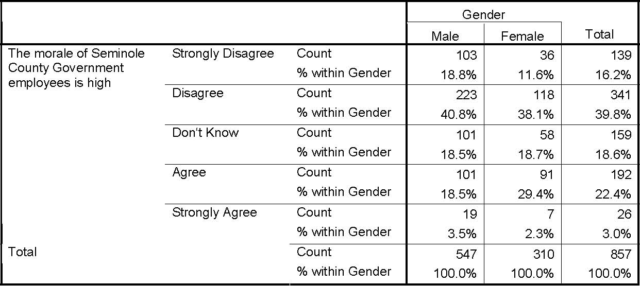
The write-up should identify that females perceive a higher level of morale among county employees. The write-up might include a sentence such as, “Females express a higher level of morale than males. For example, whereas 31.7% of females agree or strongly agree that morale among county employees is high, only 22.0% of male respondents agree or strongly agree with this statement.” The write-up should further note that respondents are mixed about their perception of employee morale. Across both genders, 56.0% disagree or strongly disagree that morale is high, 25.4% agree or strongly agree, and 18.6% don’t know.
Regarding the relationship between gender and stress, the following results are obtained:
I Seldom Feel Stressed Because of My Work × Gender
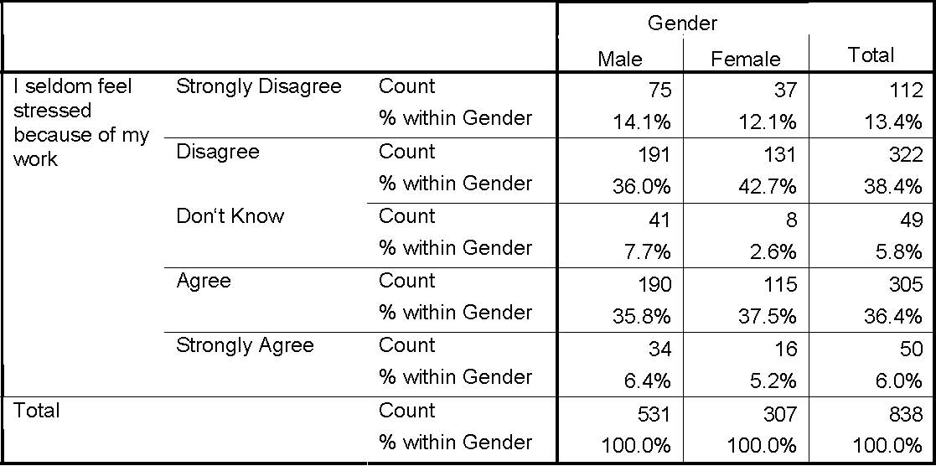
2. Use the Public Perceptions data set. Is the relationship between gender (Gender) and trusting the county government to do what is right most of the time (Trust) positive or negative? Is the difference between men and women large or small?
Ans: Note: This is a trick question of sorts: Gender is a nominal-level variable; thus, it is not meaningful to ask whether the relationship is positive or negative!
The following output shows that the difference is quite small. As a point of further discussion, you may note that in Chapter 9 we see that this relationship is in fact statistically significant, even though its practical significance is low.

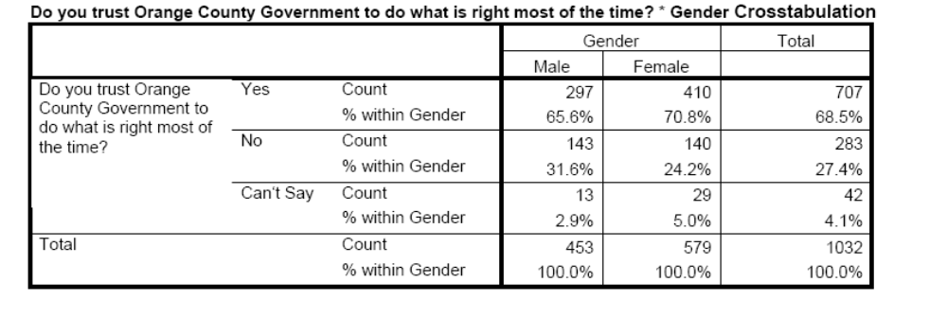

3. Use the Public Perceptions data set. The three most important issues are (see Part I of the survey in Chapter 20): helping public schools (Pubschl), fighting illegal drug use (Figtdrug), and dealing with the problems of gangs (Gangs). Do Whites and non-Whites agree on the importance of these priorities? On which issues is there a difference?
Ans: After recoding the Race variable, the variables, such as Figtdrug, Gangs, and Pubschl, do not differ much between Whites and non-Whites. A small difference exists regarding support for schools. Whites and non-Whites differ only a little in the extent that they find this issue very important (64.8% vs. 72.8%, respectively). However, they do not vary with regard to finding it important (91.3% and 95.8%, respectively, agree that this is an important or very important issue).
Note: In this chapter, we have not yet introduced χ². However, if you were to perform such a test, the new findings would be, for each of the three crosstabs respectively, χ² = 5.77 (df = 3, p = .124); χ² = 5.49 (df = 3, p = .140); and χ² = 7.72 (df = 3, p = .052).
Helping Public Schools × White Crosstabulation
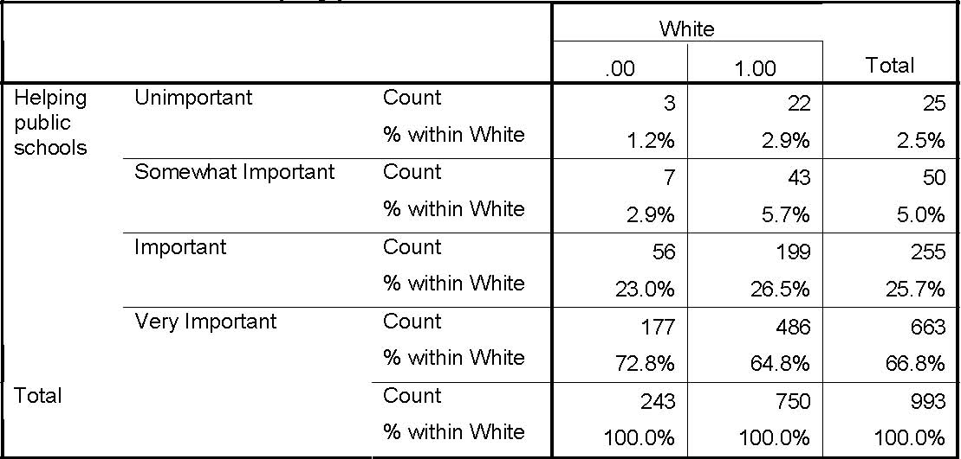
Fighting Against Illegal Drug Use × White Crosstabulation
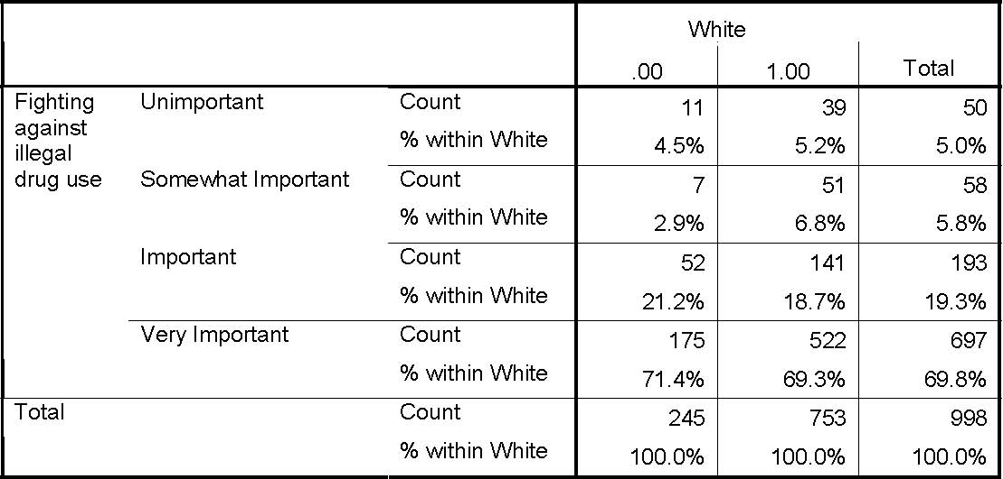

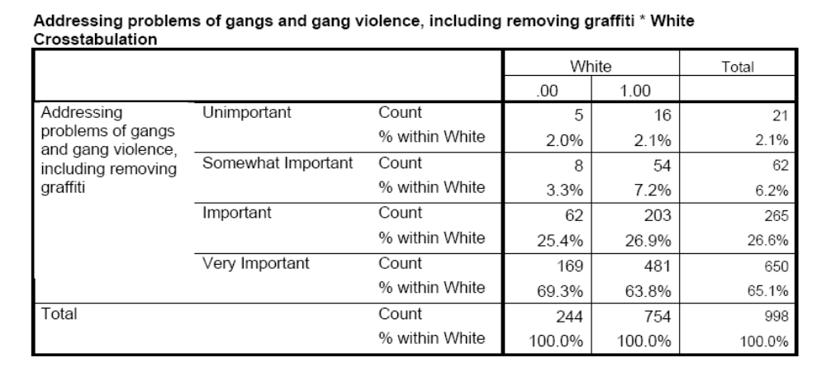
4. Use the Employee Attitudes data set. A manager wishes to examine the relationship between race (Race) and perceptions that the people who get promoted are among the best qualified (Bestqual) in the public works department. However, very few employees are minorities, and a manager is concerned that separate analysis for each minority group might reveal their identity. Therefore, the manager wants to compare Caucasian employees against non-Caucasian employees. Recode the variable Race in this manner and report on the above relationship.
Ans: Be sure to analyze only employees in the public works department (dept = 13). The results are as follows (n = 181):
The People That Get Promoted Are the Best Qualified for the Job × Caucasian Crosstabulation
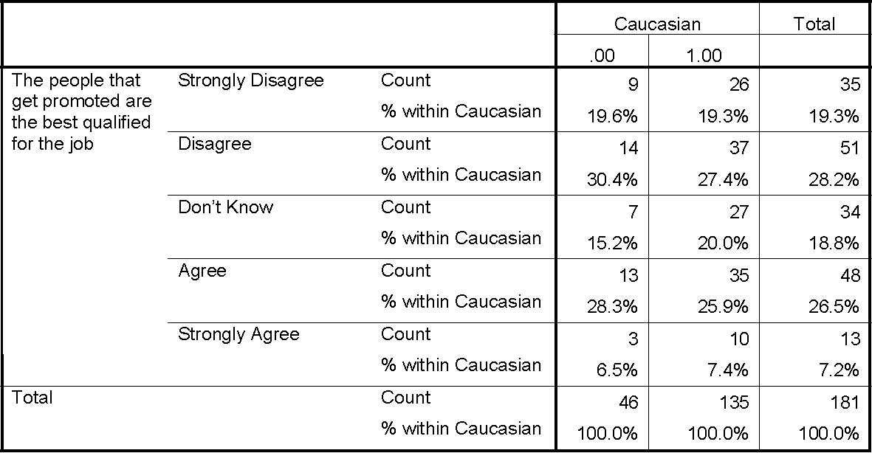
5. Use the Employee Attitudes data set. Examine the relationship between the morale of county employees (Himorale) and being satisfied with one’s job (Satisjob). Is this table easy or difficult to interpret?

Ans: Note: Chapter 11 discusses Kendall’s τ-c, which can also be used to interpret whether a relationship exists between these two variables in a contingency table and, if so, whether it is positive or negative.

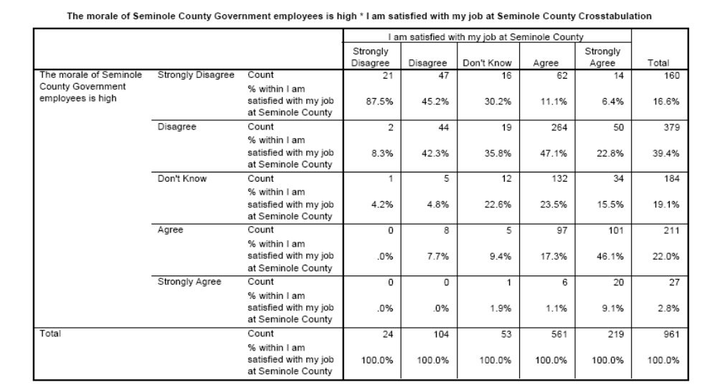
6. Open the Watershed data set and make a pivot table from variables in that data set. For example, consider region and drinking water impairment as the two categorical variables and show the mean level of conventional pollutants in each data cell. You may choose other continuous variables, as well. Note: See footnotes in Chapter 8 of the textbook for information on how to create pivot tables in SPSS and Excel.
Ans: This is a good time to practice creating pivot tables (or, Analyze  Reports  OLAP Cubes). An impressive feature to share with students is the ease with which you can swap the variables from rows to columns and create embedded results. That is usually a high note in the class and a great way to end the lecture.

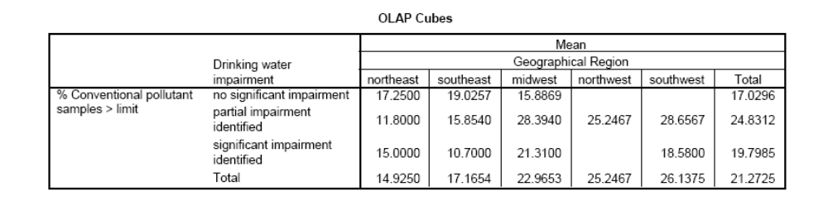
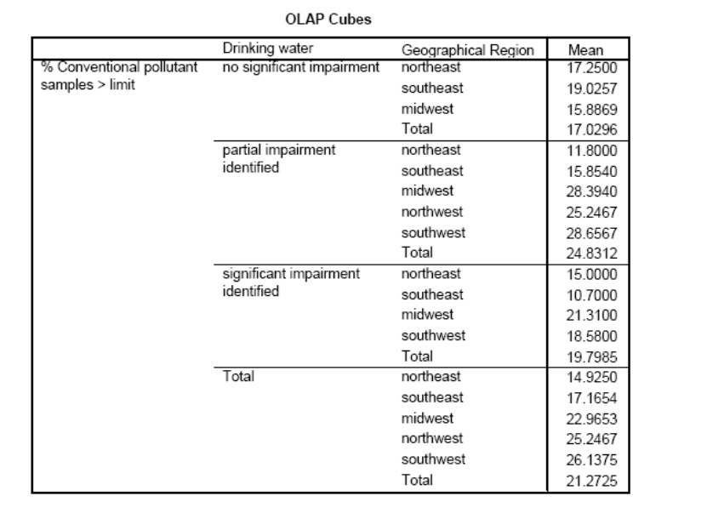

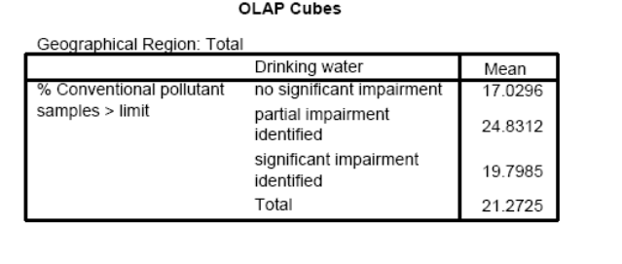
7. Does class attendance affect a student’s academic performance? To answer this question, you can conduct a study based on your personal experience. Consider all the classes you have taken in college. Code as ordinal variables your attendance in a course (for example, good or not so good) and your academic performance (e.g., A or not A). Conduct a contingency table analysis to examine the relationship between attendance (the independent variable) and academic performance (the dependent variable). Write a paragraph to report your finding.

Ans: Make sure that you code the both variables as ordinal variables before constructing the contingency table. Instead of using two categories “Good” or “Not So Good” for attendance, you could code it with three categories of “Excellent”, “Good”, or “Not Good”. You can also do the same in coding academic performance. But make sure that you have enough data in each cell. If you have too little data in a cell (e.g., less than 3), combine it with other cells. The unit of analysis is courses. An alternative way of conducting this analysis is to survey students in a class to gather the data. In that case, the unit of analysis is individual students.

Chapter 9: Getting Results

Critical Thinking
1. Explain the difference between performance measurement and performance management.

Ans: This helps students refamiliarize themselves with some basics. From chapter 4, p. 60: “Performance measurement is defined as a process for assessing progress toward achievement of program goals.” And p. 66: “Performance management is defined as the assessment and management of work processes and employees toward predetermined goals, often involving an ongoing cycle of feedback and improvement, to ensure effective and efficient progress.”

2. Give some examples of how statistical concepts and tools can enhance the application of performance measurement and performance management.

Ans: Concepts like the mean state average, but we also want to know things the like 90th percentile and so on. The mean, a statistical concept, can be used to represent the average performance. For example, you can identify average response time, average crime rate, and average clearance rate in measuring the performance in a local police department. These averages can be used to set standards for performance monitoring and evaluation. The standard deviation, another statistical concept, can be used to measure performance variation. A large value in standard deviation may indicate an inconsistent and unreliable performance. For example, you can calculate the standard deviation of citizens’ evaluations of the police department over time to understand if police performance has been consistent in citizens’ eyes.

3. Consider the following expression: “What gets measured, gets done.” Discuss the pros and cons of this approach to performance management.

Ans: Measuring surely gets people’ attention and focus, but it also creates “tunnel vision,” gamesmanship, and managers need to be certain that what is measured is the right target, indeed. Imagine that you are taking a statistical course in college and you get a C in a test, you know that is not a good performance and you should improve it to an A or B. The measurement (a C in a test in this case) is often a necessary first step in an analysis designed to figure out the causes of an underperformance and discover means of performance improvement. However, having a measurement does not necessarily mean that an analysis will be done and improvement will be made. There are many cases in organizations in which performance measures are readily available but are hardly used for analysis and improvement for a variety of reasons.

4. What limitations would a manager face if he or she understood the concepts involved in performance measurement and performance management but did not have the ability to produce statistical analyses?

Ans: At the very least, it would be more difficult to tell one’s story and satisfy the critics. The idea that we need to track performance in order to know what it is has (some) validity, but not that we need to track performance in order to know whether there are problems; managers may (or should) know about problems through the grapevine, long before the data tell so. A manager should be able to interpret the results of statistical analyses and apply the results in management. The best way to gain that capacity is to learn how to conduct statistical analyses. A manager relying on others for analyses lacks the ability to judge the validity of the results.

5. How is the application of statistics in performance measurement and performance management enhanced through the use of charts (i.e., graphs and tables)? Conduct a simple experiment in which the results of a statistical analysis are presented to an audience with and without the use of charts. What differences does the presentation of charts make? Besides the visual enhancement provided, what other benefits do you see from presenting information using graphs and tables?

Ans: As the saying goes, a picture is better than a thousand words. Graphs and tables are very effective in communicating ideas with stakeholders. Performance measurement is sometime technical and the stakeholders may know little about it. Using charts, graphs, and tables help them better understand the performance measurement process and results. An informed audience is more likely to engage more in performance management, which is another benefit of visually enhanced presentations. The audience is more likely to ask questions and participate in performance measurement.
Your experiment likely proves the effectiveness of graphs, tables, and charts in communication. In the experiment, you can compare presentational effect of two groups—one group with visual presentation and the other without it. For example, to demonstrate a positive relationship between education and income (more education is associated with higher earning for individuals), you can read a set of numbers to a group of your friends and then measure their understanding of the relationship. You can show a graph of the relationship to another group and ask the same question. In the experiment, make sure that you design proper measures to assess the audience’s understanding of the ideas in communication.

6. How is your understanding of statistical concepts enhanced by studying the analyses of outputs, outcomes, efficiency, and effectiveness in this chapter?

Ans: Answers vary.

7. Is your understanding of statistical concepts enhanced by studying the quality-of-life analyses in this chapter? Why or why not?

Ans: Answers vary.

8. Explain the difference between prediction and forecasting.
Ans: Prediction concerns known values; forecasting concerns unknown, future values.
9. Discuss why prior moving averages (PMAs) forecasting may be more conservative than forecasting based on prior average changes.
Ans: PMAs do not incorporate the trend of past observations as affecting future observations.

10. Consider the trend shown in Figure W9.1. Should forecasting involve periodicity, and, if so, what period of time should be considered? What is the consequence of not using periodicity?
Ans: Yes, periodicity = 5. When no periodicity is used, period forecasts will reflect period averages.

Application Exercises
1. Calculate the mean, the sample variance, the sample standard deviation, the maximum, the minimum, and the range for each agency. Then discuss the meanings of these performances for the agencies.
Ans: The overall mean of all four groups is 5.15 and the standard deviation is 2.84. The means for Offices A, B, C, and D are 5.42, 4.17, 5.67, and 5.33, respectively. The standard deviations for them are 2.64, 2.62, 2.74, and 3.42. The maximums are 10.00, 9.00, 10.00, and 10.00, respectively, and the minimums are 1.00, 1.00, 2.00, and 1.00, respectively. The ranges are 9.00, 8.00, 8.00, and 9.00.
2. Which agency is the best performer based on these measures? Which is the worst? What makes you draw these conclusions? If the state decides to retrain agencies one at a time, what would be your priority list of retraining? Explain your rationale of creating the retraining list.
Ans: Assessed by the mean, Office C has the worst record and should be retrained first, followed by Offices A, D, and B. But Office D’s mean (5.33) and standard deviation (3.42) are larger than the overall mean of all groups (5.15) and the overall standard deviation (2.84), indicating a substandard and unreliable performance. So there should be consideration to retrain workers in Office D first.
3. Calculate the frequency and cumulative distributions for the number of errors for each agency. Let us say that the department wants 50% or more of the tests to have 5 or less errors in each agency, which agencies (or agency) meet this performance benchmark and which don’t? Explain your findings.
Ans: 66.7% of tests (8 of 12) in Office A and Office B have an error rate equal to or less than 5. That rate for Office D is 50%. Office C does not meet the standard, whose 41.7% of tests have an error rate equal to or less than 5.
4. Use five or less errors as a benchmark to distinguish the test scores into two categories for each agency (i.e., the “5 or less errors” category and the “more than 5 errors” category). Perform a contingency table analysis for all four agencies. Explain your findings.
Ans: You should be able to get a table that looks like the following. In constructing the table, make sure that you align the Agency variable in column and Error rate in row and calculate the column percentage. The results show a better performance in Offices A and B. Office C has the worst performance. More than 58% of tests in that office have error rates larger than 5.
Error Rate × Agency Crosstabulation
 |  |  | Agency |  |  |  | Total
 |  |  | A | B | C | D | Total
Error rate | 5 or less | Count | 8 | 8 | 5 | 6 | 27
Error rate | 5 or less | % within Agency | 66.7% | 66.7% | 41.7% | 50.0% | 56.3%
Error rate | above 5 | Count | 4 | 4 | 7 | 6 | 21
Error rate | above 5 | % within Agency | 33.3% | 33.3% | 58.3% | 50.0% | 43.8%
Total |  | Count | 12 | 12 | 12 | 12 | 48
 |  | % within Agency | 100.0% | 100.0% | 100.0% | 100.0% | 100.0%

5. Table W9.2 shows expenditures for the past five years. Forecast the next three periods using (a) prior moving averages (three-year spans) and (b) prior average moving changes (with last period as base). Add your forecast to the table.
a. PMAs:
Time | Expenditure (Current $’s) | Inflation (%) | Expenditure (Constant $’s) | PMA/Forecast
1 | 100 | 2.8 | 112.9 | –
2 | 102 | 4.1 | 112.0 | –
3 | 108 | 3.0 | 113.9 | –
4 | 112 | 2.4 | 114.7 | 112.9
5 | 116 | 3.2 | 116.0 | 113.5
6 | — | — | — | 114.9
7 | — | — | — | 115.2
8 | — | — | — | 115.4

The expenditure at Time 3 in constant dollars is calculated as 108 × 1.024 × 1.03 = 113.9. Note that the PMA for Time 7 is calculated as (114.9 + 116.0 + 114.7)/3. Whenever possible, we use actual rather than predicted values.
b. Average increases:
Time | Expenditure (Current $’s) | Inflation (%) | Expenditure (Constant $’s) | Increase | Avg. Increase | Forecast
1 | 100 | 2.8 | 112.9
2 | 102 | 4.1 | 112.0 | –0.9
3 | 108 | 3.0 | 113.9 | 1.9
4 | 112 | 2.4 | 114.7 | 0.8 | 0.6
5 | 116 | 3.2 | 116.0 | 1.3 | 1.3 | 115.3
6 | — | — |  | 1.3 | 1.1 | 117.3
7 | — | — |  | 1.1 | 1.2 | 118.4
8 | — | — |  |  |  | 119.6

6. Daily workload activities are shown in Table W17.3. Forecast workloads for Week 5.
Actual Workload | Avg. Weekly Workload | Avg. Increase, Avg. Forecast | Daily Variation | Daily Forecast
63 |  |  | –3.2
72 |  |  | 5.8
76 |  |  | 9.8
67 |  |  | 0.8
53 | 66.2 |  | –13.2
70 |  |  | 1.2
77 |  |  | 8.2
75 |  |  | 6.2
72 |  |  | 3.2
50 | 68.8 | 2.6 | –18.8
69 |  |  | –1.6
75 |  |  | 4.4
77 |  |  | 6.4
70 |  |  | –0.6
62 | 70.6 | 1.8 | –8.6
 |  | 72.4 | –1.2 | 71.2
 |  | 72.4 | 6.1 | 78.5
 |  | 72.4 | 7.5 | 79.9
 |  | 72.4 | 1.1 | 73.5
 |  | 72.4 | –13.5 | 58.9

7. Practice making a few professional-looking charts using Microsoft Excel. Excel allows analysts to create different types of charts, including column charts, bar charts, pie charts, and line charts. To create a chart in Excel, click on the Insert tab and then select the chart type from the Charts group. You can modify charts, apply predefined styles and layouts, and add various formatting features. Chapter 19 of this workbook provides an example of how to create a chart using Excel.
Ans: Answers vary.
8. Table W9.4 shows attendance data of a public museum. Make a worksheet for calculating forecasts based on (a) prior moving averages and (b) prior moving changes for the next five periods. Also, validate your forecasts by comparing actual and predicted values.

Ans:
a. PMAs: To forecast based on PMAs, we need only to use information from periods 14 through 16
b. Average increases:

Time | Attendance | PMA | Error | Average Error
1 | 1,205
2 | 1,309
3 | 1,325
4 | 1,226 | 1279.7 | 53.7
5 | 1,450 | 1286.7 | –163.3
6 | 1,529 | 1333.7 | –195.3
7 | 1,679 | 1401.7 | –277.3
8 | 1,543 | 1552.7 | 9.7
9 | 1,468 | 1583.7 | 115.7
10 | 1,602 | 1563.3 | –38.7
11 | 1,625 | 1537.7 | –87.3
12 | 1,698 | 1565.0 | –133.0
13 | 1,550 | 1641.7 | 91.7
14 | 1,623 | 1624.3 | 1.3
15 | 1,708 | 1623.7 | –84.3
16 | 1,767 | 1627.0 | –140.0 | –65.2
17 |  | 1699.3
18 |  | 1724.8
19 |  | 1730.4
20 |  | 1718.2
21 |  | 1724.4

Time | Attendance | Increase | Average Increase | Forecast | Error | Average Error
1 | 1,205
2 | 1,309 | 104
3 | 1,325 | 16
4 | 1,226 | –99 | 7.0
5 | 1,450 | 224 | 47.0 | 1233.0 | –217.0
6 | 1,529 | 79 | 68.0 | 1497.0 | –32.0
7 | 1,679 | 150 | 151.0 | 1597.0 | –82.0
8 | 1,543 | –136 | 31.0 | 1830.0 | 287.0
9 | 1,468 | –75 | –20.3 | 1574.0 | 106.0
10 | 1,602 | 134 | –25.7 | 1447.7 | –154.3
11 | 1,625 | 23 | 27.3 | 1576.3 | –48.7
12 | 1,698 | 73 | 76.7 | 1652.3 | –45.7
13 | 1,550 | –148 | –17.3 | 1774.7 | 224.7
14 | 1,623 | 73 | –0.7 | 1532.7 | –90.3

Time | Attendance | Increase | Average Increase | Forecast | Error | Average Error
15 | 1,708 | 85 | 3.3 | 1622.3 | –85.7
16 | 1,767 | 59 | 72.3 | 1711.3 | –55.7 | –16.1
17 |  | 72.3 | 72.1 | 1839.3
18 |  | 72.1 | 67.8 | 1911.4
19 |  | 67.8 | 70.8 | 1979.3
20 |  | 70.8 | 70.2 | 2050.0
21 |  | 70.2 | 69.6 | 2120.2

Comparison of the average error shows that the predicted values based on average increases are more accurate than those based on PMAs.
BTW, below is a plot of the actual and forecasted values. The two forecasts clearly show the conservative bias of PMAs and the progressive bias of forecasts based on average increases.

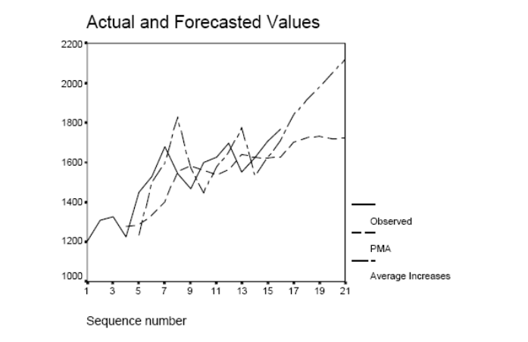

Chapter 10: Introducing Inference: Estimation from Samples

Critical Thinking
1. Would you need to use inferential statistics when population parameters are known? Why or why not?
Ans: If the parameters are known, there is no need to perform any statistical estimation, or for that matter, the hypothesis testing in the next chapter. However, you will find that it is not uncommon for researchers run statistical analyses and estimations on the population information. They do this for many reasons (see the next questions). In these cases, the information is treated as sample.
2. Can a population in one context be a sample in another context? For example, consider a class of 50 students—can this be both a sample and a population?
Ans: Let’s say that you study a class of 250 students, you draw a sample of 50. The population is the 250 and the sample is the 50. But the population 250 becomes a sample when you study the whole student body at the school. This is why having a clear idea of what your population is in a study is important. The 12 months each year can be population for a study of that period but only a sample in history.
3. How can you improve the accuracy of a confidence interval estimation? (i.e., obtain a smaller interval. Tip: look at the formula!)
Ans: Increase the sample size.
4. Can population parameters ever change?
Ans: When we say that we use samples to estimate population parameters, we seem to give the idea that the population parameters don’t change. But that is not true. Population parameters change too. The U.S. population changes every year so all population-related parameters change accordingly.
5. Give a few real-life examples of when a confidence interval estimate might be used.
Ans: A confidence interval is likely to be useful when assessing emergency response times from a sample or when making estimates of salaries for professional groups. There is obviously a lot of variation on these matters, and the CI captures as regarding any population estimate.
6. Give your own numerical example of the central limit theorem.
Ans: Any variation of the numbers in Box 10.1 will do. For example, take some random samples of n = 2 of the following data: 3, 4, 6, 7, 8, 10, and 13. The result will be a normal distribution with mean about 7.3.

Exercises
1. The authority in a school district is very concerned about a recent newspaper report of the high absence rate among students in the district. The report says that the absence rate of the district may be well above the state average of 11.30 days a year per student. The authority wants to closely monitor the absence rate trend. To start, a sample of 250 students in the district was draw to develop a baseline performance target for the performance tracking. The average absence rate of the sample is 11.90 days per student with a standard deviation of 3.90. Create a 95% and a 99% confidence intervals to estimate the absence rate of the district.
Ans: The formula for 95% CI for large samples (n >30) is: . Hence, the 95% CI is 11.9 + (1.96 × 3.9/(250)^0.5)= 11.9 + 0.48
The formula for the 99% CI is large samples (n > 30) is: 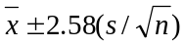. Hence, the 99% CI is 11.9 + (2.58 × 3.9/(250)^0.5)= 11.9 + 0.64

2. A citizen satisfaction survey on policing services was conducted in a city of about 100,000 residents. Of 1,934 residents in the sample who returned the survey, 895 said they were either “happy” or “very happy” with the services and 1,039 said that they were “unhappy” or chose “don’t know”. Create a 95% and a 99% confidence intervals to predict the percentage of residents who are “happy” or “very happy” about the police services.
Ans: The formula for calculating a CI from a proportion is 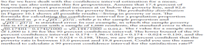. In this instance, (895/1934 = ) 46.2% of residents are “happy” or “very happy” with the services. Thus, the 95% CI is 0.462 + 1.96 × [0.462(1-0.462)/1934]^.5 = 0.462 + 0.022. The 99% CI is 0.462 + 0.092
3. The number of vehicle accidents is sampled from a city’s 20 major traffic intersections and their adjacent areas several times a day to assess traffic congestion. The police department uses the information to allocate resources of traffic control. A performance standard of an average of 2.0 accidents per hours per area is established. A traffic emergency control system is mobilized and resources are directed to traffic control once the traffic condition is equal or worse than the standard. Table W10.1 shows the accident information taken during 7:00 a.m. to 8:00 a.m. today. Should the police department mobilize the traffic emergency control system? Why or why not?
Ans: The formula for 95 % CI for small samples (n <30) is: . With these data,

Statistics
VAR00002
N | Valid | 20
N | Missing | 46
Mean |  | 1.6000
SD |  | 1.31389

And df = n−1 = 19, this t = 2.093. Hence, the 95% CI is 1.6 + 2.093 × 1.31/(20^.5)= 1.6 + 0.61. As this range includes performance standard of 2.0, the city cannot be 95% confident that current accidents are less than the standard and thus the police department should mobilize the traffic emergency control system.
(Having said this, drawing from more samples, say n = 50, with the same the mean shows the CI as 1.6 + 0.36 which is below the standard of 2.)

4. The database “Data_FL_County” (SPSS) includes Florida county governments’ total spending, administrative spending, environmental spending, conservation spending, public safety spending, economic development spending, from 1999 to 2008. The data are from all Florida counties except one which does not provide data. The data set also includes demographic and sociopolitical variables—population, income, and education, presidential votes, and many other variables. Use the county conservation spending in total spending in 2008 (“ConsTotal08”) to create a confidence interval. Explain the meaning of this estimate.
Ans: OOPS!! ‘ConsTotal08’ is the proportion of Cnsveration Spending08/Total Spending08. Total conservation spending in 2008 is “Cons08.” The difference between these two variables is shown below.
Statistics
 |  | 2008 Conservation/Total Spending | 2008 Conservation Spending
N | Valid | 64 | 64
N | Missing | 2 | 2
Mean |  | .020917 | 8052890.91
SD |  | .0521730 | 15558128.670
The formula for 95% confidence interval (CI) for large samples (n > 30 – there are 66 counties/observations) is: . Hence, the 95% CI is 8052890 + (1.96 × .15558128/[66^0.5])= 8052890 + 3753543, hence US$8.1 million + $3.8 million—quite some variation among Florida counties. Further analysis might consider population size, and so on. to explain such variation, of course. The data set includes population per county, so such analysis can be done.

Chapter 11: Hypothesis Testing With Chi-Square

Critical Thinking
1. Why does it make sense to test for relationships by stating the null hypothesis?
Ans: See p. 181: “[T]he null hypothesis (i.e., that no relationship exists) is assumed, and an objective of statistical testing is to examine whether the null hypothesis can be rejected. . . . [I]f we assume that a relationship does exist, we might be guilty of not trying hard enough to prove that it doesn’t exist. By assuming that a relationship doesn’t exist, we need only satisfy the standard of “reasonable evidence” in order to claim that it does exist.”
2. Why are standards of 1% and 5% often used? What objections might be raised against using standards of, say, 0.01% or 10%?
Ans: The standards of 1% and 5% are based on convention. The basis for this convention is explained on p. 183: “We could set the bar even higher—for example, by choosing a level of significance of one tenth of 1%—but doing so may cause us to conclude that no relationship exists when in fact one does. A standard of less than 1% is thus thought to be too risk averse. Why not settle for a 10% level of significance? If we did so, we would be accepting a 10% chance of wrongfully concluding that a relationship exists when in fact none does. Usually, that is thought to be too risky.”
3. Explain why the null hypothesis is rejected when the test value exceeds or is equal to the critical value.
Ans: See p. 184: “The critical value is the minimum value that a test statistic must be in order to rule out chance as the cause of a relationship.”
4. Distinguish between statistical significance and practical relevance. Can you find some examples in your area of interest where a statistically significant result might be practically irrelevant?
Ans: Statistical significance is used is to rule out chance as the cause of the relationship. Practical relevance concerns the implications or utility of the results for practice. Not all statistically significant results are also practically relevant. This point is raised in the text with regard to sample size, on p. 189: “[W]hen working with large samples, analysts can find minute differences between groups to be statistically significant, even when the differences have very little practical relevance. Bigger samples are not necessarily better: they merely increase the importance of questions about the practical significance of findings.”

5. Why must all cells in a χ² test have a minimum of five expected observations? (See Note 8 in Chapter 11 of the textbook.)
Ans: As the footnote states, on p. 200, “The rationale is to ensure that χ² calculations are not unduly affected by small differences in cells with low counts.” (The text on p. 187 notes that the data must not be “spread too thinly across too many cells,” but the footnote links it to the formula.)
6. What is the critical value for a chi-square test with 13 degrees of freedom at the 1% level of significance? If the χ² test statistic were 16.98, what would you conclude regarding the null hypothesis? What would you conclude if the χ² value were 68.03?
Ans: The critical value is 27.69 at the 1% level of significance, and 22.362 at the 5% level (see Appendix B of χ² values, back of the textbook). If the χ² test statistic is 16.98, we fail to reject the null hypothesis. If it is 68.03, we reject the null hypothesis and accept the alternate hypothesis (at the 1% level of significance).
7. A statistical software program reports a test to be significant at “p = .035.”At what level of significance should this be reported by the analyst (i.e., 1% or 5%)? And what about “p = .056,”“p = .0000,” and “p = .9989”?
Ans: I find this simple exercise to be a great test of student comprehension of hypothesis testing. p = .035 is significant at p < .05; p = .056 is not significant (check that students know the rules of rounding); p = .0000 is significant at p < .01; and p = .9989 is not significant.
8. Formulate three null hypotheses in a study that examines the impact of community-based policing on neighborhood crime.
Ans: Null Hypothesis 1: There is no relationship between the existence of a community-based policing program and neighborhood crime.
Null Hypothesis 2: There is no relationship between the frequency of community-based policing and neighborhood crime.
Null Hypothesis 3: There is no relationship between community-based policing and crime in affluent neighborhoods.
9. Use Table W10.1 to design a contingency table of overall health and the number of days worked. Make up your own data. Identify the dependent variable and be careful where you place it in the table. Show both percentages and frequencies.
Ans: The purpose of this exercise is to ensure that students know how to create contingency tables, and to stretch their imagination regarding variable design. Any number of “correct” answers exists. Below is one possible approach. Although “days worked” can be identified as the independent variable, instructors may note that if a smaller study was conducted among only those who both work few days and have poor health, one might consider health as an independent variable for this subset. Another insight is that making up credible data is not an easy thing to do! Finally, you might discuss the apparent patterns in the following table.
(Note: The table should have been numbered W11.1 but it is in the right place.)

Title: Impact on of Working on Overall Health
Overall Health | Days Worked
Overall Health | Few | About Half | Most | Every Day | Total
Very Poor | 7 (20.0%) | 16 (17.2%) | 11 (13.9%) | 10 (11.9%) | 44 (15.1%)
Weak | 6 (17.1%) | 18 (19.4%) | 10 (12.7%) | 4 (4.8%) | 38 (13.1%)
Fair | 10 (28.6%) | 19 (20.4%) | 12 (15.2%) | 25 (30.0%) | 66 (22.7%)
Good | 5 (14.3%) | 19 (20.4%) | 24 (30.4%) | 28 (33.3%) | 76 (26.1%)
Excellent | 7 (20.0%) | 21 (22.6%) | 22 (27.8%) | 17 (20.2%) | 67 (23.0%)
Total | 35 (100%) | 93 (100%) | 79 (100%) | 84 (100%) | 291 (100%)

10. Calculate χ² for the hypothetical data shown in Table W10.2 and determine whether the relationship is statistically significant. Welfare outcomes (e.g., time to find a job) are examined as a function of the education levels of welfare recipients. Use Table W10.3 to calculate your expected frequencies. Use Table W10.4 to calculate the χ² values for each cell.
(Note: The tables should have been numbered W11.2 and W11.3 but they are in the right place.)
First, calculate the total column percentages in the manner shown below:
Observed Frequencies
Welfare Outcome |  | Education
Welfare Outcome | No H.S. Degree | H.S. Degree | Some College | Total
Low | 60 | 55 | 10 | 125 (41.0%)
Medium | 35 | 55 | 15 | 105 (34.4%)
High | 25 | 30 | 20 | 75 (24.6%)
Total | 120 | 140 | 45 | 305 (100%)

Second, calculate the expected frequencies. For example, 0.410 × 120 = 49.2, and so on.
Expected Frequencies:
Welfare Outcome |  | Education
Welfare Outcome | No H.S. Degree | H.S. Degree | Some College | Total
Low | 49.2 | 57.4 | 18.5 | 125 (41.0%)
Medium | 41.3 | 48.2 | 15.5 | 105 (34.4%)
High | 29.5 | 34.4 | 11.1 | 75 (24.6%)
Total | 120 | 140 | 45 | 305 (100%)

2
Third, calculate χ² for each cell according to the formula ( O_{i} − E_{i} )/E_{i} :
χ² values:
Welfare Outcome |  | Education
Welfare Outcome | No H.S. Degree | H.S. Degree | Some College | Total
Low | 2.37 | 0.10 | 3.91 | 6.38
Medium | 0.96 | 0.96 | 0.02 | 1.94
High | 0.69 | 0.56 | 7.14 | 8.39
Total | 4.02 | 1.62 | 11.07 | 16.71

Fourth, compare this χ² test statistic against the critical value. The test statistic has (c − 1)(r − 1) = 4 degrees of freedom. Hence, the critical value at the 5% the level of significance is 9.488 and at the 1% level of significance is 13.277. We conclude that the relationship between education and welfare outcome is significant at the 1% level (the χ² test statistic is shown in the preceding table as 16.71). You might also want to assist students in using correct written language, such as “the relationship between education and welfare outcomes is significant (χ² = 16.71, p < .01),” and you might point out that the relationship is positive.

11. Examine Table W10.5. Does this contingency table satisfy the test assumptions for chi-square? Why or why not? If not, what might be done to correct the problem?
Ans: (Note: The table should have been numbered W11.5 but it is in the right place.)
The assumption is whether all or most cells have at least five expected observations. Even though only the observed counts are provided, a quick glance at the table shows that it probably does not meet this assumption. Indeed, the following table shows the expected frequencies: To overcome this problem, we would have to combine some of the categories.
Welfare Outcome |  | Education
Welfare Outcome | No H.S. Degree | H.S. Degree | Some College | Total
Low | 6.0 | 8.7 | 2.3 | 17
Medium | 6.0 | 8.7 | 2.3 | 17
High | 1.1 | 1.5 | 0.4 | 3
Total | 13 | 19 | 5 | 37

12. Good writing starts with knowing what to write—an outline or a list of topics. Assume that you are an analyst with the National Institutes of Health, and your data show a statistically significant relationship between exercise and the risk of heart disease. Identify five things that you will want to report on in the “Results” section of your report. Consider statistical as well as practical significance. List any charts or visual aids you will use.
Ans:
- The level of significance
- The direction of the relationship: whether the relationship between exercise and heart disease is positive or negative
- The practical significance of the relationship (using bar charts to show increases or decreases at different levels of exercise)
- The strength of the relationship
- The relationship among different population categories, such as age, gender, and race (showing bar charts for these), showing both prevalence of and risk for heart disease

13. In a sample of 57 students, 35 pass a test. Is this result consistent with a norm that states that at least 67% of students should pass the test? Is it consistent with a norm of 80%? What test statistics should you use?

Ans: This is the goodness of fit test, with df = 1.
 | Actual | Norm 1 (67%) | Norm 2 (80%)
Passed | 35 | 38.2 | 44
Failed | 22 | 18.8 | 13
The χ² test statistics are, respectively, 0.76 and 6.00. With the critical values at the 1% level being 6.64 and at the 5% level being 3.84, we conclude the pass rate is consistent with the 67% norm and not with the 80% norm (at the 5% level); the current pass rate is less than the 80% norm.
14. Explain why Kendall’s τ-c is a useful alternative to χ².

Ans: Page 193: 1. Kendall’s τ-c “does not have the third test assumption of χ², that all cells must have a minimum of five expected observations.”
2. It provides information about the level of significance as well as the strength of relationships.
3. It provides information about the direction of relationships.

Note: Kendall’s τ-c can vary from +1.00 to −1.00. A positive sign indicates a positive relationship and a negative sign indicates a negative relationship. A value of zero indicates that no relationship exists between the variables, and a value of |1.00| indicates a perfect relationship. Although there are no absolute standards, many analysts regard scores of less than |0.25| as indicating weak relationships; scores between |0.25| and |0.50|, moderate relationships; and scores greater than |0.50|, strong relationships.

Data-Based Exercises
1. Use the Employee Attitudes data set. Examine the relationship between stress (Stressed) and the morale of county employees (Himorale). Note the measurement scale of the variables. What do you conclude? Do you consider this a causal relationship or an association? Does the analysis satisfy the assumptions of the χ² test? If not, what categories might you combine to overcome this problem?
Ans: Both variables are ordinal (5-point Likert-type scale), as are most variables in this survey. This can be considered a causal relationship, in which stress is the independent variable. The relationship is positive: the more that employees agree that they are seldom stressed, the higher the morale that they perceive of the workforce in general. χ² is 129.18 (df = 16, p < .01). However, three cells have expected counts of less than 5. This problem is resolved by recoding the Himorale variable categories strongly agree and agree into a one new category (called, e.g., “AorSA”). The revised χ² value is then 116.79 (df = 12, p < .01). Clearly, this does not affect conclusions.
Results (before variable transformation):
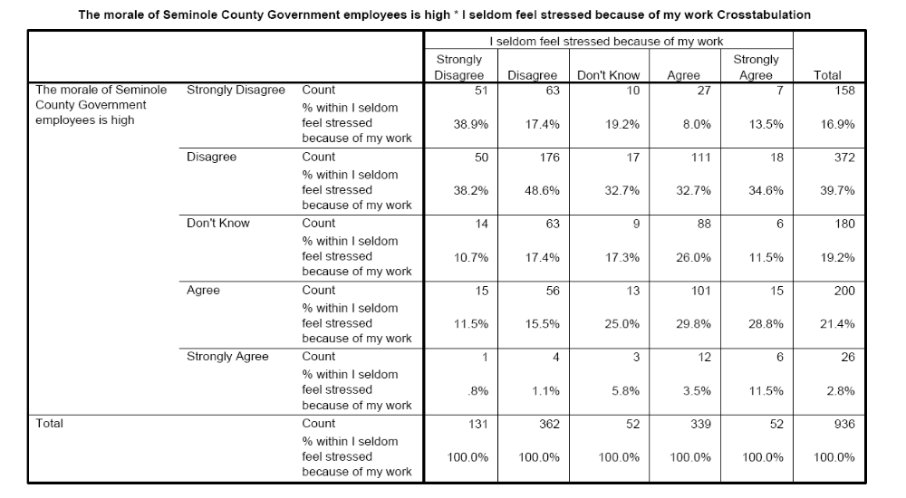

χ² Tests
 | Value | df | Asymp. Sig. (Two-Sided)
Pearson χ² Likelihood Ratio Linear-by-Linear Association N of Valid Cases | 129.180a 118.655 84.527 936 | 16  16  1 | .000  .000  .000

a. Three cells (12.0%) have expected count less than 5. The minimum expected count is 1.44.
2. Use the Public Perceptions data set. Is the relationship between watching Orange TV (Watch), the county’s cable television station, and trusting the county government to do what is right most of the time (Trust) statistically significant? Do you consider this a causal relationship or an association? Does the analysis satisfy the assumptions of the χ² test? If not, how might you address this problem?
Ans: Initially, the relationship is significant at the 5% level (χ² = 10.37, df = 4, p < .035). However, two cells violate the assumptions (expected cell counts < 5). In fact, the CS/DK category of “watch” has very few observations. Deleting this column (set watch = 3 to missing), and recalculating χ² shows χ² = 0.959 (df = 2, not significant). This example shows that marginally significant relationships are sometimes insignificant upon further examination. This what-if analysis may be important in policy discourse.

3. Use the Public Perceptions data set. Examine the relationship between residents who trust the county government to do what is right most of the time (Trust) and their belief that county government works efficiently (Works).What is the practical significance of this relationship?

Ans: χ² is 304.1 (df = 4, p < .01). Only one cell has an expected frequency count of less than five. Recoding will not affect this result. In fact, you can easily recode DK/CS as missing and reach the same conclusion. The finding has very high practical significance: Among respondents who believe that the county government works efficiently, 89.3% trust the county government, but among respondents who do not believe that the county government works efficiently, only 44.6% feel this way.

4. Use the Public Perceptions data set. In workbook Chapter 8, Data-Based Exercise 3, you evaluated the importance of selected issues. The three most important issues were helping public schools (Pubschl), fighting illegal drug use (Figtdrug), and dealing with the problems of gangs (Gangs). Do Whites and non-Whites agree on the importance of these priorities? On which issues is there a difference? Discuss the practical importance of any significant differences.

Ans: After recoding the race variable, the variables Figtdrug and Gangs do not differ between Whites and non-Whites. Respectively, we find χ² = 5.77 (df = 3, p = .127) and χ² = 5.49 (df = 3, p = .140). A difference exists regarding supporting public schools (χ² = 7.72; df = 3, p = .052). However, this statistically significant relationship has little practical significance. Whites and non-Whites differ little, only in the extent to which they find this issue very important: respectively, 64.8% and 72.8% agree with this point. However, they do not vary with regard to finding it important: respectively, 91.3% and 95.8% agree that this is an important or very important issue. Thus, Whites and non-Whites differ but a little, regarding the degree of importance, not whether supporting public school is important.
5. Examine the variables in the Employee Attitudes data set. Identify five relationships that you
hypothesize to be statistically significant. Test these hypotheses. What do you find?

Ans: This is a class exercise. Anything goes, but hypotheses must be stated and conclusions drawn correctly.

6. Compare some of the above results using χ² and Kendall’s τ-c. What do you conclude?

Ans: We would not expect findings that result in different conclusions about statistical significance, of course. For example, in the first exercise, the relationship between seldom feeling stress and the morale of country employees is significant using both χ² =129.1, p < .01, as well as τ-c = .233, p < .01.

7. In Chapter 8, Data-Based Exercise 7, you examined the relationship between attendance and academic performance based on your college experience. Now, treat those data as a sample so that you can conduct a hypothesis test. Do you find a relationship between these two variables based on the sample? Do you draw a different conclusion from the one you drew in Chapter 8? If yes, why is it different?

Ans: You need to perform a χ² test because you have two ordinal variables. Realize that, in a hypothesis test, you treat the data as a sample. It is likely that you draw a conclusion different from the case in which the data are treated as a population. For example, it is possible that you conclude from your contingency table analysis in Chapter 8 that class attendance and academic performance are related while, in a χ² test of the same data, you fail to reject the null hypothesis and conclude that there is no sufficient evidence to indicate that these two variables are related.

8. (optional) Use the Employee Attitudes data set. This is an exercise in examining control variables. First, examine the relationship between gender (Gender) and the perceived morale of county employees (Himorale).What do you conclude? Next, test the rival hypothesis that this relationship is spuriously caused by stress: maybe one gender experiences a higher level of stress. (To this end, recode the variable Stressed into two groups: high stress and low stress.) What do you conclude?
Ans: First, we examine the relationship between gender and morale, and conclude that it is significant: χ² = 18.16, df = 4, p < . 01. Then the recoded, dichotomous control variable Stressed is added. We find that the relationship between gender and morale among workers who experience stress remains significant (χ² = 14.06, df = 4, p < .01), but the relationship among workers who seldom feel stress is not significant (χ² = 9.04, df = 4, p < .06). Thus, the result is explained.
Solution Manual for Exercising Essential Statistics, 2nd edition
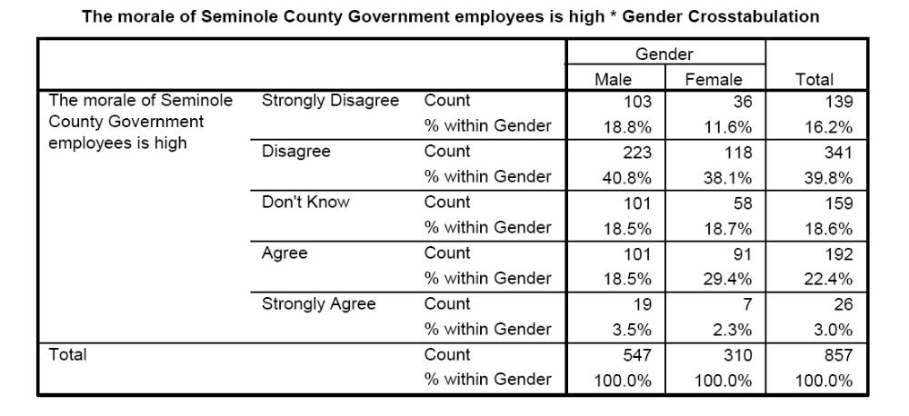
Chi-Square Tests
 | Value | df |  | Asymp. Sig. (Two-Sided)
Pearson χ² Likelihood Ratio Linear-by-Linear Association N of Valid Cases | 18.162a 18.188 10.786 857 |  | 4 4 1 | .001  .001  .001

a. 0 cells (.0%) have expected count less than 5. The
minimum expected count is 9.40.
Taking stress into account:
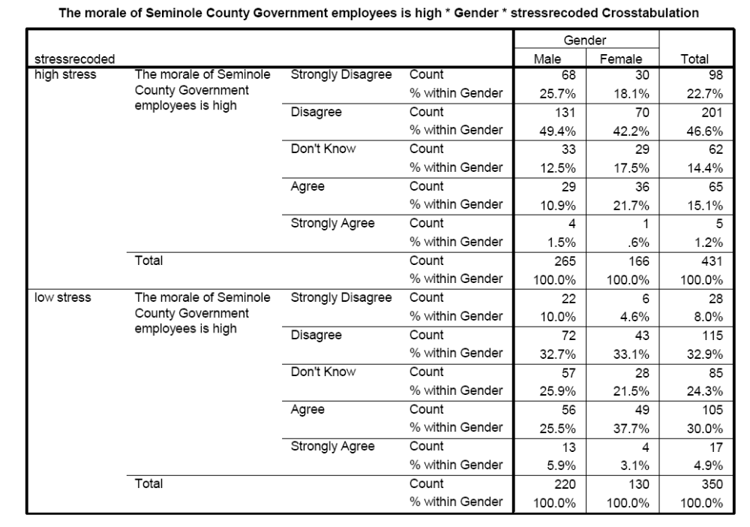

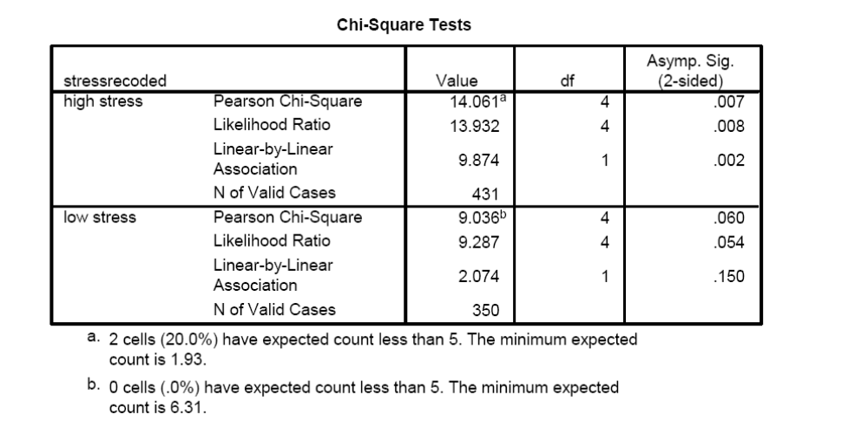
- a. Two cells (20.0%) have expected count less than 5. The minimum expected
count is 1.93.
b. Zero cells (.0%) have expected count less than 5. The minimum expected count is 6.31.

Chapter 12: The T-Test

Critical Thinking
1. Explain the importance of the four test assumptions of the independent samples t-test.
Ans: See pp. 206–207.
2. Why is the assumption of equal variances irrelevant for the paired samples t-test?
Ans: See p. 213. The paired samples t-test test whether the difference score is significantly different from zero; there is only one variable that is being tested.
3. Table W12.1 is the printout of a t-test (independent samples). The continuous variable is an index variable of environmental concern. The dichotomous variable is a measure of education (college versus no college). Interpret and write up the results. What other information would you like to have about this relationship?
Ans: The t-test of means shows a difference in the level of environmental concern between those with and without college education. The variances of the variable “environmental concern” are equal across the two groups (F = 1.065, p =.304 > .05), and the t-test statistic of equal means is 3.705 (t < .01). The printout does not provide information as to which group has higher environmental awareness. That would need to be discerned from additional analysis. Also, the printout provides no information about whether the variables meet t-test assumptions.
4. Table W12.2 is the printout of a paired samples t-test. The data are before-and-after measurements of a public safety program. Interpret and write up the results. What other information would you like to have about this relationship?
Ans: The t-test of means of paired samples shows that the program measurements increased by 1.497 and that this difference is statistically significant (t = 7.310, p < .01). The printout does not provide information about the variable that is being measured or whether there are any outliers that might affect results.
5. Explain the following statement regarding tests for normality: “Whereas failure to reject the null hypothesis indicates normal distribution of a variable, rejecting the null hypothesis does not indicate that the variable is not normally distributed.”
Ans: See p. 207: “A problem with statistical tests of normality is that they are very sensitive to small samples and minor deviations from normality. The extreme sensitivity of these tests implies the following: whereas failure to reject the null hypothesis indicates normal distribution of a variable, rejecting the null hypothesis does not indicate that the variable is not normally distributed.”
6. Table W12.3 shows the result of the Kolmogorov-Smirnov test for a variable and three of its transformations. Which variable(s) should the analysts consider for subsequent use?
Ans: The square- and square root-transformed variables meet the K-S standard for normality (p > .05), though an argument could be made that the untransformed variable is also acceptable.
7. You are analyzing your data and, using a boxplot, you see some outliers. Should your initial approach be to remove them or to keep them? Why? What are the pros and cons of each approach?
Ans: You could argue that the instinctive reaction should be not to remove them, because any variable modification increases the need for justification, and these outliers could be representative of the population. However, they should be removed if you conclude that they are implausible values or otherwise so extraordinarily large (and, hence, unrepresentative) that they greatly affect subsequent findings. Regarding t-tests, we are especially concerned about outliers that affect means. You should also remove observations that violate test assumptions. Any other observations you should leave in. After analysis, you should consider the effect of including any previously removed observations on statistical conclusions to determine robustness.
Data-Based Exercises
1. Use the Watershed data set. Replicate the analysis in the text. First, analyze the normality of the variable Conpolut and consider various transformations, as shown in Figures 12.3 and 12.4 of the textbook. Then, replicate the t-test for comparing the East (defined as Northeast and Southeast combined) with all other regions.
Ans: OOPS!! It looks like the data set varies slightly from that used in the textbook. We find the following. While this does not invalidate the text in any way; it is an asterisk for the workbook . . . . Our guess is the attached data set has a few more rows than used to make the text Table 12.2. The normality test is consistent with the Instructor Manual notes. In this example, as in the textbook, the values for regions “northeast” and “southeast” are recoded as a new value “east.”
Note: if you are teaching undergraduate students, this exercise is a bit much and our recommendation is to find something a bit simpler. There are now many useful YouTube videos for doing t-tests: for example, https://www.youtube.com/watch?v=8alv3kZt8Ug
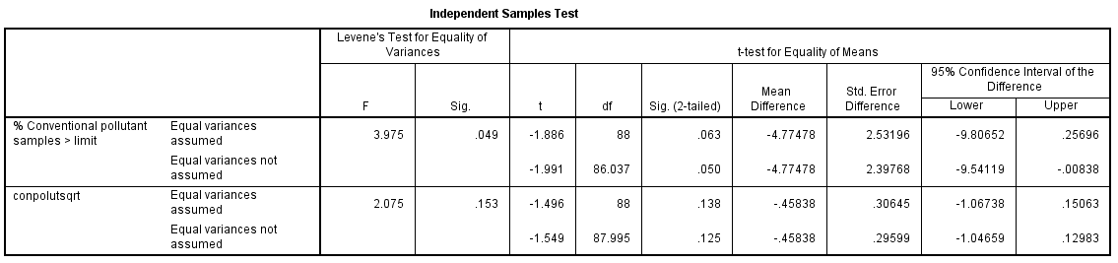

2. Use the Watershed data set. Do states in the East vary in the number of fish and wildlife advisories that have been made? (Use the variable Advisory.) Is the variable Advisory normally distributed? If not, what transformation do you suggest?
Ans: The variable Advisory is clearly not normally distributed: it is heavily skewed to the left. The K-S statistic is .224 (p = .000). This is an opportunity for doing variable transformation. Natural log transformation (ln) improves matters greatly (K-S = .092, p = .049), and visually as well, though the result is far from perfect. The K-S statistic is clearly insignificant when examined for these different regions (east: K-S = .108, p > .200; other regions: K-S = .099, p > .200). The results of the log-transformed variable are reported below. There are no differences in advisories.

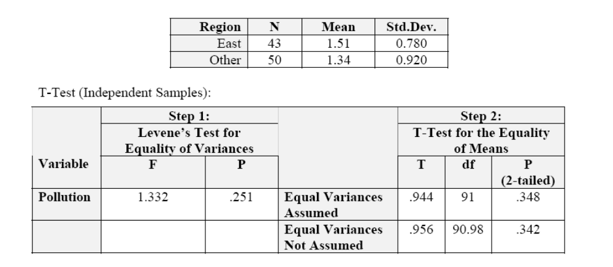
However, if you just compared the number of advisories in the Northeast against all other regions, you will find a significant difference:
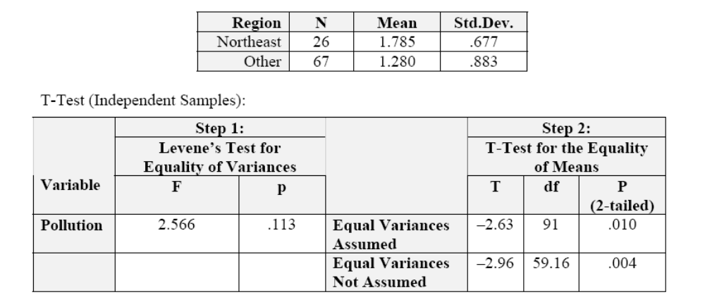
This is also a good time to show students that, again, the t-test conclusions are robust against violation of normality assumptions. If you run the above analyses with the untransformed variable Advisory, you will reach the same conclusion.
3. Use the Public Perceptions data set. An analyst wants to know whether men and women have different perceptions of customer service. To this end, we will use an index variable of customer satisfaction (see Chapter 3); the index variable is provided on the data set as the last variable, Satisfac, but you can also practice making this index variable in the following way:
Among those respondents who have had contact with a county employee (i.e., if contact = 1), create an index variable of “customer service” that is composed of the six survey items: “employees were helpful,” “employees treated me with courtesy and respect,” “employees were friendly,” “service was provided without mistakes,” “the service experience exceeded my expectations,” and “service was provided in a timely manner.” If you are using SPSS, see Chapter 17 of this workbook for instructions on creating index variables in SPSS.
After you have either created this variable or identified this variable on the data set, address the question of whether men and women vary in their customer satisfaction experience.
Ans: This is an opportunity to show students how to perform analysis on part of the data. Select only those respondents who have had contact with an employee (i.e., if contact = 1). All six survey items are measures of customer service and are thus appropriately used for the index variable that might be called “customer service.” You can also use this opportunity to show students how to calculate Cronbach’s α on the computer. The α score is .8825. Visually, the index variable appears to be normally distributed, although heavily peaked. This is confirmed by examining the ratio of the kurtosis/se(kurtosis). Also, the K-S statistic is significant (p < .01). Overall, we would be inclined to conclude that the variable is normal on the basis of visual inspection. The variable Satisfac in the data set is this index variable, for the subset of respondents who have had contact with the county government during the last 12 months.
Examining satisfaction by gender we find (for contact = 1):
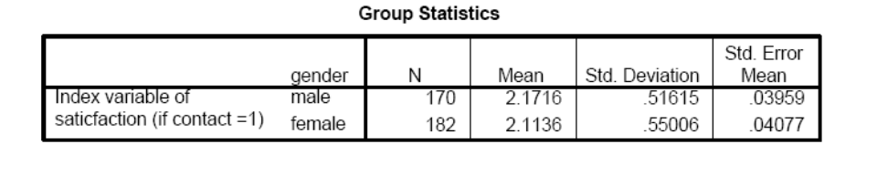

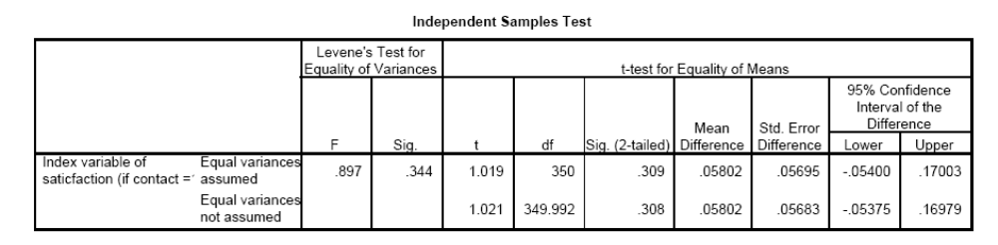
These results show that while females are slightly more satisfied (see the scale in the workbook 1 = SA to 4 = SD), the difference is not statistically significant.

4. Use the Public Perceptions data set. An analyst wants to know whether the index variable of customer service varies across race. Recode the Ethnic variable to distinguish among Whites, Blacks, other races, and Hispanics. If you are using SPSS, see Chapter 17 of this workbook for instructions on recoding variables in SPSS.

Ans: First, you could use Analyze → Compare means → Means to show the means of this variable for each race group:
Report
Index variable of satisfaction (if contact = 1)
ethrecod | Mean | N | SD
White Black/African-American Hispanic Other Total | 2.1396  2.0641  2.2014  2.1369  2.1380 | 265  26  24  28  343 | .56277  .40846  .42557  .40586  .53156

The question then arises of whether any differences between these groups are statistically significant. Keep in mind that the sample size of the other groups is quite small. It turns out that none of the differences are significant. Of course, a better method is analysis of variance (ANOVA) because of the caution stated in the textbook on p. 268. We could also group all of the other races in an “other races” variable. Then, the difference in satisfaction among Whites and non-Whites also is not statistically significant.
ANOVA is discussed in Chapter 13 and is optional for most courses. However, you could show students in class how ANOVA extends the t-test. The test of homogeneity is insignificant (Levene’s test = .616, p = .605), and the equality of variances is confirmed by analysis of the boxplots. The global F-test is .280 (p = .840), and the Scheffe test confirms that there are no differences in the level of customer satisfaction among citizens of different races who have had contact with county employees.
5. Do coastal counties spend more on conservation? Conduct a t-test to compare conservation spending in total spending using 2008 data (ConsTotal08) from the Data_FL_County data set. The data set contains the dichotomous variable Coastal.
OOPS – use Cons08 (as ConsTotal08 is the ratio of Conservation/Total spending) – yes, coastal are spend more, also as a proportion of their total spending.

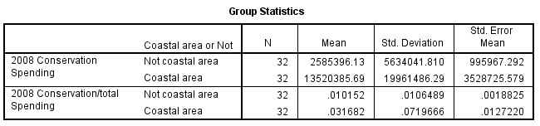
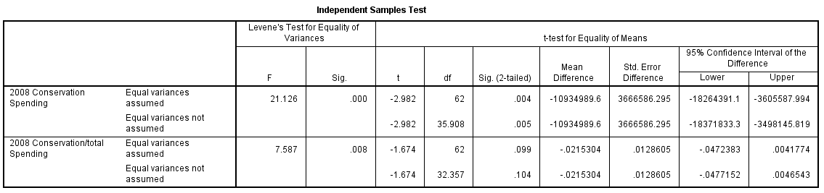

6. A group of 12 welfare recipients participate in training. Before-and-after abilities are measured through a standardized test. See Table W12.5. Is there evidence of improvement? Compare the results of both the paired samples t-test and the nonparametric alternative.
Ans: This is a paired samples problem. Using the Wilcoxon signed rank test, we find that p = .099; hence, there is no difference in the before and after scores. Of course, a paired t-test can also be used, but that is discussed in the following section. The means of before and after scores are 4.14 and 4.61, respectively. The difference is not significant (t = −1.934, p = .057).

7. Consider Table W12.5 again. Is the after-test score consistent with a norm of 5.0? And with a norm of 6.0? Use both parametric and nonparametric tests. Compare the results.
Ans: One way to set this up using the Wilcoxon signed rank test is as follows:
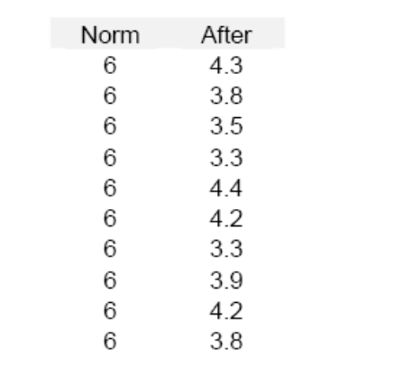

The Wilcoxon signed rank tests with norm = 5 and norm = 6 are both statistically significant, suggesting that these after test scores are significantly different from 5.0 and 6.0. However, a further test against norm = 4.0 is not significant.

8. t-Tests can be used in performance analysis and evaluation. The psychosocial functional score (PFS) is used to assess school-aged children’s psychosocial behaviors. A score of 25 points or above is considered normal. A school counseling program has used the PFS to assess participating students’ progress. A sample of 15 participating students is tested, and their PFS scores are 29, 32, 18, 23, 27, 19, 34, 32, 27, 27, 23, 26, 32, 29, and 34. Conduct a performance evaluation to assess if the participants’ average PFS score is greater than 25. Write a summary to report your findings to the program manager, who knows nothing about statistics.

Ans: The null hypothesis is that the participants’ average PFS score is equal to 25. The alternative hypothesis is that it is greater than 25 for a one-tailed test. The sample mean is 27.467 and the sample standard deviation is 5.041. With a sample size of 25, the standard error is 1.302. So the t value is 1.895. The p value is .0395 for the one-tailed test, with (15 − 1=)14 degrees of freedom. At the significance level of .05, because p < .05, we reject the null hypothesis and conclude that there is sufficient evidence to indicate that the average PFS score is greater than 25. However, for a two-tailed test, the p-value is .0789. At the significance level of .05, because p > .05, we will fail to reject the null hypothesis and conclude that there is no sufficient evidence to indicate that the average PFS score is different from 25.

9. (optional) Men and women are asked to rank six issues in the order of priority. See Table W12.5. Do men and women differ in their order of priorities? Which test statistic would you use? Can you think of some other situations that match this scenario?

Ans: This is a good exercise to clarify what the tests in this chapter require in terms of data. At first blush, these might look like independent observations, but they are not. In fact, this situation is a bit tricky, because it really doesn’t fit the tests in this chapter, even though it appears that it might. The problem might best be viewed as requiring a Spearman’s rank order correlation test. Spearman’s rank order correlation coefficient is ρ = .657, p = .156 > .05, which means that the rankings are not significantly different. If this is shown, it then serves as an introduction to the next chapter.

Chapter 13: Analysis of Variance (ANOVA)

Critical Thinking
1. Your data include a measure of air pollution that is measured on a continuous scale, as well as another variable that measures the location of that air pollution in five counties. Which test statistic should you use to examine whether mean pollution levels vary across counties?
Ans: Because one variable is metric and the other nominal with more than two categories, analysis of variance is used.
2. Table W13.1 is a sample output analysis of variance table with linearity test. Interpret the output.
Ans: There are significant differences between the means of the groups (F = 2.797, p = .043 < .05). These differences form a linear relationship that is statistically significant at the 5% level (F = 5.367, p = .022 < .05).
3. Analysis of variance can be useful, even outside your field of work. Conduct the following experiment. Choose one of your favorite locations away from your home. It could be a supermarket, a shopping mall, or a playground. Identify at least three routes to get there. Now, choose the route you use most often. Record your travel time to that location (in minutes) up to 10 times. Then, choose an alternative route and record your travel time (in minutes) up to 10 times. Choose a third route and record your travel time up to 10 times. In this experiment, make sure you use the same mode of transportation (e.g., car, bike, or public transit) each time and obtain your measurements at approximately the same time of day to rule out the impact of these confounding variables on travel time. Compare travel times for each route to determine whether the mean travel times differ between routes. Is the route you use most often the fastest?

Ans: This exercise tests the ability of students to “set up” or conceptualize the problem in statistical terms.
Route (“A” or “B”) | Travel Time

4. In the preceding exercise, the dependent variable is travel time. You tested the impact of various routes (the independent variable) on travel time. Because these routes are unrelated to each other, you tested the mean differences of three independent samples. You can follow the same logic to test the impact of times of day on travel time. For example, you could record your travel times at 10:00 a.m., 2:00 p.m., and 7:00 p.m. up to 10 times each to determine whether there is any mean difference in travel time at different times of a day. You could use the same method to test your travel times to work. If you have a flexible schedule that allows you to be at work at the time of your choice, you could use this method to choose the least time-consuming and most energy-saving way to get to work. This would truly be a performance improvement for you and for your organization. Can you think of any other ways to use analysis of variance to improve your work performance or your life?

Ans: This exercise tests the ability of students to “set up” or conceptualize the problem in statistical terms.
Route(“A” or “B”) | Travel Time | Time of Day(“noon” or “evening”)

5. Table W13.2 is a sample output analysis of variance table with linearity test. Interpret the output.

Ans: There are significant differences between the means of the groups (F = 2.797, p = .043 < .05). These differences form a linear relationship that is statistically significant at the 5% level (F = 5.367, p = .022 < .05).

6. An analyst conducts a test of homogeneity of variances in analysis of variance and finds that the Levene’s statistic = .911, p = .461 > .05. What does the analyst conclude?

Ans: See p. 230. An insignificant Levene’s test statistic means that variances are equal.

7. Table W13.3 is a sample output two-way analysis of variance table. Interpret the output.

Ans: This shows a significant interaction term between VarA and VarB.
[Insert Table W13.3—Two-Way Analysis of Variance Table NEW]
Source | Sum of Squares | df | Means Squares | F | Significance
Model | 1642.8 | 24 | 68.44 | 4.507 | .000
Var A | 229.8 | 4 | 57.45 | 3.783 | .007
Var B | 85.5 | 5 | 17.11 | 1.127 | .351
Var A × Var B | 409.5 | 14 | 29.25 | 1.926 | .032
Error | 1488.2 | 98 | 15.19
Total | 3130.9 | 122

Data-Based Exercises

1. Analysis of variance (ANOVA) is a useful tool in performance comparisons. A nonprofit foundation funds program to reduce accidents among school-aged children. The employees in the program conduct regular education workshops for students and teachers. The daily number of accidents per 1,000 students is used to assess the performance of the program in reducing accidents among students. The program is operated in School A, which collected the following data on 10 randomly selected days: 3.82, 1.01, 5.96, 8.99, 8.85, 5.54, 0.14, 4.07, 7.65, and 1.39. You are a performance analyst whose job it is to assess the performance of this program in School A. To conduct your evaluation, you collect data from two schools (School B and School C) that do not have these programs (i.e., the control groups). The following data are for School B: 6.58, 0.59, 7.00, 7.17, 7.83, 8.68, 1.17, 5.50, 6.84, and 4.09. For School C the data are as follows: 9.47, 4.86, 8.65, 5.54, 6.45, 2.71, 8.63, 9.30, 7.37, and 7.09. Assume normal distributions of the data in each group and determine whether the program in School A has a lower number of accidents.

Ans: One-way ANOVA tests for the difference of average accidents in all three schools, the p-value of the F test is .1935. At the significance level .05, because p > .05, we fail to reject the null hypothesis and we conclude that there is no sufficient evidence to indicate that at least one school’s accident average is different, which suggests that the program does not affect the accident level.

2. Use the Public Perceptions data set. An analyst wants to know whether the index variable of customer service varies across race. Recode the variable ethnic to distinguish among Whites, Blacks, other races, and Hispanics, and then calculate the means for each of these groups. Then use analysis of variance (ANOVA) to determine whether any of these differences are statistically significant.

Ans: Don’t forget to run this example on the subset of data (if contact = 1) and to recode the Ethnic variable! This question requires ANOVA, because the grouping has four (nominal) variables. The test of homogeneity is insignificant (Levene’s test = .616, p = .605), and the equality of variances is confirmed by analysis of the boxplots. The global F-test is .280 (p = .840), and the Scheffe test confirms that there are no differences in the level of customer satisfaction among citizens of different races who have had contact with county employees.

3. Use the Public Perceptions data set. An analyst wants to know whether incomes vary by age-groups. Treat the income variable as a continuous variable and treat the age variable as an ordinal-grouping variable. Calculate the means for each of these groups and then use analysis of variance to determine whether any of these differences are statistically significant. For which age-groups is the relationship linear?

Ans: The test of homogeneity is significant (Levene’s test = 5.602, p = .000), and the inequality of variances is confirmed by visual analysis of the boxplots: respondents between ages 18 and 24 have markedly lower and different distribution of their incomes. The boxplots also show that mean incomes have a curvilinear pattern: they are lowest for 18–24 years old, and for respondents over 65. When only respondents between ages 24 and 75 are considered, the boxplots suggest no major departures from equal variances (Levene’s test = 0.790, p > .05). The global F-test is then 6.139 (p = .000); the difference is that respondents older than 65 have lower incomes than others. There are no statistically significant differences in the incomes of these other groups. The test of linearity shows that the decrease is linear, though visual inspection shows that the income drop occurs only for the 66–75 age-group.
You can extend this example by considering the relationship between education and income. Although the test of homogeneity is significant (Levene’s test = 6.468, p = .000), visual analysis of the boxplots does not suggest marked differences. The global F-test is significant (F = 47.91, p = .000). Mean incomes increase for each level of education, and the increase is linear (F = 67.34, p = .000).

4. Use the Watershed data set. An analyst wants to know whether the level of conventional pollutants (conpolut) is associated with the number of aquatic/wetland species at risk (speatrsk). What are your conclusions?

Ans: The level of conventional pollutants (conpolut) is not associated with the number of aquatic/wetland species at risk (speatrsk)—the differences are not statistically significant. This also well illustrated with the additional boxplot below.
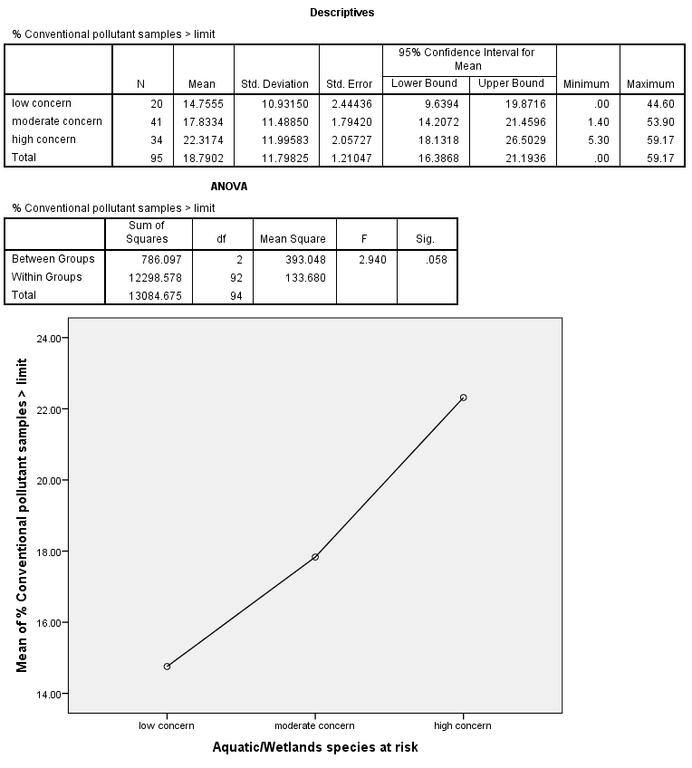
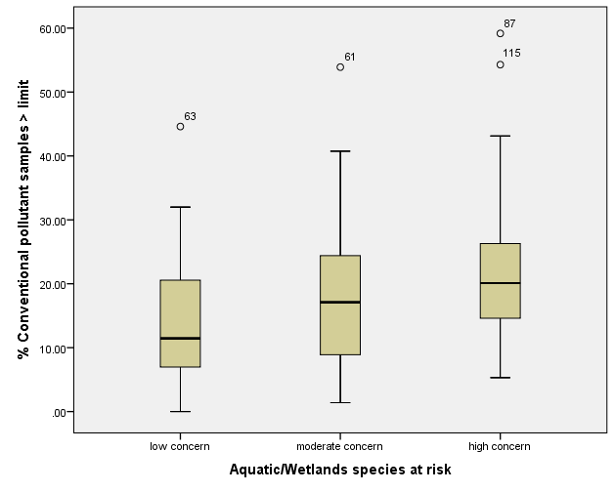

Chapter 14: Simple Regression

Critical Thinking
1. Explain why variables are assumed to be linearly related in simple regression.
Ans: See p. 235: Ordinary least squares estimates a linear relationship between the variables. See also Footnote 2 on p. 244.
You might add that nonlinearity can cause a statistically significant relationship to be estimated as being insignificant, in the following way:
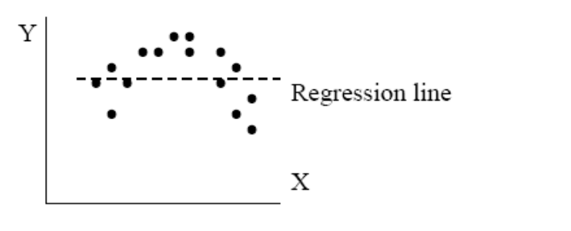
2. Explain why the slope can be used as a test of the relationship of two variables in simple regression.
Ans: See p. 235: “When the regression line is horizontal (b = 0), no relationship exists between the two variables.”
3. Explain why, if b is statistically significant, then r should be statistically significant, too.
Ans: See p. 240, Figure 14.2. When b is statistically significant, a relationship exists and, hence, r is significant, too.
4. Draw a scatterplot between two variables that has a large r² and a small, negative b. Then, draw another scatterplot that has a small r² and a large, positive b. Show the regression lines in each.
Ans: 1. a large r² and a small, negative b 2. a small r² and a large, positive b
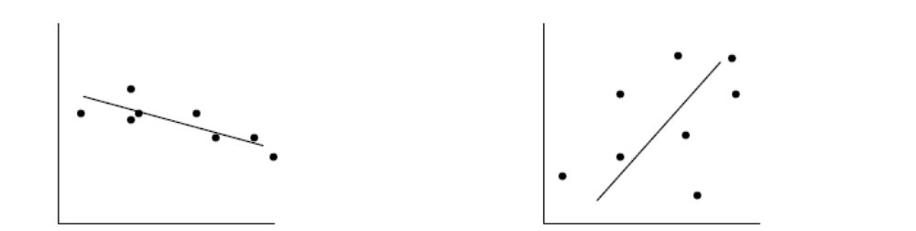
5. You are a program manager for a welfare agency and want to know whether a relationship exists between the length of time that people receive welfare (in months) and their education (total years). Both variables are continuous. Table W14.1 is the hypothetical output from your simple regression model. Interpret the results.

Ans: The length of education is not significantly related to the length of unemployment. The analyst should probably also plot the relationship, to ensure that it is linear. The write-up should include some language about how the variables are measured.
6. Explain how Spearman’s rank coefficient transforms interval-level values into ranks. Then explain why Spearman’s rank coefficient can also be used with ordinal-level variables.
Ans: See p. 241, Table 14.2: The ranks are ordinal in nature.
Data-Based Exercises
1. Use the Productivity data set. Examine the bivariate relationship between having authority (Jobauthr) and knowledge (Jobknowl) to do one’s job. What are your findings? Use simple regression.
Ans: This exercise challenges students to identify the dependent and independent variable. In the following analysis, we use Jobauthr as the dependent variable. Arguably, the relationship between these two variables might be viewed as only an association.
Model Summary
Model | R | R² | Adjusted R² | SEE
1 | .141ª | .020 | .017 | 1.22051
ªPredictors: (constant), knowledge to perform job responsibilities
ANOVAª
Model |  | Sum of Squares | df | Mean Square | F | Significance
1 | Regression  Residual  Total | 9.689  475.198  484.887 | 1  319  320 | 9.689  1.490 | 6.505 | .011^{b}
ªDependent variable: extent to employee has authority to make decisions while performing job
^{b}Predictors: (constant), knowledge to perform job responsibilities

Coefficientsª
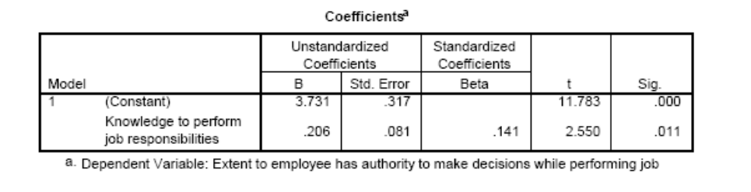
a. Dependent variable: extent to employee has authority to make decisions while performing job
2. Use the Productivity data set. Examine the bivariate relationship between employees’ perception of productivity and the perceptions of having adequate authority to do one’s job (Jobauthr). Use both simple regression and Pearson’s correlation coefficient.

Ans: Using Pearson’s correlation coefficient, we find that r = .369 (p < .01). The output from the simple regression is:
Model Summary
Model | R | R² | Adjusted R² | SEE
1 | .369ª | .136 | .133 | .79649

ªPredictors: (constant), extent to employee has authority to make decisions while performing job
ANOVAª
Model |  | Sum of Squares | df | Mean Square | F | Significance
1 | Regression  Residual  Total | 31.845  202.374  234.219 | 1  319  320 | 31  .845  .634 | 50  .197 | .000b
ªDependent variable: Employee evaluation of workcenter productivity
^{b}Predictors: (constant), Extent to employee has authority to make decisions while performing job

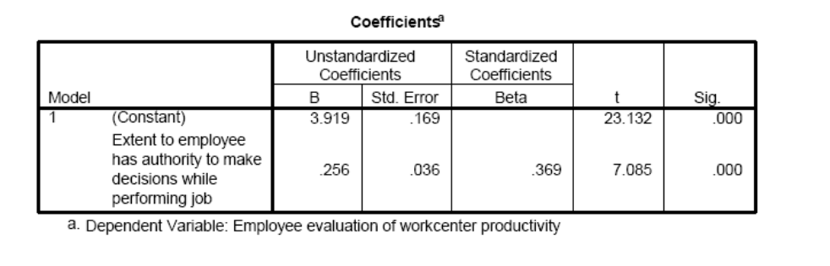

Correlations
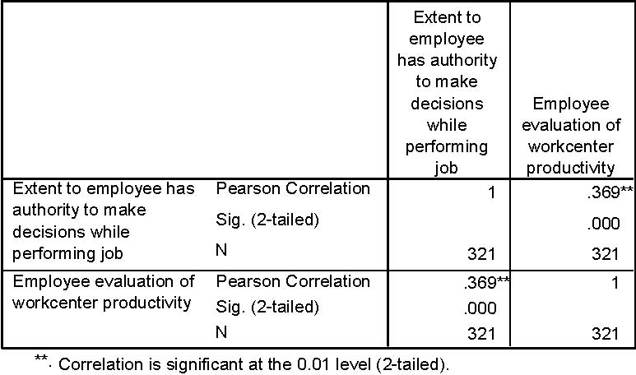

3. Examine the normality of variables used in the preceding exercises (see Chapter 11). Are Jobauthr, Productivity, and Jobknowl normally distributed? On what basis do you reach this conclusion? Is there any transformation that can make them normal? Does transformation materially affect your conclusions in this case?
Ans: These are the normality tests of the untransformed variables:
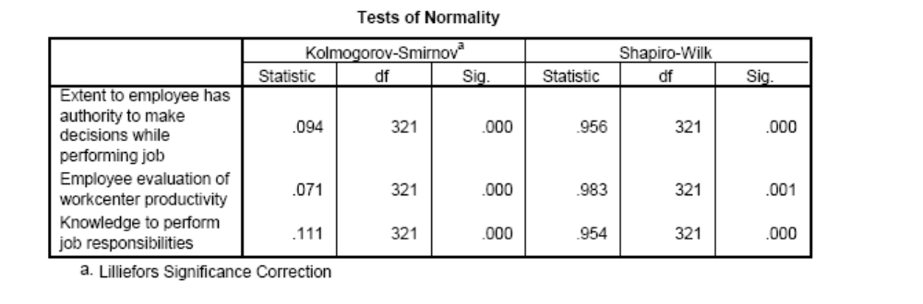
However, the graphs below suggest only minor to moderate violations of normality.
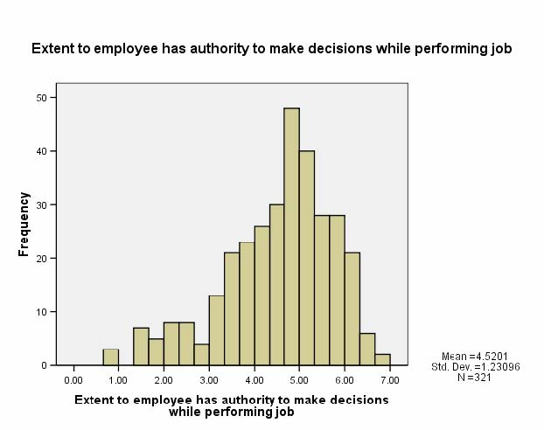

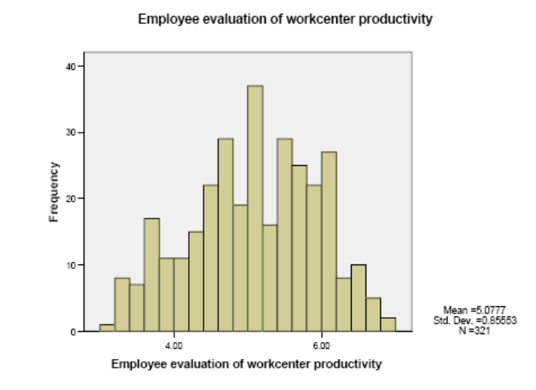

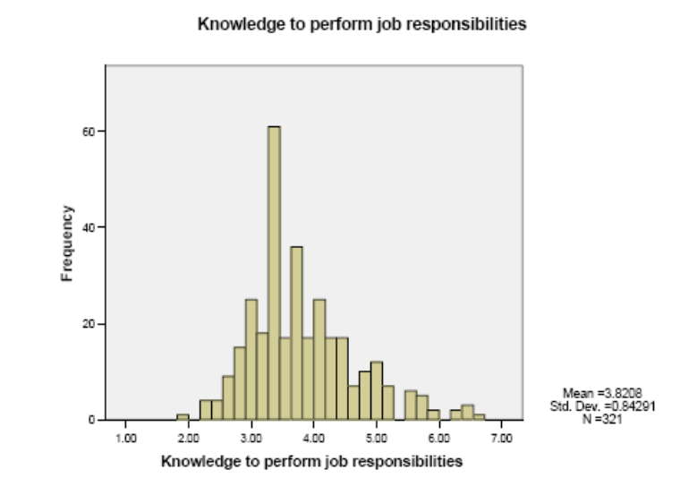
Transformation can make Jobauthr less skewed, and in fact normal by using (Jobauthr)^2.
4. Many managers believe that a government’s spending on the environment is a response to the environmental pressure such as population growth, pollution level, and economic development. (1) Use the data set Data_FL_County to conduct a hypothesis test on the relationship between the environmental spending (EnvirnTotal08) and population growth (PopGrowth08) using the Pearson correlation. (2) Run a simple regression for this relationship.
Ans: Note: environmental spending (EnvirnTotal08) is a ratio of environmental spending/total spending.

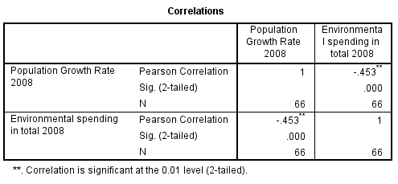

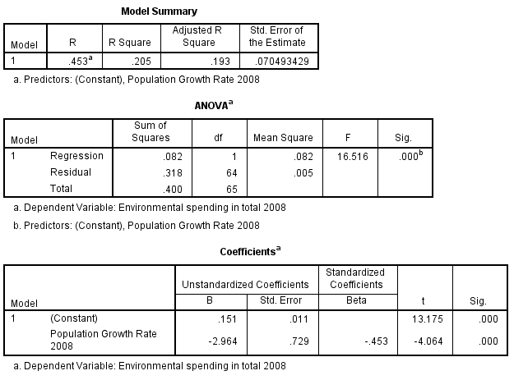

5. Use the Community Indicators data set. Which variables are associated with median household incomes?
Ans: Many variables are associated with median household incomes. Using Pearson’s correlation coefficient, we find that infant mortality rates are negatively associated (r = −578, p < .01).
6. Use the Community Indicators data set. Create the variables “Cancers per capita” and “Rapes per capita.” Which variables are associated with these variables?
Ans: Answers vary. This is another exercise to help reinforce skills and concepts.

7. Use the Productivity data set. Compare employees’ perceptions of productivity (Empleval) with those of the outside consultant (Wkctrpro). What test statistic might you use for this comparison?
Ans: We can ask, for example, whether the ranks are the same. Although students might think about using a t-test, it is obvious that the scales of these two ratings are different.
Work Center | Employees (Mean) | Outside Consultant
1 | 3.59 | .51
2 | 3.88 | .55
3 | 4.37 | .62
4 | 4.67 | .66
5 | 4.92 | .70
6 | 5.05 | .72
7 | 5.46 | .78
8 | 5.85 | .84
9 | 6.16 | .88
10 | 6.42 | .91

As is also obvious, the employees and the outside consultant have the same rankings. The Spearman’s rank order correlation coefficient is .845 (p < .01).

8. Regression is a useful tool in performance analysis. Choose a variable that you think influences your academic performance. (Many students would say that effort, attendance, instruction quality, level of difficulty, and study methods are keys to improving academic performance—choose one.) Create a database that includes all the courses you have taken in college. Recall your experiences and performance (e.g., your grade) in those courses. For example, you could measure effort with the number of hours spent studying for the course weekly. Level of difficulty could be measured with “very difficult,” “difficult,” or “not difficult.” Use simple regression to analyze the relationship between the variable of your choice and your academic performance. What do you conclude? Write a report that summarizes your findings for a person who knows nothing about statistics.

Ans: Make sure that the academic performance is an interval variable. Also, make sure that you choose the most influential variable of the academic performance. In this exercise, the unit of analysis is courses. An alternative way of performing this analysis is to survey all the students in a class to collect necessary data. The unit of analysis is individual students in that case. Your report should read something like this: “This analysis examines the possible impact of study effort on academic performance. The result shows that study effort (measured by the number of weekly study hours) may have significant impact on academic performance (measured on a score of 0 to 100). If no study time is spent, the academic performance is 55.7 points (the constant or the intercept). For every additional hour spent, the academic performance improves by 10.3 points (the slope).”

Chapter 15: Multiple Regression

Critical Thinking
1. Evaluate and explain the following statement: “Multiple regression is no substitute for bivariate analysis.”
Ans: No study conclusion rests solely or even primarily on the weight of multiple regression. Multiple regression is used to test the robustness of conclusions in the face of rival hypotheses. Principal conclusions about the behavior of the key variable and its relationships have already been stated; the role of multiple regression is to further drive the conclusion home by dealing with matters of control variables.
2. You are a program manager for a welfare agency. In workbook Chapter 14, Critical Thinking Exercise 5, you examined the relationship between the length of time that people receive welfare (in months) and their education (total years). Now you want to consider other variables that might also affect the length of unemployment. Table W15.1 lists categories of different factors that are hypothesized to be the most important in affecting the length of unemployment. Interpret and write up your results.
Ans: You might first ask whether students feel that this model is fully specified, that is, which factors are hypothesized to affect the length of unemployment and can these be considered the most important ones? Has any factor been forgotten? Also, this is an opportunity to reinforce that independent variables are considered as indicators of underlying concepts.
The results show that job training and marital status are negatively associated with length of unemployment. This makes sense, because, for example, more job training makes recipients more attractive on the job market and will shorten their length of unemployment. By contrast, medical condition (perhaps measured as the number and severity of illnesses) increases the length of unemployment. Education and number of children are insignificant. It would have been surprising if education had become significant, given the results of question 1 (this would have been an example of a suppressor effect).
You also note that R² (adjusted) is considerable: 42.3% of the variance is explained as a result of the independent variables. The output does not include the error term plot, which you want to examine to ensure that it is randomly distributed.
3. Develop a fully specified model of the factors that affect fund-raising at a nonprofit, social services organization. Focus on different categories of factors that affect fund-raising, and consider how some might be grouped as index variables.
Ans: Students must first identify different categories of factors that affect fund raising. Some possibilities are (a) prior giving by donors, (b) familiarity and reputation of the nonprofit organization by potential donors, (c) number and types of marketing campaigns, and (d) fund-raising abilities of the person doing the asking. Some of these factors could be further distinguished, such as the use of mail versus telephone campaigns.
4. Develop a fully specified model of the factors that affect teenage violence in high schools.
Ans: It can be hypothesized that the most important factors that affect high school violence are (a) ability to form and maintain stable social relations, (b) access to guns and other means of violence, (c) outlook on the future, and (d) presence of violence-oriented peer groups. Other important factors might also exist. Again, these factors can be treated as index variables, encompassing various specific measures.
5. Explain how regression can be used for prediction. What problem do you see with predicting dependent variable values based on independent variable values that lie outside the range of observations that have been used to estimate the model?
Ans: Multiple regression is easily used for prediction, by calculating the predicted dependent variable value based on values of the independent variables. The model is based on observed independent variable values; it is not valid for independent variable values that lie outside the model. See the textbook and Note 6 in Chapter 12 (p. 209) for a discussion regarding the standard errors of predictions.
6. From the variable Race, make a dummy variable that indicates whether the respondent is Caucasian. Race is coded as 1 = Caucasian, 2 = Native American, 3 = African American, 4 = Asian or Pacific Islander, and 5 = Other.

Old Variable | New Variable: Caucasian Value
1 | 1
2 | 0
3 | 0
4 | 0
5 | 0

7. Explain in your own words why the error term plot should show a random pattern. Also, which variables are shown on the axes?
Ans: See p. 249: When the error plot shows a random pattern, the cumulative effect of variables not included in the model is zero.
8. Discuss, in practical terms, how analysts determine which observations are outliers. Discuss also how you would justify the deletion of observations that are outliers.
Ans: See p. 257: “Observations are defined as outliers when their residuals exceed ± 3 standard deviations.”
9. Draw an error term plot that shows the presence of an outlier (without peeking in the textbook!).
Ans: See p. 258, Figure 15.4.
10. If two variables are highly correlated with each other (e.g., r² = 0.65), does it follow that they are multicollinear, as well?
Ans: No! Many students confuse this. See p. 259: “Multicollinearity is usually first suspected when the regression coefficients of independent variables in a multiple regression are statistically insignificant, even though in bivariate relationships they are known to be highly significant (e.g., r² > .60).” Students confuse “r² > .60” with the presence of multicollinearity.
11. Explain the problem of including irrelevant variables.
Ans: See p. 264: “The effect of including irrelevant variables is the opposite of that of omitting a relevant value; namely, it understates the importance of other independent variables.”
12. Explain why time series often leads to correlated error terms.
Ans: See p. 262: “Autocorrelation is the problem that successive observations are correlated with each other; they are not independent. This is a frequent problem with time series data, because values at t = T are often good predictors of subsequent values at t = T + 1, which are then good predictors of other values at T + 2, and so on. This feature also causes error terms to be correlated with each other, when plotted in their time-ordered sequence.”
Data-Based Exercises
Note to instructors: I have used some of these exercises as homework assignments. See the file “Homework Assignments” on this CD.
1. Consider the model shown in Table 15.1 of the textbook. In the Productivity data set, the dependent variable is Productivity, and the independent variables are labeled, respectively, Teamwork, Jobknowl, Jobauthr, Wrkdyssk, and Recogawd. After you rerun the model shown in Table 15.1, create dummy variables for each of the four departments and add to the model dummy variables for the first three departments. Are departments associated with employees’ perceptions of productivity controlled for all other factors of the model? If yes, which departments are significantly associated with employees’ perceptions of productivity? Record your answers on a separate sheet.
Ans: The following output is produced, with Department 1, Department 2, and Department 3 (Department 4 omitted):
The dependent variable is Productivity. The independent variables are Teamwork, Jobknowl, Jobauthr, Wrkdyssk, and Recogawd. The three dummy variables are Department 1, Department 2, and Department 3.
Model ANOVA Table
R | R² | Adjusted-R² | SEE
.578 | .334 | .317 | .707

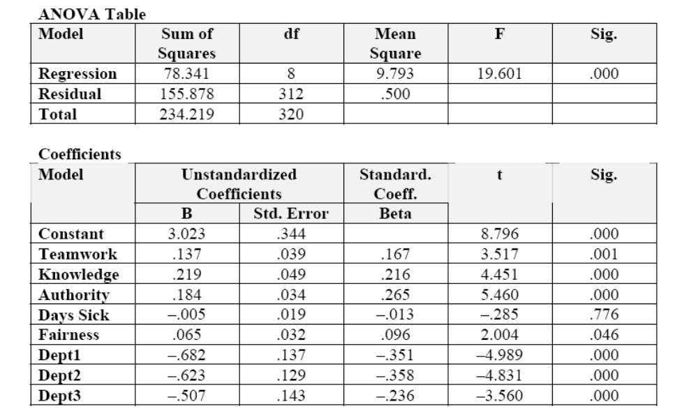

The results show that teamwork remains significantly associated with productivity improvement (p < .01). Although there are differences among departments that are associated with productivity, these differences do not affect the statistical significance of variables shown in Table 15.1. These factors further increase the adjusted R², which is now 31.7%.
The error term plot of shows a random pattern around (0,0):
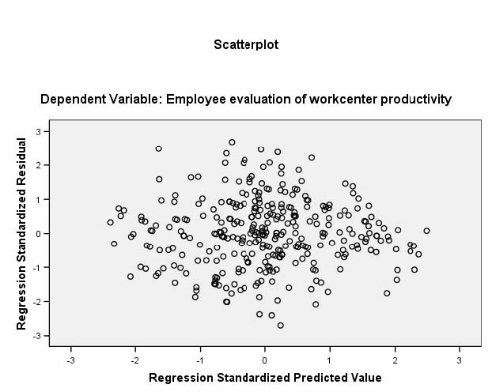

2. What contributes to a government’s spending on conservation? Many people believe that socioeconomic and political pressures are the reasons why a government spends on conservation. They think that conservation spending is a response to population growth and economic development. Also, they believe that young educated people with Democratic party affiliation are more likely to vote for conservation spending. Use the data set Data_FL_County to test this argument. Use the conservation spending in 2008 as the dependent variable (ConsTotal08). The data set includes many sociopolitical and economic variables. You may want to consider to include measures of education, income, population growth, manufacturing industry base, and political voting behaviors. Record your answers on a separate sheet.
Ans: Well, answers vary, but here is one such model. Admittedly, it only shows manufacturing growth as a predictor. (Bivariate analysis show that indeed only few variables are associated with either Cons08 or ConsTotal08)

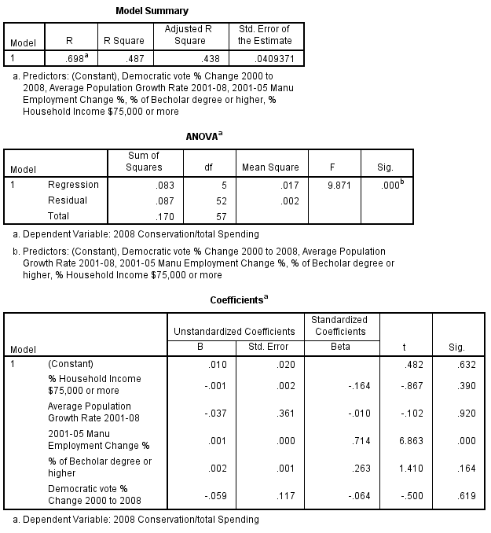

3. Use the Public Perceptions data set. Examine a multiple regression model in which the dependent variable is Posview (“I have a positive view of Orange County”). The independent variables are Quality (“The quality of life in Orange County is good”), Interest (“I believe that the county is interested in what I have to say”), Respect (“The employees treated me with courtesy and respect”), Trust (“Do you trust Orange County to do what is right most of the time?”), and Works (“Do you believe that Orange County works efficiently?”). Examine the error term plot and write up your findings.
Ans: The following results are produced, when running the model on the subset of respondents who have had contact with the county employees during the last 12 months (i.e., when contact = 1. Substantively, the results for running the model for all respondents are not much different):
Model
R | R² | Adjusted-R² | SEE
.654 | .427 | .421 | .460

Dependent variable: “I have a positive view of Orange County”
ANOVA Table
Model | Sum of Squares | df | Mean Square | F | Significance
Regression | 70.225 | 5 | 14.045 | 66.943 | .000
Residual | 94.202 | 449 | .210
Total | 164.426 | 454

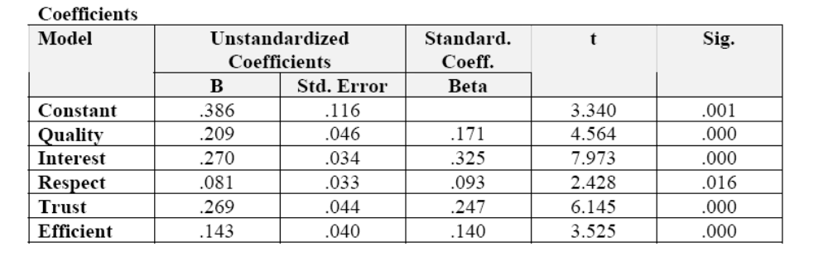
The above results show that all variables are significant. However, the pattern of error terms is not random. There are clear bands of downward sloping error terms. The bands are caused by the dependent variable, which has only four categories (indeed, one could argue against using this variable as a dependent variable . . . ). The downward sloping pattern is discussed in Chapter 14 as measurement error. For the purposes of this exercise, it is sufficient to note that the pattern of nonrandom error terms is a violation that requires further investigation.
4. Regarding the model in Exercise 2, consider the effects of race and Hispanic origin on having a positive view. Do race and Hispanic origin affect overall perceptions, when controlled for other variables mentioned in the earlier exercise?

Ans: OOPS! This should be “Regarding the model in Exercise 3, . . . .”
Examining the above model for race shows that dummy variables for White, Black, and Hispanic are not significant, when controlled for the above variables.
5. Use the Time data set. This exercise illustrates the problem of outliers. In this exercise, we examine the effect of water pollution on the concentration of fish in a lake. The data set contains two variables, Fishcon (the concentration of fish) and Contam1 (the concentration of a water pollutant). The observations are drawn from different parts of a large lake in order to test the hypothesis that alleged water pollution is affecting the stock of fish.
Note to instructors: I have used this exercise as a homework assignment. See the file “Homework Assignments” on this CD.
a. Examine and discuss whether the variables Fishcon and Contam1 are approximately normally distributed.
Ans: The variables are normally distributed:
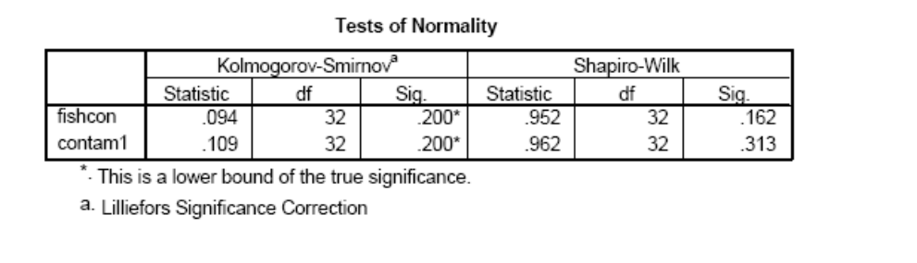
b. Make a scatterplot of Fishcon and Contam1 for the purpose of getting a visual read of the relationship. Is the relationship positive or negative? Is it strong or weak? Are there any possible outliers? Print the output and write up your answers.
Ans: The relationship is strong and negative. The outlier is clearly shown as the observation at approximately (.9, 450).
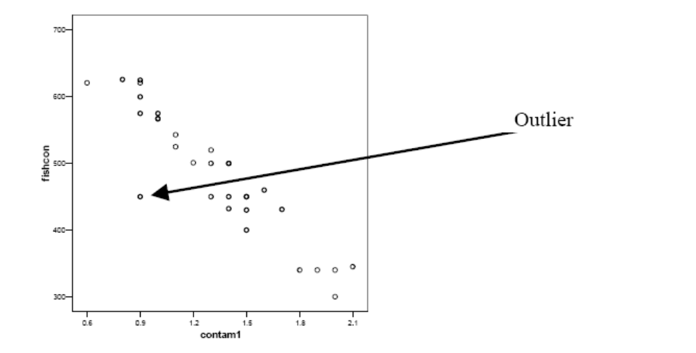
c. Based on your visual read, you wish to test the hypothesis that the two variables are related. Conduct a simple regression, with Fishcon as the dependent variable. Examine the error term plot for possible outliers. What do you conclude?
Ans: Preliminary analysis shows that CONTAM1 is statistically significant at the 1% level (t = −13.4, p < 0.01). The regression coefficient of CONTAM1 is −223.5, which suggests a negative relationship. The correlation coefficient is 0.96 and R² is 0.857, which means that 85.7% of the variance in the dependent variable is explained by the level of CONTAM1. However, the preliminary analysis also shows the presence of an outlier. Observation #14 has a standardized residual of −3.622.
d. Identify the outlier and eliminate it from subsequent analysis. Provide a write-up of the modified analysis that includes: (1) the hypothesis, (2) the relationship between the variables (y = ax + b), (3) identification and removal of outliers, (4) the correlation and percentage of variance explained (r and r²), and (5) a plot of the standardized residuals against the predicted values of the dependent variable.
Ans: The regression tests the hypothesis that the concentration of fish is associated with the level of contamination. After repeating the analysis, it is found that FISHCON and CONTAM1 are still statistically associated at the 1% level (t = −236.2, p < .01). A printout of this analysis is provided as Table 2. The R² value is now .924, and the overall relationship is given by (t-statistics in parentheses):
FISHCON = 801.3**−236.2** CONTAM1 (−18.8)
whereby,*p < .05 significance; **p < .01 significance.
Plot of the standardized residuals against the predicted values of the dependent variable:
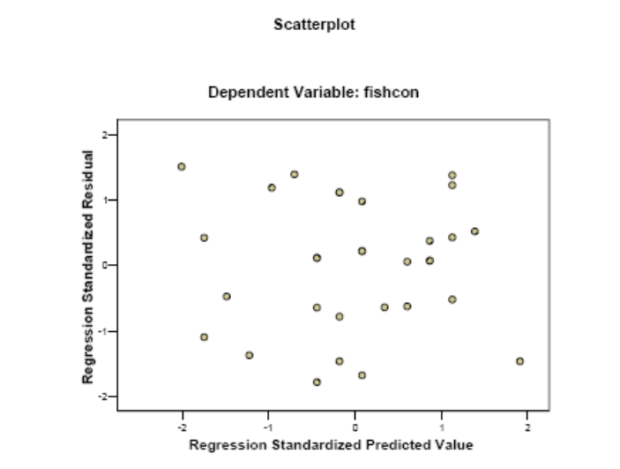

6. Use the Time data set. This exercise illustrates the use of dummy variables and includes a test of multicollinearity. The data set contains observations from 35 hypothetical cities regarding the use of citizen focus groups in various departments (Focus). The data are based on a survey. Most variables are index variables taken from different survey questions. The variables are defined as follows:
Focus = A composite measure of the breadth and depth of the use of citizen focus groups in a city. Varies from 0 (low) to 20 (high).
Mgrint = A measure of the interest of the city manager in obtaining citizen-based feedback. Varies from 1 (low) to 4 (high).
Pubcompl = A measure of public complaints about the quality and effectiveness of a wide range of municipal services. Varies from 1 (low) to 8 (high).
Budget = Indicates whether municipal budgets have increased in the past 2 years. Values are −1 = decrease in budget; 0 = no change in budget; 1 = increase in budget.
Size = City size. Varies from 1 = small to 7 = large.
Region = An indicator variable of the region in which the city is located. Values: 1 = Northeast; 2 = South; 3 = Midwest; 4 = West.
In this analysis, you wish to understand which variables cause cities to use citizen-based focus groups.
Note to instructors: I have used this exercise as a homework assignment. See the file “Homework Assignments” on this CD.
a. Briefly state your hypotheses.
Ans: This is a good exercise for getting students to clarify their thinking. For example, the rationale for hypothesizing the relationship between public complaints and the use of focus groups is, for example, that the former indicates a service problem and the use of focus groups furthers problem definition and solution generation. The rationale for including size and region is less obvious. Size may be correlated with resources (similar to budget increases), and focus groups require resources, though actually quite little. The variable Region is hard to justify, though many productivity improvement techniques seem to start in the West.
H0: There is no relationship between the use of focus groups and the interest of managers in obtaining citizen-based feedback [or any other independent variable], controlled for the effect of public complaints, budgets, size, and region [all other independent variables listed here].
HA: There is a relationship between the use of focus groups and the interest of managers in obtaining citizen-based feedback [or any other independent variable], controlled for the effect of public complaints, budgets, size, and region [all other independent variables listed here]
b. Provide a brief description of variables (univariate analysis). Also, examine the bivariate associations between Focus and Mgrint, Pubcompl, Budget, and Size. Examine the bivariate relationships that exist between all possible pairs of these variables.
Ans: This is straightforward, providing a write-up of the mean and frequency distributions of each of these variables. Many students want a template, which tells them what to write in an automatic fashion (“the mean is . . .”). Rather, I try to get them to search for conclusions (e.g., “about half the cities are small . . .”). For example, Univariate analysis of the index measure of focus groups shows that this variable varies from 0 to 20, with a mean of 10.11. About a quarter, 25.7%, have scores up to 4.0, and 25.7% have scores greater than or equal to 15.
The bivariate associations show strong correlations between the independent variables and the dependent variable. They also show a rather strong correlation between Budget and Mgrint (r = .659)
c. Examine whether Mgrint, Pubcompl, Budget, and Size are statistically associated with the use of focus groups. For this purpose, conduct a multiple regression in which the dependent variable is Focus and the independent variables are Mgrint, Pubcompl, Budget, and Size. What do you conclude? (You need not write up these results.)
The following result is obtained (R² =.910, t-test statistics in parentheses):

FOCUS = .482 + 2.211** MGRINT +.392 PUBCOMPL + 1.416* BUDGET + .893** SIZE
(6.93) (1.88) (2.61) (4.70)

whereby, *5% significant; **1% significant.

d. You now wish to include the effect of region in your analysis. To do this, you must make Region a dummy variable. Assume you wish to compare the effect of the different regions with Midwest. To make the dummy variables for the Northeast, South, and West, you must either recode the data for each region or enter the data manually. Through either of these techniques, add Northeast, South, and West to your model and rerun the analysis.
Ans: See results and write-up below.

e. Provide a complete write-up of the regression. (1) Identify which variables are significant and at what level. Identify the adjusted R² statistic (Is it a strong or weak association?). Also, discuss the β coefficients. What do you conclude? (2) Plot the standardized residuals against the standardized predicted values. What do you conclude? (3) To examine the possibility of multicollinearity, examine the bivariate correlations among the independent variables. What do you conclude? Given the significance of coefficients, is multicollinearity a problem here?

Ans: To examine the factors that affect the use of focus groups in cities, a survey was conducted that collected data about program performance as well as a range of factors that might affect it. These factors are city manager interest in productivity improvement, public complaints, changes in the budget, city size, and region.
Univariate analysis of the index measure of focus groups shows that this variable varies from 0 to 20, with a mean of 10.11. About a quarter, 25.7% have scores up to 4.0, and 25.7% have scores greater than or equal to 15.
The relationship between FOCUS and MGRINT is positive and r² = 0.904. The relationship between FOCUS and PUBCOMPL is also positive, and r² = .0667.
The results of the multiple regression are reported below. We examined the initial results for possible outliers and other problems of such as heteroscedasticity, nonlinearity, or multicollinearity, but found none. (If you see these problems, describe what was done to correct them. If you do not see such problems, note that.) The following independent variables are statistically significantly associated with effectiveness and efficiency of programs in cities managerial interest (p < .01) and size (p < .01). R²-adjusted is .912. The model is stated below (t-statistics in parentheses):
FOCUS = 1.216 + 2.347** MGRINT + 0.371 PUBCOMPL + 1.066 BUDGET
(7.091) (1.771) (1.739)
+ 0.723** SIZE−1.576 NORTHEAST + 0.402 SOUTH
(3.161) (–1.793) (0.357)
−0.162 WEST
(–0.150)
whereby, *p < 0.05 significance; **p < 0.01 significance.
Model Summaryª
Model | R | R² | Adjusted R² | Standard Error of the Estimate
1 | .965^{b} | .930 | .912 | 1.84232
ªDependent variable: perfm
^{b}Predictors: (constant), west, mgrint, northeast, pubcompl, south, size, budget

ANOVAª
Model |  | Sum of Squares | df | Mean Square | F | Significance
1 | Regression Residual Total | 1223.901  91.642  1315.543 | 7 27 34 | 174.843 3.394 | 51.513 | .000^{b}
b. ªDependent Variable: perfm
^{b}Predictors: (constant), west, mgrint, northeast, pubcompl, south, size, budget

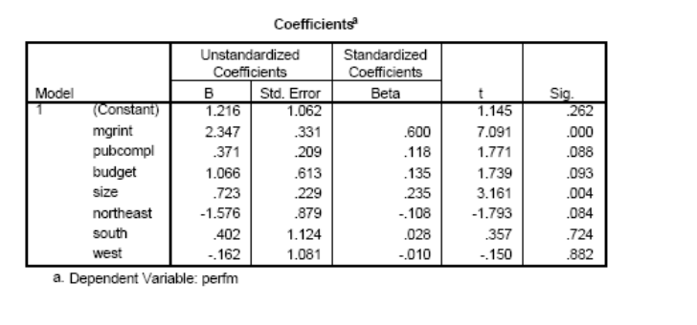

Plot of the standardized residuals against the standardized predicted values:

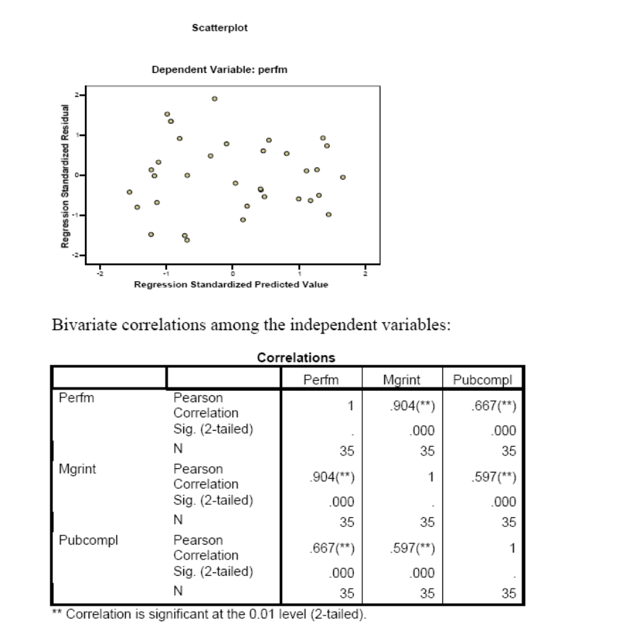

7. Use the Time data set. This exercise illustrates the problem of nonlinearity. It is commonly hypothesized that crimes are more frequent in large cities. The data set contains the following variables: Nvcrime = index of nonviolent crimes in a given year. Citysize = city size.
a. To test the above hypothesis, regress Nvcrime as a function of Citysize. Plot the standardized error term against the standardized predicted values and observe the curvilinear (parabolic) slope of the error terms.
Model Summaryª
Model | R | R² | Adjusted R² | SEE
1 | .881^{b} | .777 | .768 | .6970
ªDependent variable: nvcrime
^{b}Predictors: (constant), citysize

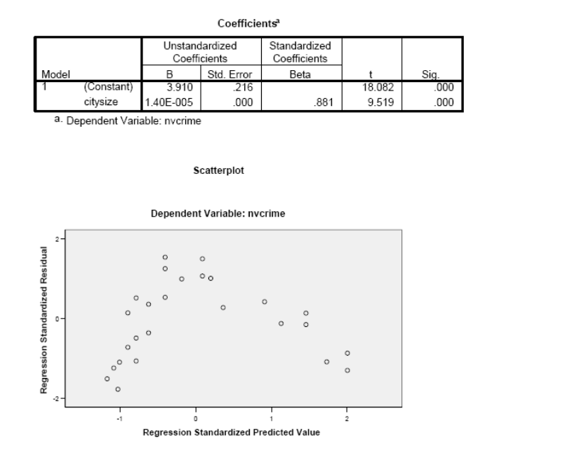

b. You suspect that this problem occurs because the relationship between the variables is nonlinear. To examine this possibility, plot Nvcrime against Citysize. Notice the faint rounded curve. Based on the nature of the curve, you decide that a transformation of Citysize is required. You decide to try a square root of Citysize. Make a square-root transformation of Citysize. To evaluate the success of this transformation, plot the transformed variable, called TCity (on the X-axis) against Nvcrime (on the Y-axis). Is the relationship still nonlinear? Was the transformation successful?

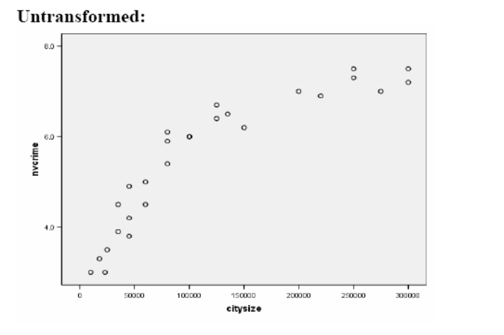
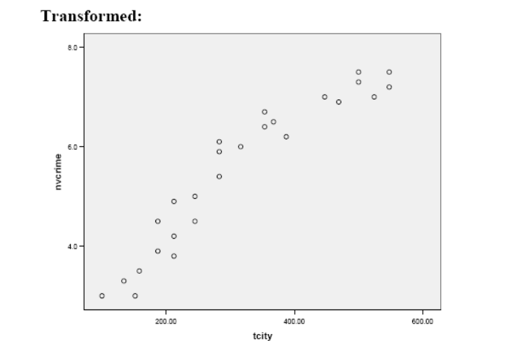
c. Next, rerun the regression using the transformed variable TCity. Hence, Nvcrime = f(TCity). Reevaluate the residuals by plotting the error term of the transformed model against the transformed independent variable, TCity. What pattern, if any, do you see? If the transformation was unsuccessful, try a log transformation. Do you see a pattern now?
Ans: The square-root transformation reduces the curvilinearity, but examination of the error term plot suggests that the transformation is still inadequate. A parabolic pattern appears (inverse of Figure 7.4 in the textbook). A log transformation is successful. In all analyses, the relationship between crime and city size is statistically significant (p < .01). It is also interesting to note that with each analysis, the adjusted R² increases as the relationship between crime and city size becomes more linear (.768, .883, and .933, respectively).
Here are the results of the square-root transformation:
Model Summaryª
Model | R | R² | Adjusted R² | SEE
1 | .942^{b} | .887 | .883 | .4957

ªDependent variable: nvcrime
^{b}Predictors: (constant), tcity

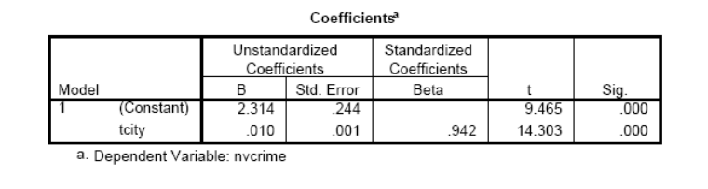
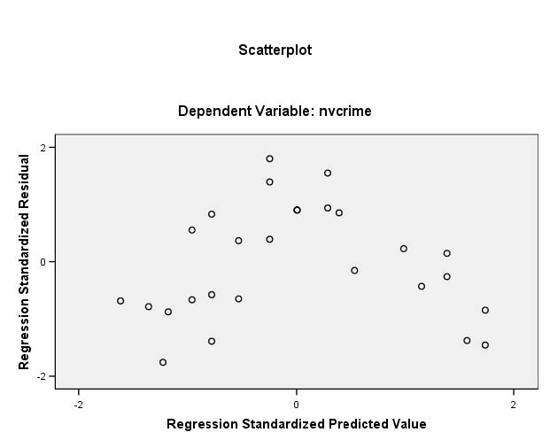

8. (optional) Refer to Data-Based Exercise 7 in Chapter 15. Add a second independent variable and run a multiple regression that examines the impact of these two variables on your academic performance (the dependent variable). Perform related tests of regression assumptions. Interpret the results. What do you conclude? Write a report that summarizes your findings for a person who knows nothing about statistics.

Ans: Make sure that you include at least two independent variables in your model to make this a multiple regression. Your report should read something like this: “This analysis examines the possible joint impact of study effort and attendance on academic performance. The result of the analysis shows that study effort (measured by the number of weekly study hours) may have significant impact on academic performance (measured on a score of 0 to 100). However, there is no evidence that attendance (measured the number of visits to classes) has significant impact on academic performance when the impact of weekly study hours is considered. If no study time is spent, the academic performance is 59.0 points (the constant or the intercept). For every additional hour spent, the academic performance improves by 9.3 points (the slope for study effort).”

Chapter 16: Logistic and Time Series Regression

Critical Thinking
1. Identify dichotomous variables that are relevant to your area of interest and develop a model to predict them.
Ans: Answers vary. Here is one possible response. Dichotomous variable: whether a student has an arrest record. Model: Juvenile arrest = f(drug use, age, gender, parents’ martial status). You might include race, too.
2. Explain the following statement: “The dichotomous nature of the dependent variable violates an assumption of multiple regression.”
Ans: See p. 274: “The dichotomous nature of the dependent variable violates an assumption of multiple regression, discussed in Chapter 15, that the dependent variable should be continuous.” See also Figure 14.1
3. The S-shaped logistic curve has values that lie between 0 and 1.What problem does this address?
Ans: It address the problem that predicted values of the dependent variable cannot be less than 0 or greater than 1.
4. Explain why a good model fit will show Hosmer and Lemeshow test statistics that are insignificant.
Ans: The Hosmer and Lemeshow test is used to compare observed and predicted values. See p. 276: “A good model fit has close correspondence between observed and predicted values and, hence, an insignificant χ² value for this test.”
5. Verify the event probability calculations shown in Table 16.2 of the textbook.
Ans: Recreate this on a spreadsheet.
6. Table W16.1 shows the output of a logistic model that predicts promotion within 5 years. Is the model adequate: why, or why not? What is the probability that a 37-year-old female who has a performance appraisal rating of 4 will be promoted? The performance variable (Appraisal) is measured on a scale of 5 = high to 1 = low; gender is defined as 1 = male, 2 = female; and age = employee’s age (in years).

Ans:
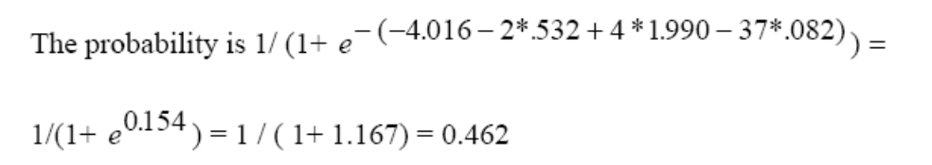
7. Give some examples of time series data in your area of interest. Discuss ways in which these data might be analyzed.
Ans: Answers vary. Students might find it difficult to find time series data with an adequate number of observations that are collected annually rather than with greater frequency.
8 Explain why autocorrelation is almost always present when using regression analysis with time series data.
Ans: See p. 288: “With time series data, the assumption of random distribution of error terms is usually violated. This is because the adjacent, time-ordered values of observations are highly correlated with each other: knowledge of today’s value is a good predictor of tomorrow’s. Autocorrelation, also called serial correlation, reflects correlation in the order (or series) in which observations are measured.”
9. The Durbin–Watson test statistic for autocorrelation of a regression model with 35 observations and four independent variables is 1.98. What do you conclude? And what would you conclude if the Durbin–Watson test statistic were 1.08?
Ans: See p. 327: Appendix D shows that for N = 35 and k = 4, d_{l} = 1.22, and du = 1.73. Hence, the Durbin–Watson value of 1.98 suggests the absence of autocorrelation. The Durbin–Watson test statistic value of 1.08 suggests the presence of autocorrelation. See also Figure 17.2 on p. 289 in the textbook.
10. Explain the following statement: “The regression of first-order differences is considered a far more stringent test than adding a trend variable.”
Ans: See p. 291: “[R]egression of first-order differences is considered a far more stringent test than adding a trend variable and is therefore preferred. Adding a trend variable is a prophylactic strategy that attempts to control for the problem. Regressing first-order differences is a preventive strategy that aims to avoid the problem.”
11. Explain how policy variables help to evaluate program effectiveness. Does the magnitude of these dummy variables matter?
Ans: Policy variables are surrogate variables that measure the timing and nature of program impact. The magnitude of these variables affects the size of the regression coefficient but not its significance.
12. Give an example of an independent variable that you suspect might have a lagged impact on a dependent variable.
Ans: There are many examples of lagged variables, such as increased police enforcement of a policy or law, and declines in illegal behaviors in a community relevant to the stepped-up enforcement.
Data-Based Exercises
1. Use the Public Perceptions data set. Predict Trust (“Trust in government”) as a function of Interest (“County officials are interested in what I have to say”), Works (“Do you believe the county government works efficiently?”), Quality (“The quality of life in Orange County is good”), and race. To this end, (1) create a dummy variable for race (1 = White, 0 = all others) from the variable Ethnic and (2) recode the values of “DK” for the variables Trust and Works as missing. Use logistic regression and report the results.

Trust = f(Interest, Works, Quality, White)
a. Verify that the dependent variable is dichotomous.
b. Does the model satisfy the standard for correctly predicted observations?

Ans: As noted in the question, be sure to recode trust value = 3 as missing and works value = 3 as missing. Yes, it does:
Classification Table
Observed |  |  | Predicted
 |  | Trust |  | Percent Correct
Variable | Group | 0 | 1 | Percent Correct
Trust | 0 | 539 | 76 | 87.6%
 | 1 | 87 | 159 | 64.6%
Overall Percentage |  |  |  | 81.1%

Note that the predicted group 0 = trust and 1 = no trust.
c. Which variables are significant?
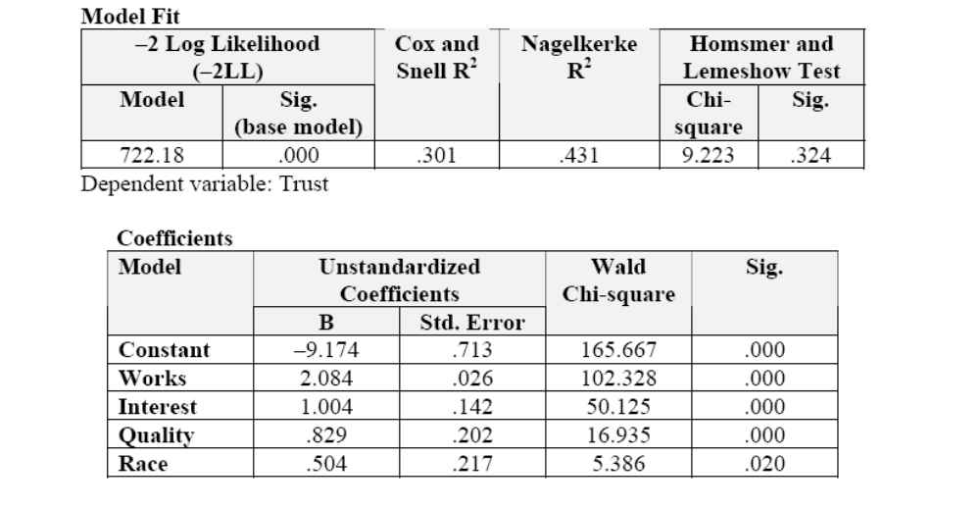
d. Calculate event probabilities.
Ans: The probability of someone not trusting government (value = 1) who agrees that the county works efficiently (value =1), strongly agrees that the county is interested in what they have to say (value = 1), strongly agrees that the quality of life in the county is good (value = 1), and is White (value = 1) is 0.86%; hence, this person has a 99.1% chance of trusting government. This is calculated as follows:
1/(1+ e ) − (−9.174 + 2.084 + 1.004 + 0.829 + 0.504).
1/(1+ e^{4.753}) = 1/( 1 + 115.9) = 0.0086.
The above values for a non-White respondent (race value = 2) are 1.4% for not trusting government or 98.6% for trusting government—a very slight impact.
By contrast, the probability of someone not trusting government who is White (value = 1) and strongly agrees that the quality of life in the county is good (value = 1), but strongly disagrees that government is interested in what they have to say (value = 4) and who disagrees that government work efficiently (value = 2) is 58.5%, or 41.5% of trusting government—a marked decline in trust. When additional respondents strongly disagree that the quality of life in the county is good (value = 4), the chance of trusting government declines further to (1 – .9443=) 5.6% (with rounding):
1/(1+ e^{−2.830}) = 1/(1+ 0.059) = 0.9443.
2. Use the Public Perceptions data set. Predict Manage (“Doing a good job managing growth”) as a function of Works (“Do you believe the county government works efficiently?”), Quality (“The quality of life in Orange County is good”), and Watch (“Watching Orange County TV”). Use logistic regression, and report the results.
Manage = f(Works, Quality, Watch)
a. Verify that the dependent variable is dichotomous.
Ans: As in the previous exercise, be sure to recode 3 as missing for Watch, Manage, and Works.
b. Does the model satisfy the standard for correctly predicted observations? If not, does it satisfy the Hosmer and Lemeshow test?
Ans: No, only 69.2% of observations are correctly predicted, but it does satisfy the Hosmer and Lemeshow test.
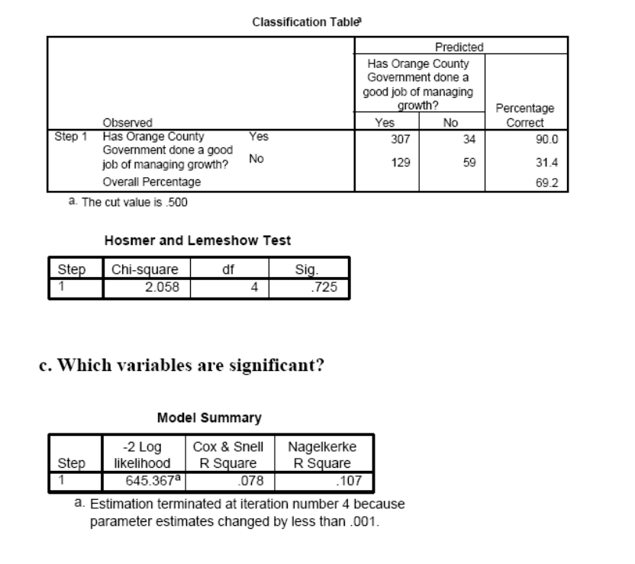

Variables in the Equation
 |  | B | SE | Wald | df |  | Significance | Exp(B)
Step 1ª | Works  Quality  Watch  Constant | 1.301  1.156  −0.152  −4.179 | .294  .264  .191  .704 | 19.539  19.126  .640  35.228 |  | 1  1  1  1 | .000  .000  .424  .000 | 3.674  3.177  .859  .015

ªVariable(s) entered on step 1: works, quality, watch.
d. Calculate event probabilities.
Ans: Create a spreadsheet as shown in Table 16.2 in the text (p. 284).
3. Various universities make data sets of past research available. One such university is the University of California, which makes data sets available through SDA: Survey Documentation and Analysis (http://sda.berkeley.edu). Explore available data sets through the Archive link. For example, select any data set (e.g., ANES Cumulative Datafile 1948–2000) and note the tab/option to run logit regression. However, you should first examine the variable descriptions by selecting “Open Extra Codebook Window.” You will likely need to recode some of the variables first. You can also download a customized subset of data.

Ans: You could use this or any of your other favorite data portals to get students familiar with available data sets.

4. Use the Time data set. This exercise illustrates the autocorrelation problem in the use of policy variables. Time series data are common in program evaluation and public policy. These data examine the impact of a law, which, among other things, increases jail time for those convicted of driving under the influence (DUI). The data set contains the following variables:
Fatal = traffic fatalities per 100,000 miles driven.
Year = year of traffic fatalities measured.
Short = a dummy variable identifying when the policy intervention occurred, namely, in 1980 when a law was passed that requires mandatory jail time for DUI. The values are 0 = pre-law adoption (pre-1980); and 1 = post-law adoption (post-1980).
Long = A dummy variable identifying the number of years of post-policy adoption. The values are 0 for prelaw adoption, 1 for 1980, 2 for 1981, 3 for 1982, and so forth. This variable gives weight to the long-term effect of policy.
Jailtime = days of jail time served by offenders as a result of the law.
Note: Although increased jail time is the primary effect of the program, data from other aspects of the program (such as midnight checkpoints) are not available to the researcher. The variables short and long model these unknown effects.

a. You wish to evaluate whether the new law has been effective. You model the effect on fatalities and explore the possibility of autocorrelation in time series data. Hence, Fatal = f(Short, Long, Jailtime). Run the regression analysis, and examine the error term for autocorrelation. Specifically, examine the Durbin-Watson test statistic. What do you conclude?
The model Fatal = f(Short, Long, Jailtime) shows autocorrelation: the Durbin-Watson test statistic is 0.814 (with N = 16 and k = 3, dl = 0.86 and du = 1.73).
b. Now, take the trend variable into account: Add Year as an independent variable to your list. Again, note the Durbin-Watson statistic. What do you conclude about adding the trend variable? Provide a complete write-up.
When the variable Year is added (hence, Fatal = f(Short, Long, Jailtime, Year), the Durbin-Watson test statistic is 2.27, suggesting no autocorrelation. The variable Long is significant (p < .05).
c. For further rigor, you examine the relationship in first-order differences. Make first-order differences, and examine Fatal = f(Short, Long, Jailtime).What do you conclude? Also, try lagging each of the independent variables for up to two periods. What do you conclude?
Ans: In first-difference form, ΔFatal = f(short, long, ΔJailtime), none of the variables are significant, but ΔFatal = f(Short) shows that Short is significant at p < .05; Durbin–Watson = 2.87 (inconclusive). Quite likely, the limited number of observations and considerable variability of the data produced these results. Lagging the independent variables does not improve on these results.
5. Use the Crime data set. The data are monthly observations of juvenile arrests in a city with a curfew for teenagers. The curfew prohibits teenagers from being outside between 8 p.m. and 1 a.m.
Note: These data are adapted from actual cities. Although these are monthly data, the same approach can be applied to weekly or daily data. In those cases, rather than controlling for periodicity by month, control variables control for periodicity by week or day.
a. Plot the number of juvenile arrests (Juvarsts) over time. What do you conclude about the impact of the curfew? What factors might underlie the periodicity?
Ans: The number of juvenile arrests over time shows a strong monthly, cyclical pattern: arrests are much greater in the warm, summer months. There is also a drop in arrests beginning in 1994, when the curfew started.

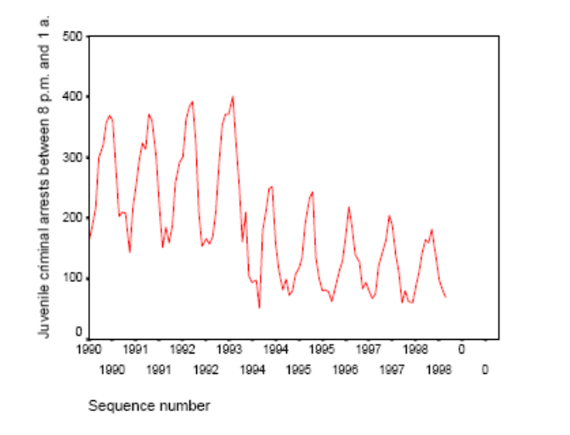
b. Run the regression of Curfew against Juvarsts. What do you conclude from the Durbin–Watson statistic?
Ans: The regression Juvarsts = f(Curfew) is strongly autocorrelated; Durbin–Watson = .443.
To attempt to correct for autocorrelation, include both the year and each of the months as control variables. Run the model in both levels and first-order difference forms, hence:
Juvarsts = f(Curfew, Month 1 – Month 11, Year), and
ΔJuvarsts = f(ΔCurfew, Month 1 – Month 11, Year).
Which of these models deals with the problem of autocorrelation? Why is Month 12 excluded from the model?
Ans: The regression in levels form of Juvarsts = f(Curfew, Year, Month_1 . . . Month_11) shows autocorrelation: the Durbin–Watson test statistic is 1.032. This latter regression in first difference form, ΔJuvarsts = f(ΔCurfew, Year, Month_1 . . . Month_11) has a Durbin–Watson test statistic of 2.349, which is in the inconclusive range. Then, ΔCurfew is significant (p = .005) and negative, indicating that the curfew is associated with a decrease in juvenile arrests.
c. It is sometimes noted in the literature that law enforcement displaces crime rather than reduces it. Rather than committing crimes between 8 p.m. and 1 a.m., juveniles will target other time periods to commit crimes. The data set includes the variable Crimarst, which measures total monthly juvenile arrests. Run the same models as under item b, with Crimarst as the dependent variable. What do you conclude?
Ans: The regression Crimarst = f(Curfew, Year, Month_1 . . . Month_11) in levels form is autocorrelated (Durbin–Watson = 0.639). In first-difference form, Durbin–Watson is 2.173, but Curfew is now no longer statistically significant. This shows that the curfew has no statistically significant impact on the level of total arrests, only on the timing of arrests.

Chapter 17: Survey of Other Techniques

Critical Thinking
1. Draw a recursive causal model (path analysis) of factors that increase student success, measured as graduation. Which variables are direct influences, which are indirect influences, and which, if any, are both? Be sure to indicate clearly the direct and indirect influences on the dependent variable.
Ans: The possibilities are endless. Here’s one approach:
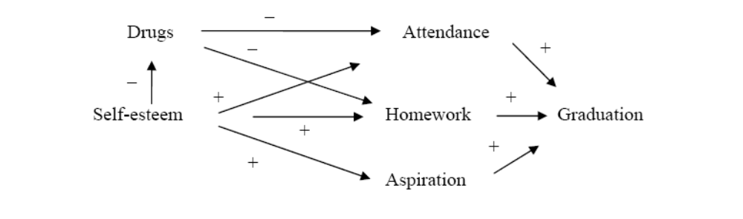

2. Figure W17.1 shows the results of a path analysis. The values above the paths are β coefficients. Which variable has the largest influence?

Ans: Variable C has the largest impact on variable A. The following table shows the effects on variable A: Students who have not yet dropped out of school, residents who have not yet used a city park, and neighborhoods that have not yet responded to an improvement proposal opportunity.
Variable |  | Effects
Variable | Indirect |  | Direct | Total
B | — |  | .62 | .62
C | .58 × .62 |  | .35 | .71
E | .20 × .35 + .20 × .58 × .62 + .47 × .35 × .62 |  | — | .24
F | .35 × .62 |  | – | .22

3. Give three examples of situations that may involve censored data.
Ans: Students who have not yet dropped out of school, residents who have not yet used a city park, and neighborhoods that have not yet responded to an improvement proposal opportunity.

4. Do censored data necessarily involve data that are collected over time?
Ans: No. In fact, censored data often are cross-sectional data that involve observations about events that have not yet occurred, for example, whether smokers have developed cancer or whether job training participants have found a job.
5. Give an example of a leading indicator of crime that might be used in regression-based forecasting.
Ans: Unemployment is often a leading indicator of crime.
Data-Based Exercises
1. Use the Productivity data set. Create a path analysis of the model shown in Figure W16.3. Does the model meet the condition of not having feedback loops? Begin by specifying (i.e., identifying) all of the regression models that are to be estimated. For each, identify the dependent and independent variables. Then, estimate (“run”) the models, record the β coefficients, and calculate direct and indirect effects.
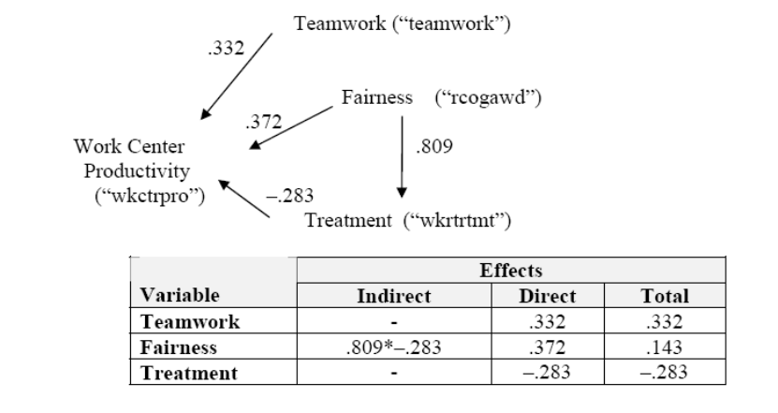

Variable |  | Effects
Variable | Indirect |  | Direct | Total
Teamwork | – |  | .332 | .332
Fairness | .809 × −.283 |  | .372 | .143
Treatment | – |  | −.283 | −.283

