

Family Structure and the Reproduction of Inequalities
Author(s): Sara McLanahan and Christine Percheski
Source: Annual Review of Sociology, Vol. 34 (2008), pp. 257-258, C-1a, C-2a, 259-276 Published by: Annual Reviews
Stable URL: http://www.jstor.org/stable/29737790 . Accessed: 19/02/2015 21:00
Your use of the JSTOR archive indicates your acceptance of the Terms & Conditions of Use, available at .
http://www.jstor.org/page/info/about/policies/terms.jsp

.
JSTOR is a not-for-profit service that helps scholars, researchers, and students discover, use, and build upon a wide range of content in a trusted digital archive. We use information technology and tools to increase productivity and facilitate new forms of scholarship. For more information about JSTOR, please contact support@jstor.org.
.

Annual Reviews is collaborating with JSTOR to digitize, preserve and extend access to Annual Review of Sociology.
http://www.jstor.org
This content downloaded from 128.228.173.22 on Thu, 19 Feb 2015 21:00:57 PM
All use subject to JSTOR Terms and Conditions

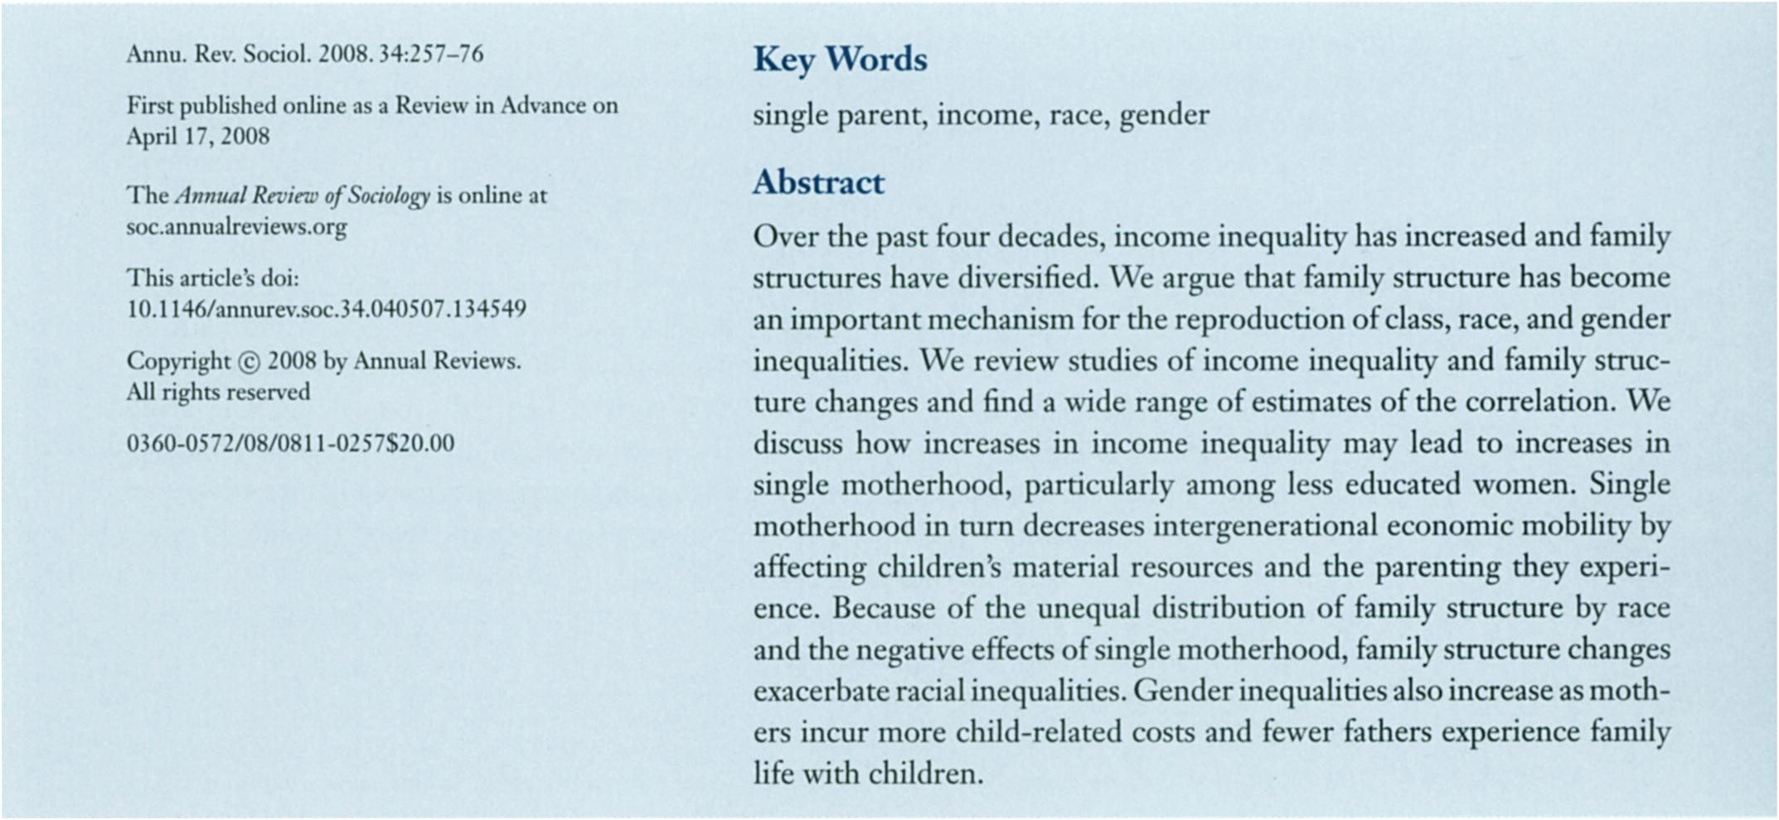
Family
Structure
and
the
Reproduction
of
Inequalities
Sara
McLanahan
and
Christine
Percheski
Office
of
Population
Research,
Princeton
University,
Princeton,
New
Jersey
08544
;
email:
mclanaha@princeton.edu,
cperches@princeton.edu
Annu.
Rev.
SodoL
2008.34:257-76

Flmpob-ahedo-J-DeasaReviewinAihnnceoii
April
17
,2008
The
Amusl
Review
of
Sociology
is
online
at
soc&iinuuKview&oiy
This
articled
do?
aimiiiemc.34.040507.134549
10.11467
Copyright
@

2006
by
Annual
Reviews.
All
lights
RMived
O572/08/08n-O257$20.OO
036O-
KeyWords
single
parent,
income,
race,
gender
Abstract
Over
the
past
four
decades,
income
inequality
has
increased
and
family
structures
have
diversified.
We
argue
that
family
structure
has
become
an
important
mechanism
for
the
reproduction
of
class,
race,
and
gender
inequalities.
We
review
studies
of
income
inequality
and
family
struc?
ture
changes
and
find
a
wide
range
of
estimates
of
die
correlation.
We
discuss
how
increases
in
income
inequality
may
lead
to
increases
in
single
motherhood,
particularly
among
less
educated
women.
Single
motherhood
in
turn
decreases
intergenerational
economic
mobility
by
affecting
children^
material
resources
and
the
parenting
they
experi?
ence.
Because
of
the
unequal
distribution
of
family
structure
by
race
and
the
negative
effects
of
single
motherhood,
fsumily
structure
changes
exa?rbateracialinequaUties.Genderinequrf^
ers
incur
more
child-related
costs
and
fewer
fathers
experience
family
life
with
children.
257

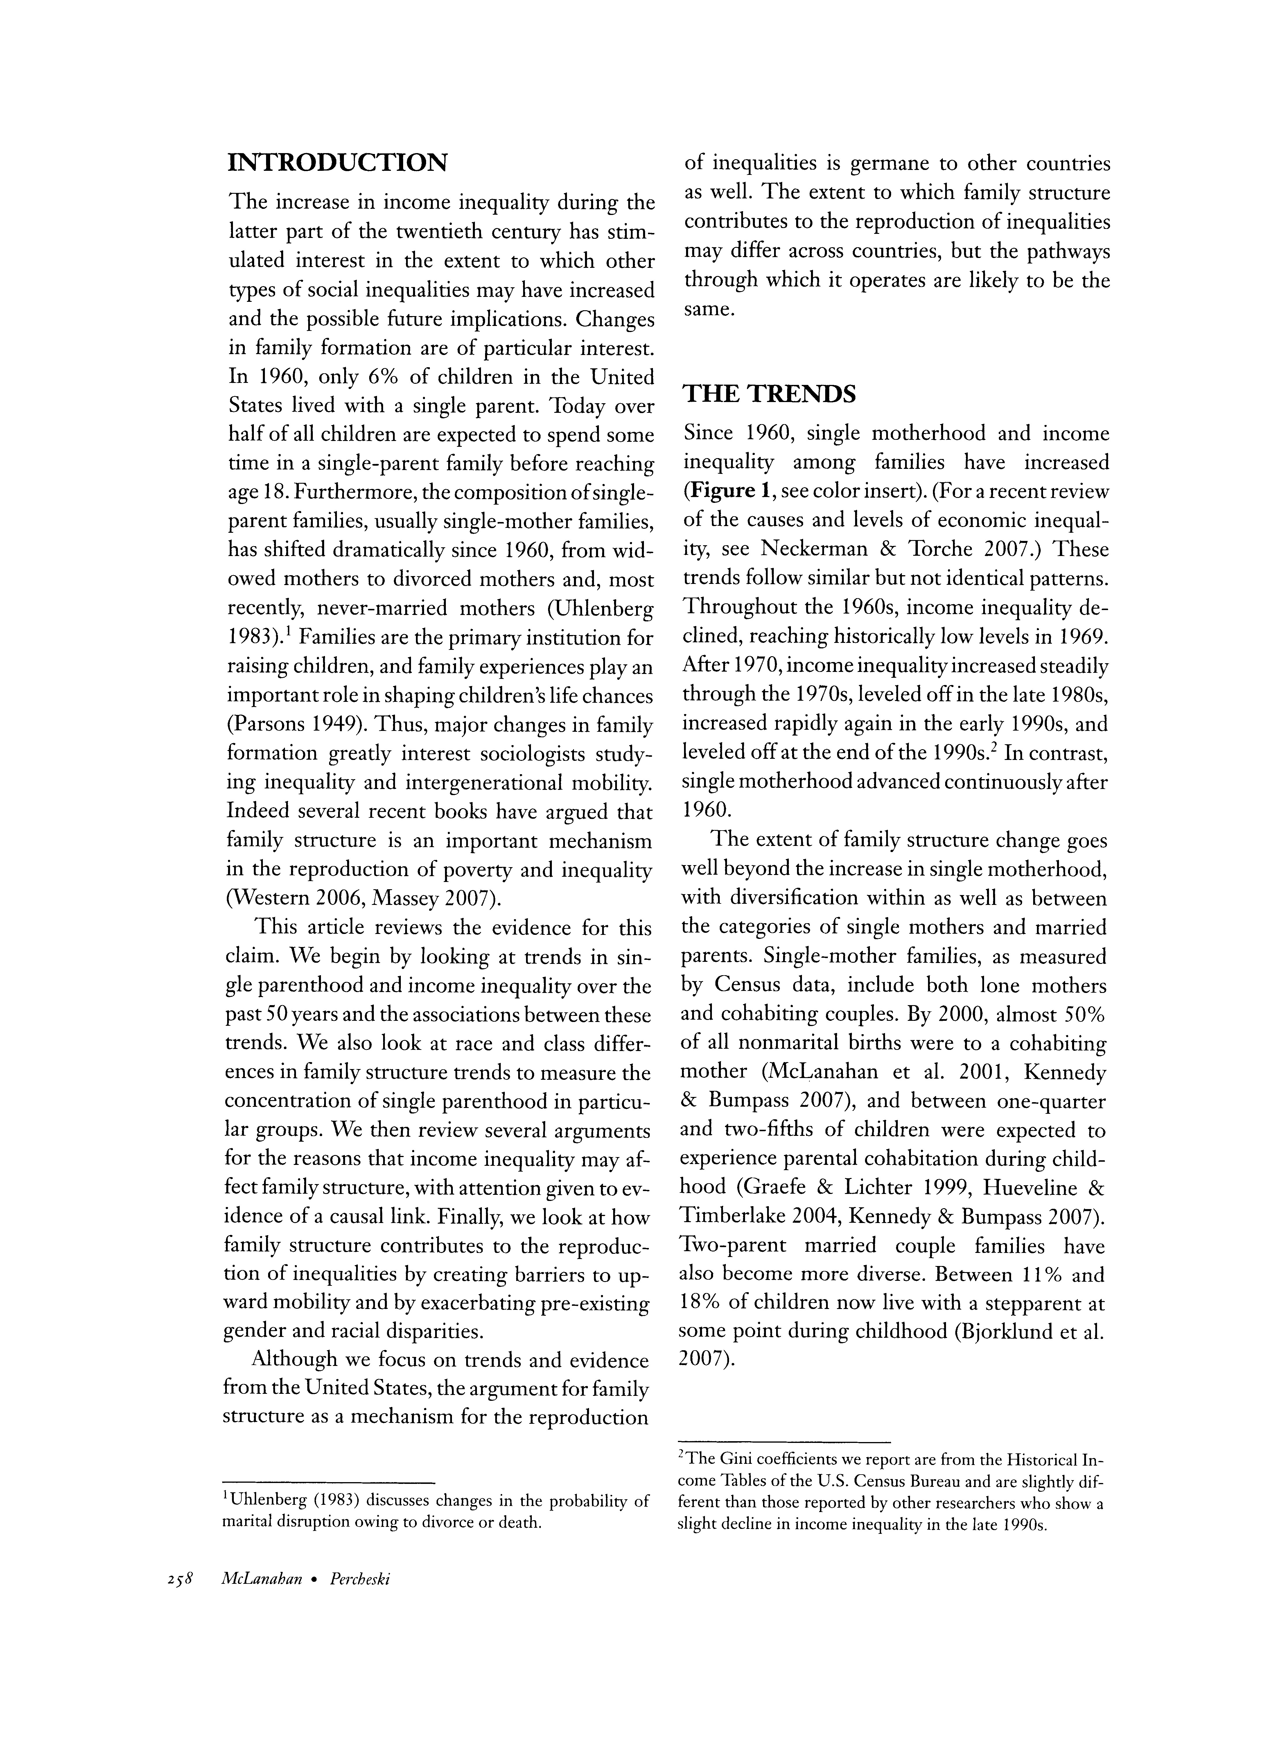
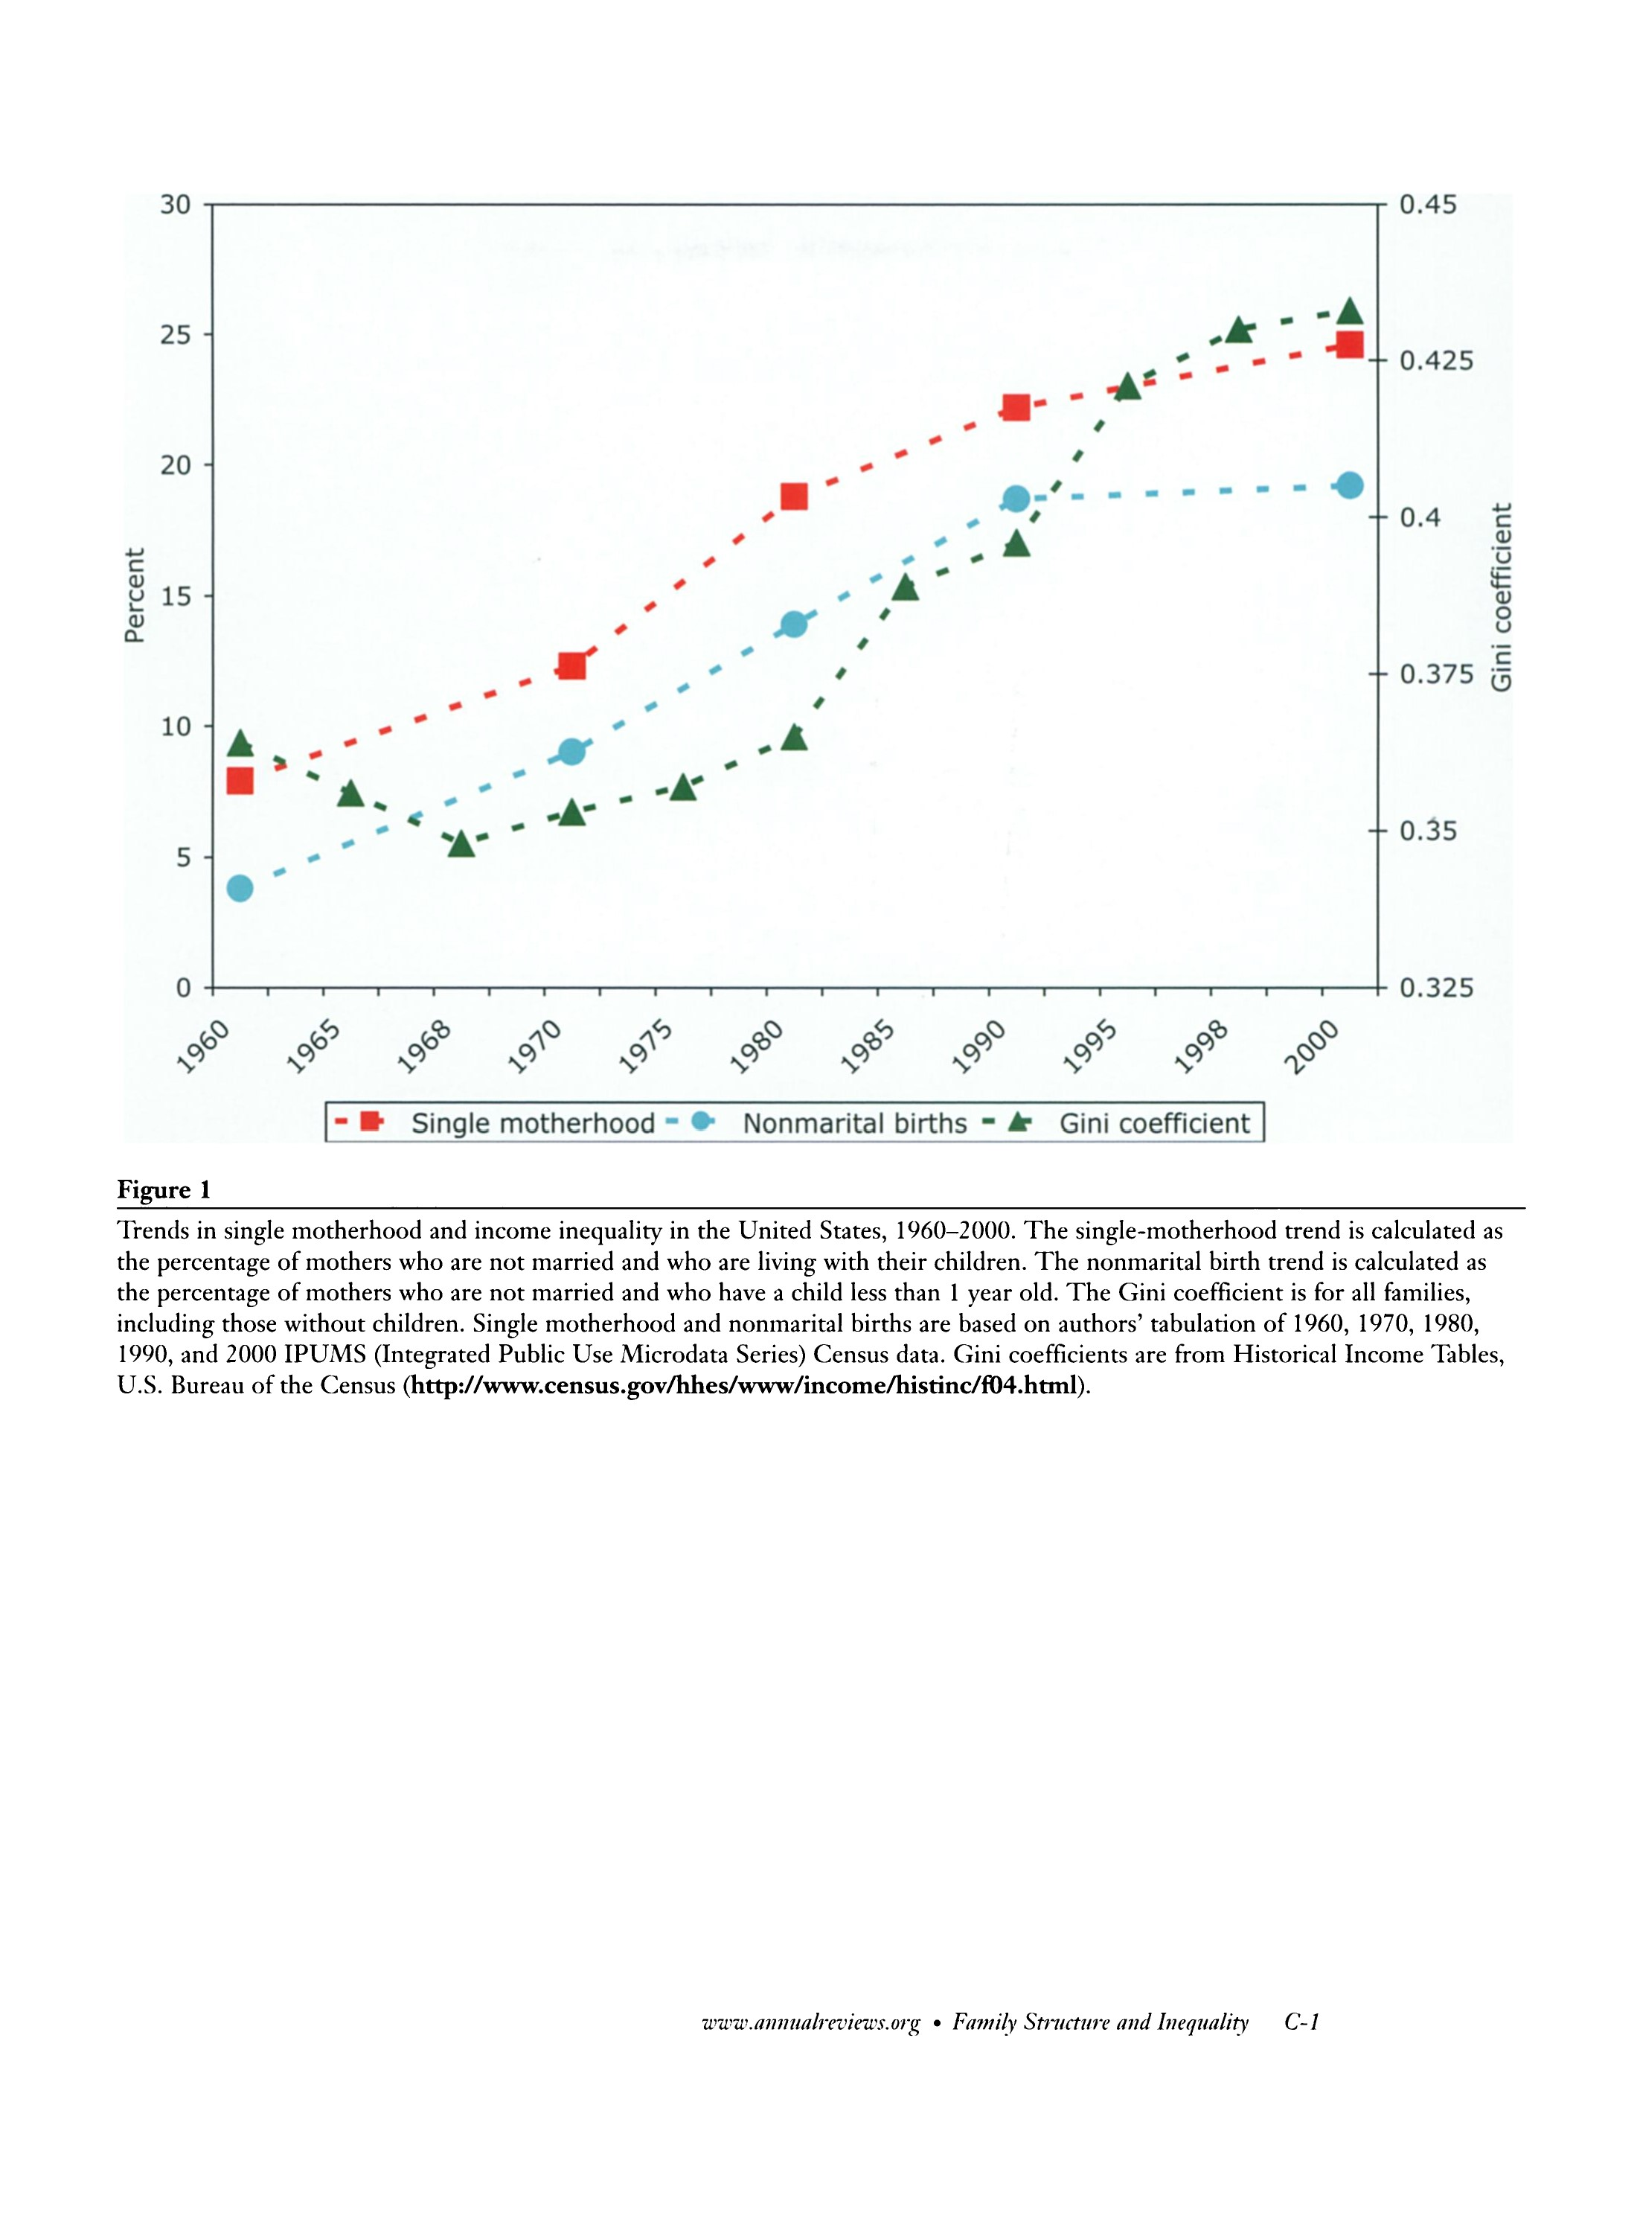

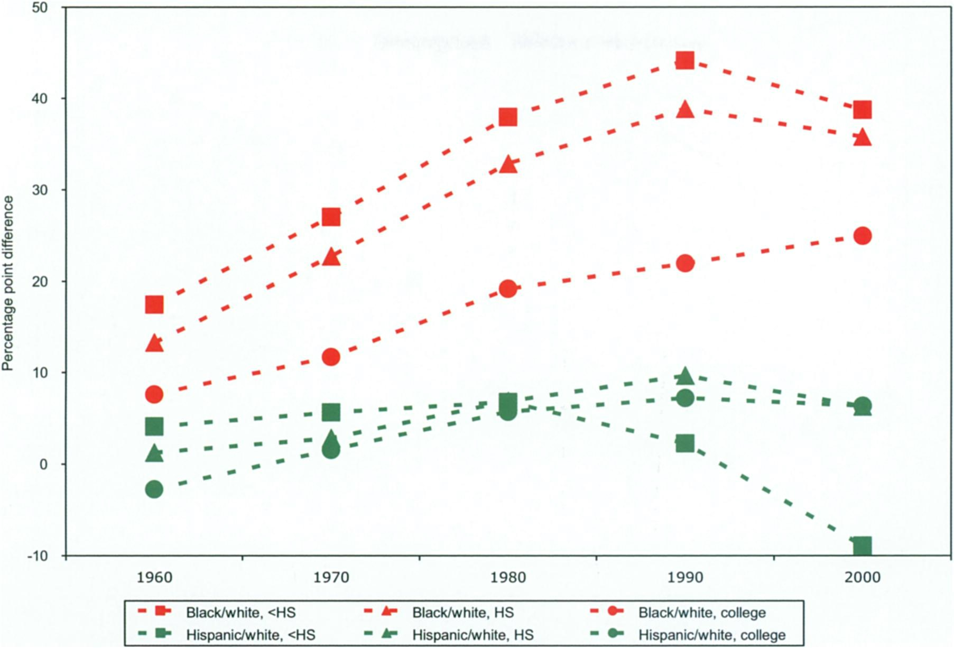
1960

1970

1980

"
?*
Bteck*vhito,<HS
m
**
Back/white,
HS
M
IBB
?
?-?!?>?
?!?!??
jUB
M
^M
*
**-
wlniiiliMa
US
^
i
aapewciiwaoi,
no
<
^
i
MpoiwCfwna?t
no
1990

2000

Figure
2

Differences
in
single
motherhood
by
race
and
education
based
on
tabulations
of
1960
,
,
1970
1980
,
1990
,
and

2000
IPUMS
Census
data.
C-2
McLanahan
?
Percheski
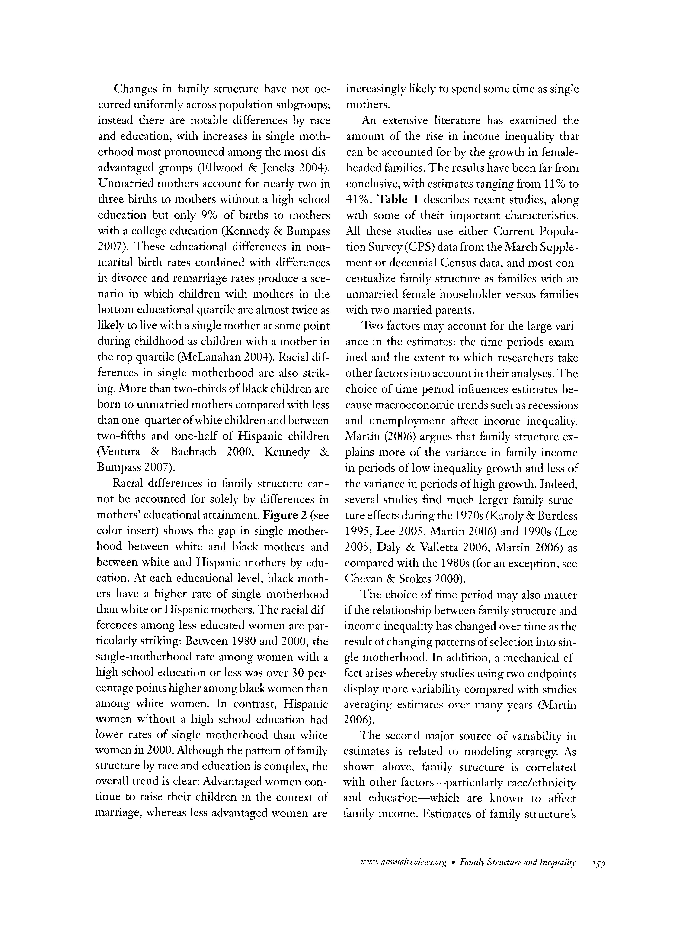
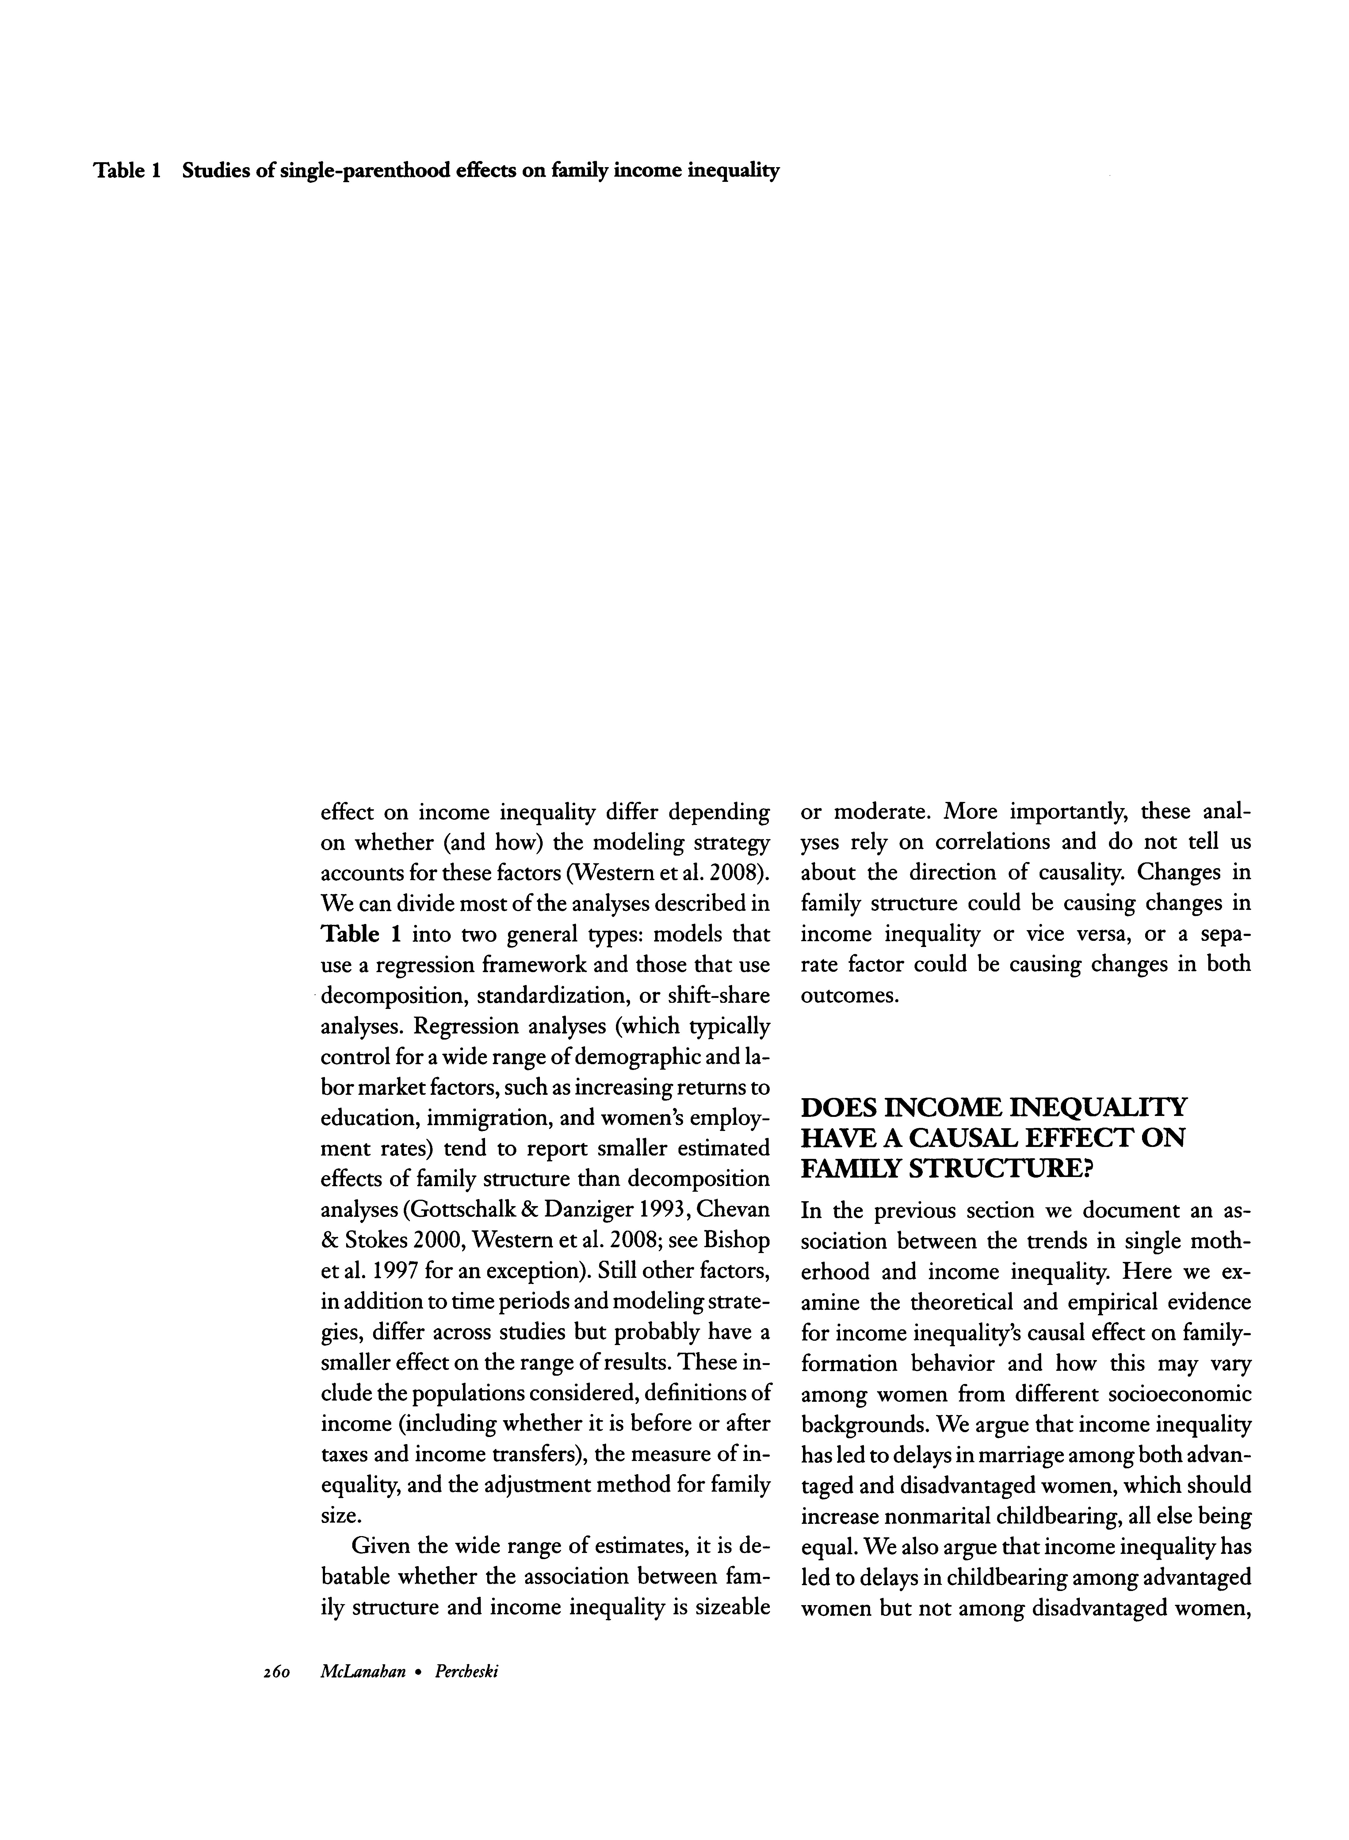
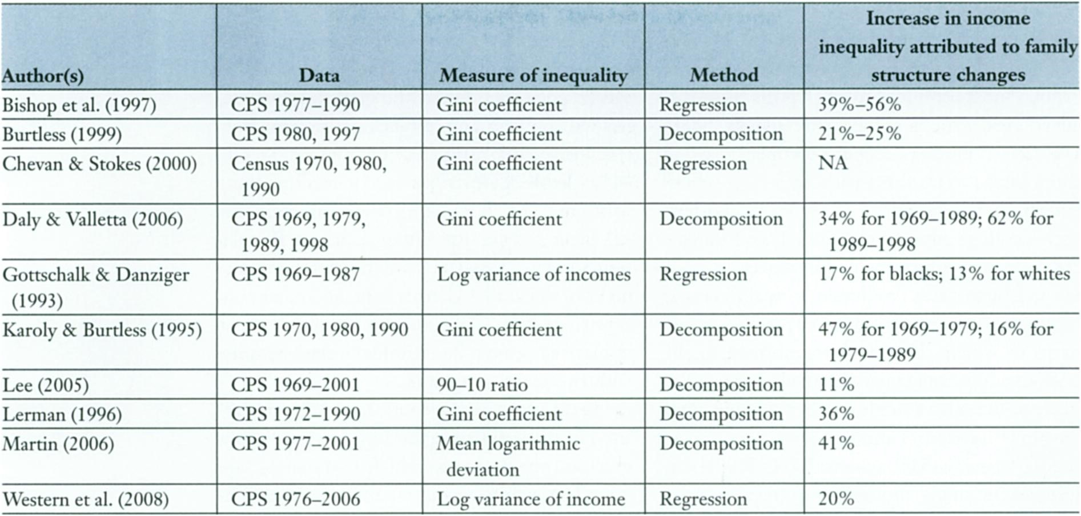
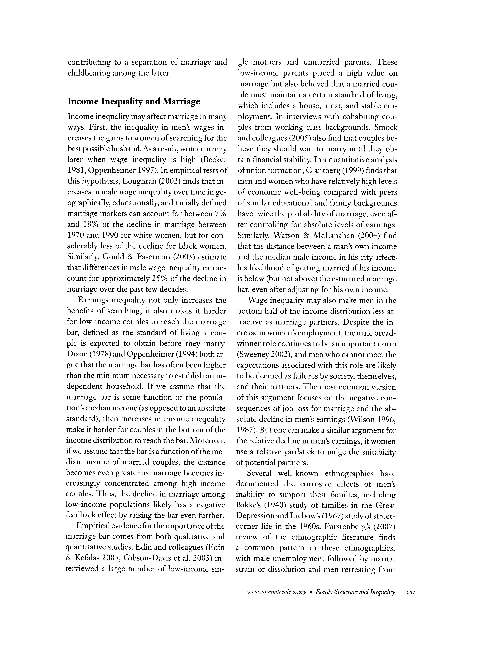
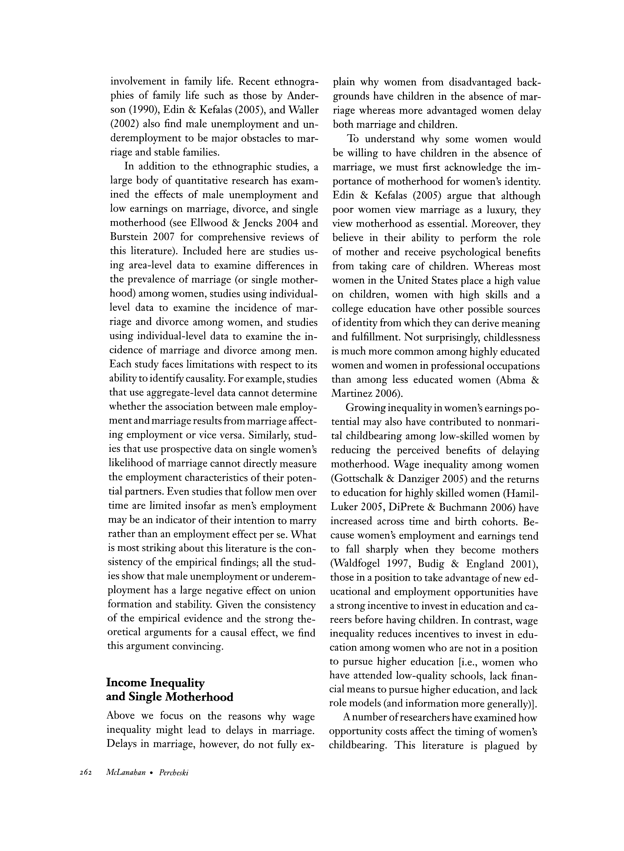
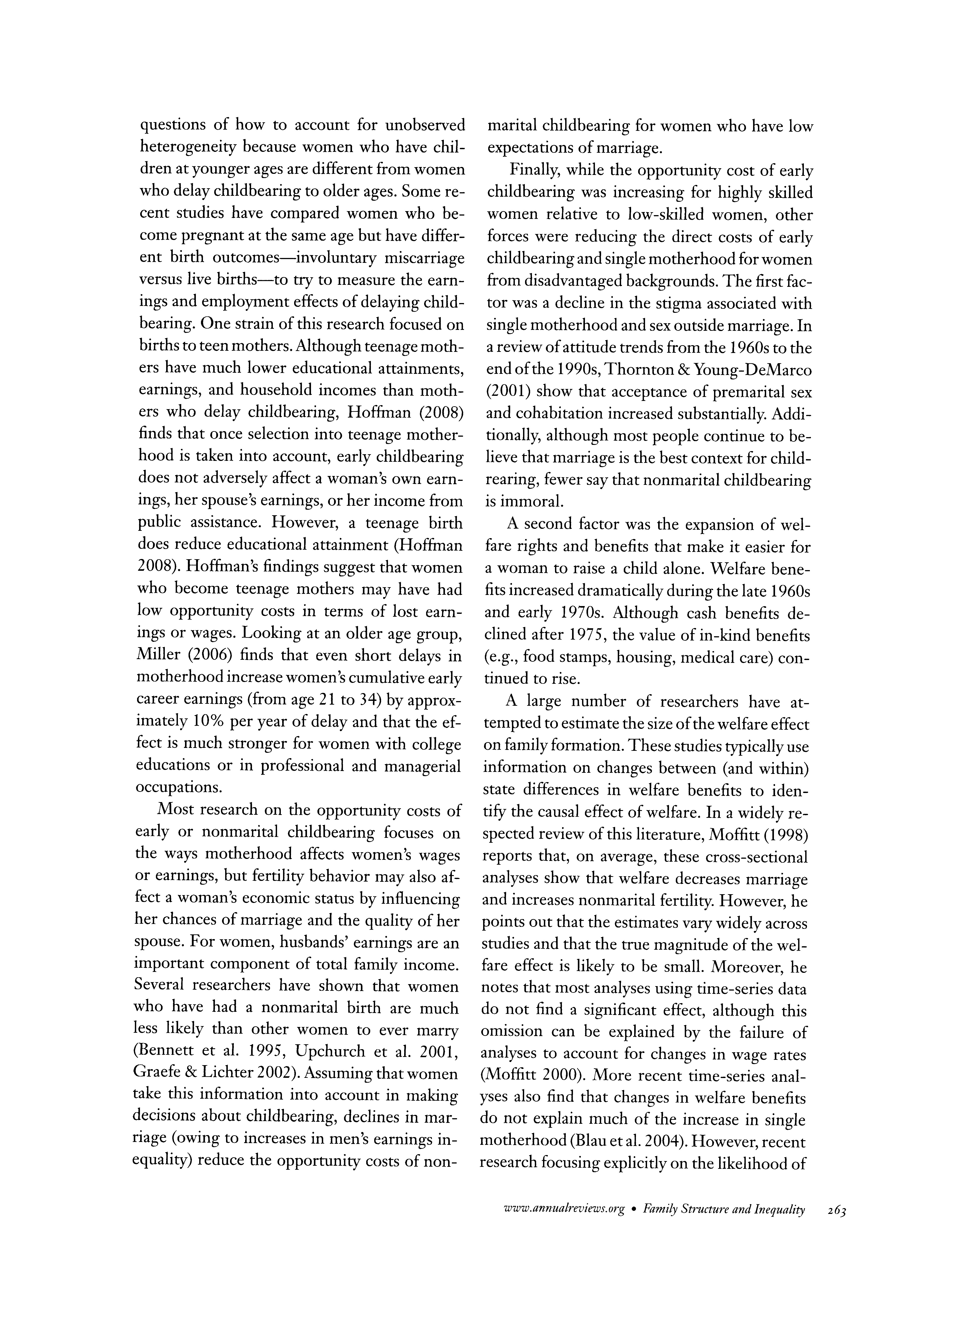
Wilson
WJ.
1996
.
When
Work
Disappears:
The
World
of
the
New
Urban
Poor.
New
York:
Knopf
Wolchik
SA,
Sandler
IN,
Millsap
RE,
Plummer
BA,
Greene
SM,
et
al.
2002
.
Six
year
follow-up
of
preventive
interventions
for
children
of
divorce.
JAMA
288:1874-81

Wolfinger
NH,
Kowaleski-Jones
L,
Smith
KR.
2003
.
Double
impact:
what
sibling
data
can
tell
us
about
the
long-term
negative
effects
of
parental
divorce.
Soc.
Biol.
50:58-76

276

McLanahan
?
Percheski

