
Social Thought and Research
The Gender Ideological Clash in Globalization: Women, Migration, and the Modernization Bulding Project of the Philippines
Author(s): Rhacel Salazar Parreñas
Source: Social Thought & Research, Vol. 28, Social "Movements" (2007), pp. 37-56
Published by: Allen Press
Stable URL: http://www.jstor.org/stable/23252120
Accessed: 05-03-2015 20:02 UTC

Your use of the JSTOR archive indicates your acceptance of the Terms & Conditions of Use, available at http://www.jstor.org/page/info/about/policies/terms.jsp
JSTOR is a not-for-profit service that helps scholars, researchers, and students discover, use, and build upon a wide range of content in a trusted digital archive. We use information technology and tools to increase productivity and facilitate new forms of scholarship. For more information about JSTOR, please contact support@jstor.org.

Allen Press and Social Thought and Research are collaborating with JSTOR to digitize, preserve and extend access to Social Thought & Research.
http://www.jstor.org
This content downloaded from 128.228.173.22 on Thu, 05 Mar 2015 20:02:44 UTC
All use subject to JSTOR Terms and Conditions

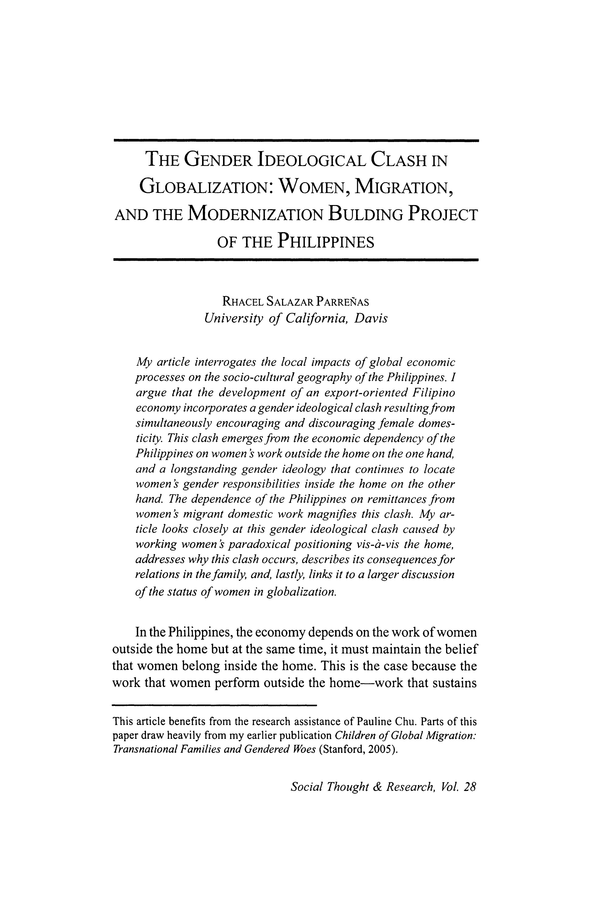
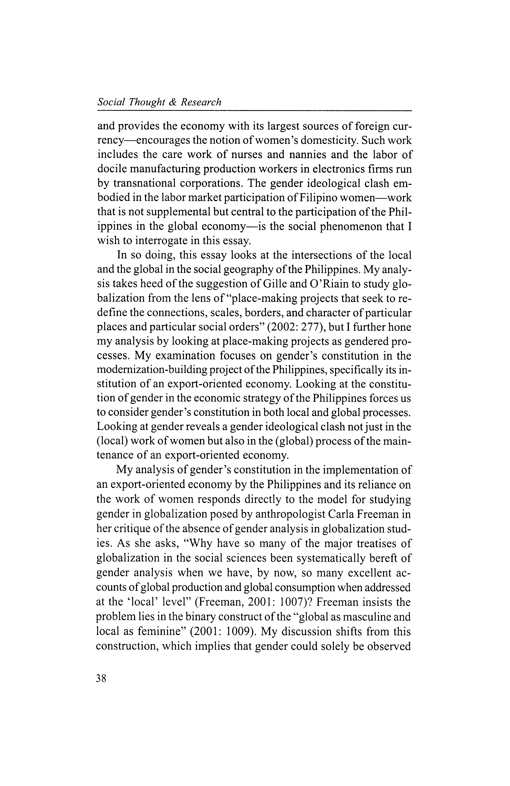
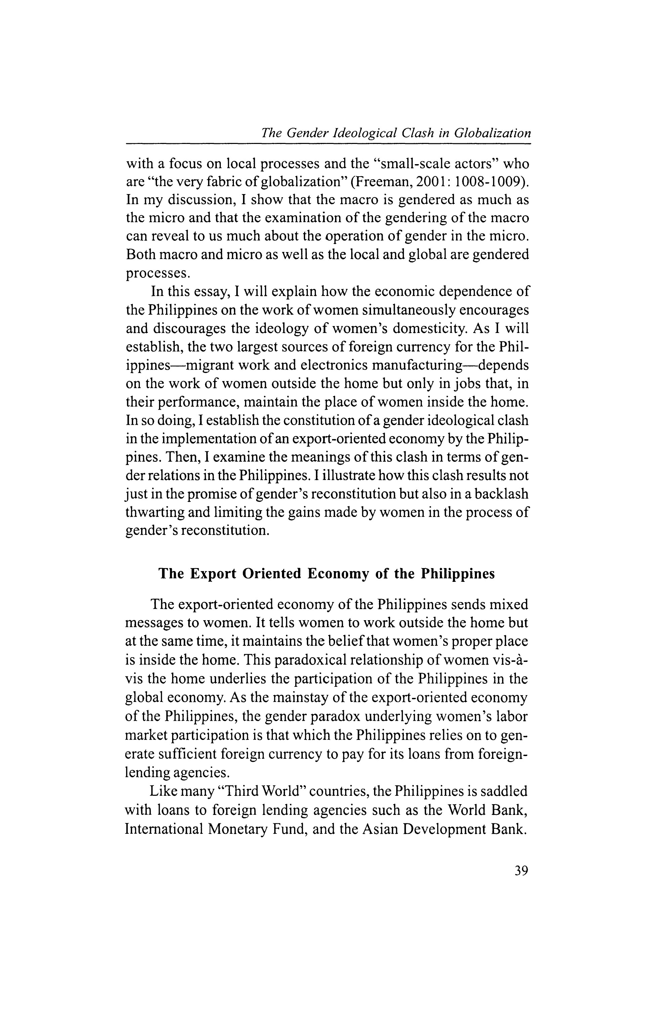
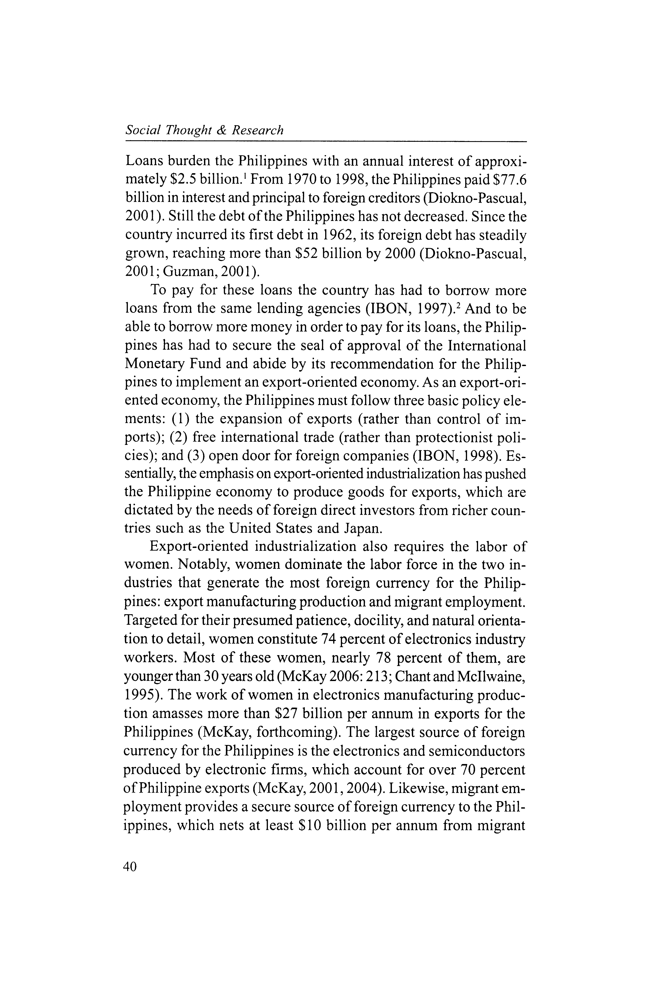
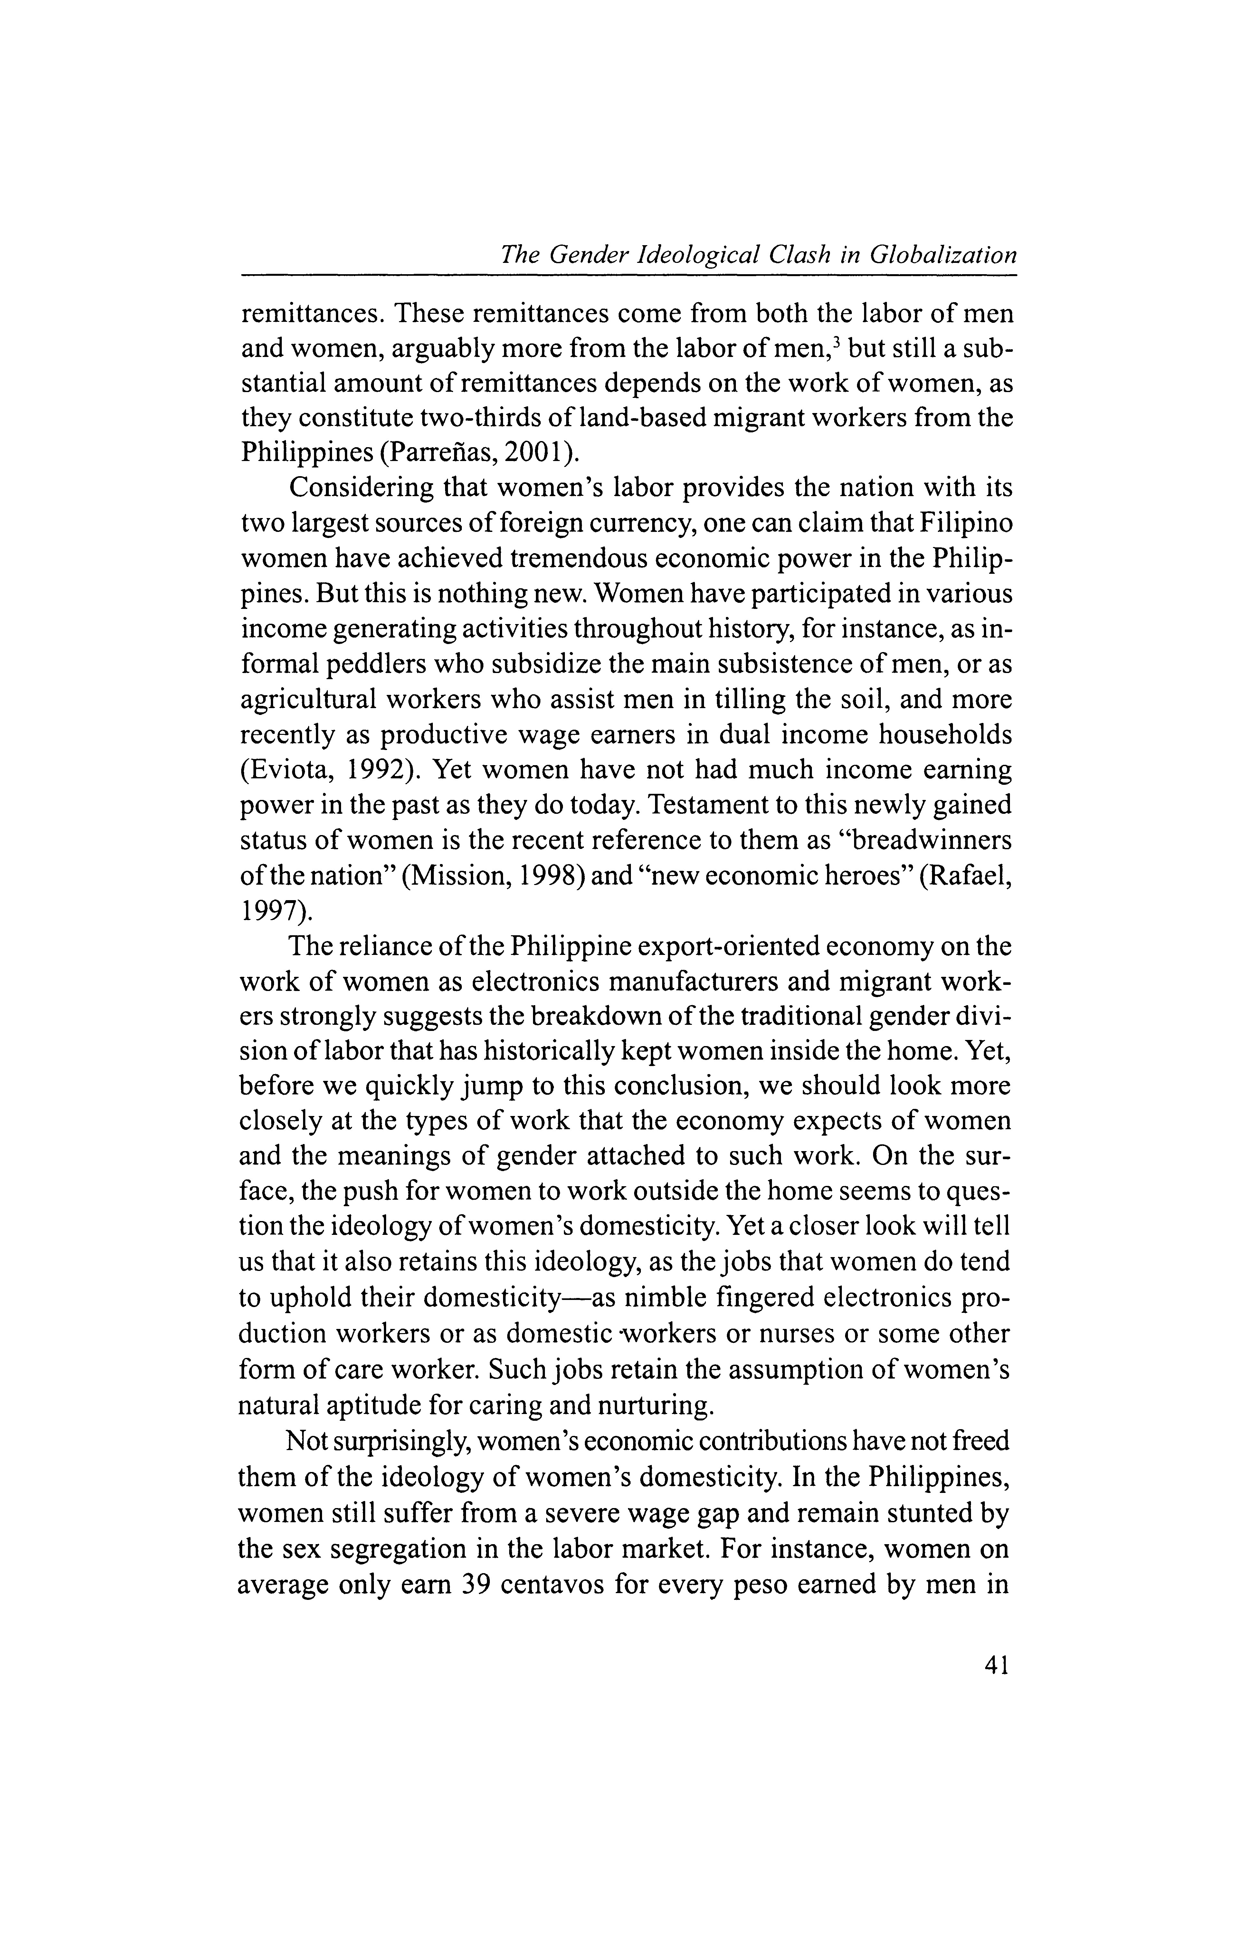
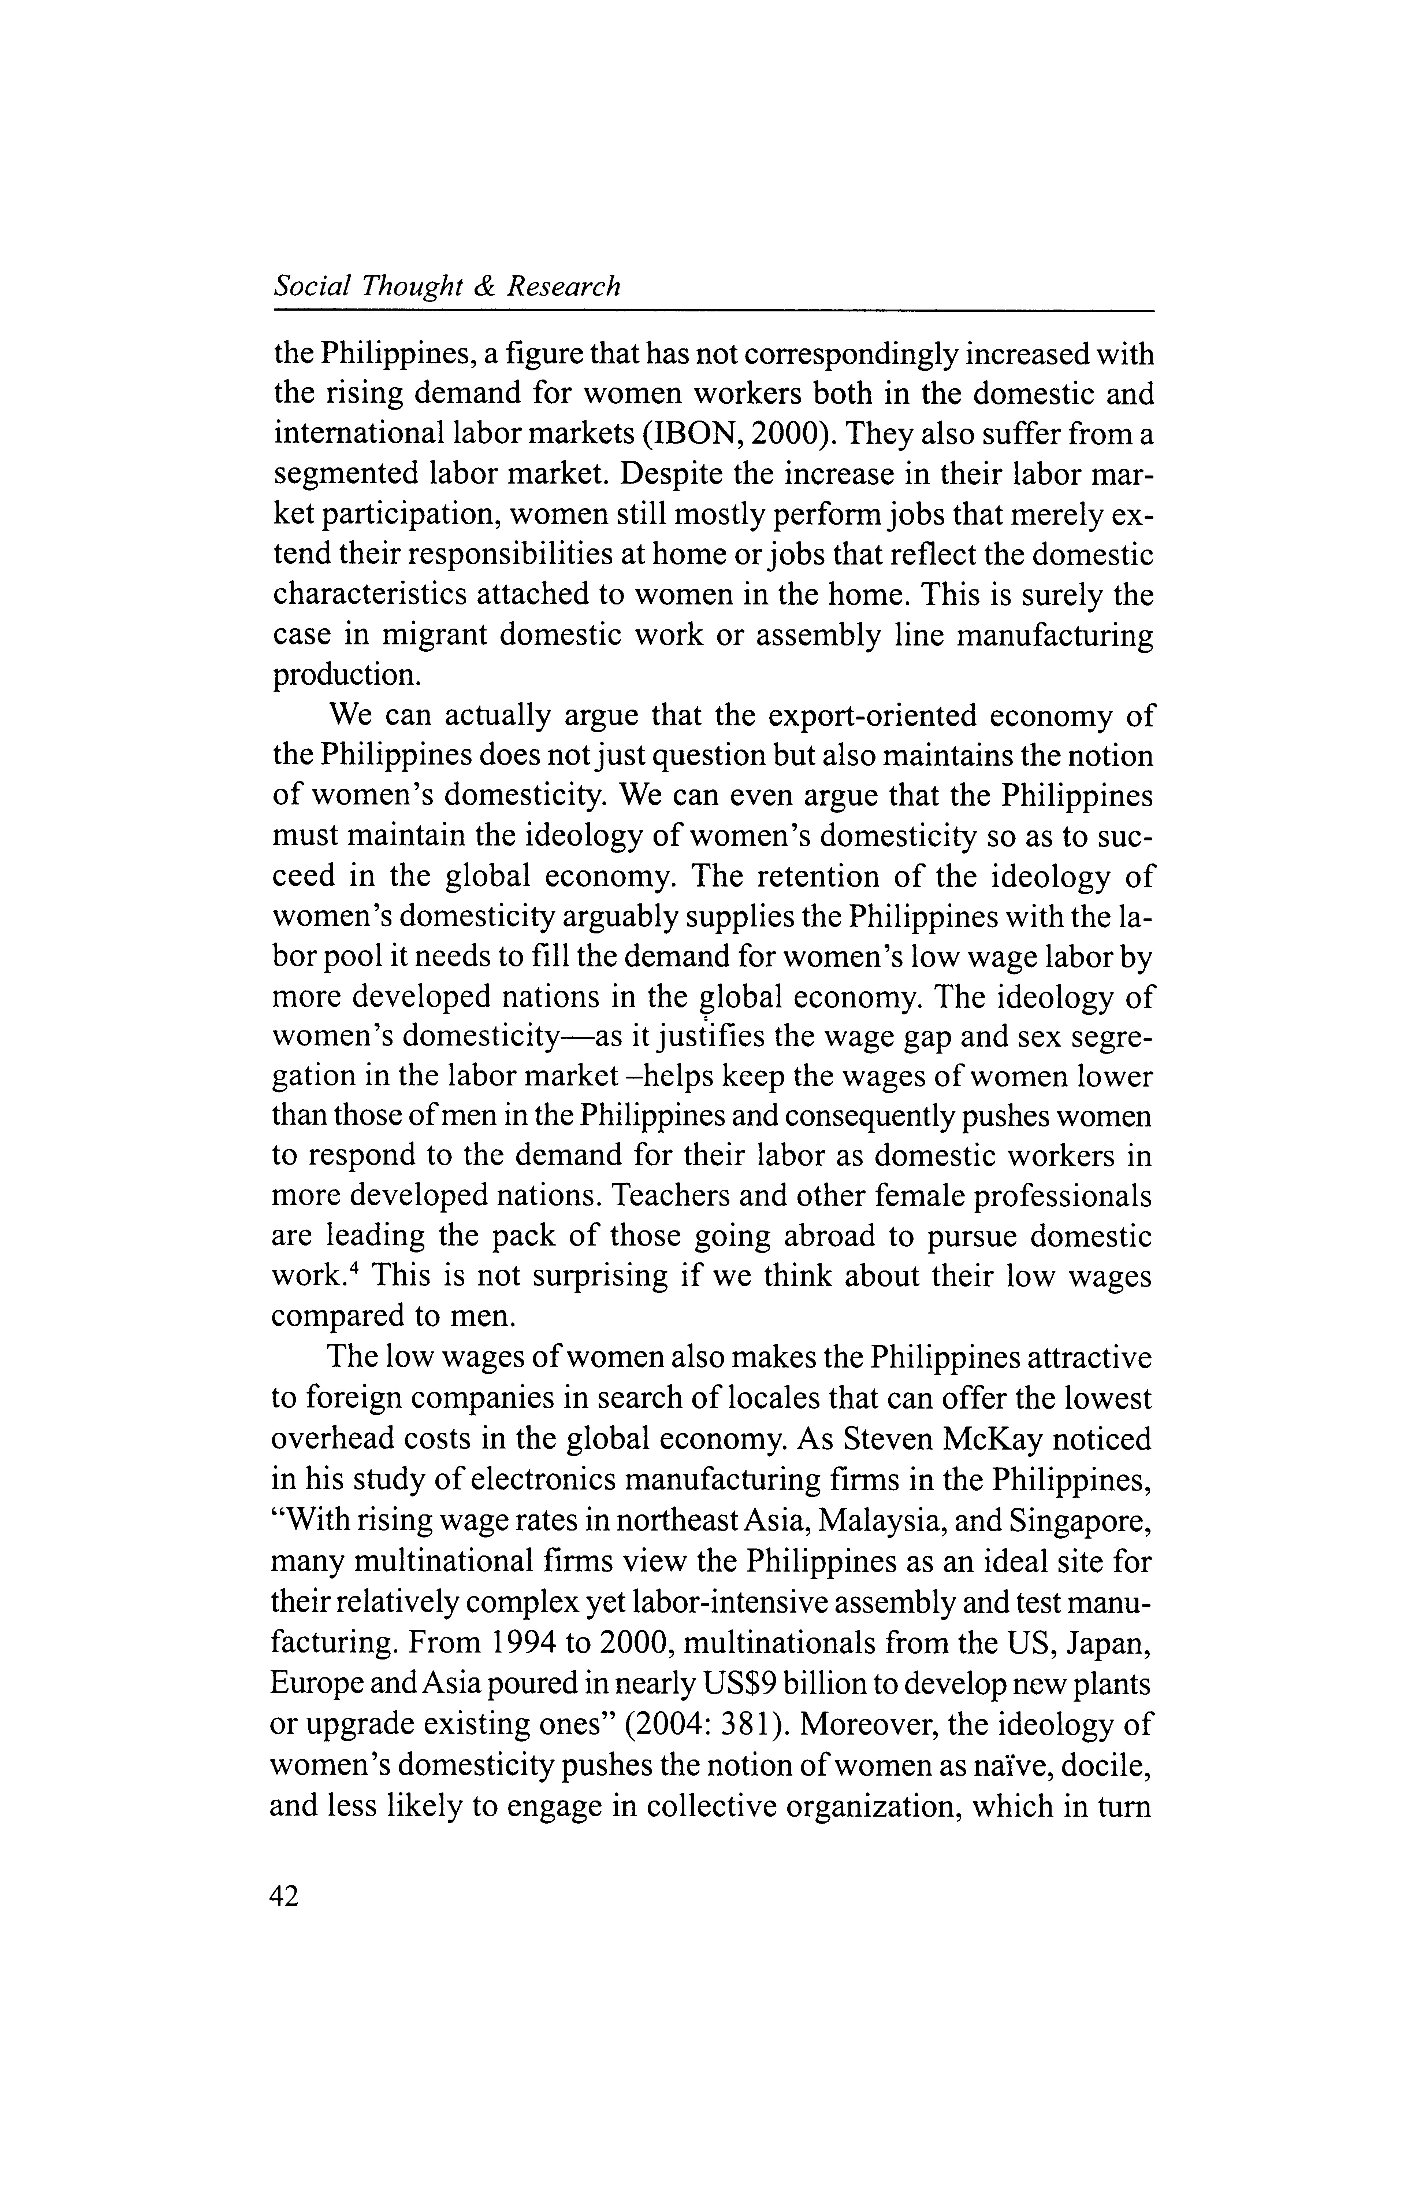
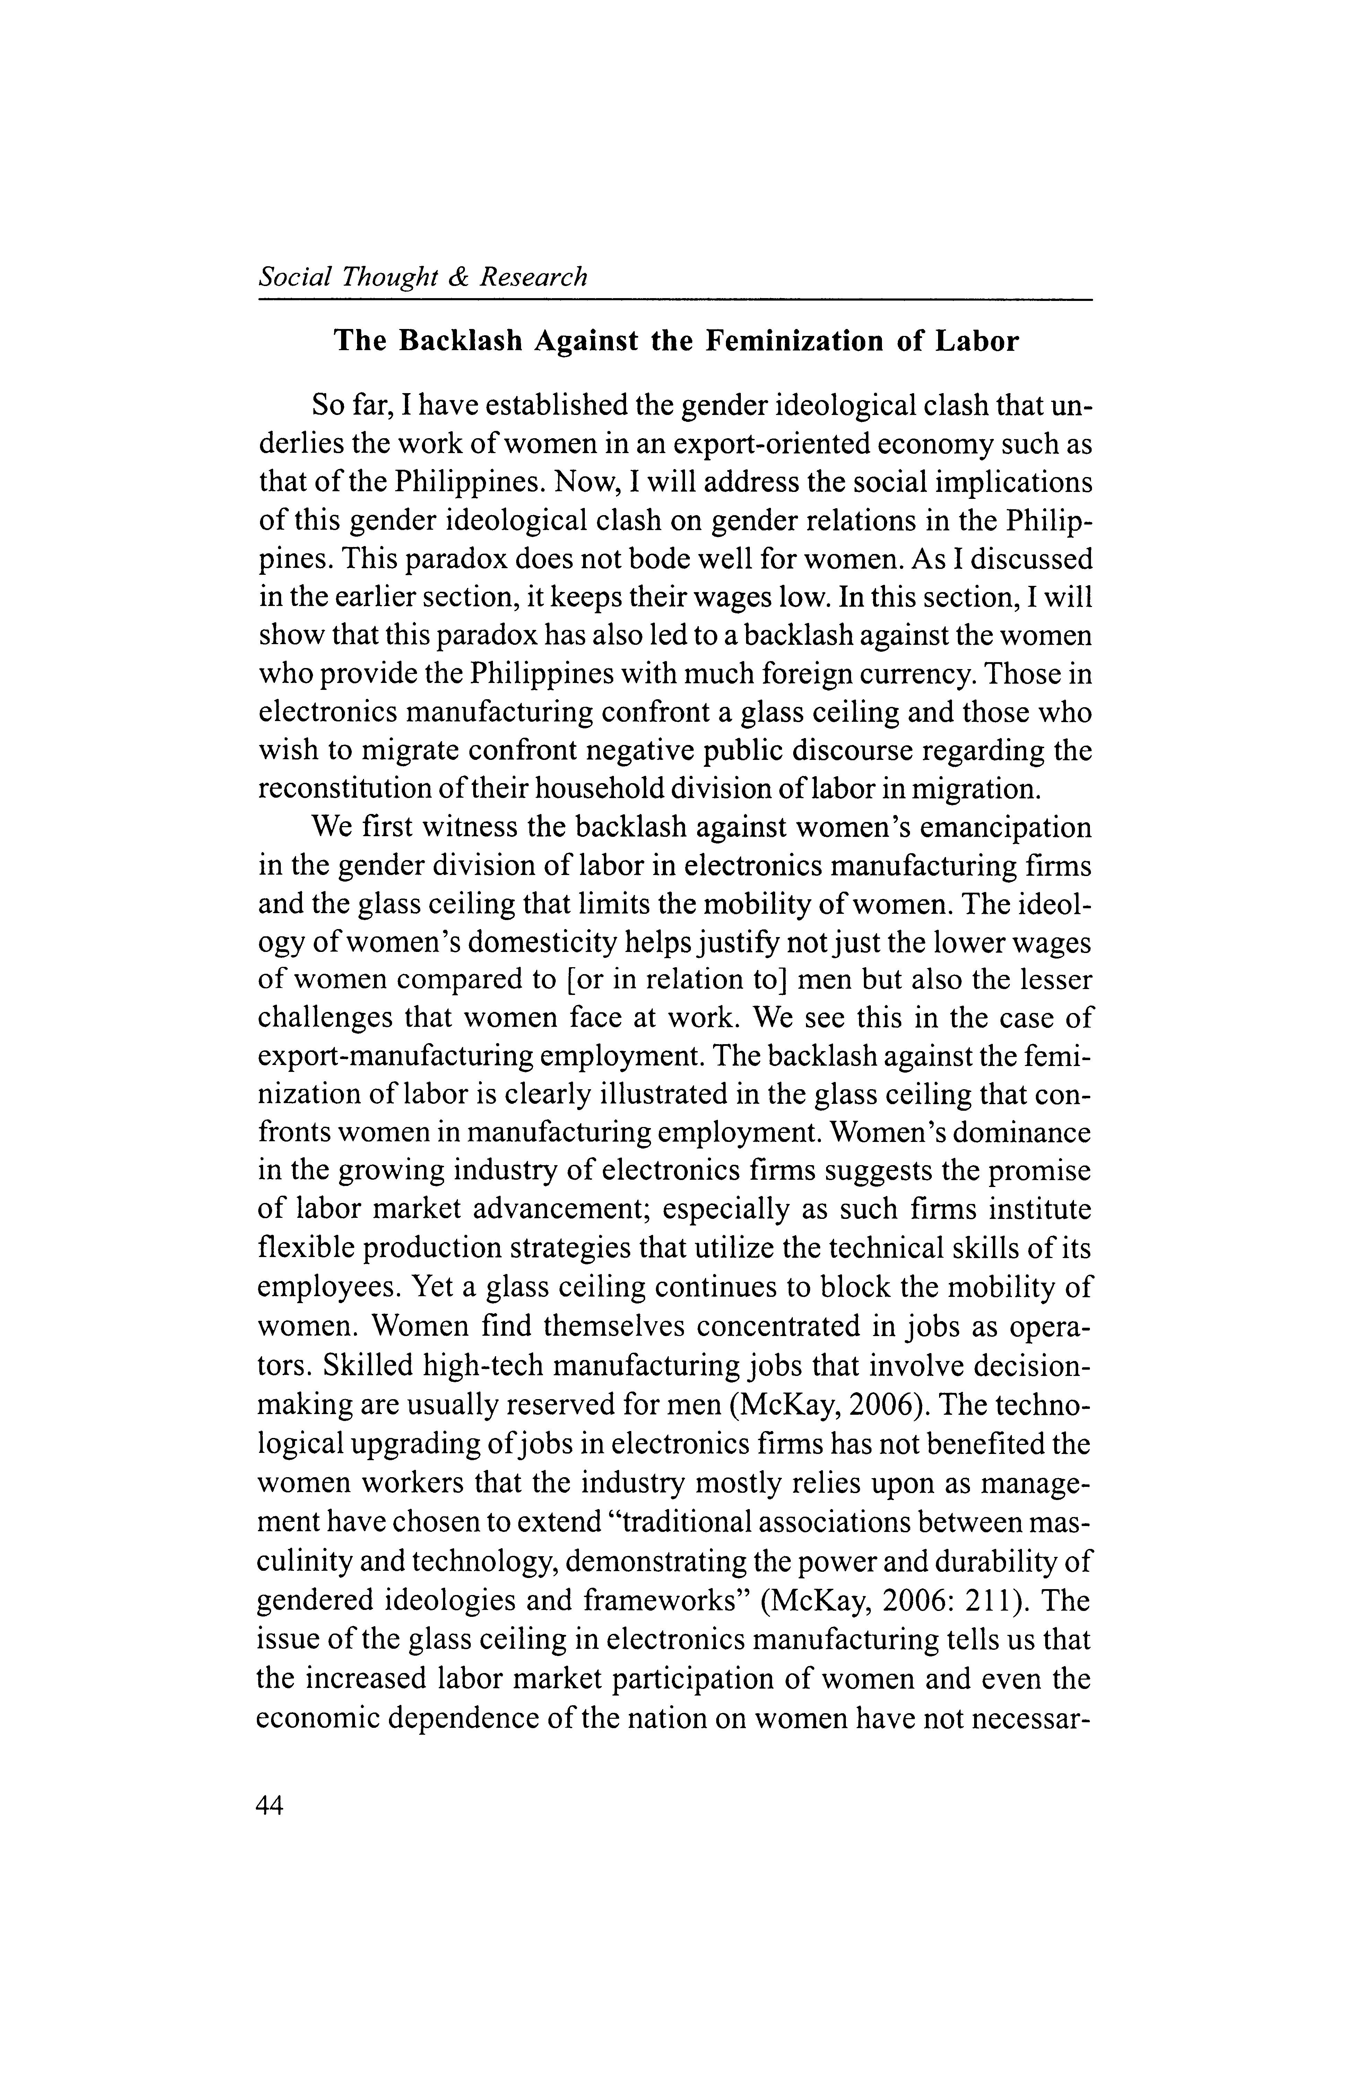
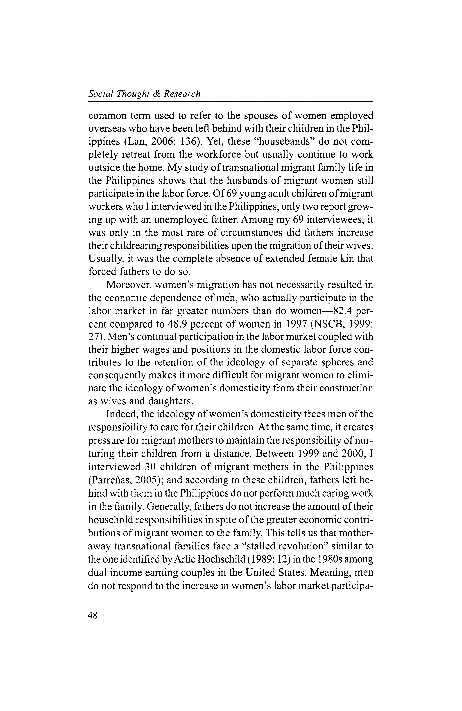

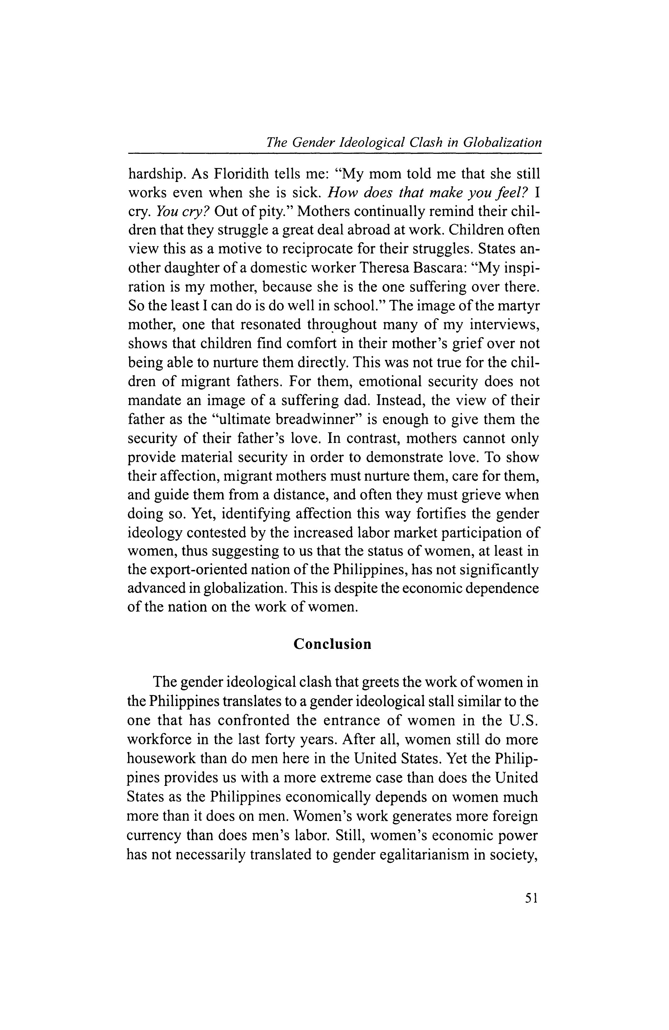
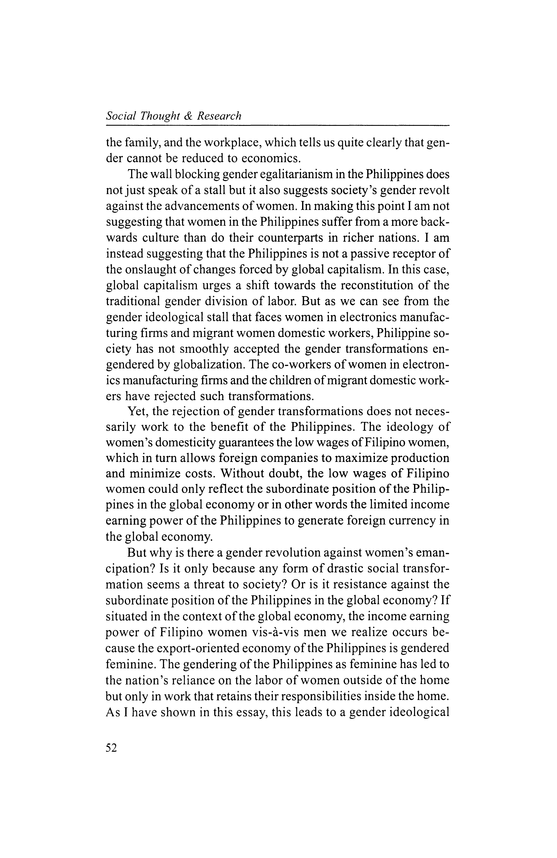
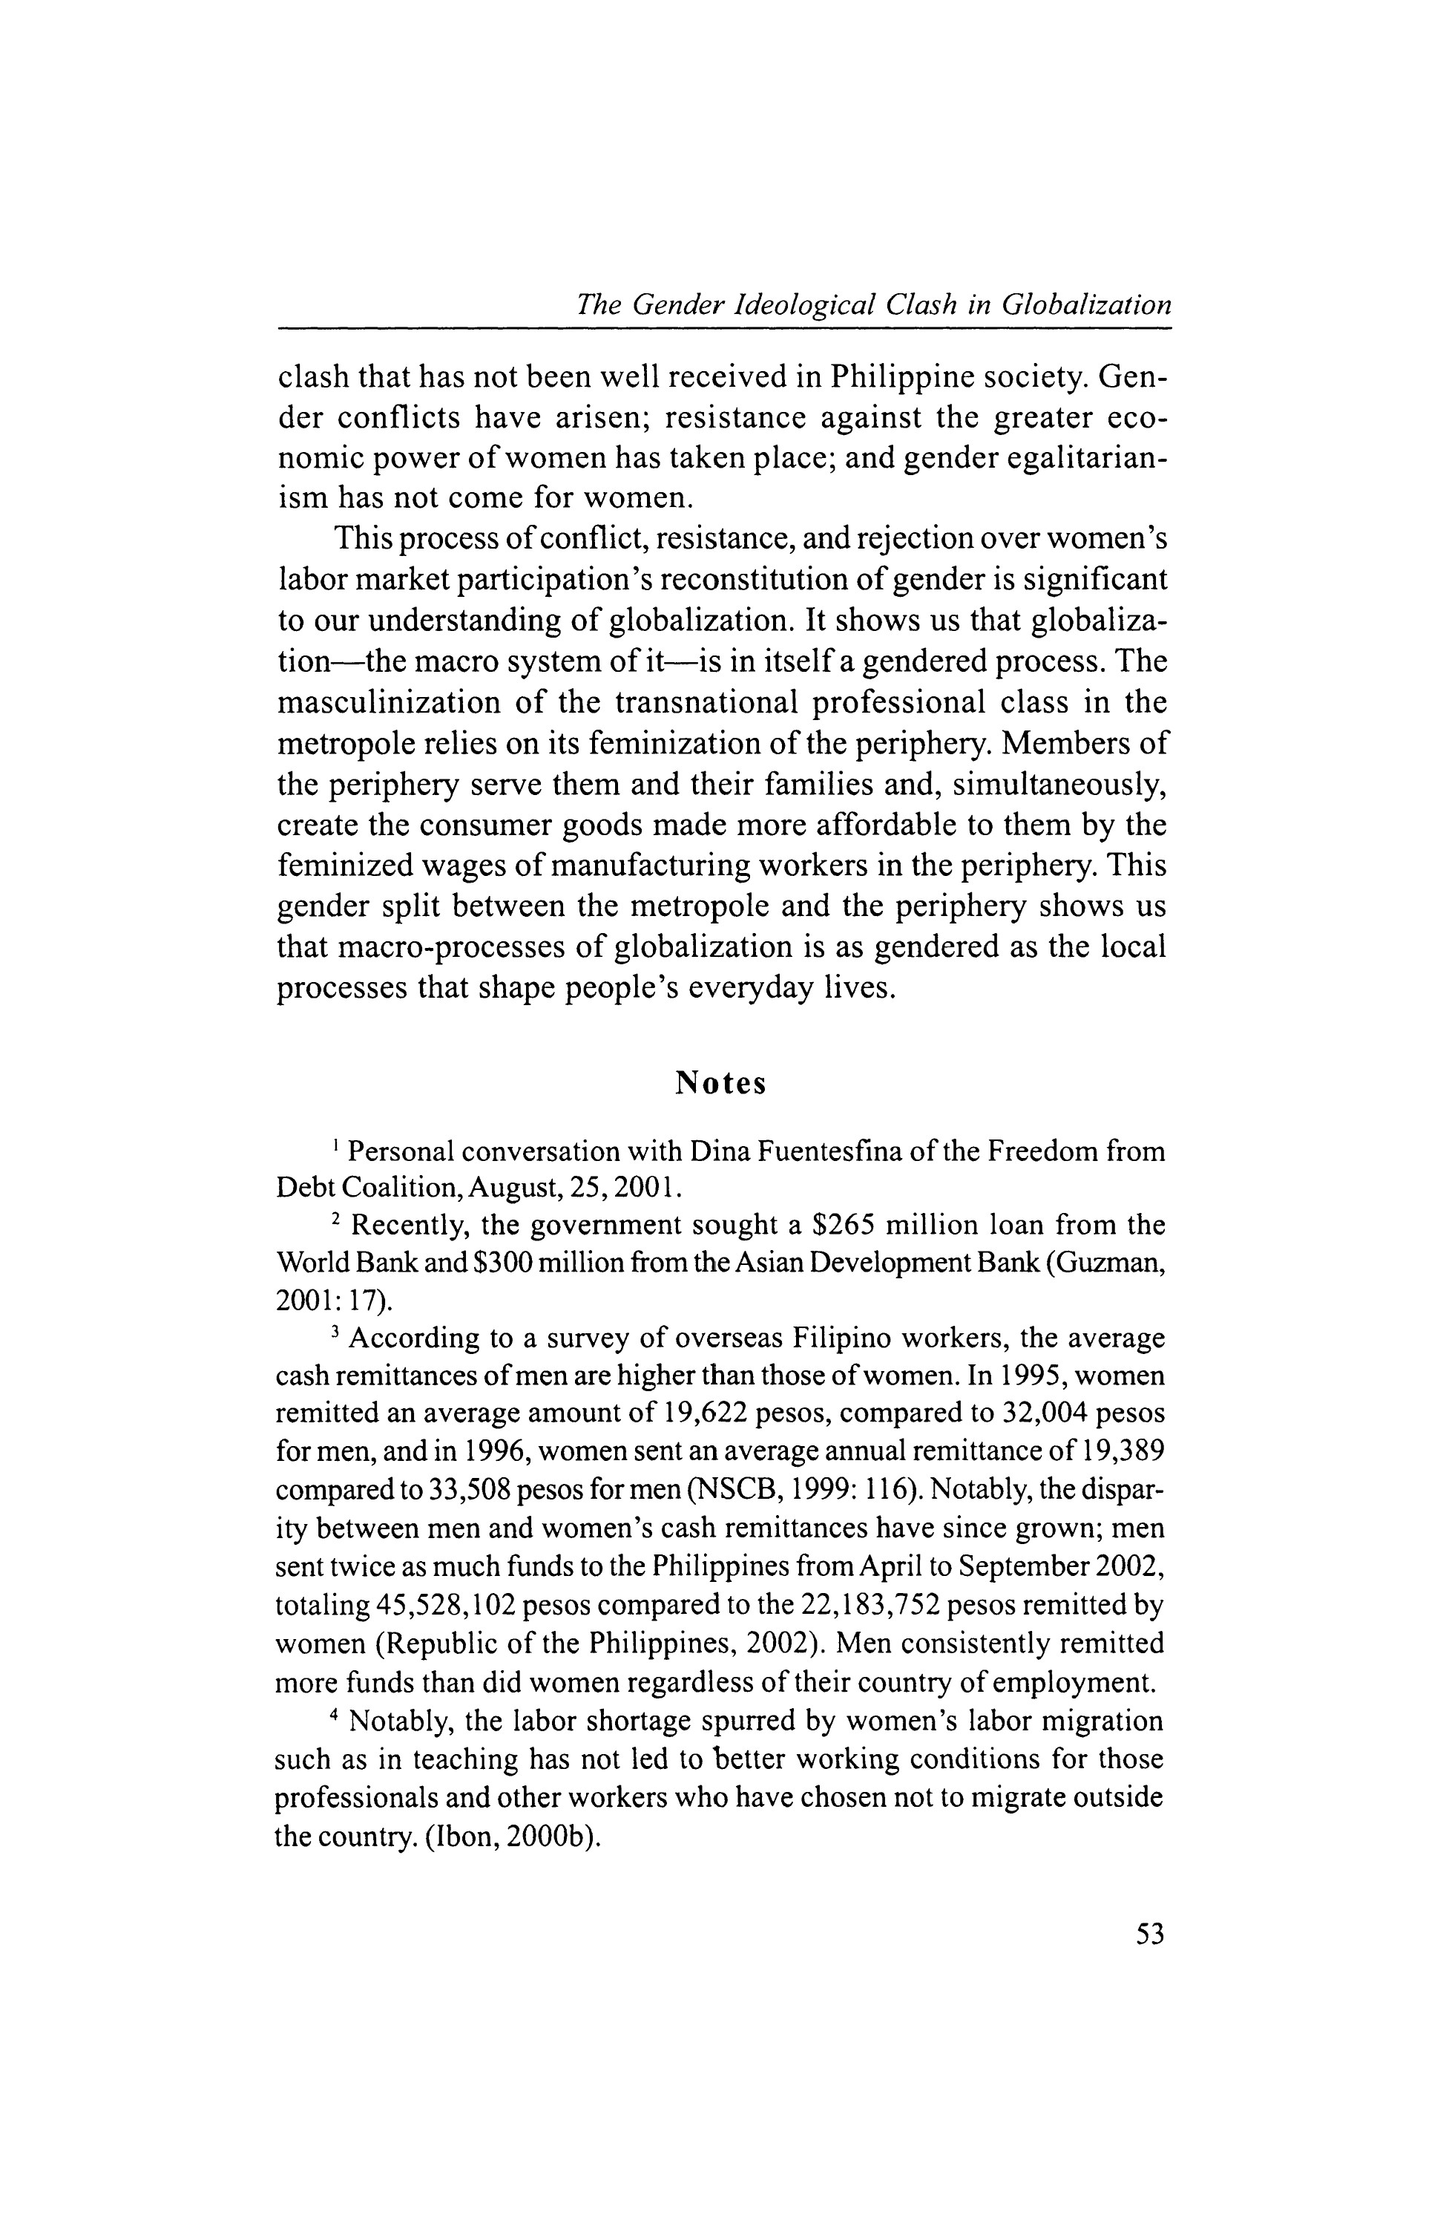
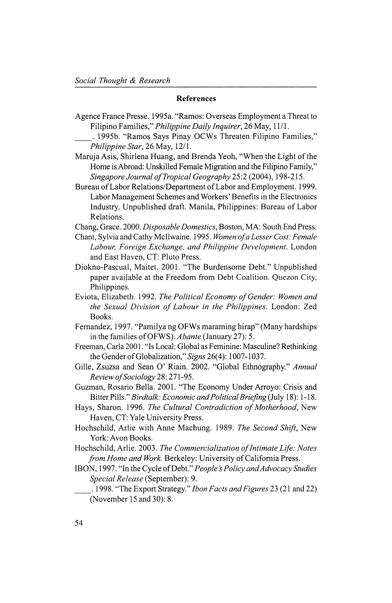
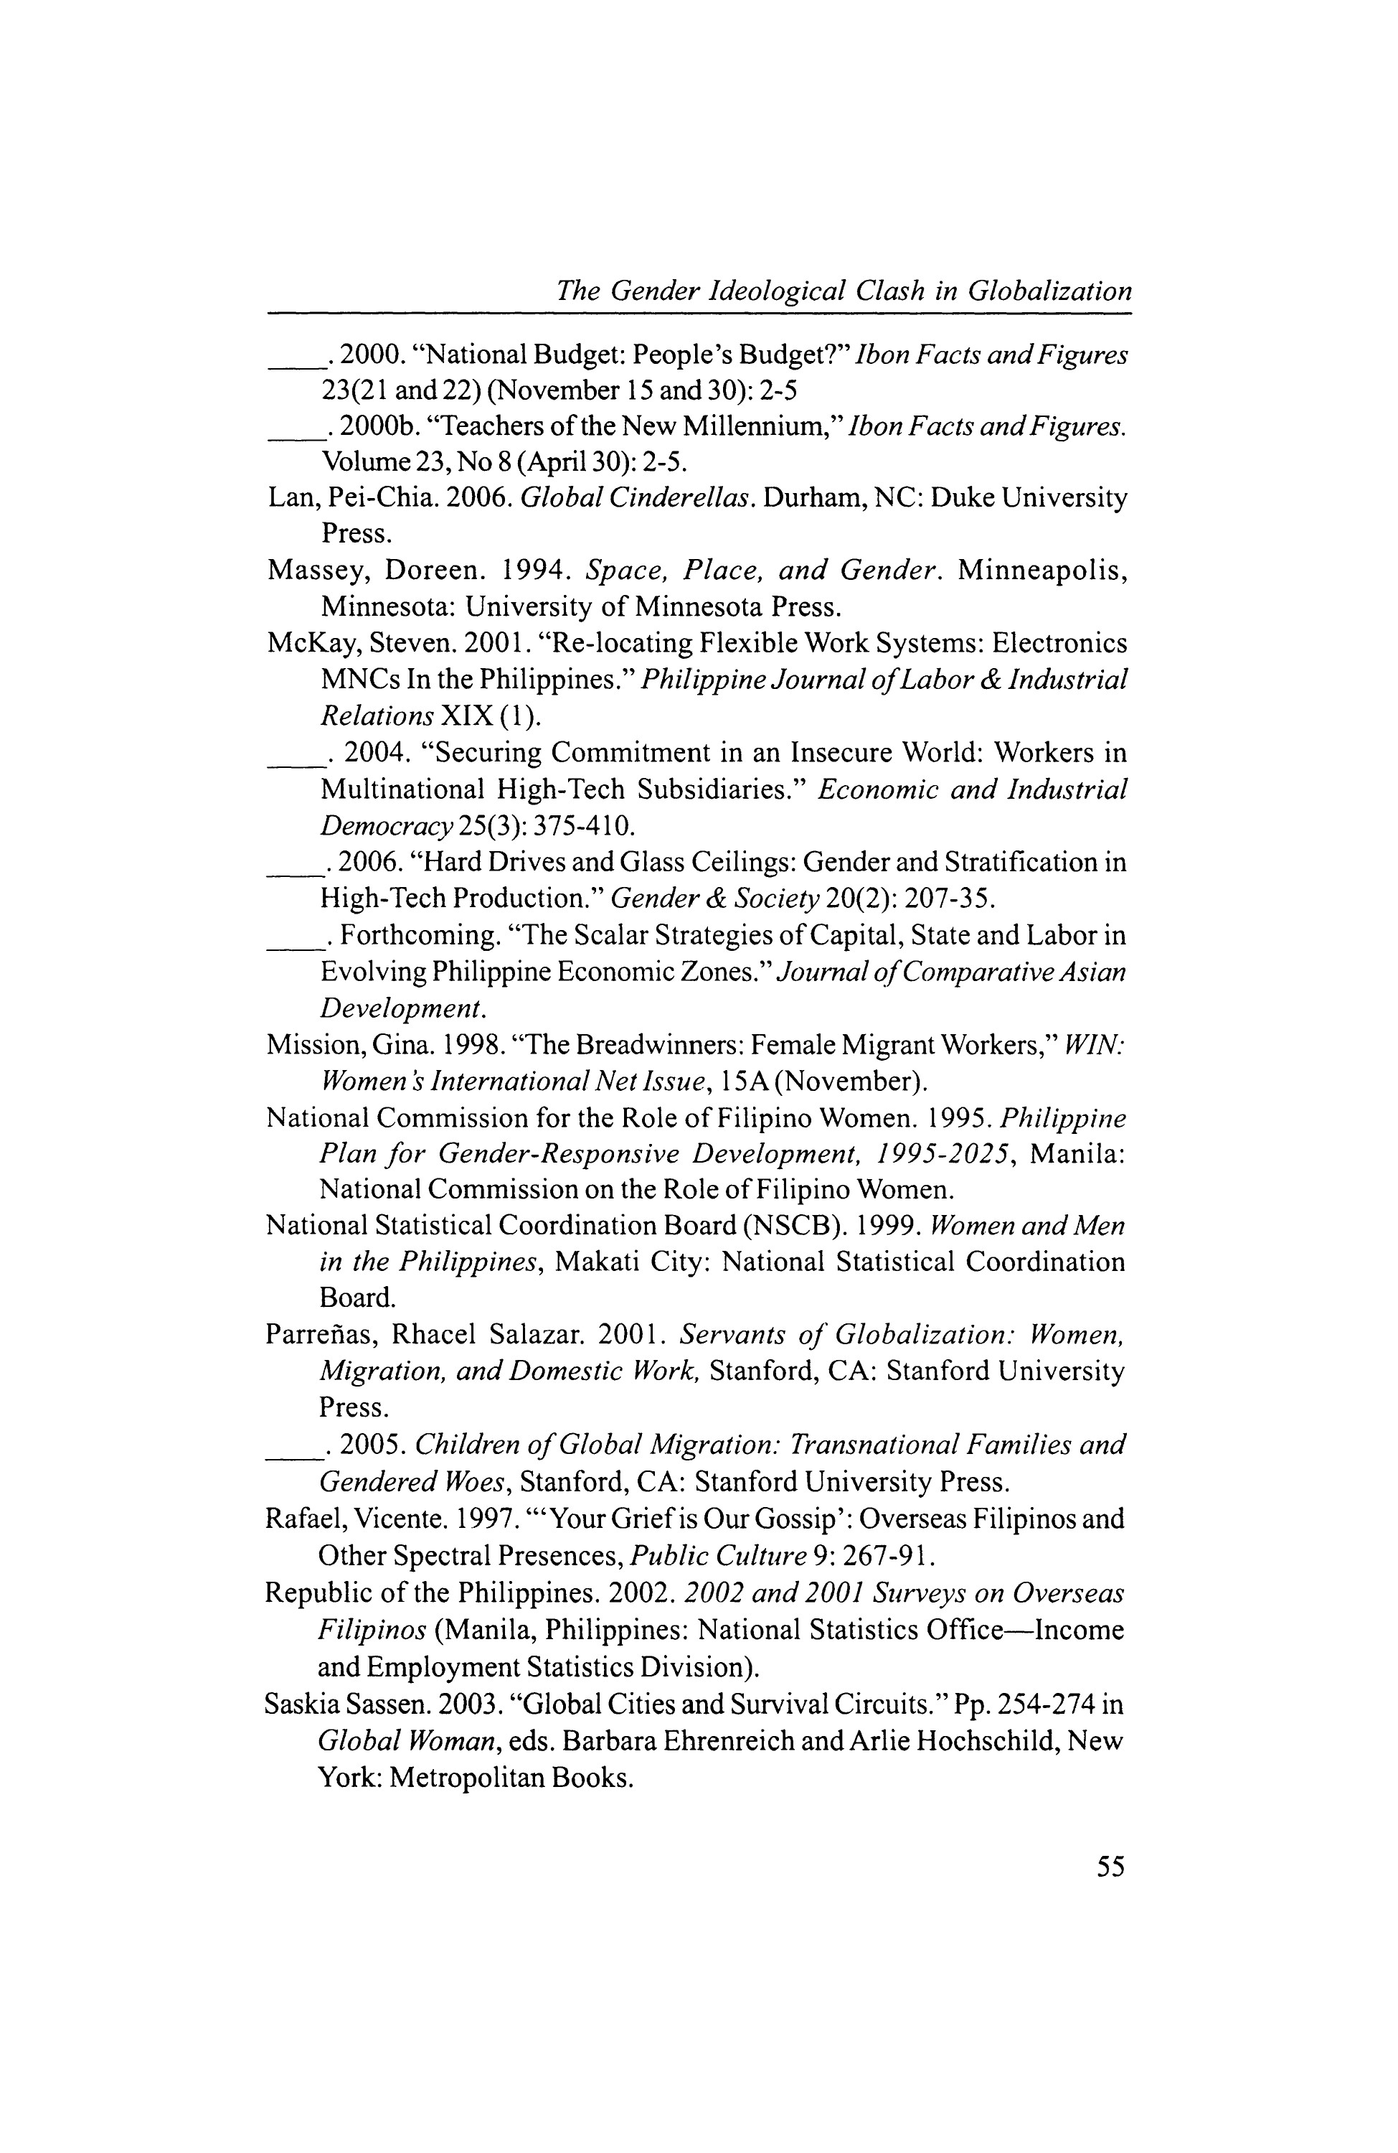

Social
Thought
&
Research
Toledo,
Lone.
1993
.
"Overseas
Job
vs.
Family
Stability."
People's
Journal
(
December
15):

4
.
56

