

"Where My Girls At?": Negotiating Black Womanhood in Music Videos
Author(s): Rana A. Emerson
Source: Gender and Society, Vol. 16, No. 1 (Feb., 2002), pp. 115-135 Published by: Sage Publications, Inc.
Stable URL: http://www.jstor.org/stable/3081879 .
Accessed: 13/02/2015 00:12
Your use of the JSTOR archive indicates your acceptance of the Terms & Conditions of Use, available at .
http://www.jstor.org/page/info/about/policies/terms.jsp

.
JSTOR is a not-for-profit service that helps scholars, researchers, and students discover, use, and build upon a wide range of content in a trusted digital archive. We use information technology and tools to increase productivity and facilitate new forms of scholarship. For more information about JSTOR, please contact support@jstor.org.
.

Sage Publications, Inc. is collaborating with JSTOR to digitize, preserve and extend access to Gender and Society.
http://www.jstor.org
This content downloaded from 128.228.173.22 on Fri, 13 Feb 2015 00:12:18 AM
All use subject to JSTOR Terms and Conditions

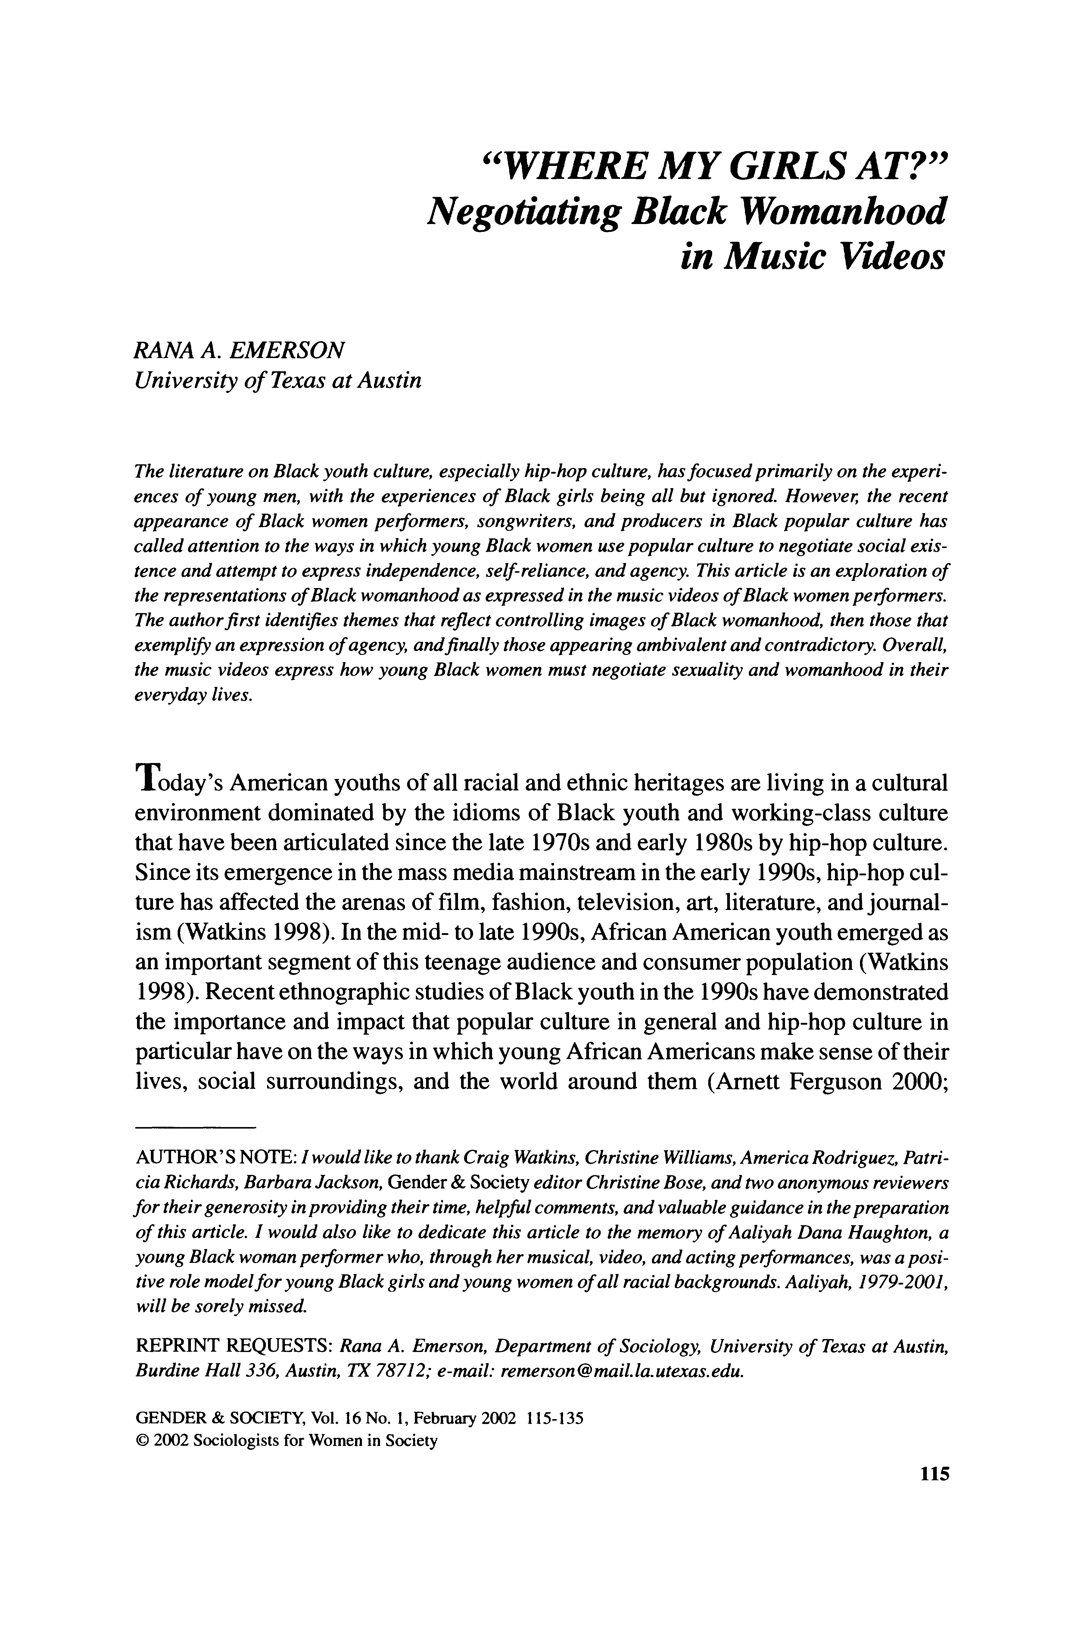
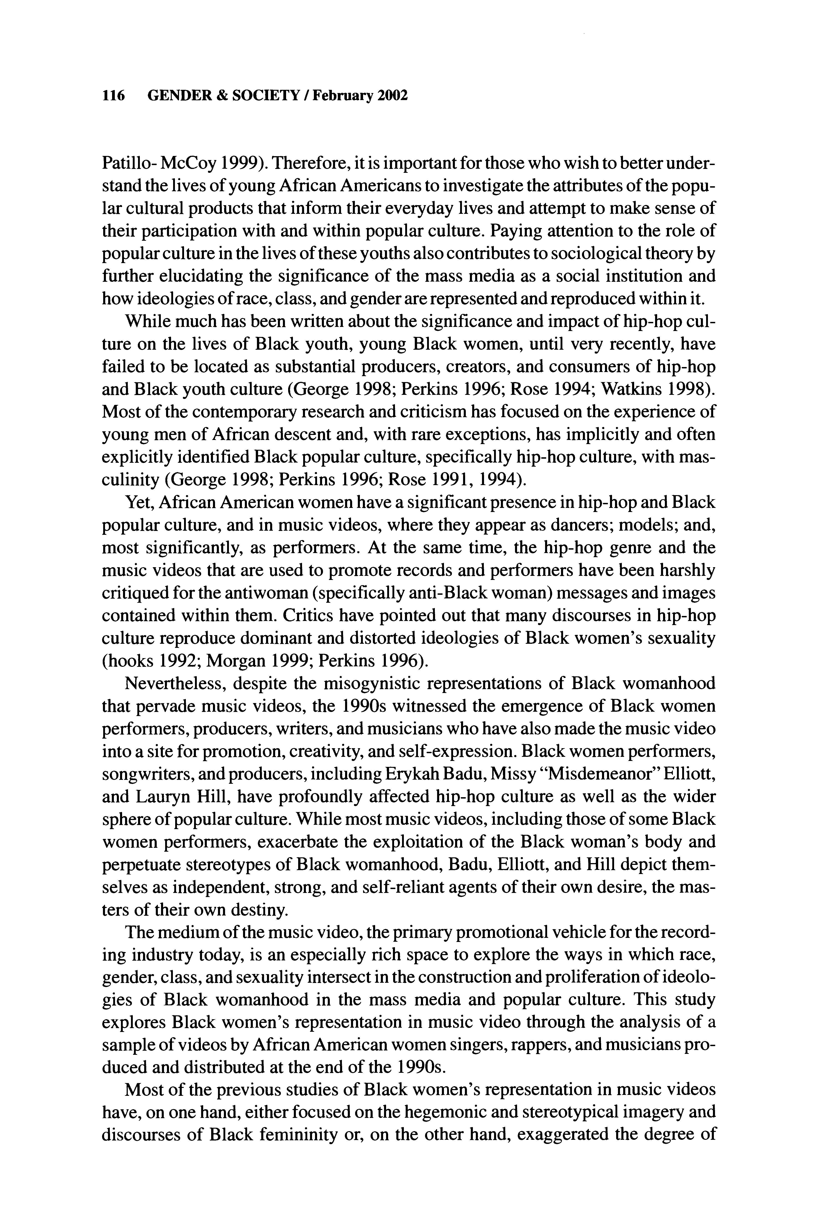
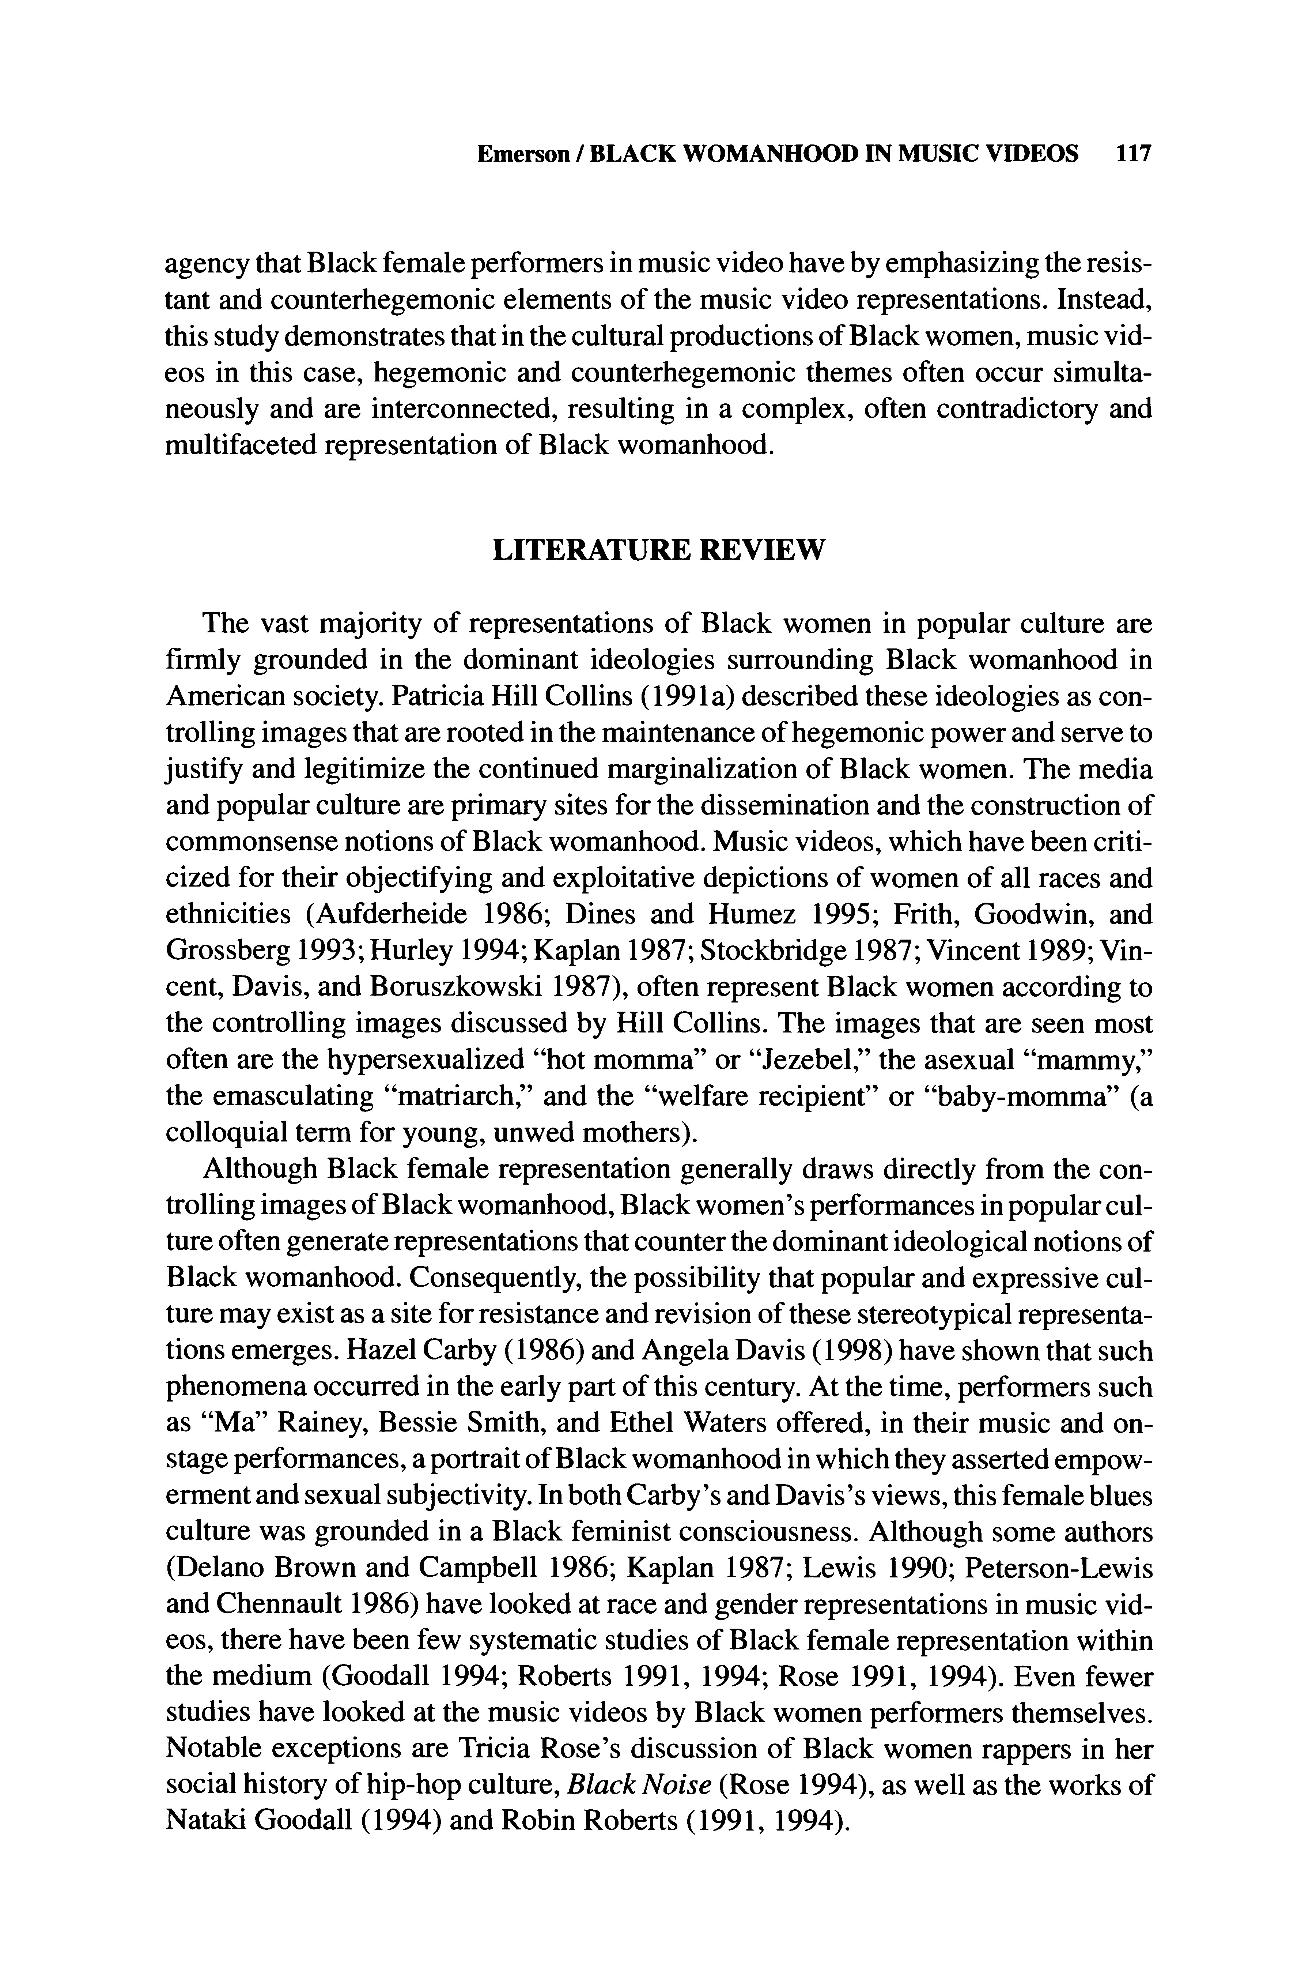
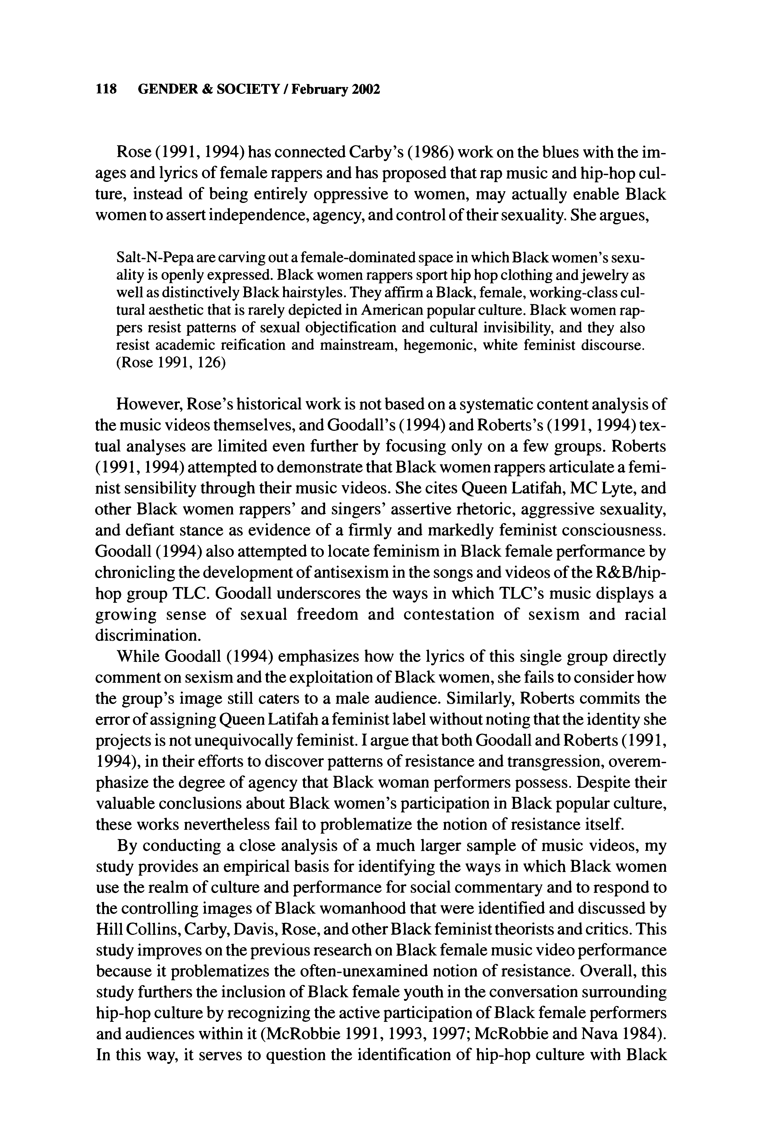
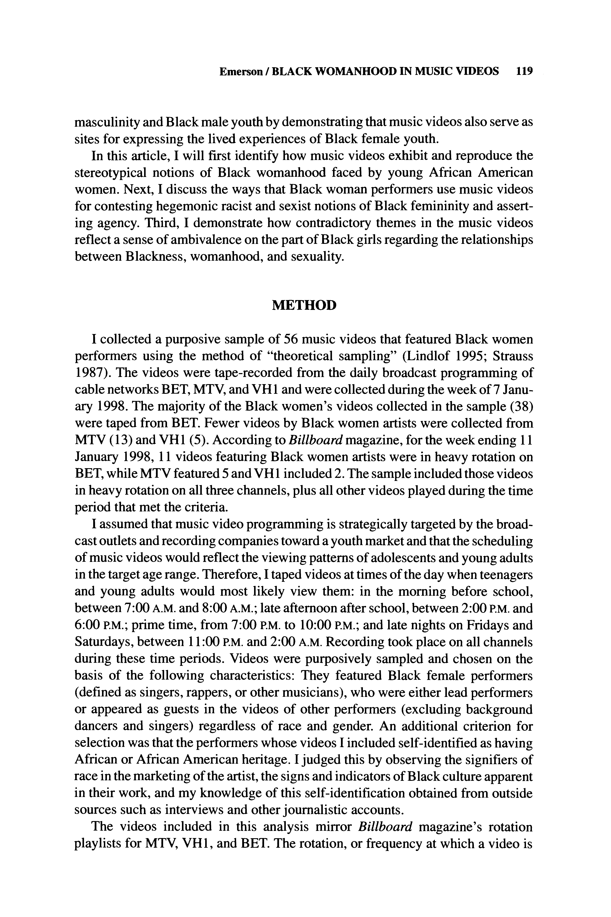
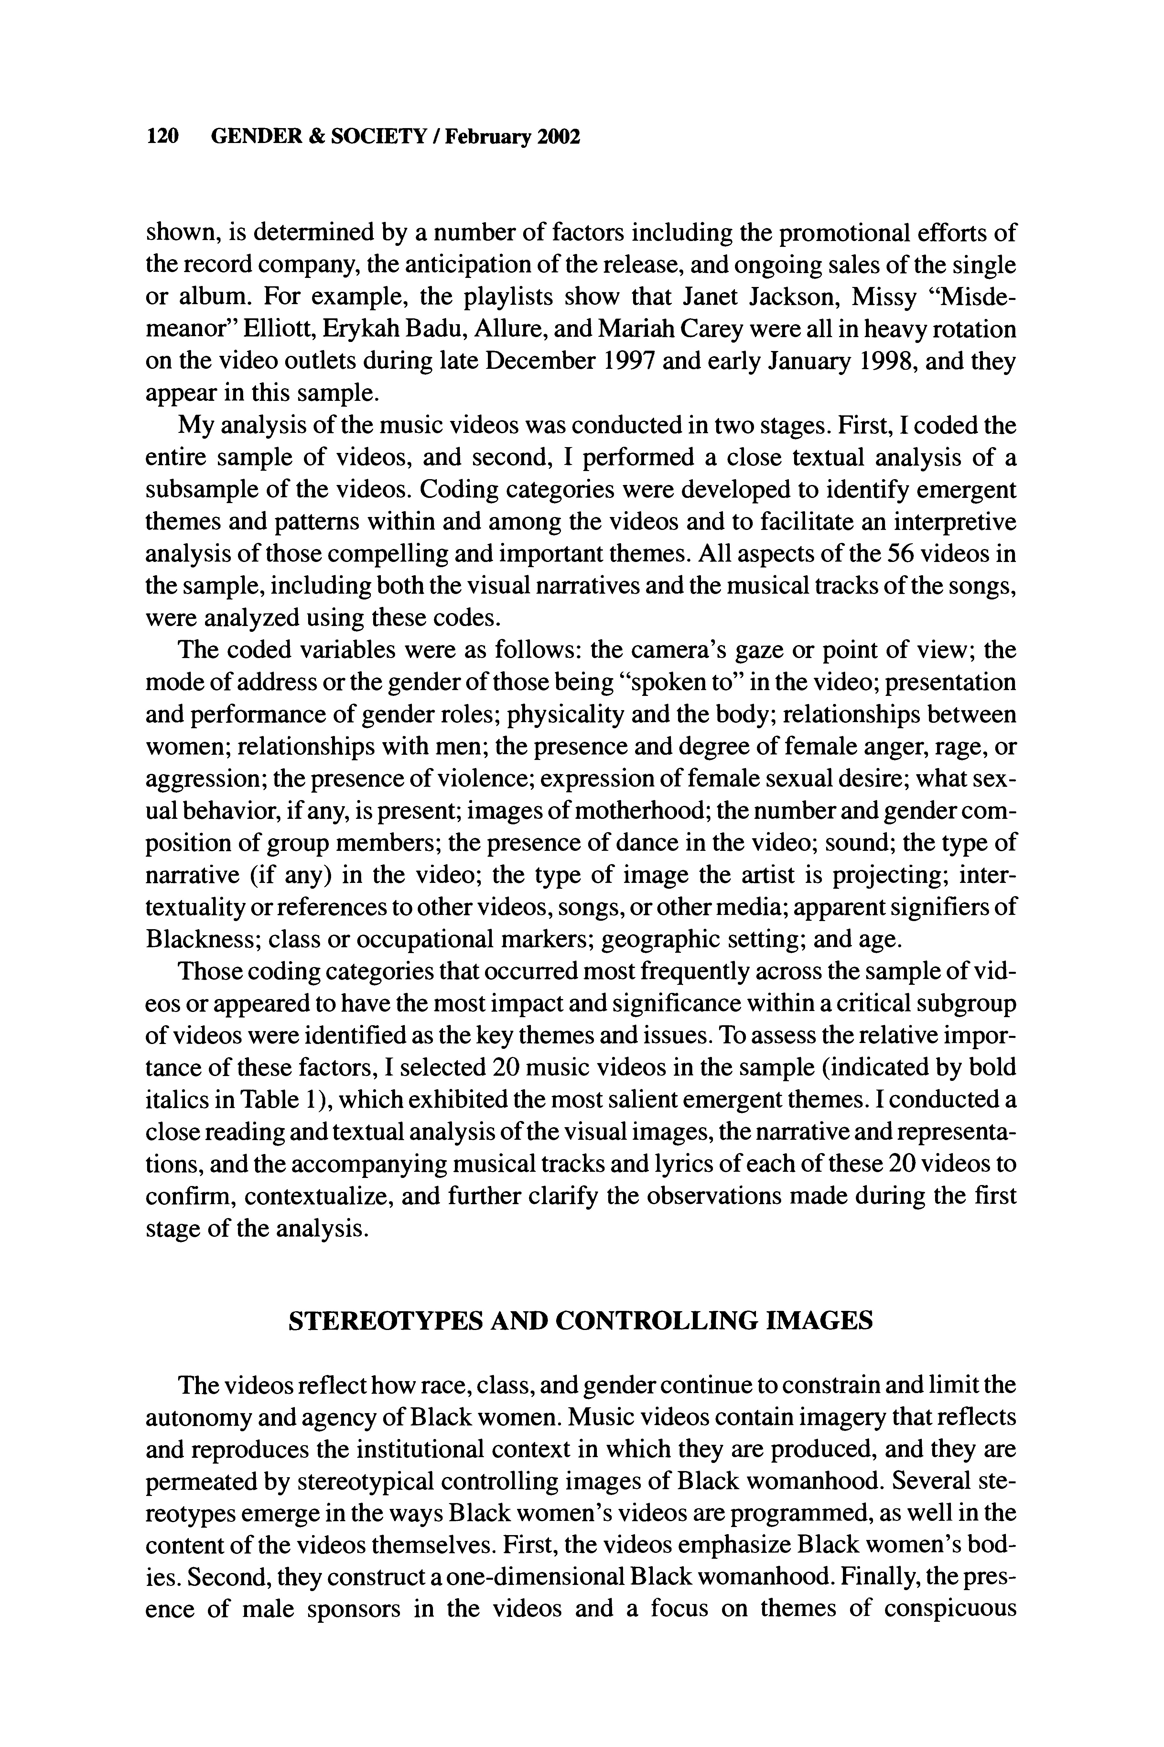
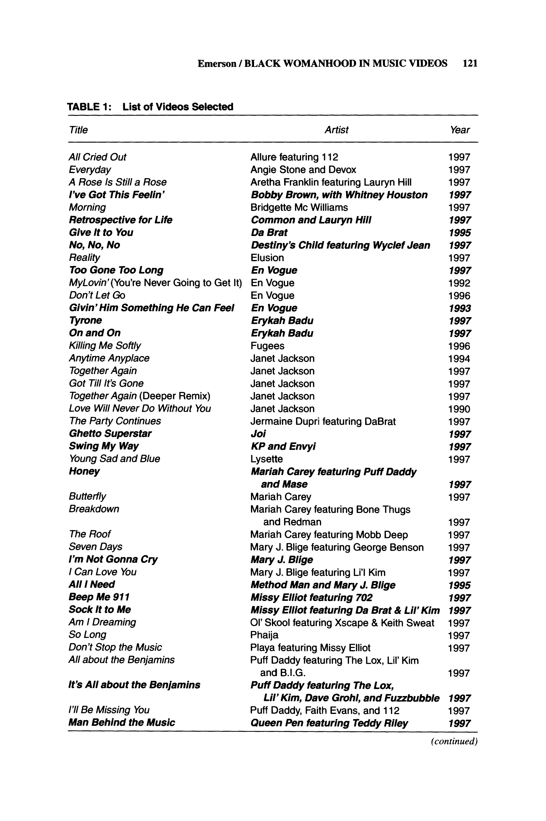
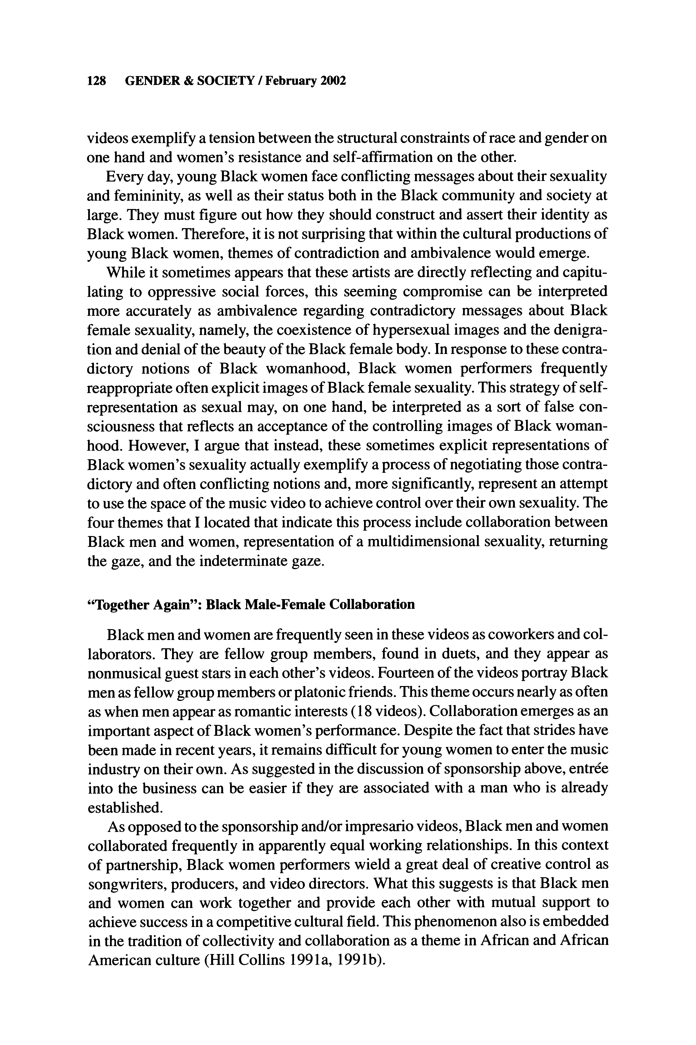
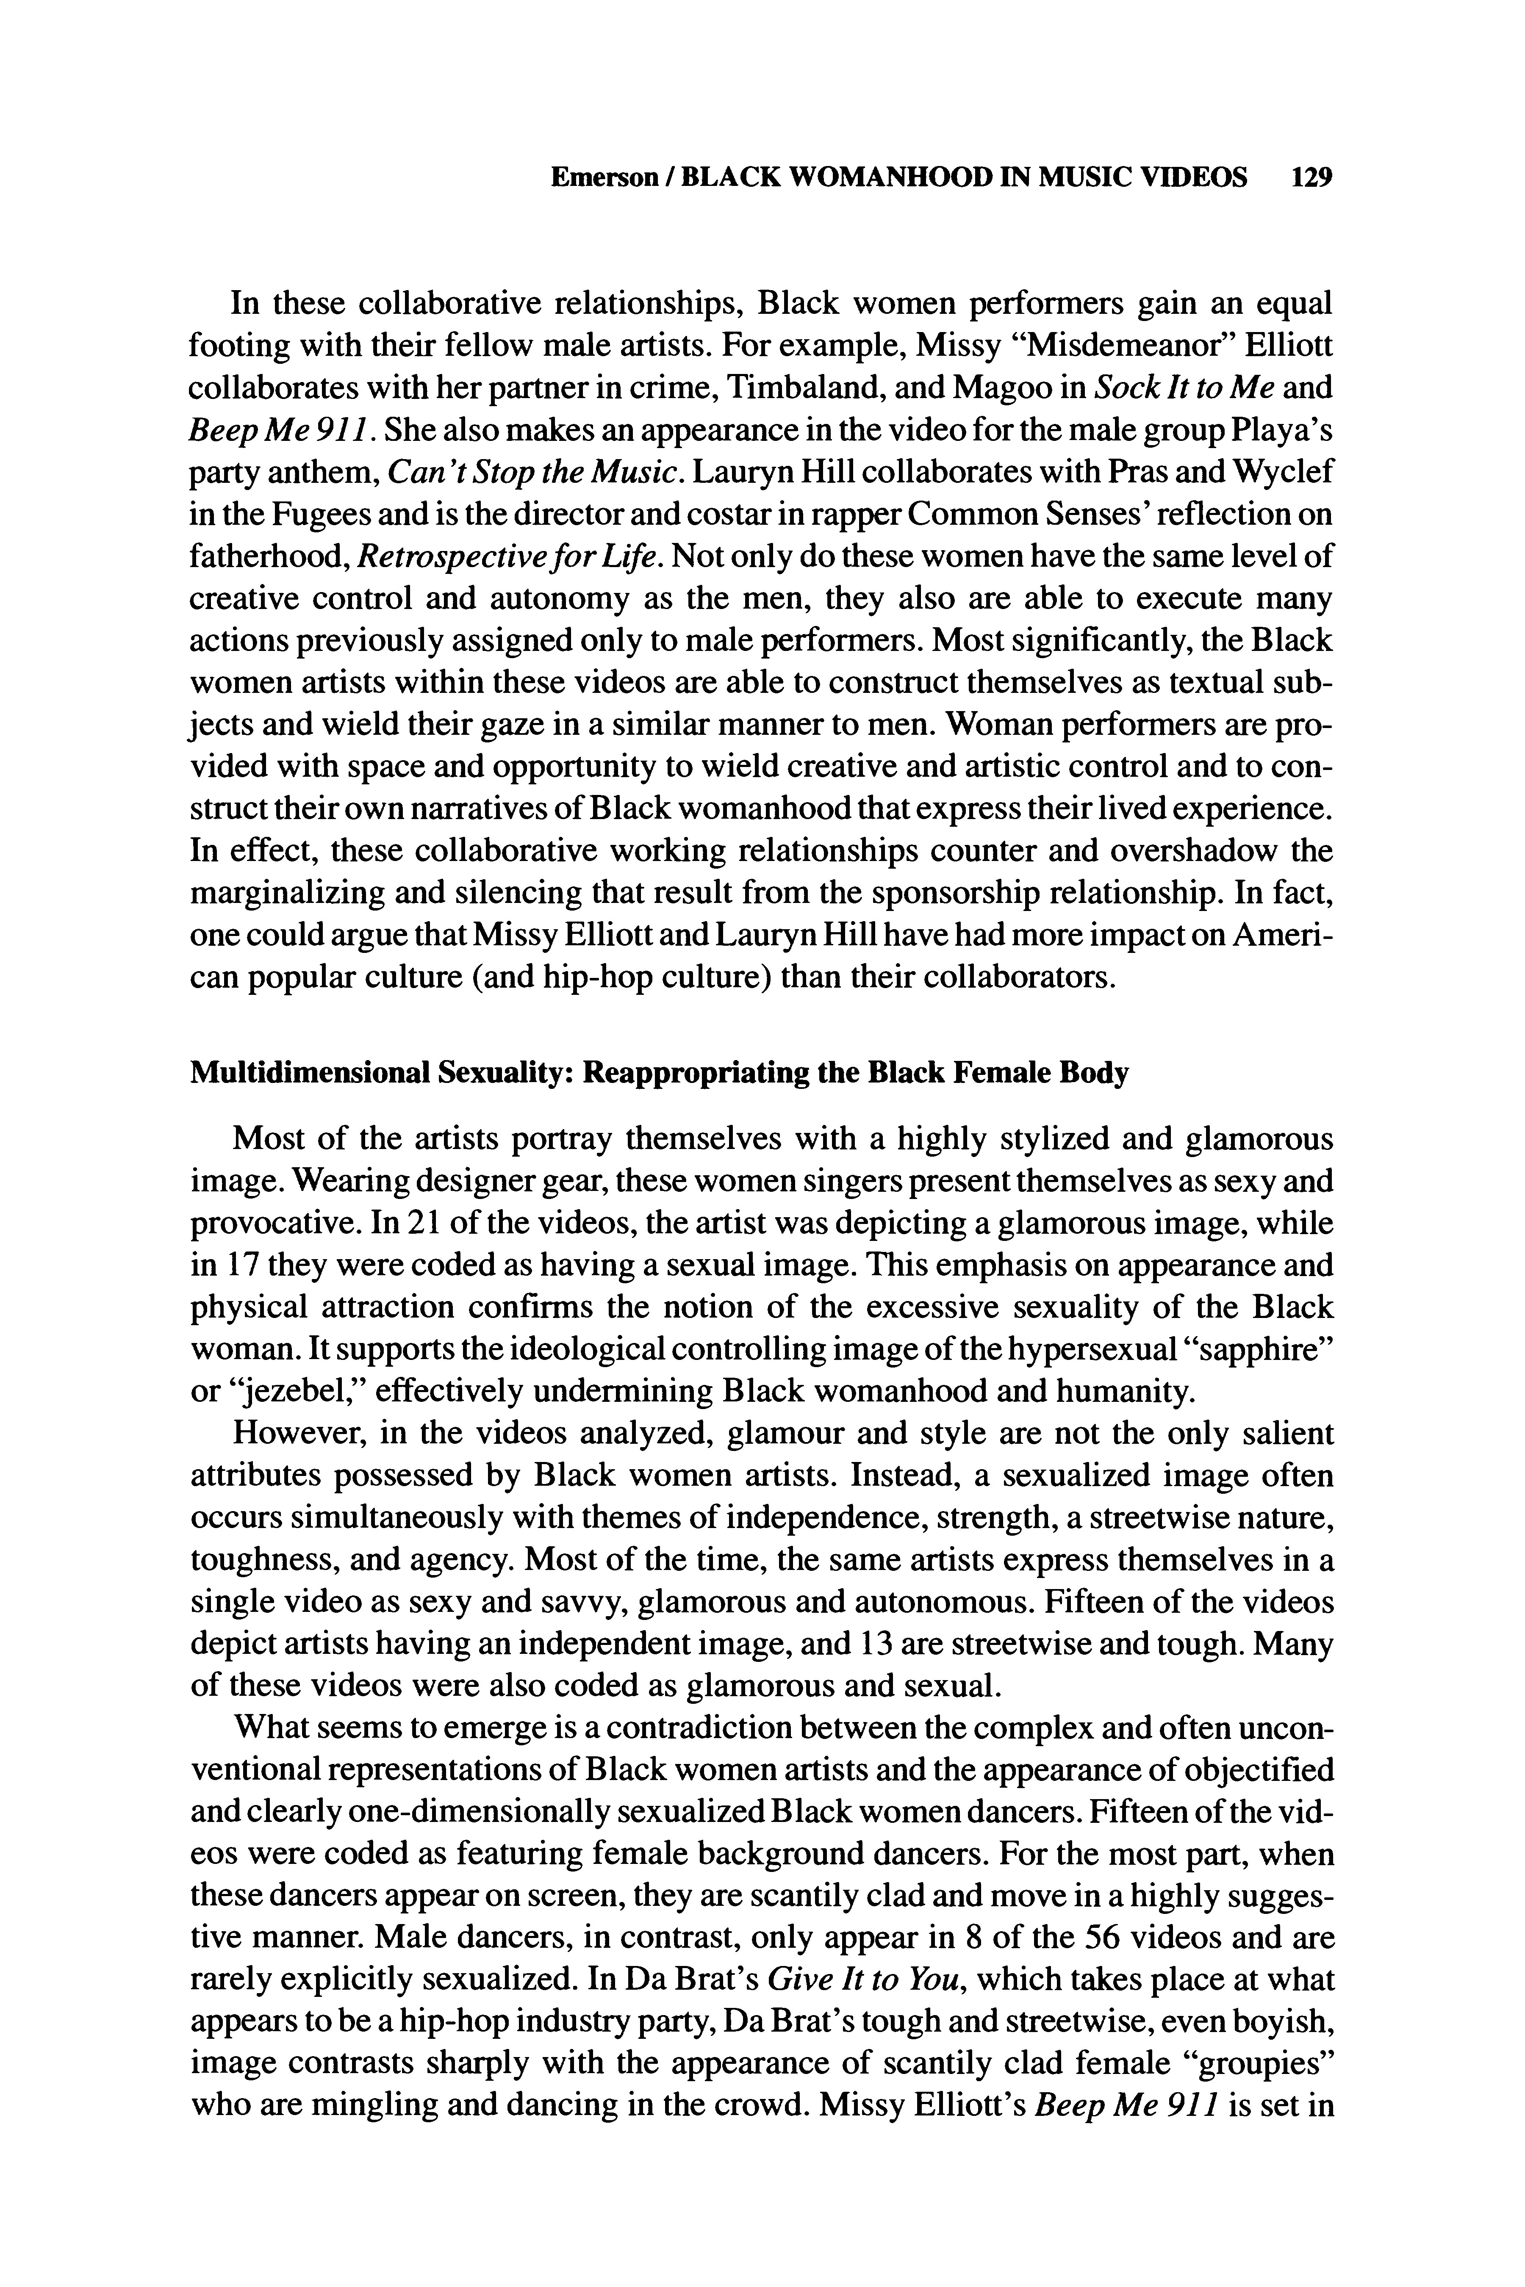
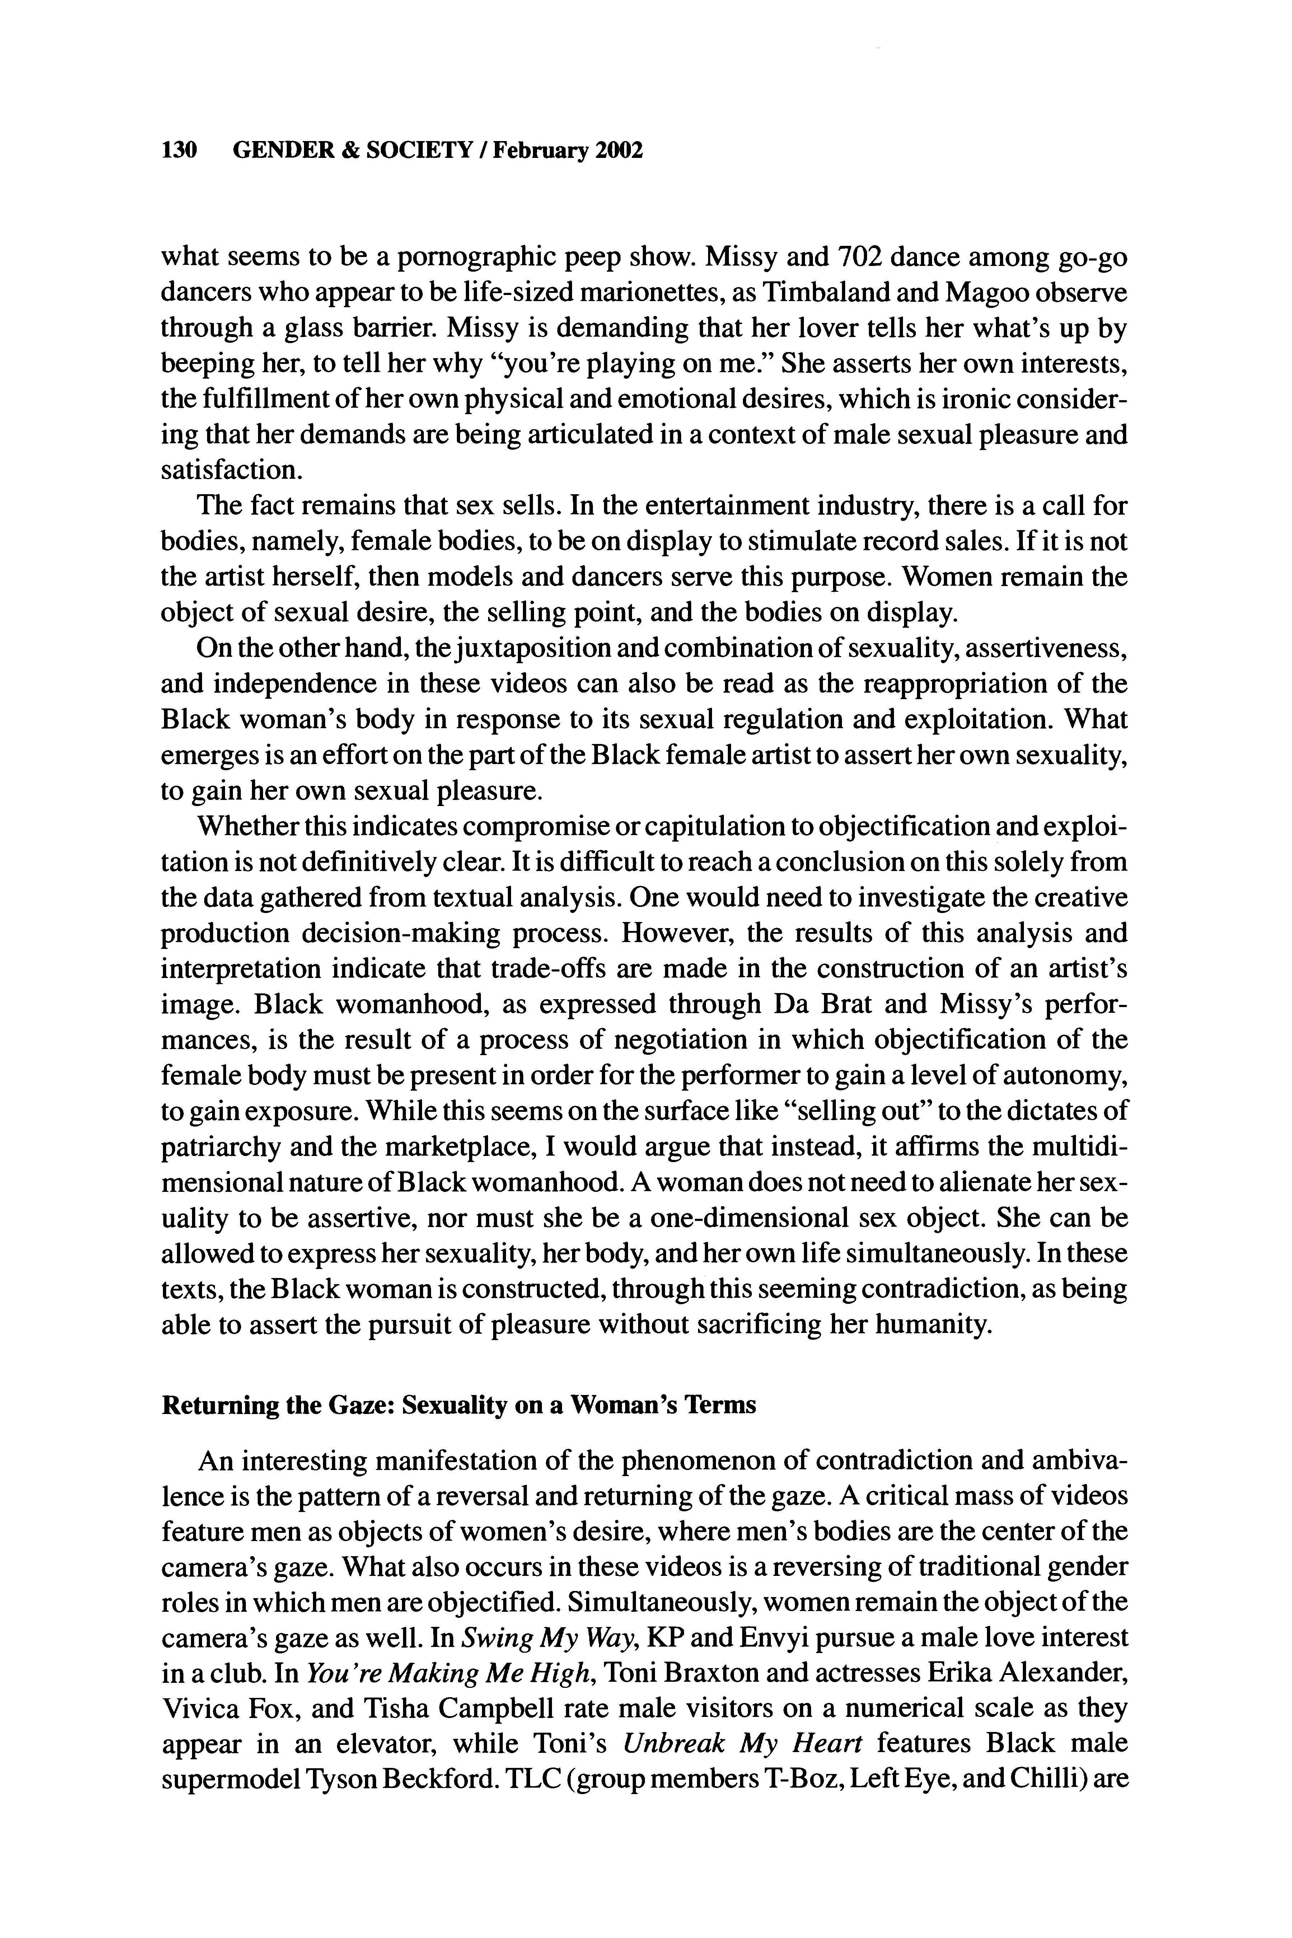
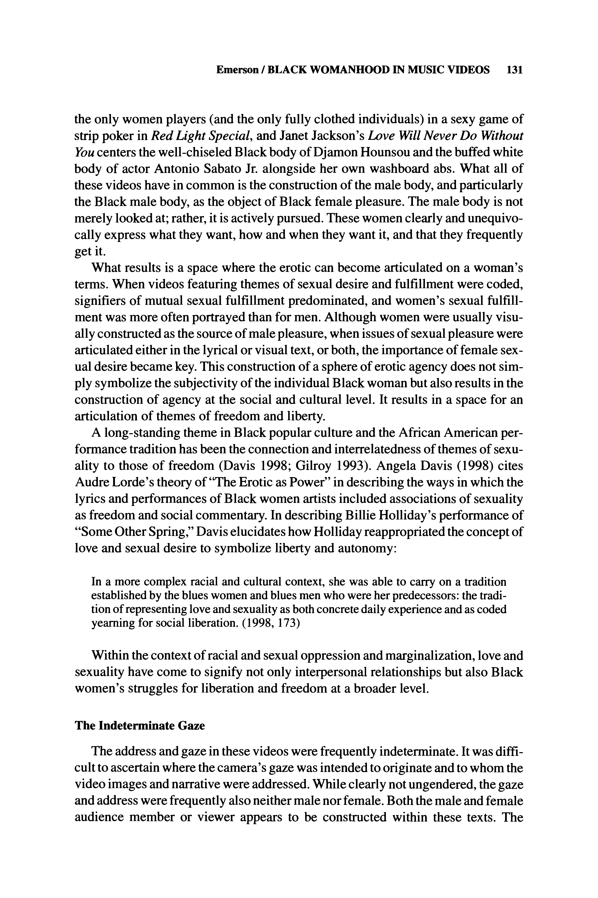
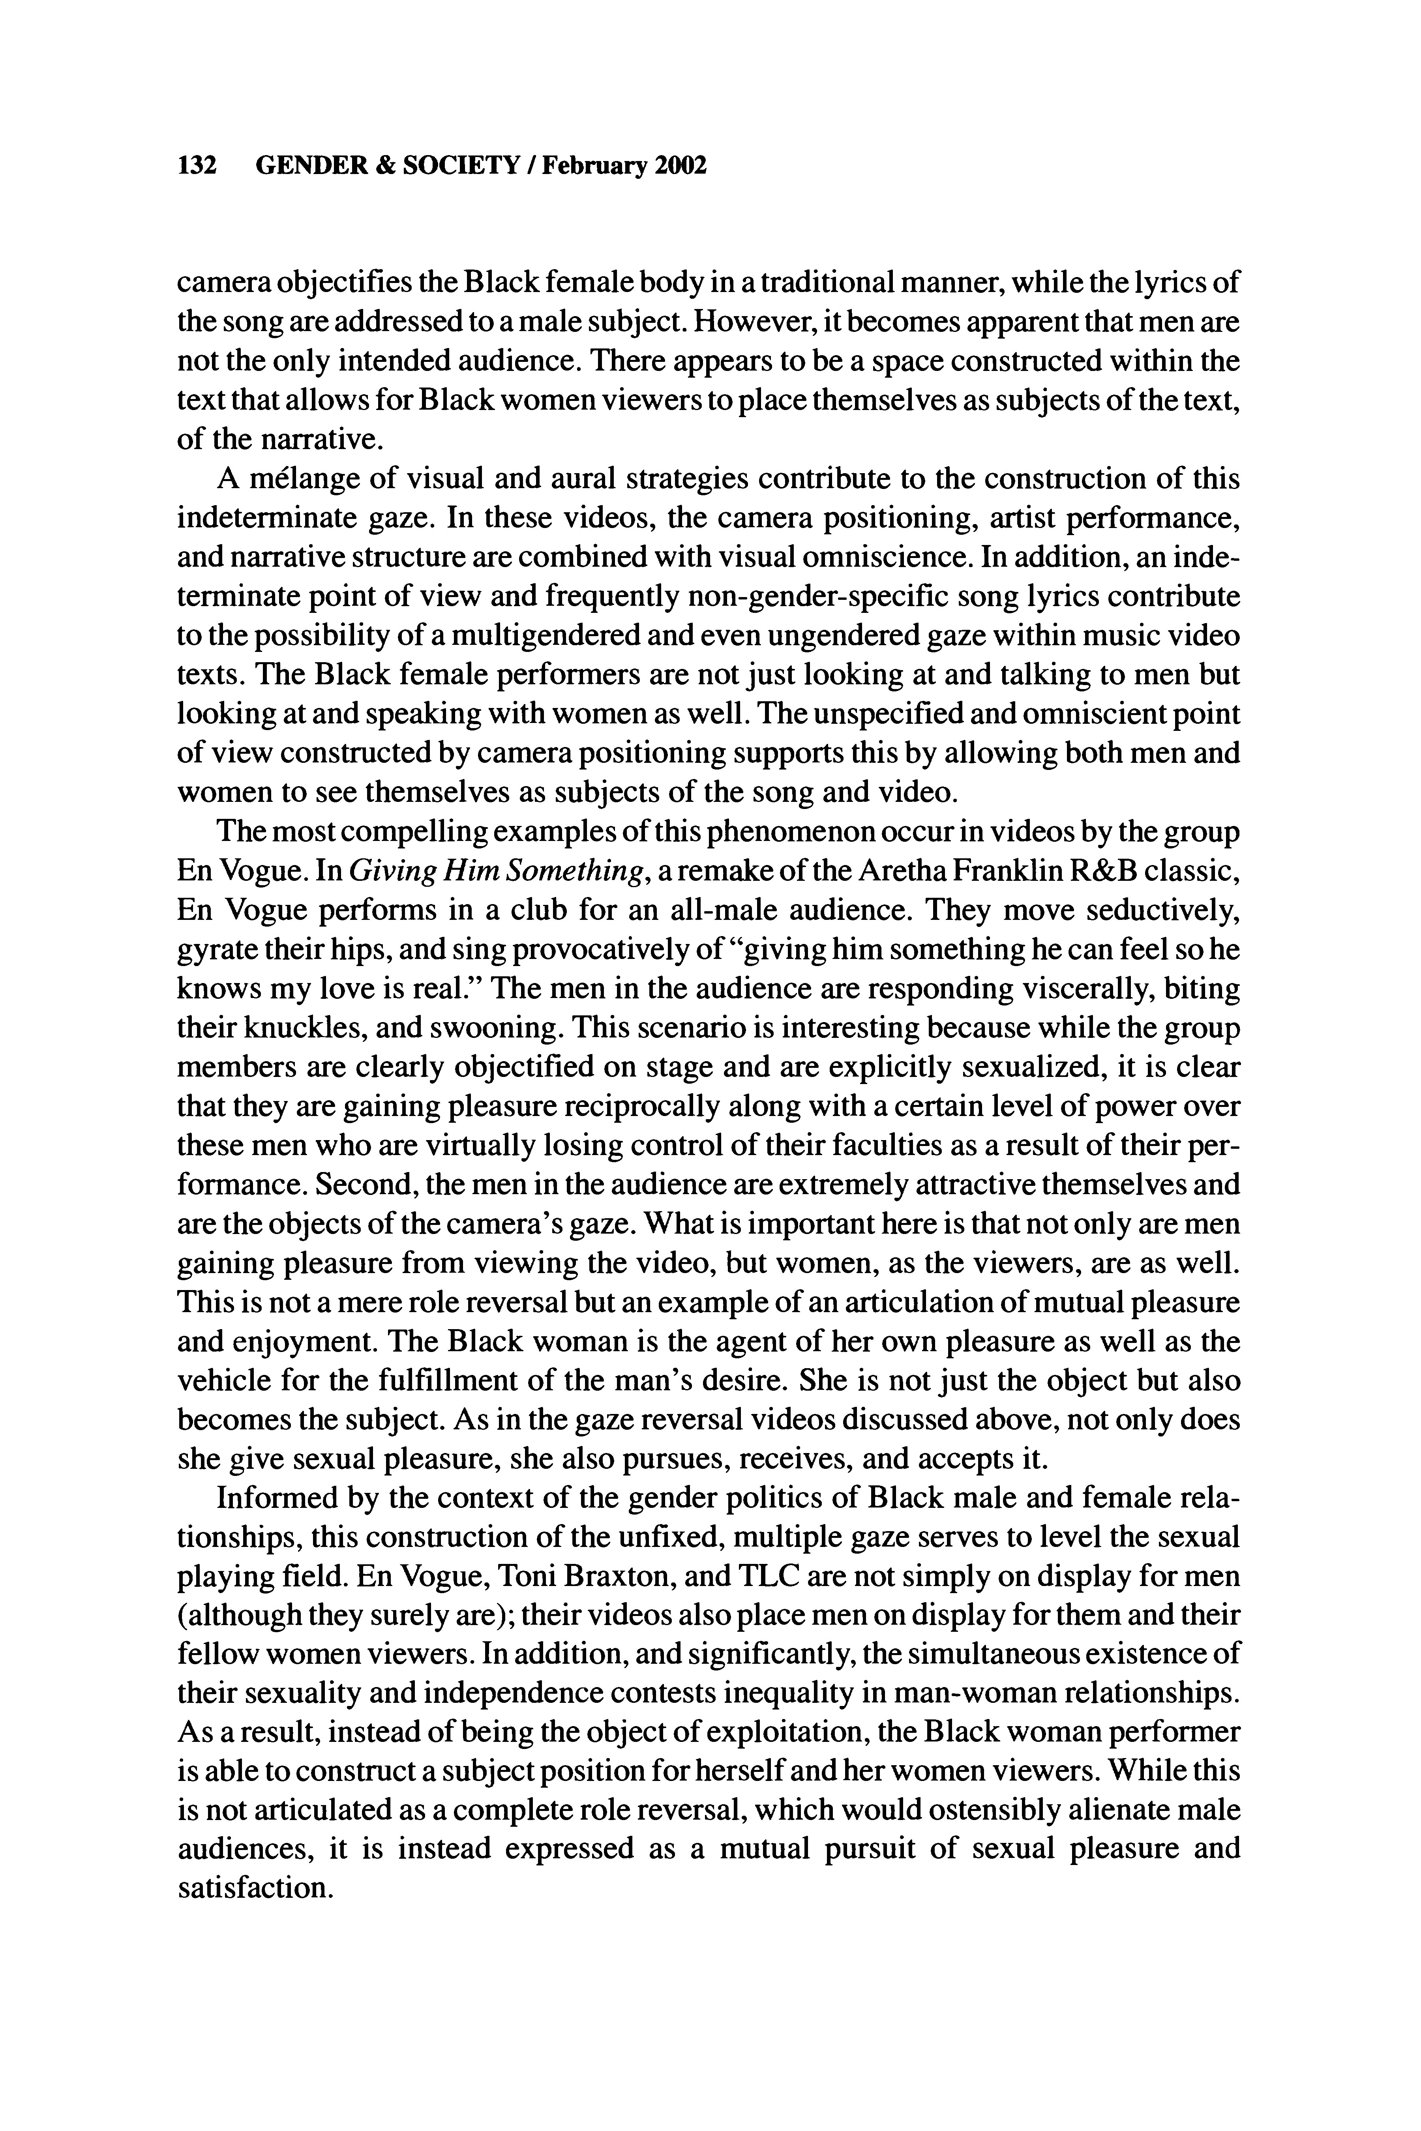
Emerson /
BLACK WOMANHOOD IN
MUSIC
VIDEOS
135

Vincent,
Richard
C.
1989
. Clio's
consciousness
raised?
Portrayal
of women
in
rock videos re-examined.
Journalism
Quarterly
66:155-60
.
Vincent,
Richard,
Dennis
K.
Davis,
and
Lilly
Ann Boruszkowski.1 987.
Sexism
on MTV:T he
portrayal
of
women
in
rock
videos. Journalism
Quarterly
64:750-55
,
941
.
Watkins,
S.
Craig.
1998
.
Representing:H ip
hop
culturea nd
the
productiono f
Black
cinema.
Chicago:
University
of
Chicago
Press.
Rana
A.
Emerson
is a doctoral candidate
in
sociology
at
the
Universityo f
Texasa t
Austin. In
2001
,
she was included
among
thefirst
cohort
of
recipientso f
the Social Science ResearchC oun-
cil
Program
on theArts Dissertation
Fellowship.
She
is
currently
writing
her
dissertation,
titled
"Hot
Girls,
Shorties
and Divas:
Exploring
the
Responseso f
Teenage
African-American
Girls
to
Representations
of
Black
Female
Sexuality
in Music Video."

