Women and Religion: The Intersections of Gender, Migration, and Politics

Learning Objective:
To examine and think critically about how religion shapes expectations of gender, racial and ethnic identities. We will also address how religious ideology affects public policy.

Please read the weekly written lecture and listen to the spotlight PowerPoint discussion.

Religion and Community
According to sociology, religion is a structured institution that organizes human behavior based on a common belief in a sacred higher power or being. Religion offers a response to particular human needs— particularly the desire to understand and explain the purpose of existence. Sociologist Emile Durkheim (whom you might recall from Soc 101 and Social Theory class) understood religious practice as a means to forming a “community of believers.” In this light, religion is not merely practiced alone but alongside others. Within this context, religion is structured around a sense of moral standards that are both agreed upon and contested by followers.
Religious symbols and rituals are used to guide human behavior. These symbols can range from a greeting, type of clothing, or performance of prayer.
List a few visible religious symbols that you recognize in your daily encounters:
1._________________________
2._________________________
3._________________________
4._________________________
5._________________________

There are more than 1,300 different religious denominations, sects, and cults in the U.S..
According to the Pew Research Religious Landscape Study, of the Abrahamic traditions in America, Christians make up 70.6% of the American population followed by Jews 1.9% and Muslims 0.9%. You can read more about the study here: https://www.pewforum.org/religiouslandscape-study/

Sociologists use the term religiosity to describe an individual’s degree of religious performance and adherence to a religious belief system. Membership within a congregation or organized religion can vary from one person to another and between religious groups. The level of commitment also varies across time and space. Religion and citizenship have been closely tied

Migration and Religion
Race and ethnicity have significantly shaped the variation in religious practitioners across the
U.S.. For example, the post-1965 immigration of groups from Latin America, Asia and the Caribbean introduced different types of religions (such as Hinduism and Santeria) that are distinct from the widely celebrated Judeo-Christian traditions already in practiced in America before this migration.
Religious congregations are likely to reflect diverse racial and ethnic characteristics. For example, Mass in a Catholic Church may be conducted in both English and Spanish to accommodate the linguistic needs of parishioners.
The chart below shows the outcomes of racial composition by faith according to the Pew Study on Religious Landscape study.
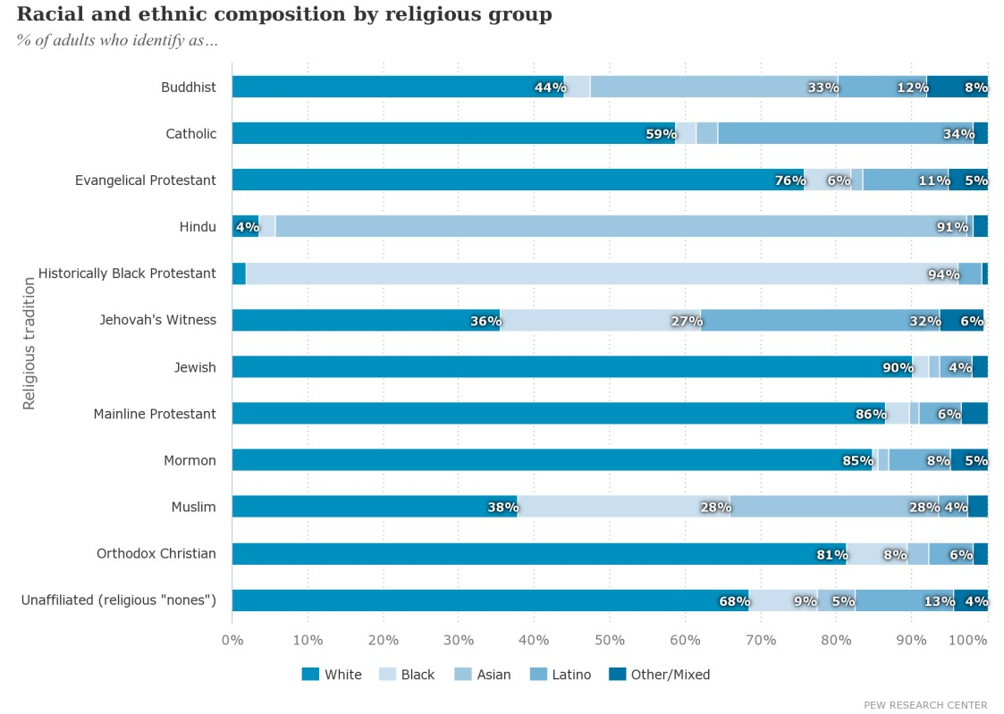
Ethnic immigrant communities may also form insular religious congregations around linguistic and regional similarities. For example, Gujarati Hindu Temples in NY often have a Gujarationly congregation because of the specific type of ethno-religious rituals that take place within their religious ceremonies. You may have noticed the Gujarati Community Center’s building, shown in the picture below, while driving on the Horace Harding Expressway service road in Flushing. Some religious communities are establishing transnational religious connections with their country of origin by using these type of cultural centers to manage and maintain these
global ties. 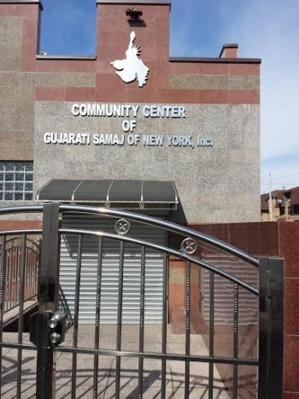

A Gendered Lens
This week, you will be reading two articles about gender and religion. The first article A Gender Lens on Religion offers an introduction to the ways in which women’s studies and feminist discourse offers a nuanced perspective on discussing religious practice. The authors provide an overview of how sociology views the study of religion and the ways in which the discipline is moving away from examining religious decline to looking at how religion is very much alive and visible in social policies. Remember to pay particular attention to the significance of women’s roles in religious traditions and how examining the idea of “doing religion” through the lived experiences of everyday life leads to understanding women’s agency in their religious performances.

The second article about Muslim American college women delves into a discussion of stereotypes about Muslims after 9/11. Mir, discusses how stigma, or a negative label that is attached to a group to discredit their identity, affects their religious performances and social interactions. She conducted her study at two private universities—one of which is a Jesuit institution. While reading the article, ask yourself if the gendered religious interactions her Muslim participants experience are applicable to other women of other religious group. How does Islamophobia complicate the gender religious experiences?

Assignment:
This week, you will read two articles located in the Week 9 article folder: Not Too "College-
Like," Not Too Normal: American Muslim Undergraduate Women's Gendered Discourses and A Gender Lens on Religion.

*****Interactive Discussion*****
After reading lecture folder and the articles in the Week 9 Article Folder, answer the following:

Paper due: Wednesday 3/27 11:59AM.
Response to classmate’s post due: 3/29 by 11:59AM.
This is an interactive discussion. PLEASE submit both your initial post and response in by the deadlines. NO assignments will be accepted after the posted deadlines.

- According to the Gendered Lens article, how does studying women and religion advance the sociological study of religion? Cite 2 specific ways that a gendered approach to studying religious practice will add a new perspective to the study of religion.

- How are the Muslim American women involved in the process of “doing religion?” Does their experience speak to maintaining or challenging patriarchal norms? Cite one specific example and discuss. Please remember to cite the page number with your response.

- The authors of the first article discuss the significance of studying conservative religions. How does this compare to Mir’s study? Does Mir portray her participants as conservative? Cite two examples supporting your answer.

- Cite one example of how Mir’s participants are stigmatized. Are they resisting these stereotypes? Discuss how Islamophobia can potentially increase the stigma these young women experience.

- Does the gendered lens article shed light on women’s agency in performing religion? Cite two examples from real life about how you have noticed women’s agency in their religious performances.

