Research Question
What is the average speed of some arbitrary object as it moves along a track?

Diagram
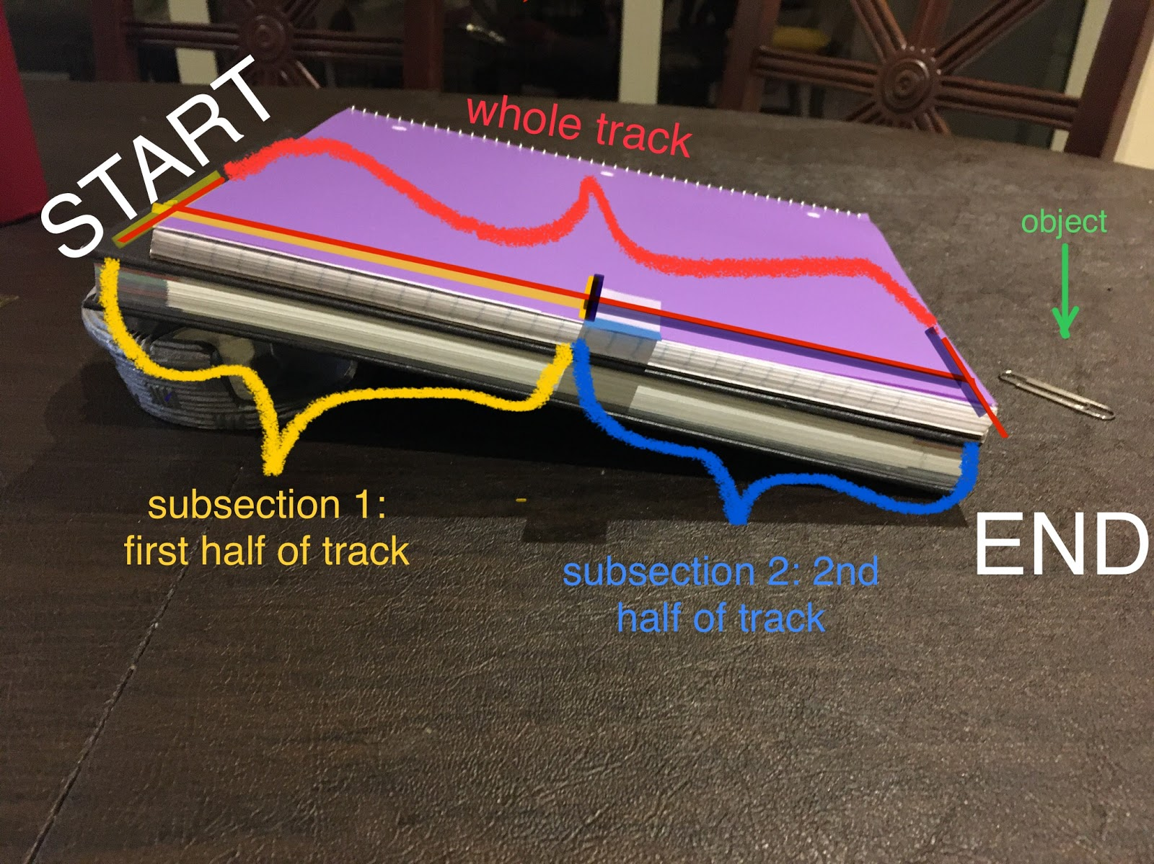

Analysis
The track was displayed using a notebook and an object to create an incline plane in order for the object to move along the track. Based on the time it took for the object to travel the whole track, the average speed will be determined with the following measurements conducted in distance and average time (see Appendix B for Equations/Formulas).
Since the unit of length is a pen and the unit of time are snaps, the experiment was performed for three trials (see Appendix A for values collected). This will allow us to use the following calculation:

Average Speed = Total Distance / Change in Time

The average speed can only be calculated once the total distance of the track is measured and the time it took for the object to travel. Notice that the first half and second half of track will have to be measured as well using the same formula but distance will be half. Total Distance units are pens and time are snaps so the units for average speed will be the number of pens / snaps (see Appendix C for calculations) which can be perform as:
The average of the data was done in two sections. The first set of data as shown in appendix b was to determine the average of the time taken by the pen and the next was to determine the average speed. Average is the number is the sum of all data that was given then divided by number of classes present ie it may be 1, 2, or 3. The average time was determined by summing up the three values of the trials then dividing them by three. The average speed was determined by dividing the total distance by time taken for the pen to roll down. The equations have been summarized at appendix b. the following are the summary of the equations.

Average Time = Sum of Values / Number of Values
Average Speed = Total Distance / Change in Time

The values that were substituted in to the equations were gotten from the table that is above. The data was in to two the first set was in the first half of the track and the next onto the other ½. The average time that as taken by adding the sum of the three trials then dividing by three. The procedure was repeated twice for the first ½ track then for the other ½. The average speed was done by dividing the distance that was provided then dividing by the average time gotten 1,1 and 1.17 respectively. The average speed and time calculations can be found on appendix c.

The average speed changed from the whole track to the subsequent 1 and 2. The values were 1.25 for the whole and 1 and 0.85 for subsequent one and 2 respectively. What caused the difference was the different in distance and time and may be the uncertainties of the materials used. The measurement devices that were used were 2 pens eraser and one snap. Of which the uncertainties of the measuring devices are shown in appendix D. the following were the uncertainties.

1 pen (smallest unit) = 2 erasers (subunit ±0.5)
1 pen 2 erasers*0.5 erasers= ±0.25 pen (uncertainty)

1 snap (smallest unit) = ±0.5 snap (uncertainty
the uncertainties interval was 0.5 for time and 0.25 for the distance. The uncertainties may have led to the deviation of data in the two sets of the experiment.

Average Speed = 2.52= 1.25 pens / snaps

Uncertainty

Appendices
Appendix A:
Unit of Length: Pen
Sub Unit: Eraser (2 erasers in one pen)
Unit of Time: Snaps
Trip | Distance (pens) | Time (snaps) |  |  |  | Avg. Speed (pens/snaps)
Whole Track | 2.5 | Trial 1 | Trial 2 | Trial 3 | Avg. Time | 2.5/2 = 1.25
Whole Track | 2.5 | 2 | 2 | 2 | 2 | 2.5/2 = 1.25
1st Half of Track | 1 | 1 | 1 | 1 | 1 | 1/1 = 1
2nd Half of Track | 1 | 1.5 | 1 | 1 | 1.17 | 1/1.17 = 0.85

Appendix B:
Equations/Formulas:
Average Time = Sum of Values / Number of Values
Average Speed = Total Distance / Change in Time

Appendix C:
Calculation:
Average Time
Whole Track: 2+2+23= 2 snaps
1st Half of Track: 1+1+13= 1 snap
2nd Half of Track:1.5+1+13 = 1.17snap
Average Speed
Whole Track: 2.52= 1.25 pens/snaps
1st Half of Track: 11= 1pen/snap
2nd Half of Track: 11.17= 0.85pen/snaps

Appendix D:
Uncertainties:
1 pen (smallest unit) = 2 erasers (subunit ±0.5)
1 pen 2 erasers*0.5 erasers= ±0.25 pen (uncertainty)

1 snap (smallest unit) = ±0.5 snap (uncertainty

