SPH 321 Global Environmental Issues and Their Effect on Human Health
Spring 2021
Module 1
Homework Assignment 1
Objective: The objective of this homework assignment is to familiarize you with the concept of Planetary Health.
Part 1 of 3:
- Determine your ecological footprint using: https://www.footprintcalculator.org/
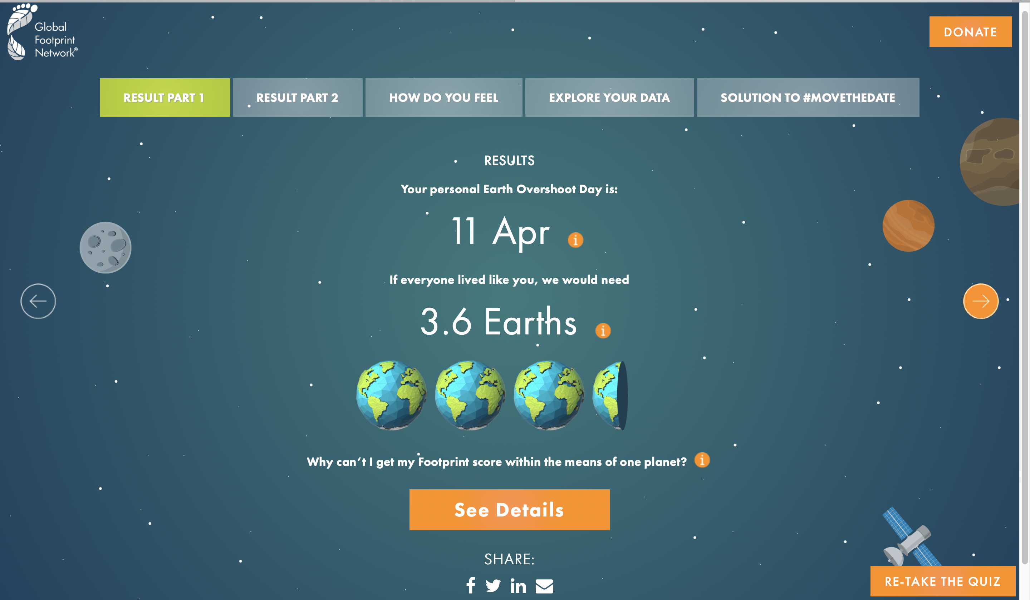
  - How many earths do we need if everybody lives like you?

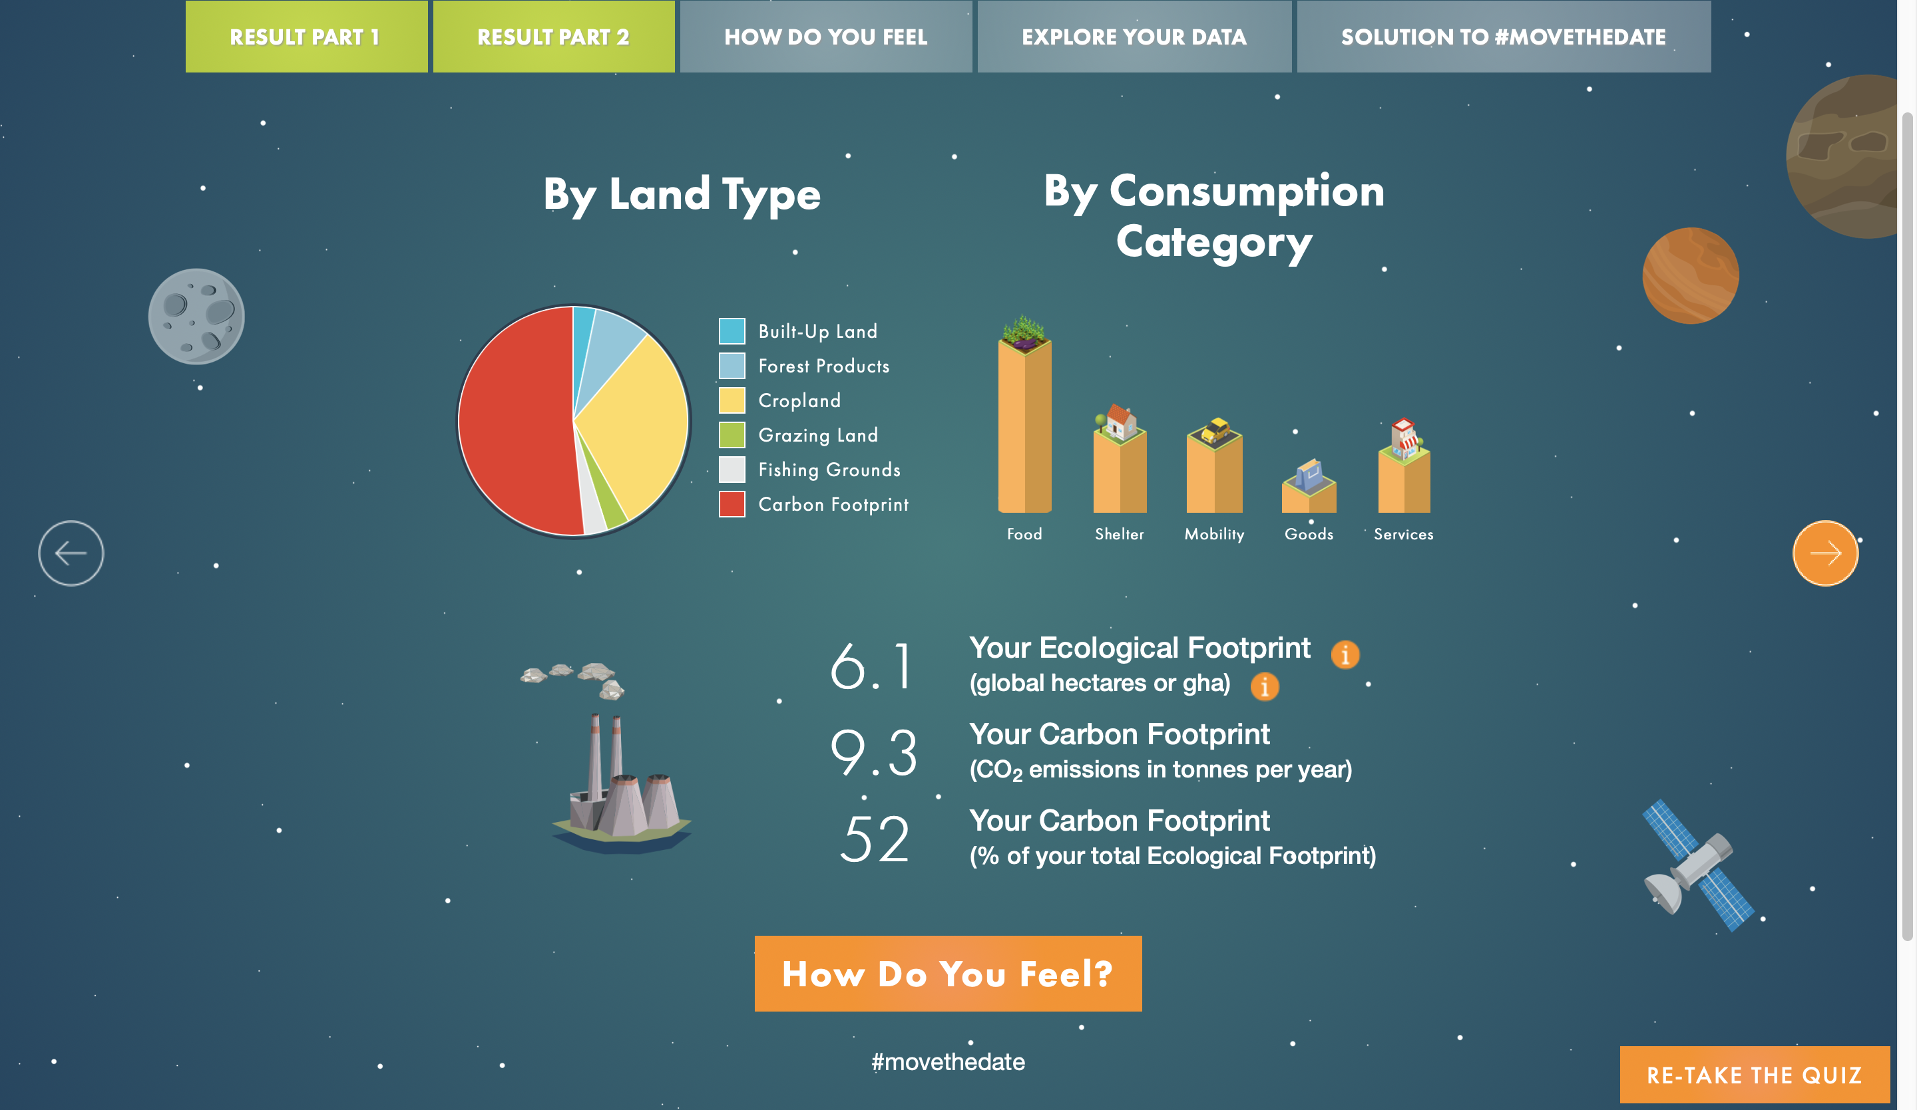
  - What is your ecological footprint (See Results part 2).

  - The USA ecological foot print per person is 8.1 gha. How do you match up in comparison?

  - Comment on the distribution of your footprint by consumption category (See Results Part 2).

  - Now that you know your footprint, how do you feel? Try considering some of these questions or reflect on something else that struck you in this exercise.
    - Are there things that you can or want to change to lessen your footprint? Does it feel impossible to change some of these aspects? Why? How? Is changing some of these metrics seemingly out of your control?
Part 2 of 3:
- Read the beginning of Safeguarding human health in the Anthropocene epoch: report of The Rockefeller Foundation–Lancet Commission on planetary health by Whitmee, et al. published in The Lancet. (posted on Blackboard and also available here: http://dx.doi.org/10.1016/S0140-6736(15)60901-1
  - Define the anthropocene in your own words based on what you’ve read here.
  - In your own words, describe why the authors contend that we need this new term?
  - Define planetary health in your own words based on what you’ve read here.
  - Consider one of the examples of the degradation of land resources from Chapter 4, or themes raised in Chapter 2 (urbanization, population growth, etc) that is of particular interest to you. Now that you have read a little bit about planetary health, reflect on the link between one of these themes and human health. 2 That is, consider in the context of your selected theme how humans are impacting the environment and the environment is in turn influencing health (or vice versa). Even though I assigned only the beginning of the Whitmee et al article, many of these themes are touched upon later in the manuscript. Scan the rest of the article to what the authors have to say on the topic and summarize it here. Please be sure to note the page numbers from the article where you gleaned information to answer this question. Your answer to this question should be no longer than 250 words.
Part 3 of 3:
- To connect Part 1 and Part 2 of this homework, consider how individual actions are related to planetary health.
  - Reflect on the footprint exercise now that you have read a bit about planetary health in a few sentences.
  - Offer an idea of a policy, a personal/household behavior change campaign, or some other sort of program, which - if implemented, could help individuals like yourself or your peers (or the larger population) both lessen your environmental footprint AND promote public health at the same time. For example, the Meatless Monday campaign aims to help people reduce weekly meat consumption (which is linked to a suite of cardiometabolic diseases) by encouraging vegetarian eating on Mondays. Your idea need not actually exist as a policy or program, you can be creative here but you need not go in depth – this is just a thought exercise. Be explicit about what environmental sustainability issue and what health issue you are addressing.

