Quantitative Analysis
Author
Class title
Assignment number
Date of submission

Table of Contents
A1.1: Chapter 2, Problem 2.1, Check the completed questionnaires. 3
A1.2: Chapter 2, Problem 2.2, Define and Label Variables. 3
A1.3: Chapter 2, Problem 2.3, Display your Dictionary or Codebook. 5
A1.3: Chapter 2, Problem 2.4, Enter Data. 9
A1.4: Chapter 2, Problem 2.5, Run Descriptives and Check the Data 10
A1.5.a, Computing N, minimum, maximum and mean for the college student data file. 11
AI.5.b, What is the sample size. 13
A1.5.d, Mean Height of the Students. 14
A1.5. f, Percentage of Male Students 14
A1.5.g, Percentage of Students with Children. 14

A1.1: Chapter 2, Problem 2.1, Check the completed questionnaires.

To open up the dataset, you first log into the SPSS software. To choose to open an existing dataset that is in the SAV format. This will enable us to be able to view our dataset and know how to interpret it and analyze it. The dataset obtained from the completed questionnaire has18 variables each of which is used to understand the participants and modelled to help in the research study

A1.2: Chapter 2, Problem 2.2, Define and Label Variables.

Different variables denote different representation in our dataset and we will define each value of a variable in order to have greater understanding of our dataset. The variable height is a scale variable and it shows the height of students in inches. The variable height is also a scale variable showing the same sex parents height.
The variable gender is the gender of the student. It is a nominal variable with two categories, 1 and 2. To label this variable, we use the syntax; VALUE LABELS gender 1 ‘male’ 2 ‘female’. From this syntax, we are now able to understand what each value in the gender column denotes, that is 1 for male and 2 represents the female.
The variable marital status is a nominal variable with three categories, 1, 2, and 3. Now we must know what each value in the variable represents and therefore we are going to use this syntax to label each value; VALUE LABELS marital 1 ‘single’ 2 ‘married’ 3 ‘divorced’. This syntax shows that the value one I the marital column represent the single, 2 represents the married and 3 represents the divorced.
The variable age is an ordinal variable with more than two categories. To label each value in the age column, we are going to use the syntax; VALUE LABELS age 1 ‘less than 22’ 2 ’22-29’ 3 ’30 or more’. From this syntax we are able to see that all those who are below 22 years of age are categorized s group one, those who are between 22-29 are categorized as group 2 and those who have 30 years of age and above are put in the group 3.
Our next variable children is a nominal variable and is used to question If the subject has children or not. To label the values in the children column, we are going to use the syntax; VALUE LABELS children 0 ‘no’ 1 ‘yes’.
The variable hrstv is a scale variable and it shows the amount of TV watched per week. The variables, tvsitcom, tvmovies, tvsports, tvnews are are nominal variables with two categories. They show television shows- sitcoms, television show – movies, television shows- sports and television shows-news respectively. To label the variables, we use the syntax VALUE LABELS (name of the variable) 0 ‘no’ 1 ‘yes’ respectively.
The variables hrsstudy and currgpa are both scale variables and they contain continuous variables. The variables show the hours of study per week and the student’s current gpa respectively. The variables evalinst, evalpro, evalphys, evalsocl are ordinal variables and the show positive evaluation, institution, positive evaluation, major, positive evaluation, major, positive eval social life respectively. To label the values in each of the variable column, we use the syntax; VALUE LABELS name_ of the_ variable 1 ‘strongly disagree’ 2 ‘disagree’ 3 ’neutral’ 4 ‘agree’ 5 ‘strongly agree’.

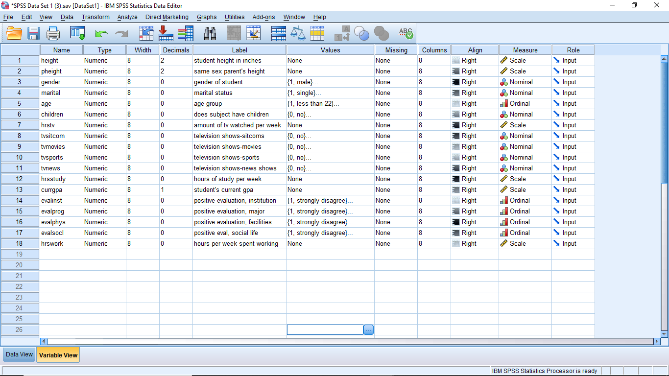

A1.3: Chapter 2, Problem 2.3, Display your Dictionary or Codebook.

To get the codebook, click on file then select display data file information then select working file. The output will show all the variable information that is the name of the variable, the position of the variable in the dataset, the measurement level and other meaningful information that helps one understand the variables better.

[DataSet1] C:\Users\hp\Downloads\SPSS Data Set 1 (3).sav

Variable Information
Variable | Position | Label | Measurement Level | Role | Column Width | Alignment | Print Format | Write Format
height | 1 | student height in inches | Scale | Input | 8 | Right | F8.2 | F8.2
pheight | 2 | same sex parent's height | Scale | Input | 8 | Right | F8.2 | F8.2
gender | 3 | gender of student | Nominal | Input | 8 | Right | F8 | F8
marital | 4 | marital status | Nominal | Input | 8 | Right | F8 | F8
age | 5 | age group | Ordinal | Input | 8 | Right | F8 | F8
children | 6 | does subject have children | Nominal | Input | 8 | Right | F8 | F8
hrstv | 7 | amount of tv watched per week | Scale | Input | 8 | Right | F8 | F8
tvsitcom | 8 | television shows-sitcoms | Nominal | Input | 8 | Right | F8 | F8
tvmovies | 9 | television shows-movies | Nominal | Input | 8 | Right | F8 | F8
tvsports | 10 | television shows-sports | Nominal | Input | 8 | Right | F8 | F8
tvnews | 11 | television shows-news shows | Nominal | Input | 8 | Right | F8 | F8
hrsstudy | 12 | hours of study per week | Scale | Input | 8 | Right | F8 | F8
currgpa | 13 | student's current gpa | Scale | Input | 8 | Right | F8.1 | F8.1
evalinst | 14 | positive evaluation, institution | Ordinal | Input | 8 | Right | F8 | F8
evalprog | 15 | positive evaluation, major | Ordinal | Input | 8 | Right | F8 | F8
evalphys | 16 | positive evaluation, facilities | Ordinal | Input | 8 | Right | F8 | F8
evalsocl | 17 | positive eval, social life | Ordinal | Input | 8 | Right | F8 | F8
hrswork | 18 | hours per week spent working | Scale | Input | 8 | Right | F8 | F8
Variables in the working file

Variable Values
Value |  | Label
gender | 1 | Male
gender | 2 | Female
Marital | 1 | Single
Marital | 2 | Married
Marital | 3 | Divorced
Age | 1 | less than 22
Age | 2 | 22-29
Age | 3 | 30 or more
Children | 0 | No
Children | 1 | Yes
Tvsitcom | 0 | No
Tvsitcom | 1 | Yes
tvmovies | 0 | No
tvmovies | 1 | Yes
Tvsports | 0 | No
Tvsports | 1 | Yes
Tvnews | 0 | No
Tvnews | 1 | Yes
Evalinst | 1 | strongly disagree
Evalinst | 2 | Disagree
Evalinst | 3 | Neutral
Evalinst | 4 | Agree
Evalinst | 5 | strongly agree
Evalprog | 1 | strongly disagree
Evalprog | 2 | Disagree
Evalprog | 3 | Neutral
Evalprog | 4 | Agree
Evalprog | 5 | strongly agree
evalphys | 1 | strongly disagree
evalphys | 2 | Disagree
evalphys | 3 | Neutral
evalphys | 4 | Agree
evalphys | 5 | strongly agree
Evalsocl | 1 | strongly disagree
Evalsocl | 2 | Disagree
Evalsocl | 3 | Neutral
Evalsocl | 4 | Agree
Evalsocl | 5 | strongly agree

A1.3: Chapter 2, Problem 2.4, Enter Data.

To enter data, you click on file, and then select new then under new choose data. A new worksheet, data editor that you can key in data is displayed. Type in each variable as it appears in your dataset in the data editor . To change the name of the variables you go to variable vie and double click to add the variable name.
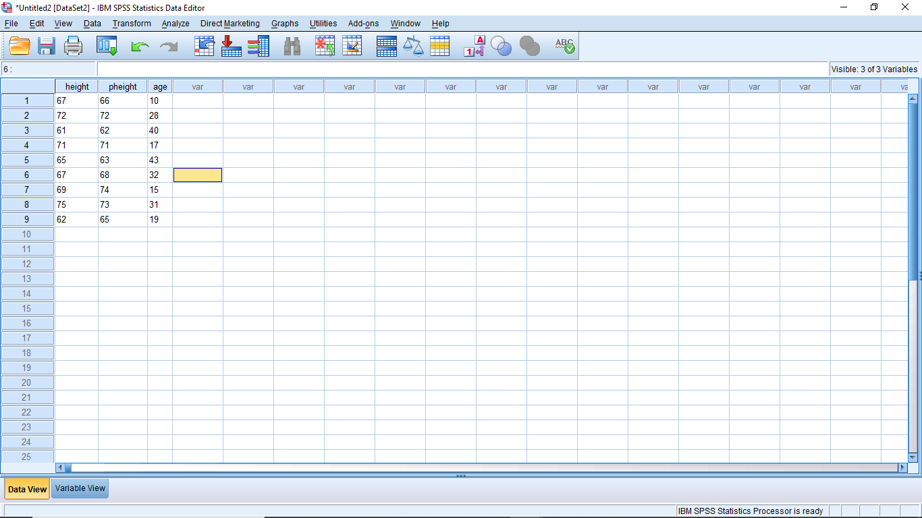
A1.4: Chapter 2, Problem 2.5, Run Descriptives and Check the Data.
To analyze the data using descriptive statistics in SPSS, we click on analyze then select descriptive statistics then click on descriptives. For our dataset, we are going to analyze height, pheight, amount of TV watched per week and the hours spent working. The resultant output shows the sample size, the minimum and maximum value for each variable respectively, the mean and the standard deviation. From this information, we are able to understand information about the dataset.

[DataSet1] C:\Users\hp\Downloads\SPSS Data Set 1 (3).sav

Descriptive Statistics
 | N | Minimum | Maximum | Mean | Std. Deviation
student height in inches | 50 | 60.00 | 75.00 | 67.3000 | 3.93959
same sex parent's height | 50 | 58.00 | 76.00 | 66.7800 | 5.10418
amount of tv watched per week | 50 | 4 | 25 | 11.98 | 6.096
hours per week spent working | 49 | 0 | 50 | 26.12 | 14.857
Valid N (listwise) | 49

A1.5.a, Computing N, minimum, maximum and mean for the college student data file

[DataSet1] C:\Users\hp\Downloads\SPSS Data Set 1 (3).sav

Descriptive Statistics
 | N | Minimum | Maximum | Mean | Std. Deviation
student height in inches | 50 | 60.00 | 75.00 | 67.3000 | 3.93959
same sex parent's height | 50 | 58.00 | 76.00 | 66.7800 | 5.10418
gender of student | 50 | 1 | 2 | 1.48 | .505
marital status | 49 | 1 | 3 | 1.82 | .782
age group | 50 | 1 | 3 | 1.96 | .807
does subject have children | 50 | 0 | 1 | .52 | .505
amount of tv watched per week | 50 | 4 | 25 | 11.98 | 6.096
television shows-sitcoms | 50 | 0 | 1 | .64 | .485
hours per week spent working | 49 | 0 | 50 | 26.12 | 14.857
hours of study per week | 50 | 2 | 38 | 15.62 | 8.310
positive eval, social life | 50 | 1 | 5 | 3.10 | 1.182
positive evaluation, facilities | 50 | 1 | 5 | 2.76 | 1.061
positive evaluation, major | 49 | 1 | 5 | 3.27 | .953
positive evaluation, institution | 50 | 2 | 5 | 3.38 | .945
student's current gpa | 50 | 2.4 | 4.0 | 3.172 | .3907
television shows-news shows | 50 | 0 | 1 | .46 | .503
television shows-sports | 50 | 0 | 1 | .52 | .505
television shows-movies | 50 | 0 | 1 | .36 | .485
Valid N (listwise) | 47

AI.5.b, what is the sample size

N represents the sample size that is the number of participants who participated in the survey. The total sample size is found to be 50 but some values are missing thus making the values to be at 49.
A1.5.c, Non- meaningful output
Some of the variables cannot be interpreted using the descriptive statistics table since we will not obtain the accurate information. These variables include the nominal variables that we assigned values to since what we have in our dataset are representations of the true values.

A1.5.d, Mean Height of the Students

The minimum height of the students in inches was found to be 60 while the max is 75. The mean height of the students is 67.3 inches.
A1. 5. e, Average Height of Same Sex Parents.
The minimum height of parents of the same sex is 58 while the maximum is 76. Their mean score is 66.78 inches.

A1.5. f, Percentage of Male Students

The percentage of the male students is 52%. They therefore make the biggest percentage of the students involved in the survey.

gender of student
 |  | Frequency | Percent | Valid Percent | Cumulative Percent
Valid | male | 26 | 52.0 | 52.0 | 52.0
Valid | female | 24 | 48.0 | 48.0 | 100.0
Valid | Total | 50 | 100.0 | 100.0

A1.5.g, Percentage of Students with Children

The percentage number of students in the survey who have children is 52%.

does subject have children
 |  | Frequency | Percent | Valid Percent | Cumulative Percent
Valid | no | 24 | 48.0 | 48.0 | 48.0
Valid | yes | 26 | 52.0 | 52.0 | 100.0
Valid | Total | 50 | 100.0 | 100.0

