Name:
Professor:
Course:
Date:
SQL

2. Use the attached "Ch08_Movieco_Create_Table.txt" and "Ch08_Movieco_Insert_data.txt" as a base to create tables and data for problems 47-48 in pp.433 of the textbook. (30%) You may need to fix minor errors so that the results will be the same as the 6 tables and the associate data displayed in pp. 433-436 of the text book. Trace the log or take a screen shot to show your work when you run sql file to create the tables and insert the data. Copy and paste the screen shot/log into the Word document file.
3. a).Use "SELECT * FROM USER_TABLES" and "DESCRIBE tablename" in sqlplus to verify the tables are created correctly. (screen shot)
b).Use "SELECT COUNT(*) FROM tablename" to verify the number of record are correct in each table. (screen shot)
c). Trace the log or take a screen shot to show your work. Copy and paste the screen shot/log into the Word document file (30%) Complete assignment on time
Question 47

CREATE TABLE MEMBERSHIP (
MEM_NUM CHAR(3) PRIMARY KEY,
MEM_FNAME VARCHAR(15) NOT NULL,
MEM_LNAME VARCHAR(15) NOT NULL,
MEM_STREET VARCHAR(40),
MEM_CITY VARCHAR(30),
MEM_STATE CHAR(2),
MEM_ZIP VARCHAR(10),
MEM_BALANCE CHAR(2));

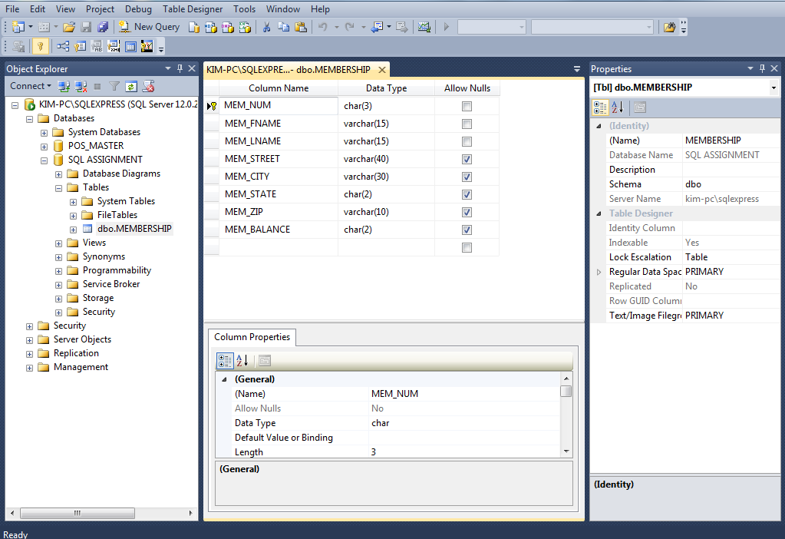

CREATE TABLE RENTAL (
RENT_NUM CHAR(4) PRIMARY KEY,
RENT_DATE DATE,
MEM_NUM CHAR(3)
FOREIGN KEY (MEM_NUM) REFERENCES MEMBERSHIP);

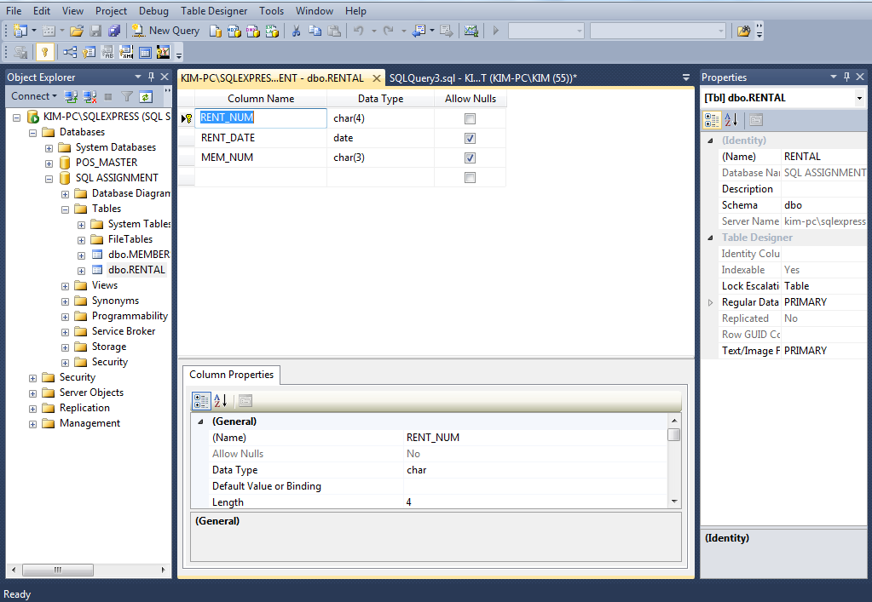

CREATE TABLE DETAILRENTAL (
RENT_NUM CHAR(4),
VID_NUM CHAR(5),
DETAIL_FEE NUMERIC(2,1),
DETAIL_DUEDATE DATE,
DETAIL_RETURNDATE DATE,
DETAIL_DAILYLATEFEE CHAR(1),
PRIMARY KEY (RENT_NUM, VID_NUM)
FOREIGN KEY RENT_NUM REFERENCES RENTAL,
FOREIGN KEY VID_NUM REFERENCES VIDEO);
);

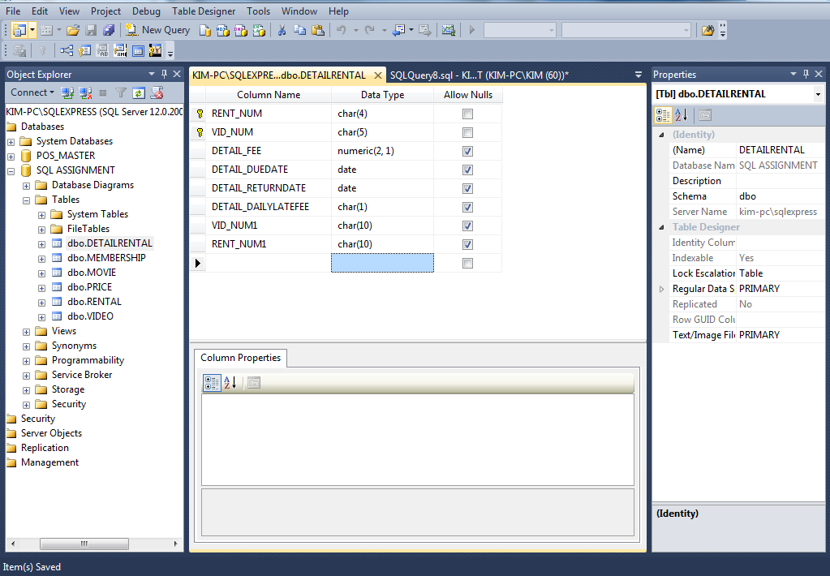

CREATE TABLE PRICE (
PRICE_CODE CHAR(1) PRIMARY KEY,
PRICE_DESCRIPTION VARCHAR(15),
PRICE_RENTFEE NUMERIC(2,1),
PRICE_DAILYLATEFEE NUMERIC(2,1));

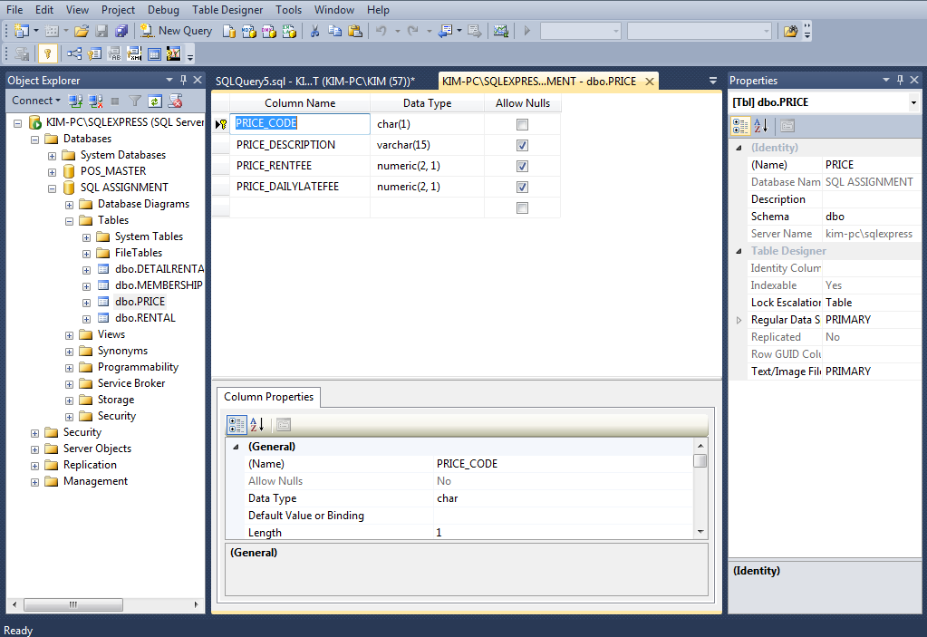

CREATE TABLE MOVIE (
MOVIE_NUM CHAR(4) PRIMARY KEY,
MOVIE_TITLE VARCHAR(40),
MOVIE_YEAR CHAR(4),
MOVIE_COST NUMERIC(4,2),
MOVIE_GENRE VARCHAR(15),
PRICE_CODE CHAR(1),
FOREIGN KEY (PRICE_CODE) REFERENCES PRICE);

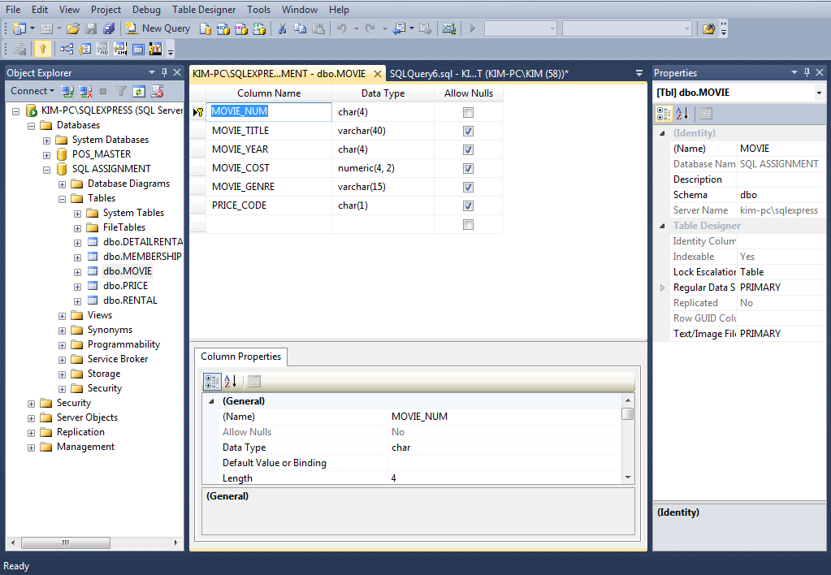

CREATE TABLE VIDEO (
VID_NUM CHAR(5) PRIMARY KEY,
VID_INDATE DATE,
MOVIE_NUM CHAR(4),
FOREIGN KEY (MOVIE_NUM) REFERENCES MOVIE);

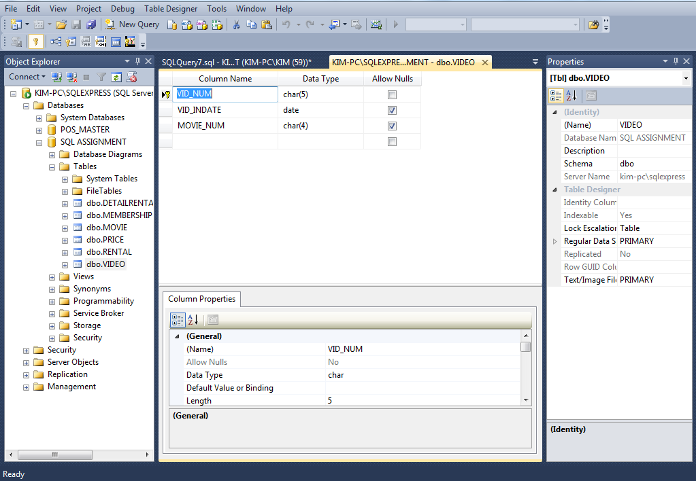

Question 48

/*INSERT DATA INTO MEMBERSHIP:*/
INSERT INTO MEMBERSHIP VALUES (102, 'TAMI', 'DAWSON', '2632 TAKLI CIRCLE', 'NORENE', 'TN', '37136', 11);
INSERT INTO MEMBERSHIP VALUES (103, 'CURT', 'KNIGHT', '4025 CORNELL COURT', 'FLATGAP', 'KY', '41219', 6);
INSERT INTO MEMBERSHIP VALUES (104, 'JAMAL', 'MELENDEZ', '788 EAST 145TH AVENUE', 'QUEBECK', 'TN', '38579', 0);
INSERT INTO MEMBERSHIP VALUES (105, 'IVA', 'MCCLAIN', '6045 MUSKET BALL CIRCLE', 'SUMMIT', 'KY', '42783', 15);
INSERT INTO MEMBERSHIP VALUES (106, 'MIRANDA', 'PARKS', '4469 MAXWELL PLACE', 'GERMANTOWN', 'TN', '38183', 0);
INSERT INTO MEMBERSHIP VALUES (107, 'ROSARIO', 'ELLIOTT', '7578 DANNER AVENUE', 'COLUMBIA', 'TN', '38402', 5);
INSERT INTO MEMBERSHIP VALUES (108, 'MATTIE', 'GUY', '4390 EVERGREEN STREET', 'LILY', 'KY', '40740', 0);
INSERT INTO MEMBERSHIP VALUES (109, 'CLINT', 'OCHOA', '1711 ELM STREET', 'GREENEVILLE', 'TN', '37745', 10);
INSERT INTO MEMBERSHIP VALUES (110, 'LEWIS', 'ROSALES', '4524 SOUTHWIND CIRCLE', 'COUNCE', 'TN', '38326', 0);
INSERT INTO MEMBERSHIP VALUES (111, 'STACY', 'MANN', '2789 EAST COOK AVENUE', 'MURFREESBORO', 'TN', '37132', 8);
INSERT INTO MEMBERSHIP VALUES (112, 'LUIS', 'TRUJILLO', '7267 MELVIN AVENUE', 'HEISKELL', 'TN', '37754', 3);
INSERT INTO MEMBERSHIP VALUES (113, 'MINNIE', 'GONZALES', '6430 VASILI DRIVE', 'WILLISTON', 'TN', '38076', 0);

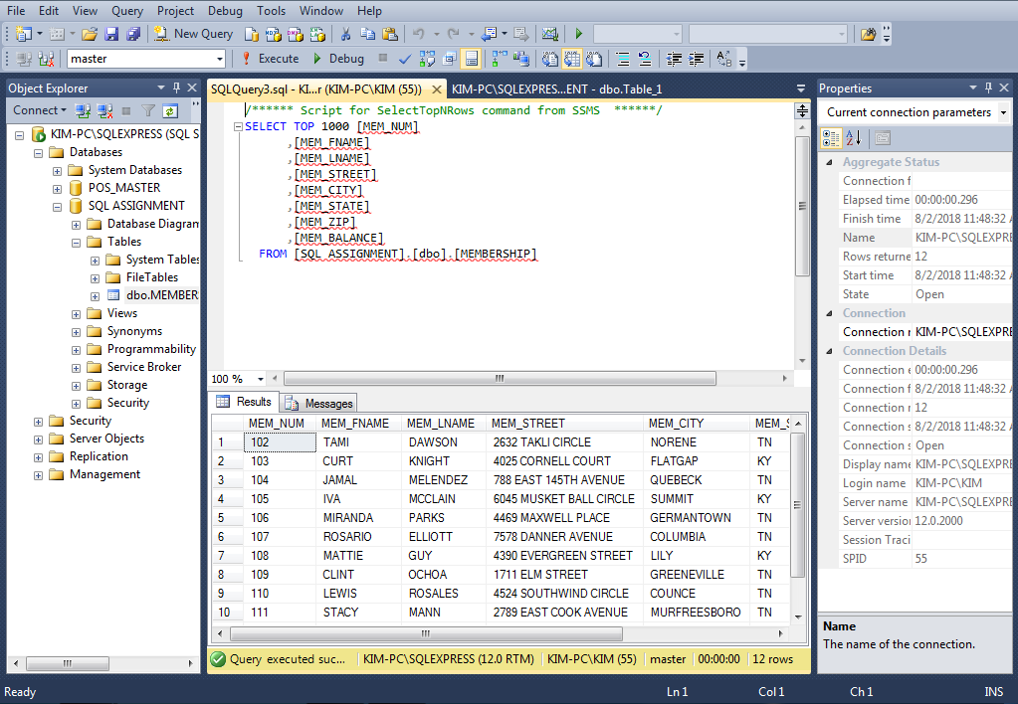

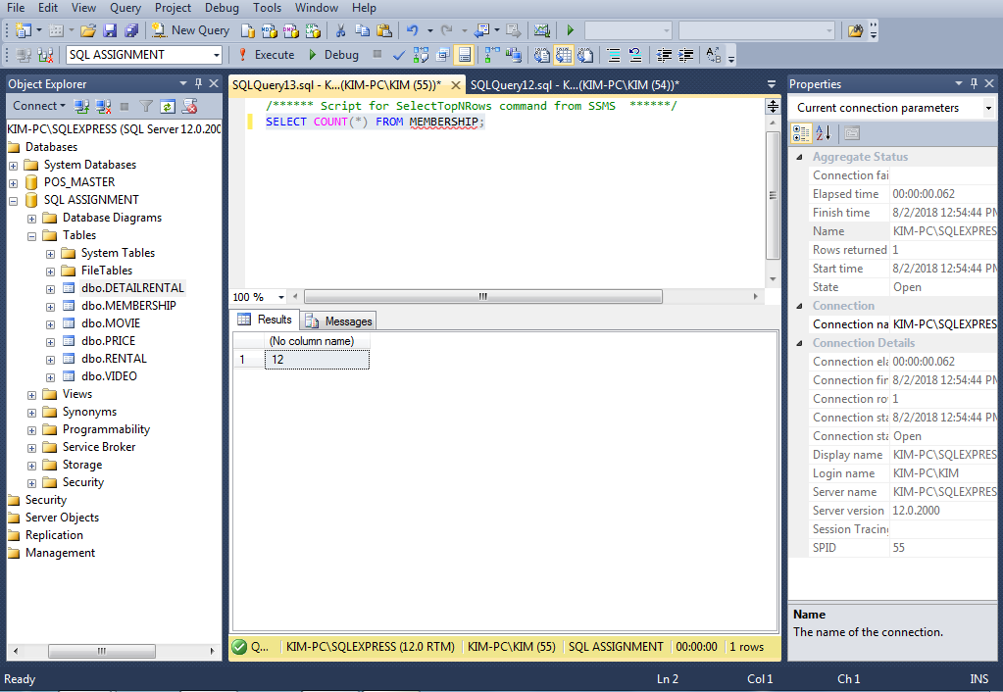

/*INSERT DATA INTO RENTAL:*/
INSERT INTO RENTAL VALUES (1001, '01-MAR-16', 103);
INSERT INTO RENTAL VALUES (1002, '01-MAR-16', 105);
INSERT INTO RENTAL VALUES (1003, '02-MAR-16', 102);
INSERT INTO RENTAL VALUES (1004, '02-MAR-16', 110);
INSERT INTO RENTAL VALUES (1005, '02-MAR-16', 111);
INSERT INTO RENTAL VALUES (1006, '02-MAR-16', 107);
INSERT INTO RENTAL VALUES (1007, '02-MAR-16', 104);
INSERT INTO RENTAL VALUES (1008, '03-MAR-16', 105);
INSERT INTO RENTAL VALUES (1009, '03-MAR-16', 111);

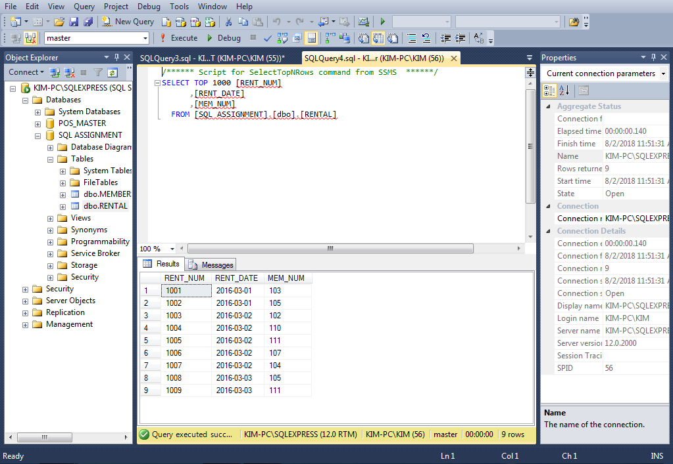

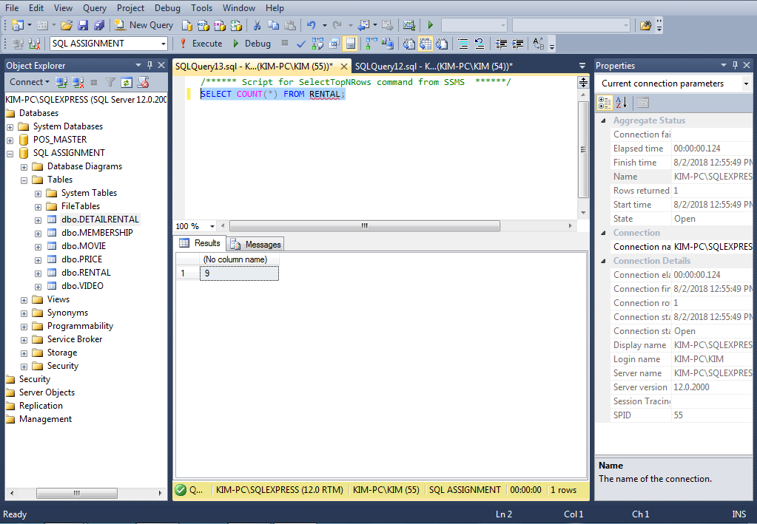

/*INSERT DATA INTO DETAILRENTAL:*/
INSERT INTO DETAILRENTAL VALUES (1001, 34342, 2, '04-MAR-16', '02-MAR-16', NULL);
INSERT INTO DETAILRENTAL VALUES (1001, 34366, 3.5, '04-MAR-16', '02-MAR-16', 3);
INSERT INTO DETAILRENTAL VALUES (1001, 61353, 2, '04-MAR-16', '03-MAR-16', 1);
INSERT INTO DETAILRENTAL VALUES (1002, 59237, 3.5, '04-MAR-16', '04-MAR-16', 3);
INSERT INTO DETAILRENTAL VALUES (1003, 54325, 3.5, '04-MAR-16', '09-MAR-16', 3);
INSERT INTO DETAILRENTAL VALUES (1003, 61369, 2, '06-MAR-16', '09-MAR-16', 1);
INSERT INTO DETAILRENTAL VALUES (1003, 61388, 0, '06-MAR-16', '09-MAR-16', 1);
INSERT INTO DETAILRENTAL VALUES (1004, 34341, 2, '07-MAR-16', '07-MAR-16', 1);
INSERT INTO DETAILRENTAL VALUES (1004, 34367, 3.5, '05-MAR-16', '07-MAR-16', 3);
INSERT INTO DETAILRENTAL VALUES (1004, 44392, 3.5, '05-MAR-16', '07-MAR-16', 3);
INSERT INTO DETAILRENTAL VALUES (1005, 34342, 2, '07-MAR-16', '05-MAR-16', 1);
INSERT INTO DETAILRENTAL VALUES (1005, 44397, 3.5, '05-MAR-16', '05-MAR-16', 3);
INSERT INTO DETAILRENTAL VALUES (1006, 34366, 3.5, '05-MAR-16', '04-MAR-16', 3);
INSERT INTO DETAILRENTAL VALUES (1006, 61367, 2, '07-MAR-16', NULL, 1);
INSERT INTO DETAILRENTAL VALUES (1007, 34368, 3.5, '05-MAR-16', NULL, 3);
INSERT INTO DETAILRENTAL VALUES (1008, 34369, 3.5, '05-MAR-16', '05-MAR-16', 3);
INSERT INTO DETAILRENTAL VALUES (1009, 54324, 3.5, '05-MAR-16', NULL, 3);

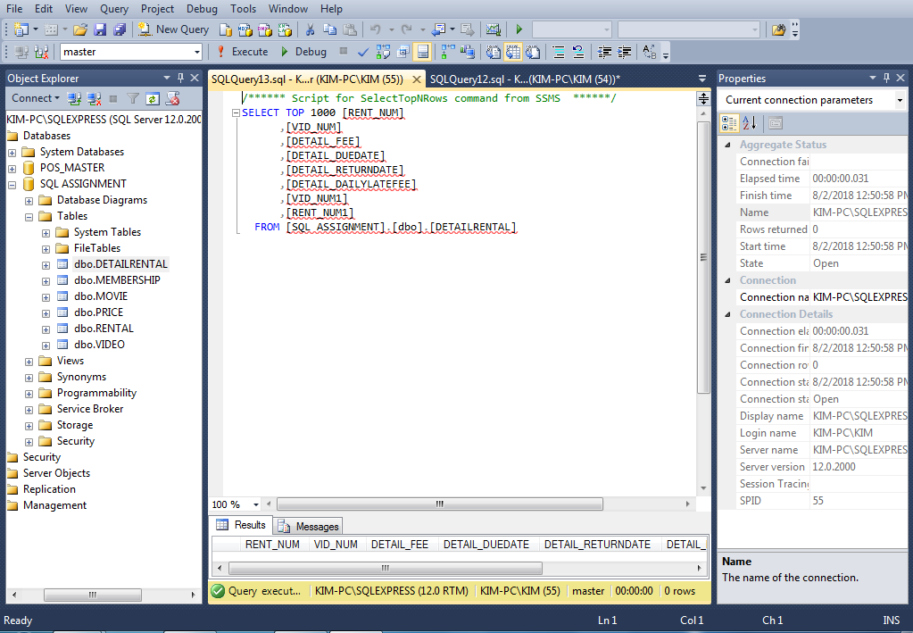

/*INSERT DATA INTO VIDEO:*/
INSERT INTO VIDEO VALUES (54321, '18-JUN-15', 1234);
INSERT INTO VIDEO VALUES (54324, '18-JUN-15', 1234);
INSERT INTO VIDEO VALUES (54325, '18-JUN-15', 1234);
INSERT INTO VIDEO VALUES (34341, '22-JAN-14', 1235);
INSERT INTO VIDEO VALUES (34342, '22-JAN-14', 1235);
INSERT INTO VIDEO VALUES (34366, '02-MAR-16', 1236);
INSERT INTO VIDEO VALUES (34367, '02-MAR-16', 1236);
INSERT INTO VIDEO VALUES (34368, '02-MAR-16', 1236);
INSERT INTO VIDEO VALUES (34369, '02-MAR-16', 1236);
INSERT INTO VIDEO VALUES (44397, '21-OCT-15', 1237);
INSERT INTO VIDEO VALUES (59237, '14-FEB-16', 1237);
INSERT INTO VIDEO VALUES (61388, '25-JAN-14', 1239);
INSERT INTO VIDEO VALUES (61353, '28-JAN-13', 1245);
INSERT INTO VIDEO VALUES (61354, '28-JAN-13', 1245);
INSERT INTO VIDEO VALUES (61367, '30-JUL-15’, 1246);
INSERT INTO VIDEO VALUES (61369, '30-JUL-15', 1246);

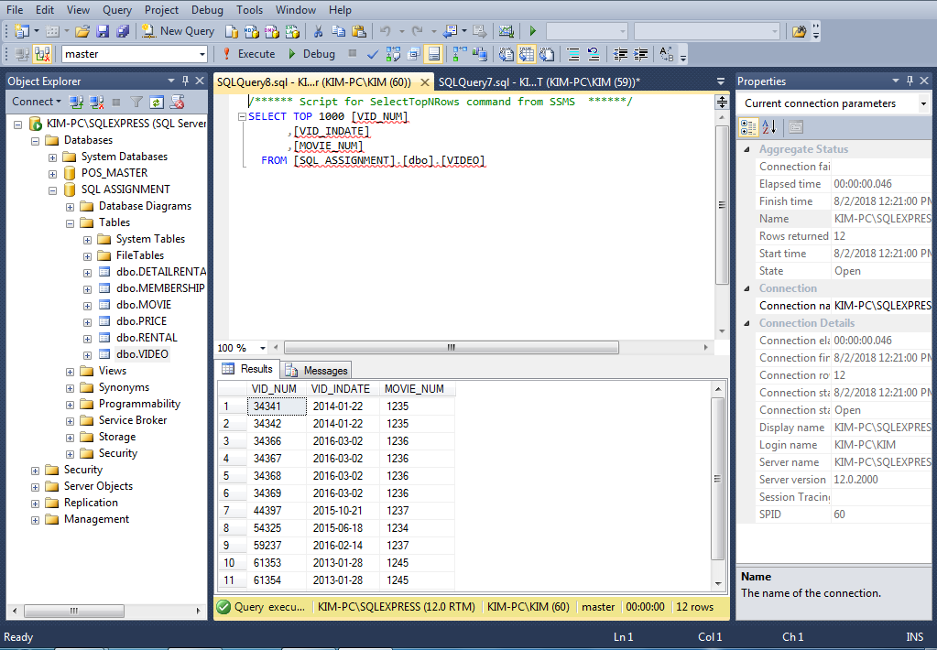

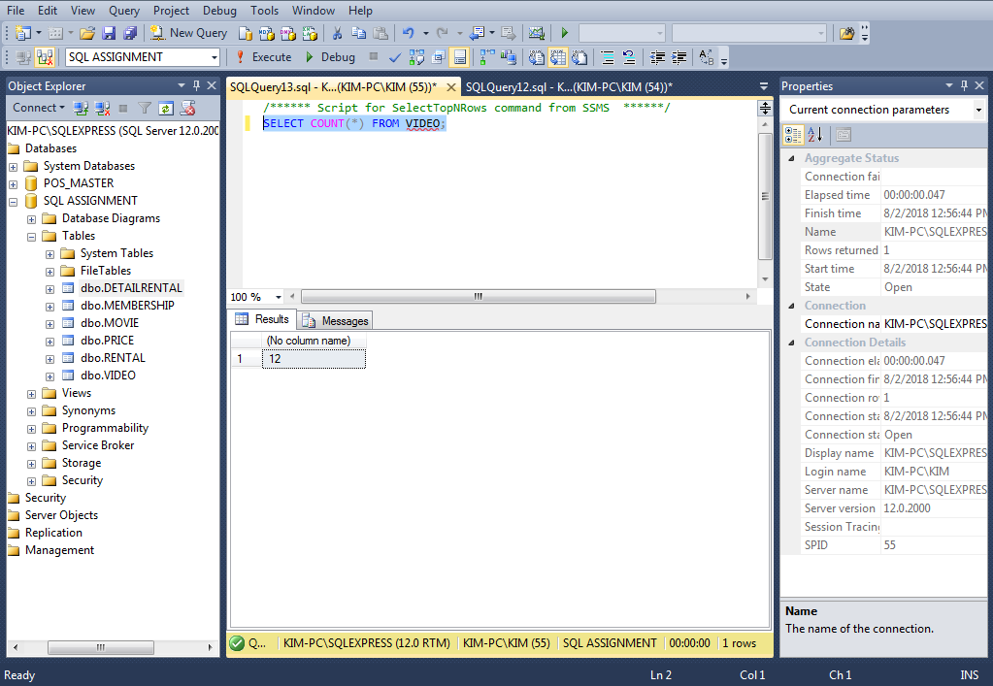

/*INSERT DATA INTO MOVIE:*/
INSERT INTO MOVIE VALUES (1234, 'The Cesar Family Christmas', 2014, 39.95, 'FAMILY', 2);
INSERT INTO MOVIE VALUES (1235, 'Smokey Mountain Wildlife', 2011, 59.95, 'ACTION', 1);
INSERT INTO MOVIE VALUES (1236, 'Richard Goodhope', 2015, 59.95, 'DRAMA', 2);
INSERT INTO MOVIE VALUES (1237, 'Beatnik Fever', 2014, 29.95, 'COMEDY', 2);
INSERT INTO MOVIE VALUES (1238, 'Constant Companion', 2015, 89.95, 'DRAMA', NULL);
INSERT INTO MOVIE VALUES (1239, 'Where Hope Dies', 2005, 25.49, 'DRAMA', 3);
INSERT INTO MOVIE VALUES (1245, 'Time to Burn', 2012, 45.49, 'ACTION', 1);
INSERT INTO MOVIE VALUES (1246, 'What He Doesn''t Know', 2013, 58.29, 'COMEDY', 1);

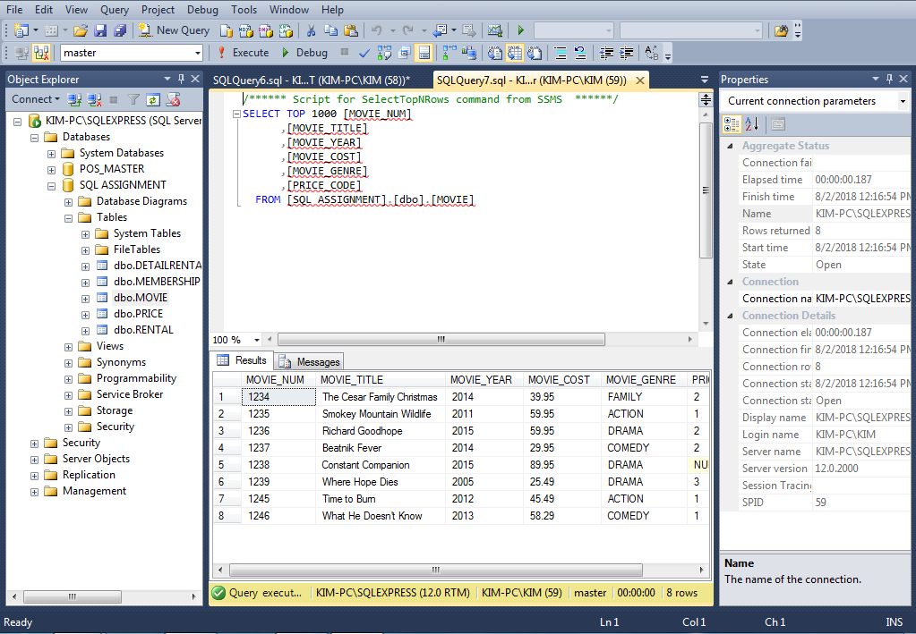

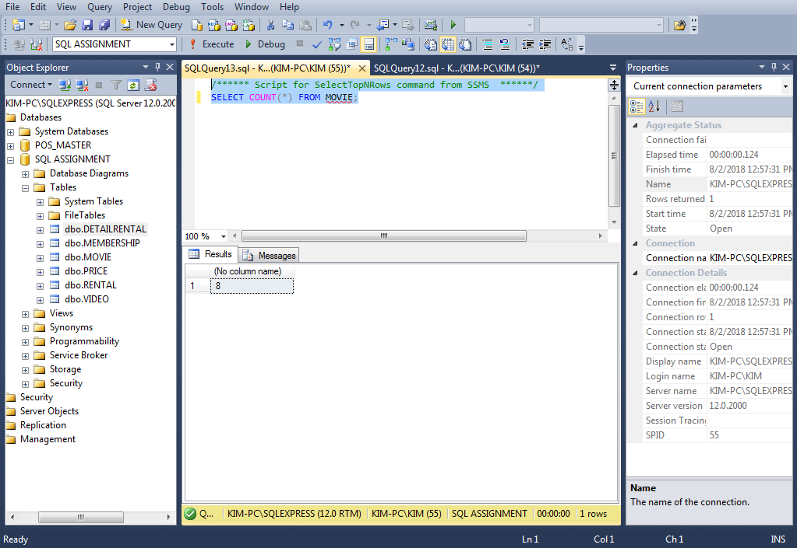

/*INSERT DATA INTO PRICE: */
INSERT INTO PRICE VALUES (1, 'Standard', 2, 1);
INSERT INTO PRICE VALUES (2, 'New Release', 3.5, 3);
INSERT INTO PRICE VALUES (3, 'Discount', 1.5, 1);
INSERT INTO PRICE VALUES (4, 'Weekly Special', 1, .5);
COMMIT;

